# Speech Recognition API

Speech recognition is a software invention that allows the user to interact with their mobile devices through speech. It is simply an application that enables a machine to single out words or phrases in a spoken language, thereafter it converts them to a machine-readable format. Speech recognition is designed with the sole purpose of creating text from speech, so instead of typing through a keypad, users talk to the device which has programs that type the text.

Use of speech recognition system in various fields :

1. Used in evolving search engines; when using search engines there can be differences between how we type our inquiries and how we verbalize the same queries. The user may have trouble expressing a phrase or their intent thus may not acquire appropriate results. With the inclusion of speech recognition in search engines, the results of accuracies will be significantly increased. As speech recognition improves, there will be a significant implication on how the public views search engines generally.
2. Impact in the healthcare industry; the feature has its use in medical reporting by medical personnel. When it was introduced in this industry doctors had trouble using it to accomplish tasks. The system had a limited understanding of medical terminologies. Therefore, doctors had to learn how to talk to the software. The technology was improved to be user-friendly and accurate; this was established by imperative improvements and inclusion of relevant vocabularies.
3. Use in service delivery; customers and clients may not want to speak to a live operator. Therefore, they opt to use speech recognition systems. This helps to make the process efficient and improves on time as it cuts on waiting time. This has its application in various airports in confirming the travel schedules of the aircraft.
4. Automated identification; In order to avoid providing sensitive and risky personal information, institutions may opt to use speech recognition to authenticate identities of their clients. This has helped to curb fraud and phone crimes by the use of voice biometrics in certain institutions like banks.
5. Communication in service providers; telecommunication providers use speech recognition to serve their clients who may want to receive customer care services. This consists of various questions by the software to establish the caller’s demands and then directs them to the appropriate operator for assistance.

The Web Speech API enables you to incorporate voice data into web apps. The Web Speech API has two parts:

-- SpeechSynthesis (Text-to-Speech)

-- SpeechRecognition (Speech-to-Text)

The Web Speech API is supported only in Google Chrome and Firefox

In the below steps, I have explained how I have implemented the Web Speech API.

The Web Speech API allows JavaScript to have access to a browser’s audio stream and to convert it to text.

1. The speech recognition interface lives on the browser’s  object as  in Chrome.
2. After that, I make sure that the Speech Recognition API is supported by the browser

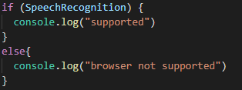

1. The next step is to create a new speech recognition object.



1. This will ask the user to allow the page to have access to the microphone.

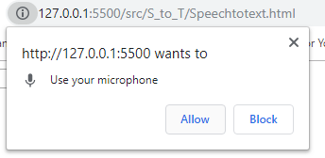

This  object has many properties, methods.

--Properties:

* recognition.grammars
* recognition.lang
* recognition.continuous
* recognition.interimResults (default: false)
* recognition.maxAlternatives (default: 1)
* recognition.serviceURI

--Methods:

* recognition.abort()
* recognition.start()
* recognition.stop()

For this project I used :

Properties -

* + Recognition.continuous :

Controls whether continuous results are returned for each recognition, or only a single result. Defaults to a single (false.)

* + Recognition.interimResults :

Controls whether interim results should be returned (true) or not (false.) Interim results are results that are not yet final (e.g. the SpeechRecognitionResult.isFinal property is false.)

Methods -

* + recognition.start() :

Starts the speech recognition service listening to incoming audio with intent to recognize grammar associated with the current SpeechRecognition.

* + recognition.stop() :

Stops the speech recognition service from listening to incoming audio, and attempts to return a SpeechRecognitionResult using the audio captured so far.

1. Listen to the events using addEventListener(). I used 3 EventListeners :

1. addEventListener("click");

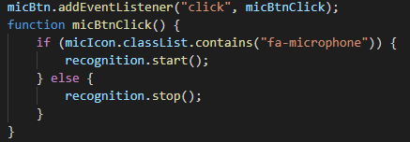

1. addEventListener("start");

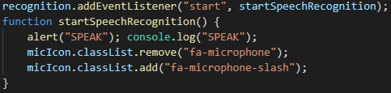

1. addEventListener("result");

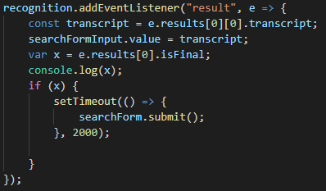

The “const transcript” event handler returns a SpeechRecognitionEvent with a property result which is a two-dimensional array. I took the first object of this matrix which contains the transcript property. This property holds the recognized speech in text format.

**Code :**

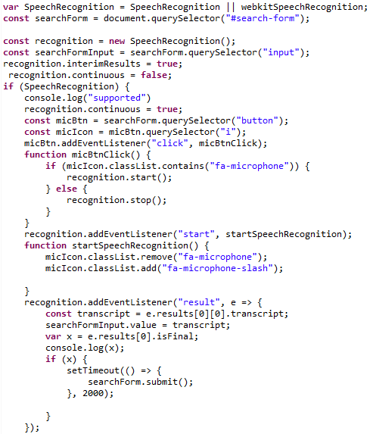

**Sample :**

1. Click on the mic button.



1. Search any product by saying its name like “jeans”.



1. Search result displayed

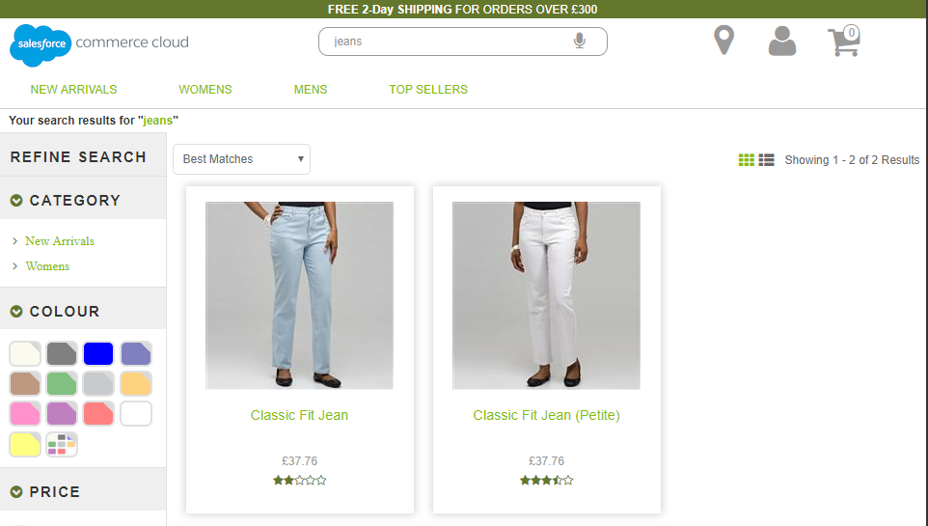

**Steps to use the Web Speech API :**

1. Import the code

--------------------------------------------------------------------------------------

<script src="${URLUtils.staticURL('/js/microphone.js')}"></script>

Here I have put the code in the microphone.js file

--------------------------------------------------------------------------------------

1. Add a button, and that’s it.

------------------------------------------------------------------------------------------------------

<button type="button" id="myBtn"><i class="fa fa-microphone"></i></button>

------------------------------------------------------------------------------------------------------