**Question:-** WAP to perfom multiple inheritance in Java

**Answer:-**

class A

{

void showA()

{

System.out.println("a class method");

}

}

class B extends A

{

void showB()

{

System.out.println("b class method");

}

}

public class C extends B

{

void showC()

{

System.out.println("c class method");

}

public static void main(String[] args)

{

A obj1=new A();

obj1.showA();

System.out.println("------------");

// object of a class can call only a class function

B obj2=new B();

obj2.showA();

obj2.showB();

System.out.println("------------");

// object of b class can call only a and b class function

C obj3=new C();

obj3.showA();

obj3.showB();

obj3.showC();

System.out.println("------------");

//class c inherit the boths classes so it can call any function of a , b //and c class which is implement of multiple inheritance

}

}

**Output:-**

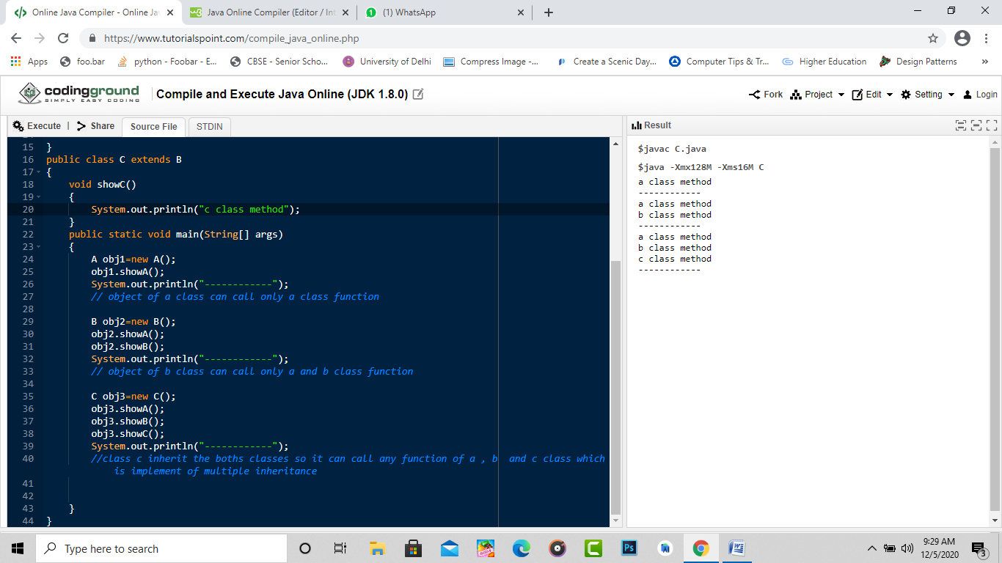

**Detailed Output**

