## User Manual

1. **Recommended method – Using Command Line Interface (Terminal/PowerShell/CMD)**
2. Have a system installed with Prolog (Can use CMD/PowerShell with administrative privileges)
3. Have the ‘menu.pl’ file copied to a destination
4. Right click outside the folder containing ‘menu.pl’ and select Open in Terminal
5. 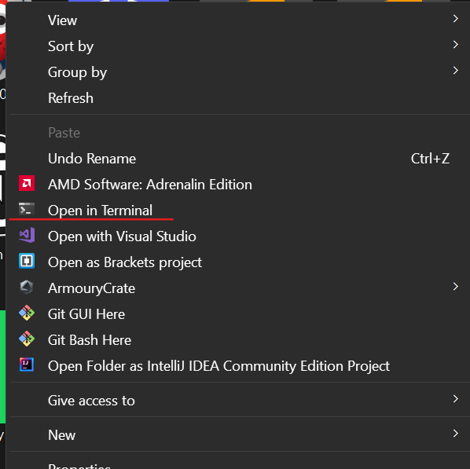Type in **‘swipl’**
6. Now after Prolog put in the command **consult(‘menu.pl’).**
7. A screenshot of a computer program

   Description automatically generated with medium confidenceThe program will show a menu after successfully running it, test out the smart battery prolog project!
8. **Alternative method, using SWI-Prolog Application**
9. Open the SWI-Prolog application
10. Hit the File toolbar, then Consult
11. Locate the ‘menu.pl’ File and click ‘Open’
12. The program will now start easily, do remember to input “10.” Or else the SWI-Prolog will run into a loop. (Force close the program if you accidentally do so!)
13. Good luck testing the program!

