Mini Assignment1 Week4

I have tried using cmd and creating stage and putting files but the issue persists and I have also pasted files from users section to outside of the users to avoid the permission error if it exists as I have did in first week where we have to import data into postgres.

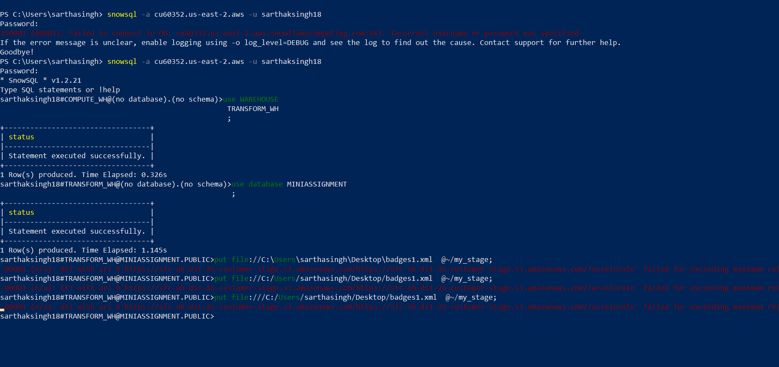

I have executed cmd in administrator mode and also executed same statement in powershell. I have also attempted this with the file reduced to the limit which snowflakes accept.

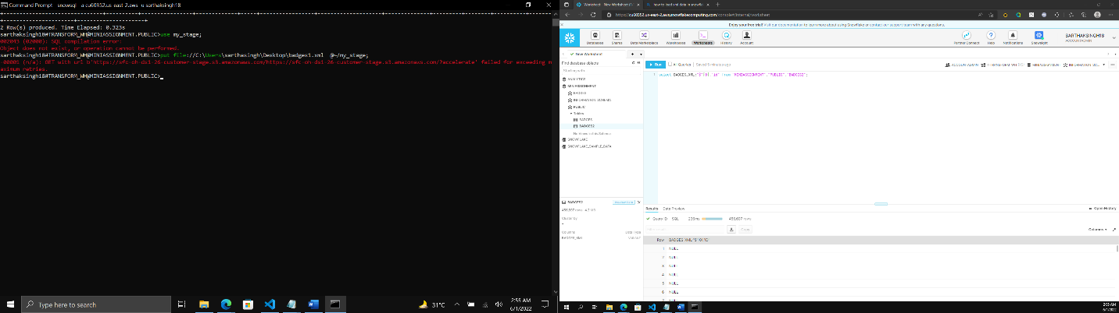

I have used nodejs to reduce file to acceptable size and it works fine I tried to upload the files into table using two approaches

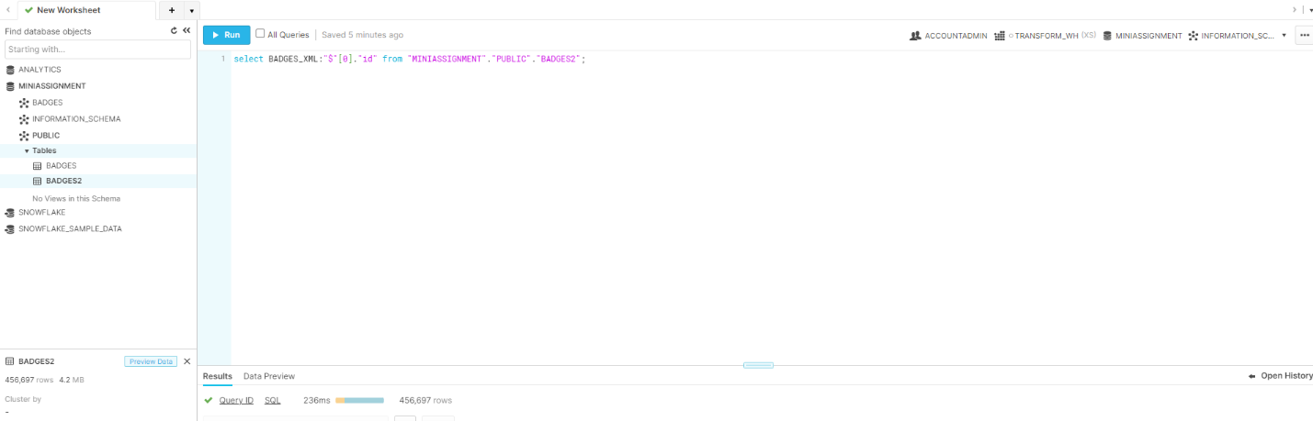

First, Created one table with the column details I thought it will automatically puts value into the snowflake table from the xml files but that was not the case we have to use the type called variant which stores xml files data. After that I encounter that I have created another table which has variant type but I think the data which is uploaded not uploaded in the proper manner or there is the issue with xml as I can’t use @ $ which used to get the key value but I can’t use them.

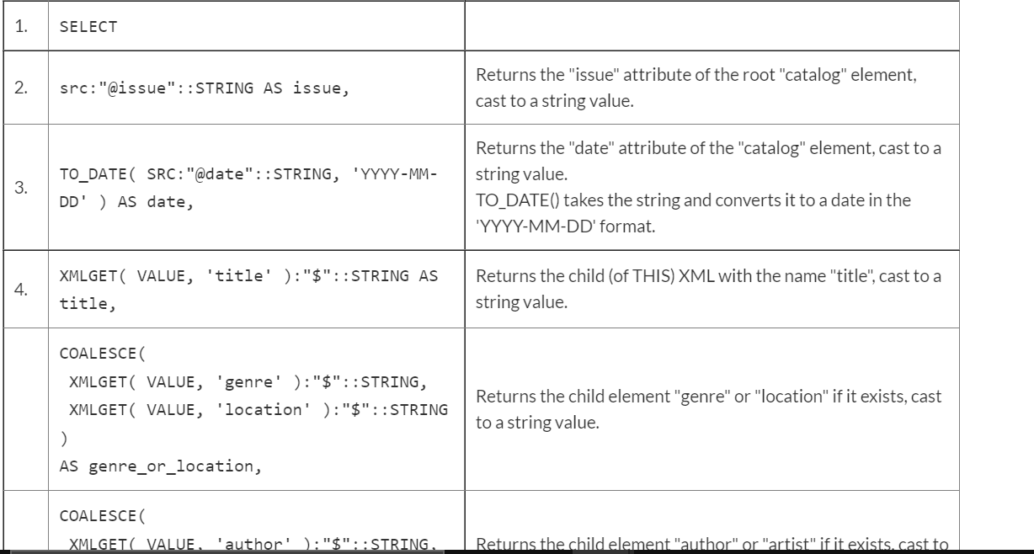

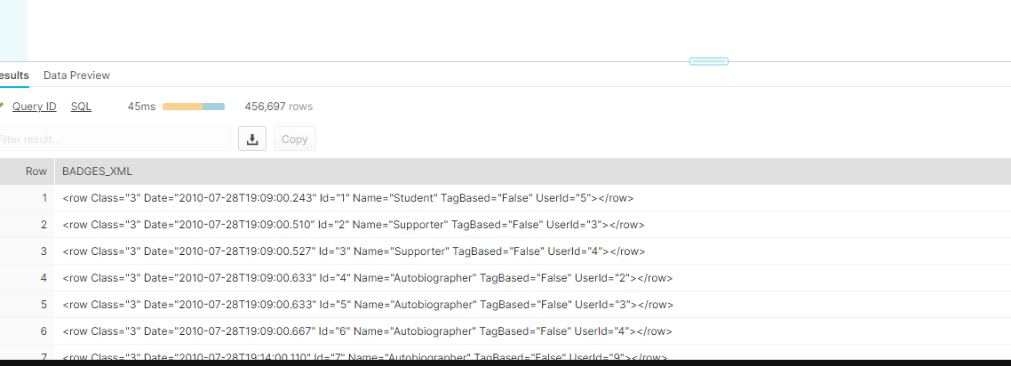

I have also tried these from the documentation but none works.



I have not worked on tdb as no queries are working on snowflake.