GameArena – Real-Time Gaming Leaderboard System
Project Documentation
Name: Sarthak Sunil Tajane
Roll No: 150096724109

Problem Statement
GameArena is a large-scale online gaming platform similar to Steam and Riot Games. The platform requires a scalable leaderboard capable of processing millions of score updates in real time while maintaining ranking accuracy, low latency, fraud prevention, fault tolerance, and high availability. The system must support global, regional, tournament, and seasonal leaderboards for millions of concurrent players.

Proposed Solution
The proposed solution uses an event-driven distributed architecture consisting of API Gateway, WebSocket Manager, Score Validator, Apache Kafka, Ranking Engine, Fraud Detection Engine, Redis, PostgreSQL, Cassandra, Analytics Engine, and Leaderboard APIs. Kafka streams score events, Redis provides real-time ranking access, PostgreSQL stores metadata, and Cassandra stores historical records.

System Architecture
Game Clients → API Gateway → WebSocket Manager → Score Validator → Kafka Cluster → Ranking Engine / Fraud Detection / Analytics → Redis (Hot Data) / PostgreSQL (Warm Data) / Cassandra (Cold Data) → Leaderboard APIs → Global, Regional, and Seasonal Rankings.

Module Description
Modules include API Gateway, WebSocket Manager, Score Validator, Kafka Event Streaming, Ranking Engine, Fraud Detection Engine, Redis Cache Layer, PostgreSQL Metadata Store, Cassandra Historical Store, Analytics Layer, and Leaderboard APIs. Each module performs a specific role in ensuring scalability and low-latency ranking updates.

Database Design
Player, Tournament, Score Event, Leaderboard, and Historical Score entities are used. PostgreSQL stores structured metadata while Cassandra stores high-volume historical events. Redis stores frequently accessed leaderboard data for fast retrieval.

Technology Stack
Python, Apache Kafka, Redis Cluster, PostgreSQL, Cassandra, Apache Spark/Flink, Docker, Kubernetes, REST APIs, gRPC, and WebSockets.

Implementation Details
Scores are validated using HMAC signatures and duplicate checks before entering Kafka. Ranking Engine consumes events and updates Redis leaderboards. PostgreSQL stores profile data and Cassandra archives score history. Leaderboard APIs provide fast rank retrieval. Complexity for updates is approximately O(log N) using sorted ranking structures.

Screenshots
Architecture diagram included below. Additional notebook execution screenshots and leaderboard outputs can be added before final submission.

Future Scope
AI-based fraud detection, predictive analytics, personalized leaderboards, cross-game rankings, active-active multi-region deployment, and advanced recommendation systems.
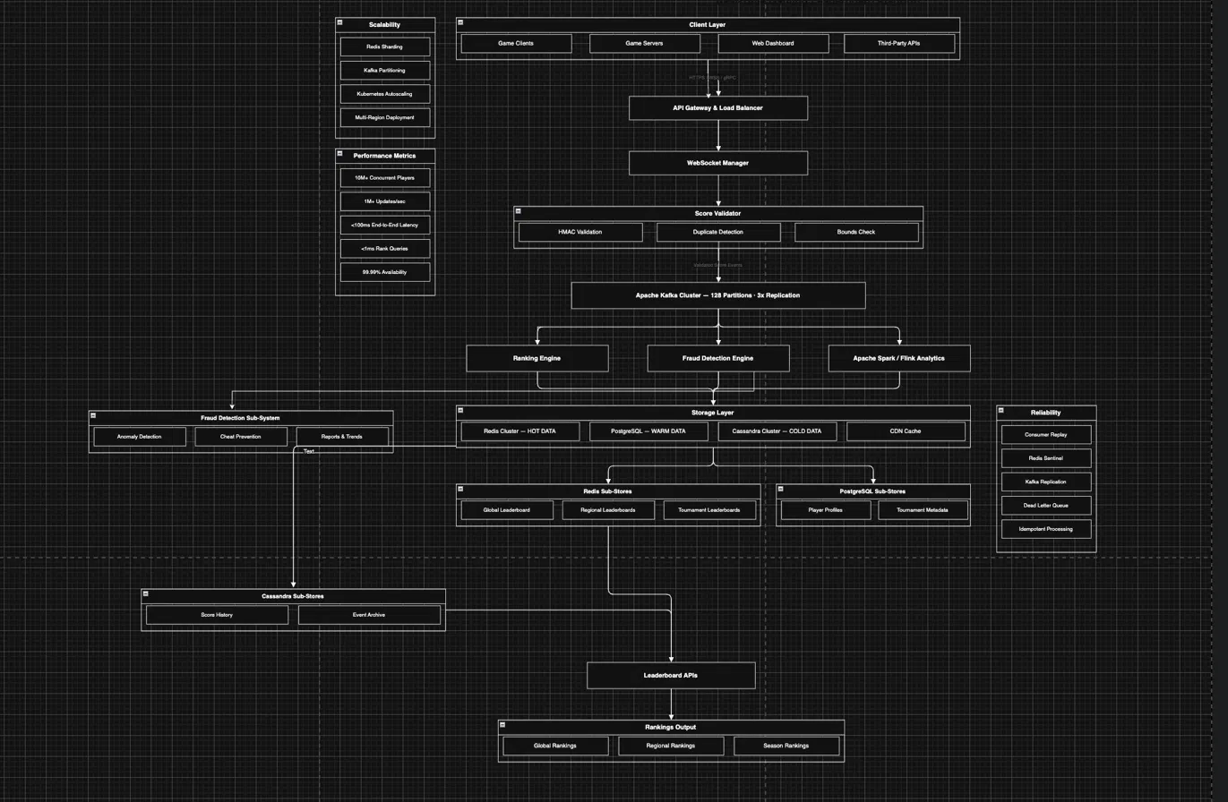

Conclusion
The proposed GameArena leaderboard system provides a scalable, fault-tolerant, and low-latency architecture capable of handling millions of players while maintaining ranking accuracy and fairness.

