
SANJIVANI UNIVERSITY
SCHOOL OF ENGINEERING AND TECHNOLOGY

ANIMAL GUESSER
A Self-Learning Decision Tree Game in C++17
Submitted By
Student 1 (Register No)
Student 2 (Register No)
Student 3 (Register No)

Career Craft Academy powered by HCL Tech
Trainer Name:
Department of Computer Science & Engineering
Date of Submission: 03/11/2026

Declaration
We declare that this report is our original work. All sources used have been acknowledged in the References section. The code in the project repository was written by our team, and any borrowed code or ideas are clearly cited.

Name | Signature | Date
Thilak R
Aarav Sharma
Ananya Patel

Acknowledgement
We express our sincere gratitude to our project guide,[Trainer Name] for his invaluable guidance, support, and constructive feedback throughout the development of this project. We also thank the Department of Computer Science & Engineering for providing the necessary infrastructure and software labs. Finally, we appreciate our peers for their helpful discussions and insights during testing.

Table of Contents

Chapter No. | Title | Page No.
Chapter 1 | Introduction | 4-5
Chapter 2 | Requirement Analysis | 6-7
Chapter 3 | Data Structures and Concepts Used | 8-9
Chapter 4 | System Design | 10-12
Chapter 5 | Implementation | 13-15
Chapter 6 | Testing and Validation | 16-18
Chapter 7 | Results and Screenshots | 19-21
Chapter 8 | Challenges and Learnings | 22
Chapter 9 | Conclusion and Future Scope | 23
References | References & Appendices | 24

CHAPTER 1

INTRODUCTION

1.1 PROBLEM STATEMENT
Guessing games such as “20 Questions” are usually written with a fixed, hard-coded list of animals and questions. Such programs cannot identify an animal they were not programmed with, and adding new knowledge means editing the source code and recompiling. There is a need for a simple program that can (a) identify an animal by asking a short series of yes/no questions, (b) admit when it is wrong and learn the missing animal and a distinguishing question directly from the player, and (c) remember what it has learned between runs.

1.2 INTRODUCTION
Animal Guesser is a console application written in C++17 using only the standard library. Its knowledge base is a binary decision tree: every internal node holds a yes/no question and every leaf holds an animal. The program starts at the root, asks the question stored at each node and follows the “yes” or “no” branch until it reaches a leaf, where it makes its guess.
If the guess is wrong, the program asks the player for the correct animal and for a question that tells the two animals apart, and then replaces the wrong leaf with a new question node. The tree therefore grows with every game, and it is saved to a text file so that the learning persists across sessions. The project demonstrates practical use of classes, dynamic memory with smart pointers, recursion, binary trees, file handling and exception handling in C++.

1.3 OBJECTIVES
- Represent animal knowledge as a binary decision tree of question nodes and animal nodes.
- Guess the animal the player is thinking of by traversing the tree through yes/no questions.
- Learn new animals at run time by splitting a wrong leaf into a new question node.
- Save the learned tree to a text file and reload it automatically on the next start-up.
- Provide a menu-driven console interface with options to view the tree, list animals and see statistics.
- Handle invalid input and end-of-input safely, without crashing or leaking memory.

1.4 SCOPE OF WORK
Within scope
- Single-player console game with a built-in starter tree of 36 animals and 35 questions.
- Learning from wrong guesses, saving, loading and resetting the knowledge base.
- Game statistics: games played, correct guesses, animals learned and accuracy.
- Input validation for menu choices, yes/no answers and free-text entries.
Outside scope
- Graphical or web interface, and multi-user or network play.
- Automatic checking of whether a question supplied by the player is factually correct.
- Editing or deleting a single learned entry (the whole tree can only be reset to the starter data).

1.5 PROJECT OVERVIEW
The whole program is contained in one source file, animal_guesser.cpp (about 480 lines), organised in three parts: the util namespace with string and input helpers, the Node and DecisionTree classes that form the game engine, and main(), which provides the menu. When the program starts it loads animals.txt if it exists; otherwise it uses the built-in starter knowledge. The main menu offers seven actions plus exit:
- Play – think of an animal and let the program guess it, learning if it is wrong.
- Show knowledge tree – print the whole tree with Y/N branches and animals marked with *.
- List known animals – print all animals in alphabetical order.
- Statistics – animals known, tree depth, games played, correct guesses, animals learned and accuracy.
- Save, Load and Reset – write the tree to disk, reload it, or return to the starter knowledge.
- Save & quit – store the tree and exit.

CHAPTER 2

REQUIREMENT ANALYSIS

2.1 User Roles

Role | Description | Main Actions
Player | Person who thinks of an animal and answers the program’s yes/no questions | Start a game, answer questions, confirm or reject the guess, view tree/statistics, save, load or reset
Teacher (same person) | The player acting as a knowledge contributor when the program guesses wrongly | Enter the correct animal, give a distinguishing question and its answer, so the tree grows

2.2 Functional Requirements

ID | Requirement | Priority (High / Medium / Low)
FR1 | The system shall ask yes/no questions by walking the decision tree from the root and shall guess the animal at a leaf. | High
FR2 | The system shall learn from a wrong guess by asking for the correct animal and a distinguishing question, and extend the tree. | High
FR3 | The system shall save the tree to animals.txt on exit (or on request) and load it at start-up. | High
FR4 | The system shall reject duplicate animals and inconsistent answers during learning. | Medium
FR5 | The system shall display the knowledge tree, the sorted list of animals and game statistics. | Medium
FR6 | The system shall validate all input and re-prompt on invalid entries without crashing. | High
FR7 | The system shall reset the knowledge base to the built-in starter data on request. | Low

2.3 Non-Functional Requirements
- Reliability: Clean recovery from invalid console input and from end-of-input without crashing.
- Data Persistence: Complete load/save cycle using a plain-text file; a corrupt file is rejected without damaging the current tree.
- Performance: A guess needs one question per tree level (at most 11 questions with the starter tree plus one learned animal); response is instant.
- Memory Safety: All nodes are owned by std::unique_ptr, so there are no manual new/delete calls and no leaks.
- Portability and Usability: Standard C++17 only; simple numbered menu and plain y/n prompts.

2.4 Software and Hardware Requirements

Item | Details
Language | C++17
Compiler / IDE | g++ with -std=c++17 (built with g++ 13.3) / any text editor or IDE
Libraries | C++ standard library only: algorithm, cctype, fstream, iostream, memory, sstream, string, vector
Build Command | g++ -std=c++17 -O2 -Wall -Wextra -o animal_guesser animal_guesser.cpp
Version Control | Git and GitHub
Operating System | Any OS with a C++17 compiler (tested on Ubuntu Linux)
Minimum Hardware | Any modern PC; a few MB of RAM and a few KB of storage

CHAPTER 3

DATA STRUCTURES AND CONCEPTS USED

Concept (Unit) | Where Used in the Project | Why Chosen / Time Complexity
Classes and Objects (Unit I) | Node and DecisionTree classes; Stats struct | Encapsulates the tree, the game logic and the counters; public interface hides the helper functions
Constructors and Destructors (Unit I) | Node(string) constructor; DecisionTree() calls reset() | Objects start in a valid state; destruction of the tree is automatic (RAII), so no memory leaks
Smart Pointers / Dynamic Memory | std::unique_ptr<Node> for root, yes and no links | Single ownership of every node; safe splicing with std::move; O(1) per node
Exception Handling (Unit II) | util::readNonEmpty and askYesNo throw runtime_error on EOF; caught in main() | Program exits gracefully and still saves the knowledge when input closes
Trees (Unit V) | Binary decision tree: question nodes (internal) and animal nodes (leaves) | One question per level; guess in O(d) time where d is the tree depth
Linked Structures (Unit III) | Nodes linked through yes/no pointers; parent pointer kept while descending | Allows a leaf to be replaced in place by a new question node in O(1)
Recursion | writeNode, readNode, printNode, collectAnimals, depthOf | Natural for tree traversal; each runs in O(n) over n nodes
STL Containers and Algorithms | std::vector<string>, std::sort, std::transform | Collect and sort animal names in O(n log n); case conversion with lambdas
File Handling | ifstream / ofstream for animals.txt; istringstream for the starter data | Persistent pre-order storage, one node per line; load/save in O(n)
String Handling | trim, toLower, normalizeAnimal, normalizeQuestion, withArticle | Consistent comparison and natural output (“a dog”, “an elephant”)

3.1 Knowledge Tree Structure
Each internal node stores a question; the left link is followed for “yes” and the right link for “no”. Leaves store an animal name. The figure below shows the top levels of the starter tree.
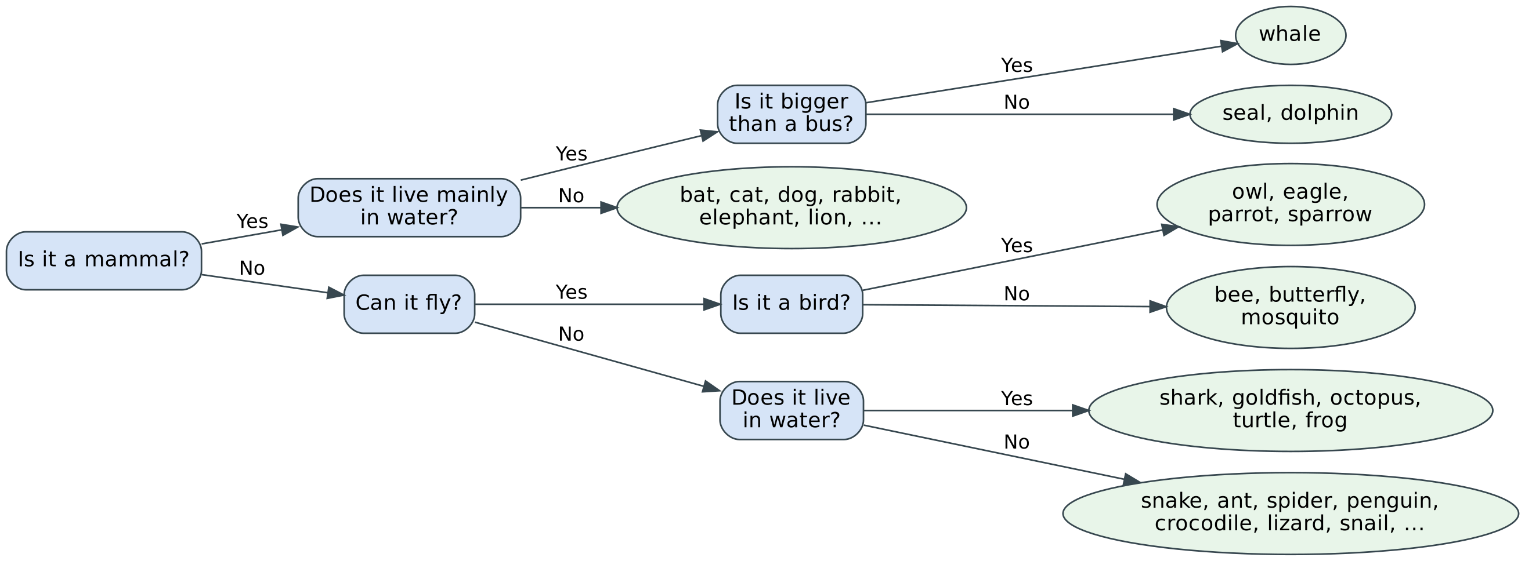
Figure 3.1: Top levels of the starter knowledge tree (blue = question, green = animal leaves)

3.2 Knowledge File Format
The tree is stored in pre-order, one node per line: Q|<question> for an internal node (followed by its yes-subtree and then its no-subtree) and A|<animal> for a leaf. The same format is used for the built-in starter data. Example:
Q|Is it a mammal?
Q|Does it live mainly in water?
A|whale
A|bat
Q|Can it fly?
A|owl
A|snake

CHAPTER 4

SYSTEM DESIGN

4.1 System Overview
The console menu in main() receives the player’s choices and forwards them to the DecisionTree engine. The engine uses the util helpers for all input and text handling, keeps the knowledge as a tree of Node objects, and delegates saving and loading to the persistence routines, which read and write animals.txt. The built-in starter data is used when no saved file exists or when the player resets the knowledge.
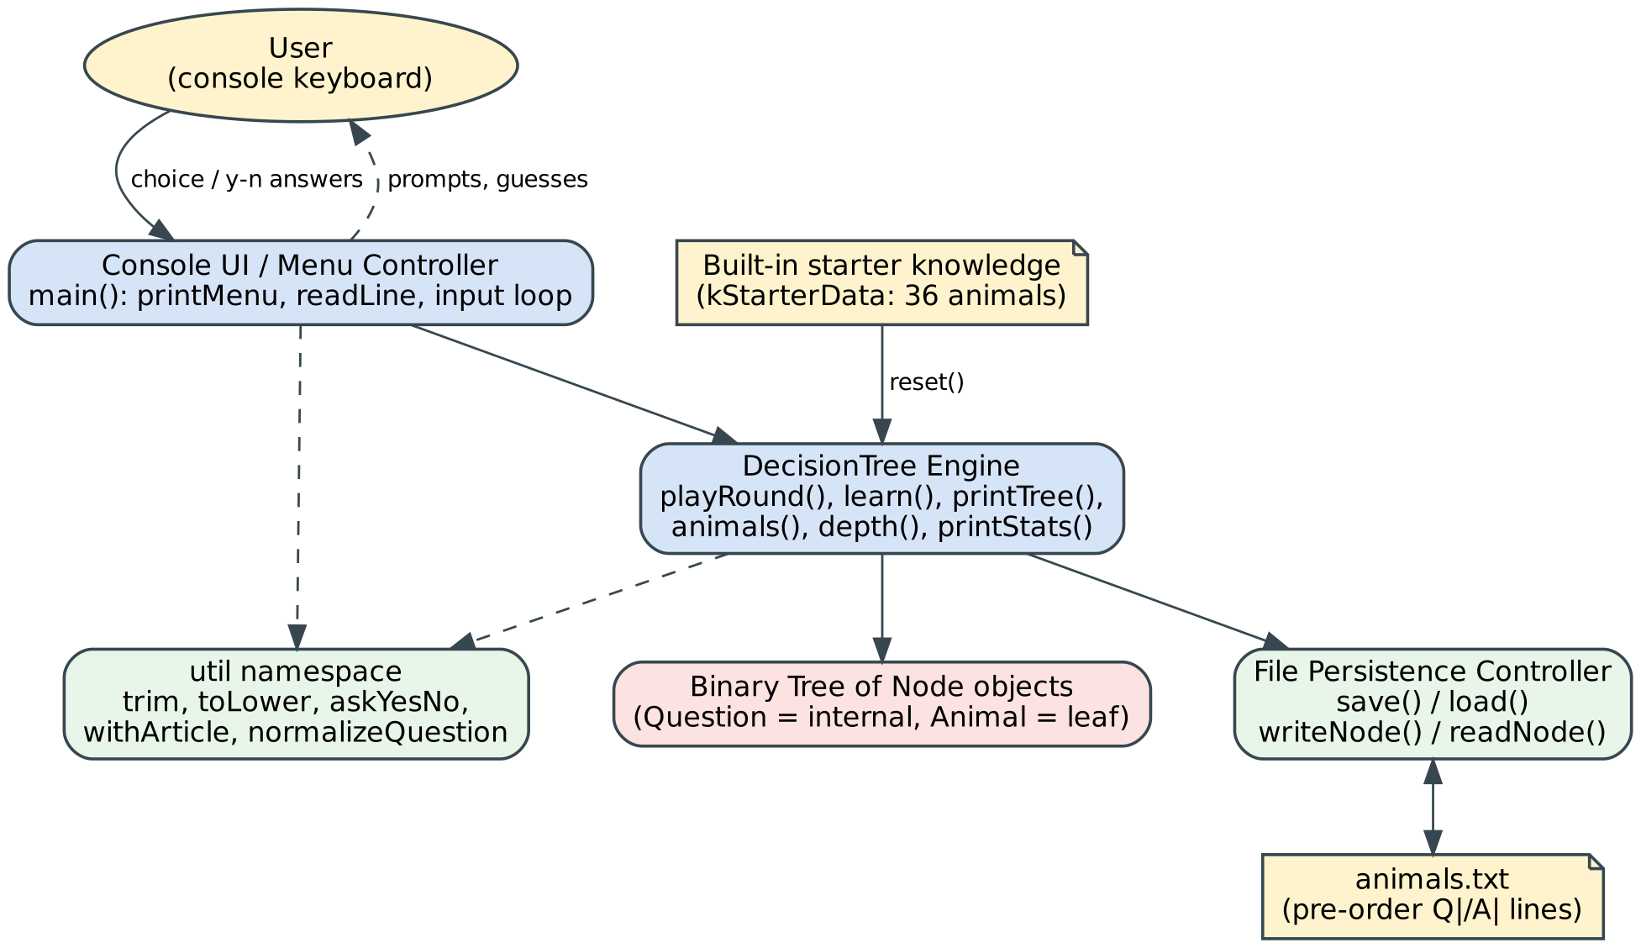
Figure 4.1: System architecture – console UI, decision-tree engine, utilities and file persistence

4.2 UML Class Diagram
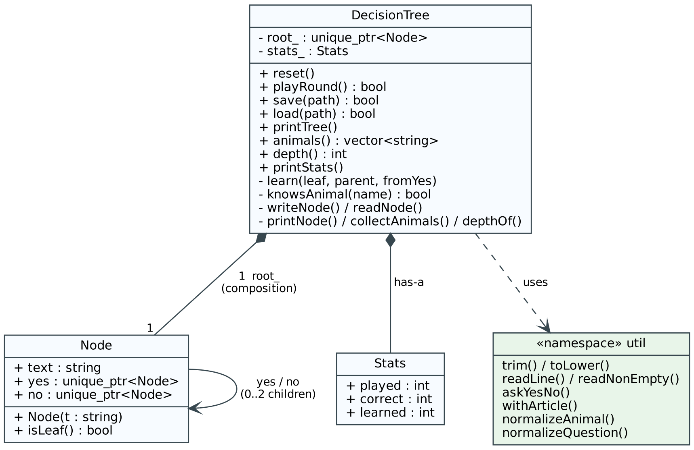
Figure 4.2: Class diagram – DecisionTree owns the root Node (which owns its yes/no children) and a Stats record

4.3 Flowcharts
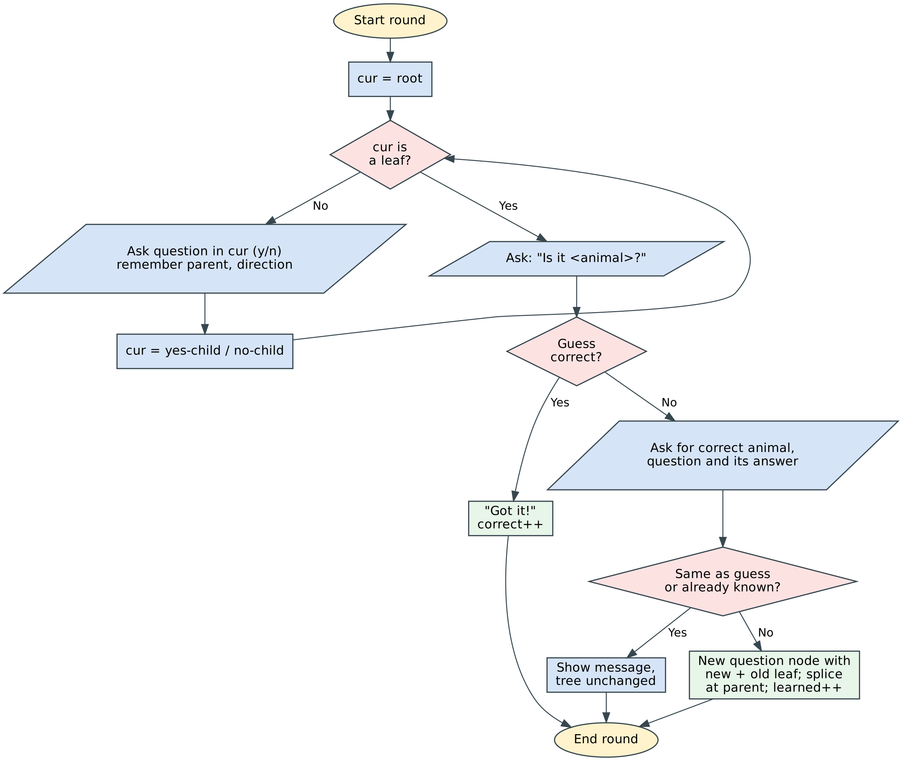
Figure 4.3: Flowchart of one game round – tree traversal, guess and learning

4.4 Menu Structure
Main Menu > [1. Play > (answer questions > guess > if wrong: learn new animal) | 2. Show knowledge tree | 3. List known animals | 4. Statistics | 5. Save knowledge | 6. Load knowledge | 7. Reset to starter knowledge | 0. Save & quit]

CHAPTER 5

IMPLEMENTATION

5.1 Project File Structure
animal_guesser.cpp (complete source: util namespace, Node, DecisionTree, main) animals.txt (knowledge file, created automatically on first save)

5.2 Module-wise Description

Module | Description | Developed By
Node / DecisionTree (engine) | Tree structure, playRound() traversal, learn() leaf splitting, knowsAnimal(), statistics | Thilak R
Persistence | save(), load(), writeNode(), readNode() and the built-in starter data | Aarav Sharma
util + User Interface | Input/string helpers, main() menu loop, printTree(), animals list, formatted output | Ananya Patel

5.3 Key Algorithms
Algorithm 1: Guessing by tree traversal
Step 1. Set cur to the root node; parent is empty.
Step 2. While cur is not a leaf: ask the question in cur, remember cur as parent and the answer as the direction, then move to the yes-child or no-child.
Step 3. At the leaf, ask “Is it <animal>?”. If the player answers yes, increase the correct counter; otherwise start learning (Algorithm 2).
Time complexity: O(d), where d is the depth of the tree
Algorithm 2: Learning a new animal (leaf splitting)
Step 1. Ask for the correct animal. If it equals the guessed animal or is already in the tree, show a message and stop (the answers must have been inconsistent).
Step 2. Ask for a yes/no question that separates the new animal from the old guess, and the answer to it for the new animal.
Step 3. Create a question node whose children are the new leaf and the old leaf (placed on the yes or no side according to the answer).
Step 4. Replace the wrong leaf with this node by assigning it to the root or to the parent’s yes/no link, and increase the learned counter.
Time complexity: O(1) for the splice; O(n log n) for the duplicate check, which collects and sorts all n animals
Algorithm 3: Saving and loading (pre-order serialization)
Step 1. Save: write “Q|question” for an internal node and recurse into the yes-child and then the no-child; write “A|animal” for a leaf.
Step 2. Load: read one line; if it starts with “A|” create a leaf; if it starts with “Q|” create a node and recursively read its yes-subtree and no-subtree.
Step 3. If any line is malformed or missing, return nullptr, so load() fails and the current tree stays unchanged.
Time complexity: O(n) for n nodes

5.4 Important Code Snippets
Node structure
struct Node {
string text; // question (internal) or animal name (leaf)
std::unique_ptr<Node> yes; // followed when answer is "yes"
std::unique_ptr<Node> no; // followed when answer is "no"

explicit Node(string t) : text(std::move(t)) {}
bool isLeaf() const { return !yes && !no; }
};
Tree traversal in playRound()
while (!cur->isLeaf()) {
bool ans = util::askYesNo(cur->text);
parent = cur;
cameFromYes = ans;
cur = ans ? cur->yes.get() : cur->no.get();
}
Learning: building and splicing the new question node
auto questionNode = std::make_unique<Node>(question);
auto newLeaf = std::make_unique<Node>(util::toLower(util::trim(newAnimal)));
auto oldLeaf = std::make_unique<Node>(oldAnimal);
if (yesForNew) {
questionNode->yes = std::move(newLeaf);
questionNode->no = std::move(oldLeaf);
} else {
questionNode->yes = std::move(oldLeaf);
questionNode->no = std::move(newLeaf);
}

if (parent == nullptr) root_ = std::move(questionNode);
else if (cameFromYes) parent->yes = std::move(questionNode);
else parent->no = std::move(questionNode);
Pre-order save
static void writeNode(std::ostream& out, const Node* n) {
if (n->isLeaf()) {
out << "A|" << n->text << '\n';
} else {
out << "Q|" << n->text << '\n';
writeNode(out, n->yes.get());
writeNode(out, n->no.get());
}
}

CHAPTER 6

TESTING AND VALIDATION

6.1 Test Cases
The program was built with g++ -std=c++17 -Wall -Wextra (no warnings) and each test below was run by feeding the inputs to the executable and recording the real output.

TC ID | Feature Tested | Input | Expected Output | Actual Output | Pass / Fail
TC1 | Start-up without save file | Run program with no animals.txt | Starter tree loaded; “starting fresh” message | “(No saved knowledge found - starting fresh.)” | Pass
TC2 | Correct guess | Menu 1; mammal y, water n, fly n, pet y, meow n, bark y; confirm y | Guess “a dog”; success message | “Is it a dog?” then “Got it!” | Pass
TC3 | Learning from wrong guess | Path leading to “lion”; answer n; animal “horse”; question “Does it neigh”; answer y | New question node created; confirmation shown | “Thanks! I've learned a horse.” | Pass
TC4 | Learned animal is recalled | Same path as TC3; answer y to “Does it neigh?” | Program now guesses “a horse” | “Is it a horse?” then “Got it!” | Pass
TC5 | Invalid yes/no answer | “maybe” at “Is it a mammal?” | Error message; same question repeated | “Please answer y or n.” then question re-asked | Pass
TC6 | Invalid menu option | “9” at the main menu | “Unknown option.” and menu shown again | “Unknown option.”; menu redisplayed | Pass
TC7 | Statistics | Option 4 after two games (1 learned) | 37 animals, 2 played, 1 correct, 1 learned, 50% | Animals 37, depth 11, played 2, correct 1, learned 1, 50% | Pass
TC8 | Persistence | Save & quit; run again; option 3 | Saved tree loaded; horse listed | “(Loaded saved knowledge from 'animals.txt'.)”; 37 animals incl. horse | Pass
TC9 | Duplicate animal | Wrong guess “lion”; teacher enters “dog” | Rejected; tree unchanged | “I already know a dog, so one of your earlier answers must have differed…” | Pass
TC10 | Same animal as guess | Wrong guess “lion”; teacher enters “lion” | Inconsistency detected; tree unchanged | “Hmm, that's what I guessed - maybe you answered a question wrongly.” | Pass
TC11 | Input closed (EOF) | End of input in the middle of a game | Exit without crash; knowledge saved | “Input closed.” then “Knowledge saved to 'animals.txt'. Goodbye!” | Pass

6.2 Input Validation and Exception Handling
All input is read line by line with std::getline and trimmed. askYesNo() accepts only y/yes/n/no in any letter case and repeats the prompt otherwise; readNonEmpty() repeats until the player types something; menu choices outside 0–7 print “Unknown option.”. When the input stream ends, the helpers throw std::runtime_error, which is caught in main() so the program prints “Input closed.” and still saves the knowledge. When loading, readNode() returns nullptr for any malformed line, so a damaged animals.txt is rejected and the current tree is kept.

6.3 Bugs Found and Fixed

Bug | Cause | Fix
Learning an animal already in the tree would create a duplicate leaf | Player answered an earlier question differently from the tree | knowsAnimal() compares normalised names; learn() refuses and explains
Learning the same animal that was guessed | Player mistake or inconsistent answers | normalizeAnimal() comparison; message shown, tree unchanged
Endless prompts or crash at end of input | getline fails at EOF inside prompt loops | readLine() returns false; helpers throw runtime_error caught in main(); knowledge still saved
Corrupt or partial animals.txt could produce a broken tree | Reader accepted incomplete subtrees | readNode() returns nullptr on any malformed line; load() returns false and keeps current tree
Inconsistent text such as “a Dog”, “DOG”, questions without “?” | Free-text entry | normalizeAnimal(), normalizeQuestion() and withArticle() standardise names and questions

CHAPTER 7

RESULTS AND SCREENSHOTS
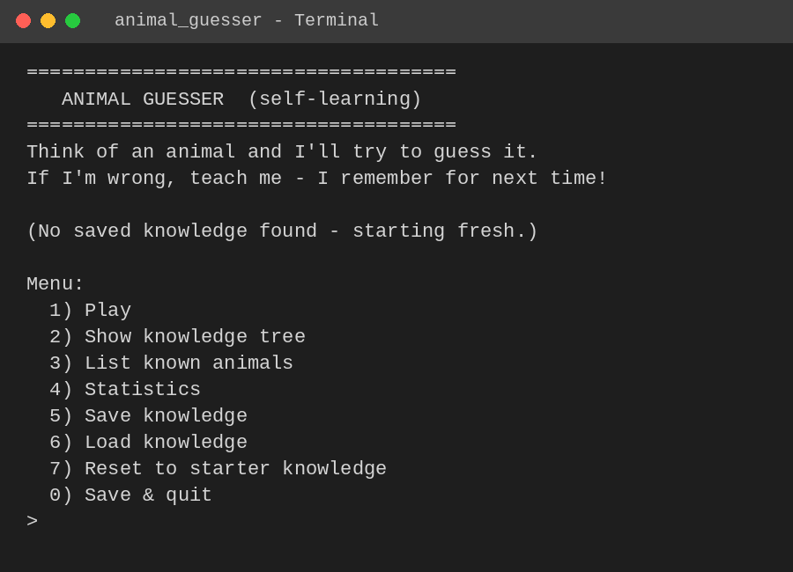
Figure 7.1: Start-up banner and main menu showing the navigation options
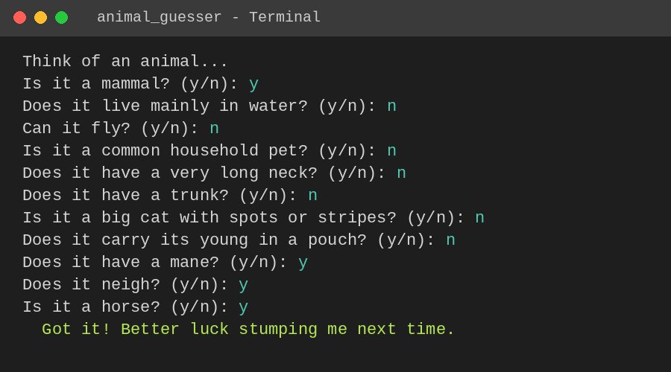
Figure 7.2: Successful guess – the learned animal “horse” is identified correctly
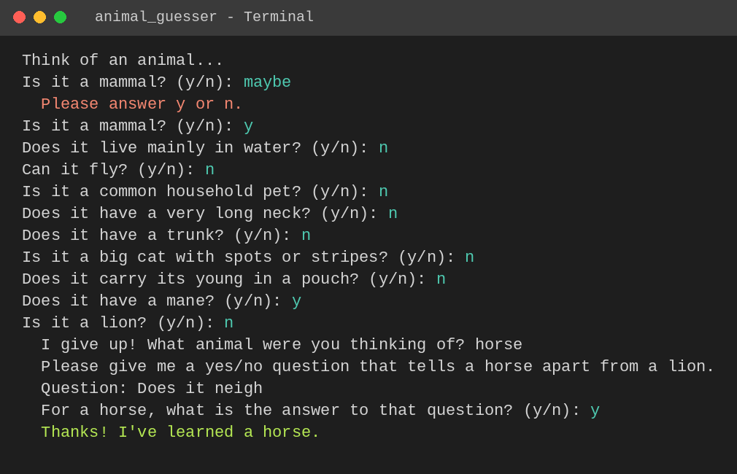
Figure 7.3: Wrong guess – the program learns a new animal and a distinguishing question
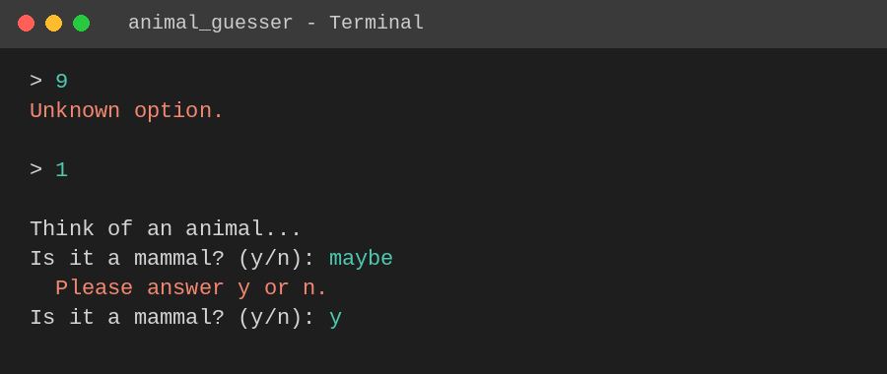
Figure 7.4: Input validation – unknown menu option and invalid yes/no answer
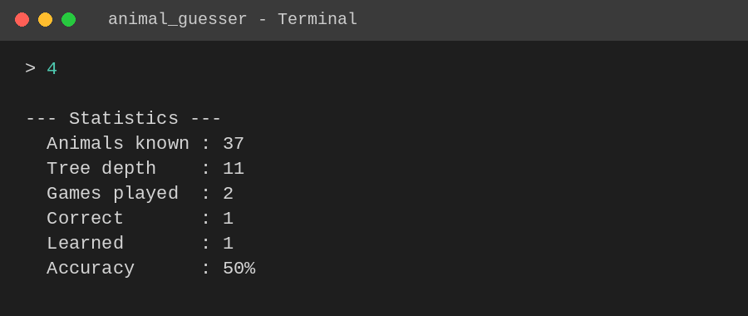
Figure 7.5: Statistics screen after two games
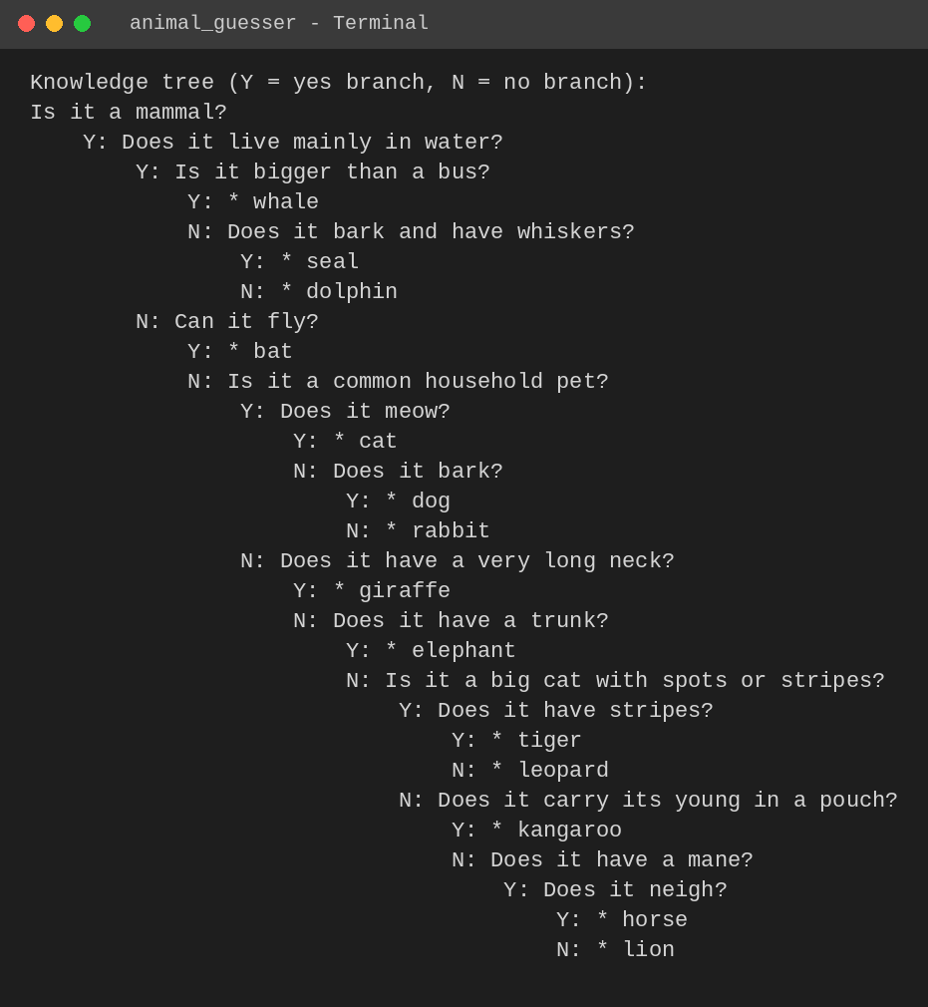
Figure 7.6: Knowledge tree loaded from animals.txt in a new session (top levels)

CHAPTER 8

CHALLENGES AND LEARNINGS

8.1 Challenges Faced
- Replacing a leaf inside the tree safely: the program must remember the parent node and the direction taken, and move ownership with std::unique_ptr; solved by tracking parent and cameFromYes while descending.
- Handling inconsistent teaching: if the player gives a different answer than before, the same animal could be inserted twice; solved by the knowsAnimal() and same-animal checks.
- Robust input: prompts must survive invalid text and end-of-input; solved with validating helper functions and exceptions caught in main().
- Reliable persistence: the tree had to be stored and rebuilt exactly; solved with a simple pre-order text format and a reader that rejects malformed data.

8.2 Key Learnings
- Hands-on application of binary decision trees as a self-learning knowledge base.
- Using std::unique_ptr, std::move and RAII for safe dynamic data structures.
- Writing recursive algorithms for traversal, serialization and deserialization.
- Designing defensive console input handling and testing a program with scripted input.
- Effective branch coordination and conflict resolution using Git in a multi-developer workflow.

CHAPTER 9

CONCLUSION AND FUTURE SCOPE

9.1 Conclusion
The Animal Guesser successfully demonstrates a self-learning program built on a binary decision tree in standard C++17. It guesses animals through yes/no questions, learns new animals and questions from the player when it is wrong, and keeps this knowledge in a text file across sessions. All objectives were met: the starter tree of 36 animals works out of the box, learning was verified by teaching a new animal (horse) and recalling it in the next round, and invalid input and end-of-input are handled without crashing or leaking memory.

9.2 Future Scope
- Graphical user interface using Qt or a web front end.
- Ability to edit or delete a learned animal or question, and an undo for a mistaken lesson.
- Choose better questions automatically (for example by information gain) and balance the tree to reduce the number of questions asked.
- Store attributes in a database or JSON file so the knowledge can be shared between users.
- Extend the game to other categories such as plants, countries or famous people.

REFERENCES & APPENDICES

References
- ISO/IEC 14882:2017, Programming Languages – C++ (C++17 standard).
- cppreference.com – C++ reference (std::unique_ptr, std::getline, std::sort, <fstream>): https://en.cppreference.com
- B. Stroustrup, A Tour of C++, Addison-Wesley.
- T. H. Cormen, C. E. Leiserson, R. L. Rivest, C. Stein, Introduction to Algorithms, MIT Press – chapters on binary trees.

Appendix A: Source Code Structure and GitHub Link
GitHub Repository: [add your repository link here]
Source file: animal_guesser.cpp (knowledge file animals.txt is created at run time)
How to compile and run:
g++ -std=c++17 -O2 -Wall -Wextra -o animal_guesser animal_guesser.cpp && ./animal_guesser

Appendix B: User Manual
- Compile the program with the command above and run ./animal_guesser from the terminal.
- Select option 1 (Play), think of an animal and answer each question with y or n.
- When the program guesses, answer y if it is right. If it is wrong, type the animal you were thinking of, then a yes/no question that distinguishes it, and the answer for your animal.
- Use options 2, 3 and 4 to view the knowledge tree, the list of known animals and the statistics.
- Use option 5 or 0 to save; option 6 reloads the saved file; option 7 resets to the starter knowledge.

Appendix C: Team Contribution Log

Team Member | Tasks Completed | Hours / Weeks
Thilak R | Decision-tree engine: Node/DecisionTree, guessing and learning logic, project lead | 30 hours / 4 weeks
Aarav Sharma | File handling: save/load, pre-order format, starter data | 24 hours / 4 weeks
Ananya Patel | Console UI, input helpers, testing & documentation | 22 hours / 4 weeks

