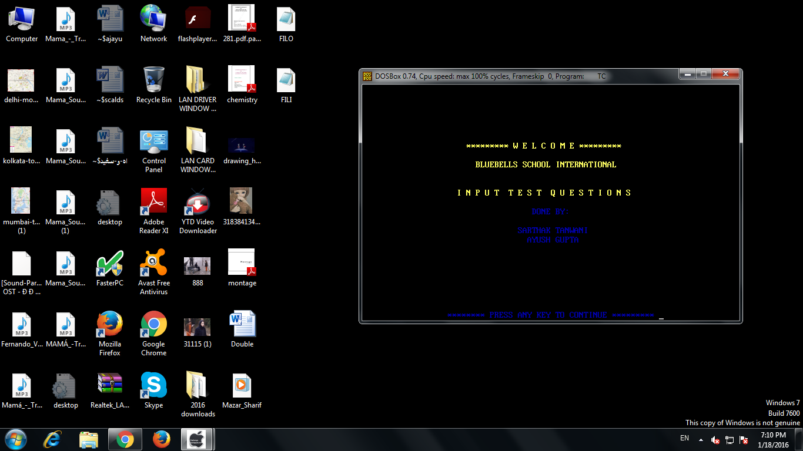

**WELCOME SCREEN FOR INPUT TEST QUESTIONS**

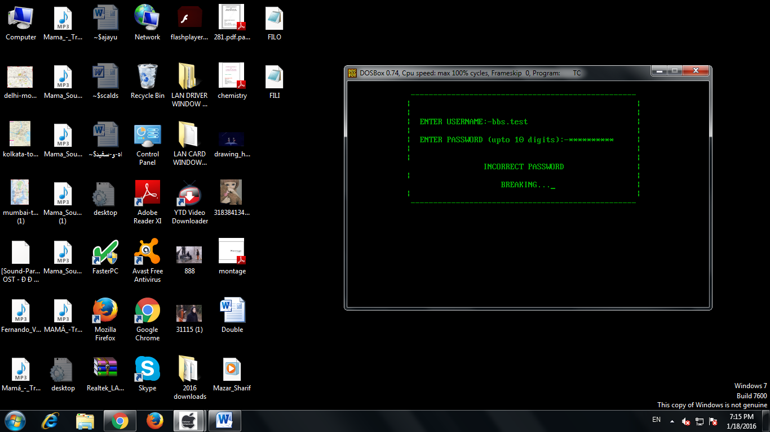

**INCORRECT PASSWORD**

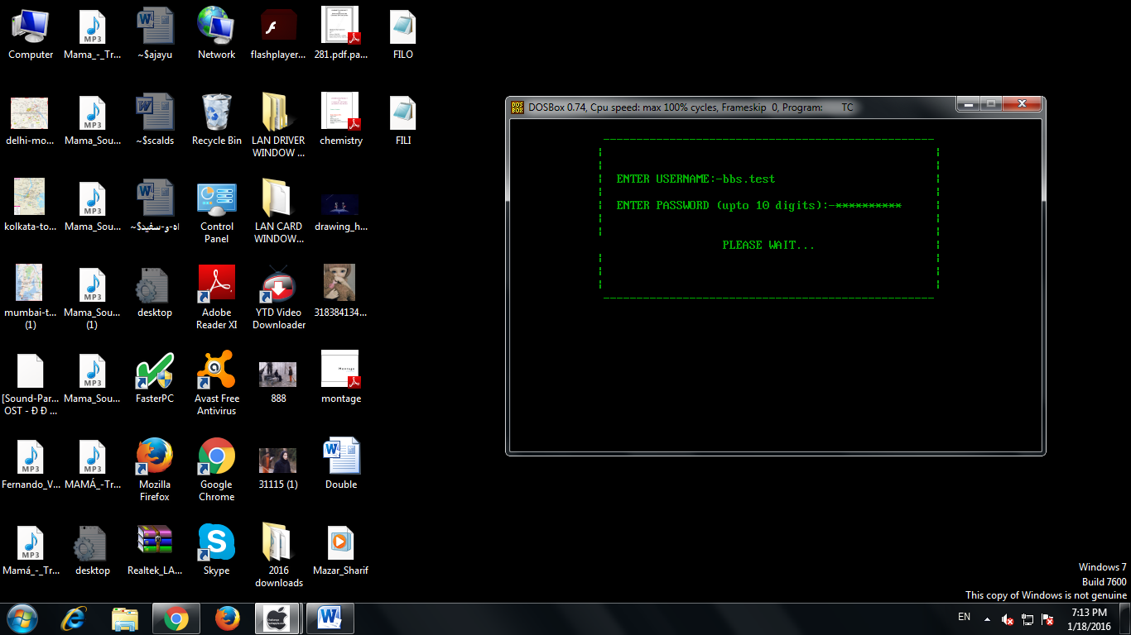

**CORRECT PASSWORD**

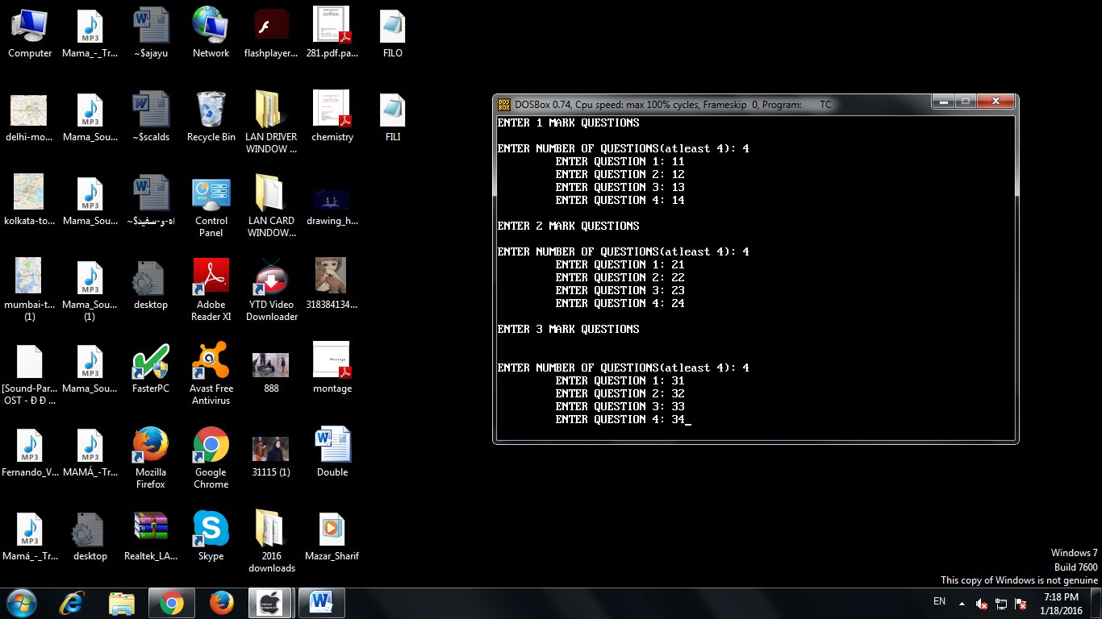

**QUESTION INPUT**

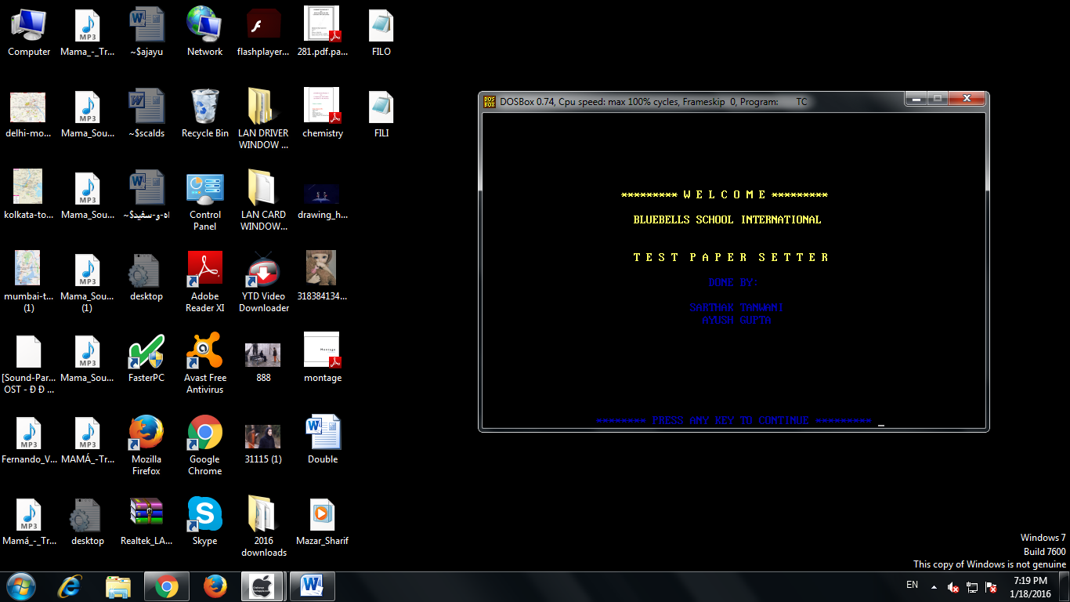

**WELCOME SCREEN FOR TEST PAPER**

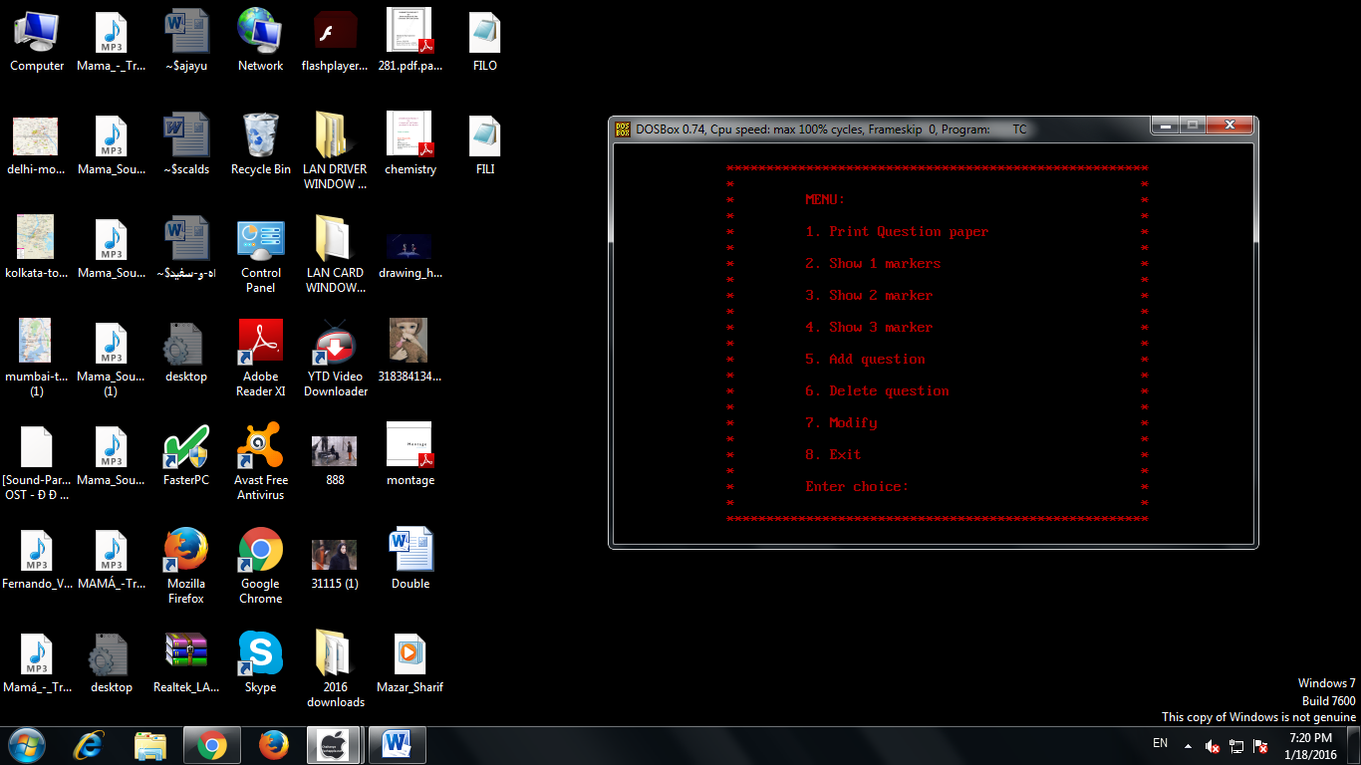

**TEST PAPER SETTER MENU**

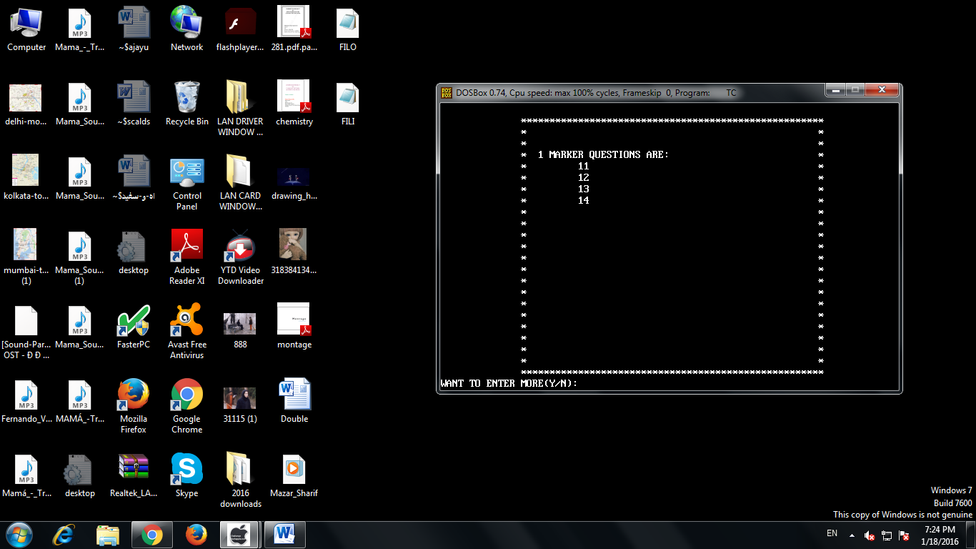

**2. SHOW 1 MARKERS**

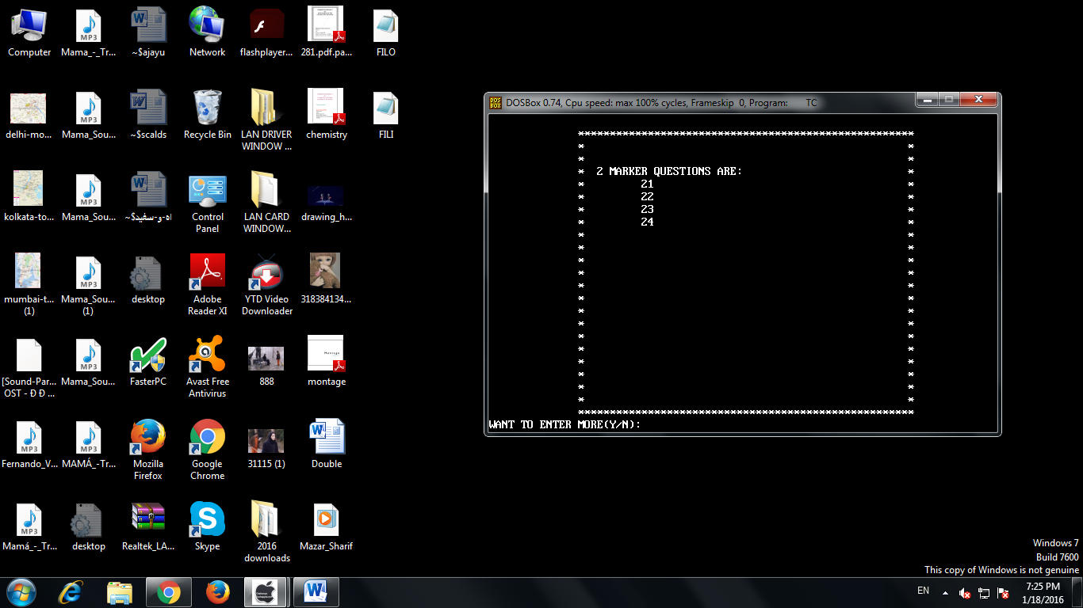

**3. SHOW 2 MARKERS**

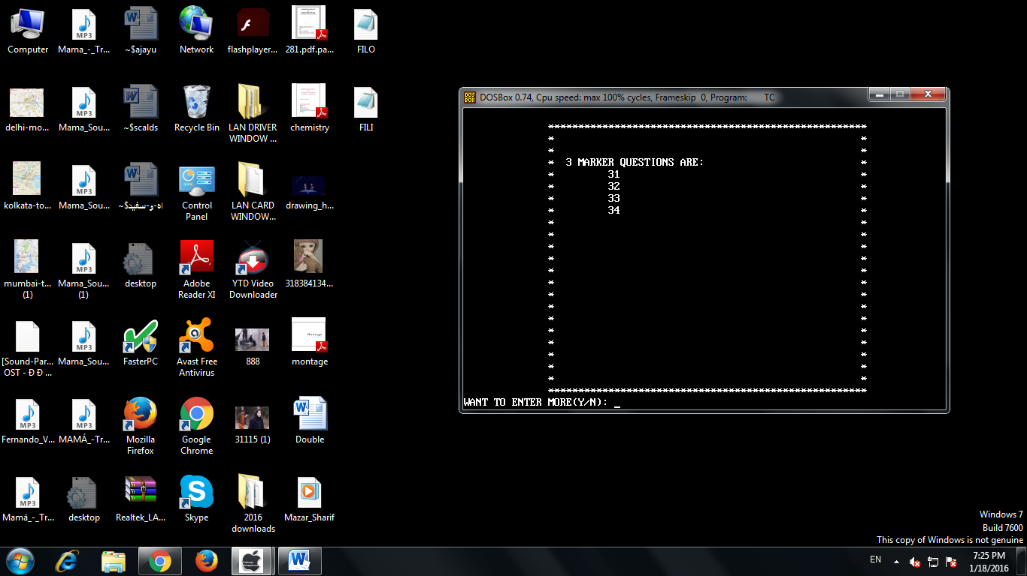

**4. SHOW 3 MARKERS**

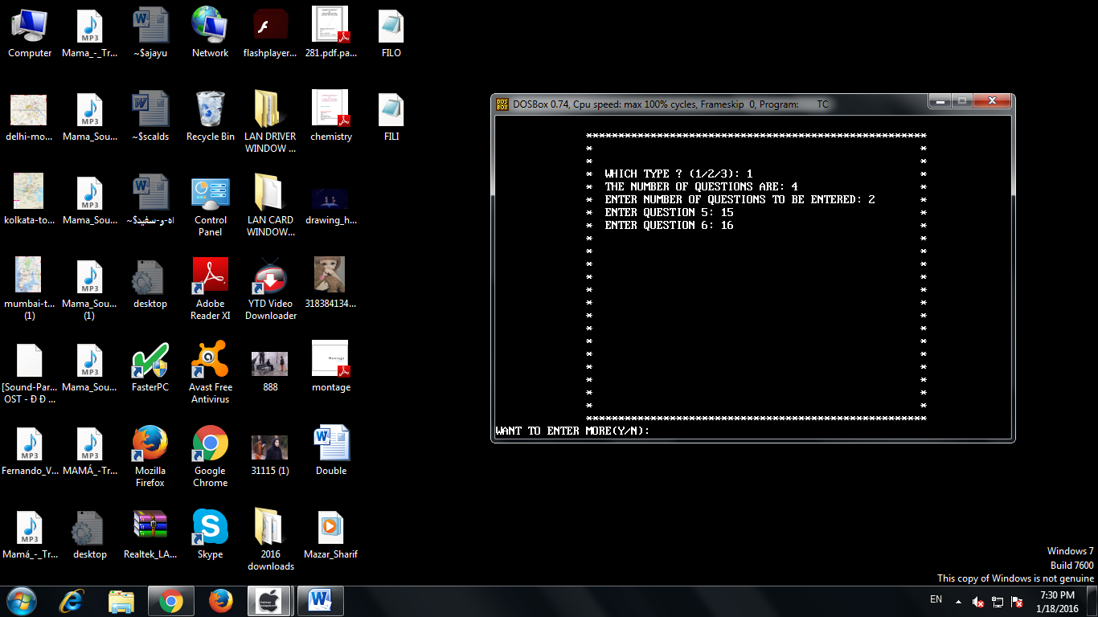

**5. ADD QUESTION**

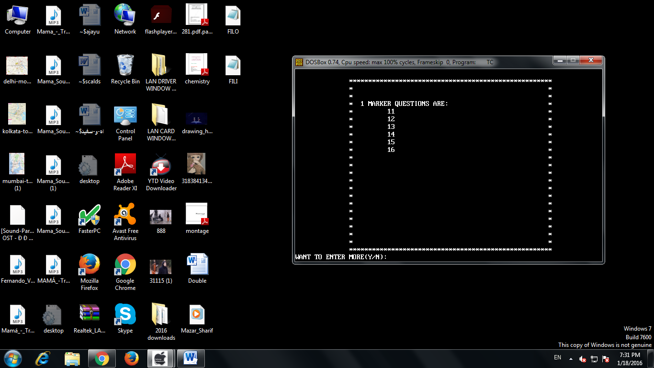

**1 MARKER QUESTIONS AFTER ADDISSION**

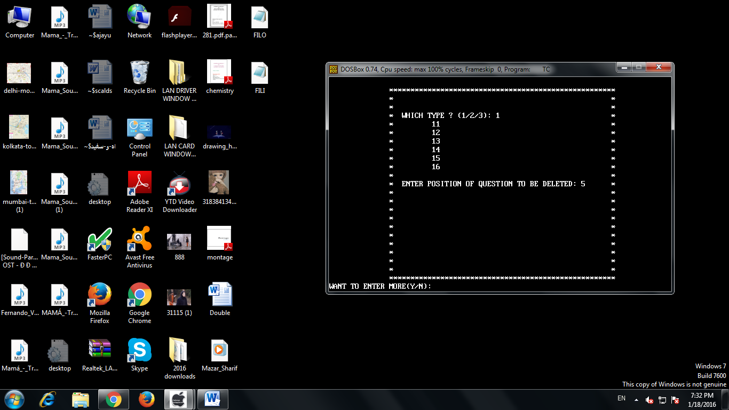

**6. DELETE QUESTION**

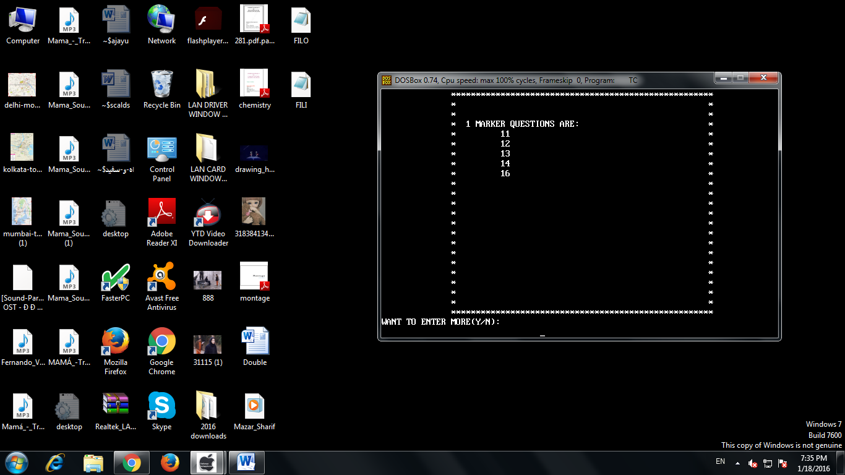

**1 MARKER QUESTIONS AFTER DELETION**

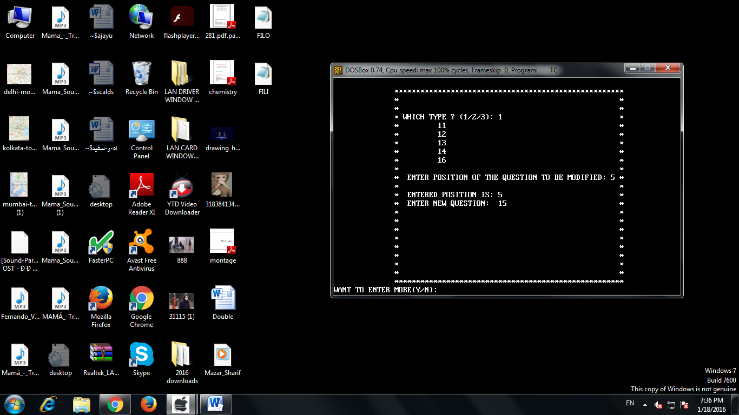

**7. MODIFY QUESTIONS**

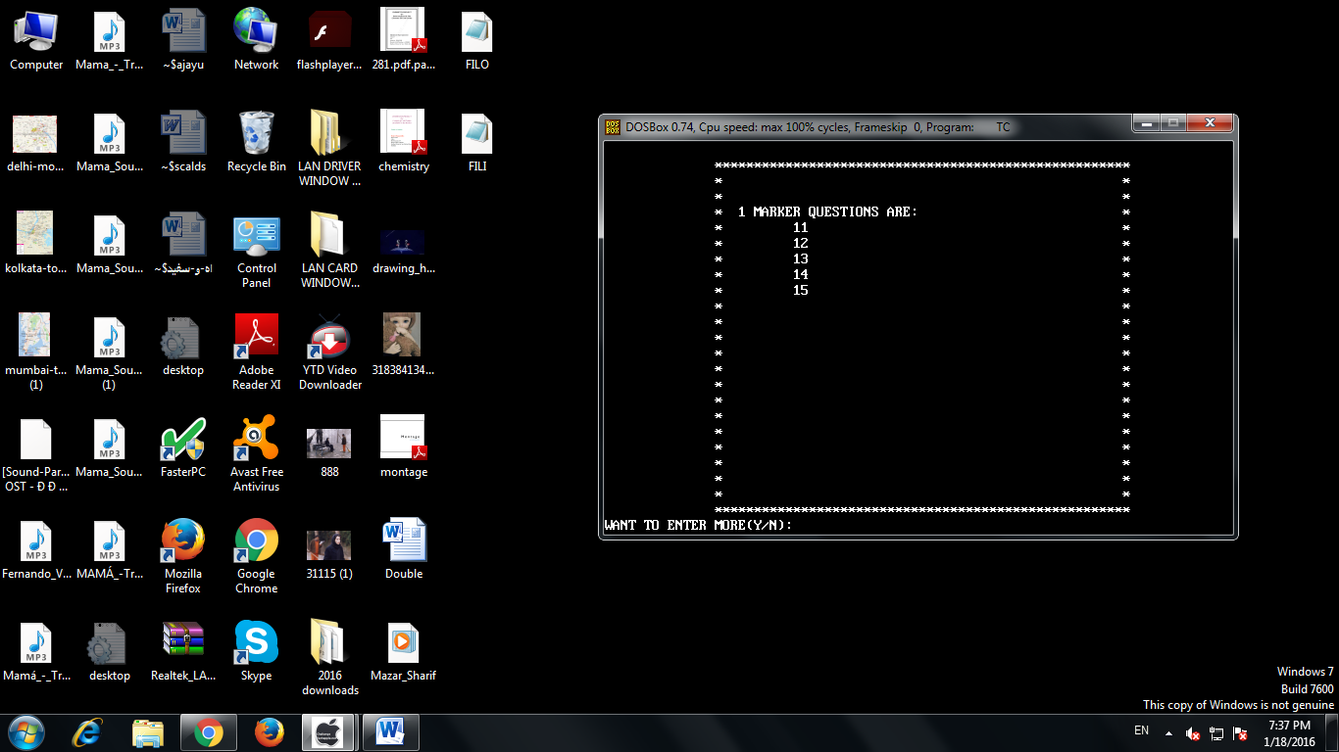

**1 MARKER QUESTIONS AFTER MODIFICATION**

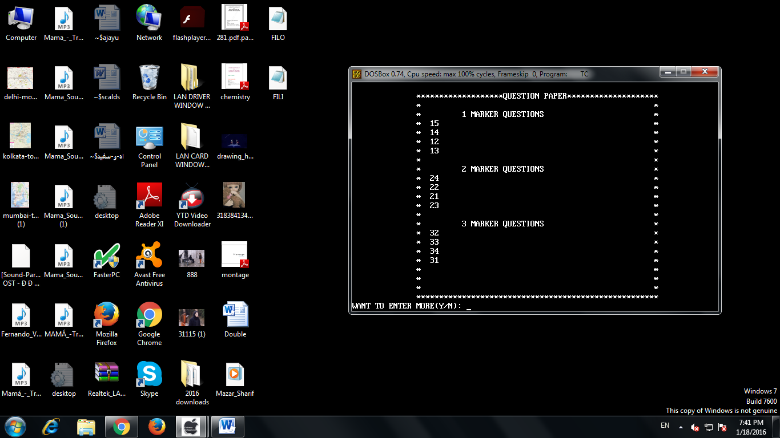

**QUESTION PAPER 1**

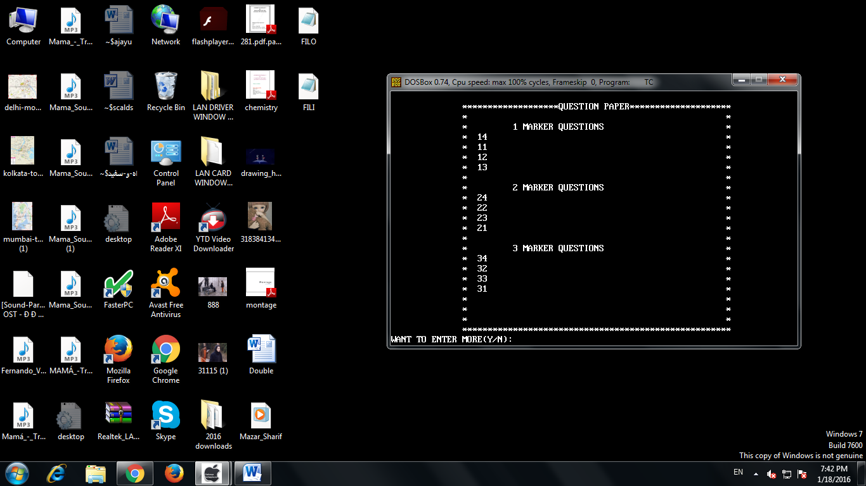

**QUESTION PAPER 2**