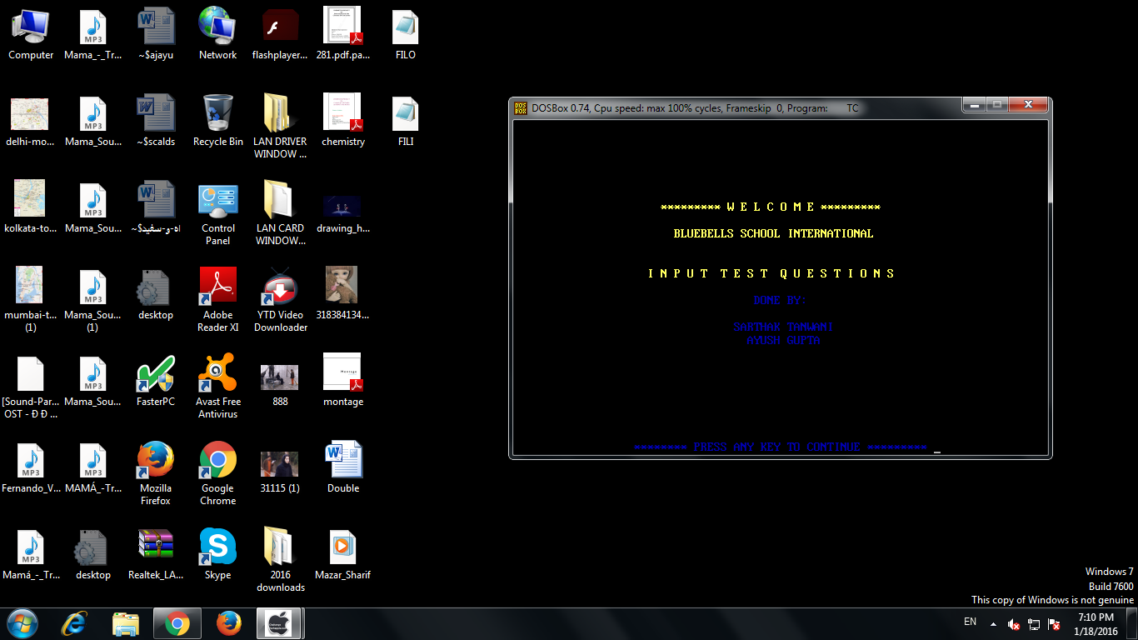

**WELCOME SCREEN FOR INPUT TEST QUESTIONS**

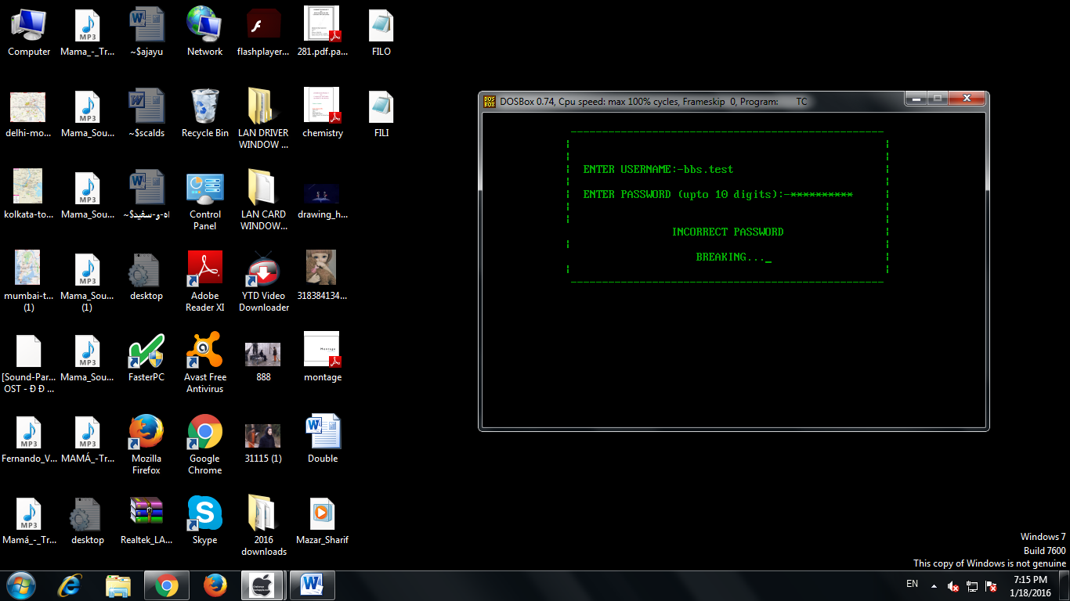

**INCORRECT PASSWORD**

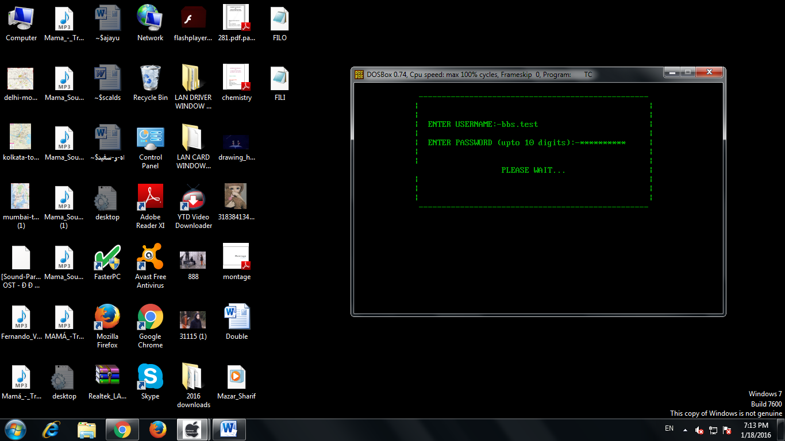

**CORRECT PASSWORD**

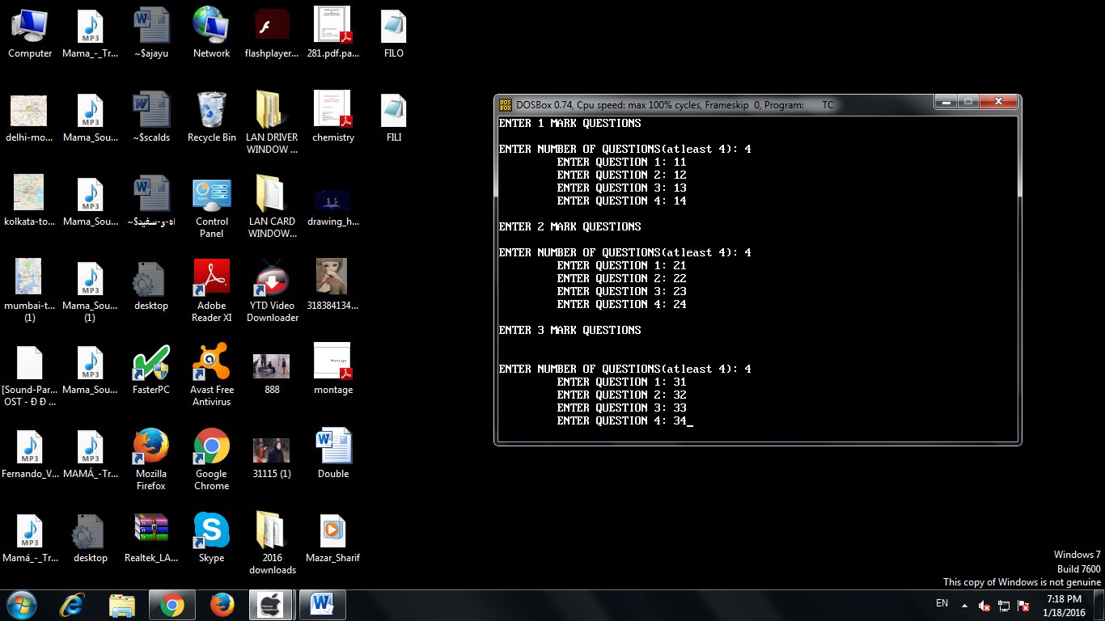

**QUESTION INPUT**

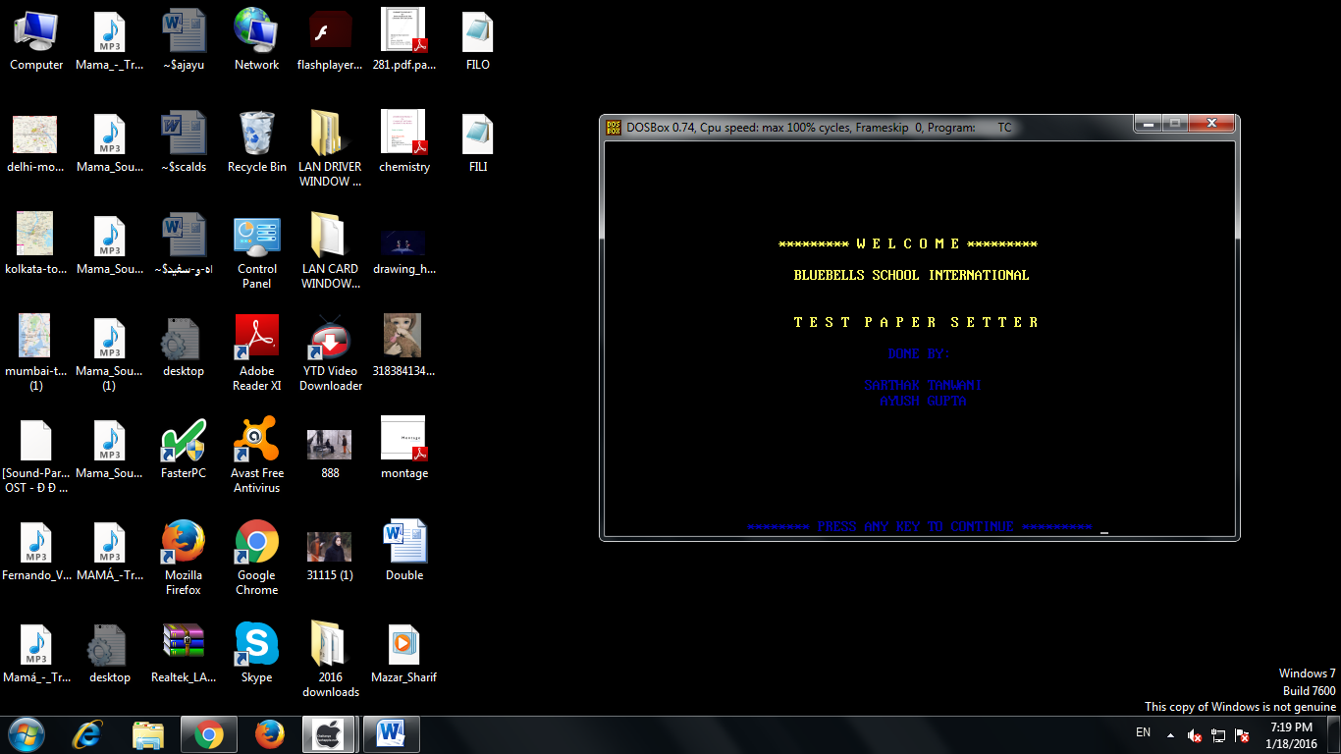

**WELCOME SCREEN FOR TEST PAPER**

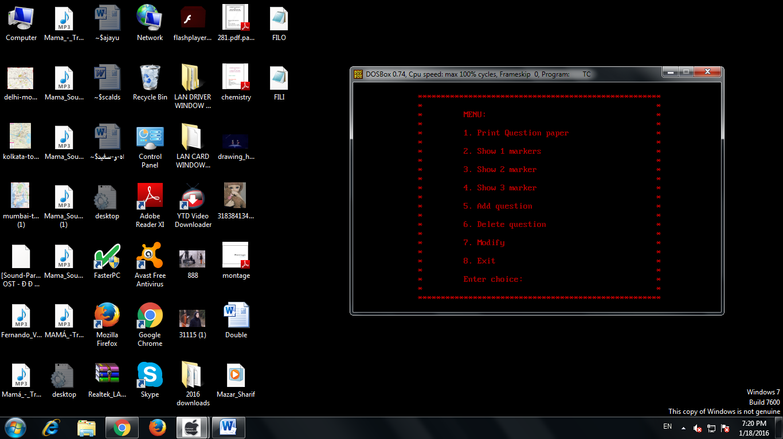

**TEST PAPER SETTER MENU**

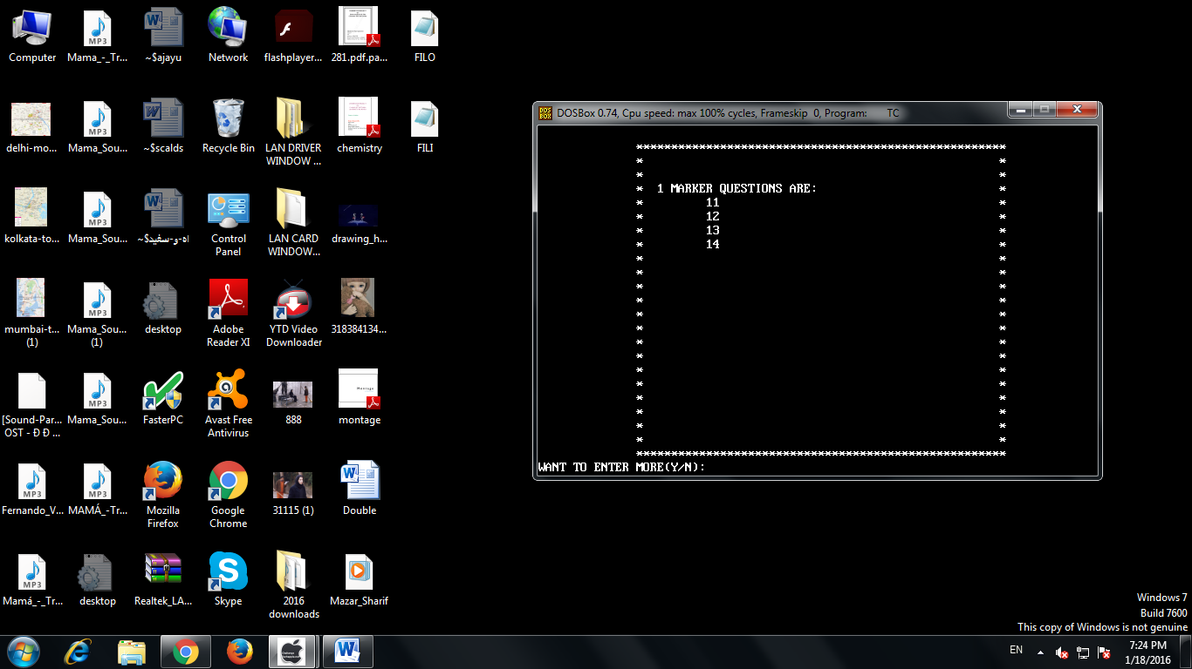

**2. SHOW 1 MARKERS**

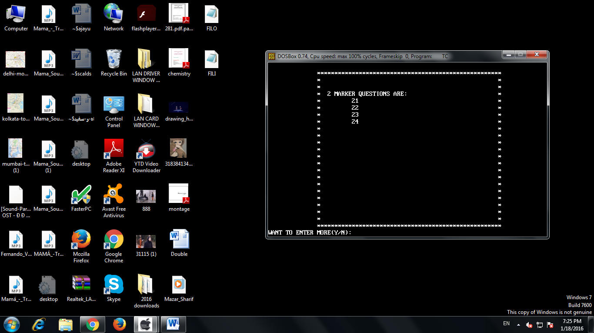

**3. SHOW 2 MARKERS**