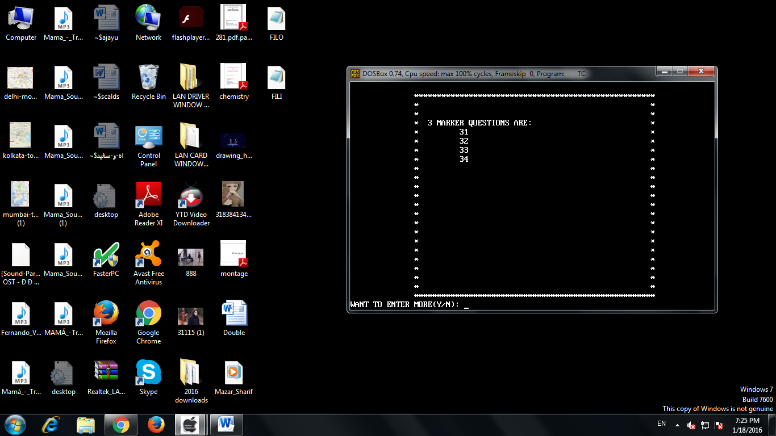

**4. SHOW 3 MARKERS**

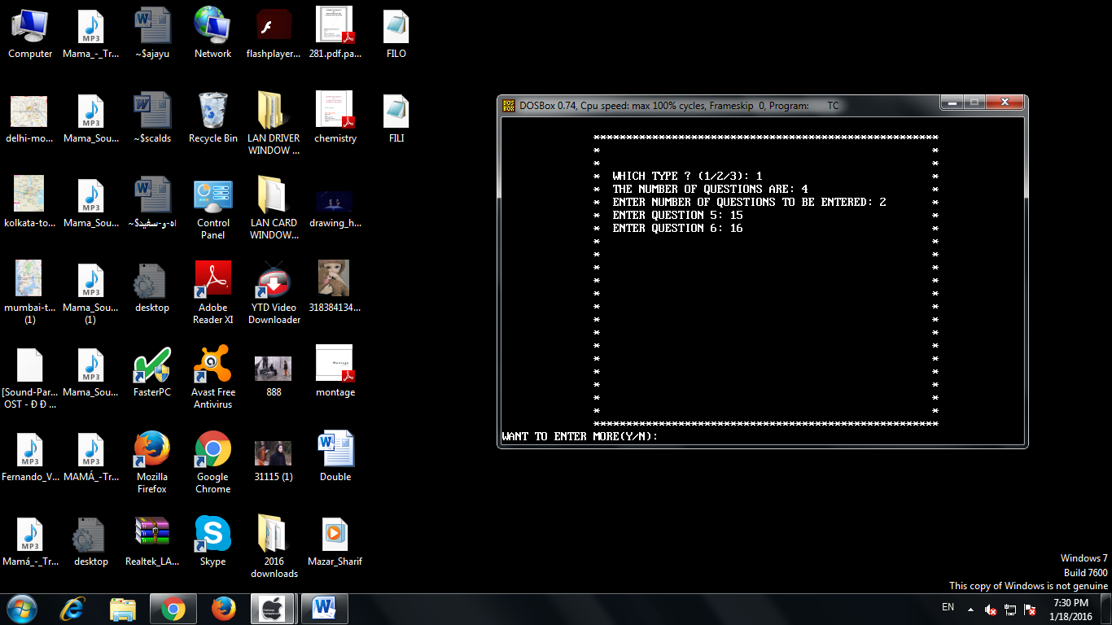

**5. ADD QUESTION**

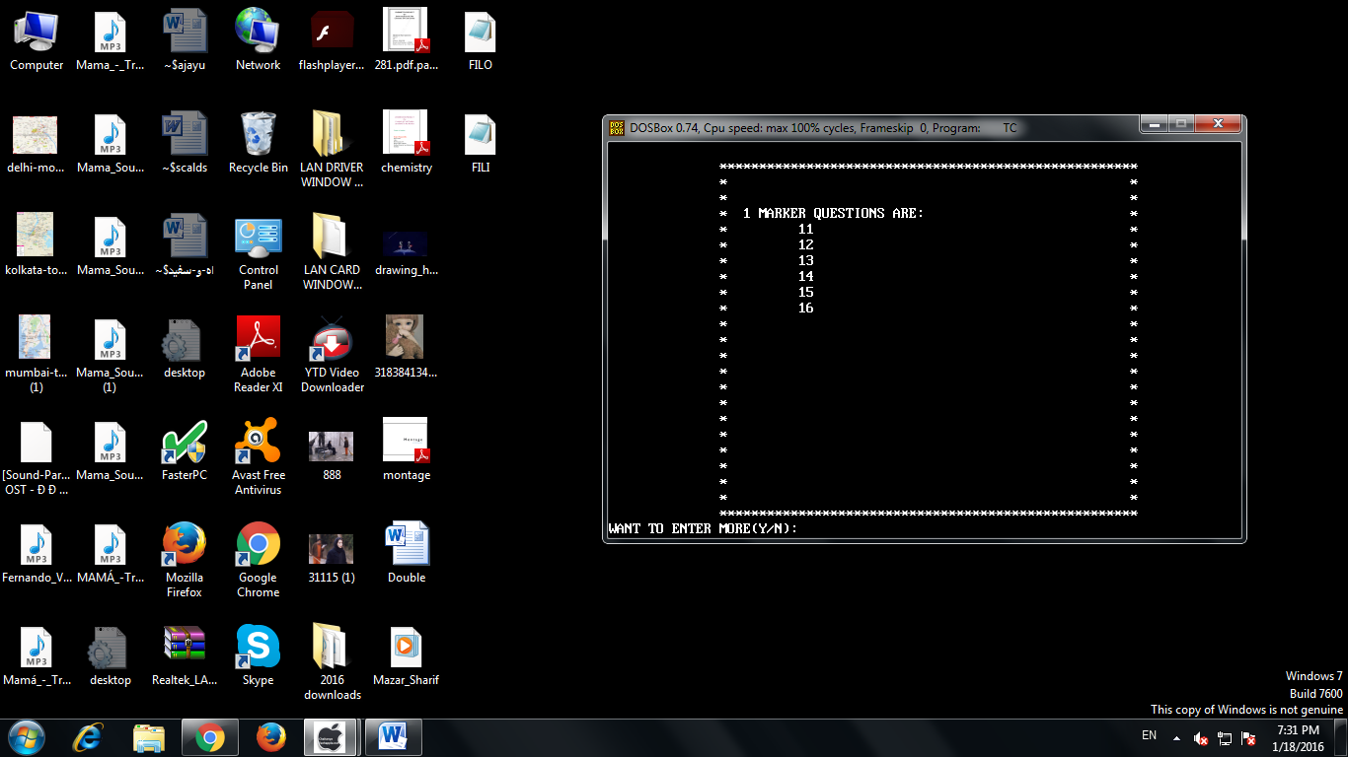

**1 MARKER QUESTIONS AFTER ADDISSION**

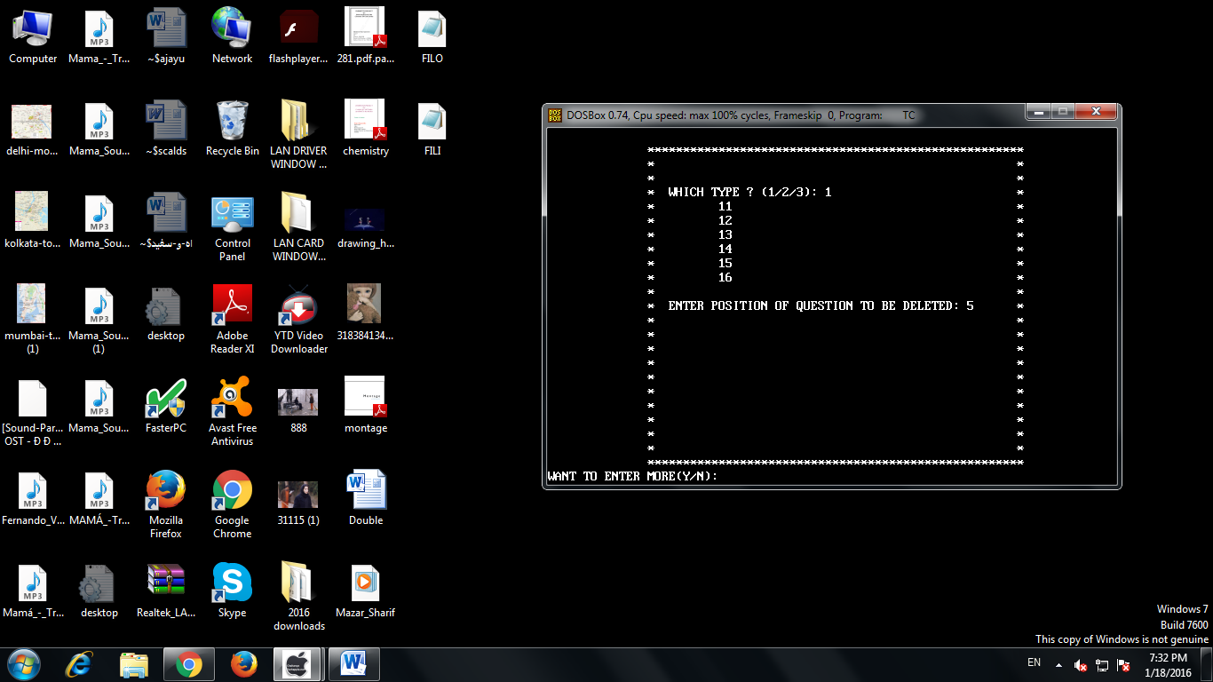

**6. DELETE QUESTION**

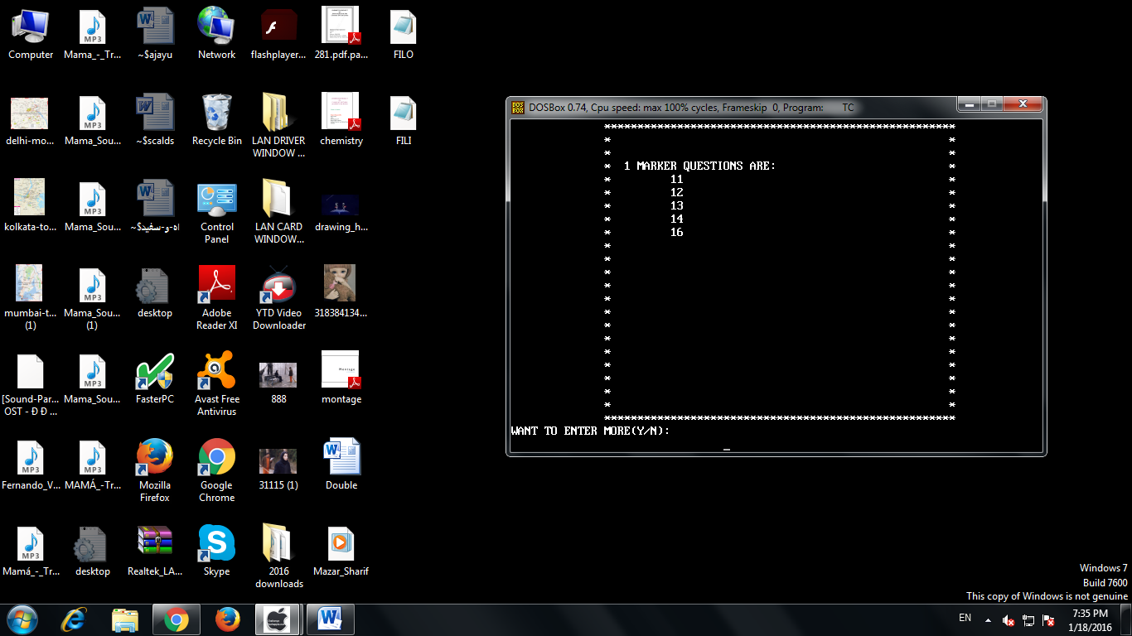

**1 MARKER QUESTIONS AFTER DELETION**

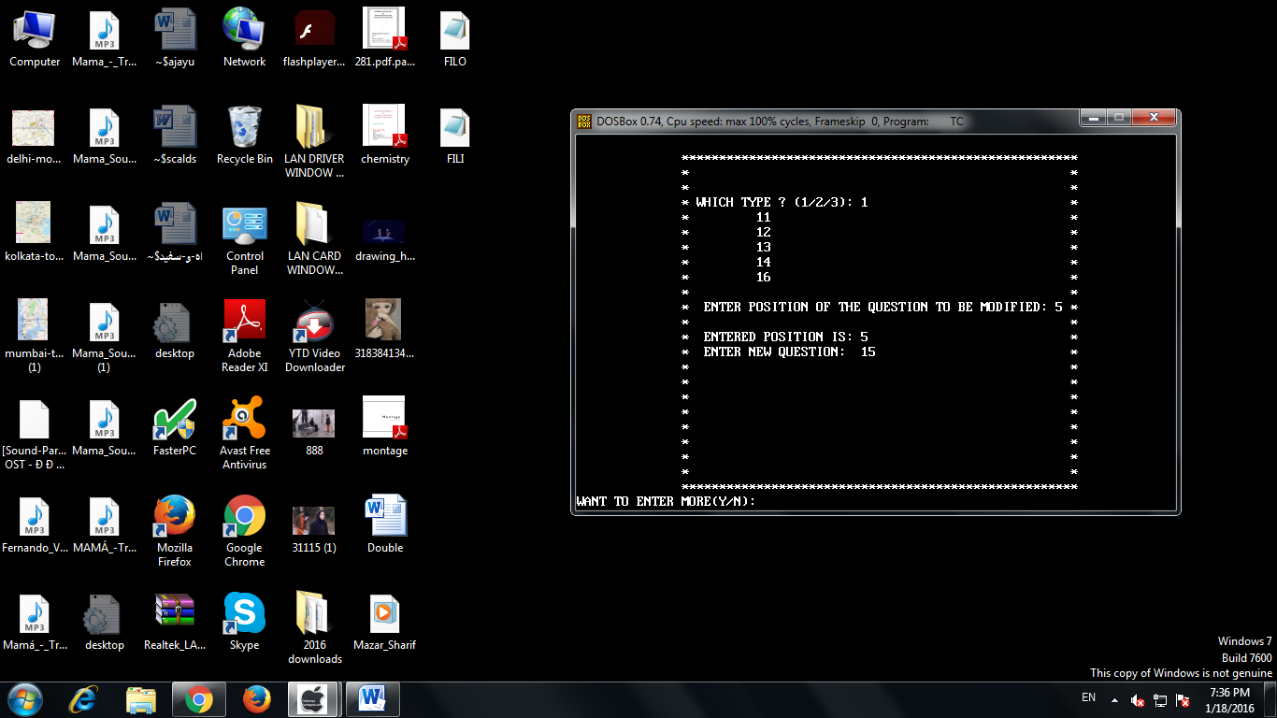

**7. MODIFY QUESTIONS**

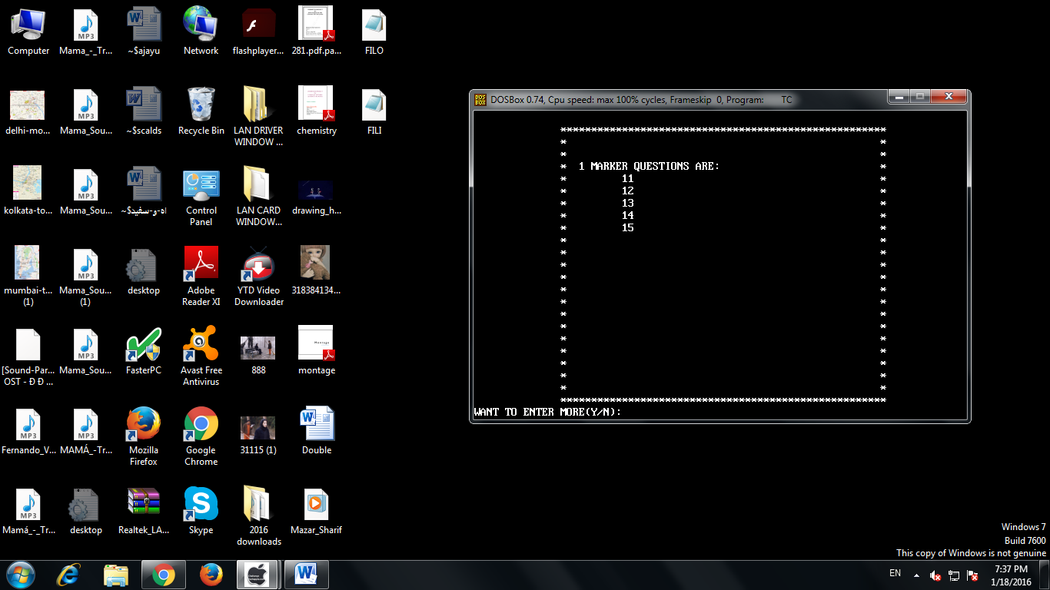

**1 MARKER QUESTIONS AFTER MODIFICATION**

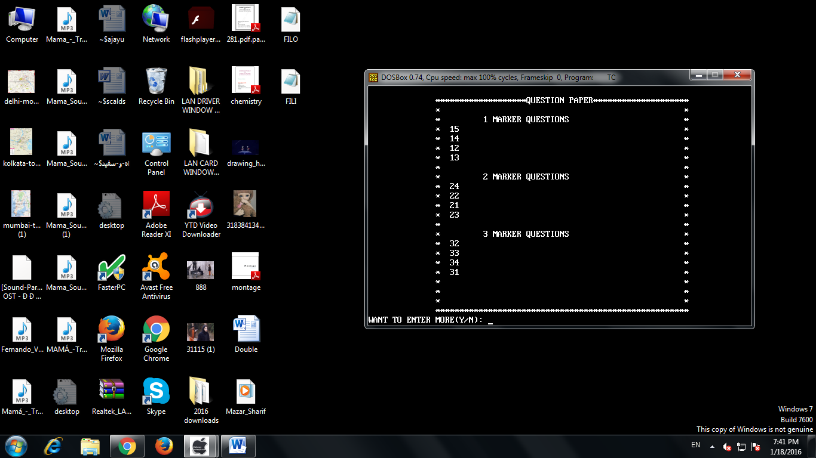

**QUESTION PAPER 1**

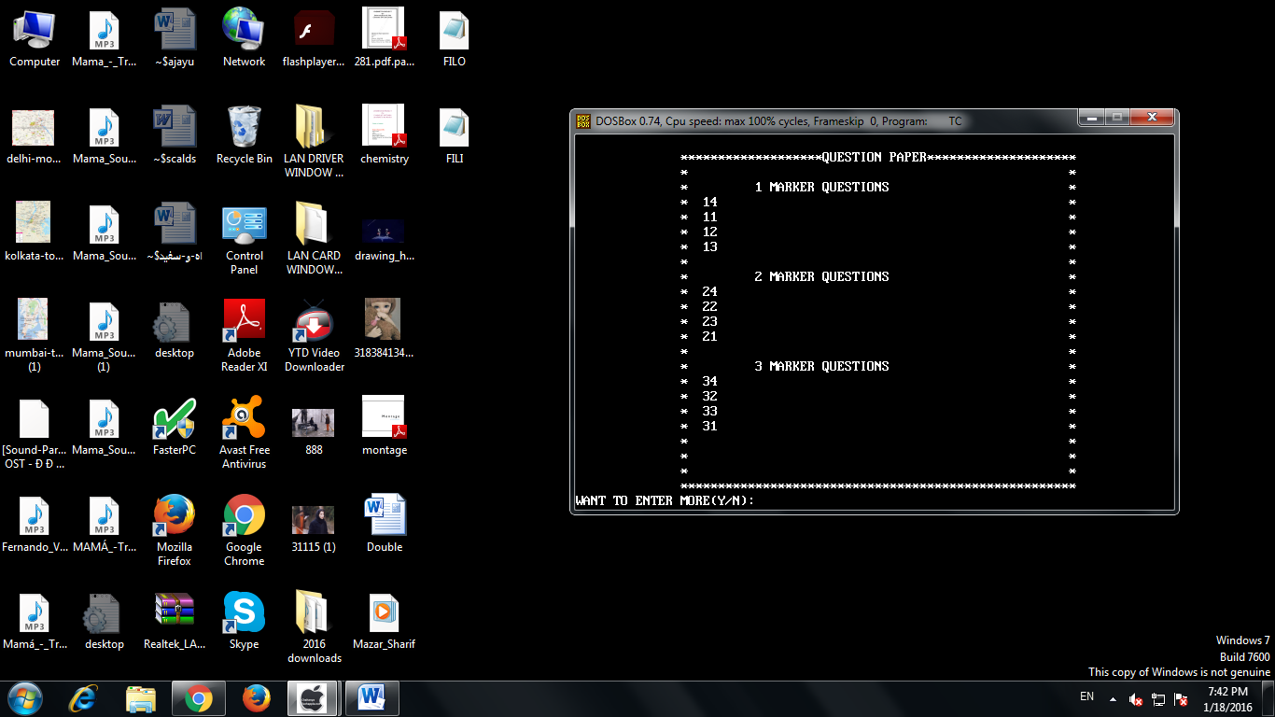

**QUESTION PAPER 2**