Billing and Stock Management System
By
Thakar Sarth B (22BSIT148)
Patel Sujal B (22BSIT115)
Rana Shahid (21BSIT085)
Submitted to



Smt. Chandaben Mohanbhai Patel Institute of Computer Applications
CHARUSAT
Changa

March 2025


Accredited with Grade A+ by NAAC,
CHAROTAR UNIVERSITY OF SCIENCE AND TECHNOLOGY
Changa

Acknowledgement

Knowledge in itself is a continuous process. At this moment of our substantial enhancement, We rarely find words to express our gratitude towards those who were constantly involved with us.
The completion of any inter disciplinary project depends upon coordination, cooperation and combined efforts of several resources of knowledge, creativity, skill, energy and time. The work being accomplished now, we feel our sincerest urge to recall and knowledge through these lines, trying our best to give full credit wherever it deserves.
We would like to thank our project guide:- Anjali Mahavar , I/C Principal Dr. Dharmendra Patel and I/C Dean Dr. Sanskruti Patel who advised and gave us moral support through the duration of our project. Without their constant encouragement we could not have been able to achieve what we have.
It’s our good fortune that we had support and well wishes of many. We are thankful to all and those names which have been forgotten to acknowledge here but contributions have not gone unnoticed.

With Sincere Regards,
Thakar Sarth B (22BSIT148)
Patel Sujal B(22BSIT115)
Shahid Rana(21BSIT085)

Table of Contents
Sr. No |  | Subject | Page No.
1 |  | Project Profile | 4
2 |  | Introduction to tools | 6
3 |  | System Study | 16
4 | 1. | Existing System | 17
 | 2. | Proposed System | 18
 | 3. | Scope of the Proposed System | 19
 | 4. | Aim and Objective of the Proposed System | 21
 | 5. | Feasibility Study | 22
 |  | Operational Feasibility | 23
 |  | Technical Feasibility | 23
 |  | Economical Feasibility | 23
 |  | System Analysis | 24
5 |  | Requirements Specification (along with System Modules) | 25
 |  | Use Case Diagram | 27
 |  | Activity Diagram | 30
 |  | Class Diagram | 29
 |  | System Design | 31
6 | 1. | Data Dictionary | 32
 | 2. | Screen Layouts | 34
 |  | System Testing | 41
7 | 1. | Test Cases | 42
 |  | Future Enhancement | 44
8 |  | Bibliography/References | 47

Project Profile

Project Profile

Project Name: | Billing and Stock Management System
Type of Application: | Web Application
Project Description: | This project is an Billing and Stock Management System (BMS) built using Python and Tkinter, with SQLite as the database. It provides a graphical user interface (GUI) for managing different aspects of inventory, including: Employee Management, Supplier Management, Category & Product Management, Sales Tracking, Billing System.
Team Size: | 3
Front End: | Python
Back End: | Python & SQLite3

Introduction to Tools

Introduction to Tools
Front-End Tools (Tkinter GUI App)
1. Tkinter (Standard Python GUI)
- Widgets Used:
  - Tk(): Initializes the main window.
  - Label(): Displays text/images.
  - Button(): Clickable buttons.
  - Frame(): Creates sections/containers.
  - messagebox.showerror(): Displays error popups.
  - ttk.Treeview: Tabular data display.
  - ttk.Combobox: Dropdown (e.g., gender, user type).
  - Text: Multi-line input (e.g., address).
2. Pillow (Image Handling)
- Handles images in GUI.
- Image.open(), .resize(), ImageTk.PhotoImage: Load & display images.
3. Layout & Styling
- Layout Methods:
  - place(), pack(), grid() (not used).
- Styling:
  - bg, text, command, cursor for visual & interaction customization.
4. Dynamic Updates
- after(): Periodic updates (e.g., time, stats every 200ms).
5. Error Handling
- Uses messagebox for alerts (e.g., DB errors).
6. Window Configuration
- geometry, config: Window size/style.
- bind(): Row selection in Treeview.
7. Animation
- Rotates images every 2 seconds using config(image=...).
8. Toplevel Window (Password Reset)
- Separate pop-up via Toplevel().
- Custom geometry for size/position.
9. Variables
- StringVar(): Stores input values (linked to widgets).
10. Product Frame
- Frame: Holds product input with border & style.
11. Invoice List (Listbox)
- Displays saved invoices.
- Scrollable, white background.

Back-End Tool: SQLite (Using sqlite3)

Purpose:

Manages product/category data in a local DB (ims.db).

Key Operations:

Connect to DB

con = sqlite3.connect('ims.db')

cur = con.cursor()

Insert Data

INSERT INTO category (name) VALUES (?)

Prevents SQL injection using ?

con.commit() saves changes

messagebox.showinfo() confirms success

Retrieve Data

fetchall() gets all records

Displays in Treeview

Search Record

SELECT * FROM category WHERE name=?

Shows result or error

Update Data

UPDATE category SET name=? WHERE cid=?

Checks input before update

Delete Data

DELETE FROM category WHERE cid=?

Confirms existence before deletion

Functions Using SQLite:

add(): Add category

show(): Show all categories

get_data(ev): Fetch selected data

delete(): Delete category

- Supporting Tools & Features (Backend & Utility)
- MessageBox (tkinter.messagebox)
- Purpose: User alerts and confirmations
- Time Module (time)
- Purpose: Real-time clock & auto-refresh
- Functions:
- strftime(): Formats current time/date
- after(200, ...): Refreshes UI every 200ms
- OS Module (os)
- Purpose: System operations & file handling
- Data Handling & Validation
- Employee Management
- add(): Validates and adds new employee
- show(): Fetches and displays all records
- update(): Validates & updates record
- delete(): Confirms and deletes employee
- search(): Searches using LIKE on Name, Email, or Contact

- Object-Oriented Programming (OOP):
- Encapsulation: The supplierClass contains all methods and variables related to supplier management.
- Reusability: Methods such as add(), update(), and delete() encapsulate their respective logic, making the code modular.
- self.root is the main Tkinter window.
- self.var_sup_invoice, self.var_name, self.var_contact store supplier details.

System Study

Existing System
- Employee Management
- Stores employee details.
- Displays the total number of employees.
- Supplier Management
- Stores supplier information.
- Displays the total number of suppliers.
- Category Management
- Manages different product categories.
- Displays the total number of categories.
- Product Management
- Stores product details such as name, price, and stock.
- Displays the total number of products.
- Sales Tracking
- Maintains a record of total sales transactions.
- Displays the number of sales made.
- Billing System
- Generates bills for customers.
- Stores generated bills in a folder (bill directory).
- Real-time Updates
- The system automatically updates total counts of employees, suppliers, categories, products, and sales.
- A clock dynamically updates the date and time.
- User Logout Feature
- A "Logout" button allows users to exit the system and go back to the login screen (login.py).
Proposed System

Improved User Interface (UI)
- Better UI Design using a more structured and modern layout.
- Enhanced Responsiveness to support different screen sizes.
- Color-coded sections for better clarity of different features.

Real-Time Data Updates
- Automated Data Updates in the dashboard for Employees, Suppliers, Products, Categories, and Sales.
- Live Clock to display current date and time dynamically.

Modular and Scalable System
- Uses separate modules (employee, supplier, category, product, sales, billing) for better code organization.
- Easy integration of new features like analytics, reports, and graphs.

Improved Database Management (SQLite3)
- Structured SQL Queries to fetch real-time data from ims.db.
- Better Error Handling to prevent database crashes.
- Modular Database Integration with a centralized structure.

Secure and Efficient Billing System
- Stores Generated Bills inside the bill directory.
- Sales Count Updates Dynamically based on the number of bills generated.

User Authentication & Logout System
- The Logout Button allows users to securely log out and return to the login screen (login.py).
- Future integration of role-based access control (admin, staff, cashier, etc.).

Error Handling and Exception Management
- Uses try-except blocks to catch and display database-related errors.
- Prevents System Crashes when fetching or updating data.
Scope of the Project
- Functional Scope

User Management
- Secure login/logout functionality (future role-based access for Admin, Employee, or Cashiers).
- Employee records with details like name, contact, role, etc.

Supplier Management
- Add, update, and delete supplier information.
- View list of suppliers and their associated products.

Category Management
- Create and manage product categories for better organization.
- Assign products to specific categories.

Product Management
- Stock management to track inventory levels.
- Add, update, and delete products with details such as name, category, supplier, price, stock quantity, etc..

Sales & Billing
- Generate bills for customer purchases.
- Store past bills for future reference.
- Calculate total sales dynamically based on bills.

Dashboard & Real-Time Data Updates
- Display total employees, suppliers, categories, products, and sales.
- Live date and time updates on the dashboard.
- Automated updates for all inventory statistics.

Technical Scope

Technology Used
- Python (for backend and UI logic).
- Tkinter (for GUI development).
- SQLite3 (for database management).
- Pillow (PIL) (for image processing).

Modular Design
- Uses separate classes for different functionalities (employeeClass, supplierClass, etc.), making the system scalable and maintainable.

Database Management
- Stores product, employee, supplier, and category data in ims.db.
- Uses optimized SQL queries for efficient data retrieval and updates.

Error Handling
- Uses try-except blocks to prevent system crashes due to database or file errors.
- Displays error messages using Tkinter’s messagebox.
Aim& Objective of the project

Aim:

The Billing and Stock Management System (BMS) aims to streamline inventory control, sales tracking, and supplier management through an automated, user-friendly, and efficient software solution. It is designed to help businesses efficiently manage stock levels, employee records, billing, and ensuring accurate data tracking and reducing manual errors.

Objectives:

Efficient Inventory Management

Automate product tracking and ensure real-time stock updates.

Categorize products for better organization and quick access

Prevent overstocking or stock shortages by maintaining updated inventory records.

Sales & Billing Automation

Enable fast billing and invoice generation.

Store past transactions for future reference.

Display total sales count dynamically.

Supplier & Employee Management

Maintain a record of suppliers and the products they provide.

Keep track of employees and their roles in the system.

Real-Time Data Updates

Display real-time stock levels, employees, and sales numbers.

Automatically update sales figures when new transactions are recorded.

Show live date & time on the system dashboard.

Secure & User-Friendly System
- Implement a login/logout system for secure access.
- Provide an easy-to-navigate GUI using Tkinter.
- Ensure data consistency and prevent errors using an SQLite database.
Feasibility Study
- A feasibility study is undertaken to determine the possibility or probability of either improving the existing system or developing a completely new system.
- An important outcome of the preliminary phase is feasibility study which aims to determine whether it would be technically, financially and operationally feasible to develop the product.
- It helps to obtain an overview of the problem and to get rough assessment of whether feasible solution exists or not. This is essential to avoid committing large resources to a project and then repent on it later.

Technical Feasibility

This aspect determines whether the project can be successfully developed with the available technology and resources.

Uses Python & Tkinter for a user-friendly GUI.

Uses SQLite database, which is lightweight and efficient.

Supports real-time data updates (inventory, sales, employees, suppliers).
Runs on Windows & Linux without needing advanced hardware.

The BMS is technically feasible as it utilizes widely available technologies and requires minimal system resources.

Economic Feasibility (Cost-Benefit Analysis)

This aspect evaluates whether the system is cost-effective in terms of investment and returns.

Development Costs: Minimal, as it uses free and open-source tools.

Maintenance Costs: Low, requiring only basic database upkeep.

Labor Costs: No need for specialized IT staff, as it is simple to use.
Potential ROI: Saves time, reduces manual errors, and improves inventory tracking, leading to increased efficiency and profits.

The BMS has low development costs and high efficiency gains, making it economically feasible.

Operational Feasibility

This aspect checks if the system fits into existing business processes and can be easily used by employees.

User-friendly interface with clear buttons and menu options.
Automates manual processes (inventory tracking, sales management).
Reduces errors caused by manual data entry.
Increases efficiency in handling suppliers, employees, and sales.

System Analysis

Requirement Specification

Project Module

Admin Module

Role:

The Admin has full control over the system. They can manage employees, products, suppliers, categories, and sales records.

Features:

Dashboard – View total employees, products, suppliers, categories, and sales.

Manage Employees – Add, edit, and remove employee records.

Manage Suppliers – Maintain supplier details (name, contact, etc.).

Manage Categories – Add new product categories.

Manage Products – Add, update, delete product details.

View Sales Reports – Track sales and generate reports.

Billing System – Generate customer invoices.

Logout System – Secure login/logout functionality.

Files Used:
- IMS.py (Main System)
- employee.py (Employee Management)
- supplier.py (Supplier Management)
- category.py (Category Management)
- product.py (Product Management)
- sales.py (Sales Records)
- billing.py (Billing System)

Employee Module

Role:

Employees are responsible for daily transactions such as managing stock, processing sales, and handling billing.

Features:

Product Management – View available stock, update stock details.

Sales Management – Record and track daily sales.

Generate Bills – Create customer invoices using the billing system.

View Reports – Check product stock levels and sales reports. Limited Access – Cannot delete records or modify admin settings.

Files Used:
- billing.py (Billing System)

Database Module

Role:

Handles all database operations such as storing and retrieving data for products, employees, suppliers, and sales.

Features:

Stores Data Securely – Uses SQLite (ims.db) to store information.

Manages Inventory – Updates stock in real-time.

Handles Transactions – Saves sales and billing details.

Files Used:

ims.db (Database File)

Use Case Diagram

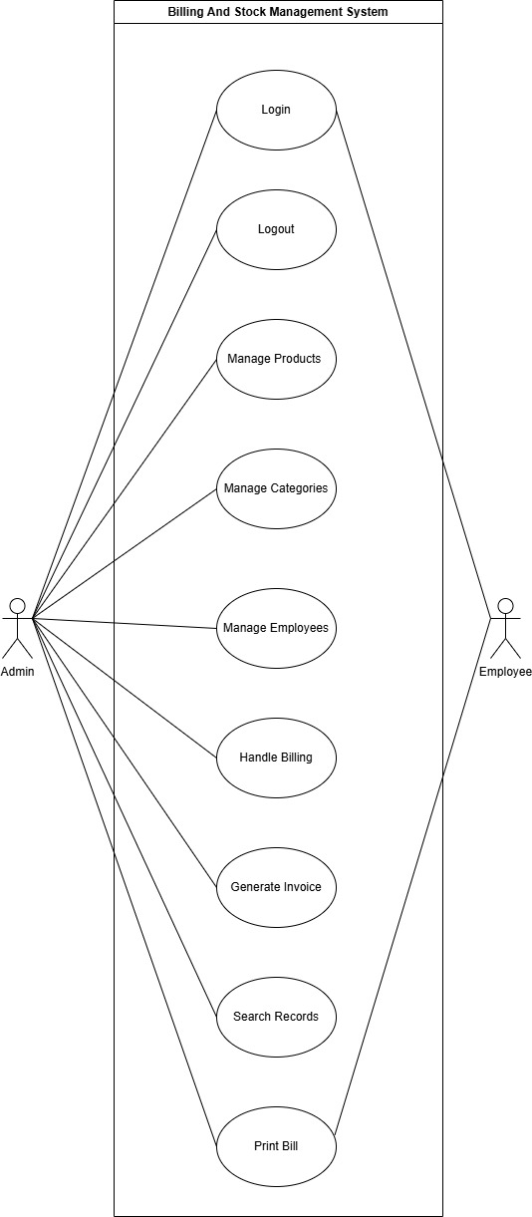
Class Diagram
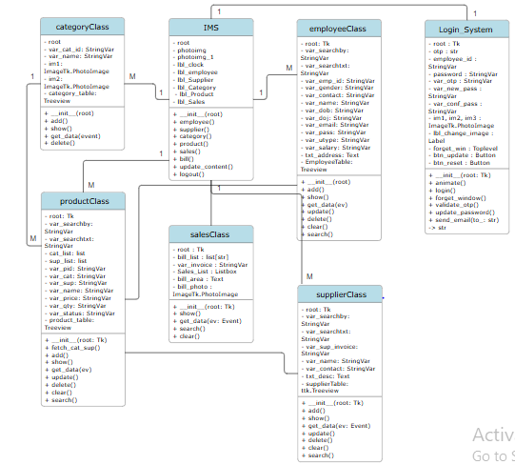
Activity Diagram
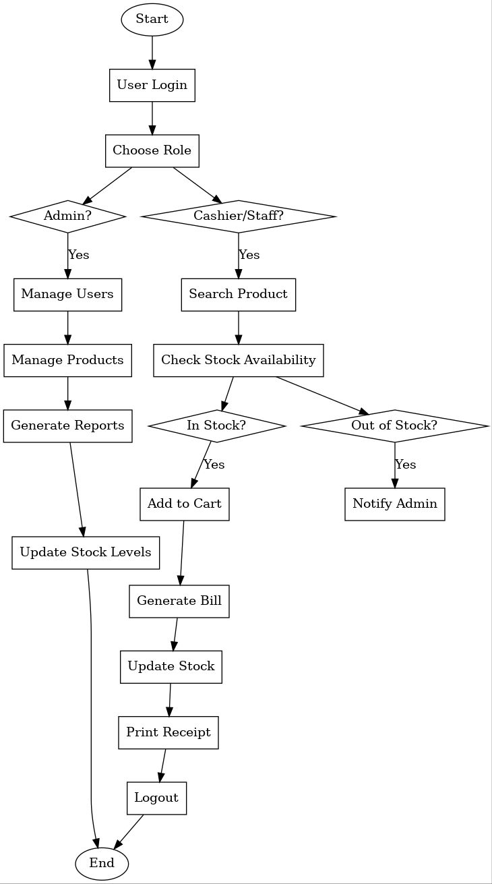

System Design

Data Dictionary:
Table: employee
Name | Type | Constraints
eid | INT | PRIMARY KEY AUTOINCREMENT
name | TEXT | NOT NULL
email | TEXT | UNIQUE, NOT NULL
gender | TEXT | CHECK(gender IN ('Male', 'Female', 'Other'))
contact | TEXT | NOT NULL
dob | TEXT | NOT NULL
doj | TEXT | NOT NULL
pass | TEXT | NOT NULL
utype | TEXT | CHECK(utype IN ('Admin', 'Staff'))
address | TEXT
salary | TEXT | CHECK(salary >= 0)

Table: supplier
Name | Type | Constraints
invoice | INT | PRIMARY KEY AUTOINCREMENT
name | TEXT | NOT NULL
contact | TEXT | NOT NULL
desc | TEXT | NOT NULL
Table: category
Name | Type | Constraints
cid | INT | PRIMARY KEY AUTOINCREMENT
name | TEXT | UNIQUE, NOT NULL
Table: product
Name | Type | Constraints
pid | INT | PRIMARY KEY AUTOINCREMENT
Supplier | INT | NOT NULL
Category | TEXT | NOT NULL
name | TEXT | NOT NULL
price | TEXT | CHECK(price >= 0)
qty | TEXT | CHECK(qty >= 0)
status | TEXT | CHECK(status IN ('Active', 'Inactive'))

Screen Layout

User side:

Login Page:
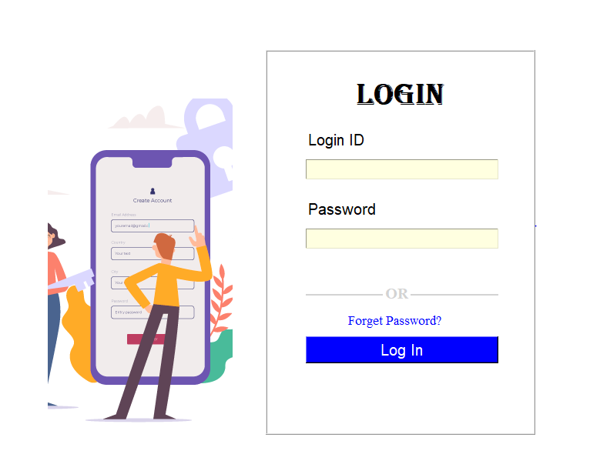
Forget Password Page:
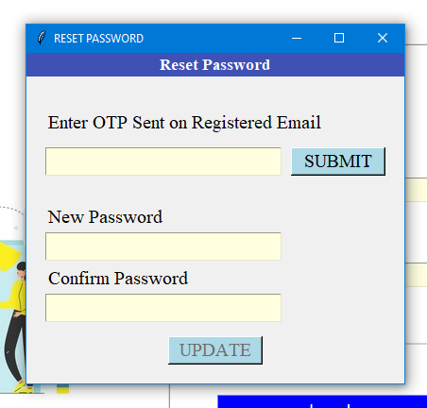

Dashboard Page:
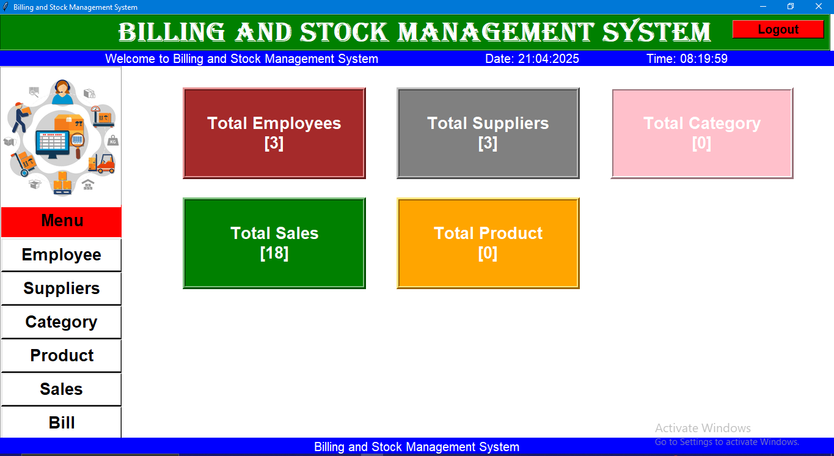
Employee page:
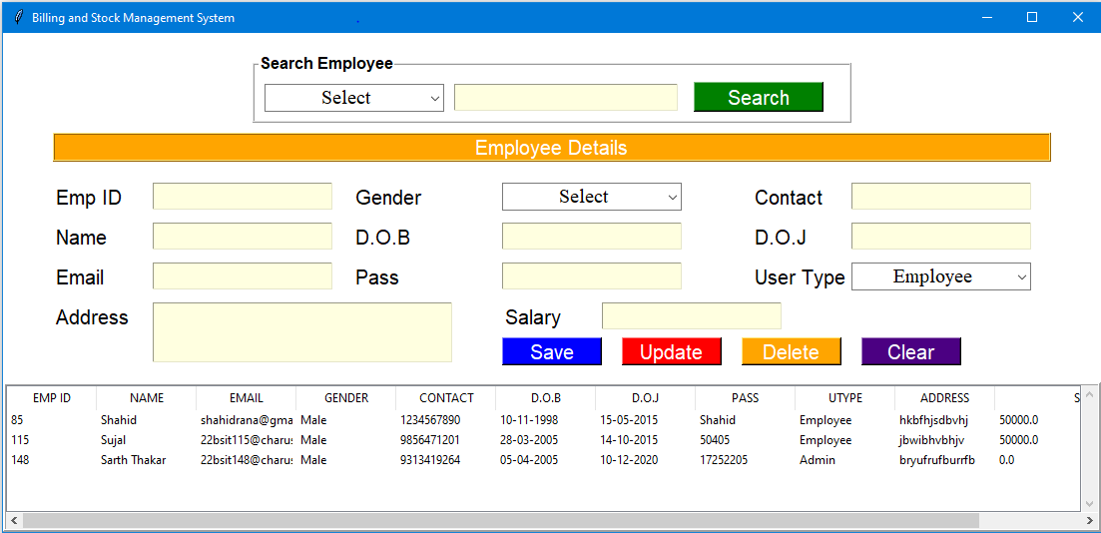

Supplier Page: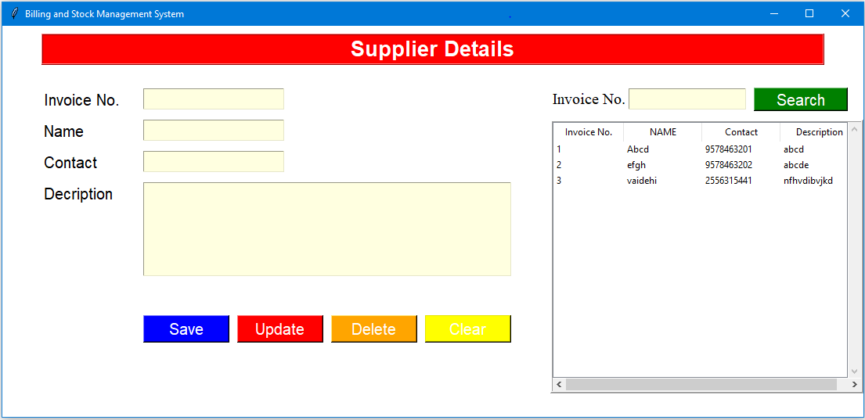
Category Page:
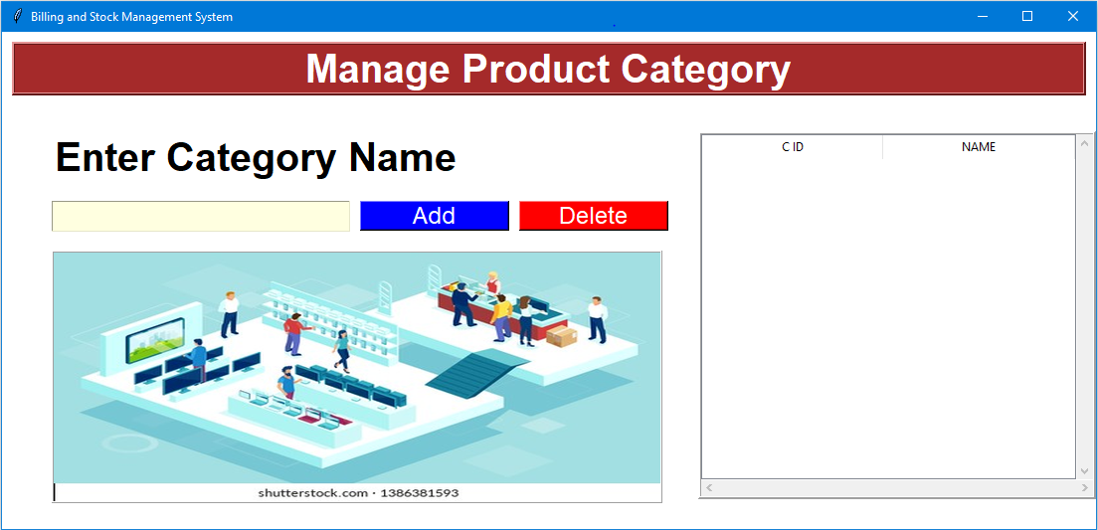

Products page:
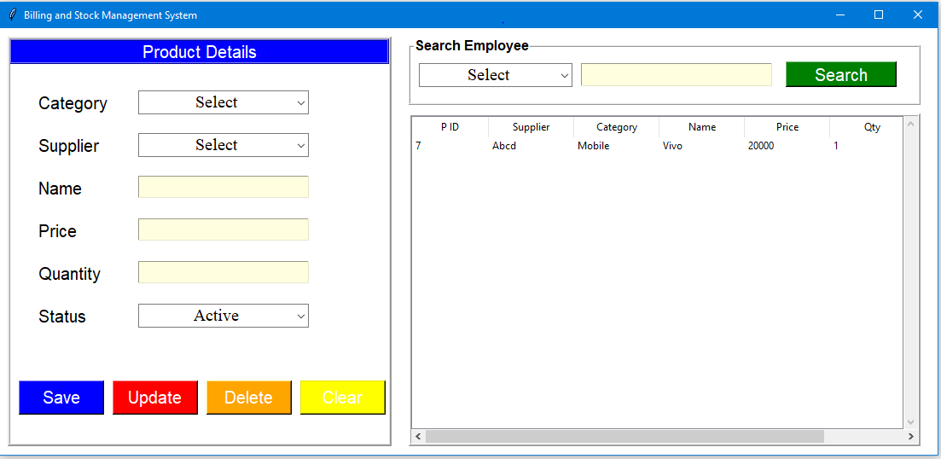
Sales Page:
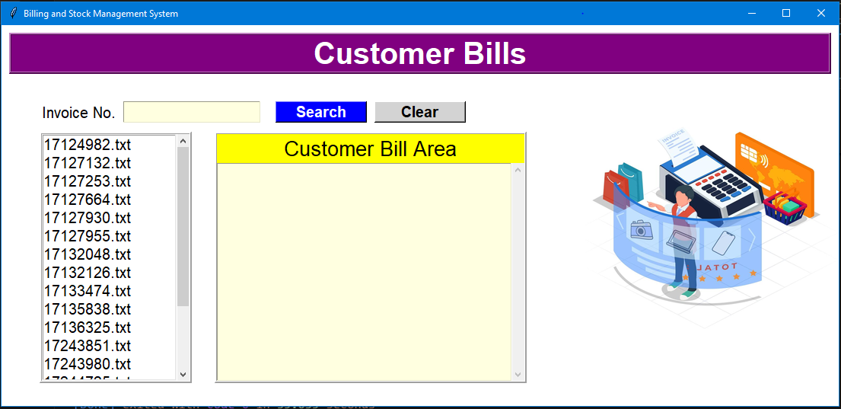

Employee side:
Bill Page: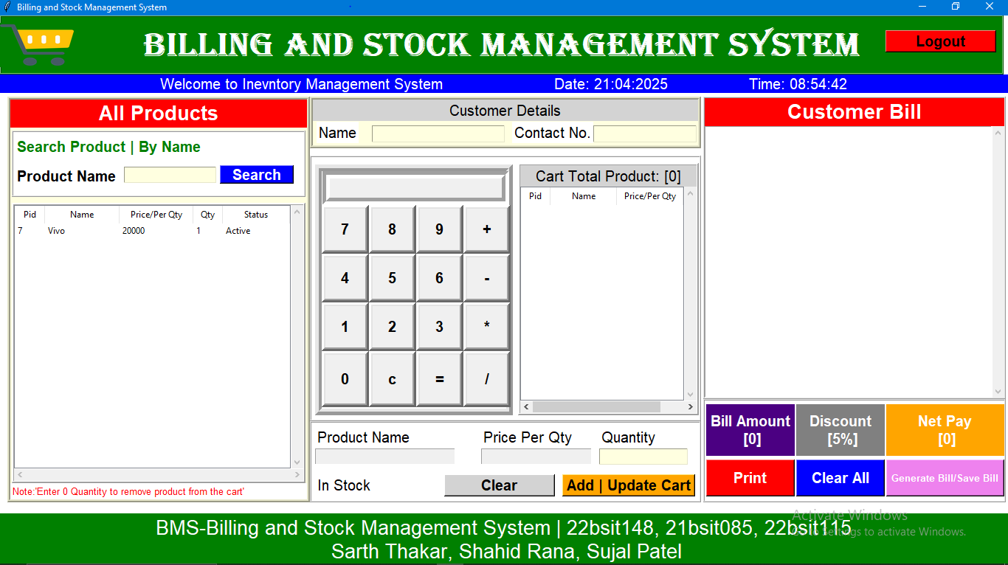

System Testing

Test Cases
Test Case ID | Test Name | Purpose | Input | Expected Output | Test Steps
TC_01 | Valid Login | To verify if a user can log in with correct credentials. | Employee ID: 1, Password: admin123 | Redirect to the dashboard (dashboard.py for Admin or billing.py for Staff). | 1. Open the application.  2. Enter valid employee ID and password.  3. Click Log In.  4. Verify successful redirection.
TC_02 | Invalid Login | To check login with incorrect credentials. | Employee ID: 1, Password: wrongpass | Show error message: "Invalid Username or Password". | 1. Open the application.  2. Enter valid Employee ID and incorrect password.  3. Click Log In.  4. Verify error message appears.
TC_03 | Empty Fields | To check login without entering credentials. | Employee ID: "", Password: "" | Show error message: "All fields are required". | 1. Open the application.  2. Leave fields blank.  3. Click Log In.  4. Verify error message appears.
TC_04 | Forgot Password - Invalid ID | To check behavior when an invalid Employee ID is entered. | Employee ID: 999 (non-existent) | Show error message: "Invalid Employee Id, Try Again". | 1. Click Forget Password.  2. Enter a non-existent Employee ID.  3. Click Submit.  4. Verify error message.
TC_05 | Forgot Password - Valid ID | To verify OTP is sent for a valid Employee ID. | Employee ID: 1 (valid) | OTP sent to registered email. | 1. Click Forget Password.  2. Enter valid Employee ID.  3. Click Submit.  4. Verify OTP is sent.
TC_06 | Forgot Password - Invalid OTP | To check if incorrect OTP is handled properly. | OTP: 123456 (wrong OTP) | Show error message: "Invalid OTP, Try Again". | 1. Enter incorrect OTP.  2. Click Submit.  3. Verify error message appears.
TC_07 | Forgot Password - Valid OTP | To check password reset after correct OTP. | OTP: Correct OTP | Enable password reset fields. | 1. Enter correct OTP.  2. Click Submit.  3. Verify password fields are enabled.
TC_08 | Reset Password - Mismatch | To check behavior when new and confirm passwords don't match. | New Password: pass123  Confirm Password: pass456 | Show error message: "New Password & Confirm Password should be same". | 1. Enter a new password.  2. Enter a different confirm password.  3. Click Update.  4. Verify error message.
TC_09 | Reset Password - Successful | To verify password is successfully updated. | New Password: pass123, Confirm Password: pass123 | Show success message: "Password Updated Successfully". | 1. Enter the same new and confirm password.  2. Click Update.  3. Verify success message.

Future Enhancement

Security Enhancements
- Password Hashing: Store hashed passwords in the database using bcrypt instead of plain text.
- Role-Based Access Control: Restrict access to certain modules based on user roles (Admin, Manager, Employee).
- Session Management: Implement session-based login with automatic logout after inactivity.

Inventory Enhancements
- Stock Alerts: Notify admins when stock levels are low.
- Barcode Scanning: Integrate barcode scanning for product entry and billing.
- Batch Management: Track products with expiration dates (useful for FMCG, medical stores).

Sales & Billing Enhancements
- Discount & Tax Calculation: Allow dynamic application of discounts and taxes.
- Invoice PDF Generation: Generate detailed invoices using the reportlab library.
- Multi-Payment Support: Add multiple payment options (cash, card, UPI, etc.).

Database Optimization
- ORM Integration: Use SQLAlchemy instead of raw SQL queries for better maintainability.
- Database Backup & Restore: Implement automatic database backup functionality.

Notifications & Email Integration
- Order Notifications: Send email notifications for new orders, stock alerts, and low inventory.
- WhatsApp API Integration: Notify suppliers or customers about orders via WhatsApp.

Mobile App Integration
- API Development: Create REST APIs using Flask or Django to integrate with a mobile app.
- Mobile Companion App: Develop an Android/iOS app for managing inventory on the go.

Cloud & Multi-Branch Support
- Cloud Database: Shift from SQLite to PostgreSQL/MySQL for cloud-based access.
- Multi-Branch Support: Enable inventory tracking across multiple warehouses or stores.

References

References:-
- https://www.geeksforgeeks.com/
- https://www.youtube.com/
- https://chatgpt.com/
- Creately

