***JS Interview Questions***

1. What is JS? What is Execution Context in JS? – FrontEndGeek JSInternals NamasteJs1
2. How JS works?
3. How variables and function are private in different module? – IIFE & Require statement
4. How did you access to module.exports?
5. What Happens when you run JS code?(Execution context details) – NamasteJs2
6. What is Hoisting in JS? – NamasteJs3
7. What is Currying JS?
8. How function works in JS? - – NamasteJs4 (have same concept of execution context)
9. How async actually works? – libuv & async IO (present in NodeJs Word)
10. What is undefined and not defined? – undefined is scanned but not assigned a value , not defined is not declared
11. What is closure?
12. <https://www.youtube.com/watch?v=t1nFAMws5FI&list=PLlasXeu85E9cQ32gLCvAvr9vNaUccPVNP&index=15> Go trough this interview video
13. What is anonymous function? , what is first class function? , func exp vs func state vs func dec?
14. Eventlistner – button click correct code – video eventlistner namasteJS
15. Garbage collection and event listeners - video eventlistner namasteJS

***React Interview Questions***

1. Build the react counter app - <https://bigfrontend.dev/react/The-React-Counter/solution>
2. useIsFirstRender() - 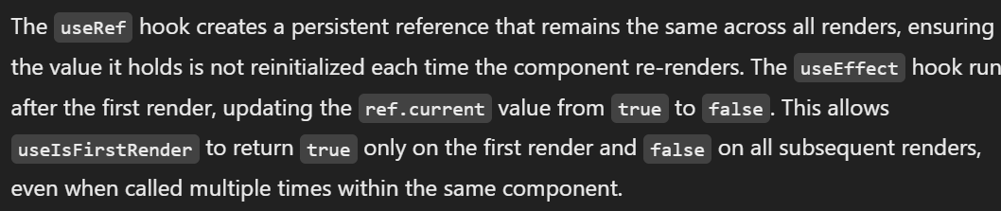

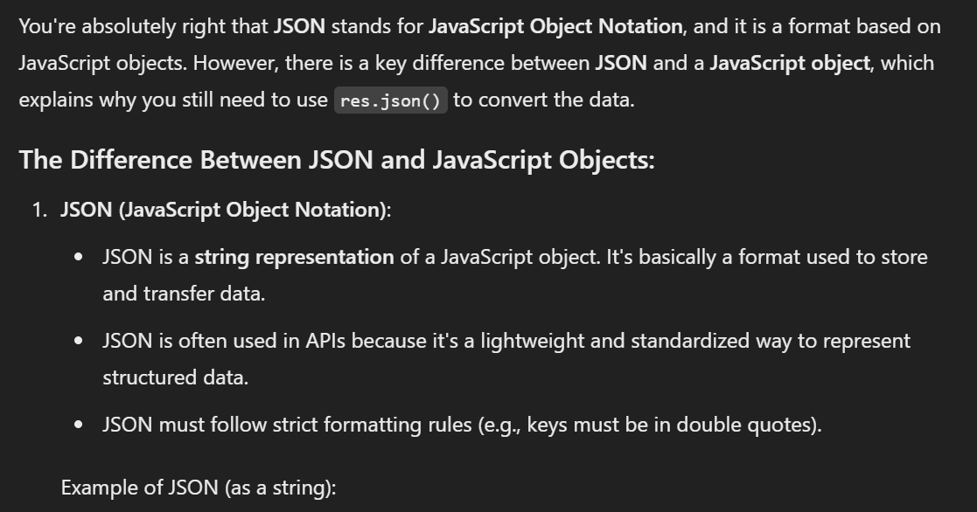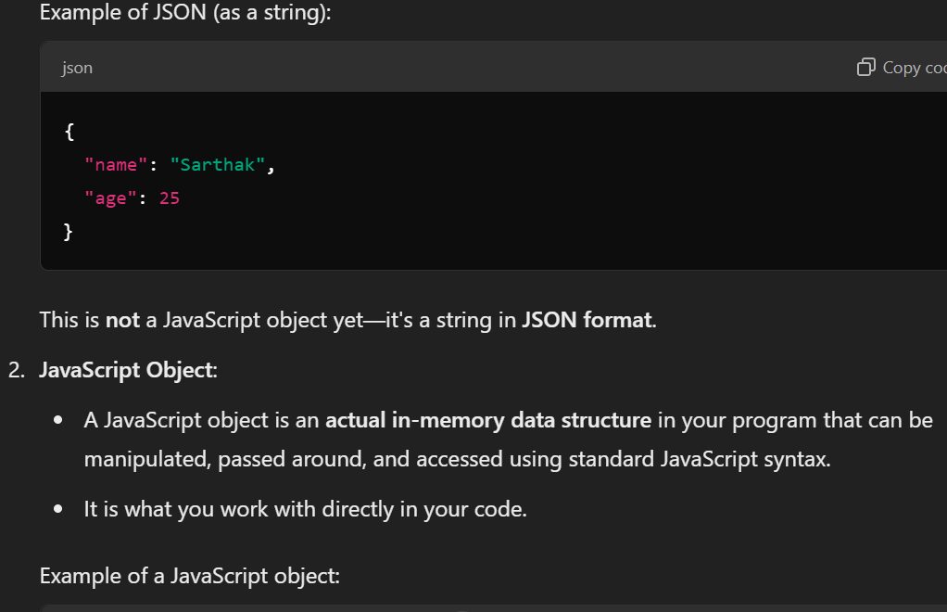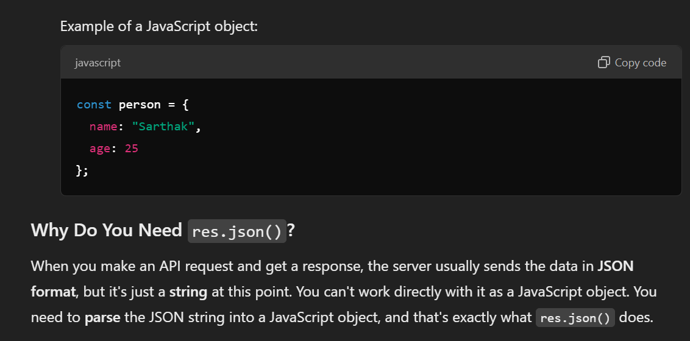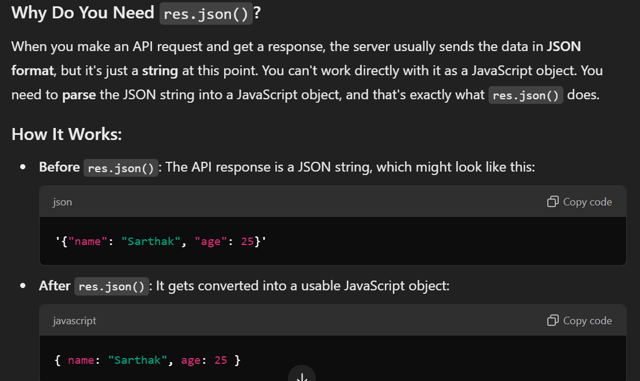

1. useClickOutside() – Concept and understanding present

