***React Knowledge***

***ReactJS Virtual DOM - What are Virtual DOM, Reconciliation, Diffing, and Batch Update in React?***

* DOM – Document Object Model – HTML page with different html tags are static , we need ability to make it dynamic – DOM API is an API provided y JS to make changes in an HTML document
* 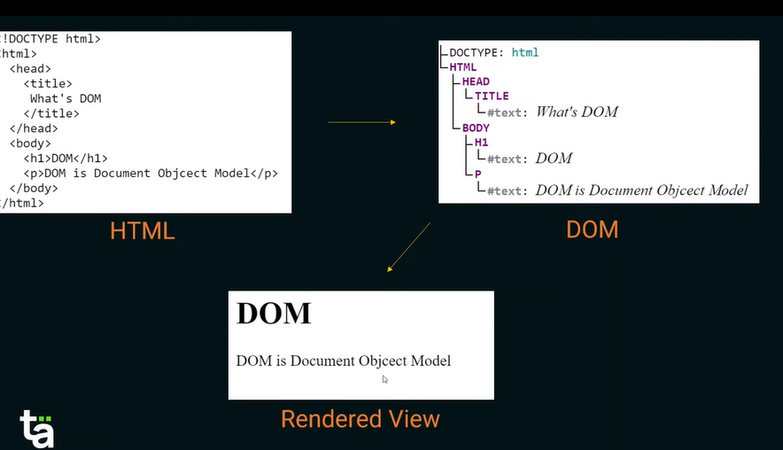 Tree Kind of Structure is used as an input to make changes in html
* DOM Manipulation – Consist of three things – Quering the DOM(find the DOM) , Updating DOM , Re-Render the DOM(Costly Operation) || If DOM update too frequently then our page can be little slower and some libraries come into place for this.
* React Never ever update the original DOM tree directly , react creates 1 object same as original DOM tree and that copy is known as virtual dom tree (Virtual DOM is nothing but in-memory copy of original DOM that react updates directly then updating orginal dom , because virtual dom is in memory and in memory operation is easy) and that virtual dom is easier to sync with original DOM.
* In React , Component gets mounted – operation gets started – component has JSX structure – that JSX is nothing but HTML like structure so DOM is created , So for that original DOM react creates Virtual DOM , each node represent element , if any node (element chamges) , react creates another Virtual DOM then react compares and update original DOM based on that.
* 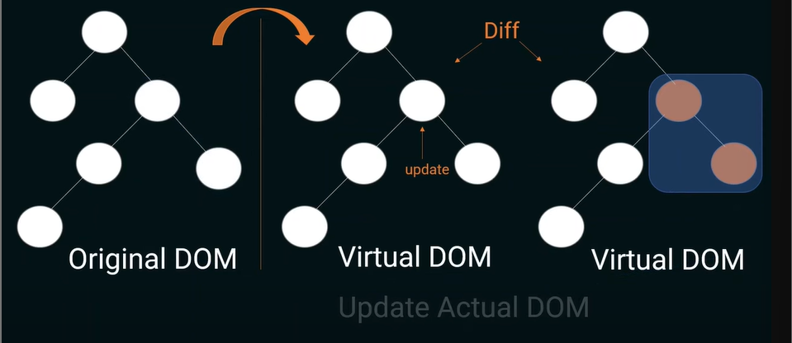
* 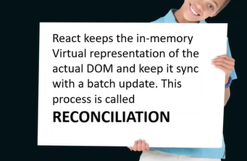
* React performs a diffing algorithm to find different what change dom tree has.
* 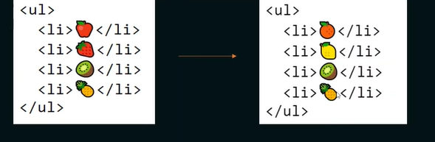 That’s why we need key *

***Deep Understanding of JSX***

* JSX is a combination of Javascript and html JavaScript XML (Xtensible Markup language).JSX is a object. , JSX is something which browser understand.
* JSX is just a syntactic sugar in background react uses document.createelement to create that element
* Instead of JSX, we can simply return React.createElement(“h1”,null,”JSX is Awesome”) , this will become more complex as element grows
* Every JavaScript is we need to use in JSX we need to use expression (curly braces ex-{topic})
* Null, undefined, Boolean – are not printed on browser if we want to print it we need to convert it to string (String(true))
* Loops don’t work on jsx , use map instead as it transform data and return transformed data.
* React uses virtual dom – it only changes, updates a place which change in state and data , react only updates that. That’s why we use keys
* Everything evaluates as value is used in JSX

***Understanding React Components***

* 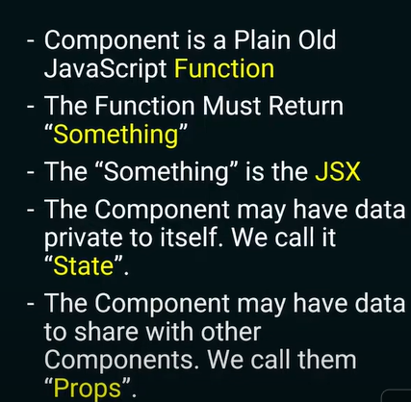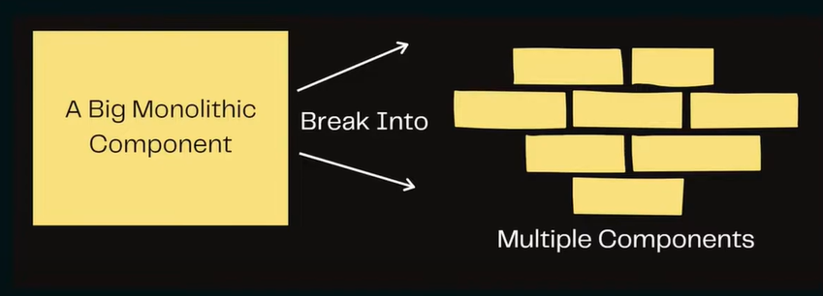

***React Component Lifecycle*** –

* There are three main component in react lifecycle - mounting , updating , unmounting
* 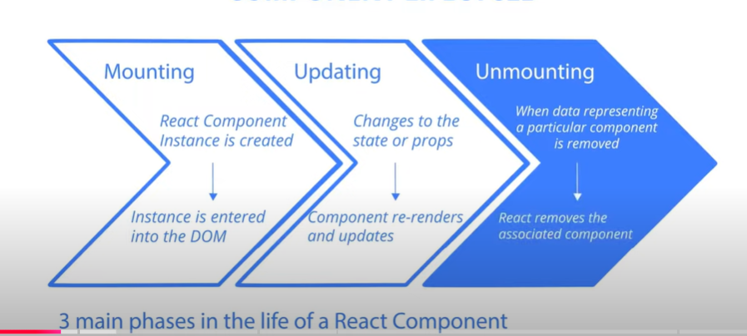
* In Class components –
  + Go through this video to learn for class component - <https://www.youtube.com/watch?v=zvM_FUVcB-0&t=1s>
* In functional Component –
  + Mounting updating unmounting with useeffect example