**Namaste - React**

***Ep -01 || Inception***

* We can use react in our project using CDN - react script tag in html file , there are two file , one is react , 2nd is react-dom (used mainly for dom manipulation )
* React is just JS code , written by facebook eng
* 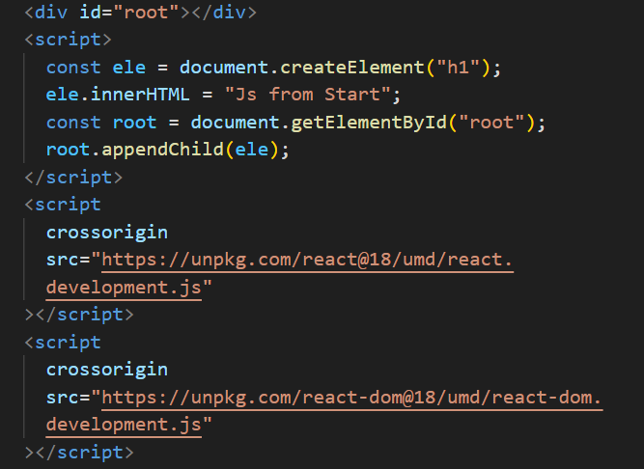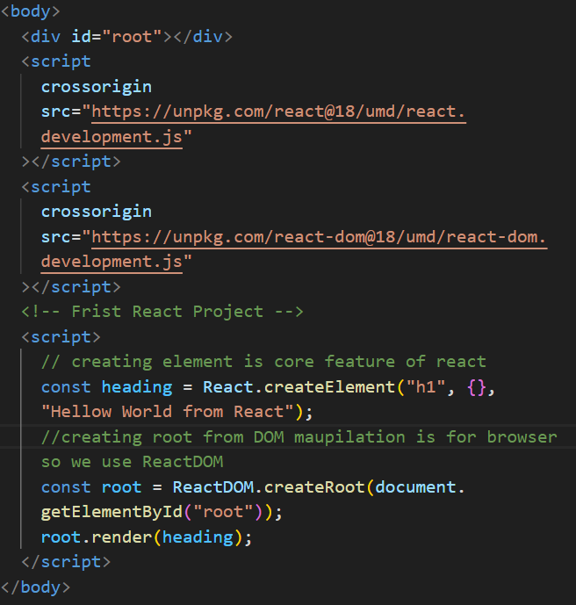
* Here, heading is react element (not h1 tag) which is JS object and it have some props and other stuff. And root.render is responsible to convert it to h1 tag and put it to dom.
* This will became more complex and complex later on, if dom tree is big , that’s why JSX is introduced (JavaScript XML)
* React is a library , it can work on small portions of app.
* Ques - what Is CDN , what is crossorigin