

**Progress Report No. 4**

**Integrated Project**

**Course Code ASP3101**

**PROJECT TITLE**

**To make a solar mobile charger**

**SUBMITTED TO: SUBMITTED BY:**

Mrs. Pooja Dhiman SARTHAK CHAWLA 1611981336

ANMOL WADHAWAN 1611981462

**Implementation of solar portable charger**

**for mobile phone**

**Proposed electronic circuit of portable solar charger**

It was designed and tested using simulation software

called National Instruments (NI) MultiSim, which is

currently one of the leading software programs for

electronic circuits design and simulations [14]. The

complete design of the proposed circuit is shown in Fig. 1



*Fig1:*

The basic block diagram of the mobile battery charger is given in Fig.2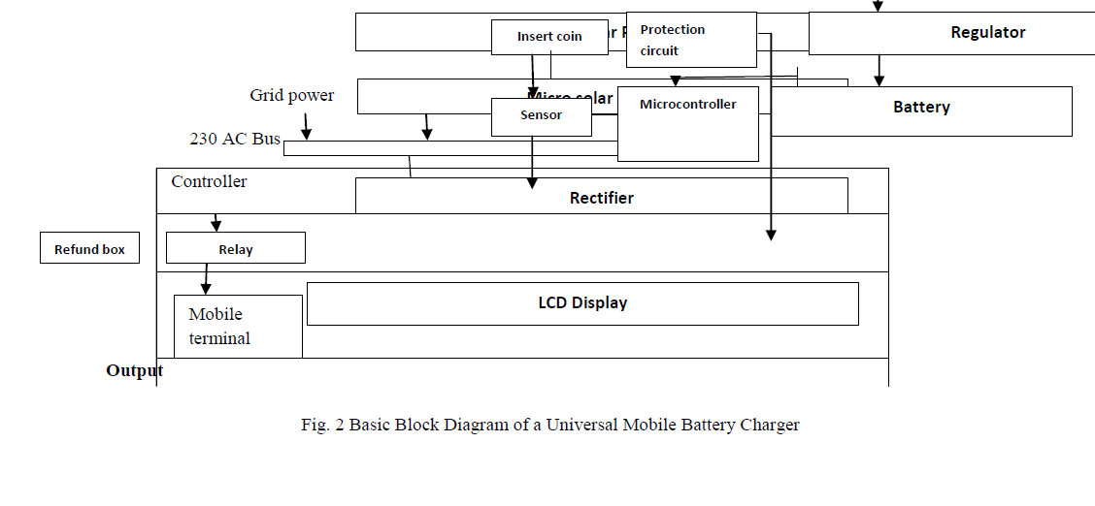 *Fig2:*

**Experimental Work and Results**

1. **Behaviour of Photovoltaic’s**

On the entire I-V curve one point exists, in which the product of the possible output voltage and current - the Output power - becomes a maximum. One disadvantage of photo voltaic lies in their strong non-linear behaviour. The I-V (Current-Voltage) curve describes the characteristic of the possible output power from PV cells;



*Fig. 3. Output power characteristics of a PV cell*

1. **Curve under different ambient conditions**

This task is carried out by the MPPT unit, which contains commonly voltage and/or current sensors and a microcontroller unit(MCU), which controls a dc/dc converter; as illustrated in

Fig.4

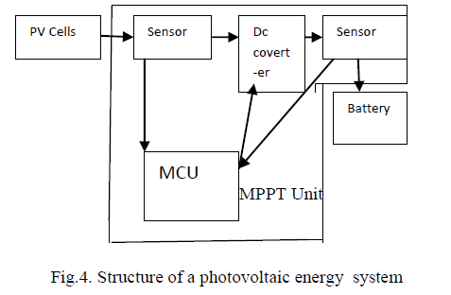

For example, if the solar radiation level is 600W/m2 and the temperature decreases by 10 K, Vop needs to be changed fromVmpp,1 to Vmpp,2, as illustrated in Fig. 4.



*Fig5:*

1. **Power supply to Mobile Battery Charger**

The micro solar inverter is mounted behind the solar panel, compact in size and the DC voltage from the solar panel is used as bias for the electronic circuit. The interconnection of solar power to the mobile battery charger.



*Fig6: Interconnection of power supply to Mobile Battery*

*Charger*

The table given below represent the practical measured results obtained for the different levels of charging currents with the supply voltage.

**Table 3: Practical readings for maximum charging**

**current at shunt resistor equal 3.4Ω**



**CONCLUSIONS:**

In this work a novel method of charging mobile batteries of different manufacturer using solar power has been designed for rural and remote areas where the current supply is not at all available all the time. This paper is very useful in today’s life. Because now days the necessity of communication is very important, so every person having cell phone but every time we cannot carry charger with us. When we are going for long travel we may forget to carry cell phone charger.

**BIBLOGRAPHY:**

* F. Boico, B. Lehman, Multiple-input Maximum Power Point

Tracking algorithm for solar panels with reduced sensing circuitry for

portable applications, J. Solar Energy 86 (2012) 463–475

* P. Görbe , A. Magyar, K. M. Hangos, Reduction of power losses

with smart grids fueled with renewable sources and applying EV

batteries, J. Cleaner Production 34 (2012) 125-137

* P. Bajpai, V. Dash, Hybrid renewable energy systems for power

generation in stand-alone applications: A review, J. Renewable and

Sustainable Energy Reviews 16 (2012) 2926–2939

* B. ChittiBabu, et. al, Synchronous Buck Converter based PV

Energy System for Portable Applications, Proceeding of the 2011 IEEE

Students' Technology Symposium 14-16 Jan. (2011), 335 – 340

* Robion, et. al, Breakthrough in Energy Generation for Mobile or

Portable Devices, 978-1-4244-1628-8/07/$25.00 ©2007 IEEE, (2007),

460 – 466

* M. H. Imtiaz, et. al, Design & Implementation Of An Intelligent

Solar Hybrid Inverter In Grid Oriented System For Utilizing PV

Energy, International Journal Of Engineering Science And Technology,

Vol. 2(12), 2010, 7524-7530

* High efficiency solar battery charger with embedded MPPT, July

2012 Doc ID 18080 Rev 4, © 2012 STMicroelectronics:

http://www.st.com.