**FIT-BEING**

**Fitness Website**

*submitted*

*in partial fulfillment*

*for the award of the Degree of*

***Bachelor of Technology***

***in Department of Computer Science Engineering***

|  |  |
| --- | --- |
|  |  |

Supervisor Submitted By:

**Dr. Naveen Hemrajani** **Sarthak Jain**

JECRC University,Jaipur Reg. No. **1302041119**

**Department of Computer Science Engineering**

JECRC University,Jaipur

**April 2016**

**CONTENTS**

1. INTRODUCTION

2. TECHNICAL DETAILS

3. HTML CODE + SCREENSHOTS

4. JAVASCRIPT

5. CSS

6. CONCLUSION

**INTRODUCTION**

Exercise is extremely important to staying healthy both in body and mind. Being active can help a person continue to do things they enjoy and be independent as they age. Long term physical activity increases the benefits of long-term health. This is the reason many health experts advise individuals to be as active as possible and to set aside at least three days a week for some form of activity that keeps the heart beating at a steady pace. Physical exercise also has many mental benefits. For example, a person diagnosed with depression or anxiety is most often asked to conduct some form of physical activity apart from taking medication. This is because, the body produces hormones known as endorphins which improve mood and relieve stress. Depression can be alleviated by improving mood and anxiety can be relieved by reducing stress.

We provide a perfect online solution to the problems regarding the health and fitness across the globe. Another method of keeping the mind healthy is to exercise it as often as possible. Just as physical exercise is good for the body, so is mental exercise for the mind. There are numerous ways to ensure a healthy mind through activity. For example, doing cross word puzzles, calculating sums in the head, learning a new word every day etc. can be extremely beneficial for the mind. This form of mental exercise is not only for the elderly. It is for all individuals who wish to keep their minds healthy.

An unhealthy mind results in an unhealthy body. Good mental health helps you to make the most of life and enjoy it. Good mental health offers you a feeling of well-being and the inner strength needed in times of trouble or unrest. Everyone knows how to care for their bodies. This is done almost every day by the majority of people. Exercise and eating the proper foods are the best ways of keeping the body healthy. But, how does one keep the mind healthy? A healthy mind requires a lot of work, as well as, a combination of the right foods and exercise.

**TECHNICAL DETAILS**

**NAME:** FIT-BEING | Fitness website

**LANGUAGE USED:** css , JavaScript , jQuery ,HTML 5

**DEVELOPMENT TOOL:** Visual Studio, Adobe Photoshop

FRONT PAGE: index.html

<!DOCTYPE html>

<html xmlns="http://www.w3.org/1999/xhtml">

<head>

<link rel="stylesheet" type="text/css" href="http://fonts.googleapis.com/css?family=Josefin+Slab">

<link rel="stylesheet" type="text/css" href="https://www.google.com/fonts/specimen/Alegreya+Sans+SC">

<link href='https://fonts.googleapis.com/css?family=Rammetto+One' rel='stylesheet' type='text/css'>

<link href='https://fonts.googleapis.com/css?family=Nunito' rel='stylesheet' type='text/css'>

<link href='https://fonts.googleapis.com/css?family=Lato:400,100,100italic,300,300italic,400italic,700italic,900,900italic,700&subset=latin,latin-ext' rel='stylesheet' type='text/css'>

<title>FIT-BEING</title>

<link rel="stylesheet" href="basicstyle.css">

<script src="https://ajax.googleapis.com/ajax/libs/jquery/1.12.0/jquery.min.js">

</script>

<script src="jquery.easing.min.js"></script>

<script src="jquery.ba-hashchange.js"></script>

<script src="basicscript.js"></script>

</head>

<body>

<main>

<div class="cd-index cd-main-content">

<div id="maindiv">

<div id="overlay"></div>

</div>

<h1 id="high">FIT </h1><h1 id="high0"> BEING</h1>

<h1 id="high1" >TRAIN INSANE</h1><h1 id="high2">OR REMAIN THE SAME</h1>

<div id="maindiv2"></div>

<button class="ham" id="anibtn"><span>togglebtn</span></button>

<div id="content">

<a id="menuword"></a>

<p></p>

<a id="menuword2" class="menuwordani" href="letsstart.html" data-type="page-transition"><span></span></a>

<a id="menuword3" class="menuwordani" href="workouts.html" data-type="page-transition"><span id="mw2s"></span></a>

<a id="menuword4" class="menuwordani"><span></span></a>

</div>

</div>

</main>

</body>

</html>

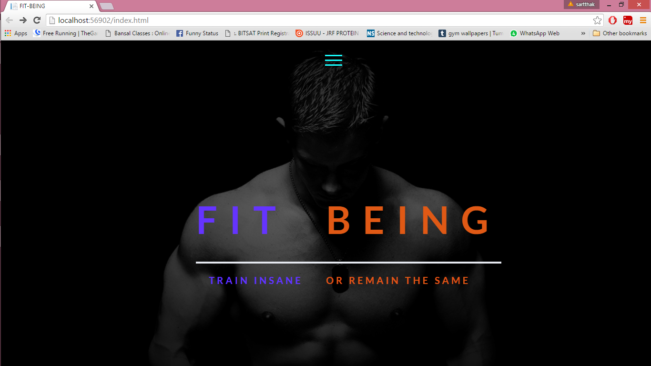

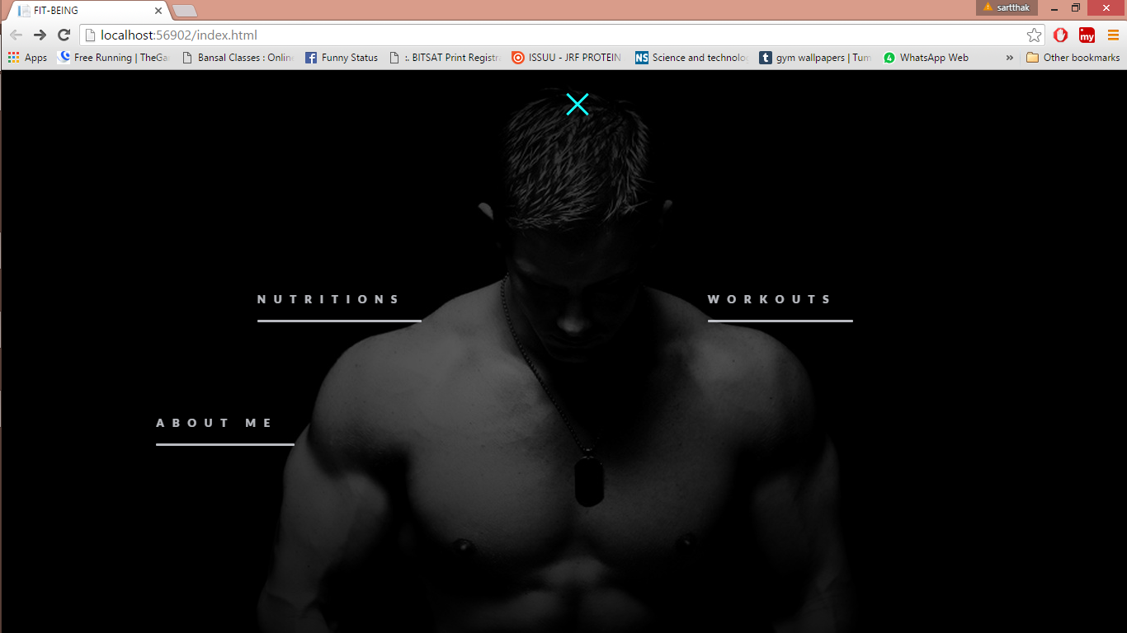

**WORKOUT:** workouts.html

<!DOCTYPE html>

<html xmlns="http://www.w3.org/1999/xhtml">

<head>

<title>workouts</title>

<link rel="stylesheet" href="basicstyle.css" />

<script src="https://ajax.googleapis.com/ajax/libs/jquery/1.12.0/jquery.min.js">

</script>

</head>

<body >

<main>

<div class="cd-workouts cd-main-content">

<ul class="workout_nav" >

<li ><a class="workout_nav_items" id="item_one" href="shoulders.html" data-type="page-transition">SHOULDERSs</a></li>

<li><a class="workout_nav_items" id="item_one" href="chest.html" data-type="page-transition">CHEST</a></li>

<li><a class="workout_nav_items" id="item_one" href="shoulders.html" data-type="page-transition">BACK</a></li>

<li><a class="workout_nav_items" id="item_one" href="shoulders.html" data-type="page-transition">BICEPS</a></li>

<li><a class="workout_nav_items" id="item_one" href="shoulders.html" data-type="page-transition">TRICEPS</a></li>

<li><a class="workout_nav_items" id="item_one" href="shoulders.html" data-type="page-transition">ABS</a></li>

<li><a class="workout_nav_items" id="item_one" href="shoulders.html" data-type="page-transition">LEGS</a></li>

</ul>

<div class="workout_content " id="workout_content_main">

<div id="overlay"></div>

<div class="workout_content_heading"> <h4 class="heading_text_one">SELECT THE MUSCLE.</h4><br />

<h1 class="heading_text_two">NAIL IT.</h1> </div>

</div>

</div>

<script src="jquery.min.js"></script>

<script src="jquery.easing.min.js"></script>

<script src="jquery.ba-hashchange.js"></script>

<script src="basicscript.js"></script>

</main>

</body>

</html>

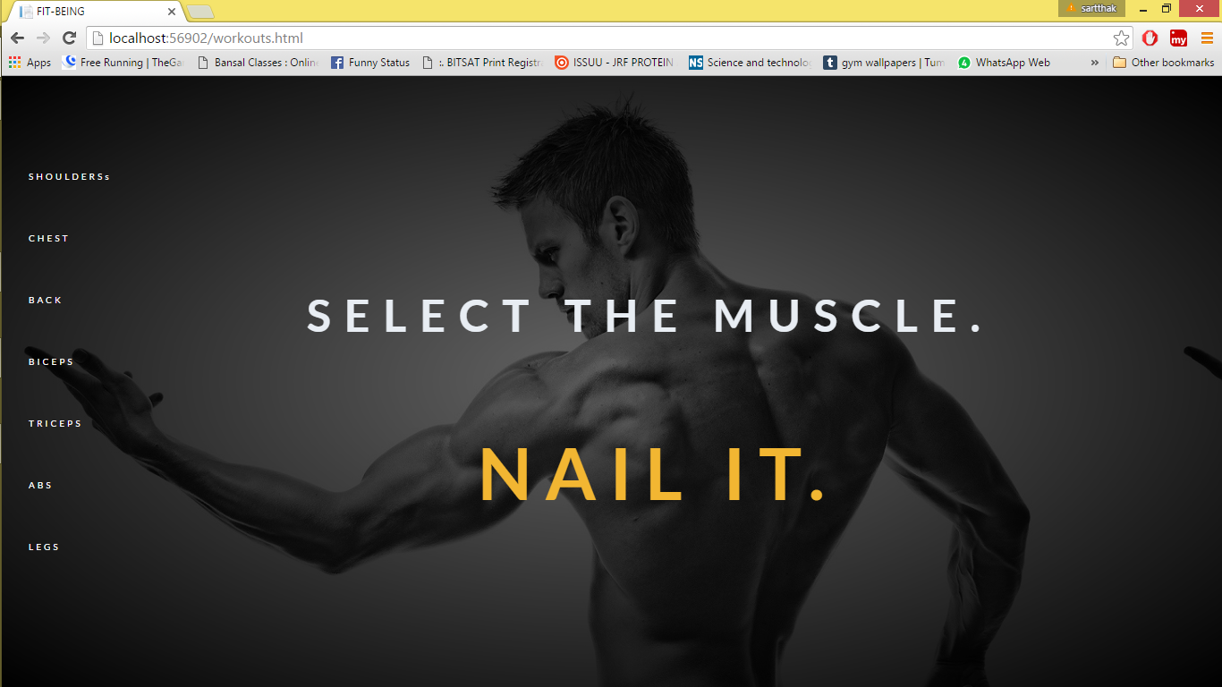

**ABOUT US:** letsstart.html

<!DOCTYPE html>

<html xmlns="http://www.w3.org/1999/xhtml">

<head>

<title>lets start</title>

<link rel="stylesheet" href="basicstyle.css">

<script src="https://ajax.googleapis.com/ajax/libs/jquery/1.12.0/jquery.min.js">

</script>

<script src="jquery.easing.min.js"></script>

<script src="jquery.ba-hashchange.js"></script>

<script src="basicscript.js"></script>

<script src="letsstartscript.js"></script>

</head>

<body>

<main>

<div class="cd-letsstart cd-main-content">

<div id="overlay"> </div>

<div id="ourstory-container">

<div id="ourstory-bg"> </div>

<div id="ourstory">

<h1 align="center">Our Story</h1>

We provide greatest fitness solution

</div>

</div>

</div>

</main>

</body>

</html>

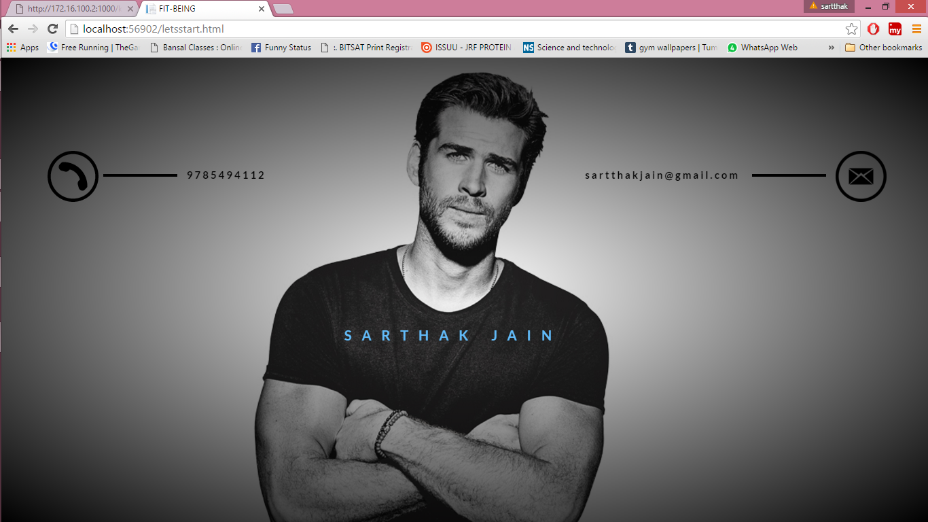

**SHOULDER WORKOUT:** chest.html

<!DOCTYPE html>

<html xmlns="http://www.w3.org/1999/xhtml">

<head>

<title>Shoulders</title>

<link rel="stylesheet" href="basicstyle.css" />

<script src="https://ajax.googleapis.com/ajax/libs/jquery/1.12.0/jquery.min.js">

</script>

<script src="jquery.easing.min.js"></script>

<script src="jquery.ba-hashchange.js"></script>

<script src="basicscript.js"></script>

</head>

<body>

<main>

<div class="cd-chest cd-main-content">

<ul class="workout_nav">

<li><a class="workout_nav_items" id="item_one" href="shoulders.html" data-type="page-transition">SHOULDERS</a></li>

<li><a class="workout_nav_items" id="item_one" href="chest.html" data-type="page-transition">CHEST</a></li>

<li><a class="workout_nav_items" id="item_one" href="shoulders.html" data-type="page-transition">BACK</a></li>

<li><a class="workout_nav_items" id="item_one" href="shoulders.html" data-type="page-transition">BICEPS</a></li>

<li><a class="workout_nav_items" id="item_one" href="shoulders.html" data-type="page-transition">TRICEPS</a></li>

<li><a class="workout_nav_items" id="item_one" href="shoulders.html" data-type="page-transition">ABS</a></li>

<li><a class="workout_nav_items" id="item_one" href="shoulders.html" data-type="page-transition">LEGS</a></li>

</ul>

<div class="workout_content " style="background-image:url('chest.jpg'); background-position-x:30%; background-size:100%">

chest bitches

</div>

</div>

</main>

</body>

</html>

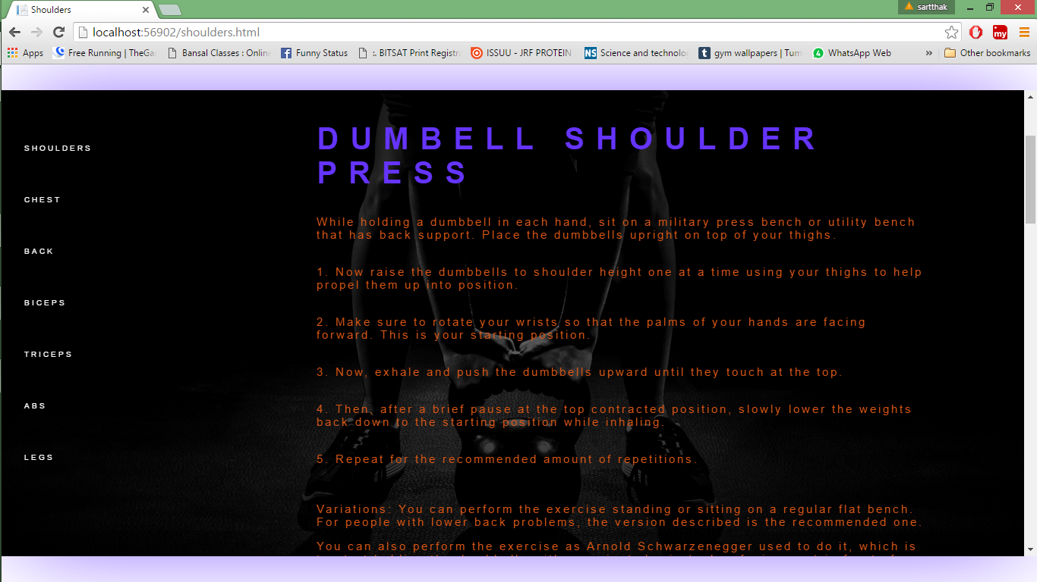

**JAVASCRIPT FOR THE WEBSITE**

$(document).ready(function main() {

var animating = false,

firstLoad = false;

var btnflag;

var cur = 0;

// $('#ourstory-container').hide(0);

$("#high").hide(0).delay(0).show(0).delay(3000).animate({ opacity: '1' }, 4000, "");

$("#high0").hide(0).delay(0).show(0).delay(4000).animate({ opacity: '1' }, 4000, "");

$("#high1").hide(0).delay(0).show(0).delay(5000).animate({ opacity: '1' }, 4000, "");

$("#high2").hide(0).delay(0).show(0).delay(6000).animate({ opacity: '1' }, 4000, "");

$("#first").hide(0).delay(2000).show(0);

$("#second").hide(0).delay(2000).show(0);

$('#maindiv').animate({ width: '100%' }, 2000, "easeInOutCirc").delay(0).animate({ height: '100%', top: '0' }, 1000, "easeInOutCirc");

// $('#maindiv2').animate({ left:'50%' }, 2000, "easeInOutCirc").delay(0).animate({ height: '100%', top: '0' }, 1000, "easeInOutCirc");

$('#content').hide();

$('#menuword2').hide(0);

$('#menuword3').hide(0);

$('#menuword4').hide(0);

showLetsstartPage();

showWorkoutPage();

/*

$("#homebtn").click(function () {

$('#homebtn').delay(0).animate({ left: '600px', opacity: '0' }, 500, "easeInOutCirc");

$('#maindiv').removeClass("maindivani").delay(700).animate({ left: '30%' }, 500, "easeInOutCirc");

$('#closebtn').delay(100).animate({ left: '1200px', opacity: '1' }, "easeInOutCirc");

$('#high').delay(1200).animate({ left: '+=150%' }, "easeInOutCirc");

// $('#first').delay(1300).animate({ width: '+=100%' }, 500, "easeInOutCirc").delay(500).animate({ left: '+=100%' }, 500, "easeInOutCirc");

// $('#second').delay(1500).animate({ width: '+=100%' }, 500, "easeInOutCirc").delay(500).animate({ left: '+=100%' }, 500, "easeInOutCirc");

// $('#third').delay(1700).animate({ width: '+=100%' }, 500, "easeInOutCirc").delay(500).animate({ left: '+=100%' }, 500, "easeInOutCirc");

$('#content').delay(1200).show(0);

$('#menuword').delay(1400).animate({ opacity: '1', left: '10px' }, 500, "easeInOutCirc");

$('#menuword2').delay(1400).animate({ opacity: '1', left: '10px' }, 500, "easeInOutCirc");

$('#menuword3').delay(1400).animate({ opacity: '1', left: '10px' }, 500, "easeInOutCirc");

$('#menuword4').delay(1400).animate({ opacity: '1', left: '10px' }, 500, "easeInOutCirc");

}); /*not using these button functions now*/

$("#closebtn").click(function () {

// $('#maindiv').delay(500).animate({ height: '100%', top: '0px' }, "easeInOutCirc");;

$('#menuword').delay(0).animate({ opacity: '0', left: '0px' }, 500, "easeInOutCirc");

$('#menuword2').delay(0).animate({ opacity: '0', left: '0px' }, 500, "easeInOutCirc");

$('#maindiv').delay(500).animate({ left: '0%' }, 1000, "easeInOutCirc");

$('#homebtn').delay(600).animate({ left: '10px', opacity: '1' }, "easeInOutCirc");

$('#closebtn').delay(600).animate({ left: '600px', opacity: '0' }, "easeInOutCirc");

$('#content').delay(700).hide(0);

// $('#high').delay(600).animate({ marginLeft: '-=150%' }, "easeInOutCirc");

/// $('#first').delay(100).animate({ left: '0%' }, 500, "easeInOutCirc").delay(500).animate({ width: '0%' }, 500, "easeInOutCirc");

// $('#second').delay(300).animate({ left: '0%' }, 500, "easeInOutCirc").delay(500).animate({width: '0%' }, 500, "easeInOutCirc");

// $('#third').delay(500).animate({ left: '0%' }, 500, "easeInOutCirc").delay(500).animate({ width: '0%' }, 500, "easeInOutCirc");

});

$("#menuword2").click(function () {

btnflag = 1;

// $('#maindiv2').load('letsstart.html');

// $('#maindiv').delay(700).css("transform", "scale(0.5)");

//$('#first').delay(700).animate({ width: '+=40%' }, 500, "easeInOutCirc").delay(100).animate({ height: '100%', top: '0px' }, 500, "easeInOutCirc").delay(100).animate({top:'100%',height:'0%'},500,"easeInOutCirc");

// $('#second').delay(700).animate({ left: '-=60%' }, 500, "easeInOutCirc").delay(100).animate({ height: '100%', top: '0px' }, 500, "easeInOutCirc").delay(100).animate({ top: '0%', height: '0%' }, 500, "easeInOutCirc");;

// $('#second').delay(1500).animate({ width: '+=100%' }, 500, "easeInOutCirc").delay(500).animate({ left: '+=100%' }, 500, "easeInOutCirc");

// $('#third').delay(1700).animate({ width: '+=100%' }, 500, "easeInOutCirc").delay(500).animate({ left: '+=100%' }, 500, "easeInOutCirc");

// $("#maindiv").delay(2200).hide(0);

});

$("#menuword3").click(function () {

btnflag = 2;

});

$("#item_one").click(function () { btnflag=3});

(function () {

"use strict";

var toggles = document.querySelectorAll(".ham");

for (var i = toggles.length - 1; i >= 0; i--) {

var toggle = toggles[i];

toggleHandler(toggle);

};

function toggleHandler(toggle) {

toggle.addEventListener("click", function (e) {

e.preventDefault();

if (this.classList.contains("is-active") === true) {

this.classList.remove("is-active");

$("#high").delay(2000).show(0).animate({ opacity: '1' }, 1000);

$("#high0").delay(2000).show(0).animate({ opacity: '1' }, 1000);

$("#high1").delay(2000).show(0).animate({ opacity: '1' }, 1000);

$("#high2").delay(2000).show(0).animate({ opacity: '1' }, 1000);

$('#menuword').delay(0).animate({ opacity: '0', left: '0px' }, 500, "easeInOutCirc");

$('#content').delay(1500).animate({ height: '0%' }, 1000, "easeInOutCirc");

if (btnflag == 1) {

btnflag = 0;

// $('#ourstory-container').delay(500).animate({ top: '100%', opacity: '0' }, 400, "swing");

// $('#ourstory').delay(0).animate({ top: '100%' }, 400, "swing");

// $('#ourstory-bg').delay(200).animate({ opacity: '0' }, 400, "swing");

// $('#maindiv').delay(2000).removeClass("newbg1").delay(2000).addClass("oldbg");//.delay(500).animate({ top: '0%', left: '0%', height: '100%', width: '100%' }, 1000, "easeInOutCirc");

// $('#maindiv').delay(2500).animate({ width: '50%',left:'0%' }, 1000, "easeInOutCirc");

// $('#maindiv2').delay(2500).animate({ left: '50%' }, 1000, "easeInOutCirc");

}

else {

// $('#maindiv').delay(2500).animate({ left: '0%' }, 1000, "easeInOutCirc");

// $('#maindiv2').delay(2500).animate({ left: '50%' }, 1000, "easeInOutCirc");

var toggles = document.querySelectorAll(".menuwordani");

for (var i = toggles.length - 1; i >= 0; i--) {

var toggle = toggles[i];

// toggle.classList.remove("rev");

toggle.classList.add("is-active");

};

$('#menuword2').delay(1500).hide(0);

$('#menuword3').delay(1500).hide(0);

$('#menuword4').delay(1500).hide(0);

}

} else {

$("#high").animate({ opacity: '0' }, 1000).delay(100).hide(0);

$("#high0").animate({ opacity: '0' }, 1000).delay(100).hide(0);

$("#high1").animate({ opacity: '0' }, 1000).delay(100).hide(0);

$("#high2").animate({ opacity: '0' }, 1000).delay(100).hide(0);

this.classList.add("is-active");

// $("#maindiv").animate({ left: '-20%' }, 1000, "easeInOutCirc");

// $("#maindiv2").animate({ left: '70%' }, 1000, "easeInOutCirc");

$('#content').delay(0).show(0).animate({ height: '100%' }, 1000, "easeInOutCirc");

$('#menuword').delay(0).show(0).delay(1000).animate({ opacity: '1', left: '10px' }, 500, "easeInOutCirc");

$('#menuword2').delay(1000).show(0);

$('#menuword3').delay(1000).show(0);

$('#menuword4').delay(1000).show(0);

var toggles2 = document.querySelectorAll(".menuwordani");

for (var j = toggles2.length - 1; j >= 0; j--) {

var toggle2 = toggles2[j];

toggle2.classList.remove("is-active");

};

}

});

}

})();

(function () {

"use strict";

var toggles = document.querySelectorAll(".menuwordani");

for (var i = toggles.length - 1; i >= 0; i--) {

var toggle = toggles[i];

toggleHandler(toggle);

};

function toggleHandler(toggle) {

toggle.addEventListener("click", function (e) {

e.preventDefault();

if (this.classList.contains("is-active") === true) {

this.classList.remove("is-active");

} else {

for (var i = toggles.length - 1; i >= 0; i--) {

var toggle = toggles[i];

toggle.classList.add("is-active");

};

}

// setTimeout(function () { window.location = "letsstart.html" }, 3400);

});

}

})();

$('main').on('click', '[data-type="page-transition"]', function (event) {

event.preventDefault();

//detect which page has been selected

var newPage = $(this).attr('href');

//if the page is not animating - trigger animation

if (!animating) changePage(newPage, true);

firstLoad = true;

});

$(window).on('popstate', function () {

if (firstLoad) {

var newPageArray = location.pathname.split('/'),

//this is the url of the page to be loaded

newPage = newPageArray[newPageArray.length - 1];

if (!animating) changePage(newPage,false);

}

firstLoad = true;

});

function changePage(url, bool) {

animating = true;

if (url == 'index.html') {

btnflag = 0;

}

else if (url == 'letsstart.html')

btnflag = 1;

else if (url == 'workouts.html')

btnflag = 2;

else if (url == 'shoulders.html')

btnflag = 11;

else if (url == 'chest.html')

btnflag = 12;

if ((btnflag == 1)|| (btnflag == 2)) {

//going from index to letsstart or workouts

removeWorkoutPage();

removeIndexPage();

if (cur == 0)

//index is current

setTimeout(function () { loadNewContent(url, bool); }, 2000);

else

setTimeout(function () { loadNewContent(url, bool); }, 700); //shoulder ,chest etc are current

} else if (btnflag >= 11 && cur>=2)

{

removeWorkoutPage();

setTimeout(function () { loadNewContent(url, bool); }, 700);

}

else if(btnflag==0)

{

removeWorkoutPage();

removeLetsstartPage();

setTimeout(function () { loadNewContent(url, bool); }, 700);

} }

function loadNewContent(url, bool) {

url = ('' == url) ? 'index.html' : url;

var newSectionName = 'cd-' + url.replace('.html', ''),

section = $('<div class="cd-main-content ' + newSectionName + '"></div>');

section.load(url + ' .cd-main-content > *', function (event) {

// load new content and replace <main> content with the new one

$('main').html(section);

if(section.hasClass(".cd-letsstart")) {

$(".cd-main-content").addClass(".cd-letsstart");

}

else if (section.hasClass(".cd-workouts"))

{

$(".cd-main-content").addClass(".cd-workouts");

// $(".workout_content").animate({ left: '10%', width: '80%' }, 300, "easeInOutCirc");

}

else if (section.hasClass(".cd-shoulders"))

{

// reloadScript('#shoulderscript');

}

else if (section.hasClass(".cd-chest")) {

$(".cd-main-content").addClass(".cd-chest");

}

else

{ $(".cd-main-content").removeClass(".cd-letsstart");

}

if (btnflag == 1) {

showLetsstartPage();

cur = 2;

}

else if (btnflag == 2) {

showWorkoutPage();

cur = 2;

} else if (btnflag >= 11) {

showWorkoutPage();

cur = 3;

}

else if (btnflag == 0) {

showIndexPage();

cur = 0;

}

if (url != window.location && bool) {

//add the new page to the window.history

window.history.pushState({ path: url }, '', url);

}

animating = false;

});

}

function removeIndexPage() {

$('#menuword').delay(1300).hide(0);

$('#menuword2').delay(1300).hide(0);

$('#menuword3').delay(1300).hide(0);

$('#menuword4').delay(1300).hide(0);

$('#content').delay(1300).animate({ height: '0%' }, 1000, "easeInOutCirc");

$('#maindiv').delay(1300).animate({ top:'50%',height: '6px' }, 300, "easeInOutCirc");

$('#maindiv').animate({ width:'20%',left:'40%' }, 300, "easeInOutCirc");

// $('#maindiv').delay(2300).animate({ left: '-87%' }, 1000, "easeInOutCirc");

// $('#maindiv2').delay(2300).animate({ left: '-37%' }, 1000, "easeInOutCirc");

var toggles = document.querySelectorAll(".menuwordani");

setTimeout(function () {

for (var i = toggles.length - 1; i >= 0; i--) {

var toggle = toggles[i];

// toggle.classList.remove("rev");

toggle.classList.add("is-active");

};

}, 100); };

function showIndexPage() {

$('#maindiv').css({ height: '6px', top: '50%', left: '40%', width: '20%' });

$('#maindiv').animate({ left: '0%', width: '100%' }, 300, "easeInOutCirc");

$('#maindiv').delay(350).animate({ top: '5%', height: '90%' }, 300, "easeInOutCirc");

$('#maindiv').delay(350).animate({ top: '0%', height: '100%', left: '0%', width: '100%' }, 300, "easeInOutCirc");

$("#overlay").delay(1000).animate({ opacity: '0.6' }, 1000);

$('#maindiv2').css({ height: '100%', top: '0%' });

$('#maindiv').delay(0).animate({ left:'0%' }, 1000, "easeInOutCirc");

// $('#maindiv2').delay(0).animate({ left: '50%' }, 1000, "easeInOutCirc");

$('#content').delay(1000).animate({ height: '100%' }, 500, "easeInOutCirc");

$('#menuword2').delay(1500).show(0);

$('#menuword3').delay(1500).show(0);

$('#menuword4').delay(1500).show(0);

var toggles = document.querySelectorAll(".menuwordani");

for (var i = toggles.length - 1; i >= 0; i--) {

var toggle = toggles[i];

// toggle.classList.remove("rev");

toggle.classList.add("is-active");

};

setTimeout(function () {

for (var i = toggles.length - 1; i >= 0; i--) {

var toggle = toggles[i];

// toggle.classList.remove("rev");

toggle.classList.remove("is-active");

};

}, 2000);

};

function removeLetsstartPage() {

$('#ourstory-container').delay(0).animate({ top: '100%', opacity: '0' }, 400, "swing");

$(".cd-letsstart").delay(0).animate({ top: '50%', height: '6px' }, 300, "easeInOutCirc");

$(".cd-letsstart").animate({ width: '20%', left: '40%' }, 300, "easeInOutCirc");

};

function showLetsstartPage() {

$("#overlay").delay(1000).animate({ opacity: '0.6' }, 1000);

$(".cd-letsstart").animate({ left: '0%', width: '100%' }, 300, "easeInOutCirc");

$(".cd-letsstart").delay(350).animate({ top: '5%', height: '90%' }, 300, "easeInOutCirc");

$(".cd-letsstart").delay(350).animate({ top: '0%', height: '100%', left: '0%', width: '100%' }, 300, "easeInOutCirc");

$('#ourstory-container').show(0).delay(1200).animate({ top: '30%', opacity: '1' }, 400, "swing");

$('#ourstory').delay(1400).animate({ top: '0%' }, 400, "swing");

$('#ourstory-bg').delay(5100).addClass("bluraniclass");

btnflag = 0;

};

function showWorkoutPage() {

// $(".workout_nav_items").animate({ opacity: '1' },500);

$("#overlay").delay(1000).animate({ opacity: '0.6' }, 1000);

$(".heading_text_one").delay(2000).animate({ opacity: '1' }, 1000);

$(".heading_text_two").delay(3000).animate({ opacity: '1' }, 1000);

$(".workout_content").animate({ left: '0%', width: '100%' }, 300, "easeInOutCirc");

$(".workout_content").delay(350).animate({ top: '5%', height: '90%' }, 300, "easeInOutCirc");

$("#workout_content_main").delay(350).animate({ top: '0%', height: '100%', left: '0%', width: '100%' }, 300, "easeInOutCirc");

// $(".workout_content").delay(300).animate({ top: '0%', height: '100%',left:'13%',width:'87%' }, 300,"easeInOutCirc");

};

function removeWorkoutPage() {

// $(".workout_nav_items").animate({ opacity: '0' },500);

// $(".workout_content").animate({ top: '5%', height: '90%', left: '15%', width: '80%' }, 100);

$(".workout_content").delay(0).animate({ top: '50%', height: '6px' }, 300, "easeInOutCirc");

$(".workout_content").animate({ width: '20%', left: '40%' }, 300, "easeInOutCirc");

};

function reloadScript(id) {

var $el = $('#' + id);

$('#' + id).replaceWith('<script id="' + id + '" src="' + $el.prop('src') + '"></script>');

}

});

**CSS :**  basicscript.css

.cd-main-content {

overflow: auto;

background-color:white;

}

#overlay{

width:100%;

height:500%;

opacity:0;

background-color:black;

}

body {

background-color: white;

}

#maindiv {

position: fixed;

width: 0%;

top: 30%;

left: 0px;

height: 40%;

overflow: hidden;

background: radial-gradient(transparent 0%, black 100%),url("manlean.jpeg");

z-index: -1;

background-color: black;

background-position-x: 50%;

}

#maindiv2 {

position: fixed;

width: 150%;

top: 30%;

left: 100%;

height: 40%;

overflow: hidden;

z-index: -1;

background-color: black;

// background-image: url("womanlean2.jpg");

background-repeat: no-repeat;

background-position-x: 30%;

background-position-y: 10%;

}

.oldbg {

// -webkit-animation-name: bgani;

animation-duration: 6s;

background-image: url("pushupgirl.jpg");

transition: background 0.5s;

animation-fill-mode: forwards;

}

.newbg1 {

background-position-x: 90%;

background-position-y: 30%;

background-image: url("ourstoryimg.jpg");

transition: background 0.5s;

-webkit-animation-name: bgani2;

animation-duration: 6s;

animation-fill-mode: forwards;

}

@-webkit-keyframes bgani {

0% {

background-size: 100%;

}

100% {

background-size: 130%;

}

}

@-webkit-keyframes bgani2 {

0% {

background-size: 100%;

}

100% {

background-size: 130%;

}

}

.maindivani {

-webkit-animation-name: maindivani;

-webkit-animation-timing-function: cubic-bezier(0.785, 0.135, 0.15, 0.86);

-webkit-animation-duration: 3s;

-webkit-animation-fill-mode: forwards;

}

@-webkit-keyframes maindivani {

0% {

width: 0%;

margin-left: -100px;

height: 50%;

top: 200px;

}

50% {

width: 100%;

height: 50%;

top: 200px;

margin-left: 0px;

}

100% {

width: 100%;

height: 100%;

top: 0px;

margin-left: 0px;

}

}

#high,#high0,.heading_text_one,.heading_text_two {

position: fixed;

opacity:0;

left: 30%;

top: 40%;

font-family: 'Lato', sans-serif;

z-index: +1;

letter-spacing: 25px;

font-size: 80px;

text-shadow:-1px -7px 108px -27px rgba(0,0,0,0.75);

color: #6534ff;

}

#high0{

left:50%;

color:#e05915;

}

#high:before{

position:fixed;

top:68%;

content:'';

background-color:#e6e9f0;

display:block;

height:4px;

width:47%;

text-shadow:-1px -7px 108px -27px rgba(0,0,0,0.75);

}

#high1,#high2{

position: fixed;

opacity:0;

left: 32%;

top: 70%;

font-family: 'Lato', sans-serif;

z-index: +1;

letter-spacing: 5px;

font-size: 20px;

color: #6534ff;

}

#high2{

left:50%;

color:#e05915;

}

@-webkit-keyframes highani {

from {

opacity:0;

}

to {

opacity:1;

}

}

.ham {

display: block;

position: fixed;

overflow: hidden;

z-index: +1;

outline: none;

width: 60px;

height: 60px;

font-size: 0px;

background-color: transparent;

box-shadow: none;

left: 49%;

border: none;

cursor: pointer;

transition: background 0.3s;

}

.ham span {

display: block;

position: absolute;

top: 32px;

left: 12px;

right: 12px;

height: 3px;

background-color: #18ffff;

}

.ham span::before,

.ham span::after {

position: absolute;

display: block;

left: 0;

width: 100%;

height: 3px;

background-color: #18ffff;

content: "";

transition-duration: 0.3s,0.3s;

transition-delay: 0.3s,0s;

}

.ham span {

transition: background 0s 0.3s;

}

.ham span::before {

top: -10px;

transition-property: top,transform;

}

.ham span::after {

bottom: -10px;

transition-property: bottom,transform;

}

.ham.is-active span {

background: none;

}

.ham.is-active span::before {

top: 0;

transform: rotate(45deg);

}

.ham.is-active span::after {

bottom: 0;

transform: rotate(-45deg);

}

.ham.is-active span::before,

.ham.is-active span::after {

transition-delay: 0s, 0.3s;

}

.mainbtn {

visibility: hidden;

outline: none;

position: fixed;

left: 10px;

top: 10px;

width: 5%;

z-index: +1;

height: 0;

padding-bottom: 4.5%;

color: white;

background-color: white;

font-family: 'MS Gothic';

border: none;

border-radius: 50%;

overflow: hidden;

-webkit-transition: all 600ms cubic-bezier(0.785, 0.135, 0.15, 0.86);

-webkit-transition-duration: 1s;

}

#homebtn{

opacity: 1;

-webkit-animation-delay: 1s;

// -webkit-animation-name: btnanimation;

-webkit-animation-duration: 0.4s;

}

/*these were the old buttons not using now*/

#closebtn {

left: 600px;

opacity: 0;

width: 5%;

padding-bottom: 4.5%;

}

.mainbtn:hover {

color: black;

box-shadow: 0 12px 16px 0 rgba(0,0,0,0.24), 0 17px 50px 0 rgba(0,0,0,0.19);

background-color: red;

}

.mainbtn img {

width: 76%;

height: auto;

padding: 12%;

display: block;

}

@-webkit-keyframes btnanimation {

from {

top: 900px;

opacity: 0;

}

to {

top: 10px;

opacity: 1;

}

}

.navigation {

left: 10px;

border-style: solid;

width: 100%;

position: absolute;

z-index: 10;

float: left;

font-family: 'Adobe Arabic';

letter-spacing: 5px;

font-size: 20px;

}

.navigation:hover {

transition: all 0.4s ease-in-out;

background-size: 430%;

}

#first {

position: fixed;

border: none;

top: 40%;

width: 0%;

height: 20%;

left: 0%;

color: green;

background-color: black;

overflow: hidden;

}

#second {

position: fixed;

width: 60%;

left: 100%;

height: 20%;

border: none;

top: 40%;

background-color: white;

overflow: hidden;

}

#third {

position: fixed;

left: 0%;

width: 0%;

height: 250px;

color: yellow;

background-color: yellow;

top: 500px;

overflow: hidden;

}

#content {

width: 100%;

left: 0%;

top:0%;

height: 0%;

font-size: 30px;

overflow: hidden;

position: fixed;

font-family: 'Lato', sans-serif;

// font-family: 'Nunito', sans-serif;

// font-family: 'Rammetto One', cursive;

// font-family: 'Josefin Slab',serif;

background-color:transparent;

background-position-x:30%;

opacity:0.8;

color:#e6e9f0;

}

#menuword {

padding: 10px;

position: fixed;

font-weight: 900;

opacity: 0;

top: 10%;

left:45%;

font-size:40px;

}

.menuwordani {

position: fixed;

text-decoration:none;

font-size:13px;

top: 60%;

left: 13%;

font-weight: 800;

letter-spacing: 10px;

padding: 10px;

cursor: pointer;

}

#menuword3 {

position: fixed;

top: 38%;

left: 62%;

font-weight: 800;

// letter-spacing: 10px;

padding: 10px;

cursor: pointer;

}

#menuword4 {

position: fixed;

left:22%;

top: 38%;

font-weight: 800;

// letter-spacing: 10px;

padding: 10px;

cursor: pointer;

}

#menuword2 span::before {

content: " ABOUT ME";

opacity: 0;

color:#e6e9f0;

-webkit-animation-name: menuword2anirev;

animation-duration: 1.3s;

animation-fill-mode: forwards;

transition: all 600ms cubic-bezier(0.785, 0.135, 0.15, 0.86);

}

#menuword2.is-active span:before {

-webkit-animation-name: menuword2ani;

animation-duration: 1.3s;

animation-fill-mode: forwards;

transition: all 600ms cubic-bezier(0.785, 0.135, 0.15, 0.86);

}

#menuword3 span::before {

content: " WORKOUTS";

color:#e6e9f0;

opacity: 0;

-webkit-animation-name: menuword2anirev;

animation-duration: 1.3s;

animation-fill-mode: forwards;

transition: all 600ms cubic-bezier(0.785, 0.135, 0.15, 0.86);

}

#menuword3.is-active span:before {

-webkit-animation-name: menuword2ani;

animation-duration: 1.3s;

animation-fill-mode: forwards;

transition: all 600ms cubic-bezier(0.785, 0.135, 0.15, 0.86);

}

#menuword4 span::before {

content: " NUTRITIONS";

opacity: 0;

-webkit-animation-name: menuword2anirev;

animation-duration: 1.3s;

animation-fill-mode: forwards;

transition: all 600ms cubic-bezier(0.785, 0.135, 0.15, 0.86);

}

#menuword4.is-active span:before{

-webkit-animation-name: menuword2ani;

animation-duration: 1.3s;

animation-fill-mode: forwards;

transition: all 600ms cubic-bezier(0.785, 0.135, 0.15, 0.86);

}

@-webkit-keyframes menuword2ani {

0% {

opacity: 1;

}

25%{opacity:0;}

100% {

opacity: 0;

}

}

@-webkit-keyframes menuword2anirev {

0% {

opacity: 0;

}

85% {

opacity: 0;

}

100% {

opacity: 1;

}

}

.menuwordani span::after {

position: absolute;

content: "";

display: block;

width: 100%;

height: 3px;

border-radius: 5px;

bottom: -10px;

opacity: 1;

background-color: #e6e9f0;

-webkit-animation-name: spanani;

animation-duration: 1.3s;

animation-fill-mode: forwards;

animation-timing-function: cubic-bezier(0.785, 0.135, 0.15, 0.86);

-webkit-animation-direction: reverse;

}

.menuwordani.is-active span:after {

-webkit-animation-name: spanani2;

animation-duration: 1.3s;

animation-fill-mode: forwards;

animation-direction:normal;

animation-timing-function: cubic-bezier(0.785, 0.135, 0.15, 0.86);

}

@-webkit-keyframes spanani {

0% {

bottom: -10px;

width: 100%;

}

35% {

bottom: 40px;

width: 100%;

}

65% {

bottom: 40px;

width: 100%;

}

100% {

width: 0%;

bottom: 40px;

}

}

@-webkit-keyframes spanani2 {

0% {

bottom: -10px;

width: 100%;

}

35% {

bottom: 40px;

width: 100%;

}

65% {

bottom: 40px;

width: 100%;

}

100% {

width: 0%;

bottom: 40px;

}

}

.cd-letsstart{

position:fixed;

top:50%;

left:40%;

width:20%;

height:6px;

z-index:-2;

background: radial-gradient(transparent 0%, black 100%),url("aboutme.jpg");

background-size:100%;

}

#ourstory-container {

position: fixed;

box-shadow: -1px -7px 108px -27px rgba(0,0,0,0.75);

top: 100%;

height: 100%;

width: 80%;

left: 10%;

opacity: 0;

}

#ourstory-bg {

position: absolute;

top: 0px;

left: 0px;

right: 0px;

bottom: 0px;

background-position-x: 60%;

background-position-y: 60%;

// background-image: url("mybody1.jpg");

background-size: 112%;

// -webkit-filter: blur(0px);

opacity:1;

z-index: 12;

-webkit-transition:-webkit-filter 2s ease;

}

.bluraniclass {

-webkit-animation-name: blurani;

animation-duration: 2s;

animation-fill-mode:forwards;

}

@-webkit-keyframes blurani{

from{-webkit-filter:blur(0px);}

to{-webkit-filter:blur(10px);}

}

#ourstory {

position: relative;

border: none;

font-family: 'Rammetto One', cursive;

color: seagreen;

width: 100%;

height: 80%;

color: cadetblue;

font-size: 30px;

top: 100%;

z-index: 13;

overflow: auto;

}

.scroll {

font-size: 40px;

letter-spacing: 20px;

align-content: center;

}

.scrollani1 {

-webkit-animation-name: scrollani11;

animation-duration: 1s;

}

@-webkit-keyframes scrollani11 {

from {

opacity: 0;

left: 20px;

}

to {

opacity: 1;

left: 200px;

}

}

.cd-workouts{

position:fixed;

}

.workout_nav{

position:fixed;

padding:20px;

left:0%;

z-index:10;

top:0%;

width:10%;

height:100%;

list-style-type:none;

margin:0;

background-color:transparent;

color:white;

font-family: 'Lato', sans-serif;

text-decoration:none;

padding-top:80px;

}

li{

padding-bottom:30px;

padding-top:20px;

}

.workout_nav_items{

color:white;

text-decoration:none;

letter-spacing:3px;

font-size:10px;

padding:10px;

transition-duration:0.3s;

}

.workout_nav_items:hover{

color:darkgray;

font-size:15px;

}

.workout_content{

position:fixed;

box-shadow: 0px 0px 208px -27px #6534ff;

color:white;

top:50%;

left:40%;

width:20%;

height:6px;

opacity:1;

background-color:ThreeDLightShadow;

overflow:auto;

overflow-x:hidden;

}

#workout_content_main{

background: radial-gradient(transparent 0%, black 100%),url("white_image1.jpg");

overflow:hidden;

}

.workout_content_heading{

position:fixed;

left:30%;

top:40%;

z-index:10;

text-shadow:-1px -7px 108px -27px rgba(0,0,0,0.75);

}

.heading_text_one{

opacity:0;

top:25%;

left:25%;

letter-spacing:15px;

font-size:30px;

color:#e8edf3;

font-size:50px;

}

.heading_text_two{

opacity:0;

left:39%;

top:50%;

color:#f2b632;

letter-spacing:15px;

}

#workout_content_shoulder{

background: radial-gradient(transparent 0%, black 100%),url("shoulder.jpg");

background-position-x:50%;

}

.workout_heading,.workout_text{

font-family: 'Lato', sans-serif;

z-index: +1;

letter-spacing: 15px;

font-size: 40px;

text-shadow:-1px -7px 108px -27px rgba(0,0,0,0.75);

color: #6534ff;

}

.workout_text{

font-size:15px;

letter-spacing:3px;

color:#e05915;

}

.workout_content.image1{

background-image:url("chest.jpg");

}

.animation-element {

opacity: 0.1;

background-color:transparent;

width:60%;

padding:4%;

height:initial;

top:30%;

z-index:3;

position: fixed;

}

.animation-image{

opacity:0;

position:absolute;

top:80%;

left:10%;

z-index:1;

box-shadow: -1px -7px 108px -27px rgba(0,0,0,0.75);

}

#content_one {

left:20%;

position:absolute;

}

#content_two{

top: 200%;

left: 0%;

position:absolute;

}

#content_three{

top: 300%;

position:absolute;

left:20%;

}

#content_four{

top: 400%;

left:0%;

position:absolute;

}

.animation-element.slide-leftodd {

opacity: 0.1;

transition: all 500ms linear;

transform: translate3d(-400px, 0px, 0px);

}

.animation-element.slide-lefteven {

opacity: 0.1;

left:50%;

transition: all 500ms linear;

transform: translate3d(400px, 0px, 0px);

}

.animation-element.slide-leftodd.in-view,.animation-element.slide-lefteven.in-view {

opacity: 1;

transform: translate3d(10%, 0px, 0px);

}

**CONCLUSION**

This highly animated fitness website is a medium to improve and encourage the concept of health and fitness in the globe. It also helps to give people the knowledge of how to stay fit and away from diseases such as obesity, malnutrition, joint pain ,ececssive fat etc.

This website is the basic model. A lot of things will be added on this website in the future .

Future goals:

1. Online store for buyng suppliments and other fitness related products.
2. Discussion forum for different people across the globe to share mutual problems.
3. Health online transformation programmes from the greatest trainers across the globe.
4. Daily articles from the highly educated people across the globe.
5. Wallpaper gallery
6. Motivational quotes.

**REFERENCES**

Content-

[www.bodybuilding,com](http://www.bodybuilding,com)

[www.fitness.com](http://www.fitness.com)

[www.menxp.com](http://www.menxp.com)

[www.wallpapershd.com](http://www.wallpapershd.com)

[www.nutritionongo.com](http://www.nutritionongo.com)

Animation and framework-

[www.bestwebsite.com](http://www.bestwebsite.com)

[www.awards.com](http://www.awards.com)

[www.insoshell.com](http://www.insoshell.com)

study material-

[www.w3school.com](http://www.w3school.com)

[www.codepen.com](http://www.codepen.com)

[www.jsfiddle.com](http://www.jsfiddle.com)

[www.stackoverflow.com](http://www.stackoverflow.com)

[www.iamshacha.com](http://www.iamshacha.com)

HOSTING:

Microsoft azure