[**DUMBBELL SHOULDER PRESS**](javascript:pop('dumbbell-shoulder-press'))



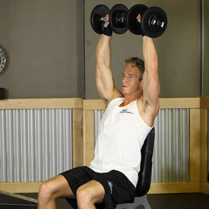

While holding a dumbbell in each hand, sit on a military press bench or utility bench that has back support. Place the dumbbells upright on top of your thighs.

1. Now raise the dumbbells to shoulder height one at a time using your thighs to help propel them up into position.
2. Make sure to rotate your wrists so that the palms of your hands are facing forward. This is your starting position.
3. Now, exhale and push the dumbbells upward until they touch at the top.
4. Then, after a brief pause at the top contracted position, slowly lower the weights back down to the starting position while inhaling.
5. Repeat for the recommended amount of repetitions.

**Variations:** You can perform the exercise standing or sitting on a regular flat bench. For people with lower back problems, the version described is the recommended one.

You can also perform the exercise as Arnold Schwarzenegger used to do it, which is to start holding the dumbbells with a supinated grip (palms facing you) in front of your shoulders and then, as you start pushing up, you align the dumbbells in the starting position described on step 3 by rotating your wrists and touch the dumbbells at the top. As you come down, then you would go back to the starting position by rotating the wrist throughout the lowering portion until the palms of your hands are facing you. This variation is called the Arnold Press. However, it is not recommended if you have rotator cuff problems.

[**UPRIGHT ROW**](javascript:pop('upright-barbell-row'))**(EZ-BAR)**

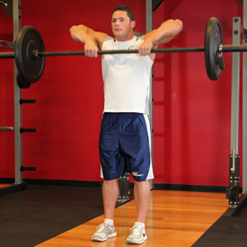

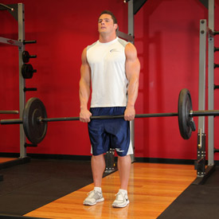

1. Grasp a barbell with an overhand grip that is slightly less than shoulder width. The bar should be resting on the top of your thighs with your arms extended and a slight bend in your elbows. Your back should also be straight. This will be your starting position.
2. Now exhale and use the sides of your shoulders to lift the bar, raising your elbows up and to the side. Keep the bar close to your body as you raise it. Continue to lift the bar until it nearly touches your chin. Tip: Your elbows should drive the motion, and should always be higher than your forearms. Remember to keep your torso stationary and pause for a second at the top of the movement.
3. Lower the bar back down slowly to the starting position. Inhale as you perform this portion of the movement.
4. Repeat for the recommended amount of repetitions.

**Variations:** This exercise can also be performed using a straight bar attached to a low pulley and it can also be performed using dumbbells, though this later exercise should be reserved by people that are well familiarized with correct execution.

#### [BENT-OVER REAR-DELT RAISE](javascript:pop('seated-bent-over-rear-delt-raise'))

#### C:\Users\29\Desktop\377_1.jpg

#### C:\Users\29\Desktop\377_2.jpg

1. Place a couple of dumbbells looking forward in front of a flat bench.
2. Sit on the end of the bench with your legs together and the dumbbells behind your calves.
3. Bend at the waist while keeping the back straight in order to pick up the dumbbells. The palms of your hands should be facing each other as you pick them. This will be your starting position.
4. Keeping your torso forward and stationary, and the arms slightly bent at the elbows, lift the dumbbells straight to the side until both arms are parallel to the floor. Exhale as you lift the weights. (Note: avoid swinging the torso or bringing the arms back as opposed to the side.)
5. After a one second contraction at the top, slowly lower the dumbbells back to the starting position.
6. Repeat for the recommended amount of repetitions.

**Variation:** This exercise can also be performed standing but those with lower back problems are better off performing this seated variety.

#### [LATERAL RAISE](javascript:pop('side-lateral-raise'))

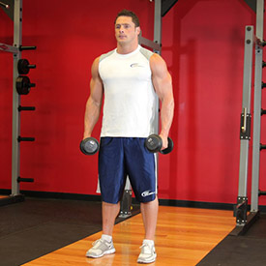

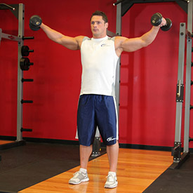

**FRONT BARBELL RAISE**

**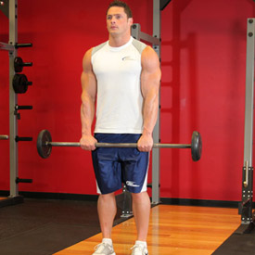**

**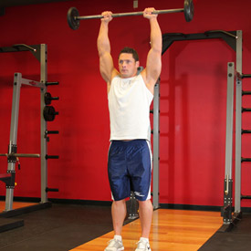**

1. To begin, stand straight with a barbell in your hands. You should grip the bar with palms facing down and a closer than shoulder width grip apart from each other.
2. Your feet should be shoulder width apart from each other. Your elbows should be slightly bent. This is the starting position.
3. Lift the barbell up until it is directly over your head while exhaling. Make sure to keep your elbows slightly bent when performing each repetition.
4. Once you feel the contraction, begin to lower the barbell back down to the starting position as you inhale.
5. Repeat for the recommended amount of repetitions.

**Variations:** This exercise can also be performed with dumbbells in each hand or by using a close or wide grip with the barbell. By alternating the widths of your grip, you will be able to contract different parts of the shoulders for an overall better physique.