***The DETECT model:***

***A model for simulating the transport and production of CO2 in a one-dimensional soil profile***

User Manual

Version 1.01

E. Ryan1, K. Ogle2,3,4, H. Kropp5, K.E. Samuels-Crow2,

Y. Carrillo6 and E. Pendall6

August, 2017

1Lancaster Environment Centre, Lancaster University, Lancaster, UK

2School of Informatics, Computing, and Cyber Systems, Northern Arizona University, Flagstaff, Arizona, USA

3Center for Ecosystem Science and Society, Northern Arizona University, Flagstaff, Arizona, USA

4Department of Biological Sciences, Northern Arizona University, Flagstaff, Arizona, USA

5Department of Geography, Colgate University, Hamilton, NY, USA

6Hawksbury Institute for the Environment, Western Sydney University, NSW, Australia

© 2017 E. Ryan and K. Ogle. All rights reserved.

Table of Contents

|  |  |
| --- | --- |
| **Contents** ………………………………………………………………………………...  **Introduction** ……………………………………………………………………………..  **1. Accessing the Matlab files for running the DETECT model** ………………….......  **2. Running the DETECT model at a grassland site in Wyoming, USA**. ...…………  **3. Running the DETECT at a user specified site**. ….………………………………...  *3.1 Measurements required from the site in order to drive the DETECT model*  *3.2 Using the HYDRUS software to estimate the environmental data for all depths*  *3.3 Creating the .mat file which stores all driving data*  *3.4 Estimating the parameters for the DETECT model*  **4. Plotting the output as time-series of soil respiration and soil CO2** ………………..  **5. Appendix A: Settings used for the HYDRUS software** ….…………………..……..  **References** ….……………………………………………………………………....……. | 3  5  6  7  9  15  17  18 |

Introduction

The Deconvolution of Temporally varying Ecosystem Carbon componenTs (DETECT) model simulates the production and transport of CO2 in a one-dimensional soil profile and over time. The partial differential equation that describes the transport component is solved separately and independently in four ways by partitioning the soil CO2 into four different components: (i) the 13C signature of soil CO2 respired from microbial sources; (ii) the 13C signature of soil CO2 respired from root sources; (iii) the 12C signature of soil CO2 respired from microbial sources; (iv) the 12C signature of soil CO2 respired from root sources. Total soil CO2 concentration is then defined as the sum of the soil CO2 from these four components.

Full details of the model description is contained in Ryan et al. (in review). We will make the paper available along with the model code once it is published. In the meantime, please e-mail [Kiona.Ogle@nau.edu](mailto:Kiona.Ogle@nau.edu) if you would like a copy of the submitted manuscript. The description of the isotopic components, which is not given in Ryan et al. (in review), is provided in the comments of the Matlab code. In particular, please see *Data_6hourly_Creator.m* (lines 144-153) and *DETECTmodel.m* (lines 104-121).

The purpose of this manual is threefold:

1. First, we explain how to run the DETECT model at a grassland site in Wyoming, USA. This field site was used in a field experiment called the Prairie Heating And CO2 Enrichment (PHACE) experiment. Hereafter, we refer to this site as the PHACE site. Running the DETECT model at the PHACE site just requires the user to open the Matlab file *ScriptFile.m* (assuming Matlab is installed) and press the *Run* button. The model will run and predict soil CO2 and concentration for each of the depth and time increments, as well as the respiration of CO2 from the soil’s surface at each time point. Running the model in this way is an excellent way of understanding how it works, and also how easy it is to run.
2. Secondly, we explain how to run the DETECT model at a field site specified by the user. This is more time-consuming to set up because it requires that the user provide various measurements from the field site, such as continuous environmental data at multiple depths (soil water content and soil temperature), meteorological data (e.g. atmospheric pressure) and soil property data. It also requires the user to use the environmental data to estimate soil water content and soil temperature for all depths by their own means or by software such as HYDRUS, the latter of which we explain how to use. Full details are given in section 3 on page 13.
3. Lastly, we provide Matlab files to demonstrate how the model output can used to create time-series of soil CO2 concentration at different depths, and a time-series of the respiration of CO2 from the soil’s surface.
4. Accessing the Matlab Files for running the DETECT model

The files required to run the DETECT model can be found at <http://jan.ucc.nau.edu/ogle-lab/zzz_modelDETECT.html>. Once saved on your computer, the subfolders within the main *DETECT_Model* folder should look like figure 1.

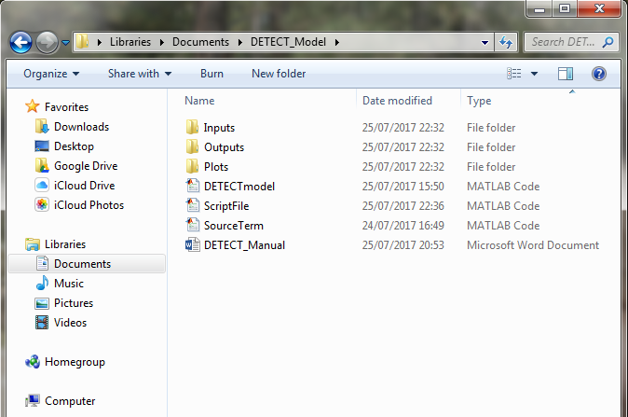

Figure 1. Subfolders of the *DETECT_Model* folder which stores all the files to run the DETECT model.

Within this folder, the Matlab code for running the DETECT model is stored in the three files called *DETECTmodel.m*, *ScriptFile.m* and *SourceTerm.m*. See section 2 for details about how to use these files to run the model.

The **Inputs** subfolder contains six csv files where site and plot level data are stored. These data along with other information are fused into one file, called *PHACEdata_6hourly.mat* file, by running a Matlab script file call *Data_6hourly_Creator.m*. The mat file is what is read into the main Matlab script file (*ScriptFile.m*) from which the DETECT model is run. Section 3 gives more detail about what specific information and site measurements are required to run the DETECT model at a field site other than the PHACE site. Running the model at the PHACE site requires no changes to any of the files in the *Inputs* subfolder.

The **Outputs** subfolder stores the output files resulting from running the DETECT model. Each run produces three output files, and these are called *info_6hourly.mat*, *output_6hourly.mat* and *outCO2_6hourly.mat*. When running the model with parameters corresponding to the antecedent terms (Ryan et al., in review), *_ant* is added to the end of the names of each of the three files. See section 2 for details about all the outputs that are produced and stored within these mat files.

The **Plots** subfolder contains Matlab script files used to create a time series of soil CO2 for multiple depths, and a time-series of the respiration of CO2 from the soil’s surface. See section 4 for details about how to produce these figures.

1. Running the DETECT model at a grassland site in Wyoming, USA.

Running the DETECT model at a grassland site in Wyoming, USA (a.k.a. the PHACE site), is very straightforward and we recommend that all users of the model do this prior to using the model at their own site(s). In order to run the model, please make sure that: (1) Matlab is installed and ready to run on your computer, and (2) the *DETECT_model* folder along with all its subfolders are downloaded from the Ogle lab webpage (see section 1) and saved on your PC or workspace. It does not matter where on your PC or workspace the folder is stored.

Next, open up the *ScriptFile.m*, located within the main *DETECT_model* folder (Figure 2). The purpose of this file is to read in the site data, define the model parameters, run the DETECT model, and to write the output files to the *Outputs* subfolder. The code for the DETECT model is stored in the *DETECTmodel.m* file, which uses the inputs defined in *ScriptFile.m* to: (1) estimate the diffusion of soil CO2 for all depths and times, (2) estimate the production of soil CO2 for all depths and times via another function stored in *SourceTerm.m*, and (3) numerically solve the partial differential equation which describes the transport of soil CO2 for different depths and times (Ryan et al., in review, Eqn. 1).

Please read the comments (green text in Figure 2 and *ScriptFile.m*) prior to running the model. Next scroll down until line 39 is at the top of the window (Figure 3). To run the DETECT model using the antecedent parameterization (Ryan et al., in review), change line 40 to be *running_antecedent_vers=1*.

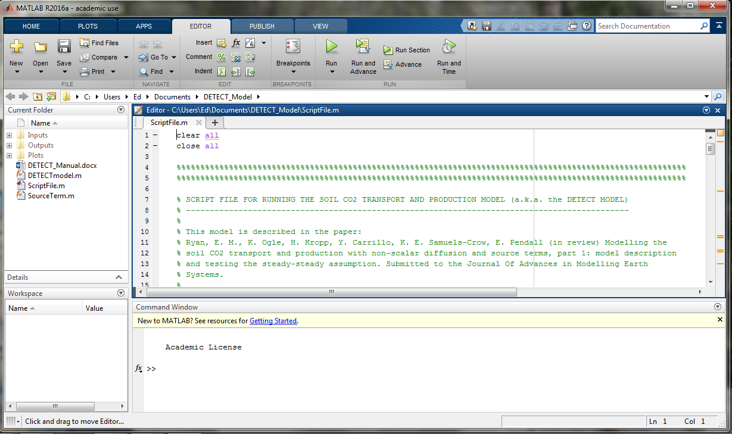

Figure 2. A screenshot of the *ScriptFile.m* file open in Matlab.

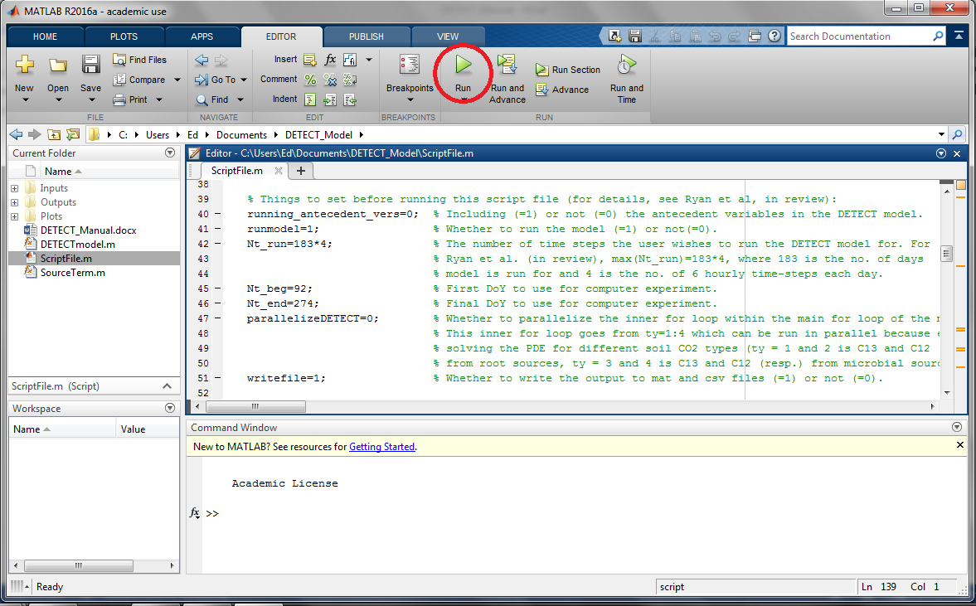

Figure 3. A screenshot of the *ScriptFile.m* file open in Matlab, from line 39.

To run the model for shorter number of time steps such as 10 or 100 (as opposed to the maximum amount of 183×4=732), edit line 42. Other settings on lines 40-51 can be changed if required; see the comments next to each one. Press the *Run* button on the top panel (Figure 3, red circle) after establishing the values for these settings (whether using the original or edited values),. The numbers that you will now see in the command window refer to the completed time-steps. On a PC, running the DETECT model for a 6 month simulation takes 30-40 minutes depending on its processing power. We are working on a parallelized version of the model, which will greatly reduce the computational cost of running the model.

1. Running the DETECT model at a user specified site.

*3.1 Measurements required from the site in order to drive the DETECT model*

First, the user needs to decide over what period the measurements will be collected. In Ryan et al. (in review), we used a period of 183 days which represented April to September of 2008. Variables that are measured continuously over time require temporal gap-filling. Ryan et al. (2015) describes some useful gap-filling strategies. Once the user has collected and gapfilled all of these measurements, the user is required to store them as csv files, using the csv files currently in the *Inputs* subfolder as templates.

The following continuous measurements are required in order to run DETECT at a user-specified site:

* Volumetric soil water content (θ, m2/m2) for at least one depth (but preferably two or three depths) at 6 hourly intervals. If measurements at 6 hourly intervals are not possible, then the daily time-step is adequate.
* Soil temperature (Ts, °C), at least one depth (preferably two or three depths) at 6 hourly intervals. We do not recommend using daily measurements since soil temperature can vary significantly throughout the day.
* Atmospheric pressure (P, kPa).
* Vegetation greenness (Gness, %). Gness is measured by taking aerial photographs of the plot at regular time intervals and then using an inbuilt Matlab function to quantify the greenness of the vegetation. For specific details, please see Zelikova et al. (2015). For the PHACE site, we used Gness as a proxy for how root C changes over time. If measurements of Gness are unavailable, then a different way of simulating the temporal

changes in root C, but this would require the user to edit the *SourceTerm.m* file.

* The atmospheric CO2 concentration for the site (ppm).

The following measurements are also required to run DETECT. These are assumed to be fixed over time but vary by depth:

* The initial soil CO2 concentration (mg CO2 m-3). For the PHACE site, we estimated these by running the DETECT model between 1st April 2007 and 31st March, 2008 and taking the soil CO2 concentration predicted on the final day as the initial conditions for this run which began on 1st April, 2008.
* The parameters required to estimate soil water potential (SWP), where SWP is then used to estimate the diffusivity of soil CO2 at different depths. These parameters are soil bulk density (BD, g cm-3), the *b* parameter from the Moldrup function (Ryan et al., in review, Table 1) and θ at a soil water potential of -100 cmH20 (θ100, m2/m2). For the PHACE site, we assumed that all of these three parameters remained unchanged with depth, but the user has the option of varying them.

The following measurements are also required to run DETECT, however these are assumed to be fixed over both time and depth:

* Parameter values for the Gamma and Exponential functions which are used simulate the distribution by depth of microbial carbon (C), root C, and soil organic C. The values of these parameters can be obtained by comparing different distributions (by trial and improvement) with measurements of root C, microbial C and soil organic C from a handful of depths. Matlab code to do this comparison is given in lines 183 – 238 of the *Data_6hourly_Creator.m* file, and the resulting plot is given in figure 4.
* The 13C signatures of CO2 respired by roots and microbes.

The time steps (t, hours) and depth increments and (z, metres). For the PHACE site, these were 6 hours and 0.01m. The user can user a smaller resolution for both of these, but this will mean that all of the dataset dimension of the driving data that vary by depth and/or time will need to be increased. Due to inaccuracies in the numerical solutions of the partial differential equations at the heart of the DETECT model, we strongly recommend that time and depth increments are not greater than 6 hours and 0.01m.

*3.2 Using the HYDRUS software to estimate the environmental data for all depths*

For the PHACE site, the HYDRUS software was used to estimate θ and Ts at all depths

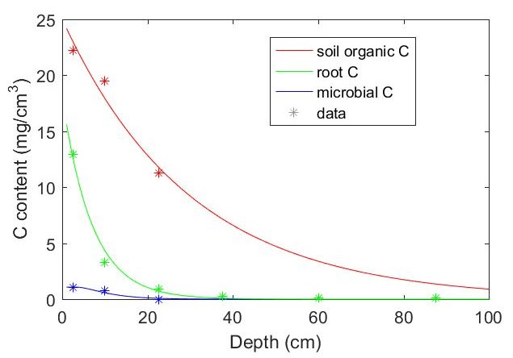

Figure 4: The predicted and observed distribution by depth of soil organic C, root C and microbial C.

(for further details, see Ryan et al., in review). The parameters used in the HYDRUS software were chosen based on the measurements of θ and Ts at multiple depths.

*HYDRUS Components*

For the PHACE site, we used HYDRUS to simultaneously model heat transport, root water uptake, and water flow that included vapor flow and snow hydrology from March 1, 2007 until July 30, 2013. The model was set up to include an atmospheric boundary layer condition and free drainage as the lower boundary layer. We assumed free drainage was appropriate since we were only interested in soil water above 1 meter and lack information for greater depths. Snow layer and sublimation constants were set to the default values provided by HYDRUS. Heat transport parameters were fit using inverse modelling from the two depths of 3cm and 10cm to estimate parameters for the Chung and Horten model. The upper boundary condition for Ts was set to the air temperature data collected 10cm above the soil. The lower boundary condition for Ts was set to a zero gradient, consistent with the free drainage assumption in the model.

*Root Water Uptake and Transpiration*

The S shaped root water stress model was used at the PHACE site. This uses a parameter

that estimates the pressure head at which root water uptake is reduced by 50%. We did a literature search for water potential and hydraulic conductance of shortgrass steppe plants. Most papers involving water potential data focused on blue gramma, with Sala et al (1981) showing that blue gramma leaf conductance was half of the maximum observed conductance at approximately a water potential of -3.5MPa. We therefore set the parameter to -35,000 cm. Total living fractional surface cover for all species was incorporated into growth tables for transpiration, and surface faction cover was converted to leaf area index by HYDRUS. Root distributions were set up using the Feddes function in HYDRUS and considered to root to depths of 45cm. Crop height was set to 30cm. The option for including interception was according to the Von Hoyningen Hune model; this requires an interception constant which – for shortgrass steppe – we could not find estimates for. As a result, we did not include interception for these initial estimates. The Penman Montieth equation was used to calculate potential evapotranspiration.

*3.3 Creating the .mat file that stores all driving data*

Once the data required to drive the DETECT model are stored as csv files in the same format as the csv files currently in the *Inputs* subfolder, open the Matlab script file called *Data_6hourly_Creator.m* which is also stored in the *Inputs* subfolder (Figure 5). This creates the mat file that stores all the environmental, meteorological and other site data required to drive the DETECT model. For the PHACE site, this is called *PHACEdata_6hourly.mat*. In particular, the *Data_6hourly_Creator.m* does the following:

* Converts continuous measurements given on the daily time-step to the 6 hourly time-step.
* Computes the antecedent θ datasets (θRant, θMant) and antecedent Ts dataset (Tsant ). See Ryan et al. (in review) for details on how these antecedent datasets are computed.
* Creates vectors of the relative depth-dependent distribution of microbial C, root C, and soil organic C. Gamma and Exponential functions are used to simulate these distributions, with the parameters of these functions determined by comparing different predicted distributions with measurements of microbial C, root C and soil organic C at a number of depths. We provide Matlab script at the end of *Data_6hourly_Creator.m* to enable the user to estimate the parameters of these Gamma and Exponential functions.
* Gives the user-specified values of the 13C isotopic signatures of root and microbial respired CO2 (lines 159-160). We assume that these isotopic values do not vary with depth. If unknown at the user-specified site, use the default values provided.

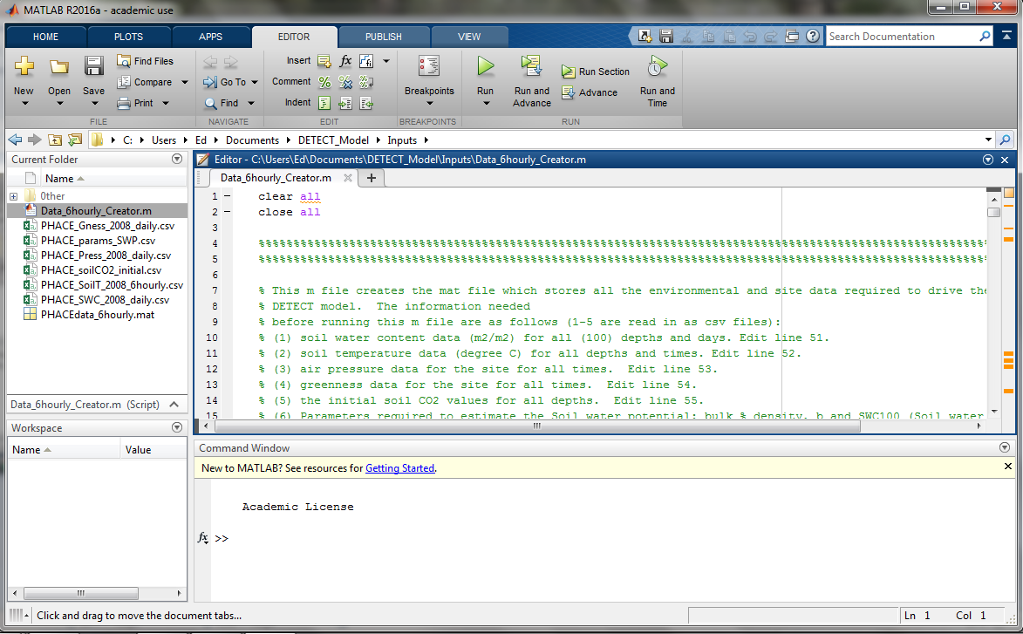

Figure 5. A screenshot of the *Data_6hourly_Creator.m* file open in Matlab.

Lines 30-37 of the *Data_6hourly_Creator.m* contain eightvalues the user must set before running this script file (Figure 6). The comments in this script file explain what each setting is. For example *write_file = 0* would be used if for example the user was working out what parameter values to use for the Gamma and Exponential functions to represent the distribution of microbial C, root C and soil organic C (in this case *Xrel_params* would also be set to 1). This allows the user flexibility to estimate these parameters by trial and improvement without writing the datasets as a *mat* file. Once all the datasets and values that need to be specified are correct, the user can change *write_file* =from 0 to 1*.*

*3.4 Estimating the parameters for the DETECT model*

The main Matlab script file for the DETECT model (*ScriptFile.m*) contains estimates of the 20 model parameters based on the PHACE site. Running the model at a different field site may require different values of these parameters. We recommend first focusing on the 15 parameters that correspond to the non-antecedent version of DETECT. We propose the following strategy for estimating these parameters:

* *Tau* (parameter 20): *Tau* refers to the temperature for which the base respiration rates correspond to it. For the PHACE site, we used 10°C., but the user should change this value as necessary.

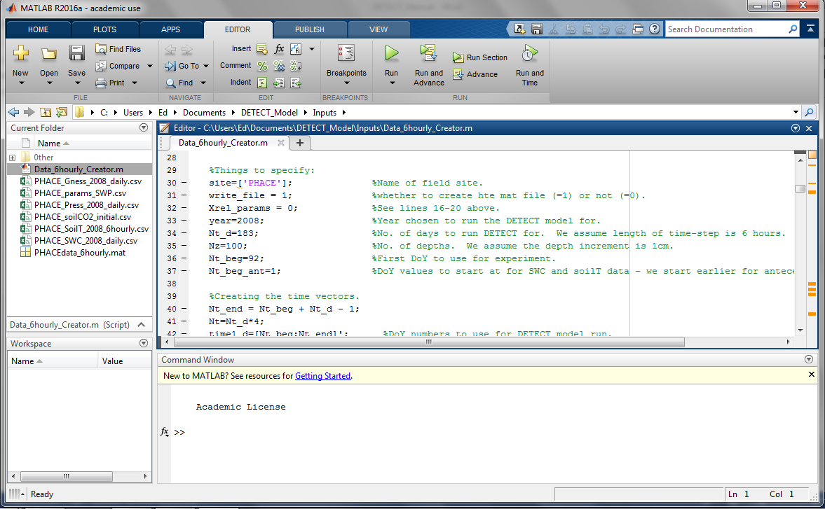

Figure 6. A screenshot of the *Data_6hourly_Creator.m* file open in Matlab from line 29.

* *Solfrac*, *Dliq* and *To* (parameters 14, 15 and 18): These parameters were taken from the literature and treated as being site invariant. We recommend using the given values.
* M*, C* and R* (parameters 1, 6 and 7): These parameters represent the total microbial C, root C and soil organic C over the entire soil profile (i.e. 0-100 cm). For the PHACE site, we estimated them by adding up the predicted values of microbial C, root C and soil organic C between the surface and a depth of 100cm (Figure 4).
* *RrBase*, *RmBase, Km* and *CUE*  (parameters 2, 8, 12 and 13): These were estimated from measurements made at the site or a nearby site (Ryan et al., in review; Ryan et al., 2015; Tucker et al., 2013)
* *α1(R)*, *α1(M)* *Eo(R) and Eo(M)* (parameters 3, 9, 16 and 17): These represent the response of soil respiration at different depths to changes in θ and Ts. We estimated these using a parameter estimates of a model that was used to predict ecosystem respiration at the PHACE site (Ryan et al., 2015).

The antecedent parameters (*α2(R)*, *α3(R)*, *α2(M)*, *α3(M)*, and *α4*) are more challenging to estimate. We estimated these using a parameter estimates of a model that was used to predict ecosystem respiration at the PHACE site (Ryan et al., 2015). However, these parameters may require tuning either informally (trial and improvement) or formally (e.g. non-linear regression).

1. Plotting the output as time-series of soil respiration and soil CO2

To plot soil respiration (Rsoil) over time, there are two options for using *Rsoil_timeseries.m.* To use the non-antecedent parameterizations of DETECT we set Ns=1 (Figures 7, 8). Setting Ns=2 to plot the time-series for both the non-antecedent and antecedent parameterizations (Figures 7, 9). Finally, figure 10 shows the time-series of the predicted versus measured soil CO2 concentration for three different depths (see caption).

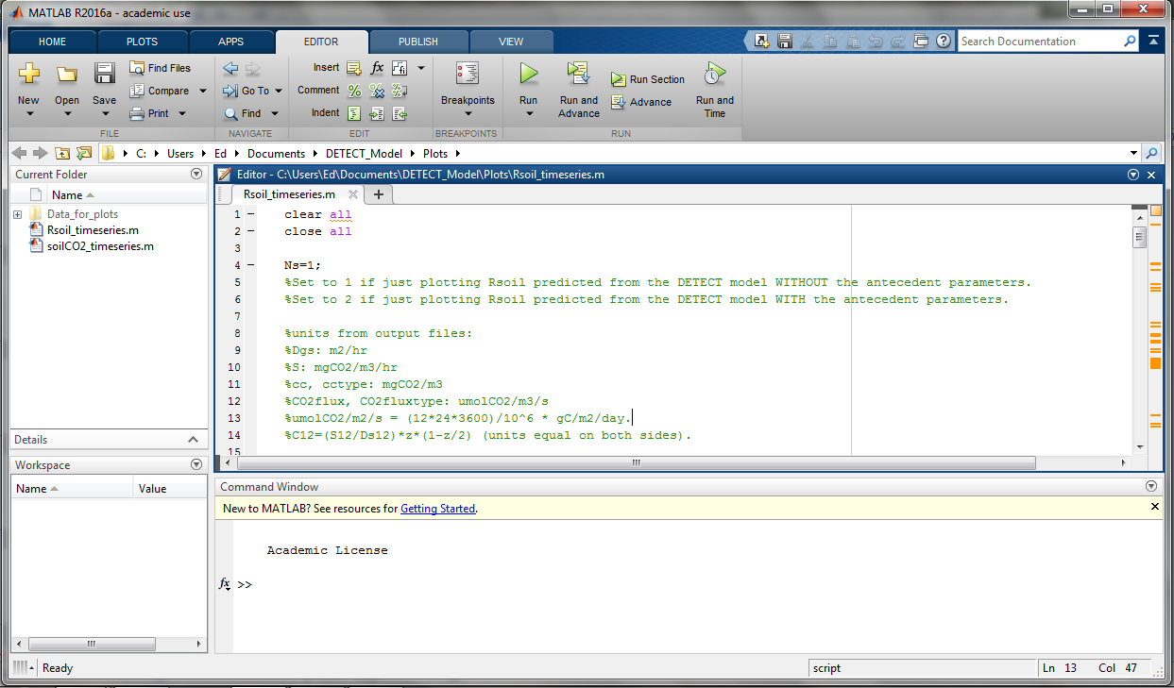

Figure 7 A screenshot of the *Rsoil_timeseries.m* file opened in Matlab.

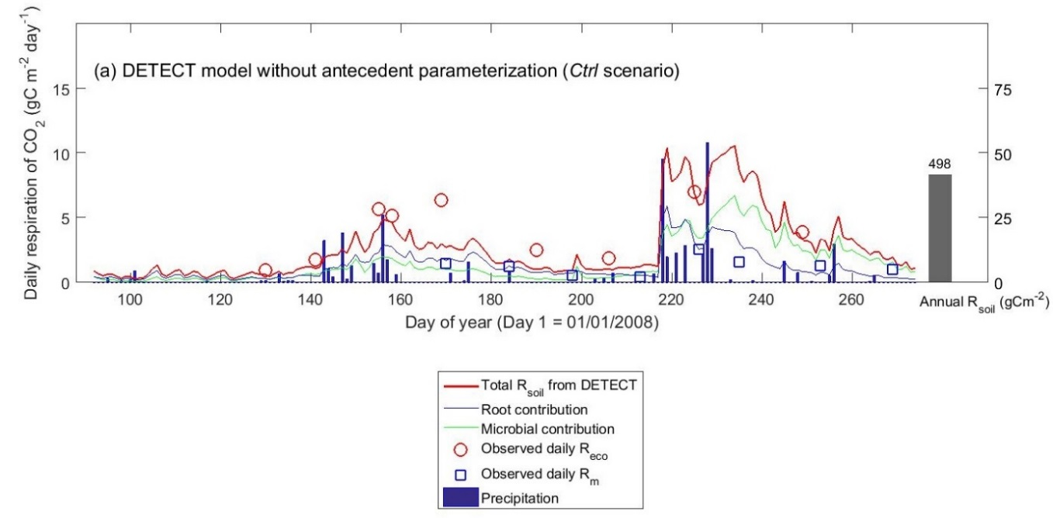

Figure 8. Time-series of predicted Rsoil and its root and microbial contributions (1st April – 30th September), using the non-antecedent parametrization of DETECT

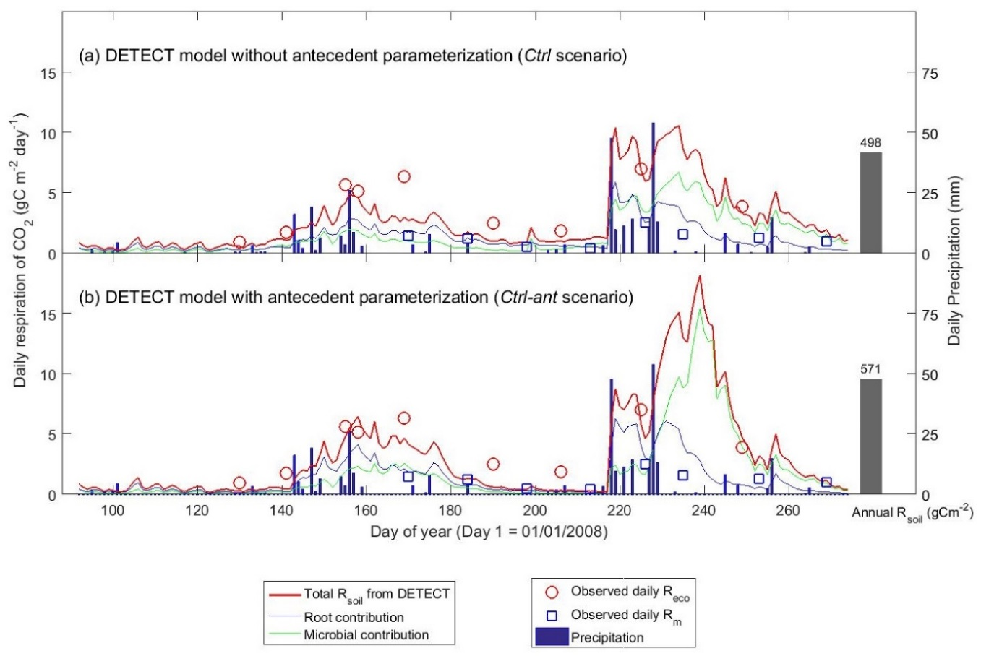

Figure 9. Time-series of predicted Rsoil and its root and microbial contributions using the non-antecedent (panel a) and antecedent (panel b) parametrizations of the DETECT model.

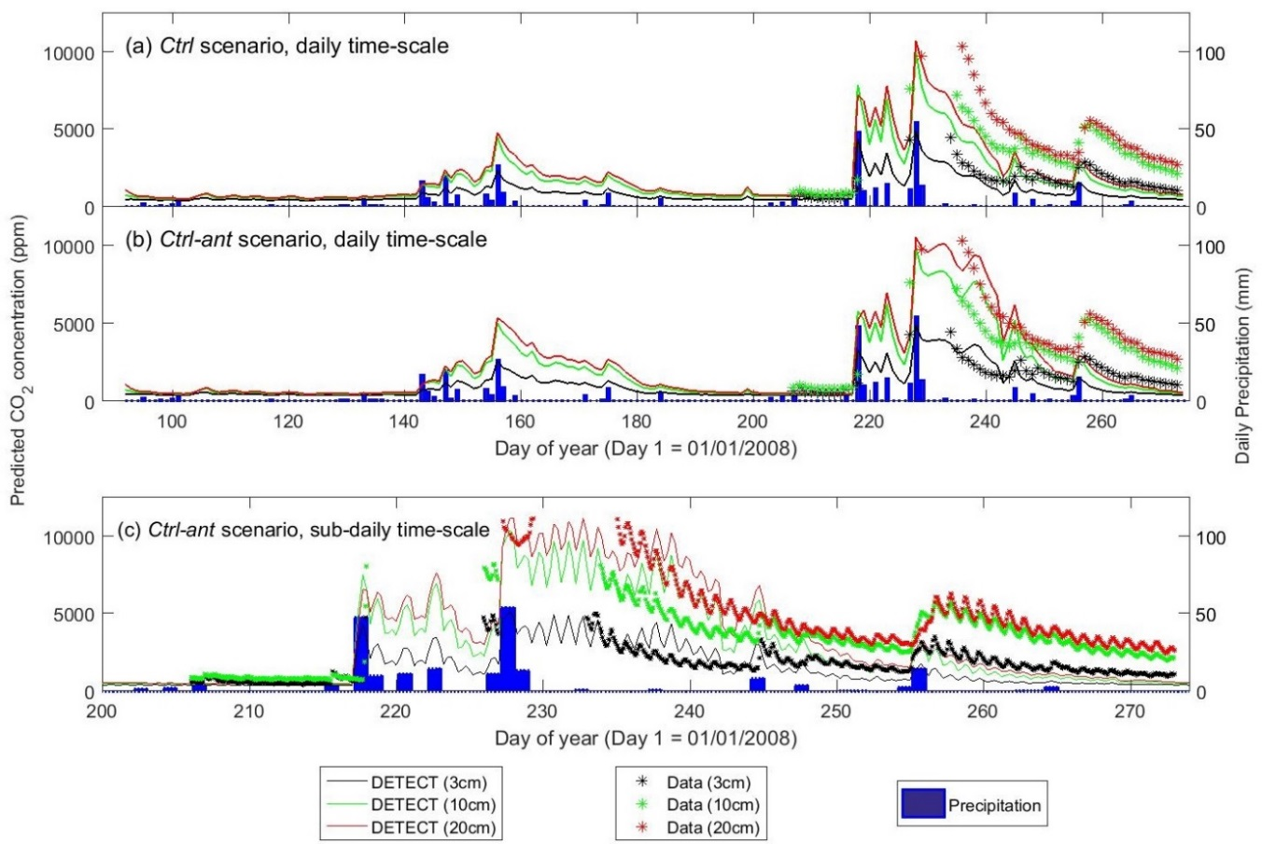

Figure 10. Time-series of predicted versus observed soil CO2 concentrations ([CO2], ppm) at depths 3 cm, 10 cm, and 20 cm. This is shown at the daily (panels a and b, with and without antecedent terms in DETECT, respectively), and 6-hourly (panel c) time-scales.

1. Appendix A: settings used in the HYDRUS software

*Main Processes*

1. Water flow Simulated
   1. Vapor flow **on**
   2. Snow hydrology? –**on**
2. Inverse Solution **off**
3. Heat Transport **on**
4. Root Water Uptake **off**

*Geometry Information*

1. Only 1 soil material
2. 1 layer for mass balance
3. Vertical
4. 100 depth of soil profile cm

*Time Information*

1. Days
2. Interval 0-2313
3. Time variable boundary conditions 2313
4. Meteorological data-Pennman-Monteith

*Water flow-Hydraulic properties*

1. Set based on Rosetta calculations with no inverse (exp base 10)
2. Qr: .03
3. Qs: 0.28
4. A=.005
5. N=1.57
6. Ks=12.5
7. Left l at .5

*Boundary Conditions (BC)*

1. Atmospheric BC with surface layer
2. Free Drainage
3. In water contents

*Heat Transport Parameters*

1. Solid=.79
2. Org=0
3. Disp=2
4. b1=1.38E+016
5. b2=3.711E+013
6. Temperature Amplitude –set to zero since I have detailed temperatures during the day
7. Interval for one temp cycle 1

*Heat Transport Boundary Conditions*

1. Upper-Temperature BC-set to measurements 10cm above soil
2. Lower-Temperature BC- zero gradient
3. Snow parameters left as default

*Variable Boundary Conditions*

1. Entered Precipitation combined data in cm from csv file storing the precipitation data.
2. Set Hcrit at 100000

*Meterological parameters*

1. Set radiation to Net Radiation and read in average daily radiation
2. Measurement Height: Wind-225cm Temp-130
3. Specified relative humidity.

References

Ryan, E., Ogle, K., Kropp, H., Samuels-Crow, K., Carrillo, Y., and Pendall, E.: Modelling soil CO2 production and transport with dynamic source and diffusion terms: Testing the steady-state assumption using DETECT v1.0, Geoscientific Model Development, in review.

Ryan, E. M., Ogle, K., Zelikova, T. J., LeCain, D. R., Williams, D. G., Morgan, J. A., and Pendall, E.: Antecedent moisture and temperature conditions modulate the response of ecosystem respiration to elevated CO2 and warming, Global Change Biology, 2015.

Sala, O. E., Lauenroth, W., Parton, W., and Trlica, M.: Water status of soil and vegetation in a shortgrass steppe, Oecologia, 48, 327-331, 1981.

Tucker, C. L., Bell, J., Pendall, E., and Ogle, K.: Does declining carbon‐use efficiency explain thermal acclimation of soil respiration with warming?, Global Change Biology, 19, 252-263, 2013.

Zelikova, T. J., Williams, D. G., Hoenigman, R., Blumenthal, D. M., Morgan, J. A., and Pendall, E.: Seasonality of soil moisture mediates responses of ecosystem phenology to elevated CO2 and warming in a semi‐arid grassland, Journal of Ecology, 103, 1119-1130, 2015.