**Ex 9 :**

**ListofPlayers.js**

import React from 'react';

const ListofPlayers = () => {

const players = [

{ name: 'Dhawan', score: 60 },

{ name: 'Shreyas', score: 95 },

{ name: 'Pant', score: 35 },

{ name: 'Kishan', score: 82 },

{ name: 'Sanju', score: 40 },

{ name: 'Washington', score: 78 },

{ name: 'Axar', score: 90 },

{ name: 'Ashwin', score: 55 },

{ name: 'Chahal', score: 33 },

{ name: 'Arshdeep', score: 68 },

{ name: 'Thakur', score: 74 },

];

const underPerformers = players.filter(p => p.score < 70);

return (

<div>

<h2>Team Lineup</h2>

<ul>

{players.map((p, index) => (

<li key={index}>{p.name} - {p.score} runs</li>

))}

</ul>

<h3>Underperformers (Below 70)</h3>

<ul>

{underPerformers.map((p, index) => (

<li key={index}>{p.name} - {p.score} runs</li>

))}

</ul>

</div>

);

};

export default ListofPlayers;

**IndianPlayers.js**

import React from 'react';

const IndianPlayers = () => {

const oddTeam = ['Dhawan', 'Pant', 'Washington', 'Ashwin', 'Thakur'];

const evenTeam = ['Shreyas', 'Kishan', 'Sanju', 'Axar', 'Chahal', 'Arshdeep'];

const [skipper, deputy, ...rest] = evenTeam;

const t20List = ['Tilak Varma', 'Jitesh Sharma', 'Ravi Bishnoi'];

const ranjiList = ['Rahane', 'Pujara', 'Manoj Tiwary'];

const combinedSquad = [...t20List, ...ranjiList];

return (

<div>

<h2>Odd Team Members</h2>

<p>{oddTeam.join(', ')}</p>

<h2>Even Team Roles</h2>

<p>Skipper: {skipper}</p>

<p>Deputy: {deputy}</p>

<p>Rest: {rest.join(', ')}</p>

<h2>Combined T20 & Ranji Players</h2>

<ul>

{combinedSquad.map((player, idx) => (

<li key={idx}>{player}</li>

))}

</ul>

</div>

);

};

export default IndianPlayers;

**App.js**

import React from 'react';

import ListofPlayers from './ListofPlayers';

import IndianPlayers from './IndianPlayers';

function App() {

const flag = false;

return (

<div style={{ padding: '2rem' }}>

<h1>Cricket Player Stats Dashboard</h1>

{flag ? <ListofPlayers /> : <IndianPlayers />}

</div>

);

}

export default App;

**Output :**

**Flag = true**

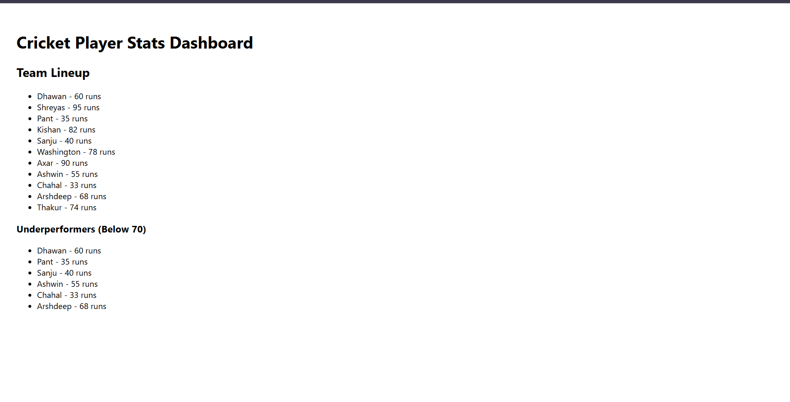

**Flag = false**

