Architecture Document
Low-Field MRI Enhancement Pipeline
This document describes the technical architecture of our MRI enhancement system. The pipeline takes high-field MRI scans, simulates what they would look like on a low-field scanner, and then applies a series of image processing techniques to recover the lost quality. The goal is to make low-cost MRI scanners produce images closer to expensive high-field machines.

1. Application

1.1 Architecture Type
We use a monolithic batch processing architecture. This means the entire pipeline runs as a single Python program that processes patient volumes one after another. We chose this approach because medical image processing needs to be deterministic and reproducible — every time you run it on the same data, you should get the exact same result. A distributed or microservices setup would add unnecessary complexity for this use case.

1.2 Key Design Decisions
- Sequential stage processing — each stage feeds directly into the next, making it easy to debug and verify intermediate results
- File-based I/O using NIfTI format (.nii.gz) at each stage boundary, so intermediate results can be inspected independently
- Batch orchestration — the system processes 92+ patient volumes without requiring any manual intervention
- Safety guards built into the final stage to prevent the enhancement from producing unrealistic results

1.3 End-to-End Architecture
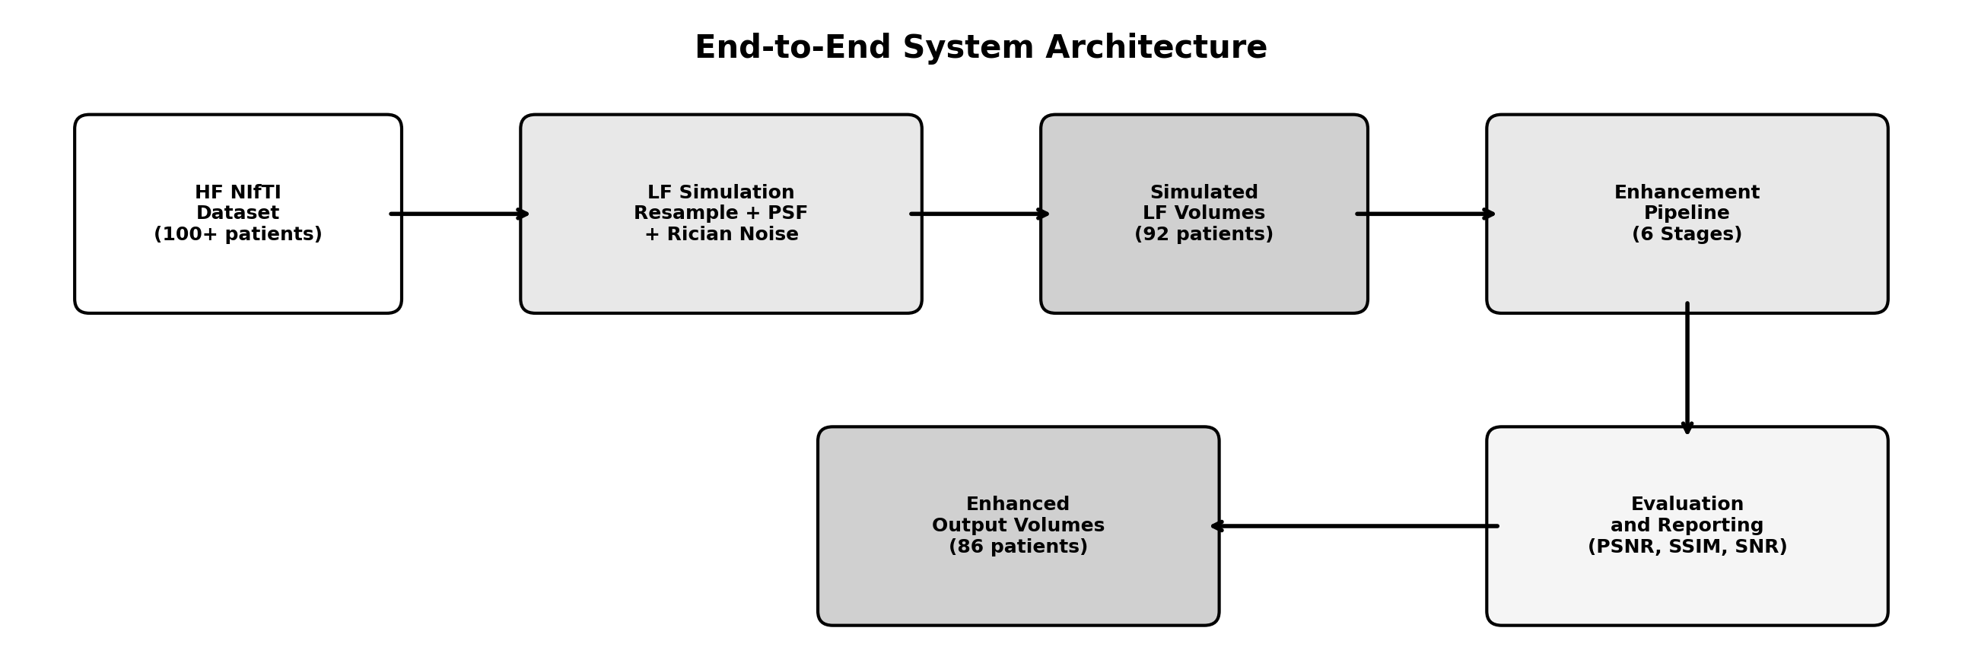

2. Low-Field Simulation Module
Before we can enhance low-field images, we need a dataset to work with. Since paired real low-field and high-field scans of the same patient are very hard to obtain, we simulate the low-field data from high-field source scans. The simulation follows well-established MRI physics to ensure the degraded images are realistic.

2.1 Simulation Architecture
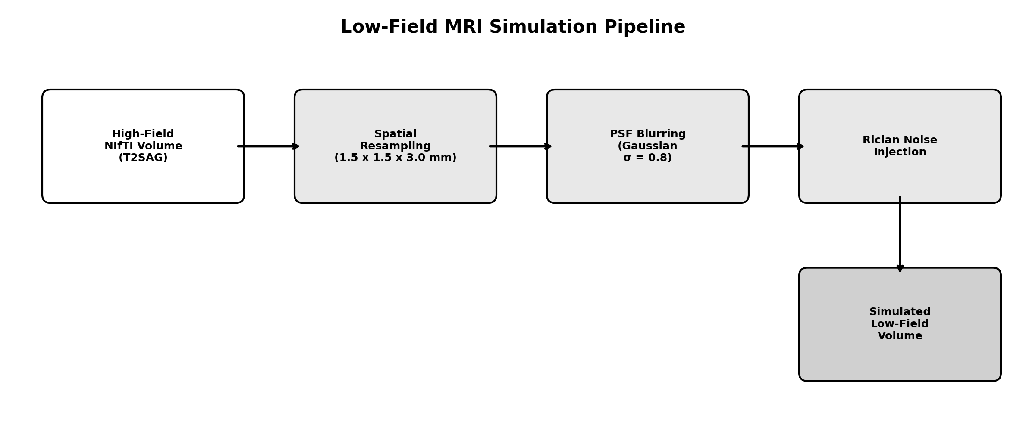

2.2 How It Works
The simulation has three main steps. First, we downsample the high-resolution volume to a coarser voxel grid (1.5 x 1.5 x 3.0 mm) to mimic the lower spatial resolution of budget scanners. Then we apply a Gaussian point spread function with sigma 0.8 to simulate the inherent blurring in low-field acquisitions. Finally, we inject Rician noise — the specific type of noise that occurs in MRI — calibrated so the resulting signal-to-noise ratio is roughly 25 to 40 percent of the original high-field value.

2.3 Dataset
- We started with over 100 high-field T2-weighted sagittal NIfTI volumes. The simulation script processed 92 of these successfully. The remaining volumes were skipped because they were in 2D or 4D format rather than the expected 3D format.

3. Enhancement Pipeline Module
This is the core of the project. The enhancement pipeline takes a noisy, blurry low-field volume and applies six processing stages to improve its diagnostic quality. Each stage is carefully tuned to avoid introducing artificial patterns or noise.

3.1 Enhancement Architecture
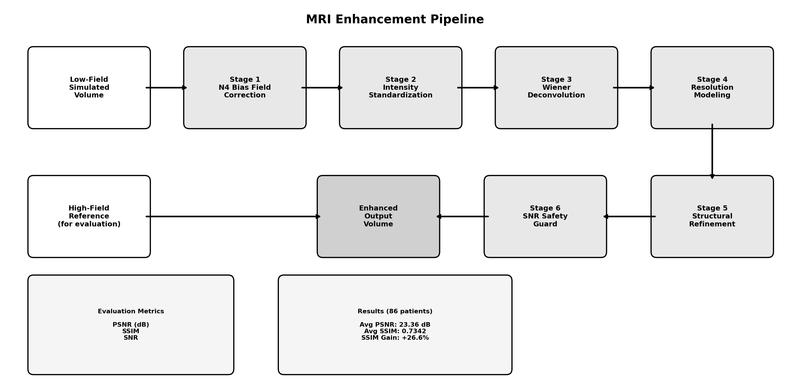

3.2 Processing Stages
Stage | What It Does | Technical Details
1. N4 Bias Correction | Removes the uneven brightness that occurs across the image due to magnetic field inhomogeneity | SimpleITK N4BiasFieldCorrection with iteration schedule [30, 30, 20, 10]
2. Intensity Standardization | Normalizes the intensity range so all volumes have comparable brightness levels | Percentile clipping at 2nd and 98th percentile, then mean-intensity matching to HF reference
3. Wiener Deconvolution | The main denoising step — removes noise while trying to sharpen edges | Slice-wise Wiener filter with 9x9 PSF kernel, sigma 0.8, balance factor 0.4
4. Resolution Modeling | Blends sharp and slightly smoothed versions of the image for a natural look | Gaussian smoothing with sigma [0.2, 0.2, 0.6], blended at 85/15 ratio
5. Structural Refinement | Adds subtle edge sharpening to bring out anatomical boundaries | Unsharp masking with alpha 0.1 and sigma 0.5
6. SNR Safety Guard | Prevents the enhancement from producing unrealistic results | Clamps output SNR to 70-90 percent of the high-field reference

4. Evaluation and Reporting
Every enhanced volume is compared against the high-field ground truth to measure how much quality we recovered. The high-field reference is first resampled to match the low-field voxel grid, so we are comparing images at the same resolution.

4.1 Metrics
Metric | What It Measures
PSNR (Peak Signal-to-Noise Ratio) | How close the pixel values are to the reference, measured in decibels. Higher is better.
SSIM (Structural Similarity Index) | How well the structural patterns (edges, textures, shapes) are preserved. Ranges from 0 to 1, where 1 is perfect.
SNR (Signal-to-Noise Ratio) | The ratio of meaningful signal to background noise within the image itself.

4.2 Results
Stage | Average PSNR | Average SSIM
HF Original (Reference) | Reference | 1.0000
LF Simulated (Input) | 23.64 dB | 0.5801
Enhanced (Output) | 23.36 dB | 0.7342
The SSIM improved by 26.6 percent on average, which means the enhancement pipeline successfully recovered a significant amount of structural detail that was lost during the simulation. The PSNR stayed roughly the same, which is expected since our pipeline focuses on structural improvement rather than pixel-level reconstruction.

5. Technology Stack
Component | Technology
Language | Python 3.13
Medical Image I/O | NiBabel and SimpleITK
Image Processing | scikit-image (Wiener deconvolution), SciPy (Gaussian filtering)
Bias Correction | SimpleITK N4BiasFieldCorrectionImageFilter
Visualization | Matplotlib and Seaborn

6. Data Flow

6.1 File Formats and Naming
- All volumes are stored as compressed NIfTI (.nii.gz)
- High-field source: {PatientID}_T2SAG.nii.gz
- Simulated low-field: {PatientID}_LF.nii.gz
- Enhanced output: {PatientID}_enhanced.nii.gz

6.2 Directory Layout
D:\01_MRI_Data\nifti_output\
high_field_nifti\ (source HF volumes)
low_field_simulated\ (simulated LF volumes)
D:\lowfieldPipeline\
outputs\ (enhanced volumes)
report.txt (filtered metrics)
report2.txt (comparative PSNR/SSIM)
final_batch_report.txt (full batch report)

