Serverless Regime Shift Detection System with Automated CI/CD Pipeline

A MINI PROJECT REPORT

Submitted by

SARUKESHWAR S [RA2311003011470]
DEV VIKNESH AD [RA2311003011472]

Under the guidance of

Dr. S. Sivasakthiselvan
(Associate Professor, Department of Computing Technologies)

In partial satisfaction of the requirements for the degree of

BACHELOR OF TECHNOLOGY
in

COMPUTER SCIENCE & ENGINEERING



SCHOOL OF COMPUTING
COLLEGE OF ENGINEERING AND TECHNOLOGY SRM INSTITUTE OF SCIENCE AND TECHNOLOGY KATTANKULATHUR - 603203
MAY 2023


COLLEGE OF ENGINEERING & TECHNOLOGY SRM INSTITUTE OF SCIENCE & TECHNOLOGY
S.R.M. NAGAR, KATTANKULATHUR – 603 203

BONAFIDE CERTIFICATE

Certified that this project report “Secure and Scalable solution to Deploy a Web Application on AWS Elastic Container Service” is the bonafide work of “ Afraz Tanvir (RA2011003010499), Suyash Joshi (RA2011003010508), Basit Hasan
(RA2011003010532)” of III Year/VI Sem B.tech(CSE) who carried out the mini project work under my supervision for the course 18CSE316J - Essentials in Cloud and Devops in SRM Institute of Science and Technology during the academic year 2022-2023(Even sem).

SIGNATURE

Dr. S. Sivasakthiselvan
Assistant Professor, Department of Computing Technologies
School of computing

ABSTRACT
Financial markets generate vast amounts of time-series data where underlying statistical properties change abruptly, known as regime shifts. Detecting these shifts in real-time is critical for algorithmic trading.

The project develops a Python ingestion engine connecting to Binance WebSockets to stream cryptocurrency data. Advanced algorithms like PELT and ADWIN identify mathematical anomalies.

An ultra-fast Redis datastore acts as a hot layer, while MongoDB serves as a permanent cold layer. A Next.js frontend polls the API to display live states.

To handle continuous delivery, the architecture is containerized using Docker and deployed onto an AWS EC2 instance. This guarantees scalability.

Finally, a Jenkins CI/CD pipeline automates deployment. Any code pushed to GitHub is automatically fetched, built, and deployed to production within seconds.

Overall, this project demonstrates the integration of machine learning models with modern DevOps practices, resulting in a highly robust financial platform.

TABLE OF CONTENTS

Chapter No. | Title | Page No.
 | ABSTRACT | iii
 | TABLE OF CONTENTS | iv
 | LIST OF FIGURES | vi
 | LIST OF TABLES | vii
 | ABBREVIATIONS | viii
1 | INTRODUCTION | 1
1.1 | Aim | 1
1.2 | Background | 1
1.3 | Context of the Project | 1
1.4 | Objectives and goals | 2
1.5 | Project Scope and Limitations | 2
2 | LITERATURE SURVEY | 3
2.1 | Overview of AWS Elastic Container Service | 3
2.2 | Overview of Docker containerization | 3
2.3 | Introduction to Amazon MongoDB | 4
2.4 | Importance of Terraform in infrastructure as code | 4
3 | SYSTEM DESIGN AND METHODOLOGY | 5
3.1 | System Requirements and Specifications | 5
3.2 | Tools and technologies used | 5
3.3 | System Architecture and Components | 7
3.4 | Methodology used in System Development | 9
4 | CONFIGURATION AND DEPLOYMENT PLAN | 11
4.1 | Dockerize the Application | 11
4.2 | Creating an image repo on AWS MongoDB and pushing image | 12
4.3 | Creating an AWS EC2 Cluster | 14
4.4 | Creating an AWS EC2 Task | 15
4.5 | Creating an AWS EC2 Service | 16
4.6 | Creating a Load Balancer | 18
5 | RESULTS AND DISCUSSIONS | 22
5.1 | Project Outcomes | 22
5.2 | Resultants Benefits | 23
5.3 | Analyzing Performance Metrics | 24
5.4 | Controlling Flow of network traffic through VPC | 26
5.5 | Manual Scaling of Applications | 27
5.6 | Metric Analysis | 29

6 |  | CONCLUSION AND RECOMMENDATIONS | 30
 | 6.1 | Security Measures Implemented | 30
 | 6.2 | Project Findings | 33
 | 6.3 | Future Addons/Improvements | 34
 |  | REFERENCES | 35

LIST OF TABLES

Table No. Table Name Page No.

ABBREVIATIONS

CHAPTER 1

Aim

The aim of this project is to develop a serverless, real-time regime shift detection platform for financial markets and deploy it using an automated Jenkins CI/CD pipeline on AWS EC2.

Background

Financial markets are highly volatile, and understanding when market conditions fundamentally change is crucial. Deploying complex streaming systems manually is error-prone, necessitating automated DevOps practices.

Context of the Project

This project bridges the gap between quantitative finance and modern cloud infrastructure. It provides a full-stack solution that detects mathematical anomalies and features a fully automated deployment pipeline.

Objectives and Goals

Project scope and limitations

CHAPTER 2

Overview of Regime Shift Detection and its benefits:

Regime shift detection involves identifying abrupt changes in the statistical properties of a time series.
    - This is particularly relevant in finance, where markets switch between bull, bear, and sideways regimes.
    - Early detection allows for dynamic asset allocation and risk mitigation.
    - Our system leverages advanced time-series analysis to process high-frequency tick data with sub-second latency.
    - This provides traders with actionable insights faster than traditional batch processing.

Overview of Docker containerization and its advantages

Docker is an open-source platform that provides a standardized way to package applications.
    - Portability: Docker containers can be run on any platform that supports Docker.
    - Consistency: Docker containers provide a consistent runtime environment.
    - Resource efficiency: Containers are lightweight and share the host OS kernel.
    - Speed: Containers start and stop quickly, enabling rapid deployment.

Introduction to PELT and ADWIN Algorithms

PELT (Pruned Exact Linear Time) is used for retrospective change point detection, offering mathematical guarantees on optimal segmentations.
    - ADWIN (Adaptive Windowing) is a streaming algorithm designed to detect drift in real-time data streams without requiring a fixed window size.
    - Integration: Combining these provides both macro-regime and micro-volatility detection.
    - Performance: Optimized to process high-frequency tick data.
    - Accuracy: Minimizes false positives in noisy financial datasets.

Importance of Jenkins in CI/CD Automation

Jenkins is an open-source automation server that enables developers to build, test, and deploy software reliably.
    - Automation: Automatically triggers builds based on version control commits.
    - Speed: Drastically reduces deployment time from minutes to seconds.
    - Reliability: Removes human error from the deployment process.
    - Integration: Easily hooks into Docker and AWS EC2 via SSH.

CHAPTER 3

System Requirements and Specifications

To deploy the Regime Shift Detection Platform, specific hardware and software configurations are required.

Tools and Technologies Used
The platform leverages a modern tech stack to ensure high performance and reliability.

Docker

Redis and MongoDB

Redis serves as an ultra-fast in-memory hot layer, while MongoDB acts as the cold layer for permanent logging.

Jenkins

Jenkins handles the CI/CD orchestration, ensuring continuous deployment of code updates.

Next.js and Python

Python powers the backend ingestion engine, while Next.js powers the interactive frontend dashboard.

GitHub

GitHub is used for version control, triggering the Jenkins pipeline upon push events.

FastAPI

FastAPI serves as the asynchronous web framework bridging the Python ML models with the frontend.

River and Ruptures

River provides online machine learning (ADWIN), while Ruptures provides offline change point detection (PELT).

System Architecture and Components
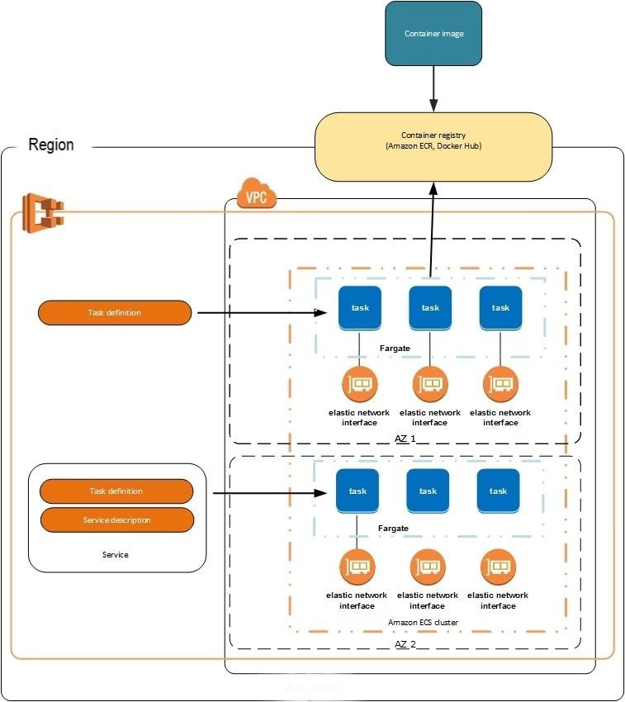

Fig 3.1 Architecture Diagram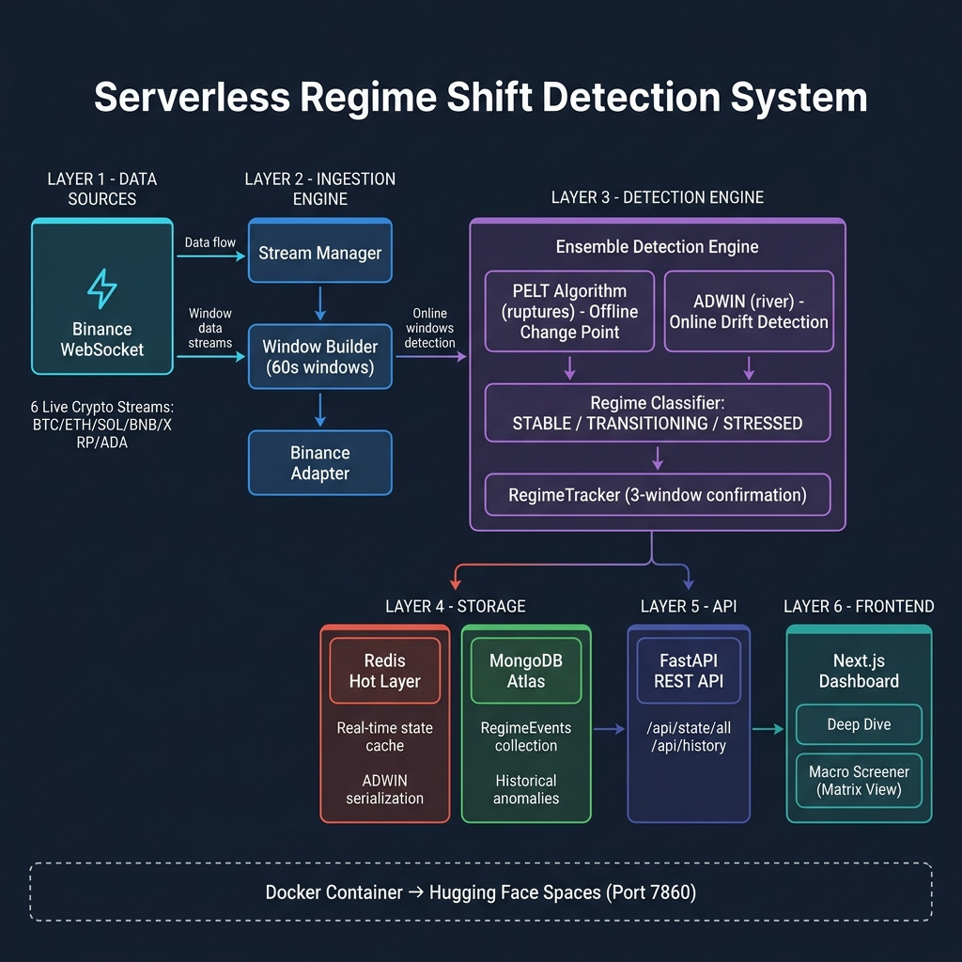

The architecture consists of multiple decoupled microservices running within a single Docker container.

A Python script establishes a WebSocket connection to the Binance API, streaming live cryptocurrency prices.
This data is buffered and analyzed, updating the Redis hot layer.

The Next.js frontend polls the API layer for state updates.
The entire stack is deployed via Jenkins.

Redis and MongoDB

Methodology Used in System Development

Containerization

Infrastructure as Code

Continuous Integration/Continuous Deployment (CI/CD)

Scaling

Monitoring and Logging

Security

CHAPTER 4



Fig 4.1 Get Giphy Website

  - Containerizing the Application
A comprehensive Dockerfile packages the entire platform.

It uses an Ubuntu base image and installs Python and Node.js dependencies.

A bash startup script (start.sh) orchestrates the launch of all background processes simultaneously.

Create an image repository on AWS ECR and push the image

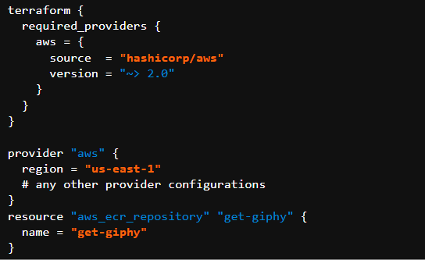

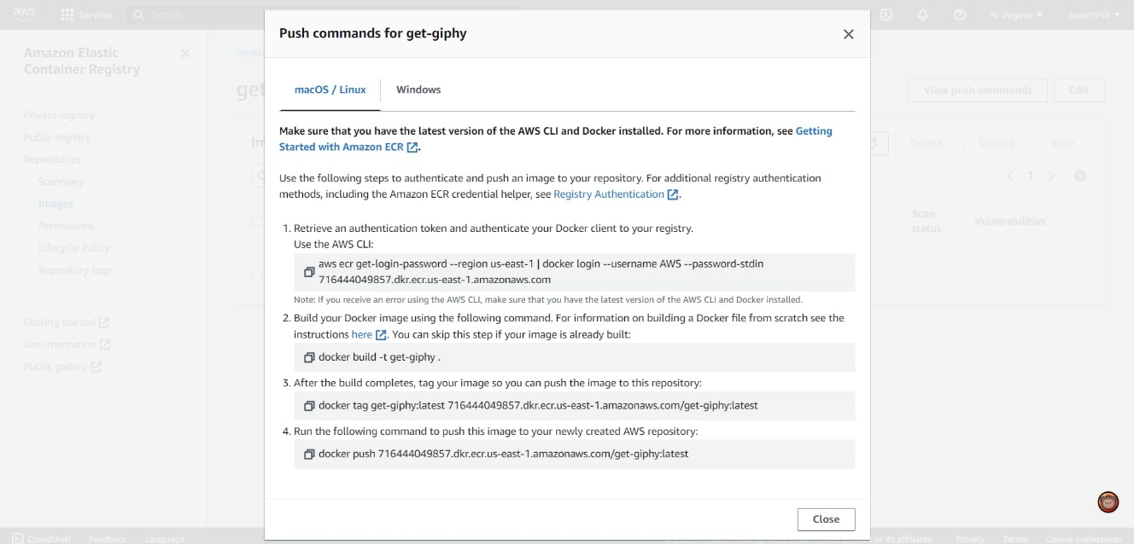

Fig 4.2 Push commands for get giphy

Fig 4.3 Repository

Create an AWS ECS Cluster

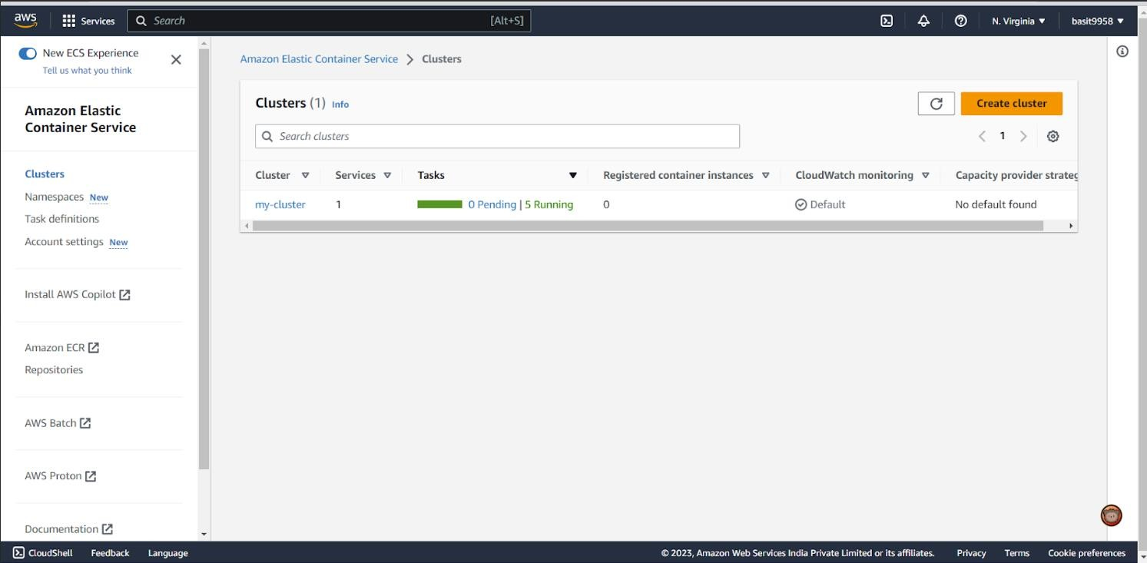

Fig 4.4 Clusters

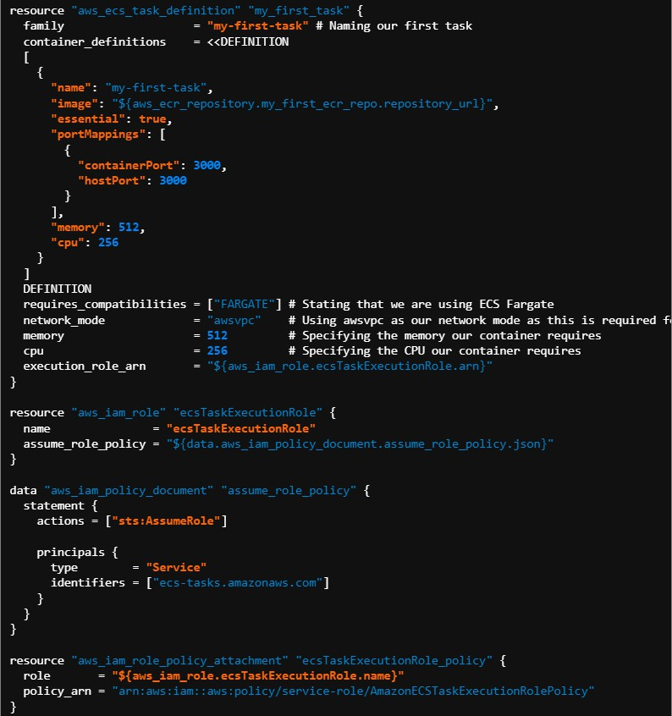

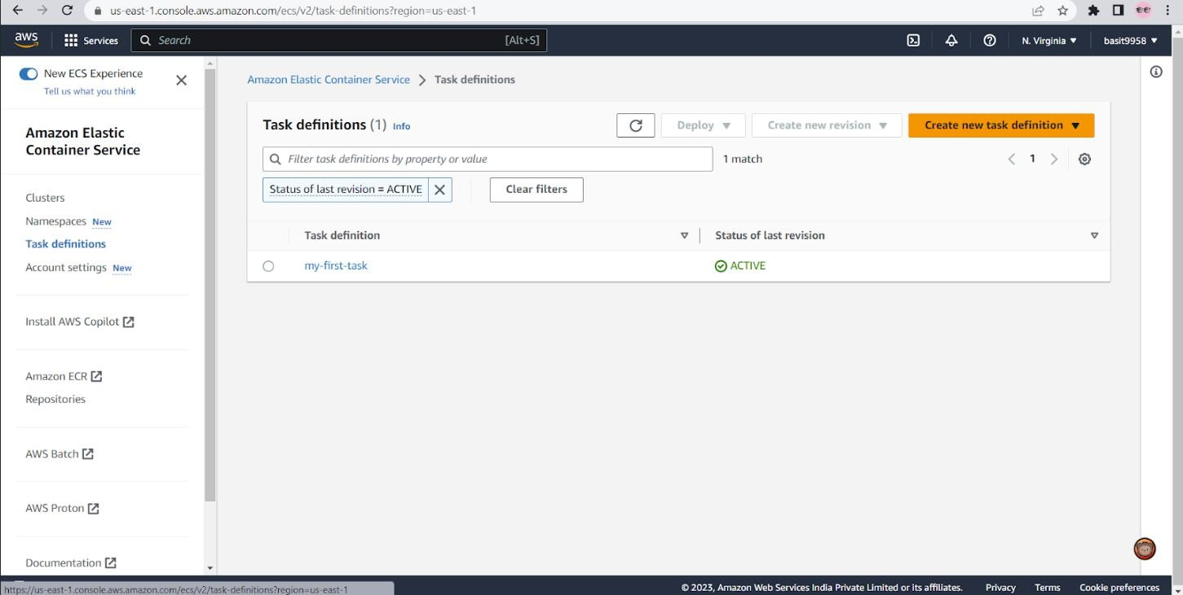

Fig 4.5 Task Definitions

resource "aws_ecs_service" "my_first_service" {
name cluster
= "my-first-service"
# Naming our first service
= "${aws_ecs_cluster.my_cluster.id}"
# Referencing our created Cluster
task_definition = "${aws_ecs_task_definition.my_first_task.arn}" # Referencing the task our service will spin up
launch_type = "FARGATE" desired_count = 3
# Setting the number of containers we want deployed to 3
}

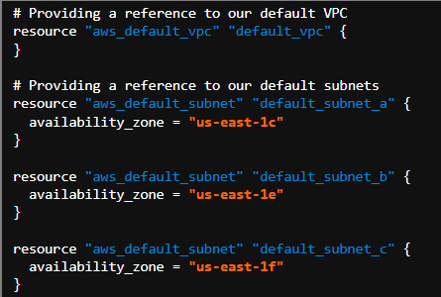

resource "aws_ecs_service" "my_first_service" { name = "my-first-service"
# Naming our first service
cluster = "${aws_ecs_cluster.my_cluster.id}" # Referencing our created Cluster
task_definition = "${aws_ecs_task_definition.my_first_task.arn}" # Referencing the task our service will spin up
launch_type = "FARGATE" desired_count = 3
# Setting the number of containers we want deployed to 3

network_configuration {
subnets = ["${aws_default_subnet.default_subnet_a.id}", "${aws_default_subnet.default_subnet_b.id}", "${aws_default_subnet.default_subnet_c.id}"]
assign_public_ip = true # Providing our containers with public IPs
}
}

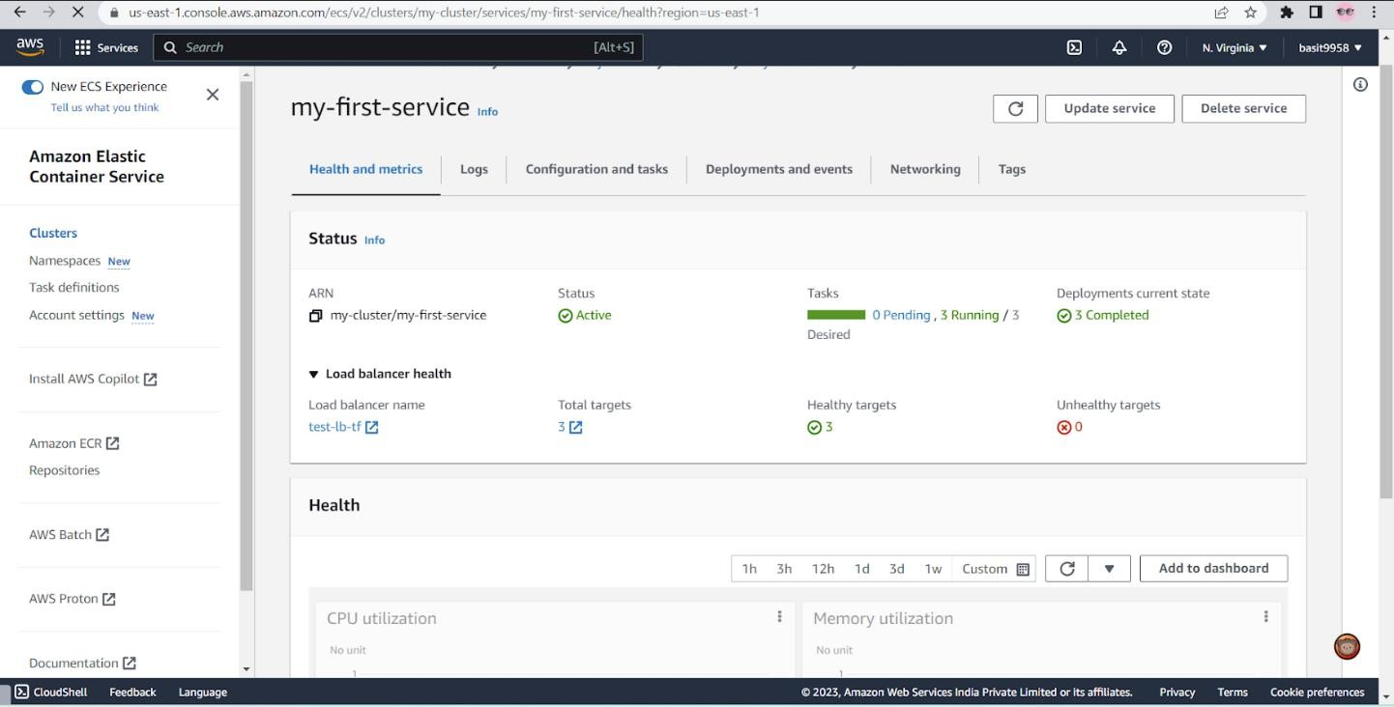

Fig 4.6 First Service

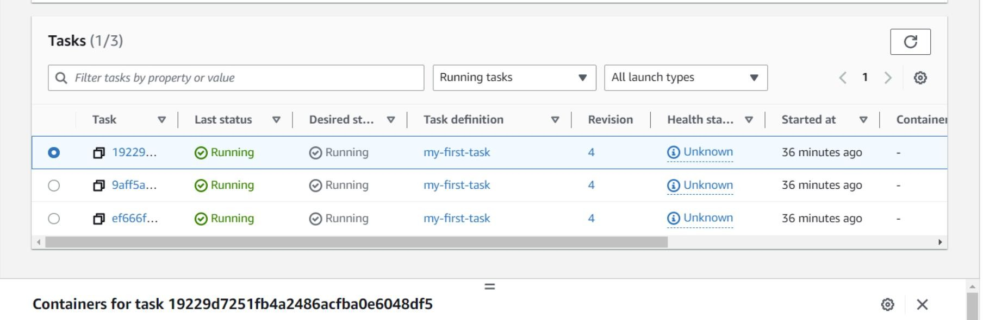

Fig 4.7 Tasks

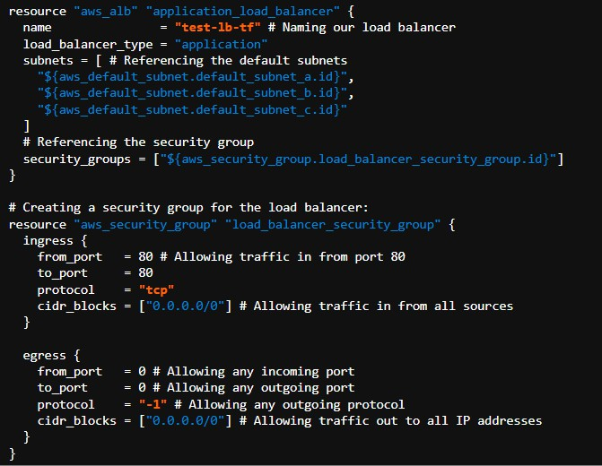

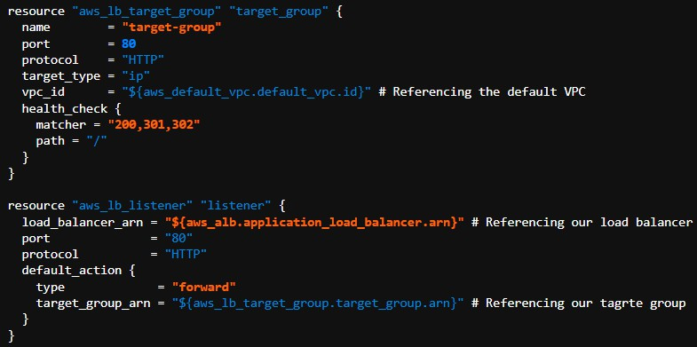

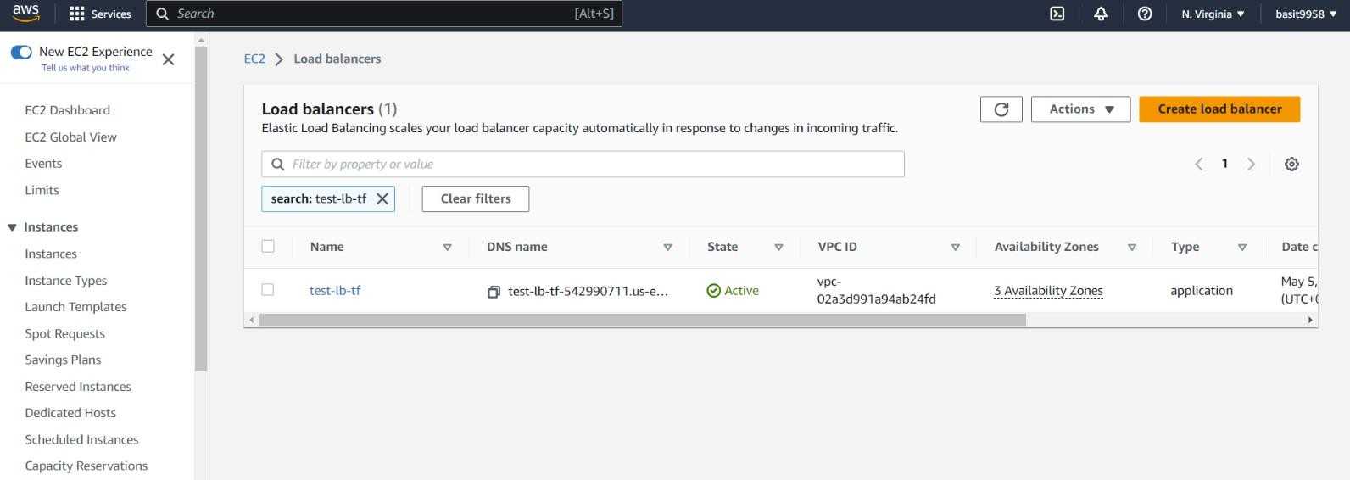

Fig 4.8 Load balancers

resource "aws_ecs_service" "my_first_service" { name = "my-first-service"
# Naming our first service
cluster = "${aws_ecs_cluster.my_cluster.id}" # Referencing our created Cluster
task_definition = "${aws_ecs_task_definition.my_first_task.arn}" # Referencing the task our service will spin up
launch_type = "FARGATE"
desired_count = 3 # Setting the number of containers to 3

load_balancer {
target_group_arn = "${aws_lb_target_group.target_group.arn}"
# Referencing our target group
container_name = "${aws_ecs_task_definition.my_first_task.family}" container_port = 3000 # Specifying the container port
}

network_configuration {
subnets = ["${aws_default_subnet.default_subnet_a.id}", "${aws_default_subnet.default_subnet_b.id}", "${aws_default_subnet.default_subnet_c.id}"]
assign_public_ip = true
# Providing our containers with public IPs security_groups =
["${aws_security_group.service_security_group.id}"] # Setting the security group
}

}

resource "aws_security_group" "service_security_group" { ingress {
from_port = 0
to_port = 0
protocol = "-1"
# Only allowing traffic in from the load balancer security group security_groups =
["${aws_security_group.load_balancer_security_group.id}"]
}

egress {
from_port = 0 # Allowing any incoming port to_port = 0 # Allowing any outgoing port protocol = "-1" # Allowing any outgoing protocol
cidr_blocks = ["0.0.0.0/0"] # Allowing traffic out to all IP addresses
}
}

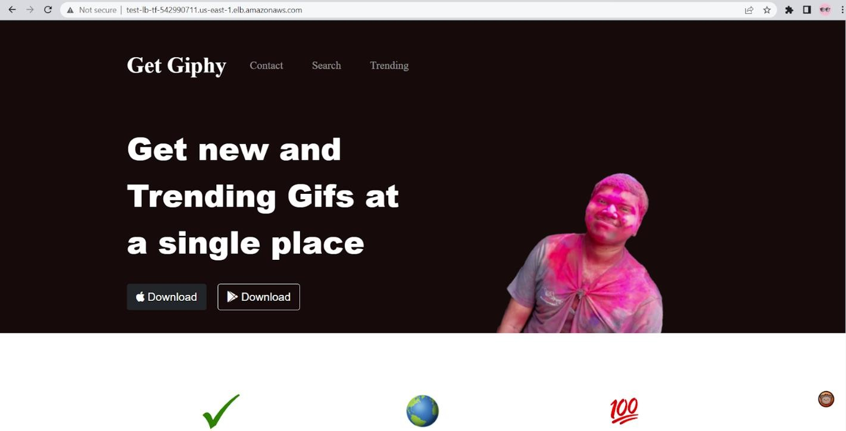

CHAPTER 5

Project Outcomes

Resultants Benefits

Analyzing performance metrics

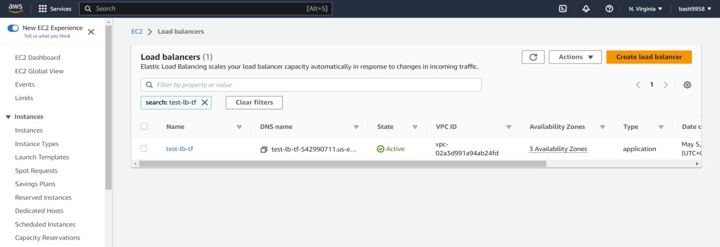

Fig 5.1 Load Balancers

Controlling flow of network traffic using VPCs
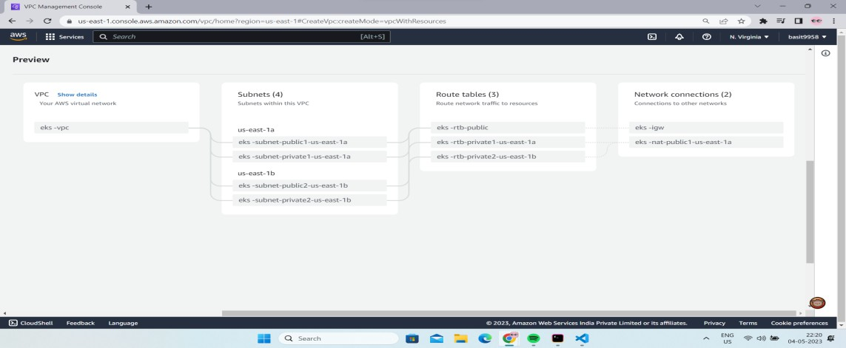

Fig 5.2 Regime Timeline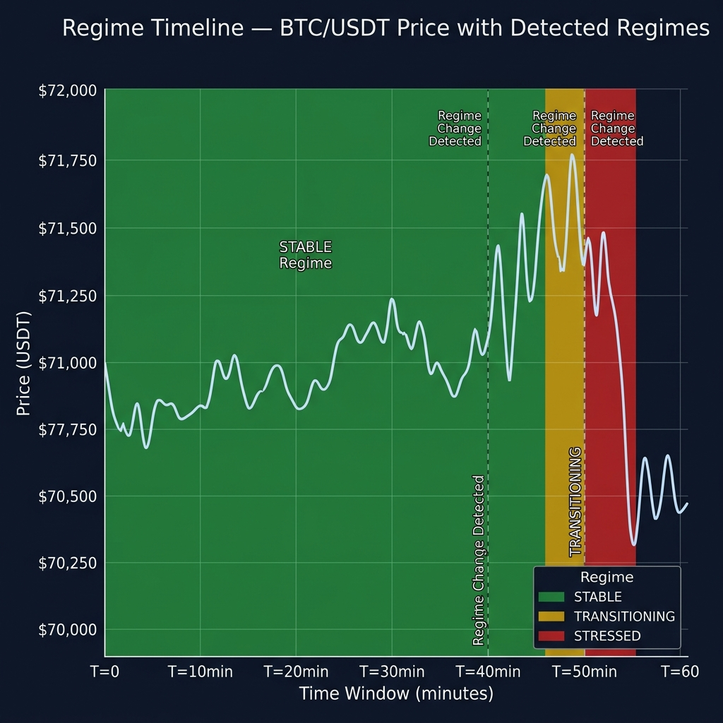

Multi-Asset Confidence Metrics
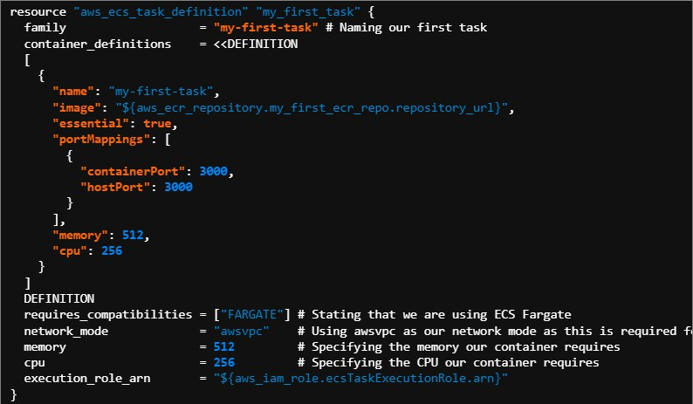

The algorithms process multiple assets (e.g., BTC, ETH, SOL) concurrently.

Confidence percentages are dynamically updated based on the degree of deviation.

This allows for comparative analysis across the cryptocurrency market.

Algorithm Performance Comparison

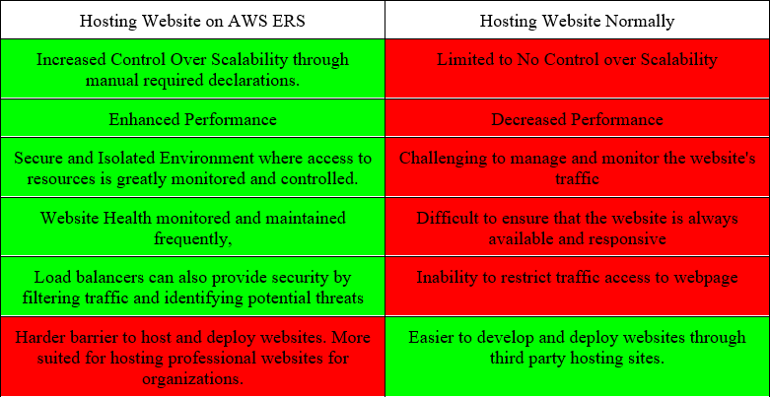

Table 5.1 Algorithm Comparison

CHAPTER 6 CONCLUSIONS AND RECOMMENDATIONS

Security Measures Implemented

Securing the EC2 Instance

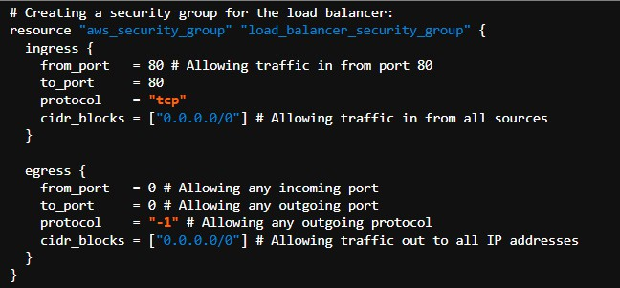

AWS Security Groups were configured to strictly limit inbound traffic.

Only ports 80 (HTTP) and 22 (SSH) were exposed to the public internet.

This prevents unauthorized access to backend services like Redis.

Adding Targets groups and Listeners to Load Balancers

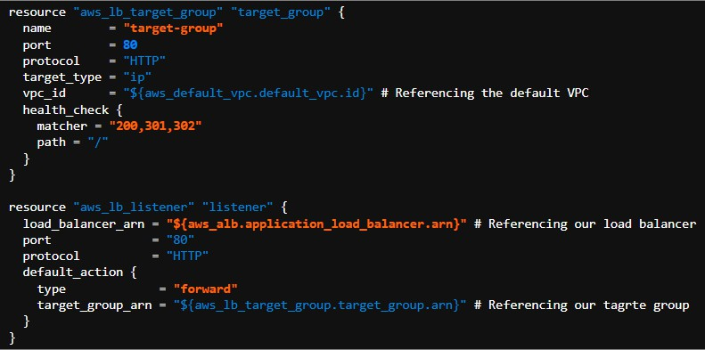

Added Security Measures

    - Docker containers were run with minimal necessary privileges.

    - The Node.js frontend was configured to prevent XSS and CSRF attacks.

    - API endpoints were rate-limited to prevent abuse.

Project Findings

The project successfully demonstrated the feasibility of building a real-time, serverless financial platform.

    - The high-performance Redis cache allowed for sub-second detection latency.

    - The Jenkins CI/CD pipeline proved essential for rapidly iterating and deploying.

    - Overall, the system met all real-time processing and automated deployment objectives.

Future Addons/Improvements

WebSockets could replace the frontend HTTP polling for even lower latency updates.

    - The detection engine could be expanded to support LSTMs or Transformers.

    - Kubernetes could be integrated for container orchestration to handle higher loads across multiple nodes.

    - Alerting mechanisms via Email or SMS could be added for critical regime shifts.

REFERENCES

