Use Case Specification

DMT/RM01/TMP

|  |  |
| --- | --- |
| Project Code | PRJ_MakeMy Journey_001 |
| Project Name | MakeMyJourney |

|  |  |  |
| --- | --- | --- |
| Prepared/Modified by | Role | Date of Preparation |
| Sarulatha R | Test Engineer | 27-06-2018 |
| Reviewed by | Role | Date of Review |
| Sabareeshwari B | SME |  |
| Approved by | Role | Date of Approval |
| Christy | Test Manager |  |
| Circulation List |  | Version Number of the template: |
| Version Number | 1 |  |

<<Customer>> REVIEW HISTORY

<<Customer comments on the Use case along with the signed off is tracked here>>

|  |  |  |  |  |  |  |
| --- | --- | --- | --- | --- | --- | --- |
| Version | <<Version number>> |  |  |  |  |  |
| Date | <<Date of Review>> |  |  |  |  |  |
| Reviewed by | << Reviewer Name>> |  |  |  |  |  |
| Reviewed UI Specification doc | << Whether UI Specification doc is reviewed >> |  |  |  |  |  |
| All Open Queries/issues closed | << Whether all the open queries and issues resolved>> |  |  |  |  |  |
| Agreement on Assumptions | <<Whether all the assumptions have been agreed upon by the customer>> |  |  |  |  |  |
| Sign Off | <<Signature>> |  |  |  |  |  |

Disclaimer:

The scope of the project ‘<<**MakeMy Journey**>>’ is restricted to the contents of this signed off use case.

TABLE OF CONTENTS

1.Use Case Name: 4

2.Actor(s) 4

3.Preconditions 4

4.Flow of Events 4

4.1 Basic Flow 4

4.2 Alternative Flows 5

4.2.1 Alternate Flow 1 5

4.3 Sub Flows 6

4.3.1 Sub Flow 1 6

5.Post Conditions 8

6.Special Requirements 8

7.Extension Points 8

8.Business Rules 9

9.Diagrams 9

Use Case Diagram 10

10.Scenarios 11

Success Scenarios 11

Failure Scenarios 11

11.Issues 11

12.UI Specifications 10

13.Inter System Dependencies 11

14.Integration with an already existing System of the 11

15.Assumptions 11

REVISION HISTORY OF THE WORK PRODUCT…………………………….. .. 11

Use Case Name: Make my journey user registration form

Use Case ID:MakeMy Journey_001

**Brief Description:** This usecase describes the process of registration of MakeMy Journey User Registration form.

Actor(s)

1. User/Customer

2. System.

Preconditions - Users

1. User after giving his user name needs to click on Check Availability for the availabity of user name.

2. User should give their security Ouestion and answer.

3. User has a valid user and active Email ID.

Flow of Events

4.1 Basic Flow

**Name:** Successful login.

1. User visits the MakeMy Journey URL [**http://www.makemyjourney.co.in**](http://www.makemyjourney.co.in) using any standard browser.
2. User enters his/her user name and checks the availability.
3. User gives the valid credentials for registration.
4. User clicks submit button.
5. On successful login, home page is displayed.

**Name:** Registration for MakeMy Journey

1. User visits link available on the Admin Home Page.
2. User sign up using this link.
3. User enters his/her user name and checks the availability
4. User enters security question and answer.
5. User enters first name
6. User enters last name.
7. User selects gender as male/female.
8. User enters date of birth.
9. User enters mobile number
10. User clicks on submit button.
11. System displays the message ”Thank You” message for confirming the registration.

* 1. Alternative Flows

Alternate Flow 1: Successful registration to MakeMy Journey

**Name:** Registration for MakeMy Journey

1. User visits link available on the Admin Home Page.
2. User sign up using this link.
3. User enters his/her user name and checks the availability
4. User changes security question and answer.
5. User enters first name
6. User enters last name.
7. User selects gender as male/female.
8. User enters date of birth.
9. User enters mobile number
10. User clicks on submit button.
11. System displays the message ”Thank You” message for confirming the registration.

Alternate Flow 2: Successful Exam Addition

**Name:** Registration for MakeMy Journey

1. User visits link available on the Admin Home Page.
2. User sign up using this link.
3. User enters his/her user name and checks the availability
4. User enters security question and answer.
5. User enters first name
6. User enters last name.
7. User selects gender as male/female.
8. User enters date of birth.
9. User changes mobile number.
10. User clicks on submit button.
11. System displays the message ”Thank You” message for confirming the registration.

Exceptional Flow

Exceptional Flow 1: Failure in Registration of MakeMy Journey

**Name:** Registration for MakeMy Journey

1. User visits link available on the Admin Home Page.
2. User sign up using this link.
3. User enters his/her user name.
4. User enters security question and answer.
5. User enters first name
6. User enters last name.
7. User selects gender as male/female.
8. User enters date of birth.
9. User enters invalid mobile number.
10. User clicks on submit button.
11. System displays the message ”Invalid Mobile number”.

Exceptional Flow 2: Unsuccessful Addition due to invalid date

**Name:** Registration for MakeMy Journey

1. User visits link available on the Admin Home Page.
2. User sign up using this link.
3. User enters his/her user name as existing for registration.
4. User enters security question and answer.
5. User enters first name
6. User enters last name.
7. User selects gender as male/female.
8. User enters date of birth.
9. User enters mobile number.
10. User clicks on submit button.
11. System displays the message ”User name is not unique”.

Exception Flow 3:Server Down

**Name:** Registration for MakeMy Journey

1. User visits link available on the Admin Home Page.
2. User sign up using this link.
3. User enters his/her user name and checks the availability
4. User enters security question and answer.
5. User enters first name
6. User enters last name.
7. User selects gender as male/female.
8. User enters date of birth.
9. User enters mobile number
10. User clicks on submit button.
11. The system displays an error message regarding web server unavailability problem.

Exception Flow 4: Database Connectivity Error

**Name:** Registration for MakeMy Journey

1. User visits link available on the Admin Home Page.
2. User sign up using this link.
3. User enters his/her user name and checks the availability
4. User enters security question and answer.
5. User enters first name
6. User enters last name.
7. User selects gender as male/female.
8. User enters date of birth.
9. User enters mobile number.
10. User clicks on submit button.
11. The system displays an error message regarding database connectivity problem.

Exception Flow 5: Network Connectivity Error

**Name:** Registration for MakeMy Journey

1. User visits link available on the Admin Home Page.
2. User sign up using this link.
3. User enters his/her user name and checks the availability
4. User enters security question and answer.
5. User enters first name
6. User enters last name.
7. User selects gender as male/female.
8. User enters date of birth.
9. User enters mobile number.
10. User clicks on submit button.
11. The system displays an error message regarding network connectivity problem.

Post Conditions

| Flow Name | Post Condition |
| --- | --- |
| Successful registration to MakeMy Journey | System displays the message ”Thank You” message for confirming the registration. |
| Unsuccessful registration to MakeMy journey | System displays the message ”Invalid Mobile number”. |
| Web Server Down | The system should display an error message to the user regarding web server unavailability problem |
| Database Connectivity Error | The system should display an error message to the user regarding the database connectivity problem |
| Network Connectivity Error | The system should display an error message to the user regarding the network connectivity problem |

Special Requirements

Performance

The user should receive the mails and sms after registration for MakeMy Journey.

Availability

* 1. Website is up and running 24*7.

Business Rules

| Business Rule Name | Business Rule Description | System action (if BR fails) |
| --- | --- | --- |
| BR01 | The sign up should be done using valid credentials | Error message is displayed if not valid |
| BR02 | The account should be active | Error message is displayed if theaccount is not active |
| BR03 | The user names should be distinct | Error message is displayed if same names are entered |

Diagrams

Use Case Diagram

* 1. For Successful Addition of Exam

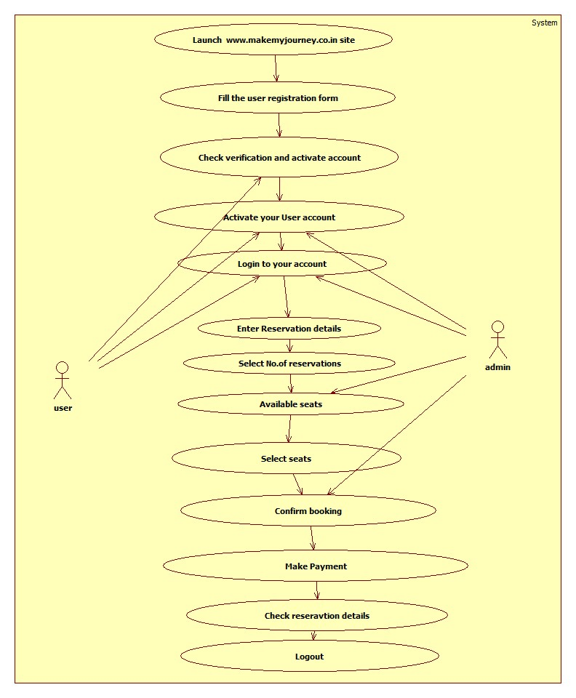

Scenarios

Success Scenarios

* Successful submission of Make My Journey

Failure Scenarios

* Failed submission of due to leaving a field blank.
* Failed submission of due to entering wrong name
* Failed submission of Exam Application due to network error.

Issues

1. What is to be done if web server is down?
2. What is to be done if there is data connectivity error?

Assumptions

1.Only user can avail this service.

REVISION HISTORY OF THE WORK PRODUCT

<to be maintained by projects>

|  |  |  |  |  |  |
| --- | --- | --- | --- | --- | --- |
| # | Date | Version # | Section Changed | Details of changes made | Approved By |
| 1 |  |  |  |  |  |
| 2 |  |  |  |  |  |