Use Case Specification

Use Case ID: Online Banking Application 1.0

|  |  |
| --- | --- |
| Project Code | PRJ\_OnlineBanking\_001 |
| Project Name | Online Banking System |

|  |  |  |
| --- | --- | --- |
| Prepared/Modified by | Role | Date of Preparation |
| Sarulatha R | Test Engineer | 07/20/2018 |
| Reviewed by | Role | Date of Review |
| Geethika Uddaraju | Test Lead |  |
| Approved by | Role | Date of Approval |
|  |  |  |
| Circulation List |  | Version Number of the template: |
| Version Number | 1.0 |  |
|  |  |  |

<<Customer>> REVIEW HISTORY

<<Customer comments on the Use case along with the signed off is tracked here>>

|  |  |  |  |  |  |  |
| --- | --- | --- | --- | --- | --- | --- |
| Version | 1.0 |  |  |  |  |  |
| Date | <<Date of Review>> |  |  |  |  |  |
| Reviewed by | << Reviewer Name>> |  |  |  |  |  |
| Reviewed UI Specification doc | << Whether UI Specification doc is reviewed >> |  |  |  |  |  |
| All Open Queries/issues closed | << Whether all the open queries and issues resolved>> |  |  |  |  |  |
| Agreement on Assumptions | <<Whether all the assumptions have been agreed upon by the customer>> |  |  |  |  |  |
| Sign Off | <<Signature>> |  |  |  |  |  |

Disclaimer:

The scope of the project **‘Online Banking System’** is restricted to the contents of this signed off use case.

TABLE OF CONTENTS

[1.Use Case Name: <<Online Banking System>> 4](#_Toc302030199)

[2.Actor(s) 4](#_Toc302030200)

[3.Preconditions 4](#_Toc302030201)

[4.Flow of Events 4](#_Toc302030202)

[4.1 Basic Flow 4](#_Toc302030203)

[4.2 Alternative Flows 5](#_Toc302030204)

[4.2.1 Alternate Flow 1 5](#_Toc302030205)

[4.3 Exception Flows 6](#_Toc302030206)

4.3.1 Exception Flow 1 9

[5.Post Conditions 9](#_Toc302030208)

[6.Special Requirements 10](#_Toc302030209)

[7.Extension Points 10](#_Toc302030210)

[8.Business Rules 10](#_Toc302030212)

[9.Diagrams 11](#_Toc302030213)

[Use Case Diagram 11](#_Toc302030214)

[10.Scenarios 14](#_Toc302030216)

11. [Success Scenarios 1](#_Toc302030217)4

12. [Failure Scenarios 14](#_Toc302030218)

13. [Assumptions 1](#_Toc302030223)4

REVISION HISTORY OF THE WORK PRODUCT…………………………….. .. 15

1. Use Case Name: ONLINE BANKING SYSTEM

**Use Case ID:** PRJ\_ONLINE\_BANKING \_001

**Brief Description:** This use case describes the process by which administrator can log into the Online Banking system. This Use Case also describes the process by which a new user/applicant

can register on the Online Banking portal.

1. **ACTORS:**
2. Administrator
3. Applicant/new user
4. Application
5. **PRECONDITIONS:**

**ADMINISTRATOR**

1. Administrator is an employee of an Online Banking Portal.
2. Administrator has an access to the Online Banking Portal Website.
3. Administrator has a valid user id and a password.
4. Administrator has an access to the Online Banking Portal.

**APPLICANT/NEW USER**

1. New user/Applicant is not a member of the website.
2. New user/Applicant has an access to the Online Banking Portal Website.
3. New user/Applicant can register as a new user.

**4. Flow of Events:**

**4.1 Basic Flow:**

**4.1.1 Basic Flow: Admin Login**

1. Administrator visits the Online Banking Portal[**http://ndafile:8081/OnlineBankingProjectSpring/**](http://ndafile:8081/OnlineBankingProjectSpring/)using any standard browser.
2. Administrator enters his/her user-id and password and clicks on the login button in the section of a admin login page given for administrator login.
3. The system validates the user id and password combination with the database.
4. If the authentication is unsuccessful, a login failure message is displayed.
5. On successful login, the admin home page is displayed.
6. On Successful login, the user-id and role fields are stored in the HTTP session for future use during that session.

**4.2 Alternative Flows:**

**4.2.1 ALTERNATE FLOW1: Successful Applicant registration**

Administrator adds new account holder

1. By clicking on Add Account Holder field available on admin’s home page.
2. Then, enters account holder name.
3. Then, enters account holder address.
4. Then, enters account holder PAN card number.
5. Then, enters account holder email Id.
6. Then, enters account holder account type.
7. Then, enters account holder opening balance.
8. Then, enters account opening date.
9. Then, selects account holder login security question.
10. Then, enters answer of security question.
11. Then, clicks on Register button.
12. After clicking register page displays the message ”Successful Registration”.
    1. **ALTERNATE FLOW2:**

**EXCEPTION FLOW1: All fields on the Login web page are not filled**

1. Administrator enters the URL<http://ndafile:8081/OnlineBankingProjectSpring/>
2. Administrator clicks on Admin Login.
3. Administrator enters user name in user id.
4. Administrator enters password.
5. System displays the message “Invalid Credentials”.

**EXCEPTION FLOW2: All fields on the Login web page are not specified**

1. Admin enters the URL http://ndafile:8081/OnlineBankingProjectSpring/
2. Admin clicks on Admin Login.
3. Admin enters user id.
4. Admin enters invalid password.
5. System displays the message “Invalid Credentials”.

**EXCEPTION FLOW3: The User name field is given data apart from characters**

1. Administrator should access this website <http://ndafile:8081/OnlineBankingProjectSpring/>
2. Administrator should click on Admin Login.
3. Administrator needs to enter valid user name and password.
4. Admin clicks on Add Account Holder link available on admin’s home page.
5. Admin enters account holder name which is invalid.
6. Admin enters account holder address.
7. Admin enters account holder PAN card number.
8. Admin enters account holder email Id.
9. Admin enters account holder account type.
10. Admin enters account holder opening balance.
11. Admin enters account opening date.
12. Admin selects account holder login security question.
13. Admin enters answer of security question.
14. Admin clicks on Register button.
15. System displays the message ”unsuccessful Registration”.

**EXCEPTION FLOW4: The User Name field is given with more than 10 characters**

1. Administrator should access this website <http://ndafile:8081/OnlineBankingProjectSpring/>
2. Administrator should click on Admin Login.
3. Administrator needs to enter valid user name and password.
4. Admin clicks on Add Account Holder link available on admin’s home page.
5. Admin enters account holder name.
6. Admin enters account holder address.
7. Admin enters account holder PAN card number which is invalid.
8. Admin enters account holder email Id.
9. Admin enters account holder account type.
10. Admin enters account holder opening balance.
11. Admin enters account opening date.
12. Admin selects account holder login security question.
13. Admin enters answer of security question.
14. Admin clicks on Register button.
15. System displays the message ”unsuccessful Registration”.

**EXCEPTION FLOW5: Passwords having less than six characters.**

1. Administrator should access this website <http://ndafile:8081/OnlineBankingProjectSpring/>
2. Administrator should click on Admin Login.
3. Administrator needs to enter valid user name and password.
4. Admin clicks on Add Account Holder link available on admin’s home page.
5. Admin enters account holder name.
6. Admin enters account holder address.
7. Admin enters account holder PAN card number.
8. Admin enters account holder email Id which is invalid.
9. Admin enters account holder account type

**EXCEPTION FLOW6:** **Unsuccessful USER registration due to improper selection of account type.**

Administrator should access this website <http://ndafile:8081/OnlineBankingProjectSpring/>

1. Administrator should click on Admin Login.
2. Administrator needs to enter valid user name and password.
3. Admin clicks on Add Account Holder link available on admin’s home page.
4. Admin enters account holder name.
5. Admin enters account holder address.
6. Admin enters account holder PAN card number.
7. Admin enters account holder email Id.
8. Admin fails to enter account holder due to improper selection of account type.
9. Admin enters account holder opening balance.
10. Admin enters account opening date.
11. Admin selects account holder login security question.

**4.3.7 Exceptional flow 7 – Unsuccessful USER registration due to user fails to select security question**.

1. Administrator should access this website <http://ndafile:8081/OnlineBankingProjectSpring/>
2. Administrator should click on Admin Login.
3. Administrator needs to enter valid user name and password.
4. Admin clicks on Add Account Holder link available on admin’s home page.
5. Admin enters account holder name.
6. Admin enters account holder address.
7. Admin enters account holder PAN card number.
8. Admin enters account holder email Id.
9. Admin enters account holder account type.
10. Admin enters account holder opening balance.
11. Admin enters account opening date.
12. Admin fails to select account holder login security question.
13. Admin enters answer of security question.
14. Admin clicks on Register button.
15. System displays the message ”unsuccessful Registration”.

**4.3.8 Exceptional flow 8– Unsuccessful USER registration due to insufficient opening balance**

1. Administrator should access this website <http://ndafile:8081/OnlineBankingProjectSpring/>
2. Administrator should click on Admin Login.
3. Administrator needs to enter valid user name and password.
4. Admin clicks on Add Account Holder link available on admin’s home page.
5. Admin enters account holder name.
6. Admin enters account holder address.
7. Admin enters account holder PAN card number.
8. Admin enters account holder email Id.
9. Admin enters account holder account type.
10. Admin enters insufficient account holder opening balance.
11. Admin enters account opening date.
12. Admin selects account holder login security question.
13. Admin enters answer of the security question.
14. Admin clicks on Register button.
15. System displays the message ”unsuccessful Registration”.

# **Post Conditions:**

| Flow Name | Post Condition |
| --- | --- |
| Successful admin login | Login has been submitted successfully |
| Unsuccessfull Login due to invalid user id | Login page is not submitted. |
| Unsuccessfull Login due to invalid password | Login page is not submitted. |
| Unsuccessfull registration due to invalid HOLDER name | Login page is not submitted. |
| Unsuccessfull registration due to invalid pan card number | Login page is not submitted. |
| Successfully admin login into the site. | Successfully administrator log in to the application. |
| Successfully applicant is registered. | Successfully applicant gets registered. |
| Administrator password less than six characters. | Administrator log in failed. |
| User Name field more than 10 characters. | Administrator log in failed. |
| All the mandatory fields are not filled. | Access unsuccessful |
| Passwords without at least three of the four available character types: lowercase letters, uppercase letters, numbers, and symbols. | Administrator access unsuccessful. |

# **Special Requirements:**

**PERFORMANCE:**

Using this application user can transfer funds, track service request and generate mini statement in secure way. This application has various specifications which has increased its performance.

**AVAILABILITY:**

1. This application is made available for all the users who wants to do banking online.
2. The portal is accessible 24X7 including week offs and holidays.
3. **USER INTERFACE:**
4. The letters will be white in color with black background.
5. The active links should be displayed with white underline.
6. Error is displayed in that field with red color.
7. SECURITY
8. The system will not allow the user to add details for registration only admin can do it.
9. The system will not allow the user to view all transactions report.
10. The system will not allow the user view service requests.
11. The system will not allow the user to view other person confidential details.
12. Business Rules

| Business Rule Name | Business Rule Description | System action (if BR fails) |
| --- | --- | --- |
| BR01 | User Id should contain only valid characters | System should not accept invalid user id. |
| BR02 | Password should contain only 3 attempts | System should not accept more than 3 attempts. |
| BR03 | Account holder name should contain only valid characters | System should not accept invalid name. |
| BR04 | Pan card number should contain only 10 numbers. | System should not accept more than 10 numbers. |

# **Diagrams**

# **USE CASE –USER LOGIN**D:\sarulatha\Project\Usecase_User_uml.jpg

USE CASE – ADMIN LOGIN

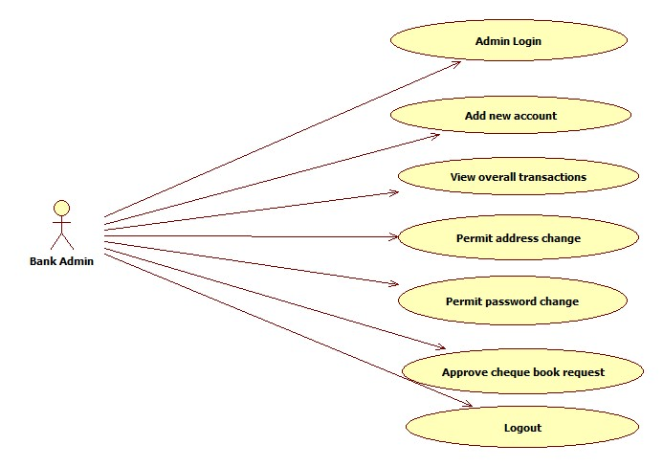

USE CASE – GENERAL FLOW

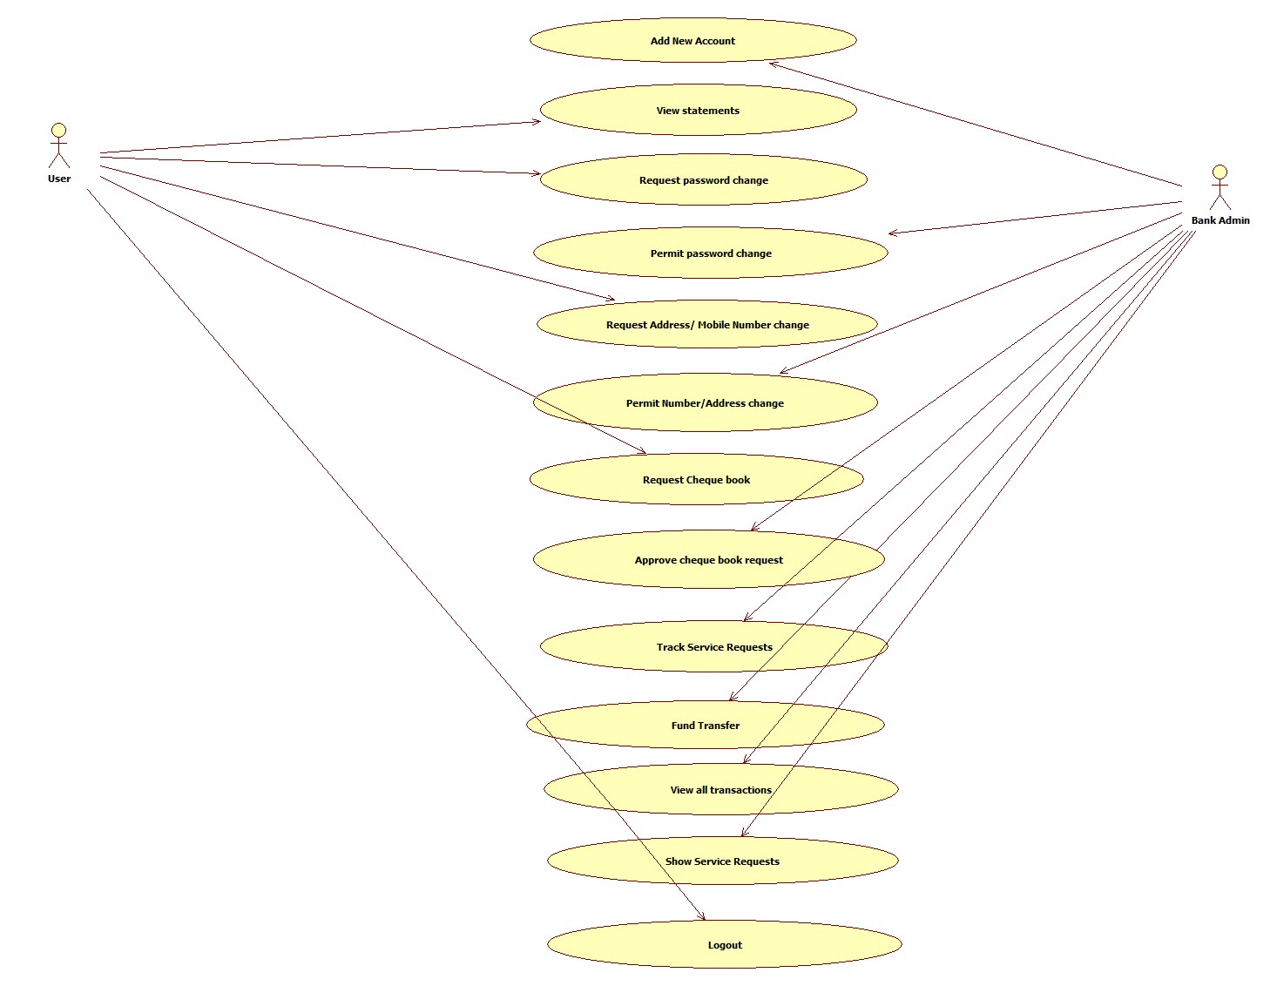

# **10. Scenarios**

Success Scenarios

1. Applicant successfully registers in the portal.
2. User successfully log in to the portal.
3. Administrator successfully adds new account holders.

Failure Scenarios

1. All mandatory fields on the Login web page are not given.
2. Unsuccessful Admin login due to invalid User Id.
3. Unsuccessful Admin login due to invalid Password.
4. Unsuccessful Registration due to invalid Account Holder name.
5. Unsuccessful Registration due to invalid Account Holder address.
6. Unsuccessful Registration due to invalid Account Holder pan card.
7. Unsuccessful Registration due to invalid Account Holder e-mail Id.
8. Unsuccessful Registration due to invalid Account Holder account type.
9. Unsuccessful Registration due to invalid Account Holder opening balance.
10. Unsuccessful Registration due to invalid Account Holder Secret Question.

Assumptions

1. Administrator is an employee of company and having access to Intranet.
2. When the applicant stays inactive for 20 minutes in the leave application portal, it automatically expires the session.
3. The administrator has enough permissions to alter the portal like adding an exam etc.

**REVISION HISTORY OF THE WORK PRODUCT**

|  |  |  |  |  |  |
| --- | --- | --- | --- | --- | --- |
| S NO. | Date | Version # | Section Changed | Details of changes made | Approved By |
| 1 |  |  |  |  |  |
| 2 |  |  |  |  |  |