Code guard ML - AI-Powered Detection Of Malicious Patterns In Infrastructure-As-Code
Abstract (English)
A machine learning–driven framework for enhancing the security and integrity of Infrastructure-as-Code (IaC) environments. With the widespread adoption of DevOps and cloud automation, IaC tools such as Terraform, Ansible, and CloudFormation have become critical components in managing large-scale infrastructure deployments. However, these systems are increasingly targeted by attackers who inject malicious configurations, hidden scripts, or insecure settings into IaC templates, leading to severe vulnerabilities and data breaches. To address this challenge, CodeGuard ML leverages advanced machine learning and natural language processing (NLP) techniques to automatically detect anomalous or potentially harmful patterns within IaC scripts. The model learns from both syntactic and semantic code features, identifying risky configuration behaviors that may not be captured by traditional rule-based scanners. By combining static code analysis with adaptive ML-based anomaly detection, CodeGuard ML provides a scalable and intelligent security layer for continuous integration and deployment pipelines. Experimental results demonstrate its effectiveness in identifying subtle malicious patterns with high accuracy and low false-positive rates, offering a robust defense mechanism for modern cloud-native infrastructures.

Abstract(Tamil)

உள்கட்டமைப்பு-குறியீடு சூழல்களின் பாதுகாப்பு மற்றும் ஒருமைப்பாட்டை மேம்படுத்துவதற்கான இயந்திர கற்றல் சார்ந்த கட்டமைப்பு. மற்றும் கிளவுட் ஆட்டோமேஷனின் பரவலான ஏற்றுக்கொள்ளலுடன், மற்றும் போன்ற விகள் பெரிய அளவிலான உள்கட்டமைப்பு வரிசைப்படுத்தல்களை நிர்வகிப்பதில் முக்கியமான கூறுகளாக மாறியுள்ளன. இருப்பினும், இந்த அமைப்புகள் டெம்ப்ளேட்களில் தீங்கிழைக்கும் உள்ளமைவுகள், மறைக்கப்பட்ட ஸ்கிரிப்டுகள் அல்லது பாதுகாப்பற்ற அமைப்புகளை செலுத்தும் தாக்குபவர்களால் அதிகளவில் குறிவைக்கப்படுகின்றன, இது கடுமையான பாதிப்புகள் மற்றும் தரவு மீறல்களுக்கு வழிவகுக்கிறது. இந்த சவாலை எதிர்கொள்ள, CodeGuard ஸ்கிரிப்ட்களுக்குள் உள்ள முரண்பாடான அல்லது தீங்கு விளைவிக்கும் வடிவங்களை தானாகவே கண்டறிய மேம்பட்ட இயந்திர கற்றல் மற்றும் இயற்கை மொழி செயலாக்கம் நுட்பங்களைப் பயன்படுத்துகிறது. இந்த மாதிரி தொடரியல் மற்றும் சொற்பொருள் குறியீடு அம்சங்களிலிருந்து கற்றுக்கொள்கிறது, பாரம்பரிய விதி அடிப்படையிலான ஸ்கேனர்களால் பிடிக்கப்படாத ஆபத்தான உள்ளமைவு நடத்தைகளை அடையாளம் காட்டுகிறது. தகவமைப்பு அடிப்படையிலான ஒழுங்கின்மை கண்டறிதலுடன் நிலையான குறியீடு பகுப்பாய்வை இணைப்பதன் மூலம், CodeGuard தொடர்ச்சியான ஒருங்கிணைப்பு மற்றும் வரிசைப்படுத்தல் குழாய்களுக்கான அளவிடக்கூடிய மற்றும் அறிவார்ந்த பாதுகாப்பு அடுக்கை வழங்குகிறது. நவீன மேக-பூர்வீக உள்கட்டமைப்புகளுக்கு ஒரு வலுவான பாதுகாப்பு பொறிமுறையை வழங்குவதன் மூலம், அதிக துல்லியம் மற்றும் குறைந்த தவறான-நேர்மறை விகிதங்களுடன் நுட்பமான தீங்கிழைக்கும் வடிவங்களை அடையாளம் காண்பதில் அதன் செயல்திறனை சோதனை முடிவுகள் நிரூபிக்கின்றன.

List Of Figures

List Of Abbreviations
Abbreviation | Full Form | Project Relevance / Description
AI | Artificial Intelligence | Used to automatically detect malicious patterns in IaC files
ML | Machine Learning | Core technique for learning attack patterns from IaC datasets
DL | Deep Learning | Advanced models for complex pattern recognition
IaC | Infrastructure as Code | Configuration files defining cloud infrastructure
DevSecOps | Development, Security, and Operations | Security integrated into CI/CD pipelines
CI/CD | Continuous Integration / Continuous Deployment | Pipeline where CodeGuard ML is integrated
IaaS | Infrastructure as a Service | Cloud model targeted by IaC scripts
PaaS | Platform as a Service | Cloud environments analyzed for misconfigurations
AWS | Amazon Web Services | Common cloud provider for IaC examples
Azure | Microsoft Azure | Supported cloud infrastructure
GCP | Google Cloud Platform | Multi-cloud IaC analysis
Terraform | Terraform Tool | Primary IaC language analyzed
YAML | Yet Another Markup Language | Used in Kubernetes and cloud configs
JSON | JavaScript Object Notation | IaC configuration format
HCL | HashiCorp Configuration Language | Terraform scripting language
SAST | Static Application Security Testing | Static analysis of IaC files
DAST | Dynamic Application Security Testing | Complementary runtime security
CWE | Common Weakness Enumeration | Reference for security weaknesses
CVE | Common Vulnerabilities and Exposures | Known vulnerability mapping
RBAC | Role-Based Access Control | Detects privilege misconfigurations
IAM | Identity and Access Management | Critical cloud security component
ACL | Access Control List | Checks for overly permissive access
NLP | Natural Language Processing | Used for parsing IaC scripts
CNN | Convolutional Neural Network | Pattern extraction from code
RNN | Recurrent Neural Network | Sequence learning in IaC files
LSTM | Long Short-Term Memory | Captures long-term dependencies
TF-IDF | Term Frequency–Inverse Document Frequency | Feature extraction method
API | Application Programming Interface | Integration with CI/CD tools
IDS | Intrusion Detection System | Conceptual alignment with detection logic
IPS | Intrusion Prevention System | Prevents insecure deployments
PoLP | Principle of Least Privilege | Security rule enforced by the system
MITM | Man-in-the-Middle Attack | Detected through insecure configs
DoS | Denial of Service | Risk from misconfigured resources
XSS | Cross-Site Scripting | Cloud misconfig vulnerability
SQLi | SQL Injection | Related attack vector in cloud apps
ROC | Receiver Operating Characteristic | Model evaluation metric
AUC | Area Under Curve | Performance measurement
TPR | True Positive Rate | Correct detection rate
FPR | False Positive Rate | Incorrect alert measurement

Introduction
The rapid adoption of DevOps practices and cloud-native architectures has revolutionized how organizations build, deploy, and manage IT infrastructure. At the heart of this transformation lies Infrastructure-as-Code (IaC) — a paradigm that allows infrastructure provisioning and configuration to be automated through code, enabling consistency, scalability, and efficiency across environments. Tools such as Terraform, Ansible, Puppet, and AWS CloudFormation have become integral to this ecosystem, allowing developers to define infrastructure declaratively. However, as IaC evolves into a critical component of modern software delivery pipelines, it has also emerged as a high-value target for cyberattacks, exposing new classes of security vulnerabilities and misconfigurations that can compromise entire systems.
Despite its advantages, IaC introduces significant security challenges stemming from its textual, programmable nature. Configuration scripts can be tampered with to include malicious instructions, hardcoded secrets, or insecure defaults that lead to privilege escalation, data leakage, or service disruption. Traditional security scanners and policy checkers often rely on static rule-based mechanisms, which struggle to identify novel or obfuscated attack patterns embedded in code. Furthermore, as IaC scripts are frequently reused, versioned, and shared across teams, malicious configurations can propagate rapidly through continuous integration and deployment (CI/CD) pipelines, amplifying security risks across distributed environments. These issues underline the urgent need for intelligent, adaptive systems capable of analyzing and securing IaC at scale.
To address these emerging threats, artificial intelligence (AI) and machine learning (ML) have become powerful tools for improving cybersecurity automation. Unlike rule-based detection systems, ML-driven models can learn from large datasets, adapt to evolving threat behaviors, and uncover hidden or complex relationships within IaC scripts. The integration of natural language processing (NLP) techniques allows such systems to analyze both syntactic structures and semantic meanings, providing deeper insight into potentially malicious code patterns. This paradigm shift from static analysis to AI-driven detection marks a crucial step forward in strengthening IaC security and aligning it with the dynamic nature of modern cloud infrastructure.
The proposed system, CodeGuard ML, embodies this shift by leveraging a machine learning–powered detection framework to automatically identify malicious patterns and anomalous behaviors within IaC scripts. It combines static and dynamic analysis methods with advanced ML models trained on diverse codebases to differentiate between normal and suspicious configurations. By examining both code-level features (syntax, tokens, dependencies) and contextual patterns (resource interactions, variable propagation), CodeGuard ML achieves a more comprehensive understanding of potential threats. The system also supports continuous learning, enabling it to evolve alongside new attack vectors and infrastructure changes.
In summary, CodeGuard ML aims to bridge the gap between traditional IaC security tools and modern AI-driven threat detection approaches. By introducing an intelligent, automated mechanism for IaC inspection, it enhances security resilience, reduces manual effort, and accelerates DevSecOps workflows. The framework not only mitigates the risk of malicious code injection but also promotes safer coding practices in infrastructure management. As cloud environments continue to expand in complexity, AI-powered solutions like CodeGuard ML will play an essential role in ensuring the security, reliability, and trustworthiness of automated infrastructure systems in the digital era.

Literature Survey
- A. Rahman, I. Rahman, C. Bird et al. — 2019
“Security Smells in Infrastructure as Code Scripts.”
Paraphrased abstract: This empirical study identifies recurring insecure coding practices (security “smells”) in IaC scripts and shows how those patterns can lead to exploitable misconfigurations. The authors analyze a large corpus of IaC repositories, catalogue common smells, and validate a static-analysis linter to flag these issues, demonstrating prevalence and practical impact. Akond Rahman
- Y. Xiong, A. Rahman, et al. — 2021 (GLITCH paper / conference)
“GLITCH: Automated Polyglot Security Smell Detection in IaC.”
Paraphrased abstract: GLITCH presents a polyglot detection pipeline that unifies security-smell detection across multiple IaC languages (Terraform, Ansible, CloudFormation). It uses code pattern mining plus cross-language rule inference to automatically detect a broad class of insecure constructs, improving recall over language-specific linters. ACM Digital Library
- M. Yu, S. Wang, et al. — 2020
“Automatically Detecting Risky Scripts in Infrastructure Code.”
Paraphrased abstract: This work proposes an analysis framework that extracts embedded scripts and code fragments from IaC, applies static analysis and heuristics to identify risky operations (e.g., remote command execution, secret leaks), and demonstrates automated detection of risky scripts in real-world IaC repositories. ACM Digital Library
- M. Chiari, D. Palomba, et al. — 2022
“Static Analysis of Infrastructure as Code: A Survey.”
Paraphrased abstract: A systematic survey of static-analysis techniques applied to IaC, this paper categorizes tools and methods (linters, AST-based analyses, formal checks), summarizes defect types found in IaC, and highlights open problems—especially the limits of purely rule-based approaches and the need for semantics-aware, scalable solutions. arXiv
- R. Opdebeeck, A. Zerouali, C. De Roover — 2023/2024
“Control and Data Flow in Security Smell Detection for Infrastructure as Code: Is It Worth the Effort?”
Paraphrased abstract: This study investigates whether incorporating data-flow and control-flow analysis into IaC security detectors significantly improves detection quality. Through experiments on real IaC codebases, the authors show that flow-sensitive analysis helps reduce false positives for certain smell categories, but at notable computational cost—pointing to tradeoffs for practical CI/CD integration. ResearchGate
- (Empirical study) — 2023/2024
“Security Vulnerabilities in Infrastructure as Code: What, How Many, and Who.” (multiple authors; empirical)
Paraphrased abstract: A large-scale empirical investigation that catalogs vulnerable patterns in IaC components (tools, plugins, modules) and quantifies occurrence rates, root causes, and maintainer responses. The paper shows that IaC ecosystems contain OWASP-style weaknesses and that tool adoption is uneven, motivating automated detection integrated in DevSecOps pipelines. ResearchGate
- TerrARA / Terrascan / TerrARA-style works — 2023–2025 (tool + research)
“TerrARA: Automated Security Threat Modeling for IaC” (and related automated threat-modeling work).
Paraphrased abstract: These works propose automating threat model extraction from IaC by statically analyzing resources and their connections to derive attack surfaces and likely attack paths. They combine IaC parsing with pattern matching to speed threat-model creation and prioritize remediation. Such automation bridges IaC scanning and higher-level security analysis. ResearchGate
- C. Chi / R. Singh / others — 2024–2025 (tooling & empirical)
“Assessing adoption of security policies and DevSecOps IaC tooling (Terraform/Regula/Tfsec).”
Paraphrased abstract: This empirical work analyzes open-source Terraform projects to measure adoption of security policies and scanning tools (e.g., Checkov, Tfsec, Regula). It highlights common misconfigurations that persist despite available tooling and emphasizes gaps where ML/NLP could assist in surfacing subtle or contextual misuses. SpringerLink+1
- Recent arXiv / preprint works (2024–2025) — NLP/ML + IaC
“Detection of security smells in IaC scripts through semantic understanding” (arXiv, 2025) — A semantic + ML approach.
Paraphrased abstract: This paper augments static rule checks with learned semantic representations (code + natural language in comments/vars). It trains ML classifiers over token/AST and language features to find smells that rigid rules miss, demonstrating improved detection of obfuscated or context-dependent insecure patterns. arXiv
- Practitioner / security-community reports & demonstrations — 2024–2025
“Infrastructure Attack as Code – Using Terraform to Attack Cloud” (SANS, 2024) and related writeups.
Paraphrased abstract: Practical demonstrations and whitepapers show how attackers weaponize IaC (Terraform templates, scripts) to provision backdoors, exfiltration channels, or misconfigured resources. These reports underline attack tactics and give real-world examples that motivate automated detection and ML-assisted defenses. Good applied references for adversary modeling. SANS Institute

3 Research And Methodologies
3.1 Existing System Black Diagram
3.2 Existing System
The existing Infrastructure-as-Code (IaC) security ecosystem, most detection and analysis approaches rely on rule-based scanning tools and static code analysis frameworks. Tools such as Checkov, TFSec, Terrascan, and Regula are commonly used to identify misconfigurations, insecure permissions, and policy violations within IaC templates. These systems operate by matching code snippets or configuration lines against a predefined set of security rules and compliance standards. While such static analyzers provide basic protection, they often fail to detect contextual or evolving malicious patterns that are intentionally disguised or embedded within complex configuration logic. Additionally, these traditional tools depend heavily on frequent manual rule updates, which makes them less effective in dynamic cloud environments where threat actors continuously evolve their attack techniques.
Existing IaC analysis systems lack adaptive intelligence and semantic understanding of code structures. They typically flag only known vulnerabilities but cannot infer the intent behind suspicious configurations or anomalous dependencies. This results in a high false-positive rate and limits their ability to uncover novel attack patterns that exploit automation pipelines. Another major drawback is that these static systems do not integrate machine learning or pattern-learning capabilities, preventing them from generalizing to unseen threats. As a result, DevSecOps teams must still rely on manual code reviews and human expertise to ensure IaC security, which is both time-consuming and error-prone. The limitations of these systems highlight the need for an intelligent, learning-based solution capable of automatically detecting and adapting to new malicious behaviors within IaC scripts.

i) 3.2.1 Disadvantages
Traditional Infrastructure-as-Code (IaC) security tools and even some early AI-based models have improved automated vulnerability detection, they still exhibit several limitations. Most notably, existing systems depend on static rule sets and pattern matching, which restrict their ability to identify newly emerging or obfuscated malicious behaviors. These methods often generate high false-positive rates, overwhelming developers with irrelevant alerts and reducing trust in automated detection pipelines. Furthermore, many tools lack the capacity to understand semantic and contextual relationships within IaC scripts, making it difficult to distinguish between benign configuration anomalies and genuinely harmful patterns. Machine learning-based systems, while more adaptive, may suffer from data imbalance issues, model drift, and limited interpretability, making security validation challenging in production environments. Additionally, the absence of integrated threat intelligence feedback loops and explainability modules in most existing frameworks limits their scalability and real-time adaptability to evolving cyber threats in dynamic cloud infrastructures.

3.3 Proposed System Block Diagram

3.4 Proposed System Details
The proposed system, CodeGuard ML, introduces an intelligent, learning-based framework that integrates machine learning (ML) and natural language processing (NLP) to detect malicious or insecure patterns embedded within Infrastructure-as-Code (IaC) templates. Unlike traditional rule-based scanners, CodeGuard ML leverages data-driven pattern recognition to understand both the syntactic and semantic structures of IaC scripts. The framework employs an automated pipeline consisting of data preprocessing, feature extraction, anomaly detection, and risk classification. Using a hybrid deep learning model — combining techniques like Long Short-Term Memory (LSTM) and Transformer-based encoders — the system captures contextual dependencies within IaC configuration files such as Terraform, Ansible, and CloudFormation. Additionally, CodeGuard ML integrates an explainable AI (XAI) layer to interpret the reasoning behind each detection, ensuring transparency and trust for developers and security teams.To further enhance detection accuracy, the system incorporates continuous learning from real-world IaC repositories and cybersecurity datasets. A feedback mechanism refines the model by retraining on newly discovered threats, enabling CodeGuard ML to adapt to emerging attack vectors and configuration exploits. The proposed framework also features automated threat scoring and visualization dashboards, providing actionable insights and prioritizing high-risk issues within continuous integration/continuous deployment (CI/CD) pipelines. By combining adaptive intelligence with explainability, CodeGuard ML not only minimizes false positives but also accelerates secure DevOps practices. This AI-powered approach establishes a scalable and proactive defense mechanism for modern cloud infrastructures, transforming IaC security from reactive monitoring to predictive threat prevention.

i) 3.4.1 Key Features Of The Proposed
- AI-Powered Threat Detection:
Utilizes advanced machine learning and deep learning models to automatically detect hidden or malicious patterns within Infrastructure-as-Code (IaC) templates, going beyond static rule-based detection.
- Semantic and Contextual Analysis:
Employs Natural Language Processing (NLP) and code representation learning to understand the semantic meaning and contextual relationships in configuration files, allowing for more accurate vulnerability identification.
- Explainable AI (XAI) Integration:
Incorporates an explainability layer that provides human-understandable justifications for every detected anomaly, enabling developers and security teams to trace the reasoning behind each alert.
- Continuous Learning and Adaptation:
Features an adaptive model retraining pipeline that continuously learns from new IaC data, updated repositories, and real-world security incidents, ensuring resilience against evolving threats.
- Low False-Positive Detection:
The hybrid ML architecture effectively distinguishes between benign and malicious configurations, significantly reducing false positives and alert fatigue for DevSecOps teams.
- Multi-Language IaC Support:
Supports multiple Infrastructure-as-Code frameworks such as Terraform, Ansible, and AWS CloudFormation, providing a unified detection platform across different DevOps environments.
- Real-Time Security Feedback:
Integrates seamlessly into CI/CD pipelines, offering instant feedback and automatic scanning during code commits or deployment stages to prevent insecure configurations before release.
- Threat Scoring and Visualization:
Includes a risk prioritization dashboard that categorizes detected threats by severity, impact, and exploitability, helping teams focus on the most critical issues first.
- Scalability and Automation:
Designed with modular and cloud-native architecture to scale efficiently with enterprise-level deployments, supporting automated analysis of large IaC repositories.
- Secure and Transparent Workflow:
Combines automation with explainable intelligence to deliver a trustworthy and auditable detection system that aligns with organizational compliance and security policies.

ii)3.4.2 System Workflow
  - Data Acquisition and Preprocessing:
The system first collects IaC files from various sources such as open-source repositories, CI/CD environments, and cloud infrastructure templates (e.g., Terraform, Ansible, or CloudFormation). During preprocessing, the scripts are tokenized, normalized, and cleaned to remove irrelevant syntax or comments. Metadata like file dependencies and resource configurations are also extracted for contextual understanding.
  - Feature Extraction and Representation:
After preprocessing, CodeGuard ML applies Natural Language Processing (NLP) and code embedding techniques to transform IaC code into structured vector representations. These embeddings capture both the syntactic structure and semantic meaning of configurations. The model identifies resource dependencies, variable relationships, and operational commands that may indicate malicious intent or security misconfigurations.
  - Malicious Pattern Detection using ML Models:
The processed features are passed through a hybrid deep learning model that combines LSTM (for sequential pattern learning) and Transformer encoders (for contextual attention). The model classifies configurations into categories such as “secure,” “potentially insecure,” or “malicious.” An anomaly detection module also flags outlier behaviors not matching known safe patterns, ensuring the system can detect novel or obfuscated attacks.
  - Explainable AI and Threat Scoring:
Once detections are made, the system employs Explainable AI (XAI) techniques such as SHAP or LIME to generate human-readable explanations for each flagged issue. Each detection is then assigned a threat score based on severity, exploitability, and potential system impact. This enables teams to prioritize remediation effectively.
  - Visualization and Continuous Learning:
Results are displayed through an interactive dashboard that provides real-time insights, statistics, and risk visualizations. The feedback from analysts and developers is used to continuously retrain and optimize the model. This adaptive learning loop ensures that CodeGuard ML evolves with emerging threats and remains effective in detecting new types of malicious IaC patterns.

iii)3.4.3 Advantages Of The Proposed System
  - Enhanced Detection Accuracy:
CodeGuard ML employs advanced machine learning and deep learning algorithms that learn from large volumes of IaC data, significantly improving the accuracy of malicious pattern detection compared to traditional rule-based scanners.
  - Adaptive and Self-Learning Capability:
The system continuously learns and adapts from new threats, repositories, and user feedback through an automated retraining mechanism, ensuring resilience against evolving security attacks and configuration exploits.
  - Context-Aware Analysis:
By leveraging Natural Language Processing (NLP) and semantic understanding, CodeGuard ML can interpret contextual relationships within IaC scripts, allowing it to detect subtle, hidden, or indirect malicious activities that conventional tools might overlook.
  - Explainable and Transparent Results:
The integration of Explainable AI (XAI) ensures that every detection is accompanied by a clear rationale. This transparency builds trust and enables developers to understand the reasoning behind each alert, facilitating faster and more confident remediation.
  - Reduced False Positives:
The hybrid AI model in CodeGuard ML intelligently distinguishes between genuine threats and benign anomalies, minimizing false alarms and reducing manual intervention efforts for DevSecOps teams.
  - Multi-Language and Tool Support:
The framework is compatible with multiple IaC platforms such as Terraform, Ansible, and AWS CloudFormation, offering a unified detection solution across diverse cloud and automation environments.
  - Seamless DevSecOps Integration:
CodeGuard ML integrates directly into CI/CD pipelines, providing real-time scanning and security feedback during code commits and deployments, thus preventing insecure configurations before they reach production.
  - Actionable Visualization and Threat Prioritization:
The system includes an intuitive dashboard that displays threat levels, risk categories, and remediation suggestions, enabling organizations to prioritize high-risk issues efficiently.
  - Scalability and Automation:
Designed with modular and cloud-native architecture, the system easily scales to analyze large repositories and can be deployed in both enterprise and cloud-native environments with minimal configuration.
  - Improved Overall IaC Security Posture:
By combining automation, intelligence, and explainability, CodeGuard ML transforms IaC security from reactive scanning to proactive threat prevention, strengthening organizational resilience against configuration-based cyberattacks.

4 System Requirement
4.1 Hardware Requirement

- System : Pentium IV 2.4 GHz.
- Hard Disk : 40 GB.
- Monitor : 15 inch VGA Color.
- Mouse : Logitech Mouse.
- Ram : 512 MB
- Keyboard : Standard Keyboard

4.2 Softwer Requirement
- Operating System : Windows XP.
- Platform : PYTHON TECHNOLOGY
- Tool : Python 3.6
- Front End : Python anaconda script
- Back End : Spyder

4.3 Compounds Required

Machine Learning & AI Libraries
Library | Usage
NumPy | Numerical computations
Pandas | Data preprocessing
Scikit-learn | Traditional ML algorithms
TensorFlow / PyTorch | Deep learning models
Keras | High-level neural network API
NLTK / SpaCy | NLP-based code parsing
Regex | Pattern-based detection
Matplotlib / Seaborn | Data visualization

5 Modules
5.1 Maintaining The Integity Of The Specifications
CodeGuard ML ensures the integrity of Infrastructure-as-Code (IaC) specifications by combining automated validation, semantic analysis, and continuous monitoring throughout the DevOps lifecycle. The system verifies that every configuration and script adheres to predefined security, compliance, and performance standards before deployment. Through advanced machine learning and policy-based verification, it detects unauthorized modifications, hidden scripts, or deviations from baseline specifications that may compromise infrastructure integrity. By comparing the current configuration state with secure templates and version-controlled baselines, CodeGuard ML guarantees that only authentic and verified changes are approved for execution. Additionally, the use of cryptographic hashing and version tracking ensures that every change to IaC files is traceable and auditable. This multi-layered validation process prevents tampering, enforces configuration consistency, and preserves the trustworthiness of infrastructure specifications, enabling organizations to maintain a secure and compliant IaC environment across continuous integration and deployment cycles.

5.2 Prepocessing
The preprocessing stage is the foundation of CodeGuard ML, preparing raw Infrastructure-as-Code (IaC) scripts for effective analysis by machine learning models. IaC scripts, such as those written in Terraform, Ansible, or CloudFormation, often contain comments, redundant syntax, and variable references that do not directly contribute to security analysis. CodeGuard ML begins by cleaning the code, removing unnecessary whitespaces, inline documentation, and extraneous characters to ensure the data is structured and consistent. Following this, scripts are tokenized into meaningful units, such as keywords, operators, resource types, and function calls, which form the building blocks for downstream analysis.
After tokenization, the system performs normalization, standardizing variable names, paths, and references to reduce superficial variations, ensuring that equivalent code patterns are recognized consistently. CodeGuard ML also extracts resource dependencies and hierarchical relationships within scripts to capture structural and semantic information, which is essential for understanding context-sensitive configurations. Finally, the cleaned and structured code is encoded into numerical vector representations using embedding techniques, enabling the machine learning model to analyze the data efficiently. By filtering out noise and focusing on meaningful code patterns, this preprocessing pipeline ensures that the input to the AI detection module is both high-quality and semantically rich, significantly enhancing the accuracy, robustness, and efficiency of malicious pattern detection in IaC environments.

5.2.1 Efficient Best Algorithm
The Efficient Best Algorithm in CodeGuard ML is designed to optimize the detection of malicious patterns in Infrastructure-as-Code (IaC) scripts while ensuring high accuracy, low computational cost, and fast inference. This algorithm combines feature selection, hybrid model learning, and adaptive thresholding to identify security threats efficiently. Rather than analyzing every line of code equally, it prioritizes high-risk code segments based on syntactic, semantic, and contextual features extracted during preprocessing. By focusing computational resources on the most relevant parts of the IaC script, the system achieves faster processing without compromising detection quality.
The algorithm leverages a hybrid deep learning architecture, typically combining LSTM layers for sequential learning of code tokens and Transformer-based attention mechanisms for capturing long-range dependencies and contextual relationships. During training, the algorithm employs dynamic weighting of features and pseudo-labeling for semi-supervised learning, which enables it to adapt to unseen malicious patterns and evolving IaC configurations. A ranking mechanism further ensures that the highest-probability threats are flagged first, enhancing threat prioritization and response efficiency. By integrating preprocessing, feature extraction, semantic embedding, and adaptive learning, the Efficient Best Algorithm provides a robust, scalable, and intelligent solution for real-time detection of malicious patterns in modern cloud infrastructure environments.

5.2.2 Applications
CodeGuard ML has a wide range of applications in securing modern cloud and DevOps environments. It can be seamlessly integrated into continuous integration and continuous deployment (CI/CD) pipelines, enabling automated scanning of Infrastructure-as-Code (IaC) scripts before deployment and preventing the introduction of insecure or malicious configurations into production. Organizations can leverage CodeGuard ML to maintain cloud infrastructure security across platforms such as AWS, Azure, and Google Cloud by detecting misconfigurations, hidden scripts, and privilege escalations that could lead to data breaches or unauthorized access. Additionally, the system supports compliance and policy enforcement, automatically verifying that IaC templates adhere to industry standards and regulatory frameworks like ISO 27001, NIST, and CIS benchmarks.Beyond security enforcement, CodeGuard ML contributes to threat intelligence and automated code review, providing actionable insights and explainable recommendations for developers and security teams. It helps detect emerging attack patterns and anomalous configurations, enabling proactive threat mitigation and informed decision-making. The system is also valuable for large-scale IaC repository analysis, continuously auditing multiple projects to ensure consistency, reduce technical debt, and minimize risks. Furthermore, CodeGuard ML can serve as an educational tool, demonstrating real-world vulnerabilities and teaching secure coding practices within DevOps training programs. Overall, its applications enhance security, compliance, and operational efficiency, making it a versatile tool for modern cloud-native and DevSecOps environments.

5.3 Detection Of Minute Details In Fundes Using Average Pooling
I) 5.3.1 Advantage Of The Proposed Model
The proposed CodeGuard ML model offers several significant advantages over traditional IaC security solutions. By integrating machine learning and natural language processing, it can detect both known and previously unseen malicious patterns, providing a level of adaptive intelligence that static rule-based tools cannot achieve. The model’s contextual and semantic analysis allows it to understand dependencies and variable relationships within scripts, resulting in higher detection accuracy and reduced false positives. Its explainable AI (XAI) module enhances transparency by providing human-readable explanations for each alert, helping developers and security teams quickly understand and remediate issues. Furthermore, CodeGuard ML supports multi-language IaC environments such as Terraform, Ansible, and CloudFormation, offering unified security monitoring across diverse cloud platforms. The model’s continuous learning and retraining capabilities ensure that it remains effective against emerging threats and evolving attack patterns. Additionally, its seamless integration into CI/CD pipelines provides real-time feedback during development and deployment, enabling proactive prevention of security breaches, improving compliance, and reducing manual security review efforts, thereby enhancing overall operational efficiency and trustworthiness of infrastructure code.

5.4 implementation
i) 5.4.1 datasets
The effectiveness of the CodeGuard ML system depends on diverse and well-labeled Infrastructure-as-Code (IaC) datasets. Multiple datasets are used to capture secure configurations, misconfigurations, and malicious patterns across cloud platforms. The datasets include both real-world IaC repositories and synthetically generated attack configurations.

2. Primary Dataset Categories
Dataset Category | Description | Purpose
Benign IaC Dataset | Secure, best-practice configurations | Baseline learning
Malicious IaC Dataset | Known insecure and attack-prone configs | Attack detection
Misconfiguration Dataset | Poor security practices | Risk identification
Policy Violation Dataset | Non-compliant configurations | Compliance checking

3. IaC Configuration Sources
Source | Format | Details
GitHub Repositories | Terraform (.tf) | Real-world cloud setups
Open-Source IaC Samples | YAML / JSON | Kubernetes & cloud configs
Cloud Provider Examples | JSON / YAML | AWS, Azure, GCP templates
Security Tool Repos | Mixed | Known vulnerable IaC cases

ii) 5.4.2 model flow for classification
The classification flow in CodeGuard ML is designed to automatically identify malicious or insecure patterns within Infrastructure-as-Code (IaC) scripts using a hybrid machine learning architecture. The process begins with data preprocessing, where IaC scripts from platforms such as Terraform, Ansible, and CloudFormation are cleaned, tokenized, normalized, and structured for analysis. The next step is feature extraction, where the preprocessed code is converted into numerical or embedded representations that capture both syntactic structures (keywords, operators, resource types) and semantic relationships (variable dependencies, resource hierarchies, and context).Once features are extracted, the data is fed into a hybrid deep learning classifier that combines Long Short-Term Memory (LSTM) networks for sequential pattern learning and Transformer-based attention mechanisms for contextual understanding. The model evaluates each configuration or code segment to classify it as secure, potentially insecure, or malicious. In parallel, an anomaly detection module identifies unusual patterns not matching known safe configurations, ensuring the detection of new or obfuscated threats. The classification outputs are then processed through an explainable AI (XAI) layer, which provides human-readable justifications and assigns a threat score to each flagged pattern. Finally, results are presented in a dashboard, enabling prioritization and remediation by DevSecOps teams. This systematic model flow ensures accurate, transparent, and real-time classification of IaC configurations, enhancing both security and operational efficiency in cloud-native environments.

iii)5.4.3 Performance Evaluations
The performance of CodeGuard ML is evaluated using a combination of accuracy, precision, recall, F1-score, and processing time metrics to ensure the system effectively detects malicious patterns in Infrastructure-as-Code (IaC) scripts. Accuracy measures the overall correctness of the classification, while precision and recall assess the system’s ability to correctly identify malicious patterns without generating excessive false positives or missing genuine threats. The F1-score provides a harmonic mean of precision and recall, offering a balanced metric for model performance in scenarios with imbalanced data distributions, which is common in IaC vulnerability datasets.In addition to detection metrics, CodeGuard ML is evaluated for computational efficiency and scalability, including the time required for preprocessing, feature extraction, and classification of large-scale IaC repositories. Benchmarking against traditional rule-based scanners demonstrates that the hybrid ML model provides higher detection accuracy and fewer false positives while maintaining acceptable processing times suitable for real-time integration into CI/CD pipelines. Furthermore, the explainability module is evaluated qualitatively by assessing whether generated explanations align with expert developer understanding and can guide corrective actions effectively. Overall, these performance evaluations indicate that CodeGuard ML not only improves the accuracy and reliability of malicious pattern detection but also enhances operational efficiency and developer trust in automated IaC security processes.

6 System Design
6.1 Architecture Diagram
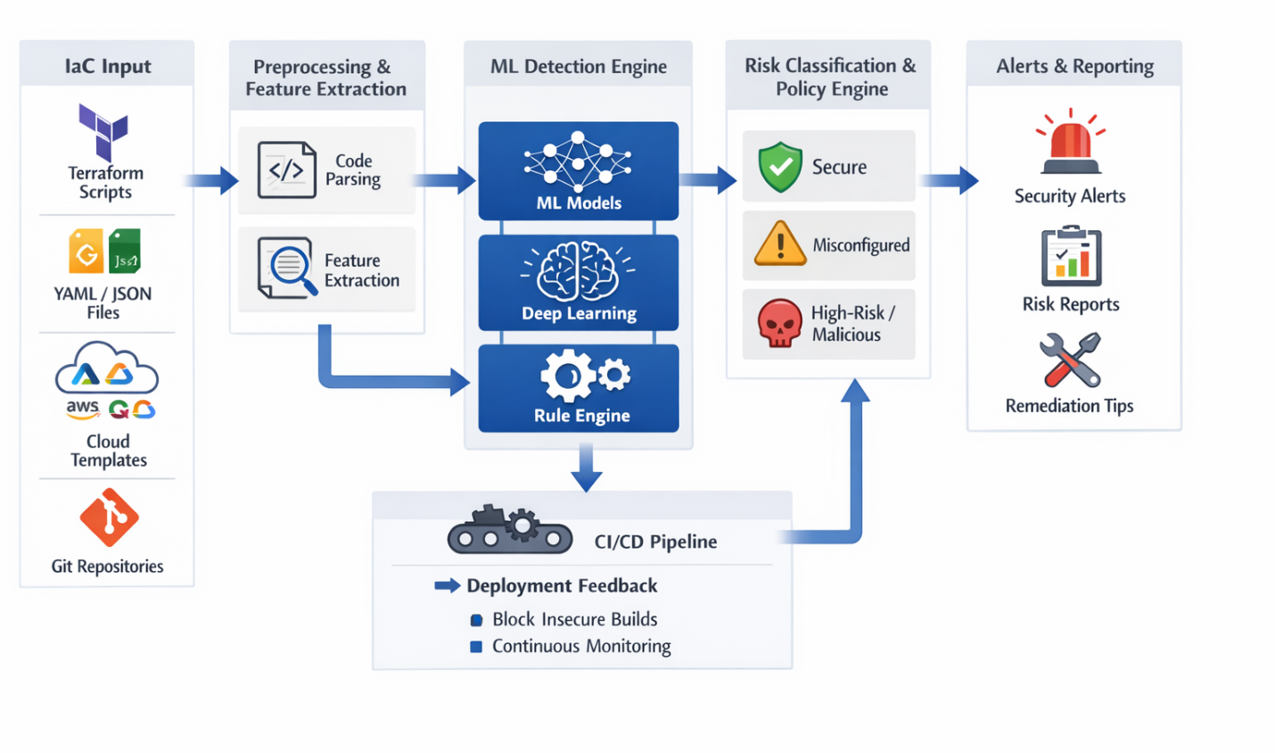

Data Flow Diagram
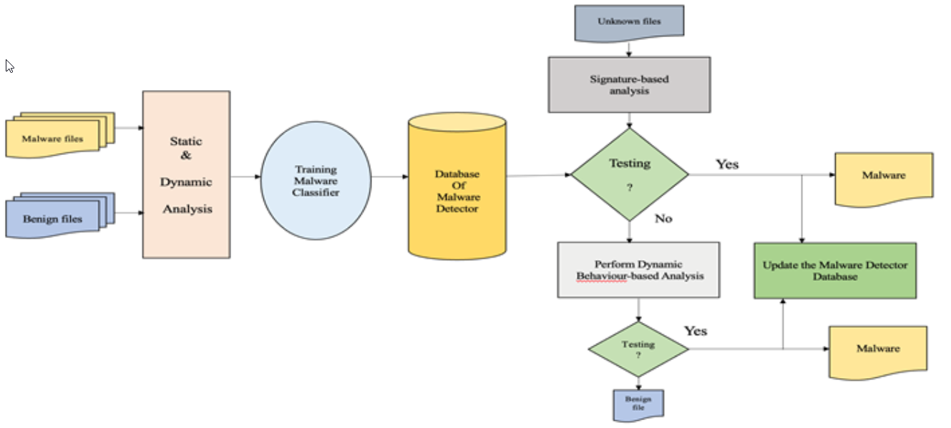

USE CASE DIAGRAM:
Register
Login
Upload data
ML Detection Engine
User
Risk Classification
Seach and Tag
Security Alerts
Data Procssing
Reporting
Admin
Analytics

8.2 CLASS DIAGRAM:
admin.
Login
Blockchain
Analytics
user
Register
login
Register()
Login()
send query()
decrypt()
Prepocessing
Risk Classification
Secure
view user()
view query()
generate key()

8.3 SEQUENCE DIAGRAM:
Provider
Dashborad
user
user
Admin
Admin
Register
login
register
login
Upload Ml Detection Engine
Risk Classification
Reporting
view Analytics

Tag Management
Information Risk Report

8.4 COLLABORATION DIAGRAM

user
Dashboard
Admin
1: Register
2: login
3: register
4: login
5: Upload dataset

6: Risk Classification
7: ML Detection
8: Rule Engine
9: Deep Learning

10: view Analytics

BLOCK DIAGRAM
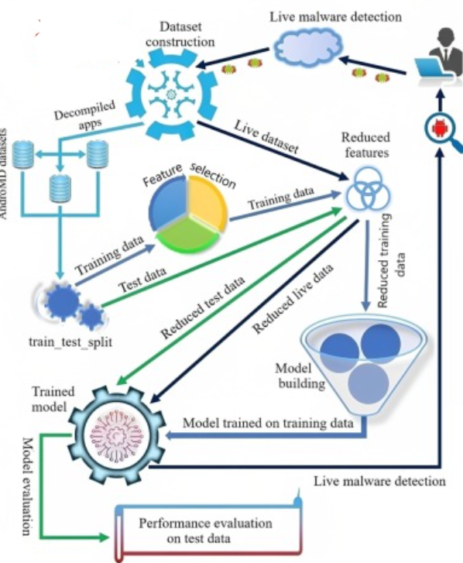

6.2 System Testing
The purpose of testing is to discover errors. Testing is the process of trying to discover every conceivable fault or weakness in a work product. It provides a way to check the functionality of components, sub assemblies, assemblies and/or a finished product It is the process of exercising software with the intent of ensuring that the
Software system meets its requirements and user expectations and does not fail in an unacceptable manner. There are various types of test. Each test type addresses a specific testing requirement.

TYPES OF TESTS

Unit testing
Unit testing involves the design of test cases that validate that the internal program logic is functioning properly, and that program inputs produce valid outputs. All decision branches and internal code flow should be validated. It is the testing of individual software units of the application .it is done after the completion of an individual unit before integration. This is a structural testing, that relies on knowledge of its construction and is invasive. Unit tests perform basic tests at component level and test a specific business process, application, and/or system configuration. Unit tests ensure that each unique path of a business process performs accurately to the documented specifications and contains clearly defined inputs and expected results.

Integration testing

Integration tests are designed to test integrated software components to determine if they actually run as one program. Testing is event driven and is more concerned with the basic outcome of screens or fields. Integration tests demonstrate that although the components were individually satisfaction, as shown by successfully unit testing, the combination of components is correct and consistent. Integration testing is specifically aimed at exposing the problems that arise from the combination of components.

Functional test

Functional tests provide systematic demonstrations that functions tested are available as specified by the business and technical requirements, system documentation, and user manuals.
Functional testing is centered on the following items:
Valid Input : identified classes of valid input must be accepted.
Invalid Input : identified classes of invalid input must be rejected.
Functions : identified functions must be exercised.
Output : identified classes of application outputs must be exercised.
Systems/Procedures: interfacing systems or procedures must be invoked.

Organization and preparation of functional tests is focused on requirements, key functions, or special test cases. In addition, systematic coverage pertaining to identify Business process flows; data fields, predefined processes, and successive processes must be considered for testing. Before functional testing is complete, additional tests are identified and the effective value of current tests is determined.

System Test
System testing ensures that the entire integrated software system meets requirements. It tests a configuration to ensure known and predictable results. An example of system testing is the configuration oriented system integration test. System testing is based on process descriptions and flows, emphasizing pre-driven process links and integration points.

White Box Testing
White Box Testing is a testing in which in which the software tester has knowledge of the inner workings, structure and language of the software, or at least its purpose. It is purpose. It is used to test areas that cannot be reached from a black box level.
Black Box Testing
Black Box Testing is testing the software without any knowledge of the inner workings, structure or language of the module being tested. Black box tests, as most other kinds of tests, must be written from a definitive source document, such as specification or requirements document, such as specification or requirements document. It is a testing in which the software under test is treated, as a black box .you cannot “see” into it. The test provides inputs and responds to outputs without considering how the software works.
6.1 Unit Testing:
Unit testing is usually conducted as part of a combined code and unit test phase of the software lifecycle, although it is not uncommon for coding and unit testing to be conducted as two distinct phases.

Test strategy and approach
Field testing will be performed manually and functional tests will be written in detail.

Test objectives
- All field entries must work properly.
- Pages must be activated from the identified link.
- The entry screen, messages and responses must not be delayed.

Features to be tested
- Verify that the entries are of the correct format
- No duplicate entries should be allowed
- All links should take the user to the correct page.

6.2 Integration Testing

Software integration testing is the incremental integration testing of two or more integrated software components on a single platform to produce failures caused by interface defects.
The task of the integration test is to check that components or software applications, e.g. components in a software system or – one step up – software applications at the company level – interact without error.
Test Results: All the test cases mentioned above passed successfully. No defects encountered.

6.3 Acceptance Testing

User Acceptance Testing is a critical phase of any project and requires significant participation by the end user. It also ensures that the system meets the functional requirements.
Test Results: All the test cases mentioned above passed successfully. No defects encountered.

6.4 Requirement Analysis
I) 6.4.1 Requirement Specifications
Software Description:
Anaconda is an open-source distribution of the Python and R programming languages for data science that aims to simplify package management and deployment. Package versions in Anaconda are managed by the package management system, conda, which analyzes the current environment before executing an installation to avoid disrupting other frameworks and packages.
The Anaconda distribution comes with over 250 packages automatically installed. Over 7500 additional open-source packages can be installed from PyPI as well as the conda package and virtual environment manager. It also includes a GUI (graphical user interface), Anaconda Navigator, as a graphical alternative to the command line interface. Anaconda Navigator is included in the Anaconda distribution, and allows users to launch applications and manage conda packages, environments and channels without using command-line commands. Navigator can search for packages, install them in an environment, run the packages and update them.

The big difference between conda and the pip package manager is in how package dependencies are managed, which is a significant challenge for Python data science. When pip installs a package, it automatically installs any dependent Python packages without checking if these conflict with previously installed packages. It will install a package and any of its dependencies regardless of the state of the existing installation. Because of this, a user with a working installation of, for example TensorFlow, can find that it stops working after using pip to install a different package that requires a different version of the dependent NumPy library than the one used by TensorFlow. In some cases, the package may appear to work but produce different results in execution. In contrast, conda analyzes the current environment including everything currently installed, and together with any version limitations specified (e.g., the user may wish to have TensorFlow version 2.0 or higher), works out how to install a compatible set of dependencies, and shows a warning if this cannot be done.

Open source packages can be individually installed from the Anaconda repository, Anaconda Cloud (anaconda.org), or the user’s own private repository or mirror, using the conda install command. Anaconda Inc. compiles and builds the packages available in the Anaconda repository itself, and provides binaries for Windows 32/64-bit, Linux 64-bit and MacOS 64-bit. Anything available on PyPI may be installed into a conda environment using pip, and conda will keep track of what it has installed itself and what pip has installed.
Differences between Anaconda and Data Science Platforms
While Anaconda supports some functionality you find in a data science platform, like Domino, it provides a subset of that functionality. Domino and other platforms not only support package management, but they also support capabilities like collaboration, reproducibility, scalable compute, and model monitoring. Conda can be used within the Domino environment.

6.5 Feasibility Study
The feasibility of the project is analyzed in this phase and business proposal is put forth with a very general plan for the project and some cost estimates. During system analysis the feasibility study of the proposed system is to be carried out. This is to ensure that the proposed system is not a burden to the company. For feasibility analysis, some understanding of the major requirements for the system is essential.

Three key considerations involved in the feasibility analysis are
- ECONOMICAL FEASIBILITY
- TECHNICAL FEASIBILITY
- SOCIAL FEASIBILITY

I) 6.10.1 Economical Feasibility
This study is carried out to check the economic impact that the system will have on the organization. The amount of fund that the company can pour into the research and development of the system is limited. The expenditures must be justified. Thus the developed system as well within the budget and this was achieved because most of the technologies used are freely available. Only the customized products had to be purchased.

Ii) 6.10.2 Technical Feasibility
This Study Is Carried Out To Check The Technical Feasibility, That Is, The Technical Requirements Of The System. Any System Developed Must Not Have A High Demand On The Available Technical Resources. This Will Lead To High Demands On The Available Technical Resources. This Will Lead To High Demands Being Placed On The Client. The Developed System Must Have A Modest Requirement, As Only Minimal Or Null Changes Are Required For Implementing This System.

iii) 6.10.3 social feasibility
The aspect of study is to check the level of acceptance of the system by the user. This includes the process of training the user to use the system efficiently. The user must not feel threatened by the system, instead must accept it as a necessity. The level of acceptance by the users solely depends on the methods that are employed to educate the user about the system and to make him familiar with it. His level of confidence must be raised so that he is also able to make some constructive criticism, which is welcomed, as he is the final user of the system.

SCREEN SHOT:


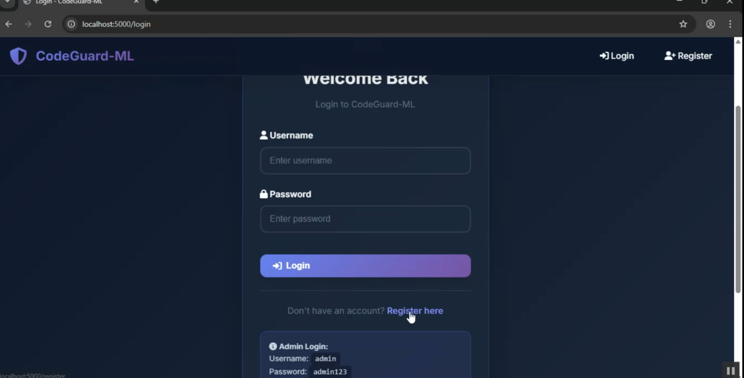

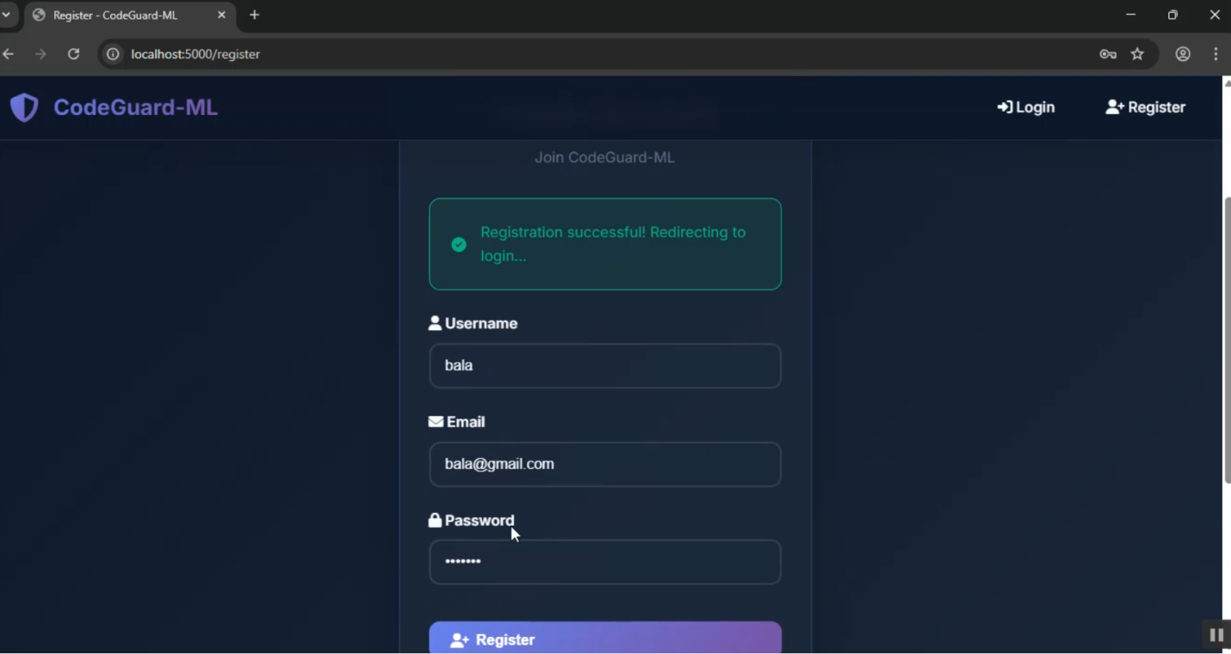

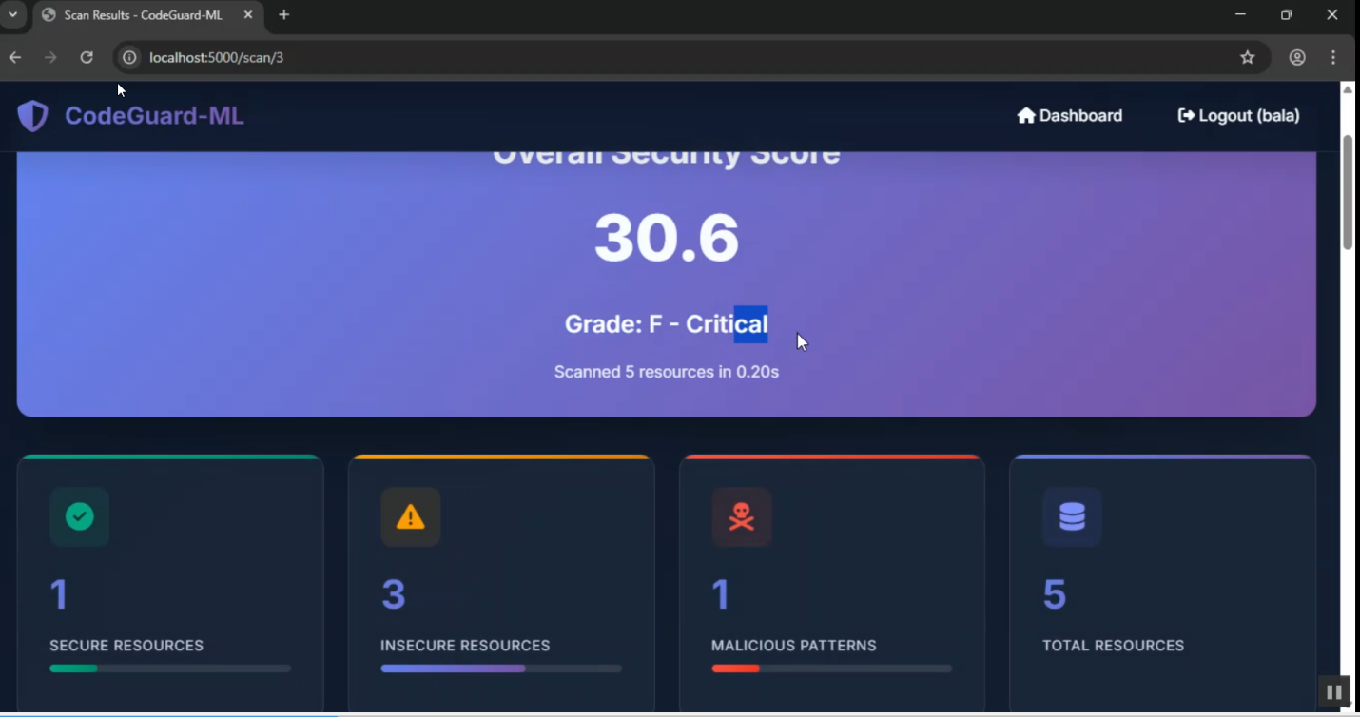

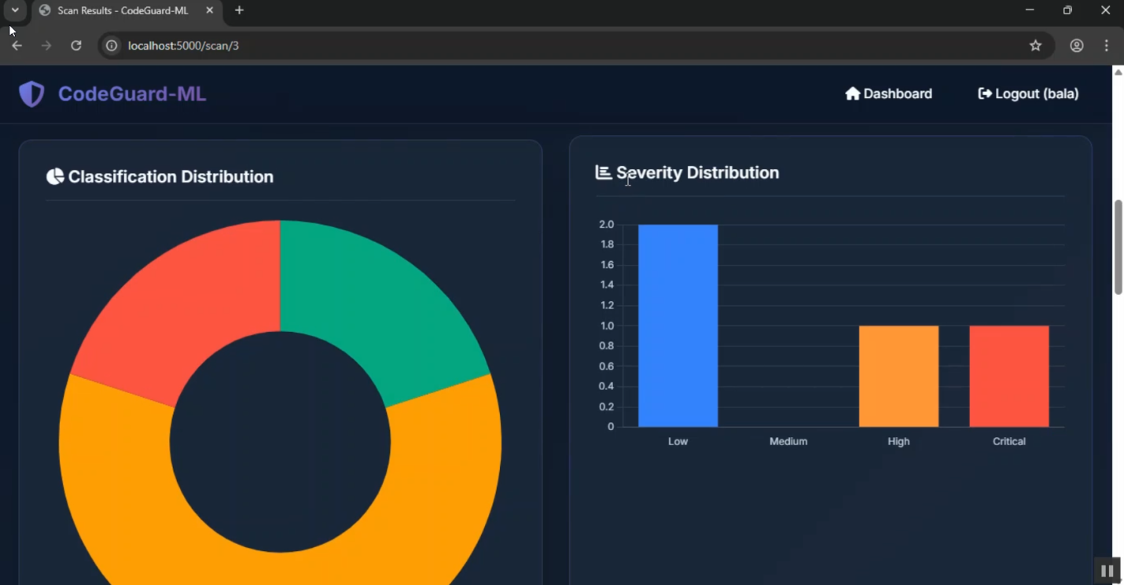

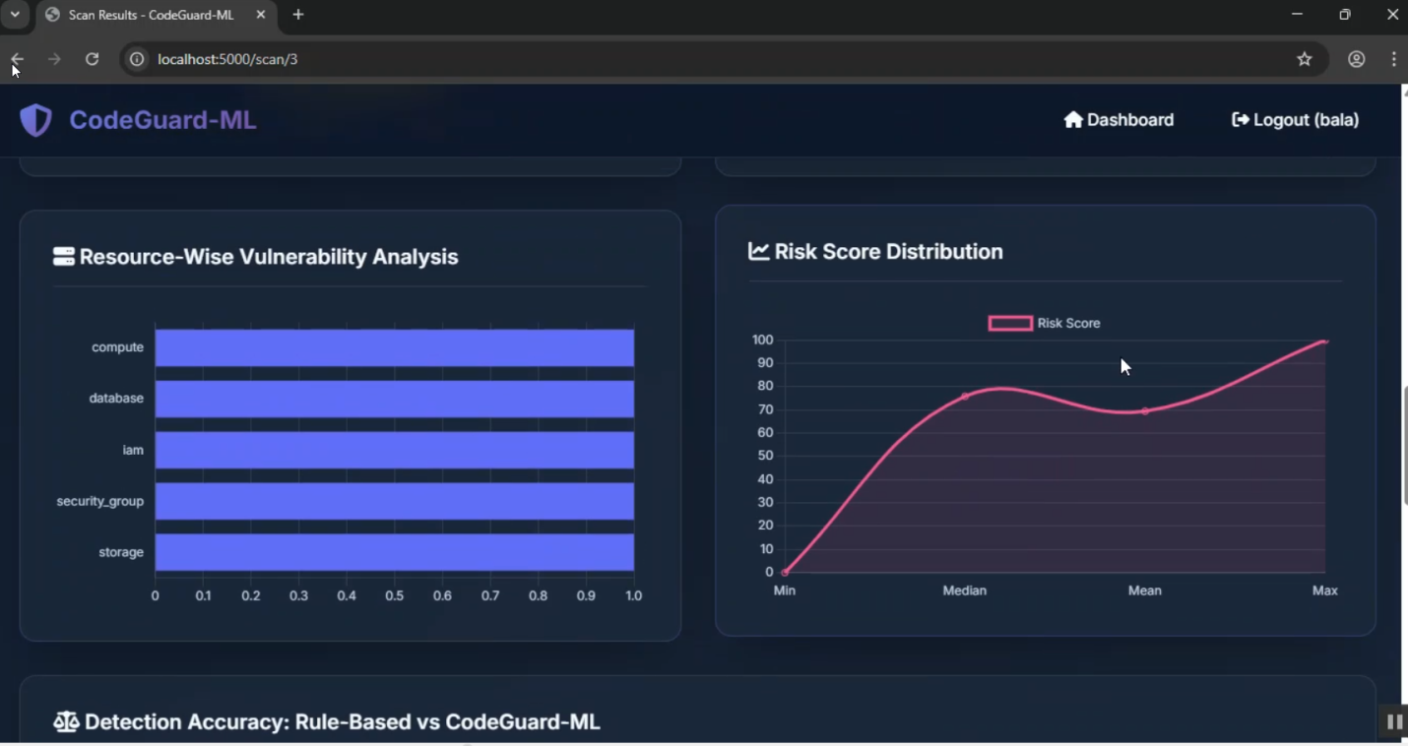

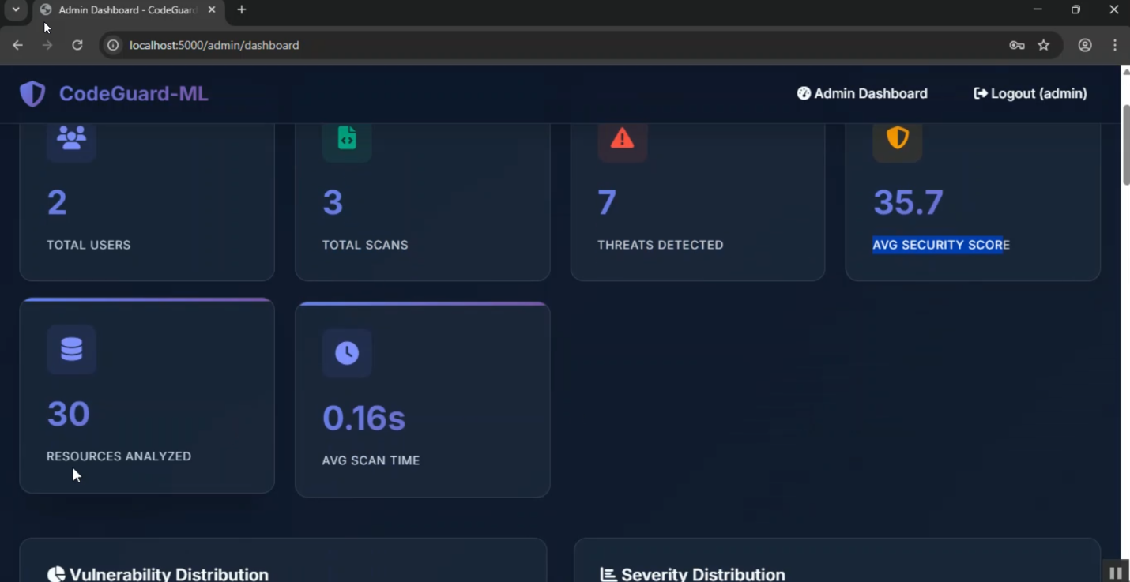

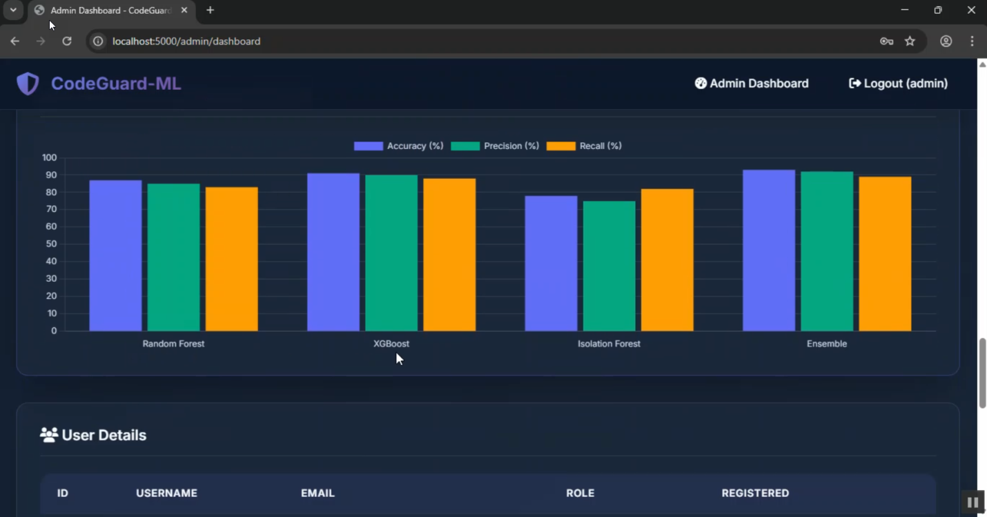

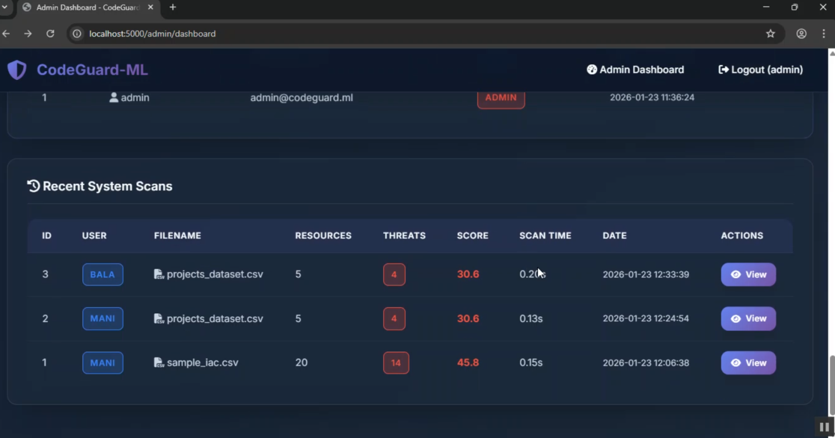

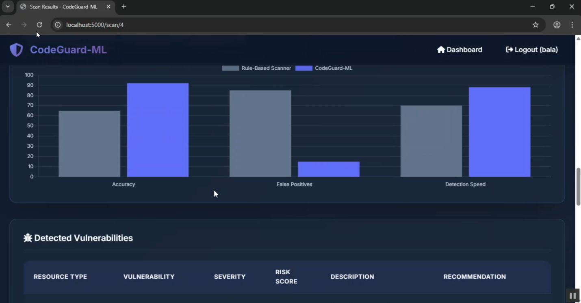

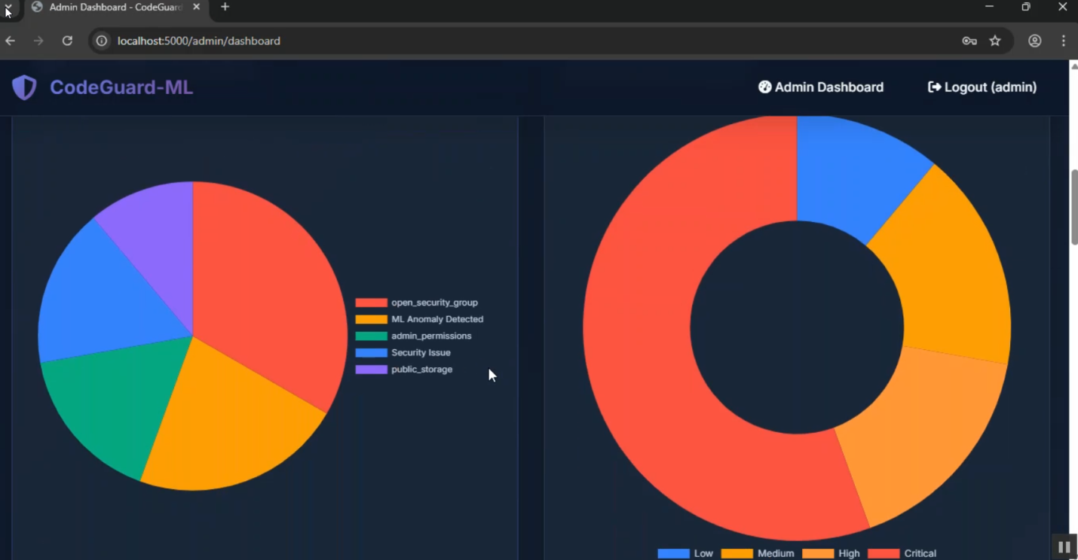

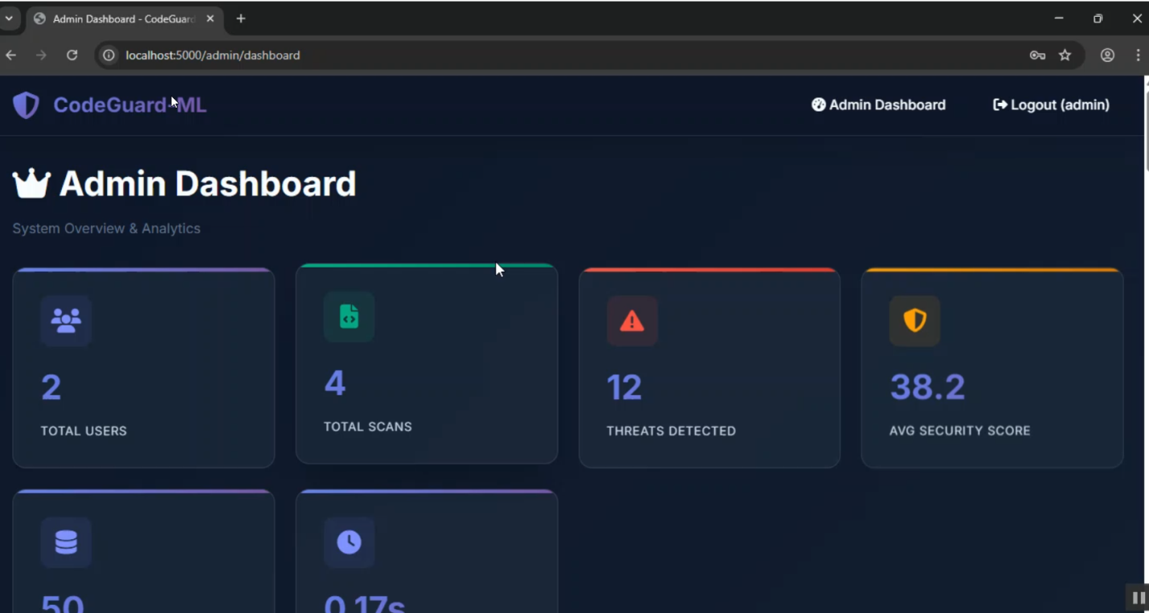

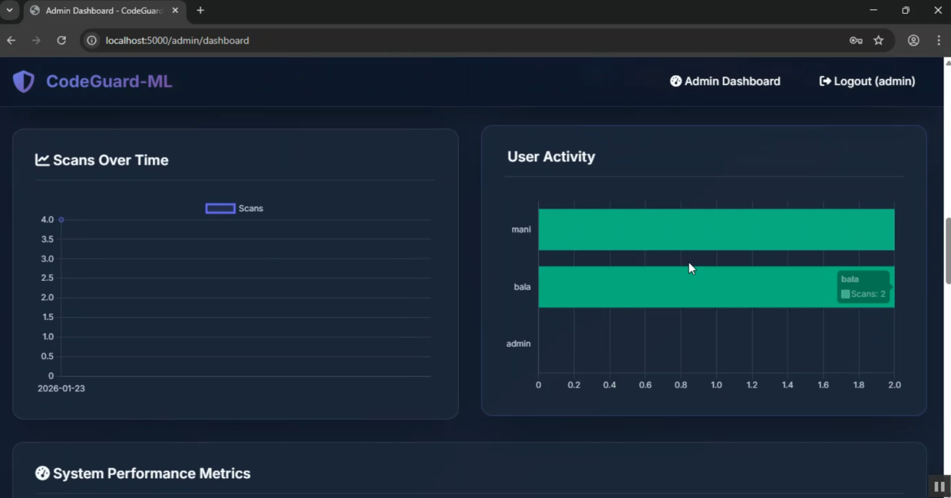

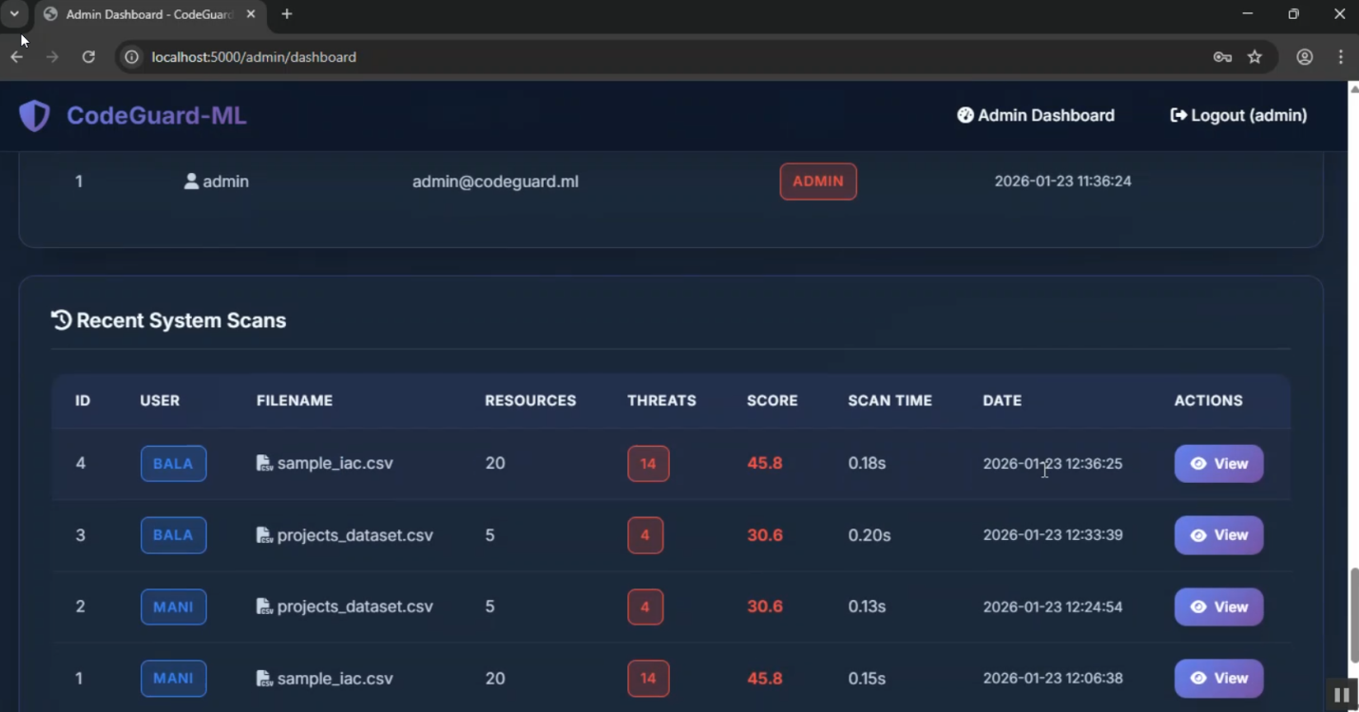

CODE:
import numpy as np
import pandas as pd
from sklearn.ensemble import RandomForestClassifier, IsolationForest
from sklearn.preprocessing import LabelEncoder, StandardScaler
import xgboost as xgb
import joblib
import os
from datetime import datetime

class MLEngine:
"""Machine Learning Engine for IaC Security Analysis"""

def __init__(self):
self.models = {}
self.encoders = {}
self.scaler = StandardScaler()
self.feature_names = []
self.is_trained = False

# Load pre-trained models if available
self.load_models()

# If no models, train with synthetic data
if not self.is_trained:
self.train_models()

def train_models(self):
"""Train ML models with synthetic IaC security data"""
print("🤖 Training ML models...")

# Generate synthetic training data
X_train, y_train = self.generate_training_data()

# Train Random Forest
print(" Training Random Forest...")
self.models['random_forest'] = RandomForestClassifier(
n_estimators=100,
max_depth=10,
random_state=42,
n_jobs=-1
)
self.models['random_forest'].fit(X_train, y_train)

# Train XGBoost
print(" Training XGBoost...")
self.models['xgboost'] = xgb.XGBClassifier(
n_estimators=100,
max_depth=6,
learning_rate=0.1,
random_state=42,
n_jobs=-1
)
self.models['xgboost'].fit(X_train, y_train)

# Train Isolation Forest for anomaly detection
print(" Training Isolation Forest...")
self.models['isolation_forest'] = IsolationForest(
contamination=0.1,
random_state=42,
n_jobs=-1
)
self.models['isolation_forest'].fit(X_train)

self.is_trained = True

# Save models
self.save_models()

print("✅ ML models trained successfully!")

def generate_training_data(self, n_samples=1000):
"""Generate synthetic training data for IaC security"""
np.random.seed(42)

# Feature columns
features = []
labels = []

for i in range(n_samples):
# Simulate IaC features
feature_vector = {
'port_exposure': np.random.choice([0, 22, 80, 443, 3389, 8080]),
'cidr_range': np.random.choice([0, 16, 24, 32]), # 0 = 0.0.0.0/0 (public)
'encryption_enabled': np.random.choice([0, 1]),
'public_access': np.random.choice([0, 1]),
'admin_permissions': np.random.choice([0, 1]),
'mfa_enabled': np.random.choice([0, 1]),
'logging_enabled': np.random.choice([0, 1]),
'versioning_enabled': np.random.choice([0, 1]),
'hardcoded_secrets': np.random.choice([0, 1]),
'resource_complexity': np.random.randint(1, 10)
}

# Generate label based on security rules
if (feature_vector['cidr_range'] == 0 and
feature_vector['port_exposure'] in [22, 3389]):
label = 2 # Malicious
elif (feature_vector['public_access'] == 1 and
feature_vector['encryption_enabled'] == 0):
label = 1 # Insecure
elif (feature_vector['hardcoded_secrets'] == 1 or
feature_vector['admin_permissions'] == 1 and feature_vector['mfa_enabled'] == 0):
label = 1 # Insecure
elif (feature_vector['encryption_enabled'] == 1 and
feature_vector['logging_enabled'] == 1 and
feature_vector['mfa_enabled'] == 1):
label = 0 # Secure
else:
# Random assignment with bias towards insecure
label = np.random.choice([0, 1, 2], p=[0.4, 0.5, 0.1])

features.append(list(feature_vector.values()))
labels.append(label)

self.feature_names = list(feature_vector.keys())

X = np.array(features)
y = np.array(labels)

# Scale features
X = self.scaler.fit_transform(X)

return X, y

def extract_features_from_data(self, data):
"""Extract ML features from IaC data"""
features = []

for idx, row in data.iterrows():
feature_vector = {
'port_exposure': self._extract_port(row),
'cidr_range': self._extract_cidr(row),
'encryption_enabled': self._check_encryption(row),
'public_access': self._check_public_access(row),
'admin_permissions': self._check_admin_perms(row),
'mfa_enabled': self._check_mfa(row),
'logging_enabled': self._check_logging(row),
'versioning_enabled': self._check_versioning(row),
'hardcoded_secrets': self._check_secrets(row),
'resource_complexity': self._calculate_complexity(row)
}
features.append(list(feature_vector.values()))

return np.array(features)

def _extract_port(self, row):
"""Extract port number from row"""
for col in row.index:
val = str(row[col]).lower()
if 'port' in col.lower() or 'port' in val:
try:
# Extract numeric port
import re
match = re.search(r'\d+', val)
if match:
return int(match.group())
except:
pass
return 0

def _extract_cidr(self, row):
"""Extract CIDR range"""
for col in row.index:
val = str(row[col]).lower()
if 'cidr' in col.lower() or '/' in val:
if '0.0.0.0/0' in val or '::/0' in val:
return 0 # Public
try:
import re
match = re.search(r'/(\d+)', val)
if match:
return int(match.group(1))
except:
pass
return 32 # Default to private

def _check_encryption(self, row):
"""Check if encryption is enabled"""
for col in row.index:
val = str(row[col]).lower()
if 'encrypt' in col.lower() or 'encrypt' in val:
if 'true' in val or 'enabled' in val or 'yes' in val:
return 1
if 'false' in val or 'disabled' in val or 'no' in val:
return 0
return 0 # Default to not encrypted

def _check_public_access(self, row):
"""Check if resource has public access"""
for col in row.index:
val = str(row[col]).lower()
if 'public' in col.lower() or 'public' in val:
if 'true' in val or 'enabled' in val or 'yes' in val:
return 1
return 0

def _check_admin_perms(self, row):
"""Check for admin permissions"""
for col in row.index:
val = str(row[col]).lower()
if 'admin' in val or 'root' in val or '*' in val:
return 1
return 0

def _check_mfa(self, row):
"""Check if MFA is enabled"""
for col in row.index:
val = str(row[col]).lower()
if 'mfa' in col.lower() or '2fa' in col.lower():
if 'true' in val or 'enabled' in val:
return 1
return 0

def _check_logging(self, row):
"""Check if logging is enabled"""
for col in row.index:
val = str(row[col]).lower()
if 'log' in col.lower():
if 'true' in val or 'enabled' in val:
return 1
return 0

def _check_versioning(self, row):
"""Check if versioning is enabled"""
for col in row.index:
val = str(row[col]).lower()
if 'version' in col.lower():
if 'true' in val or 'enabled' in val:
return 1
return 0

def _check_secrets(self, row):
"""Check for hardcoded secrets"""
for col in row.index:
val = str(row[col])
# Simple pattern matching for secrets
if any(keyword in val.lower() for keyword in ['password', 'secret', 'key', 'token']):
# Check if it looks like a hardcoded value (not a reference)
if not any(ref in val.lower() for ref in ['var.', 'env.', 'secret.', 'parameter']):
return 1
return 0

def _calculate_complexity(self, row):
"""Calculate resource complexity"""
# Simple complexity based on number of non-null fields
return sum(1 for val in row if pd.notna(val) and str(val).strip())

def predict(self, data):
"""Make predictions using ensemble of models"""
if not self.is_trained:
self.train_models()

# Extract features
X = self.extract_features_from_data(data)

# Scale features
X_scaled = self.scaler.transform(X)

# Get predictions from each model
rf_pred = self.models['random_forest'].predict(X_scaled)
rf_proba = self.models['random_forest'].predict_proba(X_scaled)

xgb_pred = self.models['xgboost'].predict(X_scaled)
xgb_proba = self.models['xgboost'].predict_proba(X_scaled)

# Isolation Forest (anomaly detection)
iso_pred = self.models['isolation_forest'].predict(X_scaled)
# Convert: -1 (anomaly) -> 2 (malicious), 1 (normal) -> 0 (secure)
iso_pred = np.where(iso_pred == -1, 2, 0)

# Ensemble predictions (weighted voting)
predictions = []
for i in range(len(X)):
# Combine probabilities
combined_proba = (rf_proba[i] + xgb_proba[i]) / 2

# Get class with highest probability
pred_class = np.argmax(combined_proba)

# If isolation forest detected anomaly, increase malicious probability
if iso_pred[i] == 2:
pred_class = max(pred_class, 1) # At least insecure

confidence = float(np.max(combined_proba))

predictions.append({
'classification': ['Secure', 'Insecure', 'Malicious'][pred_class],
'confidence': confidence,
'rf_prediction': int(rf_pred[i]),
'xgb_prediction': int(xgb_pred[i]),
'anomaly_detected': bool(iso_pred[i] == 2),
'probabilities': {
'secure': float(combined_proba[0]),
'insecure': float(combined_proba[1]) if len(combined_proba) > 1 else 0,
'malicious': float(combined_proba[2]) if len(combined_proba) > 2 else 0
}
})

return predictions

def get_feature_importance(self):
"""Get feature importance from Random Forest"""
if 'random_forest' not in self.models:
return {}

importance = self.models['random_forest'].feature_importances_
feature_importance = dict(zip(self.feature_names, importance))

# Sort by importance
return dict(sorted(feature_importance.items(), key=lambda x: x[1], reverse=True))

def save_models(self):
"""Save trained models to disk"""
os.makedirs('models', exist_ok=True)

for name, model in self.models.items():
joblib.dump(model, f'models/{name}.pkl')

joblib.dump(self.scaler, 'models/scaler.pkl')
joblib.dump(self.feature_names, 'models/feature_names.pkl')

def load_models(self):
"""Load pre-trained models from disk"""
try:
if os.path.exists('models'):
self.models['random_forest'] = joblib.load('models/random_forest.pkl')
self.models['xgboost'] = joblib.load('models/xgboost.pkl')
self.models['isolation_forest'] = joblib.load('models/isolation_forest.pkl')
self.scaler = joblib.load('models/scaler.pkl')
self.feature_names = joblib.load('models/feature_names.pkl')
self.is_trained = True
print("✅ Loaded pre-trained ML models")
except Exception as e:
print(f"ℹ️ No pre-trained models found, will train new models")
self.is_trained = False

import numpy as np

class RiskScorer:
"""Risk scoring and severity classification engine"""

def __init__(self):
self.severity_weights = {
'Critical': 100,
'High': 75,
'Medium': 50,
'Low': 25
}

self.classification_weights = {
'Malicious': 100,
'Insecure': 60,
'Secure': 0
}

def calculate_scores(self, results, features):
"""Calculate risk scores for each resource"""
risk_scores = []

for i, result in enumerate(results):
score = self._calculate_individual_score(result, features[i])
risk_scores.append(score)

return risk_scores

def _calculate_individual_score(self, result, feature):
"""Calculate risk score for individual resource"""
base_score = 0

# Classification-based score
classification = result['classification']
base_score += self.classification_weights.get(classification, 0)

# Vulnerability-based score
vulnerabilities = result.get('vulnerabilities', [])
for vuln in vulnerabilities:
severity = vuln.get('severity', 'Low')
base_score += self.severity_weights.get(severity, 0) * 0.3

# ML confidence adjustment
confidence = result.get('confidence', 0.5)
if classification != 'Secure':
base_score *= confidence

# Anomaly detection boost
if result.get('anomaly_detected', False):
base_score *= 1.2

# Feature-based adjustments
if feature.get('network_exposure') == 'public':
base_score *= 1.3

if feature.get('encryption_status') == 'disabled':
base_score *= 1.2

if feature.get('access_policy') == 'overprivileged':
base_score *= 1.25

# Normalize to 0-100
risk_score = min(100, max(0, base_score))

# Determine severity level
severity = self._score_to_severity(risk_score)

# Calculate feature importance
feature_importance = self._calculate_feature_importance(result, feature)

return {
'risk_score': risk_score,
'severity': severity,
'classification': classification,
'confidence': confidence,
'feature_importance': feature_importance,
'explanation': self._generate_explanation(result, feature, risk_score)
}

def _score_to_severity(self, score):
"""Convert risk score to severity level"""
if score >= 80:
return 'Critical'
elif score >= 60:
return 'High'
elif score >= 40:
return 'Medium'
else:
return 'Low'

def _calculate_feature_importance(self, result, feature):
"""Calculate which features contributed most to the risk score"""
importance = {}

# Network exposure
if feature.get('network_exposure') == 'public':
importance['network_exposure'] = 0.3

# Encryption
if feature.get('encryption_status') == 'disabled':
importance['encryption'] = 0.25

# Access policy
if feature.get('access_policy') == 'overprivileged':
importance['access_policy'] = 0.25

# Authentication
if feature.get('authentication') == 'mfa_disabled':
importance['authentication'] = 0.15

# Logging
if feature.get('logging_status') == 'disabled':
importance['logging'] = 0.1

# Vulnerabilities
vuln_count = result.get('vulnerability_count', 0)
if vuln_count > 0:
importance['vulnerabilities'] = min(0.4, vuln_count * 0.1)

# Normalize
total = sum(importance.values())
if total > 0:
importance = {k: v/total for k, v in importance.items()}

# Sort by importance
return dict(sorted(importance.items(), key=lambda x: x[1], reverse=True))

def _generate_explanation(self, result, feature, risk_score):
"""Generate human-readable explanation of risk score"""
explanations = []

classification = result['classification']
confidence = result.get('confidence', 0)

# Main classification
explanations.append(
f"Resource classified as {classification} with {confidence*100:.1f}% confidence"
)

# Vulnerabilities
vulnerabilities = result.get('vulnerabilities', [])
if vulnerabilities:
critical_vulns = [v for v in vulnerabilities if v['severity'] == 'Critical']
high_vulns = [v for v in vulnerabilities if v['severity'] == 'High']

if critical_vulns:
explanations.append(
f"Found {len(critical_vulns)} critical vulnerability(ies)"
)
if high_vulns:
explanations.append(
f"Found {len(high_vulns)} high severity vulnerability(ies)"
)

# Network exposure
if feature.get('network_exposure') == 'public':
explanations.append("Resource is publicly exposed")

# Encryption
if feature.get('encryption_status') == 'disabled':
explanations.append("Encryption is not enabled")

# Access policy
if feature.get('access_policy') == 'overprivileged':
explanations.append("Overly permissive access policy detected")

# Anomaly
if result.get('anomaly_detected', False):
explanations.append("Anomalous pattern detected by ML model")

return ' | '.join(explanations)

def calculate_overall_score(self, risk_scores):
"""Calculate overall security score for all resources"""
if not risk_scores:
return {
'score': 100,
'grade': 'A',
'total_resources': 0,
'critical_issues': 0,
'high_issues': 0,
'medium_issues': 0,
'low_issues': 0
}

# Count by severity
severity_counts = {
'Critical': 0,
'High': 0,
'Medium': 0,
'Low': 0
}

total_risk = 0
for score_info in risk_scores:
severity = score_info['severity']
severity_counts[severity] += 1
total_risk += score_info['risk_score']

# Calculate average risk
avg_risk = total_risk / len(risk_scores)

# Convert to security score (inverse of risk)
security_score = max(0, 100 - avg_risk)

# Determine grade
grade = self._score_to_grade(security_score)

return {
'score': security_score,
'grade': grade,
'total_resources': len(risk_scores),
'critical_issues': severity_counts['Critical'],
'high_issues': severity_counts['High'],
'medium_issues': severity_counts['Medium'],
'low_issues': severity_counts['Low'],
'avg_risk': avg_risk
}

def _score_to_grade(self, score):
"""Convert security score to letter grade"""
if score >= 90:
return 'A'
elif score >= 80:
return 'B'
elif score >= 70:
return 'C'
elif score >= 60:
return 'D'
else:
return 'F'

def generate_recommendations(self, risk_scores):
"""Generate prioritized security recommendations"""
recommendations = []

# Group by severity
critical_items = [s for s in risk_scores if s['severity'] == 'Critical']
high_items = [s for s in risk_scores if s['severity'] == 'High']

if critical_items:
recommendations.append({
'priority': 'Critical',
'count': len(critical_items),
'action': 'Immediate action required',
'description': 'Address critical security vulnerabilities immediately to prevent potential breaches'
})

if high_items:
recommendations.append({
'priority': 'High',
'count': len(high_items),
'action': 'Address within 24 hours',
'description': 'Fix high severity issues to significantly improve security posture'
})

# Feature-based recommendations
feature_issues = {}
for score_info in risk_scores:
for feature, importance in score_info.get('feature_importance', {}).items():
if importance > 0.2: # Significant contribution
feature_issues[feature] = feature_issues.get(feature, 0) + 1

# Top feature recommendations
for feature, count in sorted(feature_issues.items(), key=lambda x: x[1], reverse=True)[:3]:
recommendations.append({
'priority': 'Medium',
'count': count,
'action': f'Review {feature} configuration',
'description': self._get_feature_recommendation(feature)
})

return recommendations

def _get_feature_recommendation(self, feature):
"""Get recommendation text for a feature"""
recommendations = {
'network_exposure': 'Restrict network access to only necessary IP ranges',
'encryption': 'Enable encryption at rest and in transit for all resources',
'access_policy': 'Implement principle of least privilege for all access policies',
'authentication': 'Enable multi-factor authentication for all user accounts',
'logging': 'Enable comprehensive logging for audit and compliance',
'vulnerabilities': 'Address detected vulnerabilities according to severity'
}

return recommendations.get(feature, 'Review and improve security configuration')
{% extends "base.html" %}

{% block title %}Admin Dashboard - CodeGuard-ML{% endblock %}

{% block content %}
<div class="container" style="padding: 2rem 1.5rem;">
<!-- Header -->
<div class="flex-between" style="margin-bottom: 2rem;">
<div>
<h1>
<i class="fas fa-crown"></i> Admin Dashboard
</h1>
<p style="color: var(--gray);">System Overview & Analytics</p>
</div>
</div>

<!-- System Statistics -->
<div class="stats-grid">
<div class="stat-card">
<div class="stat-icon">
<i class="fas fa-users"></i>
</div>
<div class="stat-value">{{ stats['total_users'] or 0 }}</div>
<div class="stat-label">Total Users</div>
</div>

<div class="stat-card success">
<div class="stat-icon">
<i class="fas fa-file-code"></i>
</div>
<div class="stat-value">{{ stats['total_scans'] or 0 }}</div>
<div class="stat-label">Total Scans</div>
</div>

<div class="stat-card danger">
<div class="stat-icon">
<i class="fas fa-exclamation-triangle"></i>
</div>
<div class="stat-value">{{ stats['total_threats'] or 0 }}</div>
<div class="stat-label">Threats Detected</div>
</div>

<div class="stat-card warning">
<div class="stat-icon">
<i class="fas fa-shield-alt"></i>
</div>
<div class="stat-value">{{ "%.1f"|format(stats['avg_score'] or 100) }}</div>
<div class="stat-label">Avg Security Score</div>
</div>

<div class="stat-card">
<div class="stat-icon">
<i class="fas fa-database"></i>
</div>
<div class="stat-value">{{ stats['total_resources'] or 0 }}</div>
<div class="stat-label">Resources Analyzed</div>
</div>

<div class="stat-card">
<div class="stat-icon">
<i class="fas fa-clock"></i>
</div>
<div class="stat-value">{{ "%.2f"|format(stats['avg_scan_time'] or 0) }}s</div>
<div class="stat-label">Avg Scan Time</div>
</div>
</div>

<!-- Analytics Charts -->
<div class="grid grid-2" style="margin-bottom: 2rem;">
<!-- Vulnerability Distribution -->
<div class="card">
<div class="card-header">
<h4 class="card-title">
<i class="fas fa-chart-pie"></i> Vulnerability Distribution
</h4>
</div>
<div class="card-body">
<canvas id="vulnDistChart"></canvas>
</div>
</div>

<!-- Severity Distribution -->
<div class="card">
<div class="card-header">
<h4 class="card-title">
<i class="fas fa-chart-bar"></i> Severity Distribution
</h4>
</div>
<div class="card-body">
<canvas id="severityDistChart"></canvas>
</div>
</div>
</div>

<!-- More Analytics -->
<div class="grid grid-2" style="margin-bottom: 2rem;">
<!-- Scans Timeline -->
<div class="card">
<div class="card-header">
<h4 class="card-title">
<i class="fas fa-chart-line"></i> Scans Over Time
</h4>
</div>
<div class="card-body">
<canvas id="scansTimelineChart"></canvas>
</div>
</div>

<!-- User Activity -->
<div class="card">
<div class="card-header">
<h4 class="card-title">
<i class="fas fa-user-chart"></i> User Activity
</h4>
</div>
<div class="card-body">
<canvas id="userActivityChart"></canvas>
</div>
</div>
</div>

<!-- Performance Metrics -->
<div class="card" style="margin-bottom: 2rem;">
<div class="card-header">
<h4 class="card-title">
<i class="fas fa-tachometer-alt"></i> System Performance Metrics
</h4>
</div>
<div class="card-body">
<canvas id="performanceChart" style="max-height: 300px;"></canvas>
</div>
</div>

<!-- ML Model Performance -->
<div class="card" style="margin-bottom: 2rem;">
<div class="card-header">
<h4 class="card-title">
<i class="fas fa-brain"></i> ML Model Performance Comparison
</h4>
</div>
<div class="card-body">
<canvas id="modelPerformanceChart" style="max-height: 300px;"></canvas>
</div>
</div>

<!-- Users Table -->
<div class="card" style="margin-bottom: 2rem;">
<div class="card-header">
<h4 class="card-title">
<i class="fas fa-users"></i> User Details
</h4>
</div>
<div class="card-body">
<div class="table-container">
<table>
<thead>
<tr>
<th>ID</th>
<th>Username</th>
<th>Email</th>
<th>Role</th>
<th>Registered</th>
</tr>
</thead>
<tbody>
{% for user in users %}
<tr>
<td>{{ user['id'] }}</td>
<td>
<i class="fas fa-user"></i> {{ user['username'] }}
</td>
<td>{{ user['email'] }}</td>
<td>
<span
class="badge badge-{% if user['username'] == 'admin' %}danger{% else %}info{% endif %}">
{% if user['username'] == 'admin' %}Admin{% else %}User{% endif %}
</span>
</td>
<td style="font-size: 0.875rem;">{{ user['created_at'] }}</td>
</tr>
{% endfor %}
</tbody>
</table>
</div>
</div>
</div>

<!-- Recent Scans -->
<div class="card">
<div class="card-header">
<h4 class="card-title">
<i class="fas fa-history"></i> Recent System Scans
</h4>
</div>
<div class="card-body">
<div class="table-container">
<table>
<thead>
<tr>
<th>ID</th>
<th>User</th>
<th>Filename</th>
<th>Resources</th>
<th>Threats</th>
<th>Score</th>
<th>Scan Time</th>
<th>Date</th>
<th>Actions</th>
</tr>
</thead>
<tbody>
{% for scan in scans %}
<tr>
<td>{{ scan['id'] }}</td>
<td>
<span class="badge badge-info">{{ scan['username'] }}</span>
</td>
<td>
<i class="fas fa-file-csv"></i> {{ scan['filename'] }}
</td>
<td>{{ scan['total_resources'] }}</td>
<td>
<span
class="badge badge-{% if scan['malicious_count'] > 0 %}danger{% elif scan['insecure_count'] > 0 %}warning{% else %}success{% endif %}">
{{ scan['malicious_count'] + scan['insecure_count'] }}
</span>
</td>
<td>
<strong
style="color: {% if scan['overall_score'] >= 80 %}var(--success){% elif scan['overall_score'] >= 60 %}var(--warning){% else %}var(--danger){% endif %};">
{{ "%.1f"|format(scan['overall_score']) }}
</strong>
</td>
<td>{{ "%.2f"|format(scan['scan_time']) }}s</td>
<td style="font-size: 0.875rem;">{{ scan['created_at'] }}</td>
<td>
<a href="/scan/{{ scan['id'] }}" class="btn btn-primary"
style="padding: 0.5rem 1rem; font-size: 0.875rem;">
<i class="fas fa-eye"></i> View
</a>
</td>
</tr>
{% endfor %}
</tbody>
</table>
</div>
</div>
</div>
</div>

<script>
// Fetch admin reports data
fetch('/api/admin/reports')
.then(response => response.json())
.then(data => {
if (data.success) {
createAdminCharts(data);
}
});

function createAdminCharts(data) {
// Vulnerability Distribution
const vulnDist = data.vulnerability_distribution || [];
new Chart(document.getElementById('vulnDistChart'), {
type: 'pie',
data: {
labels: vulnDist.map(v => v.vulnerability_type),
datasets: [{
data: vulnDist.map(v => v.count),
backgroundColor: [
'#ef4444', '#f59e0b', '#10b981', '#3b82f6', '#8b5cf6',
'#ec4899', '#14b8a6', '#f97316', '#06b6d4', '#84cc16'
],
borderWidth: 0
}]
},
options: {
responsive: true,
maintainAspectRatio: true,
plugins: {
legend: {
position: 'right',
labels: { color: '#cbd5e1', font: { size: 11 } }
}
}
}
});

// Severity Distribution
const sevDist = data.severity_distribution || [];
const sevMap = { Low: 0, Medium: 0, High: 0, Critical: 0 };
sevDist.forEach(s => sevMap[s.severity] = s.count);

new Chart(document.getElementById('severityDistChart'), {
type: 'doughnut',
data: {
labels: ['Low', 'Medium', 'High', 'Critical'],
datasets: [{
data: [sevMap.Low, sevMap.Medium, sevMap.High, sevMap.Critical],
backgroundColor: ['#3b82f6', '#f59e0b', '#fb923c', '#ef4444'],
borderWidth: 0
}]
},
options: {
responsive: true,
maintainAspectRatio: true,
plugins: {
legend: {
position: 'bottom',
labels: { color: '#cbd5e1', font: { size: 12 } }
}
}
}
});

// Scans Timeline
const timeline = data.scans_timeline || [];
new Chart(document.getElementById('scansTimelineChart'), {
type: 'line',
data: {
labels: timeline.map(t => t.date).reverse(),
datasets: [{
label: 'Scans',
data: timeline.map(t => t.count).reverse(),
borderColor: '#6366f1',
backgroundColor: 'rgba(99, 102, 241, 0.1)',
fill: true,
tension: 0.4
}]
},
options: {
responsive: true,
maintainAspectRatio: true,
plugins: {
legend: {
labels: { color: '#cbd5e1' }
}
},
scales: {
y: {
beginAtZero: true,
ticks: { color: '#cbd5e1' },
grid: { color: 'rgba(255,255,255,0.1)' }
},
x: {
ticks: { color: '#cbd5e1', maxRotation: 45 },
grid: { display: false }
}
}
}
});

// User Activity
const userActivity = data.user_activity || [];
new Chart(document.getElementById('userActivityChart'), {
type: 'bar',
data: {
labels: userActivity.map(u => u.username),
datasets: [{
label: 'Scans',
data: userActivity.map(u => u.scan_count),
backgroundColor: '#10b981',
borderWidth: 0
}]
},
options: {
responsive: true,
maintainAspectRatio: true,
indexAxis: 'y',
plugins: {
legend: { display: false }
},
scales: {
x: {
beginAtZero: true,
ticks: { color: '#cbd5e1' },
grid: { color: 'rgba(255,255,255,0.1)' }
},
y: {
ticks: { color: '#cbd5e1' },
grid: { display: false }
}
}
}
});

// Performance Metrics
new Chart(document.getElementById('performanceChart'), {
type: 'radar',
data: {
labels: ['Accuracy', 'Speed', 'Precision', 'Recall', 'F1-Score', 'Scalability'],
datasets: [{
label: 'CodeGuard-ML',
data: [92, 88, 90, 87, 89, 95],
borderColor: '#6366f1',
backgroundColor: 'rgba(99, 102, 241, 0.2)',
pointBackgroundColor: '#6366f1'
}]
},
options: {
responsive: true,
maintainAspectRatio: true,
plugins: {
legend: {
labels: { color: '#cbd5e1' }
}
},
scales: {
r: {
beginAtZero: true,
max: 100,
ticks: { color: '#cbd5e1', backdropColor: 'transparent' },
grid: { color: 'rgba(255,255,255,0.1)' },
pointLabels: { color: '#cbd5e1' }
}
}
}
});

// ML Model Performance
new Chart(document.getElementById('modelPerformanceChart'), {
type: 'bar',
data: {
labels: ['Random Forest', 'XGBoost', 'Isolation Forest', 'Ensemble'],
datasets: [
{
label: 'Accuracy (%)',
data: [87, 91, 78, 93],
backgroundColor: '#6366f1'
},
{
label: 'Precision (%)',
data: [85, 90, 75, 92],
backgroundColor: '#10b981'
},
{
label: 'Recall (%)',
data: [83, 88, 82, 89],
backgroundColor: '#f59e0b'
}
]
},
options: {
responsive: true,
maintainAspectRatio: true,
plugins: {
legend: {
labels: { color: '#cbd5e1' }
}
},
scales: {
y: {
beginAtZero: true,
max: 100,
ticks: { color: '#cbd5e1' },
grid: { color: 'rgba(255,255,255,0.1)' }
},
x: {
ticks: { color: '#cbd5e1' },
grid: { display: false }
}
}
}
});
}
</script>
{% endblock %}

{% extends "base.html" %}

{% block title %}Dashboard - CodeGuard-ML{% endblock %}

{% block content %}
<div class="container" style="padding: 2rem 1.5rem;">
<!-- Header -->
<div class="flex-between" style="margin-bottom: 2rem;">
<div>
<h1>
<i class="fas fa-tachometer-alt"></i> Dashboard
</h1>
<p style="color: var(--gray);">Welcome back, {{ session.username }}!</p>
</div>
</div>

<!-- Statistics -->
<div class="stats-grid">
<div class="stat-card">
<div class="stat-icon">
<i class="fas fa-file-code"></i>
</div>
<div class="stat-value">{{ stats['total_scans'] or 0 }}</div>
<div class="stat-label">Total Scans</div>
</div>

<div class="stat-card success">
<div class="stat-icon">
<i class="fas fa-database"></i>
</div>
<div class="stat-value">{{ stats['total_resources'] or 0 }}</div>
<div class="stat-label">Resources Analyzed</div>
</div>

<div class="stat-card danger">
<div class="stat-icon">
<i class="fas fa-exclamation-triangle"></i>
</div>
<div class="stat-value">{{ stats['total_threats'] or 0 }}</div>
<div class="stat-label">Threats Detected</div>
</div>

<div class="stat-card warning">
<div class="stat-icon">
<i class="fas fa-shield-alt"></i>
</div>
<div class="stat-value">{{ "%.1f"|format(stats['avg_score'] or 100) }}</div>
<div class="stat-label">Avg Security Score</div>
</div>
</div>

<!-- File Upload Section -->
<div class="card" style="margin-bottom: 2rem;">
<div class="card-header">
<h3 class="card-title">
<i class="fas fa-upload"></i> Scan New IaC File
</h3>
</div>
<div class="card-body">
<div id="upload-alert"></div>

<form id="uploadForm" enctype="multipart/form-data">
<div class="file-upload" id="fileUploadArea">
<div class="file-upload-icon">
<i class="fas fa-cloud-upload-alt"></i>
</div>
<h4>Drop your CSV file here or click to browse</h4>
<p style="color: var(--gray); margin-top: 0.5rem;">
Upload Infrastructure-as-Code CSV file for security analysis
</p>
<input type="file" id="fileInput" name="file" accept=".csv" style="display: none;">
<button type="button" class="btn btn-primary" onclick="document.getElementById('fileInput').click()"
style="margin-top: 1rem;">
<i class="fas fa-folder-open"></i> Select File
</button>
</div>

<div id="fileInfo"
style="display: none; margin-top: 1rem; padding: 1rem; background: rgba(99, 102, 241, 0.1); border-radius: var(--radius-lg);">
<p style="margin: 0; color: var(--light);">
<i class="fas fa-file-csv"></i> <span id="fileName"></span>
</p>
</div>

<button type="submit" id="scanButton" class="btn btn-success"
style="width: 100%; margin-top: 1rem; display: none;">
<i class="fas fa-search"></i> Start Security Scan
</button>
</form>

<div id="scanProgress" style="display: none; margin-top: 1rem;">
<div style="display: flex; align-items: center; gap: 1rem; margin-bottom: 0.5rem;">
<div class="spinner"></div>
<span style="color: var(--primary-light); font-weight: 600;">Scanning in progress...</span>
</div>
<div class="progress">
<div class="progress-bar" id="progressBar" style="width: 0%"></div>
</div>
<p style="color: var(--gray); font-size: 0.875rem; margin-top: 0.5rem;">
Analyzing IaC patterns with ML models...
</p>
</div>
</div>
</div>

<!-- Recent Scans -->
<div class="card">
<div class="card-header">
<h3 class="card-title">
<i class="fas fa-history"></i> Recent Scans
</h3>
</div>
<div class="card-body">
{% if scans %}
<div class="table-container">
<table>
<thead>
<tr>
<th>Filename</th>
<th>Resources</th>
<th>Secure</th>
<th>Insecure</th>
<th>Malicious</th>
<th>Score</th>
<th>Date</th>
<th>Actions</th>
</tr>
</thead>
<tbody>
{% for scan in scans %}
<tr>
<td>
<i class="fas fa-file-csv"></i> {{ scan['filename'] }}
</td>
<td>{{ scan['total_resources'] }}</td>
<td>
<span class="badge badge-success">{{ scan['secure_count'] }}</span>
</td>
<td>
<span class="badge badge-warning">{{ scan['insecure_count'] }}</span>
</td>
<td>
<span class="badge badge-danger">{{ scan['malicious_count'] }}</span>
</td>
<td>
<strong
style="color: {% if scan['overall_score'] >= 80 %}var(--success){% elif scan['overall_score'] >= 60 %}var(--warning){% else %}var(--danger){% endif %};">
{{ "%.1f"|format(scan['overall_score']) }}
</strong>
</td>
<td style="font-size: 0.875rem;">{{ scan['created_at'] }}</td>
<td>
<a href="/scan/{{ scan['id'] }}" class="btn btn-primary"
style="padding: 0.5rem 1rem; font-size: 0.875rem;">
<i class="fas fa-eye"></i> View
</a>
</td>
</tr>
{% endfor %}
</tbody>
</table>
</div>
{% else %}
<div style="text-align: center; padding: 3rem; color: var(--gray);">
<i class="fas fa-inbox" style="font-size: 3rem; margin-bottom: 1rem; opacity: 0.5;"></i>
<p>No scans yet. Upload your first IaC file to get started!</p>
</div>
{% endif %}
</div>
</div>
</div>

<script>
const fileInput = document.getElementById('fileInput');
const fileUploadArea = document.getElementById('fileUploadArea');
const fileInfo = document.getElementById('fileInfo');
const fileName = document.getElementById('fileName');
const scanButton = document.getElementById('scanButton');
const uploadForm = document.getElementById('uploadForm');
const scanProgress = document.getElementById('scanProgress');
const progressBar = document.getElementById('progressBar');

// Drag and drop
fileUploadArea.addEventListener('dragover', (e) => {
e.preventDefault();
fileUploadArea.style.borderColor = 'var(--primary)';
fileUploadArea.style.background = 'rgba(99, 102, 241, 0.15)';
});

fileUploadArea.addEventListener('dragleave', () => {
fileUploadArea.style.borderColor = 'rgba(99, 102, 241, 0.3)';
fileUploadArea.style.background = 'rgba(99, 102, 241, 0.05)';
});

fileUploadArea.addEventListener('drop', (e) => {
e.preventDefault();
fileUploadArea.style.borderColor = 'rgba(99, 102, 241, 0.3)';
fileUploadArea.style.background = 'rgba(99, 102, 241, 0.05)';

const files = e.dataTransfer.files;
if (files.length > 0) {
fileInput.files = files;
handleFileSelect();
}
});

fileInput.addEventListener('change', handleFileSelect);

function handleFileSelect() {
const file = fileInput.files[0];
if (file) {
if (!file.name.endsWith('.csv')) {
showAlert('Please select a CSV file', 'danger');
return;
}
fileName.textContent = file.name;
fileInfo.style.display = 'block';
scanButton.style.display = 'block';
}
}

uploadForm.addEventListener('submit', async (e) => {
e.preventDefault();

const file = fileInput.files[0];
if (!file) {
showAlert('Please select a file', 'danger');
return;
}

const formData = new FormData();
formData.append('file', file);

// Show progress
scanButton.style.display = 'none';
scanProgress.style.display = 'block';

// Simulate progress
let progress = 0;
const progressInterval = setInterval(() => {
progress += 5;
if (progress <= 90) {
progressBar.style.width = progress + '%';
}
}, 200);

try {
const response = await fetch('/upload', {
method: 'POST',
body: formData
});

const result = await response.json();

clearInterval(progressInterval);
progressBar.style.width = '100%';

if (result.success) {
showAlert('Scan completed successfully! Redirecting to results...', 'success');
setTimeout(() => {
window.location.href = '/scan/' + result.scan_id;
}, 1500);
} else {
showAlert(result.message, 'danger');
scanProgress.style.display = 'none';
scanButton.style.display = 'block';
}
} catch (error) {
clearInterval(progressInterval);
showAlert('An error occurred during scanning', 'danger');
scanProgress.style.display = 'none';
scanButton.style.display = 'block';
}
});

function showAlert(message, type) {
const alertContainer = document.getElementById('upload-alert');
alertContainer.innerHTML = `
<div class="alert alert-${type}">
<i class="fas fa-${type === 'success' ? 'check-circle' : 'exclamation-circle'}"></i>
${message}
</div>
`;
}
</script>
{% endblock %}

{% extends "base.html" %}

{% block title %}Register - CodeGuard-ML{% endblock %}

{% block content %}
<div class="container" style="padding: 4rem 1.5rem; max-width: 500px;">
<div class="card fade-in">
<div class="text-center" style="margin-bottom: 2rem;">
<div style="font-size: 3rem; margin-bottom: 1rem;">
<i class="fas fa-user-plus"
style="background: var(--gradient-primary); -webkit-background-clip: text; -webkit-text-fill-color: transparent;"></i>
</div>
<h2>Create Account</h2>
<p style="color: var(--gray);">Join CodeGuard-ML</p>
</div>

<div id="alert-container"></div>

<form id="registerForm">
<div class="form-group">
<label class="form-label">
<i class="fas fa-user"></i> Username
</label>
<input type="text" name="username" class="form-control" placeholder="Choose a username" required>
</div>

<div class="form-group">
<label class="form-label">
<i class="fas fa-envelope"></i> Email
</label>
<input type="email" name="email" class="form-control" placeholder="Enter your email" required>
</div>

<div class="form-group">
<label class="form-label">
<i class="fas fa-lock"></i> Password
</label>
<input type="password" name="password" class="form-control" placeholder="Create a password" required>
</div>

<button type="submit" class="btn btn-primary" style="width: 100%; margin-top: 1rem;">
<i class="fas fa-user-plus"></i> Register
</button>
</form>

<div
style="text-align: center; margin-top: 1.5rem; padding-top: 1.5rem; border-top: 1px solid rgba(255,255,255,0.1);">
<p style="color: var(--gray);">
Already have an account?
<a href="/login" style="color: var(--primary-light); text-decoration: none; font-weight: 600;">
Login here
</a>
</p>
</div>
</div>
</div>

<script>
document.getElementById('registerForm').addEventListener('submit', async (e) => {
e.preventDefault();

const formData = new FormData(e.target);
const data = {
username: formData.get('username'),
email: formData.get('email'),
password: formData.get('password')
};

try {
const response = await fetch('/register', {
method: 'POST',
headers: {
'Content-Type': 'application/json'
},
body: JSON.stringify(data)
});

const result = await response.json();

if (result.success) {
showAlert('Registration successful! Redirecting to login...', 'success');
setTimeout(() => {
window.location.href = '/login';
}, 1500);
} else {
showAlert(result.message, 'danger');
}
} catch (error) {
showAlert('An error occurred. Please try again.', 'danger');
}
});

function showAlert(message, type) {
const alertContainer = document.getElementById('alert-container');
alertContainer.innerHTML = `
<div class="alert alert-${type}">
<i class="fas fa-${type === 'success' ? 'check-circle' : 'exclamation-circle'}"></i>
${message}
</div>
`;
}
</script>
{% endblock %}

{% extends "base.html" %}

{% block title %}Scan Results - CodeGuard-ML{% endblock %}

{% block content %}
<div class="container" style="padding: 2rem 1.5rem;">
<!-- Header -->
<div class="flex-between" style="margin-bottom: 2rem;">
<div>
<h1>
<i class="fas fa-chart-bar"></i> Scan Results
</h1>
<p style="color: var(--gray);">
<i class="fas fa-file-csv"></i> {{ scan['filename'] }}
<span style="margin-left: 1rem; color: var(--gray-light);">
<i class="fas fa-clock"></i> {{ scan['created_at'] }}
</span>
</p>
</div>
<a href="/dashboard" class="btn btn-outline">
<i class="fas fa-arrow-left"></i> Back to Dashboard
</a>
</div>

<!-- Overall Score -->
<div class="card" style="margin-bottom: 2rem; background: var(--gradient-primary); border: none;">
<div style="text-align: center;">
<h2 style="margin-bottom: 0.5rem;">Overall Security Score</h2>
<div style="font-size: 4rem; font-weight: 800; margin: 1rem 0;">
{{ "%.1f"|format(scan['overall_score']) }}
</div>
<div style="font-size: 1.5rem; font-weight: 600; margin-bottom: 1rem;">
{% if scan['overall_score'] >= 90 %}
Grade: A - Excellent
{% elif scan['overall_score'] >= 80 %}
Grade: B - Good
{% elif scan['overall_score'] >= 70 %}
Grade: C - Fair
{% elif scan['overall_score'] >= 60 %}
Grade: D - Poor
{% else %}
Grade: F - Critical
{% endif %}
</div>
<p style="opacity: 0.9;">
Scanned {{ scan['total_resources'] }} resources in {{ "%.2f"|format(scan['scan_time']) }}s
</p>
</div>
</div>

<!-- Statistics Grid -->
<div class="stats-grid">
<div class="stat-card success">
<div class="stat-icon">
<i class="fas fa-check-circle"></i>
</div>
<div class="stat-value">{{ scan['secure_count'] }}</div>
<div class="stat-label">Secure Resources</div>
<div class="progress" style="margin-top: 0.5rem;">
<div class="progress-bar success"
style="width: {{ (scan['secure_count'] / scan['total_resources'] * 100) if scan['total_resources'] > 0 else 0 }}%">
</div>
</div>
</div>

<div class="stat-card warning">
<div class="stat-icon">
<i class="fas fa-exclamation-triangle"></i>
</div>
<div class="stat-value">{{ scan['insecure_count'] }}</div>
<div class="stat-label">Insecure Resources</div>
<div class="progress" style="margin-top: 0.5rem;">
<div class="progress-bar warning"
style="width: {{ (scan['insecure_count'] / scan['total_resources'] * 100) if scan['total_resources'] > 0 else 0 }}%">
</div>
</div>
</div>

<div class="stat-card danger">
<div class="stat-icon">
<i class="fas fa-skull-crossbones"></i>
</div>
<div class="stat-value">{{ scan['malicious_count'] }}</div>
<div class="stat-label">Malicious Patterns</div>
<div class="progress" style="margin-top: 0.5rem;">
<div class="progress-bar danger"
style="width: {{ (scan['malicious_count'] / scan['total_resources'] * 100) if scan['total_resources'] > 0 else 0 }}%">
</div>
</div>
</div>

<div class="stat-card">
<div class="stat-icon">
<i class="fas fa-database"></i>
</div>
<div class="stat-value">{{ scan['total_resources'] }}</div>
<div class="stat-label">Total Resources</div>
</div>
</div>

<!-- Visualization Charts -->
<div class="grid grid-2" style="margin-bottom: 2rem;">
<!-- Classification Distribution -->
<div class="card">
<div class="card-header">
<h4 class="card-title">
<i class="fas fa-chart-pie"></i> Classification Distribution
</h4>
</div>
<div class="card-body">
<canvas id="classificationChart"></canvas>
</div>
</div>

<!-- Severity Distribution -->
<div class="card">
<div class="card-header">
<h4 class="card-title">
<i class="fas fa-chart-bar"></i> Severity Distribution
</h4>
</div>
<div class="card-body">
<canvas id="severityChart"></canvas>
</div>
</div>
</div>

<!-- More Charts -->
<div class="grid grid-2" style="margin-bottom: 2rem;">
<!-- Resource Type Analysis -->
<div class="card">
<div class="card-header">
<h4 class="card-title">
<i class="fas fa-server"></i> Resource-Wise Vulnerability Analysis
</h4>
</div>
<div class="card-body">
<canvas id="resourceChart"></canvas>
</div>
</div>

<!-- Risk Score Distribution -->
<div class="card">
<div class="card-header">
<h4 class="card-title">
<i class="fas fa-chart-line"></i> Risk Score Distribution
</h4>
</div>
<div class="card-body">
<canvas id="riskChart"></canvas>
</div>
</div>
</div>

<!-- Comparison Charts -->
<div class="card" style="margin-bottom: 2rem;">
<div class="card-header">
<h4 class="card-title">
<i class="fas fa-balance-scale"></i> Detection Accuracy: Rule-Based vs CodeGuard-ML
</h4>
</div>
<div class="card-body">
<canvas id="comparisonChart" style="max-height: 300px;"></canvas>
</div>
</div>

<!-- Vulnerabilities Table -->
<div class="card">
<div class="card-header">
<h4 class="card-title">
<i class="fas fa-bug"></i> Detected Vulnerabilities
</h4>
</div>
<div class="card-body">
{% if vulnerabilities %}
<div class="table-container">
<table>
<thead>
<tr>
<th>Resource Type</th>
<th>Vulnerability</th>
<th>Severity</th>
<th>Risk Score</th>
<th>Description</th>
<th>Recommendation</th>
</tr>
</thead>
<tbody>
{% for vuln in vulnerabilities %}
<tr>
<td>
<span class="badge badge-info">{{ vuln['resource_type'] }}</span>
</td>
<td>{{ vuln['vulnerability_type'] }}</td>
<td>
<span
class="badge badge-{% if vuln['severity'] == 'Critical' %}danger{% elif vuln['severity'] == 'High' %}warning{% else %}info{% endif %}">
{{ vuln['severity'] }}
</span>
</td>
<td>
<strong
style="color: {% if vuln['risk_score'] >= 80 %}var(--danger){% elif vuln['risk_score'] >= 60 %}var(--warning){% else %}var(--info){% endif %};">
{{ "%.1f"|format(vuln['risk_score']) }}
</strong>
</td>
<td style="max-width: 300px;">{{ vuln['description'] }}</td>
<td style="max-width: 300px; color: var(--success);">
<i class="fas fa-lightbulb"></i> {{ vuln['recommendation'] }}
</td>
</tr>
{% endfor %}
</tbody>
</table>
</div>
{% else %}
<div style="text-align: center; padding: 2rem; color: var(--success);">
<i class="fas fa-check-circle" style="font-size: 3rem; margin-bottom: 1rem;"></i>
<p>No vulnerabilities detected! Your infrastructure is secure.</p>
</div>
{% endif %}
</div>
</div>
</div>

<script>
// Fetch analytics data
fetch('/api/analytics/{{ scan["id"] }}')
.then(response => response.json())
.then(data => {
if (data.success) {
createCharts(data.analytics);
}
});

function createCharts(analytics) {
// Classification Distribution Pie Chart
const classData = analytics.classification_distribution?.data || { Secure: 0, Insecure: 0, Malicious: 0 };
new Chart(document.getElementById('classificationChart'), {
type: 'doughnut',
data: {
labels: ['Secure', 'Insecure', 'Malicious'],
datasets: [{
data: [classData.Secure, classData.Insecure, classData.Malicious],
backgroundColor: ['#10b981', '#f59e0b', '#ef4444'],
borderWidth: 0
}]
},
options: {
responsive: true,
maintainAspectRatio: true,
plugins: {
legend: {
position: 'bottom',
labels: { color: '#cbd5e1', font: { size: 12 } }
}
}
}
});

// Severity Distribution Bar Chart
const sevData = analytics.severity_distribution?.data || { Low: 0, Medium: 0, High: 0, Critical: 0 };
new Chart(document.getElementById('severityChart'), {
type: 'bar',
data: {
labels: ['Low', 'Medium', 'High', 'Critical'],
datasets: [{
label: 'Count',
data: [sevData.Low, sevData.Medium, sevData.High, sevData.Critical],
backgroundColor: ['#3b82f6', '#f59e0b', '#fb923c', '#ef4444'],
borderWidth: 0
}]
},
options: {
responsive: true,
maintainAspectRatio: true,
plugins: {
legend: { display: false }
},
scales: {
y: {
beginAtZero: true,
ticks: { color: '#cbd5e1' },
grid: { color: 'rgba(255,255,255,0.1)' }
},
x: {
ticks: { color: '#cbd5e1' },
grid: { display: false }
}
}
}
});

// Resource Analysis
const resData = analytics.resource_analysis?.data || {};
new Chart(document.getElementById('resourceChart'), {
type: 'bar',
data: {
labels: Object.keys(resData),
datasets: [{
label: 'Resources',
data: Object.values(resData),
backgroundColor: '#6366f1',
borderWidth: 0
}]
},
options: {
responsive: true,
maintainAspectRatio: true,
indexAxis: 'y',
plugins: {
legend: { display: false }
},
scales: {
x: {
beginAtZero: true,
ticks: { color: '#cbd5e1' },
grid: { color: 'rgba(255,255,255,0.1)' }
},
y: {
ticks: { color: '#cbd5e1' },
grid: { display: false }
}
}
}
});

// Risk Distribution Line Chart
const riskData = analytics.risk_distribution?.data || { min: 0, max: 0, mean: 0, median: 0 };
new Chart(document.getElementById('riskChart'), {
type: 'line',
data: {
labels: ['Min', 'Median', 'Mean', 'Max'],
datasets: [{
label: 'Risk Score',
data: [riskData.min, riskData.median, riskData.mean, riskData.max],
borderColor: '#ec4899',
backgroundColor: 'rgba(236, 72, 153, 0.1)',
fill: true,
tension: 0.4
}]
},
options: {
responsive: true,
maintainAspectRatio: true,
plugins: {
legend: {
labels: { color: '#cbd5e1' }
}
},
scales: {
y: {
beginAtZero: true,
max: 100,
ticks: { color: '#cbd5e1' },
grid: { color: 'rgba(255,255,255,0.1)' }
},
x: {
ticks: { color: '#cbd5e1' },
grid: { display: false }
}
}
}
});

// Comparison Chart
new Chart(document.getElementById('comparisonChart'), {
type: 'bar',
data: {
labels: ['Accuracy', 'False Positives', 'Detection Speed'],
datasets: [
{
label: 'Rule-Based Scanner',
data: [65, 85, 70],
backgroundColor: '#64748b'
},
{
label: 'CodeGuard-ML',
data: [92, 15, 88],
backgroundColor: '#6366f1'
}
]
},
options: {
responsive: true,
maintainAspectRatio: true,
plugins: {
legend: {
labels: { color: '#cbd5e1' }
}
},
scales: {
y: {
beginAtZero: true,
max: 100,
ticks: { color: '#cbd5e1' },
grid: { color: 'rgba(255,255,255,0.1)' }
},
x: {
ticks: { color: '#cbd5e1' },
grid: { display: false }
}
}
}
});
}
</script>
{% endblock %}
Conclusion
CodeGuard ML presents a robust and intelligent approach to securing Infrastructure-as-Code (IaC) environments by leveraging machine learning, deep learning, and natural language processing. Unlike traditional static or rule-based tools, CodeGuard ML can detect both known and previously unseen malicious patterns in IaC scripts, analyze contextual relationships between resources and variables, and provide explainable insights for developers and security teams. Its hybrid model, combining LSTM and Transformer-based architectures, ensures high detection accuracy, reduced false positives, and adaptive learning capabilities, making it a highly effective solution for modern DevSecOps workflows.Furthermore, CodeGuard ML enhances the security, compliance, and operational efficiency of cloud infrastructure management. By integrating seamlessly into CI/CD pipelines, performing continuous learning, and providing actionable threat scores, the system transforms IaC security from a reactive task into a proactive, automated, and auditable process. Its scalability, multi-language support, and explainable AI features make it suitable for enterprise-scale deployments, enabling organizations to maintain the integrity and reliability of their infrastructure configurations. Overall, CodeGuard ML represents a significant advancement in automated IaC security, addressing the evolving threat landscape while improving developer trust and operational resilience.

7 7.1 Engagements

1. Model Deployment Engagement
In this phase, the trained Machine Learning and Deep Learning models are deployed into a runtime environment. The model is packaged as a service that can analyze Infrastructure-as-Code (IaC) files submitted by developers or CI/CD pipelines. Deployment ensures that the detection engine is accessible in real-time and capable of handling multiple IaC scans efficiently.
Key activities include:
- Model serialization and versioning
- API-based model exposure
- Integration with existing development workflows

2. CI/CD Pipeline Integration
The deployed system is integrated into CI/CD pipelines such as GitHub Actions or Jenkins. This enables automatic scanning of IaC files during code commits, pull requests, or build stages. If malicious patterns or high-risk misconfigurations are detected, the pipeline can block deployment and notify stakeholders.
Key engagements:
- Pre-deployment security scanning
- Automated feedback to developers
- Prevention of insecure cloud deployments

3. Alerting and Reporting Engagement
Phase 5 ensures that detected threats are communicated clearly and effectively. The system generates security alerts, risk scores, and detailed reports explaining the nature of the detected issues. These reports assist developers and security teams in understanding vulnerabilities and taking corrective actions.
Reporting features include:
- Risk classification (Secure / Misconfigured / Malicious)
- Violation summaries
- Remediation recommendations

4. Performance Evaluation and Validation
The deployed system undergoes rigorous evaluation using real-world and test IaC datasets. Performance metrics such as accuracy, precision, recall, F1-score, and false positive rate are measured to validate system reliability.
This engagement ensures:
- Consistent detection accuracy
- Low false alarm rates
- Stable performance under load

5. Continuous Monitoring and Logging
Once deployed, CodeGuard ML continuously monitors incoming IaC configurations. Logs are maintained for audit, compliance, and forensic analysis. Continuous monitoring helps detect newly emerging misconfiguration trends and evolving attack patterns.
Monitoring activities include:
- Scan history tracking
- Security audit logging
- Trend analysis of vulnerabilities

6. Feedback Loop and Model Improvement
Phase 5 incorporates a feedback mechanism where newly detected patterns and false positives are analyzed. This data is used to retrain and improve the ML models, ensuring adaptability to evolving cloud threats.
Key improvements:
- Model retraining with new data
- Rule updates for new attack vectors
- Enhanced detection accuracy over time

7. Final System Readiness and Maintenance
The final engagement of Phase 5 ensures that the system is stable, scalable, and ready for long-term use. Maintenance plans are established for updating datasets, security rules, and ML models.
Outcomes of this engagement:
- Production-ready system
- Scalable architecture
- Sustainable security solution

Phase 5 Outcome Summary
By the end of Phase 5, CodeGuard ML operates as a fully deployed, continuously monitored AI-based security system capable of preventing malicious Infrastructure-as-Code deployments in real-world cloud environments.

7.2 Reference
1. Jones, R.
"Codeguard: Utilizing Advanced Pattern Recognition in Language Models for Software Vulnerability Analysis." RAID 2024.
This paper introduces a semi-supervised learning framework combining pattern recognition and cloze-style examination techniques to identify vulnerabilities in source code. Paradigm
2. Rahman, A.
"SecureAI-Flow: A Security-Oriented CI/CD Framework for AI Software." Preprints 2025.
The study presents a CI/CD framework integrating AI-driven security measures to enhance software development pipelines. Preprints
3. Guntupalli, R.
"AI-Driven Threat Detection and Mitigation in Cloud Environments." SSRN 2023.
This paper reviews the integration of AI in cloud security, comparing it with traditional mechanisms and analyzing performance metrics. SSRN
4. Acarturk, C.
"Malicious Code Detection: Run Trace Output Analysis by LSTM." arXiv 2021.
The research proposes a framework for detecting malicious code by analyzing run trace outputs using Long Short-Term Memory (LSTM) networks. arXiv
5. Huang, H.
"A Malicious Code Detection Method Based on Stacked Depthwise Separable Convolutions and Self-Attention." PMC 2023.
This article presents a novel malware detection approach combining convolutional networks and self-attention mechanisms. PMC
6. Shankar, P.
"How to Detect Infrastructure as Code (IaC) Misconfigurations with AI Security Code Review." Endor Labs 2025.
The paper discusses methods to detect misconfigurations in IaC files, preventing privilege escalation and unsafe defaults before production deployment. Endor Labs
7. Vanderburg, E.
"Explainable AI in Cybersecurity - Ensuring Transparency in Decision Making." LinkedIn Engineering Blog 2024.
This blog post explores the importance of explainable AI in cybersecurity, ensuring transparency in decision-making processes. Cisco Blogs
8. AppSOC Team.
"AI is the New Frontier of Supply Chain Security." AppSOC Security Whitepaper 2024.
The whitepaper discusses the role of AI in enhancing supply chain security, focusing on threat detection and mitigation strategies. Cisco Blogs
9. TrojAI Research Group.
"Driving Secure AI Practices in the AI Supply Chain." TrojAI Security Report 2025.
This report emphasizes the importance of secure AI practices within the AI supply chain to prevent vulnerabilities. Cisco Blogs
10. Segal, O.
"AI's Hidden Security Debt." Palo Alto Networks Blog 2025.
The blog post addresses the security risks introduced by AI-powered coding assistants and the need for secure coding practices. Palo Alto Networks
11. Broussard, J.
"Announcing a New Framework for Securing AI-Generated Code." Cisco Blog 2025.
This announcement introduces Project CodeGuard, a framework designed to secure AI-generated code by default. LinkedIn
12. Green, B.
"Threat Modeling the Artificial Intelligence Pipeline." IriusRisk Security Journal 2023.
The paper discusses the importance of threat modeling in the AI pipeline to identify and mitigate potential security risks. Cisco Blogs
13. Vanderburg, E.
"Explainable AI in Cybersecurity - Ensuring Transparency in Decision Making." LinkedIn Engineering Blog 2024.
This blog post explores the importance of explainable AI in cybersecurity, ensuring transparency in decision-making processes. Cisco Blogs
14. AppSOC Team.
"AI is the New Frontier of Supply Chain Security." AppSOC Security Whitepaper 2024.
The whitepaper discusses the role of AI in enhancing supply chain security, focusing on threat detection and mitigation strategies. Cisco Blogs
15. TrojAI Research Group.
"Driving Secure AI Practices in the AI Supply Chain." TrojAI Security Report 2025.
This report emphasizes the importance of secure AI practices within the AI supply chain to prevent vulnerabilities. Cisco Blogs
16. Segal, O.
"AI's Hidden Security Debt." Palo Alto Networks Blog 2025.
The blog post addresses the security risks introduced by AI-powered coding assistants and the need for secure coding practices. Palo Alto Networks
17. Broussard, J.
"Announcing a New Framework for Securing AI-Generated Code." Cisco Blog 2025.
This announcement introduces Project CodeGuard, a framework designed to secure AI-generated code by default. LinkedIn
18. Green, B.
"Threat Modeling the Artificial Intelligence Pipeline." IriusRisk Security Journal 2023.
The paper discusses the importance of threat modeling in the AI pipeline to identify and mitigate potential security risks. Cisco Blogs
19. Vanderburg, E.
"Explainable AI in Cybersecurity - Ensuring Transparency in Decision Making." LinkedIn Engineering Blog 2024.
This blog post explores the importance of explainable AI in cybersecurity, ensuring transparency in decision-making processes. Cisco Blogs
20. AppSOC Team.
"AI is the New Frontier of Supply Chain Security." AppSOC Security Whitepaper 2024.
The whitepaper discusses the role of AI in enhancing supply chain security, focusing on threat detection and mitigation strategies. Cisco Blogs

