Financial RAG Pipeline: Chunking Strategy Comparison and Reranking Impact Analysis
Nova Tech Solutions Inc. — Financial Document Q&A System
Course project deliverable — Retrieval-Augmented Generation on financial documents

1. Objective and Scope
This project implements a Retrieval-Augmented Generation (RAG) pipeline that answers natural-language questions over a set of financial documents for a fictional company, Nova Tech Solutions, Inc. The pipeline was built entirely in n8n, using Pinecone for vector storage, Hugging Face for embeddings, Groq for the language model, and Cohere for reranking.
Three deliverables were required: (1) a working, queryable RAG pipeline; (2) a comparison of retrieval quality across two or more chunking strategies on an identical query set; and (3) a reranking step with a measured before/after impact analysis. This report documents the architecture, methodology, results, and limitations of all three.

2. Data
The corpus consists of three fictional financial documents for Nova Tech Solutions, Inc., fiscal year 2025:
- A 10-K excerpt (Item 7, Management's Discussion and Analysis), including a consolidated statement of operations, a balance sheet summary, and narrative commentary on revenue channels.
- An earnings call transcript (CEO, CFO, and one analyst exchange) covering the same fiscal year.
- A press release announcing the fiscal year 2025 results.
All three documents were authored to be internally consistent (the same revenue, net income, and cash figures appear in each), which allowed test questions to be verified against more than one source and let the agent's prompt be tested for correct source citation.

3. Architecture
The pipeline consists of four separate n8n workflows:
- Ingestion workflow — fetches the three documents from a GitHub repository, splits them three ways in parallel (fixed, large-chunk, and section-based), embeds each chunk with Hugging Face's gte-small model (384 dimensions), and writes all chunks into a single Pinecone index with a "strategy" metadata tag distinguishing the three chunking approaches.
- Q&A workflow — a chat-triggered AI Agent (Groq gpt-oss-120b) with two retrieval tools (search_fixed_chunks, search_semantic_chunks), each backed by a Pinecone vector-store tool filtered by strategy metadata, plus a windowed conversation memory.
- Evaluation workflow — calls the Q&A workflow as a sub-workflow for five test questions, scores each answer by keyword match against a known-correct answer, and produces a pass-rate report.
- Retrieval Benchmark workflow — bypasses the LLM entirely and measures retrieval quality directly: for each of 10 benchmark queries and each of the three chunking strategies, it retrieves the top-3 chunks (baseline) and separately retrieves the top-8 chunks reranked down to the top-3 (Cohere rerank-v3.5), then scores both against the same ground-truth answer strings.
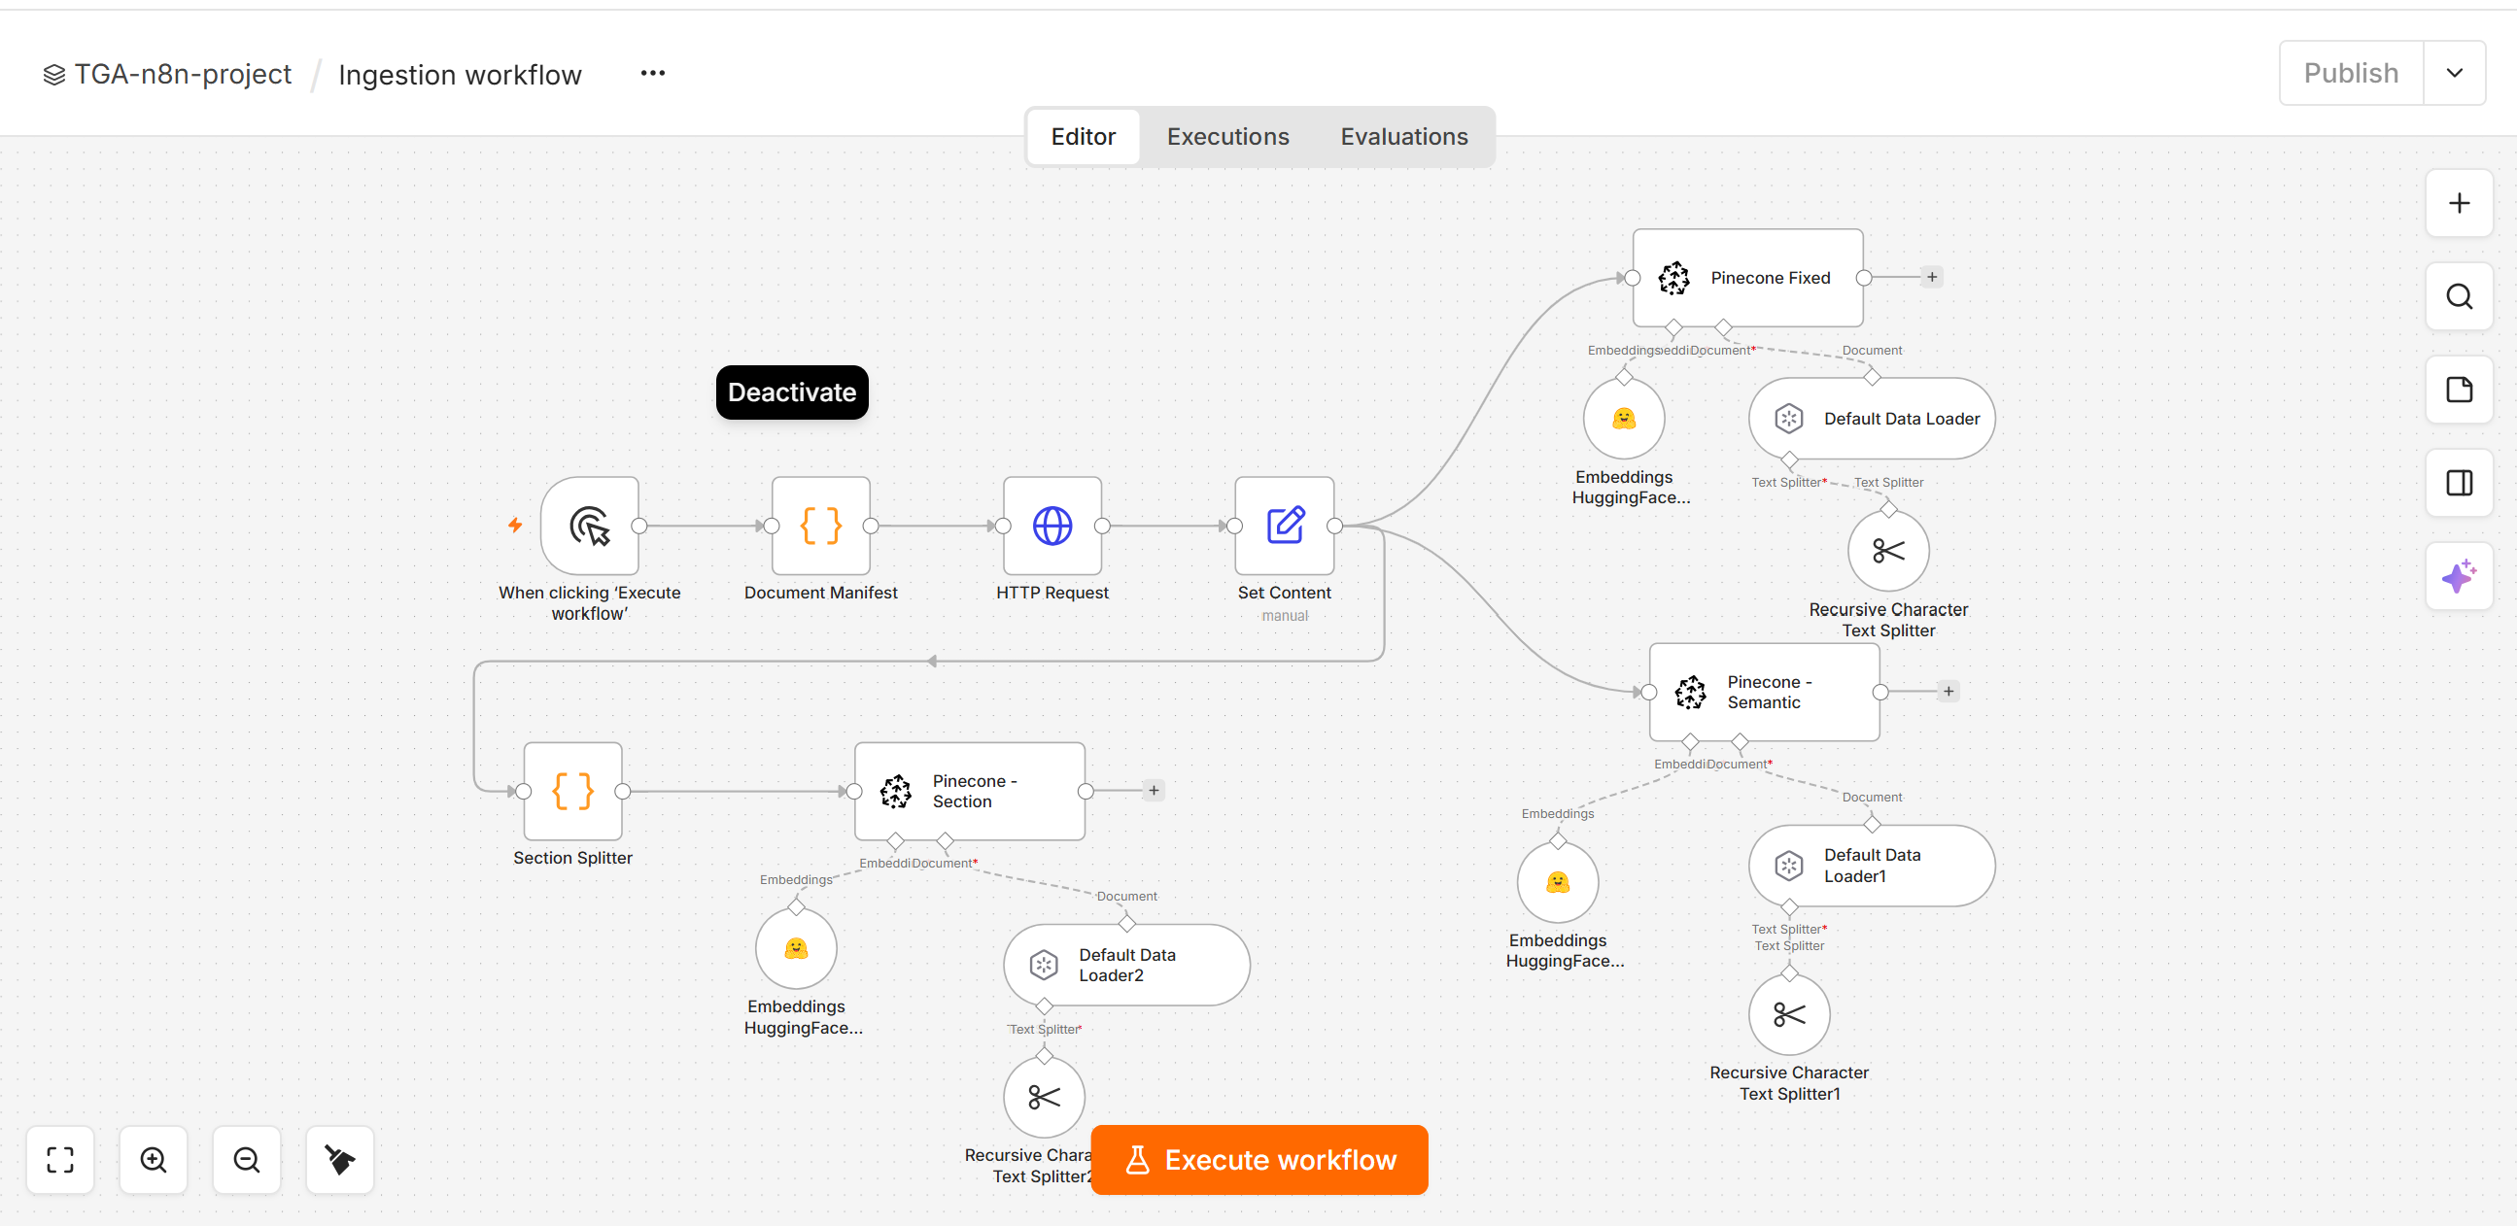

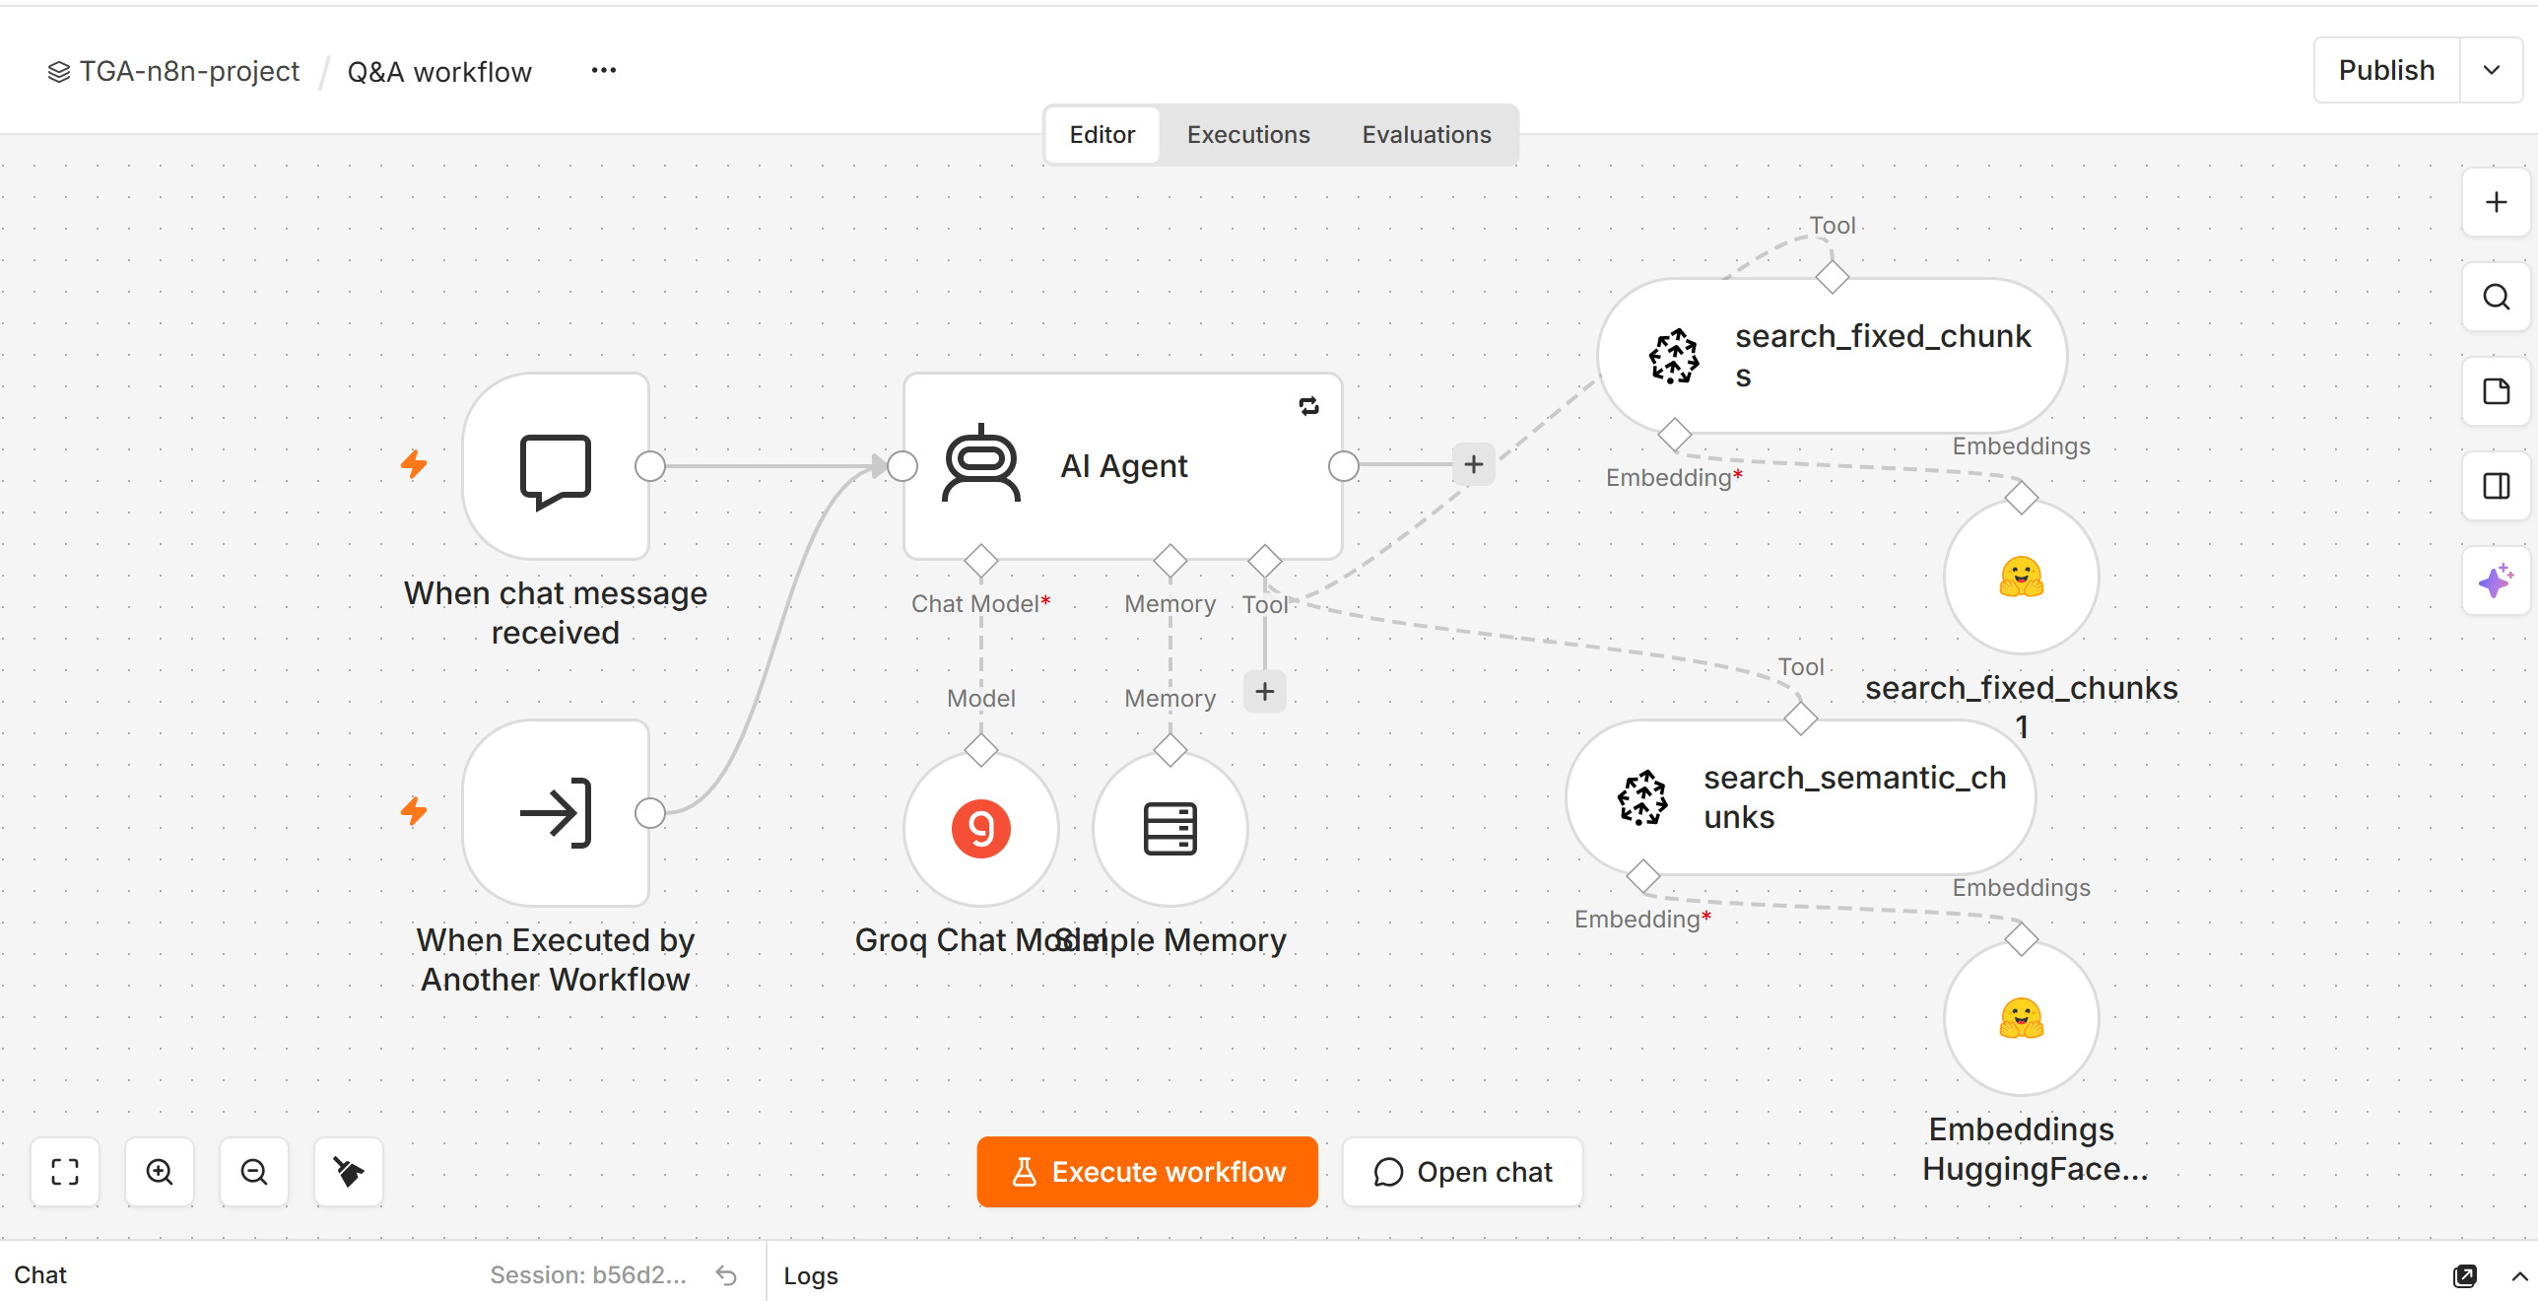

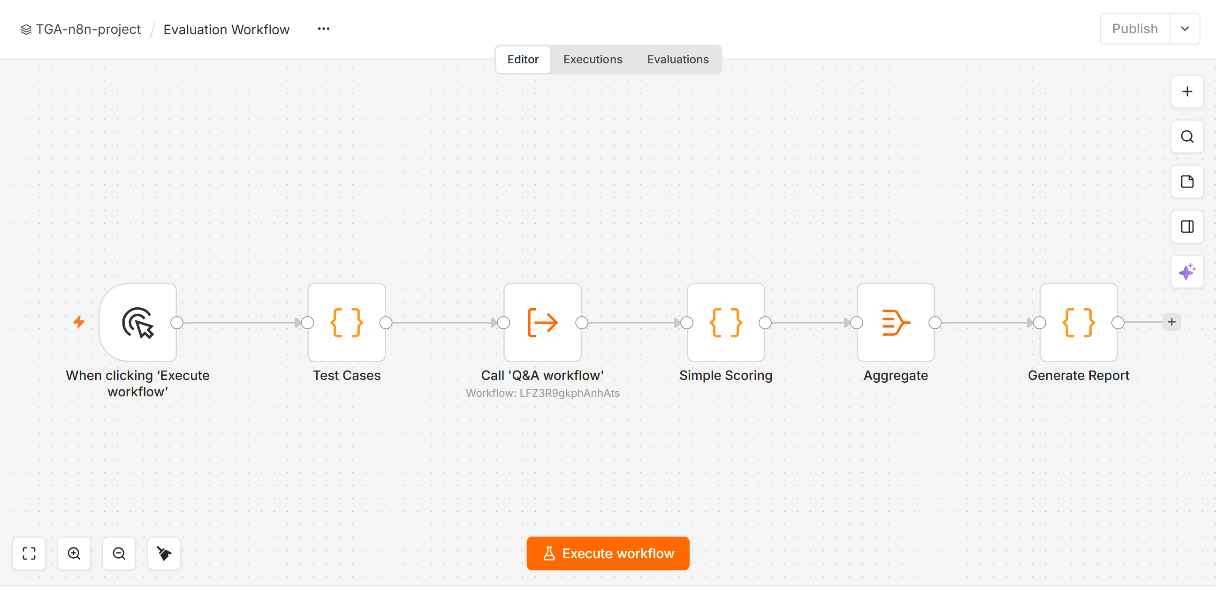

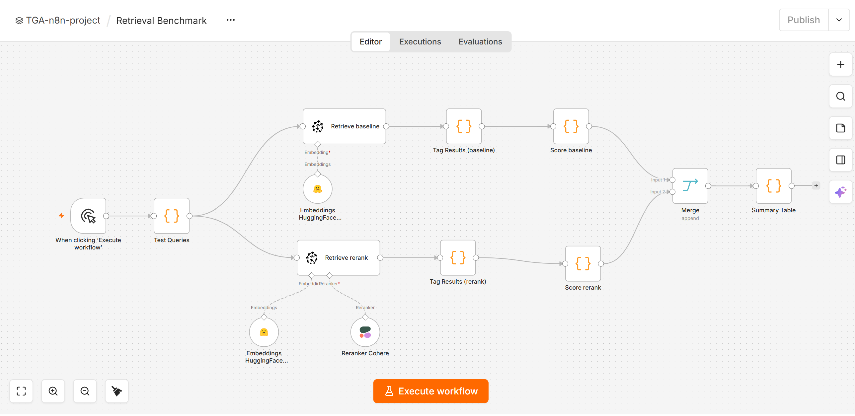

[Insert screenshot: canvas view of each of the four workflows]

4. Methodology: Chunking Strategies
Three chunking strategies were implemented and ingested in parallel from the same three source documents into the same Pinecone index, distinguished only by a "strategy" metadata field:
Strategy | Method | Chunks | Avg. chars/chunk | Design intent
Fixed-500 | Recursive character, 500 chars / 100 overlap | ~20 | 379 | Precise numeric facts; small context window
Large-1500 ("semantic" in course template) | Recursive character, 1500 chars / 300 overlap | ~6 | 1,158 | Broader context around a fact; more tokens per chunk
Section-based (true semantic) | Split on document structure: 10-K/press-release section headings and transcript speaker turns; whole section kept as one chunk (no forced re-split) | ~13 | 525 | Narrative coherence; risk of diluting a single fact inside a multi-topic section

Methodological note: the course template's second strategy is described as "semantic chunking," but its actual implementation is a recursive-character splitter with a larger chunk size (1,500 vs. 500 characters) — it does not split on meaning boundaries. This report refers to it as Large-1500 for accuracy, and adds a genuine third strategy, Section-based, which splits each document at its own structural boundaries (10-K/press-release section headings, transcript speaker turns) using a custom parser rather than a fixed character count. Section-based chunking is the strategy in this project that most closely satisfies the assignment's requirement for a true semantic-chunking comparison.

5. Query Set
Ten benchmark queries were used for the retrieval comparison, split across three query types to test different retrieval demands: factual (a specific figure), paraphrase (the question shares few or no keywords with the source sentence), and contextual (an open-ended "why" question requiring narrative understanding). Every ground-truth answer string was verified to appear verbatim in the source documents before use.
# | Question | Type | Ground-truth string
1 | What was total revenue in fiscal 2025? | Factual | 165.9
2 | How much cash and cash equivalents did the company hold at year end? | Factual | 45.20
3 | What was net income in FY2024? | Factual | 4.8
4 | What was research and development spending in FY2025? | Factual | 42.00
5 | What was total stockholders' equity? | Factual | 15.20
6 | What was the year-over-year growth rate of total sales? | Paraphrase | 25.0%
7 | Why did Professional Services revenue decline? | Contextual | low-margin
8 | Will the drag from the services business continue into next year? | Contextual | legacy customization
9 | How long can the company operate using its current cash? | Paraphrase | 24 months
10 | What happened to gross margin on services? | Contextual | 14.0%

6. Metrics
- Hit@3 — the proportion of queries for which the ground-truth answer string appears in at least one of the top-3 retrieved chunks. A binary per-query success measure.
- MRR (Mean Reciprocal Rank) — the average of 1 / rank across queries, where rank is the position (1, 2, or 3) of the first chunk containing the answer. A query with no hit in the top 3 scores 0. MRR rewards ranking the correct chunk higher, not merely retrieving it.
- Avg. chars — the average character length of the chunks returned per query, used as a proxy for the amount of context (and therefore token cost) each strategy sends downstream to the LLM.
All retrieval scoring was performed independently of the LLM: chunks were retrieved directly from Pinecone and string-matched against the ground truth in code, with no language model in the loop. This isolates chunking-strategy and reranking effects from any variance introduced by the LLM's answer generation.

7. Results: Chunking Strategy Comparison (Baseline Retrieval)
Baseline retrieval used the top 3 chunks returned by direct vector similarity search (no reranking), filtered by strategy metadata.
Strategy | Queries | Hit@3 | MRR | Avg. chars
Fixed-500 | 10 | 1.00 | 0.80 | 379
Large-1500 | 10 | 1.00 | 0.85 | 1,158
Section-based | 10 | 0.80 | 0.70 | 525

Fixed-500 and Large-1500 both achieved a perfect Hit@3 of 1.00, meaning every one of the 10 test answers was present somewhere in their top 3 chunks. Section-based chunking missed 2 of 10 queries (Hit@3 = 0.80): the R&D spending figure and the cash-runway statement. Both misses were investigated directly against the retrieved chunks and confirmed to be genuine retrieval failures, not scoring artifacts — in both cases, the correct fact was embedded inside a larger multi-topic section chunk (a financial-statement table and a multi-subject narrative paragraph, respectively), which appears to dilute the chunk's embedding relevance to a narrowly-phrased single-fact query. This is a known tradeoff of coarse, structure-based chunking: it preserves narrative coherence at the cost of sometimes burying a specific fact inside a chunk whose overall topic is broader than the query.
Large-1500 achieved the highest baseline MRR (0.85) at roughly three times the average chunk size of Fixed-500 (1,158 vs. 379 characters) — a real but costly ranking advantage, since every retrieved chunk sends more tokens downstream to the LLM.

8. Reranking Impact Analysis
For each of the same 10 queries and 3 strategies, a second retrieval pass was run: the top 8 candidate chunks were retrieved by vector similarity, then reordered by Cohere's rerank-v3.5 cross-encoder model, and the top 3 of the reranked list were scored using the identical Hit@3 / MRR methodology as the baseline.
Strategy | Queries | Hit@3 | MRR | Avg. chars
Fixed-500 | 10 | 1.00 | 0.95 | 396
Large-1500 | 10 | 1.00 | 1.00 | 1,231
Section-based | 10 | 1.00 | 0.95 | 595

Overall impact
- Hit@3 reached a perfect 1.00 for all three strategies after reranking, closing the entire gap for Section-based chunking (0.80 → 1.00).
- MRR improved for every strategy: Fixed-500 (0.80 → 0.95), Large-1500 (0.85 → 1.00), Section-based (0.70 → 0.95).
- Reranking never reduced a score in this benchmark — every group either improved or stayed at its existing maximum.

Breakdown by query type
The reranking effect was not uniform across query types. The table below shows Hit@3 and MRR before and after reranking, broken down by strategy and query type.
Strategy | Type | Baseline Hit@3 | Rerank Hit@3 | Baseline MRR | Rerank MRR
Fixed-500 | Factual | 0.90 | 1.00 | 1.00 | 1.00
Large-1500 | Factual | 0.90 | 1.00 | 1.00 | 1.00
Section-based | Factual | 0.70 | 1.00 | 0.80 | 1.00
Fixed-500 | Paraphrase | 0.75 | 1.00 | 1.00 | 1.00
Large-1500 | Paraphrase | 1.00 | 1.00 | 1.00 | 1.00
Section-based | Paraphrase | 0.50 | 1.00 | 0.50 | 1.00
Fixed-500 | Contextual | 0.67 | 0.83 | 1.00 | 1.00
Large-1500 | Contextual | 0.67 | 1.00 | 1.00 | 1.00
Section-based | Contextual | 0.83 | 0.83 | 1.00 | 1.00

The single largest improvement in the entire benchmark was Section-based chunking on paraphrased queries: baseline Hit@3 and MRR of 0.50 (the worst-performing cell in the study) both rose to a perfect 1.00 after reranking. This is consistent with how rerankers are expected to help: paraphrased queries share few keywords with the source sentence, so vector similarity alone under-ranks the correct chunk, while a cross-encoder reranker evaluates semantic relevance more directly and can recover it from further down the candidate list.
The one pattern that did not fully resolve after reranking: MRR for Fixed-500 and Section-based chunking on contextual ("why"-style) questions plateaued at 0.83 rather than reaching 1.00. Open-ended narrative questions appear to remain the hardest case for both raw retrieval and reranking in this corpus, regardless of chunking strategy.

9. End-to-End Agent Evaluation
Independently of the retrieval benchmark, the full Q&A agent (chunking + Groq LLM + prompt) was evaluated on 5 representative questions using keyword-match scoring against known-correct answers, run through the Evaluation workflow.
Question | Category | Result
What were Nova Tech's total revenues for FY2025 according to the 10-K? | Factual | Pass
How much cash did Nova Tech have at year-end 2025? | Factual | Pass
Does management expect Professional Services margin pressure to continue into 2026? | Contextual | Pass
Why did Nova Tech shift away from professional services work? | Contextual | Pass
What is the interest rate on the credit agreement? | Not in documents | Pass

Result: 5 of 5 questions passed (100%), including correctly declining to answer a question about a credit agreement that does not exist in the source documents rather than fabricating a figure. This evaluation used the agent's existing top-3 retrieval (no reranking) and is reported as supporting evidence that the pipeline behaves correctly end-to-end; the retrieval benchmark in Sections 7–8 remains the primary, controlled comparison for chunking and reranking quality, since it isolates retrieval from LLM variance and covers a larger, more diverse query set.

10. Findings and Recommendations
- For small, fact-dense financial documents like this corpus, Fixed-500 chunking is the most token-efficient strategy: it matched the largest chunk size's Hit@3 (1.00) at roughly one-third the context size, and reranking closed nearly all of its remaining ranking gap.
- Section-based chunking preserves the most narrative coherence and is best suited to "why"/contextual questions, but is more vulnerable to burying a single fact inside a broader chunk — its baseline retrieval was the weakest of the three strategies, particularly on paraphrased queries.
- Reranking is a high-value, low-cost addition for this use case: it improved every strategy's MRR, fully closed Section-based chunking's Hit@3 gap, and was most impactful exactly where retrieval was weakest (paraphrased queries against section-based chunks).
- A hybrid approach — Fixed-500 chunking for the primary factual retrieval tool, with reranking enabled on all tools — is the recommended configuration for this domain, balancing cost, precision, and paraphrase robustness.
- Contextual/open-ended questions remain the hardest case even after reranking and would benefit from a larger benchmark query set and/or a dedicated summarization-style retrieval strategy in future work.

11. Limitations
- The corpus is small (3 documents, ~39 total chunks across all strategies), so differences of one or two queries move Hit@3 by 0.10–0.20; results should be read as directionally suggestive rather than statistically robust.
- Retrieval scoring uses substring matching against a fixed ground-truth string, which is a reliable proxy for factual questions but a coarser one for contextual questions, where a correct answer could be phrased many ways.
- Larger chunks structurally contain more text and are therefore more likely to contain any given answer string; avg. chars is reported alongside Hit@3/MRR specifically so this effect is visible rather than hidden.
- LLM-based generation (Sections 3 and 9) is not fully deterministic even at low temperature; the Evaluation workflow's 5-question pass rate could vary slightly between runs.
- Both the Cohere and Groq API keys used in this project were trial/low-tier credentials for part of development; a production deployment would need production-tier keys and should re-validate rate-limit assumptions.

12. Deviations from the Course Guide
Several adjustments were made to the original course template during implementation, summarized here for transparency:
Area | Course guide specified | What was actually done
Documents | Course template used NexGen (instructor example) | Replaced with an equivalent fictional company, Nova Tech Solutions, with an internally consistent 10-K excerpt, earnings call transcript, and press release.
LLM model | Groq llama-3.3-70b-versatile (specified in course guide) | Model was retired by Groq (deprecated Aug 16, 2026) before this project began. Replaced with openai/gpt-oss-120b (Groq's recommended successor), later validated against qwen/qwen3.6-27b as a fallback for tool-calling reliability.
Agent prompt structure | Full instructions + question inside the agent's single "Prompt" field | Moved static instructions into the agent's System Message and left only the live question in the user Prompt. This reduced token growth per iteration and resolved an issue where the model looped past its max-iteration limit without producing an answer.
Rate limits | Not addressed in course guide | Groq's free-tier limits (8,000 tokens/min for gpt-oss-120b) were insufficient for multi-tool agent questions. Upgraded to Groq's pay-as-you-go Developer tier; cost for this entire project (ingestion tests, ~40 chat queries, 5-question evaluation, 60 benchmark retrieval-adjacent LLM calls) was a small fraction of a US dollar.
Reranking API | Not specified | Used Cohere Rerank (rerank-v3.5) via n8n's built-in Reranker Cohere node. Upgraded from Cohere trial key (10 calls/min) to a production key partway through benchmarking after hitting the trial rate limit on the 30-query rerank pass.
Test case design | 5 fixed example questions provided | Test questions were rewritten against the actual (fictional) source documents rather than the instructor's NexGen example, since NexGen's facts (Q3 2024 discussion, a credit agreement interest rate) do not exist in the Nova Tech corpus. One planned question ("what headwinds did management cite for 2026") was replaced after confirming the documents contain no such content — verified by checking that both the fixed and semantic retrieval tools legitimately returned nothing, not a tool malfunction.
Third chunking strategy | Course guide specifies two chunking strategies ("fixed" and "semantic", where "semantic" in the template is actually just a larger fixed-size chunk) | Added a genuine third strategy, section-based chunking, which splits on the documents' own structural boundaries (10-K/press-release headings, transcript speaker turns) rather than a fixed character count. This was necessary because the course template's "semantic" strategy does not perform semantic (meaning-based) splitting — flagged explicitly in the Methodology section below.

Appendix A: Environment and Setup
- Vector store: Pinecone, index dimension 384 (matching Hugging Face gte-small), metric cosine.
- Embeddings: Hugging Face Inference API, model thenlper/gte-small.
- LLM: Groq, model openai/gpt-oss-120b, temperature 0.1.
- Reranker: Cohere, model rerank-v3.5, top-8 candidates reduced to top-3.
- Orchestration: n8n Cloud (Pro trial → Groq Developer tier for rate limits).
- Source documents: public GitHub repository (raw file URLs), fetched at ingestion time.

Appendix B: Evidence Index
The following screenshots/exports accompany this report as separate files:
- Pinecone index record counts
- Retrieval Benchmark workflow canvas (full pipeline, both baseline and rerank branches)
- Summary Table output — all 24 rows (baseline + rerank, overall + by query type)
- Evaluation workflow Generate Report output
- Q&A workflow chat log showing correct tool routing for a two-tool question
- Exported workflow JSON: Ingestion, Q&A, Evaluation, Retrieval Benchmark

