A Project Report

On

Kirtipur Hospital Management System

Submitted in partial fulfillment of required of PROJECT-I (BIT178CO)

Of

BACHELOR IN INFORMATION TECHNOLOGY(BIT)

**Submitted to**



Purbanchal University

Biratnagar, Nepal

Submitted By

Sarun Maharjan (312267)

**KANTIPUR CITY COLLEGE**

Putalisadak, Kathmandu

2023/09/08

A Project Report

On

Kirtipur Hospital Management System

Submitted in partial fulfillment of required of PROJECT-I (BIT178CO)

Of

BACHELOR IN INFORMATION TECHNOLOGY(BIT)

**Submitted to**

Purbanchal University

Biratnagar, Nepal

Submitted By

Sarun Maharjan (312267)

**Project Supervisor**

**//TODO:**

**Sarun Maharjan**

**KANTIPUR CITY COLLEGE**

Putalisadak, Kathmandu

2023/09/08

Table of Contents

INTRODUCTION 1

FEATURES OF THE SYSTEM 2

PRODUCT DESCRIPTION 3

FUTURE OF THE PROJECT 4

OBJECTIVES 5

FLOWCHART 6

METHODLOGY 7

PLATFORM AND DEVELOPMENT ENVIRONMENT 8

SYSTEM ANALYSIS 9

CODING, TESTING AND DEBUGGING 10

UPCOMING FEATURES 11

CONCLUSION 12

REFERENCES 13

SCREENSHOTS 14

# ABSTRACT

The Kirtipur Hospital Management System is a user-friendly software application designed to streamline hospital administration and improve patient management. This report provides an overview of its key features, including user authentication, patient and doctor record management, and error handling mechanisms. The system efficiently handles infinite patient and doctor records according to disk space, offering easy options for adding, modifying, listing, searching, and deleting records. This user-centric approach enhances administrative efficiency and contributes to improved patient care in healthcare facilities.

# ACKNOWLEDGEMENTS

I take this opportunity to thank Kantipur City College and other faculty members who helped in preparing the guidelines.

I extend my sincere thanks to one and all of Kantipur City College family for the completion of this document on the project report format guidelines.

<TODO>

# DECLARATION

I declare that this project report titled Kirtipur Hospital Management System submitted in partial fulfillment of the Project-I(BIT 178CO) is a record of original work carried out by me under the supervision of <TODO> and has not formed the basis for the award of any other degree or diploma, in this or any other Institution or University. In keeping with the ethical practice in reporting scientific information, due acknowledgements have been made wherever the findings of others have been cited.

Sarun Maharjan

2023/09/08

# SUPERVISOR’S APPROVAL

This is to certify that the major project entitled Kirtipur Hospital Management System undertaken and demonstrated by Sarun Maharjan has been successfully completed under my supervision as a partial fulfillment of the requirements for the degree of Bachelors in Information Technology, 1st Semester under Purbanchal University. I, henceforth, approve this project to be awarded the certificate by the concerned authority.

During supervision, I found students hardworking, skilled and ready to undertake any professional work related to this field in future.

<<Supervisor’s Signature TODO>>

(<<Supervisor’s Name TODO>>)

Project Supervisor

Kantipur City College

Date: 2023/09/08

# INTRODUCTION

Hospital is the essential part of our lives, providing best medical facilities to people suffering from various ailments, which may be due to change in climatic conditions, increased work-load, emotional trauma stress etc. It is necessary for the hospitals to keep track of its day-to-day activities & records of its patients, doctors, nurses, ward boys and other staff personals that keep hospital running smoothly and successfully.

But keeping track of all the activities and their records on paper is very cumbersome and error prone. It also is very inefficient and a time-consuming process Observing the continuous increase in population and number of people visiting the hospital. Recording and maintaining all these records is highly unreliable, inefficient and error-prone. It is also not economically & technically feasible to maintain these records on paper.

Thus, keeping the working of the manual system as the basis of our project. We have developed an automated version of the manual system, named as “Kirtipur Hospital Management System”.

The main aim of our project is to provide a paper-less hospital up to 90%. It also aims at providing low-cost reliable automation of the existing systems. The system also provides excellent security of data at every level of user-system interaction and also provides robust & reliable storage and backup facilities.

# FEATURES OF THE SYSTEM

1. Based on non-GUI, so easy to use and time efficient.
2. High Security as its username and password to login, only authorized member of hospital can get access(user_credentials.txt).
3. Add, modify and delete of data is easy and is categorized.
4. Track every individual detail.
5. Record large amount of data.
6. Patient Record Management
7. Doctor Record Management
8. Search Functionality
9. Comprehensive Lists in Tabular format of added records

# PRODUCT DESCRIPTION

*A glance of product:*

A User-Friendly CLI Application.

Adding record of patient and doctors. Admin can store patients and doctor’s full details.

Creating, Searching, Deleting and Modification can be made in every records. With This features admin can find any record and delete or modify them in no time.

# FUTURE OF THE PROJECT

In future, the improved version of this application user detail encryption, billing, staff’s details and department can be included. By this feature we can record patients charge details, doctors and staff. Also, more features can be added like related dates regarding treatment, admitted, discharge etc. Also, it can add medicines details of patients.

# OBJECTIVES

This project can handle all data and information of a particular hospital. All data of a hospital can be access through this application. Different staffs of hospital that is authorized by admin can get access to this. Hospital details about patients and doctors are recorded and can be modified/delete through this application.

The main objective of this application development is to handle database of the Hospital. Easily can access to hospital data and time efficient. Large amount of data regarding patients and doctors can be supported.

# FLOWCHART

A flowchart is a formalized graphic representation of a logic sequence, work or manufacturing process, organization chart, or similar formalized structure. The purpose of a flow chart is to provide people with a common language or reference point when dealing with a project or process.

The flowchart of above program is:

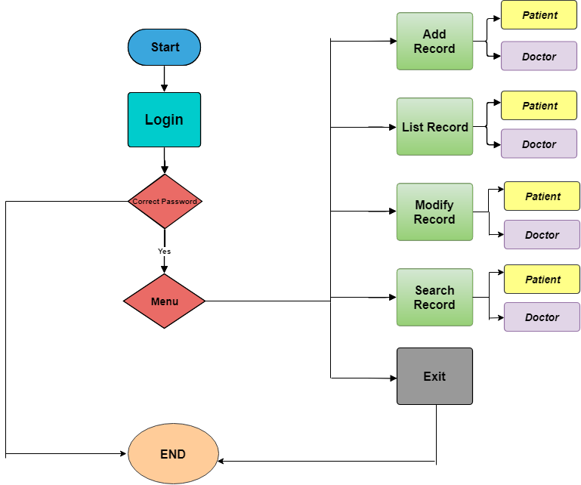

Fig: Flow Chart

# METHODLOGY

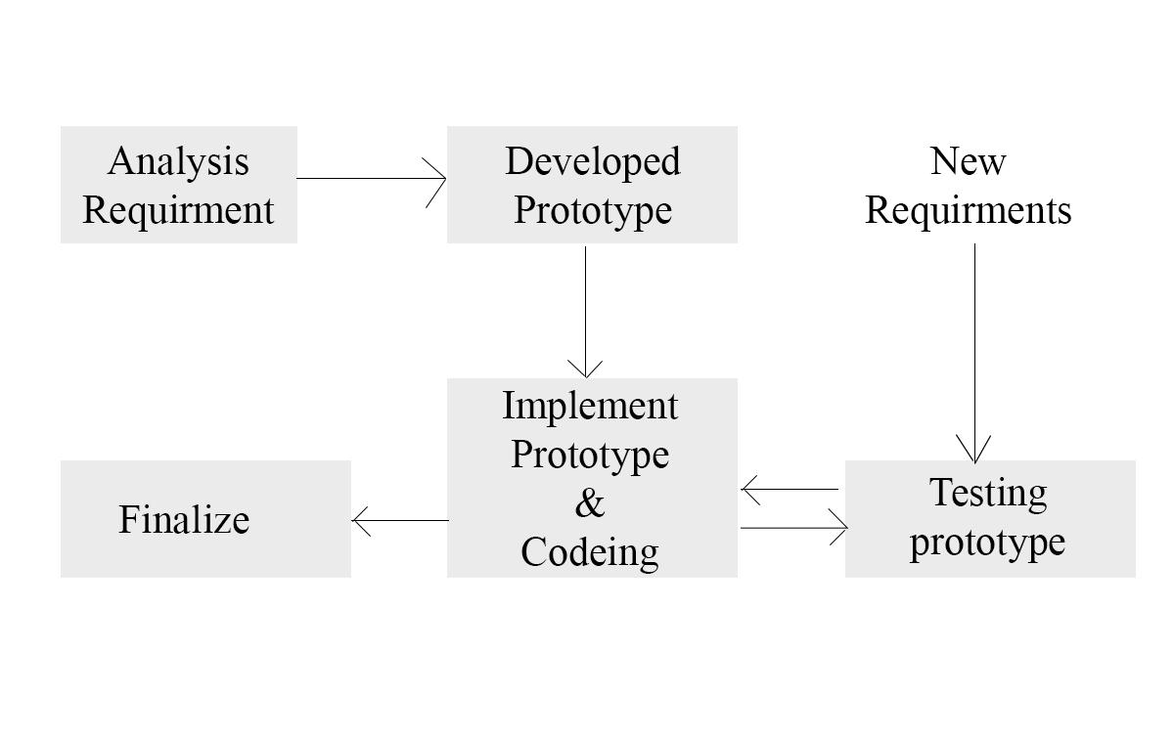

Fig: Prototype Model

Steps:

1. Analyze Requirements
2. Design and develop prototype
3. Start coding, testing and debugging
4. Finalize project

# PLATFORM AND DEVELOPMENT ENVIRONMENT

Platform: Windows 11

Code Editor: Visual Studio Code

Compiler: GCC

Language: C

Version Control: Git

Terminal: Git Bash

# SYSTEM ANALYSIS

In many hospitals, patients and doctors’ details are entered manually. The patient’s detail in separate records is tedious task. Referring to all these records and updating is needed. There is a chance for more manual errors. So, we decided to develop this application that handle overall database of hospital. For this we analyze problem and requirement of hospitals.

Problems:

1. Manually recorded data are difficult to retrieve and search
2. Less security and probability of data loss
3. Needs huge files and space to store files
4. Cannot read files by different people at a time
5. Difficulty to add and update details
6. Not time efficient

Requirement and Solution

1. Computerizing hospital system
2. Use of login system to only authorized member creates high security
3. easy to add, update and delete
4. User-friendly
5. Time efficient
6. Tabularized data

# CODING, TESTING AND DEBUGGING

After Analyzing and designing, we started Coding. While coding here starts our testing phase as well. Coding and testing were done side by side. After developing a function, test it and debug if any problem arises. Here we added new function as well. It took about 10 days for coding, testing and debugging. At last, we finalize this application.

To complete it, it took about 15 days.

Hardware and Software Requirements

Hardware Requirement:

The Hardware required for proper operation of this application are as follows:

* 1. Keyboard and mouse
  2. Visual Display Unit

Software Requirement:

The software required for the operation of this application are as follows:

1. Windows Operating System
2. GCC Compiler
3. Git (Optional) and GitHub (Optional)

# UPCOMING FEATURES

We are still thinking to add some feature to our hospital management system. We trying to make the system more dynamic and user friendly. The upcoming feature of hospital management system:

* Admin User Registration
* Staff Record
* Database Connectivity
* Store Images
* Signatures of Doctors
* Prescribe Medicine Interface
* User Data Encryption

# CONCLUSION

This software named “KIRTIPUR HOSPITAL MANAGEMENT SYSTEM” is developed using C. This project is developed to create a user-friendly environment, where user can create, add, modify, delete and search hospital records. This can handle over all data and feature of a particular hospital. Currently this application features record patients and doctor’s details. High security because only authorized member of the hospital can access to this. Authority to particular user gives accuracy and security to database.

Kirtipur Hospital Management System is huge and use in every hospital to handle their own database. This application is also developed by analyzing particular hospital requirements that can handle overall all features of a hospital. This application is applicable for hospital administration.

# REFERENCES

* <https://stackoverflow.com/>
* <https://www.google.com/>
* <https://www.w3schools.com/c/>
* <https://gcc.gnu.org/>
* <https://draw.io/>
* <https://github.com/>
* <https://git-scm.com/>

# SCREENSHOTS

