SINGLE INHERITANCE

AIM: To implement a C++ program to find out the payroll system using single inheritance

ALGORITHM:
Step 1: Include the header files
Step 2: Declare the base class emp.
Step 3: Define and declare the function get () to get the employee details.
Step 4: Declare the derived class salary.
Step 5: Declare and define the function get1 () to get the salary details.
Step 6: Define the function calculate () to find the net pay.
Step 7: Define the function display ().
Step 8: Create the derived class object.
Step 9: Read the number of employees.
Step 10: Call the function get (), get1 () and calculate () to each employee.
Step 11: Call the display ().

PROGRAM:
#include<iostream.h>
#include<conio.h>
class emp
{
public:
int eno;
char name[20],des[20];
void get()
{
cout<<"Enter the employee number:";
cin>>eno;
cout<<"Enter the employee name:";
cin>>name;
cout<<"Enter the designation:";
cin>>des;
}
};
class salary:public emp
{
float bp,hra,da,pf,np;
public:
void get1()
{
cout<<"Enter the basic pay:";
cin>>bp;
cout<<"Enter the Humen Resource Allowance:";
cin>>hra;
cout<<"Enter the Dearness Allowance :";

cin>>da;
cout<<"Enter the Profitablity Fund:";
cin>>pf;
}
void calculate()
{
np=bp+hra+da-pf;
}
void display()
{
cout<<eno<<"\t"<<name<<"\t"<<des<<"\t"<<bp<<"\t"<<hra<<"\t"<<da<<"\t"<<pf<<"\t"<<np<<"\n";
}
};
void main()
{
int i,n;
char ch;
salary s[10];
clrscr();
cout<<"Enter the number of employee:";
cin>>n;
for(i=0;i<n;i++)
{
s[i].get();
s[i].get1();
s[i].calculate();
}
cout<<"\ne_no \t e_name\t des \t bp \t hra \t da \t pf \t np \n";
for(i=0;i<n;i++)
{
s[i].display();
}
getch();
}
SAMPLE OUTPUT:
Enter the Number of employee: 1
Enter the employee No: 150
Enter the employee Name: ram
Enter the designation: Manager
Enter the basic pay: 5000
Enter the HR allowance: 1000
Enter the Dearness allowance: 500
Enter the profitability Fund: 300
E.No E.name des BP HRA DA PF NP
150 ram Manager 5000 1000 500 300 6200

MULTIPLE INHERITANCE

AIM: To implement a C++ program to find out the student details using multiple inheritance.

ALGORITHM:
Step 1: Include the header files
Step 2: Declare the base class student.
Step 3: Declare and define the function get () to get the student details.
Step 4: Declare the other class sports.
Step 5: Declare and define the function getsm() to read the sports mark.
Step 6: Create the class statement derived from student and sports.
Step 7: Declare and define the function display () to find out the total and average.
Step 8: Declare the derived class object, call the functions get(),getsm() and display().

PROGRAM:

#include<iostream.h>
#include<conio.h>
class student
{
protected:
int rno,m1,m2;
public:
void get()
{
cout<<"Enter the Roll no :";
cin>>rno;
cout<<"Enter the two marks :";
cin>>m1>>m2;
}
};
class sports
{
protected:
int sm; // sm = Sports mark
public:
void getsm()
{
cout<<"\nEnter the sports mark :";
cin>>sm;
}
};
class statement:public student,public sports
{
int tot,avg;
public:
void display()
{
tot=(m1+m2+sm);
avg=tot/3;
cout<<"\n\n\tRoll No : "<<rno<<"\n\tTotal : "<<tot;
cout<<"\n\tAverage : "<<avg;
}
};
void main()
{
clrscr();
statement obj;
obj.get();
obj.getsm();
obj.display();
getch();
}
SAMPLE OUTPUT:
Enter the Roll no: 100
Enter two marks
90
80
Enter the Sports Mark: 90
Roll No: 100
Total : 260
Average: 86.66

HIERARCHICAL INHERITANCE

AIM: To implement a C++ program to find out the area of the rectangle and triangle using hierarchical inheritance

ALGORITHM:

Step 1: Include the header files
Step 2: Declare the base class polygon.
Step 3: Declare and define the function input () to get the width and height.
Step 4: Declare the two derived classes rectangle and triangle
Step 5: Calculate the area using width and height
Step 6: Create objects for the derived classes.
Step 7: Declare the derived class object, call the functions input () and calculate the area
PROGRAM:
#include<iostream.h>
#include<conio.h>
class polygon
{
protected:
int width, height;
public:
void input(int x, int y)
{
width = x;
height = y;
}
};
class rectangle : public polygon
{
public:
int areaR ()
{
return (width * height);
}
};
class triangle : public polygon
{
public:
int areaT ()
{
return (width * height / 2);
}
};
void main ()
{
clrscr();
rectangle rect;
triangle tri;
rect.input(6,8);
tri.input(6,10);
cout <<"Area of Rectangle: "<<rect.areaR()<< endl;
cout <<"Area of Triangle: "<<tri.areaT()<< endl;
getch();
}
SAMPLE OUTPUT:
Area of Rectangle: 48
Area of triangle: 30

MULTILEVEL INHERITANCE
AIM: To implement a C++ program to find out the student details using multilevel inheritance.
ALGORITHM:
Step 1: Include the header files
Step 2: Declare the base class student.
Step 3: Declare and define the function get_ number ( ) and put_number( ).
Step 4: Declare the derived class test for student
Step 5: Declare and define the function get_ marks ( ) and put_marks( ).
Step 6: Declare the derived class result for test
Step 7: Declare and define the function display ( )
Step 8: Create objects for the derived class.
Step 9: Declare the derived class object, call the functions get_ number ( ), get_ marks ( ), display ( ).
PROGRAM:
#include<iostream.h>
#include<conio.h>
class student
{
protected:
int roll;
public:
void get_number(int a)
{
roll = a;
}
void put_number()
{
cout<<"Roll Number: "<<roll<<"\n";
}
};
class test : public student
{
protected:
float sub1;
float sub2;
public:
void get_marks(float x,float y)
{
sub1 = x;
sub2 = y;
}
void put_marks()
{
cout<<"Marks in Subject 1 = "<<sub1<<"\n";
cout<<"Marks in Subject 2 = "<<sub2<<"\n";
}
};
class result : public test
{
private:
float total;
public:
void display()
{
total = sub1 + sub2;
put_number();
put_marks();
cout<<"Total = "<<total<<"\n";
}
};
void main()
{
clrscr();
result student;
student.get_number(83);
student.get_marks(99.0,98.5);
student.display();
getch();
}
SAMPLE OUTPUT:
Roll No: 83
Marks in sub 1:99
Marks in sub 2:98.5
Total: 197.5

HYBRID INHERITANCE
AIM: To implement a C++ program to find out the student details and sport score using hybrid inheritance.
ALGORITHM:
Step 1: Include the header files
Step 2: Declare the base class stu.
Step 3: Declare and define the function get_ no () and put_no().
Step 4: Declare the derived class test for stu
Step 5: Declare and define the function get_ mark () and put_marks().
Step 6: Declare another base class sports
Step 7: Declare and define the function \getscore () and putscore ()
Step 8: Declare the derived class result from test and sports
Step 9: Declare and define the function display ()
Step 8: Create objects for the derived class.
Step 9: Declare the derived class object, call the functions get_ no ( ),get_ mark ( ),getsscore (),display ()
PROGRAM: #include<iostream.h>
#include<conio.h>
class stu
{
protected:
int rno;
public:
void get_no(int a)
{
rno=a;
}
void put_no(void)
{
cout<<"Roll no"<<rno<<"\n";
}
};
class test:public stu
{
protected:
float part1,part2;
public:
void get_mark(float x,float y)
{
part1=x;
part2=y;
}
void put_marks()
{
cout<<"Marks obtained:"<<"part1="<<part1<<"\n"<<"part2="<<part2<<"\n";
}
};
class sports
{
protected:
float score;
public:
void getscore(float s)
{
score=s;
}
void putscore(void)
{
cout<<"sports:"<<score<<"\n";
}
};
class result: public test, public sports
{
float total;
public:
void display(void);
};
void result::display(void)
{
total=part1+part2+score;
put_no();
put_marks();
putscore();
cout<<"Total Score="<<total<<"\n";
}
int main()
{
clrscr();
result stu;
stu.get_no(123);
stu.get_mark(27.5,33.0);
stu.getscore(6.0);
stu.display();
return 0;
}

VIRTUAL FUNCTION
AIM: To implement a C++ program to illustrate virtual function
ALGORITHM:
Step 1: Include the header files
Step 2: Declare the base class base.
Step 3: Declare and define the virtual function show().
Step 4: Declare and define the function display().
Step 5: Create the derived class from the base class.
Step 6: Declare and define the functions display() and show().
Step 7: Create the base class object and pointer variable.
Step 8: Call the functions display() and show() using the base class object and pointer.
Step 9: Create the derived class object and call the functions display() and show() using the derived class object and pointer.
PROGRAM:
#include<iostream.h>
#include<conio.h>
class base
{
public:
virtual void show()
{
cout<<"\n Base class show:";
}
void display()
{
cout<<"\n Base class display:" ;
}
};
class drive:public base
{
public:
void display()
{
cout<<"\n Drive class display:";
}
void show()
{
cout<<"\n Drive class show:";
}
};
void main()
{
clrscr();

base obj1;
base *p;
cout<<"\n\t P points to base:\n" ;
p=&obj1;
p->display();
p->show();
cout<<"\n\n\t P points to drive:\n";
drive obj2;
p=&obj2;
p->display();
p->show();
getch();
}
SAMPLE OUTPUT:
P points to Base
Base class display
Base class show
P points to Drive
Base class Display
Drive class Show

UNARY OPERATOR OVERLOADING

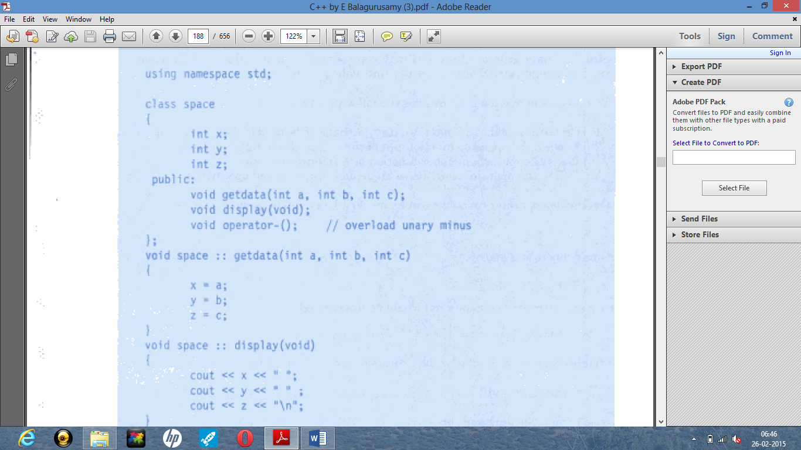
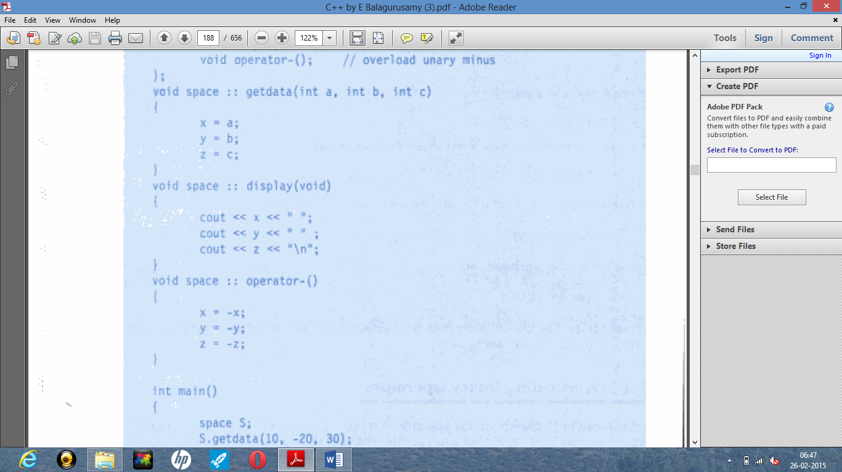
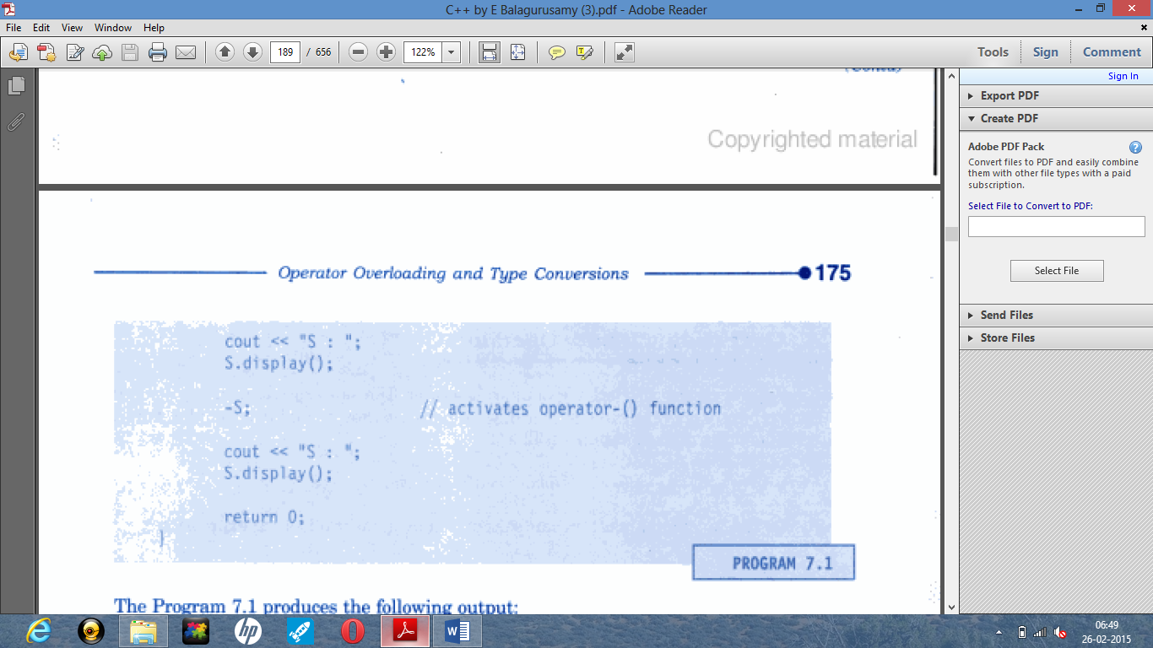

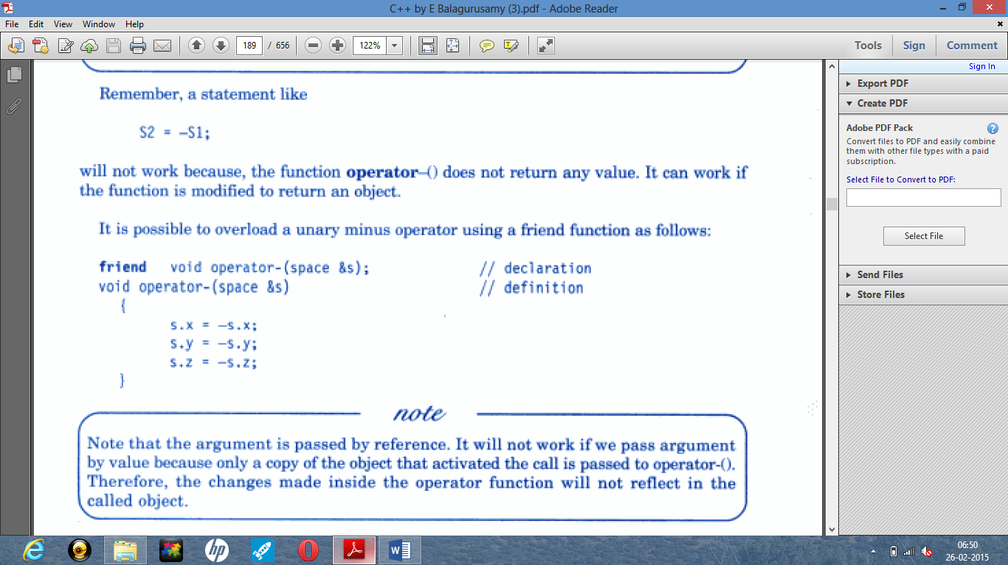

AIM: To implement a C++ program to find the complex numbers using unary operator overloading.
ALGORITHM:
Step 1: Include the header files
Step 2: Declare the class.
Step 3: Declare the variables and its member function.
Step 4: Using the function getvalue() to get the two numbers.
Step 5: Define the function operator ++ to increment the values
Step 6: Define the function operator - -to decrement the values.
Step 7: Define the display function.
Step 8: Declare the class object.
Step 9: Call the function getvalue
Step 10: Call the function operator ++() by incrementing the class object and call the function display.
Step 11: Call the function operator - -() by decrementing the class object and call the function display.
PROGRAM:
#include<iostream.h>
#include<conio.h>
class complex
{
int a,b,c;
public:
complex(){}
void getvalue()
{
cout<<"Enter the Two Numbers:";
cin>>a>>b;
}
void operator++()
{
a=++a;
b=++b;
}
void operator--()
{
a=--a;
b=--b;
}
void display()
{
cout<<a<<"+\t"<<b<<"i"<<endl;
}
};
void main()
{
clrscr();
complex obj;
obj.getvalue();
obj++;
cout<<"Increment Complex Number\n";
obj.display();
obj--;
cout<<"Decrement Complex Number\n";
obj.display();
getch();
}
SAMPLE OUTPUT:
Enter the two numbers: 3 6
Increment Complex Number
4 + 7i
Decrement Complex Number
3 + 6i
BINARY OPERATOR OVERLOADING
AIM: To implement a C++ program to add two complex numbers using binary operator overloading.
ALGORITHM:
Step 1: Include the header files
Step 2: Declare the class.
Step 3: Declare the variables and its member function.
Step 4: Using the function getvalue() to get the two numbers.
Step 5: Define the function operator +() to add two complex numbers.
Step 6: Define the function operator –()to subtract two complex numbers.
Step 7: Define the display function.
Step 8: Declare the class objects obj1,obj2 and result.
Step 9: Call the function getvalue using obj1 and obj2
Step 10: Calculate the value for the object result by calling the function operator + and operator -.
Step 11: Call the display function using obj1 and obj2 and result.
Step 12: Return the values.
PROGRAM:
#include<iostream.h>
#include<conio.h>
class complex
{
int a,b;
public:
void getvalue()
{
cout<<"Enter the value of Complex Numbers a,b:";
cin>>a>>b;
}
complex operator+(complex ob)
{
complex t;
t.a=a+ob.a;
t.b=b+ob.b;
return(t);
}
complex operator-(complex ob)
{
complex t;
t.a=a-ob.a;
t.b=b-ob.b;
return(t);
}
void display()
{
cout<<a<<"+"<<b<<"i"<<"\n"; ]
}
};
void main()
{
clrscr();
complex obj1,obj2,result,result1;
obj1.getvalue();
obj2.getvalue();
result = obj1+obj2;
result1=obj1-obj2;
cout<<"Input Values:\n";
obj1.display();
obj2.display();
cout<<"Result:";
result.display();
result1.display();
getch();
}
SAMPLE OUTPUT:
Enter the value of Complex Numbers a, b
4 5
Enter the value of Complex Numbers a, b
2 2
Input Values
4 + 5i
2 + 2i
Result
6 + 7i
2 + 3i

