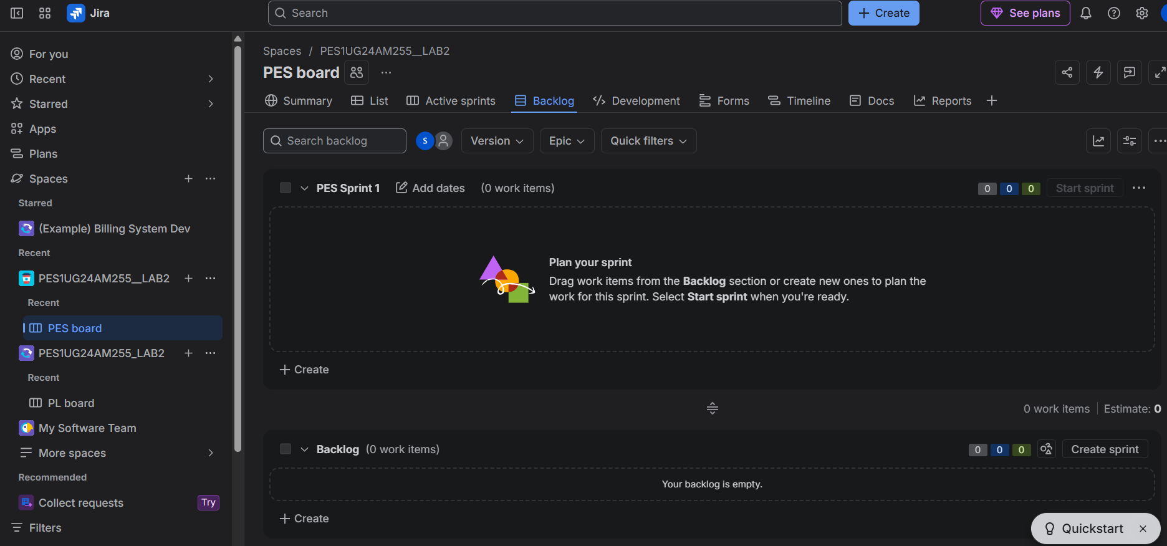
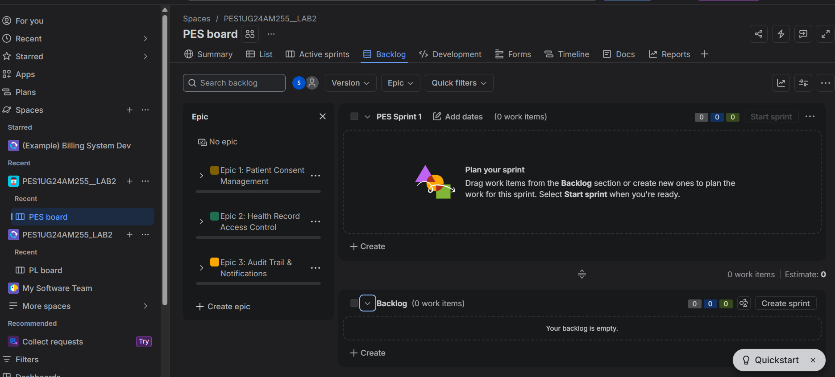
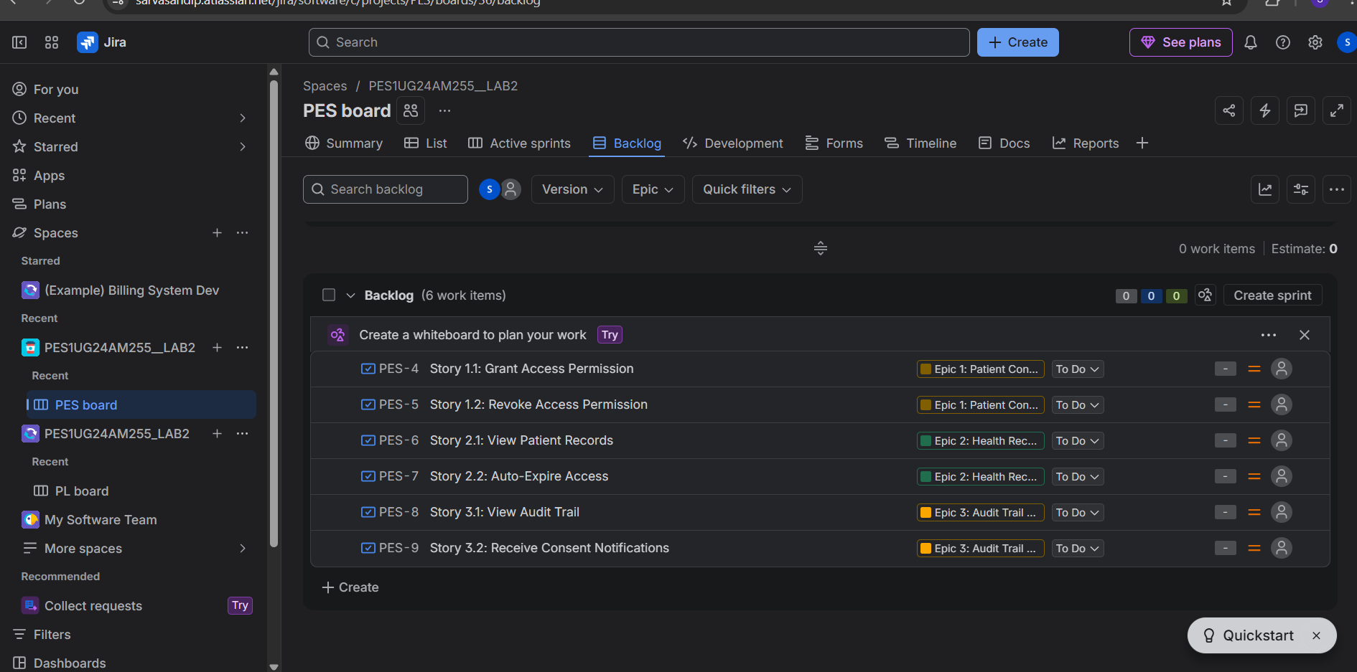
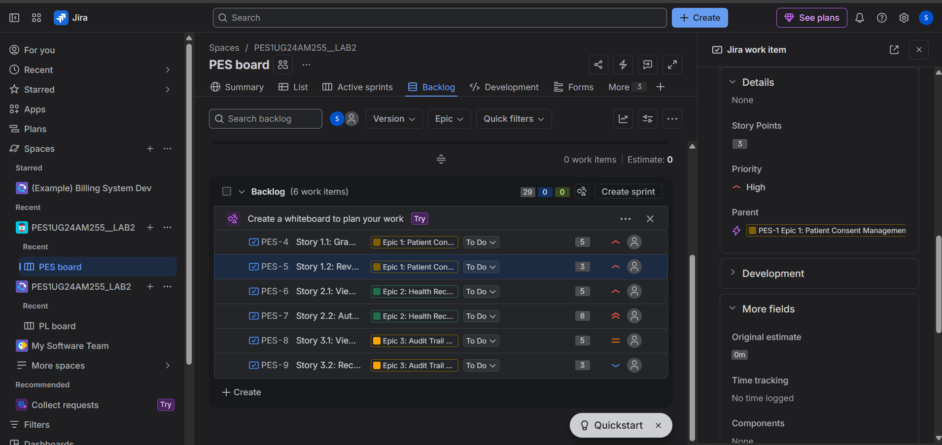
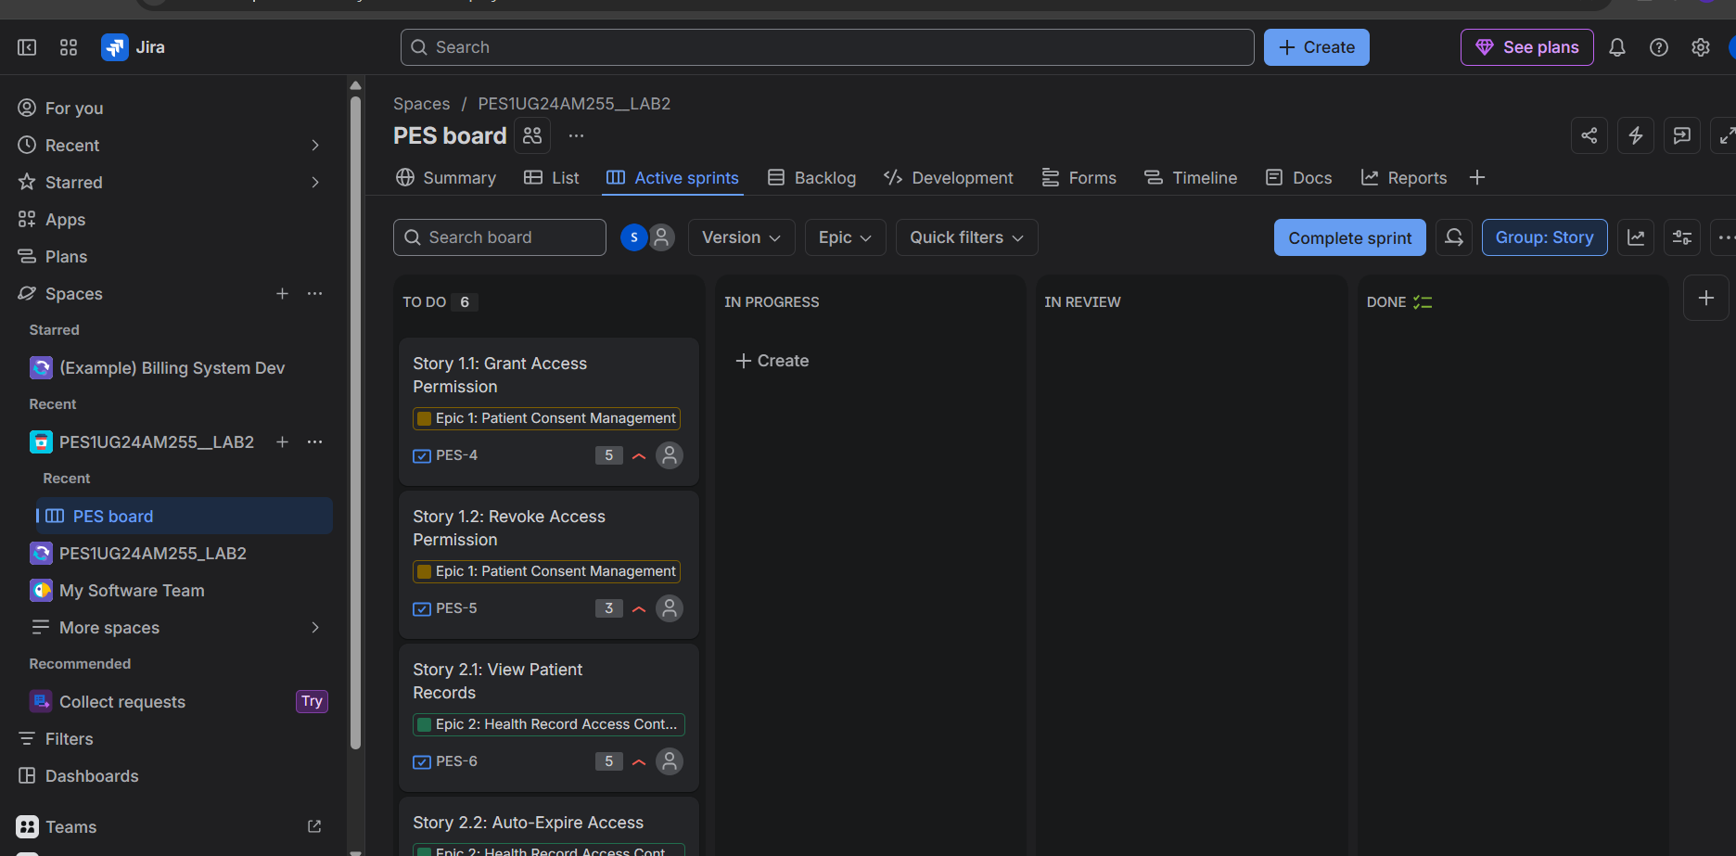
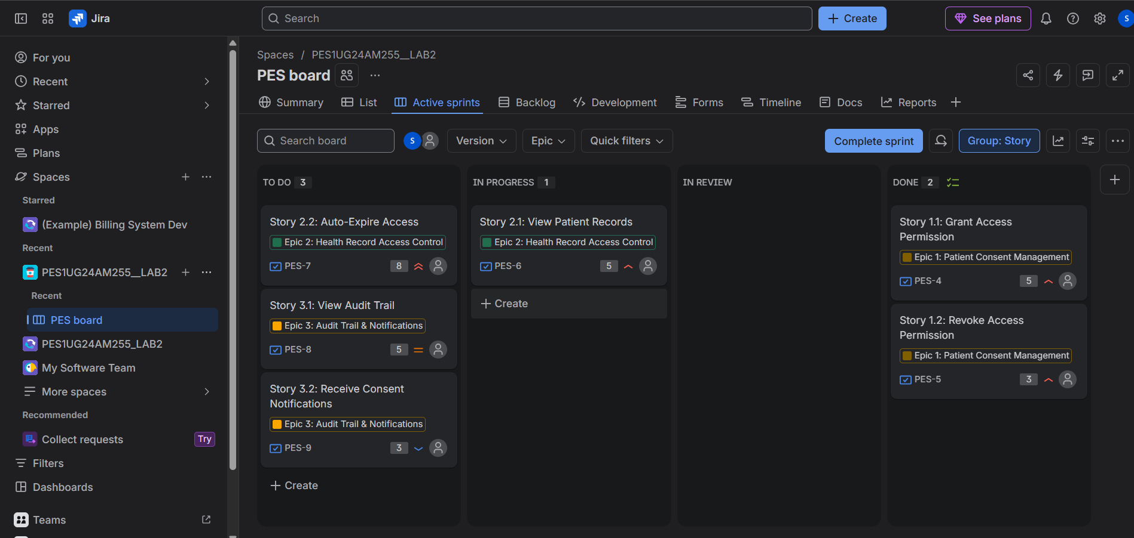
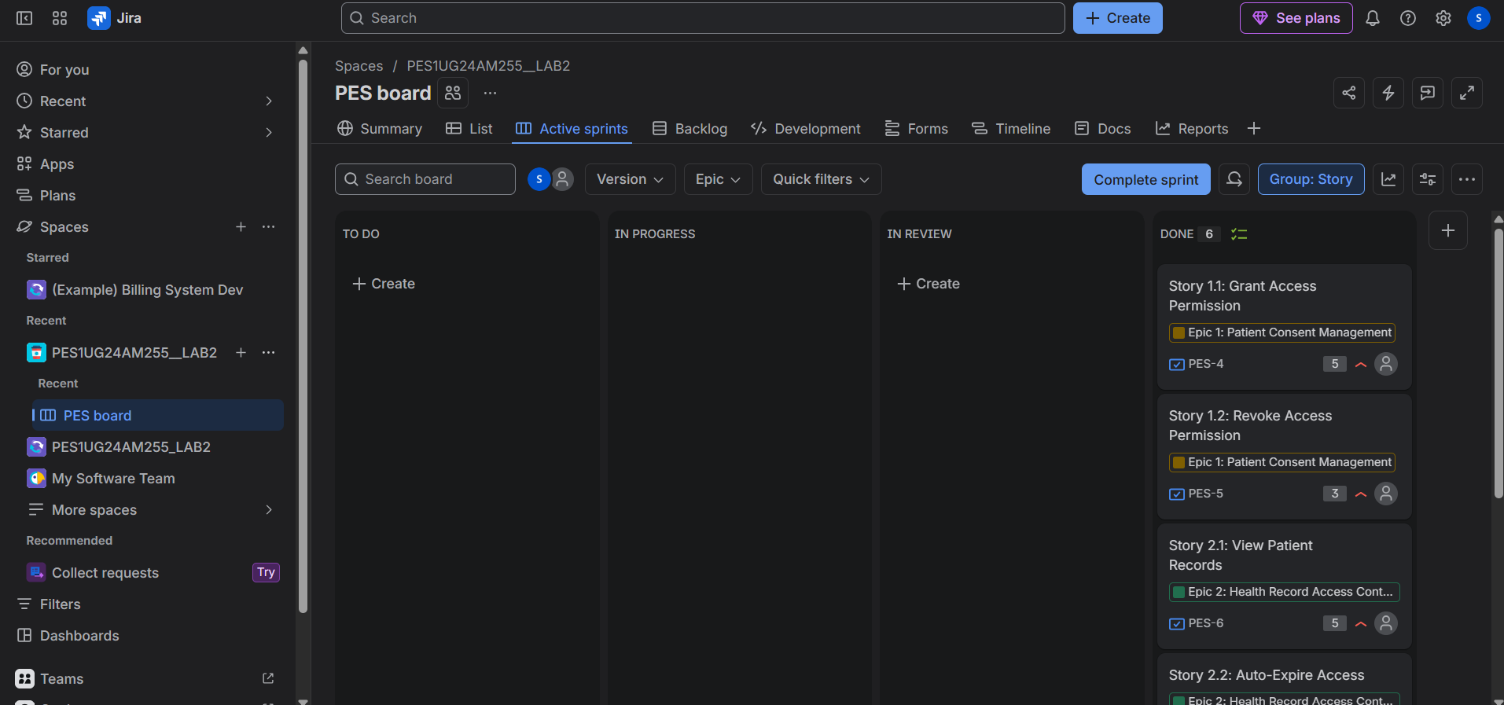
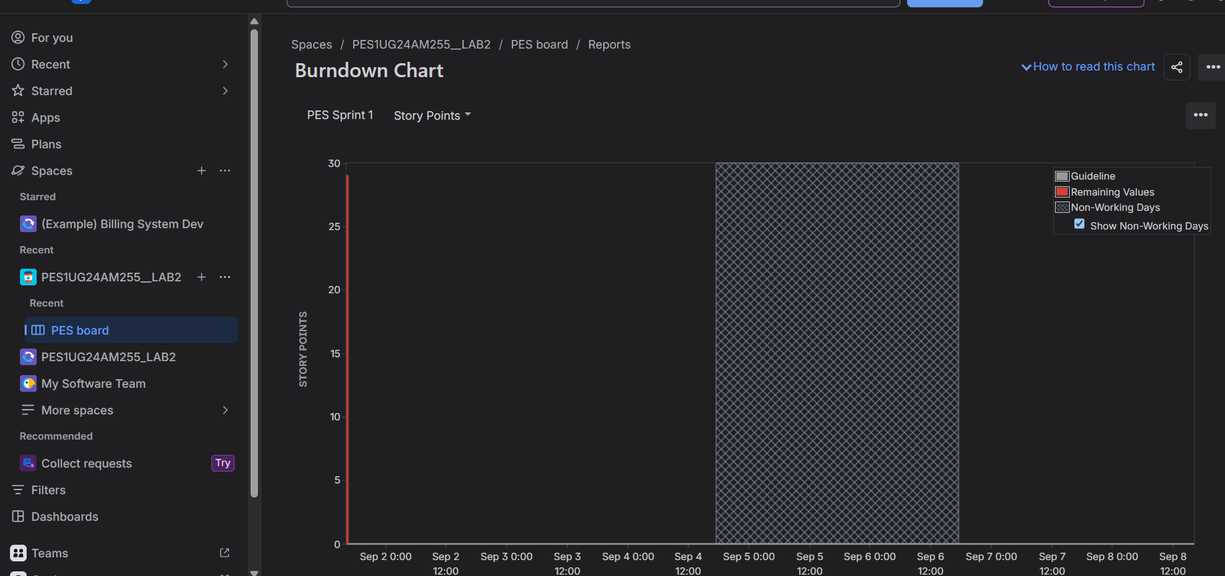
- Did your estimations reflect the actual effort?
Ans: The story points were assigned based on technical complexity. Auto-expiry (8 points) was correctly identified as the most complex due to background scheduling requirements. In a real sprint, estimations would be validated through actual development time.

- Was your backlog well-prioritized?
Ans: Yes. Security-critical stories like granting/revoking consent and auto-expiry were given highest priority as they directly protect patient data. Audit and notification features were lower priority as they are supplementary.

- How did your simulated sprint align with your plan?
Ans: All 6 stories were completed within Sprint 1 as planned. In a real scenario, the 8-point auto-expiry story might have spilled into Sprint 2 due to its complexity.

- What insights did the burndown chart give about team capacity?
Ans: The sharp drop in the burndown chart shows all work was completed on day 1 (simulated). In a real sprint, the chart would show gradual completion. The total of 29 story points in one week would be a reasonable velocity for a small team of 2-3 developers.

