Patient Health Record Consent Management System
Requirements Engineering & UML Use-Case Modelling — Lab 1 Deliverable
Problem Statement #13 | Healthcare & Telemedicine

1. Requirements Table
Stakeholders / Actors: Patient, Clinic Administrator, Clinic Doctor, Audit & Scheduler Service.
ID | Type/Priority | Description | Priority | Acceptance Criteria | Rationale
FR-001 | Functional | The system shall allow patients to grant time-bounded (e.g., 24-hour) access permissions for specific diagnostic records to verified clinic doctors. | High | Pass: Clinic access automatically revokes upon expiry timestamp. Fail: Clinic accesses records after consent expiration. | Patients must retain fine-grained, time-limited control over who views their sensitive medical data.
FR-002 | Functional | The system shall allow patients to manually revoke a previously granted consent at any time before its expiry. | High | Pass: Access is blocked within 5 seconds of revocation being confirmed. Fail: Clinic can still view the record after revocation. | Patients may change their mind or detect misuse; immediate revocation is a core patient-rights requirement.
FR-003 | Functional | The system shall verify a requesting clinic doctor's professional credentials against a registry before any consent request can be approved. | High | Pass: Consent grant is blocked and an error is shown if the doctor's credential status is 'unverified' or 'expired'. Fail: An unverified doctor is able to receive a consent grant. | Prevents impersonation and ensures only legitimate medical professionals can request access to patient data.
FR-004 | Functional | The system shall automatically expire and revoke a consent grant the moment its time-bound validity window elapses, without requiring patient action. | Medium | Pass: A scheduled job revokes access within 1 minute of the expiry timestamp. Fail: Access remains active past the expiry timestamp. | Time-bound consent is only meaningful if expiry is enforced automatically rather than relying on manual follow-up.
FR-005 | Functional | The system shall allow patients to view a real-time dashboard listing all active, expired, and revoked consents along with a history of every access event on their records. | Medium | Pass: Dashboard reflects a new access event within 10 seconds of it occurring. Fail: Dashboard shows stale or missing access entries. | Transparency into who accessed data and when builds patient trust and supports informed consent decisions.
NFR-001 | Performance & Security | All consent grant, revoke, and access events shall be permanently written to an append-only audit trail. | High | Pass: Benchmarking tests confirm target latency and security standards under simulated peak load. Fail: Any audit event is missing, editable, or deletable. | An immutable audit trail is required for regulatory compliance (e.g., HIPAA/GDPR-style accountability) and dispute resolution.
NFR-002 | Security & Privacy | All patient health data and consent tokens shall be encrypted at rest (AES-256) and in transit (TLS 1.3), with role-based access control enforced on every API call. | High | Pass: Penetration test confirms no plaintext PHI is recoverable from storage or network capture, and unauthorized roles are denied with HTTP 403. Fail: Any PHI is exposed unencrypted or an unauthorized role successfully accesses an endpoint. | Health records are highly sensitive; strong encryption and access control are mandatory for patient privacy and regulatory compliance.

2. UML Use-Case Diagram
The diagram below models the system boundary, all primary and secondary actors, the primary use cases, and the required «include» and «extend» relationships.
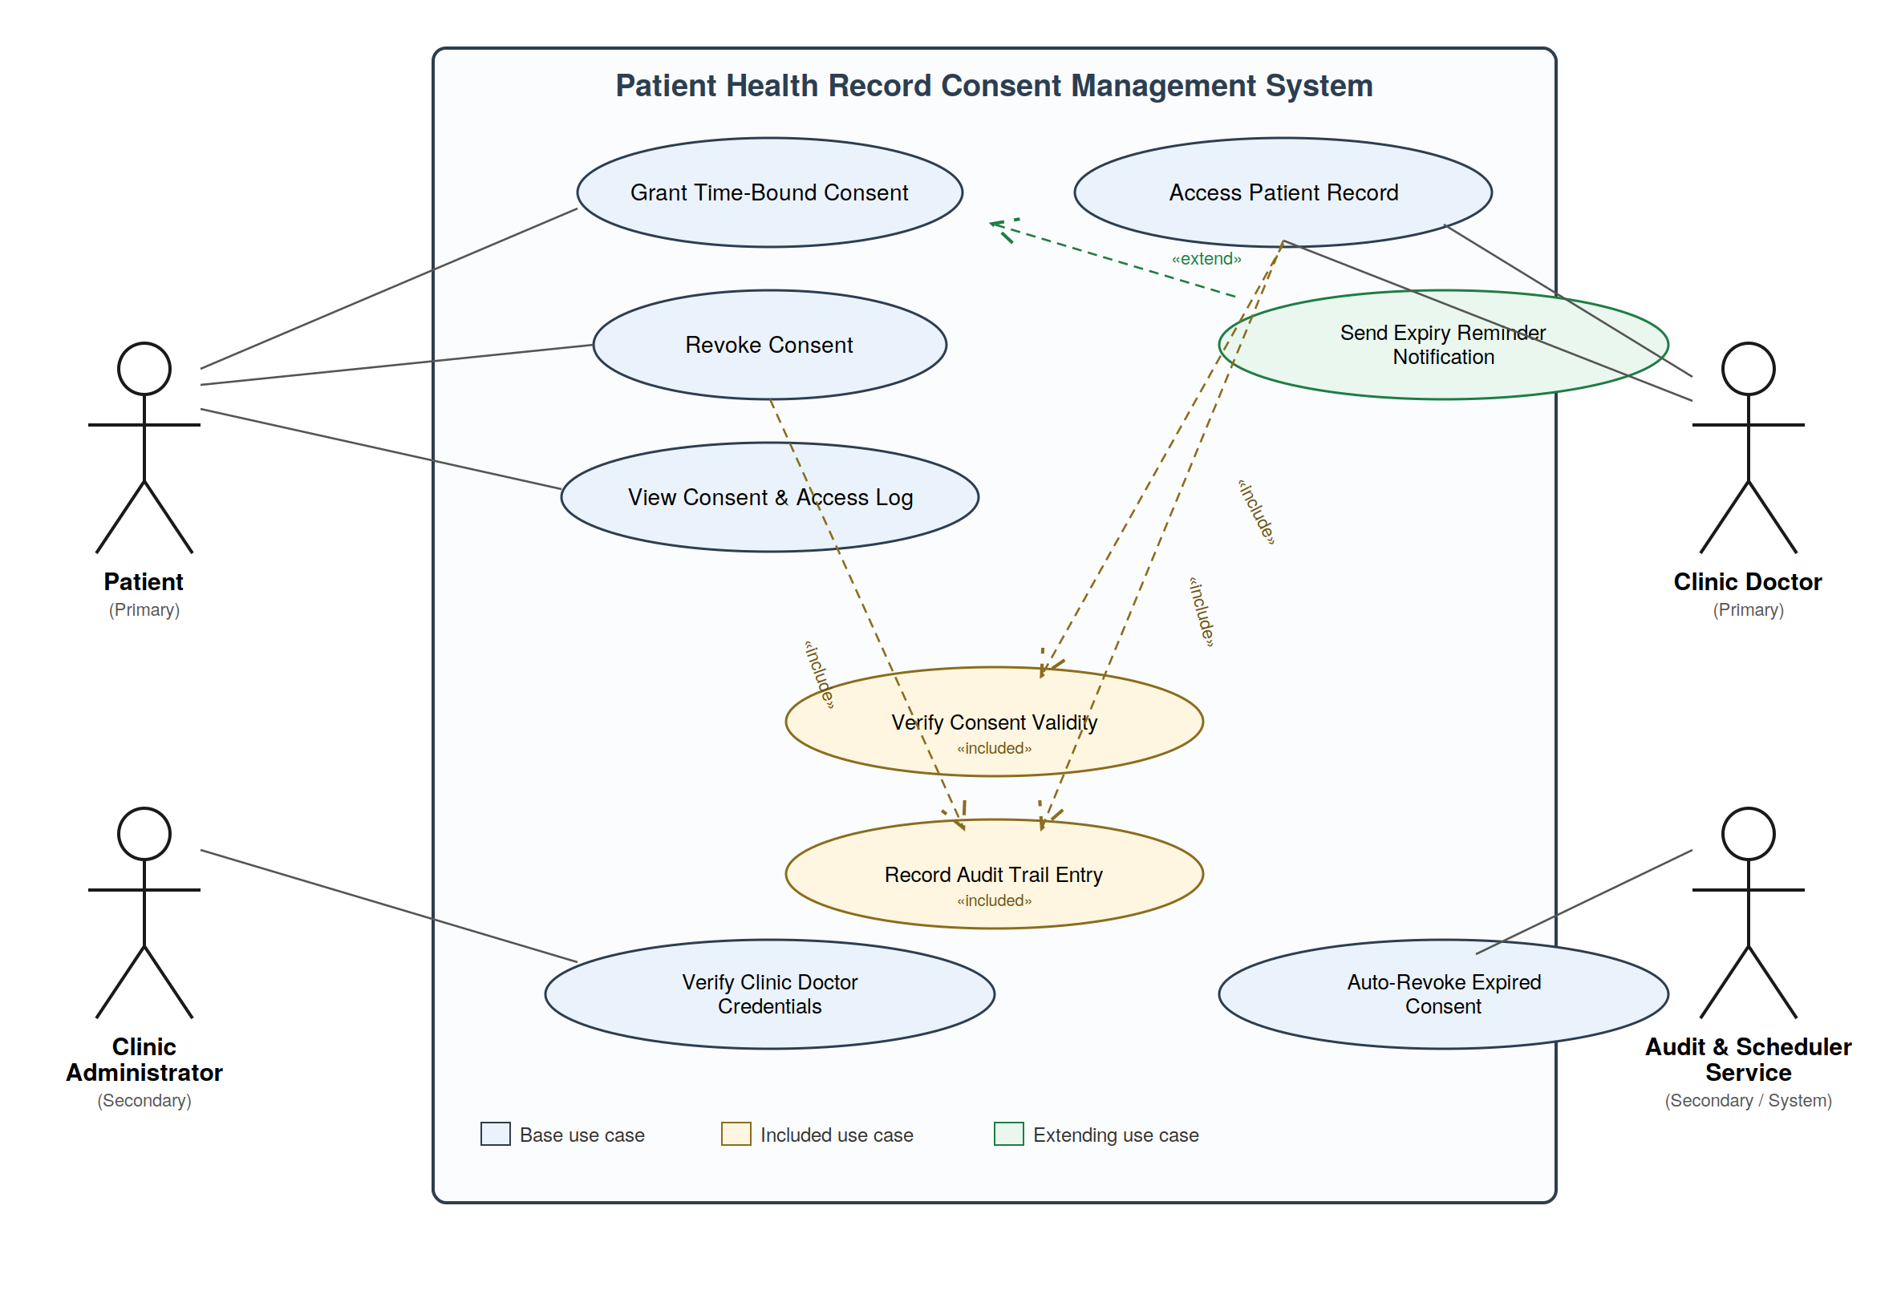

Actors
- Patient (Primary) — grants/revokes consent, views access log.
- Clinic Doctor (Primary) — requests and accesses patient records within a valid consent window.
- Clinic Administrator (Secondary) — verifies and manages clinic doctor credentials/registration.
- Audit & Scheduler Service (Secondary/System) — runs the expiry timer and writes immutable audit entries.

Include / Extend Relationships
- «include»: Access Patient Record includes Verify Consent Validity (mandatory sub-step, always executed).
- «include»: Grant Time-Bound Consent, Revoke Consent, and Access Patient Record all include Record Audit Trail Entry.
- «extend»: Send Expiry Reminder Notification extends Grant Time-Bound Consent (optional, conditional step — fires only when a consent is nearing expiry).

3. Use-Case Flow Specification

Use Case: Grant Time-Bound Consent (FR-001)
Use Case ID | UC-01
Primary Actor | Patient
Secondary Actors | Clinic Doctor, Audit & Scheduler Service
Trigger | Patient chooses to share a specific diagnostic record with a named clinic doctor.
Preconditions | 1) Patient is authenticated and logged in. 2) The target clinic doctor is registered and has a 'verified' credential status. 3) The diagnostic record selected exists in the patient's record store.
Postconditions (Success) | 1) A time-bound consent grant (with explicit expiry timestamp) is created and active. 2) The clinic doctor can access only the specified record until expiry. 3) A 'consent granted' entry is written to the append-only audit trail.

Main Success Scenario
- Patient logs into the Patient Portal and navigates to the 'Manage Consent' screen.
- Patient selects the diagnostic record(s) to be shared and searches for the target clinic doctor.
- System verifies the clinic doctor's credential status via the Clinic Administrator's registry (included: Verify Clinic Doctor Credentials).
- Patient specifies the access duration (e.g., 24 hours) and confirms the grant request.
- System validates the request, generates a time-bound access token, and activates the consent grant with a computed expiry timestamp.
- System records the grant event to the append-only audit trail (included: Record Audit Trail Entry).
- System notifies the clinic doctor that access has been granted and displays the active consent on the patient's dashboard.
- Audit & Scheduler Service starts a countdown timer for automatic expiry corresponding to the consent's validity window.

Alternate Flow A1 — Clinic Doctor Fails Credential Verification
Branches from Main Success Scenario, Step 3.
- System checks the clinic doctor's credential status and finds it is 'unverified' or 'expired'.
- System rejects the consent request and displays an error: 'This clinic doctor is not currently verified. Consent cannot be granted.'
- System logs the failed attempt to the audit trail for security monitoring.
- Patient may choose a different clinic doctor or cancel the request. Use case ends without an active consent grant.

Use Case Diagram Cross-Reference
Preconditions for A1: Same as the main flow preconditions 1 and 3 (patient authenticated, record exists), but precondition 2 (verified doctor) fails at runtime. Postconditions for A1: No consent grant is created; only a 'grant attempt failed' audit entry exists; system state is unchanged from before the use case began.

