Software Requirements Specification (SRS)
Project: Campus Ride-Share Matching System (CampusRide)
Version: 1.0
Authors: <Team Name / Member Names>
Date: 08-10-2026
Status: Draft

Revision history
Version | Date | Author | Change summary | Approval
1.0 | 08-10-2026 | Project Team | Initial SRS for the Campus Ride-Share Matching System with use-case diagrams, security requirements and RTM

Approvals
Role | Name | Signature / Email | Date
Course Coordinator
Faculty Guide / Reviewer
Team Lead

Table of Contents
1. Introduction
2. Overall description
3. External interface requirements
4. System features (detailed)
5. Non-functional requirements (detailed)
5.1 Security (objectives and requirements)
6. Quality attributes & Acceptance tests
7. System models and diagrams (UML use-case diagrams)
8. Requirements Traceability Matrix (RTM)

1. Introduction

1.1 Purpose
This document is the Software Requirements Specification (SRS) for the Campus Ride-Share Matching System (CampusRide). It defines the functional and non-functional requirements, external interfaces, security requirements and verification criteria for a web-based platform that matches students who offer rides with students who request rides. It is the baseline for the Software Architecture and Design Specification (SAD) and the Software Test Plan (STP).

1.2 Scope
CampusRide lets verified students of one campus community offer and request rides. The system matches them using pickup and drop locations, route, departure timing and available seats, and supports in-app messaging, ride history and mutual ratings.
In scope (v1.0): registration and verification, profiles and driver approval, ride offers and requests, route-based matching and ranking, booking lifecycle, chat, ratings and history, notifications, administration, moderation and audit logging.
Out of scope (v1.0): online payments or fare splitting, live GPS tracking during the ride, integration with external ride-hailing services, native mobile apps (a responsive web application / PWA is provided), and the internal implementation of third-party mapping, email and push services.

1.3 Audience
Developers, QA engineers, UI/UX designers, the campus safety office and administrators, faculty guides and assessment evaluators.

1.4 Definitions
Term | Meaning
CRMS / CampusRide | Campus Ride-Share Matching System
Rider | A student who requests a ride
Driver | A verified student who offers a ride in a vehicle
Ride offer | A trip published by a driver (route, time, seats)
Ride request | A trip need published by a rider (pickup, drop, time window, seats)
Booking | A link between a ride request and a ride offer (pending, confirmed, etc.)
OTP | One-Time Password
UI / API | User Interface / Application Programming Interface
TLS | Transport Layer Security
JWT | JSON Web Token
RBAC | Role-Based Access Control
PII | Personally Identifiable Information
WCAG | Web Content Accessibility Guidelines
SUS | System Usability Scale
RPO / RTO | Recovery Point Objective / Recovery Time Objective
SRS / SAD / STP / RTM | Software Requirements Specification / Architecture and Design Specification / Test Plan / Requirements Traceability Matrix

1.5 References
- IEEE 830 / ISO/IEC/IEEE 29148 - Requirements engineering
- OWASP Application Security Verification Standard (ASVS) and OWASP Top 10
- WCAG 2.1 - Web Content Accessibility Guidelines
- Companion documents: CampusRide SAD v1.0 and STP v1.0

2. Overall description

2.1 Product perspective
CampusRide is a new, self-contained web application. Students access it through a browser on a phone or laptop. A backend service hosts the business logic (matching, booking, messaging) and a database stores users, rides and messages. The system integrates with a maps/routing service for geocoding and route calculation, an email service for verification and alerts, and a push-notification service. Administrators use a separate admin area of the same application.

2.2 Major product functions (detailed)
- Register and verify campus users; authenticate; manage profiles
- Driver registration with vehicle/licence details and administrator approval
- Create, edit and cancel ride offers (one-time and recurring) and ride requests
- Match requests to offers by route proximity, time window, direction and seats; rank matches by compatibility score
- Booking lifecycle: join request, accept/reject, confirm, cancel, start, complete, auto-expiry
- In-app messaging between linked riders and drivers with report/block
- Ride history, mutual ratings and average-rating display
- Notifications (in-app, email, push) and departure reminders
- Safety features: driver verification, location privacy, trusted-contact ride sharing, report/block
- Administration: verification queue, moderation, configuration, analytics, audit log

2.3 User roles and characteristics (expanded)
Role | Characteristics | Main needs
Rider | Student, comfortable with smartphones, often time-constrained and cost-sensitive | Quickly find a safe ride that matches route and time; communicate with driver; see ratings
Driver | Student or campus member with a vehicle and valid licence; offers spare seats | Post trips easily (including recurring), control who joins, minimal detours, trust in riders
Administrator | Staff or senior student volunteer from the campus safety/IT office | Verify drivers, handle reports, configure rules, monitor usage and audit logs
External systems | Maps/routing API, email service, push service | Stable, documented interfaces with retry and fallback behaviour

2.4 Operating environment
- Client: current versions of Chrome, Edge, Firefox, Safari; Android 10+ and iOS 14+ mobile browsers; PWA install optional.
- Server: Linux host (cloud VM or university server) running containers for the application, database and cache.
- Network: HTTPS over campus Wi-Fi, mobile data (4G) or broadband; location access is optional and requires user consent.

2.5 Constraints
- Only users with an institutional email address may register (closed community).
- Compliance with applicable data-protection law and the institution's privacy policy; location and phone data are sensitive.
- Third-party mapping API quotas and terms of use; open-source components preferred to limit cost.
- The service area is limited to the campus and its surrounding region configured by the administrator.
- Academic schedule: delivery within one semester; a small team and no dedicated mobile-app development.

2.6 Assumptions and dependencies
- Users have a smartphone or computer with an internet connection and an institutional email account.
- Drivers hold a valid driving licence and are responsible for vehicle insurance and legal compliance; the platform only connects users.
- The mapping, email and push providers are available; the system degrades gracefully when they are not (see Section 3.4).
- An administrator group exists to verify drivers and moderate reports.

3. External interface requirements

3.1 User interfaces
Responsive web interface (mobile-first) with a bottom/side navigation: Home, Find a Ride, Offer a Ride, My Rides, Messages, Profile, and an Admin area for administrators. Key screens: registration/login, profile, create offer/request with map picker, match results with filters, booking details, chat, history and ratings, notifications, admin dashboard. Accessibility: keyboard navigation, screen-reader labels, high-contrast colours and scalable text (WCAG 2.1 AA).

3.2 Hardware interfaces
- User device: smartphone/laptop display, touch or keyboard input, optional GPS/location sensor, camera or file storage for profile photo and licence upload.
- Server hardware: virtual or physical server (minimum 4 vCPU, 8 GB RAM, 100 GB storage) - no special hardware is required.

3.3 Software interfaces
- Maps / Routing API (OpenStreetMap-based OSRM or Google Maps Platform): geocoding, reverse geocoding and route polylines over HTTPS/JSON.
- Email service (SMTP): verification OTP, password reset, notifications.
- Push service (Firebase Cloud Messaging / Web Push): optional push notifications.
- Database: PostgreSQL with PostGIS for spatial queries; cache: Redis for OTP, rate limiting and sessions.
- Internal REST API (JSON over HTTPS, documented with OpenAPI) and WebSocket channel for chat.

3.4 Communications
- TLS 1.2+ enforced for all client-server and server-database connections; secure WebSocket (WSS) for chat.
- External API calls use timeouts, retry with exponential back-off and circuit-breaker; if the routing service is unavailable the system falls back to straight-line distance and shows a notice.
- Notification delivery uses a queue with retries so that temporary email/push outages do not lose messages.

Requirement summary: this SRS specifies 42 functional requirements (CRS-F-###), 11 non-functional requirements (CRS-NF-###), 4 security objectives and 10 security requirements (CRS-SR-###), each with acceptance criteria and test-case references.

4. System features (detailed)
Each requirement below includes acceptance criteria and reference test cases. IDs follow CRS-F-###. Priority: High / Medium / Low.

4.1 Registration, Authentication & Profile
Description: Only verified campus members may use the system. Users register with an institutional email, authenticate with a password, maintain a profile and (optionally) apply to become a driver, which requires admin approval.
Req ID | Requirement (shall...) | Type | Priority | Source / Stakeholder | Acceptance criteria / Test case ref | Comments / Depend.
CRS-F-001 | The system shall allow a user to register only with an email address from the configured institutional domain(s) and shall activate the account only after the user verifies a one-time password (OTP) sent to that address. | Functional | High | University IT / Security | AC-CRS-F-001: Non-institutional email is rejected; account stays INACTIVE until a valid OTP (expires in 10 min) is entered.  Test: TC-Auth-01, TC-Auth-02 | Requires email service (SMTP).
CRS-F-002 | The system shall authenticate registered users with email and password and shall end a session after 30 minutes of inactivity. | Functional | High | Security | AC-CRS-F-002: Valid credentials create a session; invalid credentials show a generic error; an idle session requires re-login after 30 min.  Test: TC-Auth-03, TC-Auth-04 | Depends on CRS-F-001.
CRS-F-003 | The system shall temporarily lock an account for 15 minutes after 5 consecutive failed login attempts and shall record an audit event. | Functional | High | Security | AC-CRS-F-003: After 5 failures login is blocked for 15 min with a message; audit entry exists.  Test: TC-Auth-05 | Audit log (CRS-F-074).
CRS-F-004 | The system shall allow password reset through a single-use link, valid for 15 minutes, sent to the registered email address. | Functional | Medium | Users / Security | AC-CRS-F-004: Link works once within 15 min; expired or reused link is rejected; old password stops working.  Test: TC-Auth-06 | Email service.
CRS-F-005 | The system shall let a user create and edit a profile (name, department/year, phone number, photo, travel preferences). The phone number shall be hidden from other users until a booking is confirmed. | Functional | Medium | Students | AC-CRS-F-005: Profile saved and displayed; phone number is absent from API/UI responses for non-confirmed partners.  Test: TC-Prof-01 | Depends on CRS-F-002.
CRS-F-006 | The system shall allow a user to apply as a driver by submitting vehicle details (model, registration number, seat capacity) and driving licence details, and shall allow posting ride offers only after an administrator approves the application. | Functional | High | Campus Safety Office | AC-CRS-F-006: Unapproved user cannot create an offer (HTTP 403); after approval offer creation succeeds.  Test: TC-Prof-02 | Admin review (CRS-F-070).

4.2 Ride Offers & Ride Requests
Description: Drivers publish ride offers and riders publish ride requests. Both describe origin, destination, timing and seats, and both can be edited or cancelled while open.
Req ID | Requirement (shall...) | Type | Priority | Source / Stakeholder | Acceptance criteria / Test case ref | Comments / Depend.
CRS-F-010 | The system shall allow an approved driver to create a ride offer with pickup and drop locations, optional intermediate stops, departure date/time, number of available seats (1 to vehicle capacity minus 1) and optional recurrence (daily/weekly). | Functional | High | Drivers | AC-CRS-F-010: Valid offer is stored as OPEN; past times or invalid seat counts are rejected with a clear error.  Test: TC-Ride-01, TC-Ride-02 | Depends on CRS-F-006, CRS-F-014.
CRS-F-011 | The system shall allow a driver to edit or cancel an open ride offer; if confirmed riders exist they shall be notified and their bookings updated. | Functional | High | Drivers | AC-CRS-F-011: Edited fields persist; on cancellation all confirmed riders receive a notification and bookings become CANCELLED.  Test: TC-Ride-03 | Notification service.
CRS-F-012 | The system shall allow a rider to create a ride request with pickup and drop locations, earliest and latest departure time, number of seats needed (1-4) and optional co-rider preferences (for example same-gender only). | Functional | High | Riders | AC-CRS-F-012: Valid request is stored as OPEN and triggers matching; invalid time windows are rejected.  Test: TC-Ride-04 | Depends on CRS-F-014.
CRS-F-013 | The system shall allow a rider to edit or cancel an open ride request, and shall withdraw any pending join requests created from it. | Functional | Medium | Riders | AC-CRS-F-013: Request status changes to CANCELLED; pending bookings are withdrawn and drivers notified.  Test: TC-Ride-05 | -
CRS-F-014 | The system shall let users choose locations from a campus landmark list, a map pin or an address search, and shall validate that each location lies inside the configured service area. | Functional | Medium | Users | AC-CRS-F-014: Locations outside the service area are rejected; selected points are geocoded to coordinates.  Test: TC-Ride-06 | Maps/geocoding API.
CRS-F-015 | The system shall prevent a user from holding two confirmed rides whose time ranges overlap. | Functional | Medium | Product Owner | AC-CRS-F-015: Attempt to confirm an overlapping ride returns a conflict message (HTTP 409).  Test: TC-Ride-07 | Depends on CRS-F-032.

4.3 Matching
Description: The matching engine pairs requests with offers using route proximity, time overlap, direction and seat availability, and ranks the results.
Req ID | Requirement (shall...) | Type | Priority | Source / Stakeholder | Acceptance criteria / Test case ref | Comments / Depend.
CRS-F-020 | For each ride request the system shall return all open offers where seats available are at least the seats needed, the departure time lies within the rider's time window, the rider's pickup and drop are within a configurable distance (default 1 km) of the driver's route, and the pickup occurs before the drop along the route direction. | Functional | High | Riders / Product Owner | AC-CRS-F-020: Offers meeting all criteria are returned; offers failing any single criterion are excluded.  Test: TC-Match-01, TC-Match-02 | Maps/routing API; PostGIS.
CRS-F-021 | The system shall rank matches by a compatibility score computed from detour distance, departure-time difference, driver rating and preference match, and shall show the score and estimated pickup time. | Functional | High | Riders | AC-CRS-F-021: Results are ordered by descending score; the same inputs always give the same ordering.  Test: TC-Match-03 | -
CRS-F-022 | The system shall re-evaluate matches whenever a ride offer or request is created or modified and shall notify affected riders of new matches within 60 seconds. | Functional | Medium | Riders | AC-CRS-F-022: A new compatible offer produces a notification to waiting riders within 60 s.  Test: TC-Match-04 | Notification service.
CRS-F-023 | The system shall let users filter and sort match results by departure time, driver rating, detour distance and seats available. | Functional | Low | Riders | AC-CRS-F-023: Each filter/sort option changes the list as expected.  Test: TC-Match-05 | -
CRS-F-024 | The system shall guarantee that confirmed bookings never exceed the seats offered, including when several acceptances occur at the same time. | Functional | High | Product Owner | AC-CRS-F-024: 100 concurrent acceptances on an offer with 3 seats produce exactly 3 confirmed seats.  Test: TC-Match-06 | DB transaction isolation.
CRS-F-025 | The system shall show a driver the open ride requests that are compatible with the driver's offer and shall let the driver send an invitation to a rider. | Functional | Medium | Drivers | AC-CRS-F-025: Compatible requests listed; an invitation creates a pending booking visible to the rider.  Test: TC-Match-07 | Uses CRS-F-020 rules.

4.4 Booking & Ride Lifecycle
Description: A booking links a rider request to a driver offer and moves through PENDING, CONFIRMED, STARTED, COMPLETED or CANCELLED/REJECTED/EXPIRED states.
Req ID | Requirement (shall...) | Type | Priority | Source / Stakeholder | Acceptance criteria / Test case ref | Comments / Depend.
CRS-F-030 | The system shall allow a rider to send a join request for a matched offer, limited to one pending request per rider per offer. | Functional | High | Riders | AC-CRS-F-030: Request is created as PENDING; a duplicate request returns HTTP 409.  Test: TC-Book-01 | -
CRS-F-031 | The system shall allow the driver to accept or reject each pending join request. | Functional | High | Drivers | AC-CRS-F-031: Accepted request becomes CONFIRMED; rejected becomes REJECTED; only the offer owner may decide.  Test: TC-Book-02 | -
CRS-F-032 | When a join request is accepted the system shall decrement available seats, mark the booking confirmed, notify both parties and reveal the exact pickup point and contact details to them. | Functional | High | Riders / Drivers | AC-CRS-F-032: Seats reduce by the booked count; both users receive notification; exact details visible only to the two parties.  Test: TC-Book-03 | Depends on CRS-F-024.
CRS-F-033 | The system shall allow either party to cancel a confirmed booking with a reason, shall restore the seats, and shall flag users who cancel within 1 hour of departure three or more times in 30 days. | Functional | High | Riders / Drivers | AC-CRS-F-033: Seats are restored; other party notified; flag is set on the third late cancellation.  Test: TC-Book-04, TC-Book-05 | -
CRS-F-034 | The system shall allow the driver to mark a ride as started and completed, and shall allow riders to confirm pickup. | Functional | High | Drivers | AC-CRS-F-034: State transitions follow CONFIRMED -> STARTED -> COMPLETED; invalid transitions are rejected.  Test: TC-Book-06 | -
CRS-F-035 | The system shall automatically expire a pending join request when it remains unanswered for 30 minutes (configurable) or when the departure time is reached, whichever is earlier. | Functional | Medium | Product Owner | AC-CRS-F-035: Pending request changes to EXPIRED at the configured time; rider notified.  Test: TC-Book-07 | Scheduler.
CRS-F-036 | The system shall let a rider share a ride summary (driver name, vehicle number, route, departure time) with a trusted contact through a link that expires after the ride. | Functional | Medium | Campus Safety Office | AC-CRS-F-036: Link shows only the summary and stops working after the ride is completed or cancelled.  Test: TC-Book-08 | -

4.5 Messaging
Description: Riders and drivers can coordinate through in-app chat without exchanging phone numbers.
Req ID | Requirement (shall...) | Type | Priority | Source / Stakeholder | Acceptance criteria / Test case ref | Comments / Depend.
CRS-F-040 | The system shall provide in-app chat only between a rider and a driver who share a pending or confirmed booking. | Functional | High | Riders / Drivers | AC-CRS-F-040: Users without a shared booking cannot open a chat (HTTP 403).  Test: TC-Msg-01 | -
CRS-F-041 | The system shall store every message and deliver it within 2 seconds to an online recipient, show sent/delivered/read status, and notify an offline recipient. | Functional | High | Riders / Drivers | AC-CRS-F-041: Online delivery latency <= 2 s; messages remain after logout/login; offline user receives alert.  Test: TC-Msg-02 | WebSocket; Notification service.
CRS-F-042 | The system shall allow a user to report or block another user from a chat; blocked users shall not be able to message or be matched with the blocker. | Functional | High | Campus Safety Office | AC-CRS-F-042: Block prevents messages and matches in both directions; report appears in admin queue.  Test: TC-Msg-03 | Admin moderation (CRS-F-071).
CRS-F-043 | The system shall make a chat read-only 24 hours after the related ride is completed or cancelled. | Functional | Low | Product Owner | AC-CRS-F-043: Sending a message after 24 h is rejected; history stays readable.  Test: TC-Msg-04 | -
CRS-F-044 | The system shall reject messages longer than 1000 characters and shall sanitise message content before storage and display. | Functional | Medium | Security | AC-CRS-F-044: Over-length message rejected; HTML/script content is rendered as plain text.  Test: TC-Msg-05 | -

4.6 Ride History & Ratings
Description: Users can review past rides and rate each other to build trust in the community.
Req ID | Requirement (shall...) | Type | Priority | Source / Stakeholder | Acceptance criteria / Test case ref | Comments / Depend.
CRS-F-050 | The system shall maintain a ride history for each user (offered or taken, date, route, partner, status) that can be filtered by date, status and role. | Functional | Medium | Riders / Drivers | AC-CRS-F-050: History lists all completed/cancelled rides of the user only; filters return correct subsets.  Test: TC-Hist-01 | -
CRS-F-051 | After a ride is completed the system shall let each participant rate the other from 1 to 5 stars with an optional comment (maximum 300 characters) within 7 days, once per participant per ride. | Functional | High | Riders / Drivers | AC-CRS-F-051: Rating accepted once inside the 7-day window; duplicates and late ratings are rejected.  Test: TC-Rate-01, TC-Rate-02 | Depends on CRS-F-034.
CRS-F-052 | The system shall display each user's average rating and rating count on the profile and on match cards, and shall show 'New' until the user has at least 3 ratings. | Functional | Medium | Riders / Drivers | AC-CRS-F-052: Average equals the arithmetic mean of received ratings; 'New' shown below 3 ratings.  Test: TC-Rate-03 | -
CRS-F-053 | The system shall not allow ratings to be edited after submission and shall allow comments to be flagged to administrators for review. | Functional | Low | Admin | AC-CRS-F-053: Edit attempt returns an error; flagged comment appears in the admin queue.  Test: TC-Rate-04 | -

4.7 Notifications
Description: Users are kept informed about matches, bookings, messages and reminders through the channels they choose.
Req ID | Requirement (shall...) | Type | Priority | Source / Stakeholder | Acceptance criteria / Test case ref | Comments / Depend.
CRS-F-060 | The system shall notify users in-app and by email (and by push where enabled) about: new match, join request received, accepted/rejected, cancellation, new message and rating reminder. | Functional | High | Riders / Drivers | AC-CRS-F-060: Each listed event produces a notification on the user's enabled channels.  Test: TC-Notif-01 | Email / push providers.
CRS-F-061 | The system shall send a reminder to the driver and all confirmed riders 30 minutes before departure. | Functional | Medium | Riders / Drivers | AC-CRS-F-061: Reminder delivered 30 min (+/- 1 min) before departure.  Test: TC-Notif-02 | Scheduler.
CRS-F-062 | The system shall let users enable or disable each notification channel and event category, except security-critical notices. | Functional | Low | Users | AC-CRS-F-062: Disabled channel receives nothing; security notices are always sent.  Test: TC-Notif-03 | -

4.8 Administration & Monitoring
Description: Administrators verify drivers, moderate abuse, configure the system and monitor usage.
Req ID | Requirement (shall...) | Type | Priority | Source / Stakeholder | Acceptance criteria / Test case ref | Comments / Depend.
CRS-F-070 | The system shall provide administrators a dashboard to review, approve or reject driver applications with a reason. | Functional | High | Campus Safety Office | AC-CRS-F-070: Decision is saved, applicant notified, and driver permissions change accordingly.  Test: TC-Admin-01 | -
CRS-F-071 | The system shall let administrators review reports and flagged comments and warn, suspend or ban users; suspended users shall be unable to log in and their open offers and requests shall be removed. | Functional | High | Campus Safety Office | AC-CRS-F-071: Suspended user login fails; open offers/requests become CANCELLED; action is audited.  Test: TC-Admin-02, TC-Admin-03 | -
CRS-F-072 | The system shall let administrators configure matching radius, join-request expiry, rating window, service-area boundary and allowed email domains without code changes. | Functional | Medium | Admin | AC-CRS-F-072: Changed parameter takes effect for new operations; invalid values are rejected.  Test: TC-Admin-04 | -
CRS-F-073 | The system shall show administrators usage analytics (active users, rides matched, match rate, cancellations) and allow CSV export. | Functional | Low | Admin | AC-CRS-F-073: Dashboard figures equal database counts; CSV downloads correctly.  Test: TC-Admin-05 | -
CRS-F-074 | The system shall record security-relevant events and administrator actions (logins, lockouts, role changes, approvals, sanctions, configuration changes) in an audit log that administrators can search. | Functional | High | Security / Audit | AC-CRS-F-074: Every listed event creates a timestamped entry with actor and entity; entries cannot be edited via the UI.  Test: TC-Admin-06 | -

5. Non-functional requirements (detailed)
NFRs below are measurable and tied to the test plan. IDs follow CRS-NF-###.
Req ID | Requirement | Category | Priority | Acceptance criteria / Measurement
CRS-NF-001 | Returning ranked matches for a ride request shall take <= 3 seconds for 95% of requests with 5,000 active offers and 500 concurrent users. | Performance | High | 95th percentile <= 3 s in JMeter run. Test: TC-Perf-01
CRS-NF-002 | All other API calls shall respond in <= 500 ms (95th percentile) and the main pages shall load in <= 3 s on a 4G connection. | Performance | Medium | JMeter and Lighthouse reports meet limits. Test: TC-Perf-02
CRS-NF-003 | The system shall support 10,000 registered users and 1,000 concurrent sessions with <= 10% degradation of response times, and shall be horizontally scalable at the application tier. | Scalability | Medium | Load test at 1,000 sessions meets limits. Test: TC-Perf-03
CRS-NF-004 | The system shall provide 99.5% availability per month, excluding announced maintenance windows. | Reliability | High | Monitoring reports show >= 99.5% monthly uptime. Test: Ops reports
CRS-NF-005 | The system shall back up data daily with RPO <= 24 hours and RTO <= 4 hours, and a confirmed booking shall never be lost after acknowledgement. | Reliability | High | Restore drill meets RPO/RTO; failover test loses no confirmed bookings. Test: TC-Rel-01
CRS-NF-006 | The system shall protect personal data in line with applicable data-protection law and institutional policy, collect only data needed for matching, and let users export or delete their data on request. | Security/Compliance | High | Privacy checklist passes; export and deletion work. Test: TC-Sec-01
CRS-NF-007 | A first-time user shall be able to post a ride request in <= 5 steps and <= 2 minutes, and the usability study shall reach a System Usability Scale (SUS) score >= 70. | Usability | Medium | Timed task test with 10 users; SUS >= 70. Test: TC-UX-01
CRS-NF-008 | The user interface shall conform to WCAG 2.1 level AA (keyboard navigation, screen-reader labels, sufficient contrast, scalable text). | Usability/Accessibility | Medium | axe / manual audit shows no AA failures. Test: TC-UX-02
CRS-NF-009 | The web application shall work on the latest two versions of Chrome, Edge, Firefox and Safari and on mobile browsers (Android 10+, iOS 14+), with a responsive layout from 360 px to 1920 px width. | Compatibility | Medium | Cross-browser matrix passes. Test: TC-Compat-01
CRS-NF-010 | The code shall be modular (layered architecture), documented with an OpenAPI specification, and the service layer shall have >= 70% unit-test line coverage. | Maintainability | Medium | pytest-cov report >= 70%; OpenAPI published. Test: TC-Maint-01
CRS-NF-011 | The system shall retain audit and security logs for 1 year and ride history for 2 years, then archive or delete them automatically. | Audit/Data Retention | Medium | Retention job verified on test data. Test: TC-Ops-01

5.1 Security

5.1.1 Security Objectives
The following security objectives guide the security requirements:
ID | Objective | Description
SO-1 | Confidentiality | Protect personal data (identity, phone, licence details) and precise location data so that it is visible only to authorised users and, for exact pickup points, only to confirmed ride partners.
SO-2 | Authenticity and trust | Ensure that only verified members of the campus community can use the system, and that drivers are vetted before they can offer rides.
SO-3 | Integrity and accountability | Prevent unauthorised modification of rides, bookings, ratings and configuration, and keep tamper-evident records of security-relevant actions.
SO-4 | Availability and abuse resistance | Keep the service available and resistant to automated abuse such as credential stuffing, spam messages and request flooding.

5.1.2 Security Requirements
Req ID | Requirement (shall...) | Type | Priority | Acceptance criteria / Test case ref
CRS-SR-001 | TLS 1.2 or higher shall be mandatory for all network connections (HTTPS, WSS, database, external APIs) and HSTS shall be enabled.  (Objective: SO-1) | Security | High | TLS scan shows no protocol below 1.2. Test: TC-Sec-02
CRS-SR-002 | Passwords shall be stored only as salted hashes (bcrypt or Argon2) and shall never be logged; passwords shall be at least 8 characters with letters and digits.  (Objective: SO-1) | Security | High | DB inspection shows only hashes; policy enforced. Test: TC-Sec-03
CRS-SR-003 | Role-based access control (Rider, Driver, Admin) shall be enforced on the server for every endpoint, and users shall only access their own bookings, messages, history and profile data.  (Objective: SO-3) | Security | High | Cross-user and cross-role access attempts return 403/404. Test: TC-Sec-04
CRS-SR-004 | Location privacy: before a booking is confirmed other users shall see only approximate locations (rounded to about 500 m); exact pickup points, phone numbers and vehicle numbers shall be revealed only to confirmed partners.  (Objective: SO-1) | Security | High | API responses before confirmation contain no exact coordinates or phone. Test: TC-Sec-05
CRS-SR-005 | All inputs shall be validated server-side and all output encoded; the application shall use parameterised queries and CSRF protection to prevent SQL injection, XSS and CSRF.  (Objective: SO-3) | Security | High | OWASP ZAP and fuzzing show no injection/XSS findings. Test: TC-Sec-06
CRS-SR-006 | Rate limiting shall apply to login (10/min per IP), OTP requests (5/hour per account), and chat messages (30/min per user).  (Objective: SO-4) | Security | Medium | Exceeding a limit returns HTTP 429. Test: TC-Sec-07
CRS-SR-007 | Sessions shall use short-lived JWT access tokens (30 min) in HttpOnly, Secure, SameSite cookies, and tokens shall be revoked on logout, password change and suspension.  (Objective: SO-2) | Security | High | Stolen/old tokens are rejected after revocation. Test: TC-Sec-08
CRS-SR-008 | Sensitive personal data (phone number, licence details) shall be encrypted at rest using AES-256, with keys stored outside the source code.  (Objective: SO-1) | Security | Medium | DB dump shows ciphertext for those fields. Test: TC-Sec-09
CRS-SR-009 | Authentication events, administrator actions and role changes shall be written to an append-only audit log.  (Objective: SO-3) | Security | High | Audit entries exist and cannot be altered through the application. Test: TC-Sec-10
CRS-SR-010 | Uploaded files (photo, licence) shall be limited to JPG/PNG/PDF up to 5 MB, validated by content type, stored outside the web root with random names and served only to authorised users.  (Objective: SO-3) | Security | Medium | Disallowed/oversized/renamed-executable uploads are rejected. Test: TC-Sec-11

6. Quality attributes & Acceptance tests
Exit criteria for acceptance: all High-priority functional requirements are implemented and verified, no critical or high defects remain open, all NFR targets (performance, availability, accessibility) are met, security tests show no high-severity findings, and the RTM shows all test cases passed.
Acceptance test suites: Authentication & Profile, Ride Offers/Requests, Matching, Booking, Messaging, Ratings & History, Notifications, Administration, Performance, Security, Usability & Accessibility, Compatibility.
Quality attribute | Target | Verified by
Performance | Match search <= 3 s (p95); API <= 500 ms | TC-Perf-01, TC-Perf-02
Scalability | 1,000 concurrent sessions | TC-Perf-03
Reliability | 99.5% uptime; RPO 24 h / RTO 4 h | TC-Rel-01, TC-Rel-02
Security & privacy | 10 security requirements, privacy checklist | TC-Sec-01 to TC-Sec-11
Usability | 5 steps / 2 min to post a request; SUS >= 70 | TC-UX-01
Accessibility | WCAG 2.1 AA | TC-UX-02
Compatibility | Latest 2 browser versions, 360-1920 px | TC-Compat-01
Maintainability | 70% unit-test coverage, OpenAPI | TC-Maint-01

7. System models and diagrams

7.1 UML Use-Case diagrams
Two use-case diagrams are provided. Figure 1 shows the use cases of registered users (riders and drivers); Figure 2 shows administration and system-level use cases with the external systems.
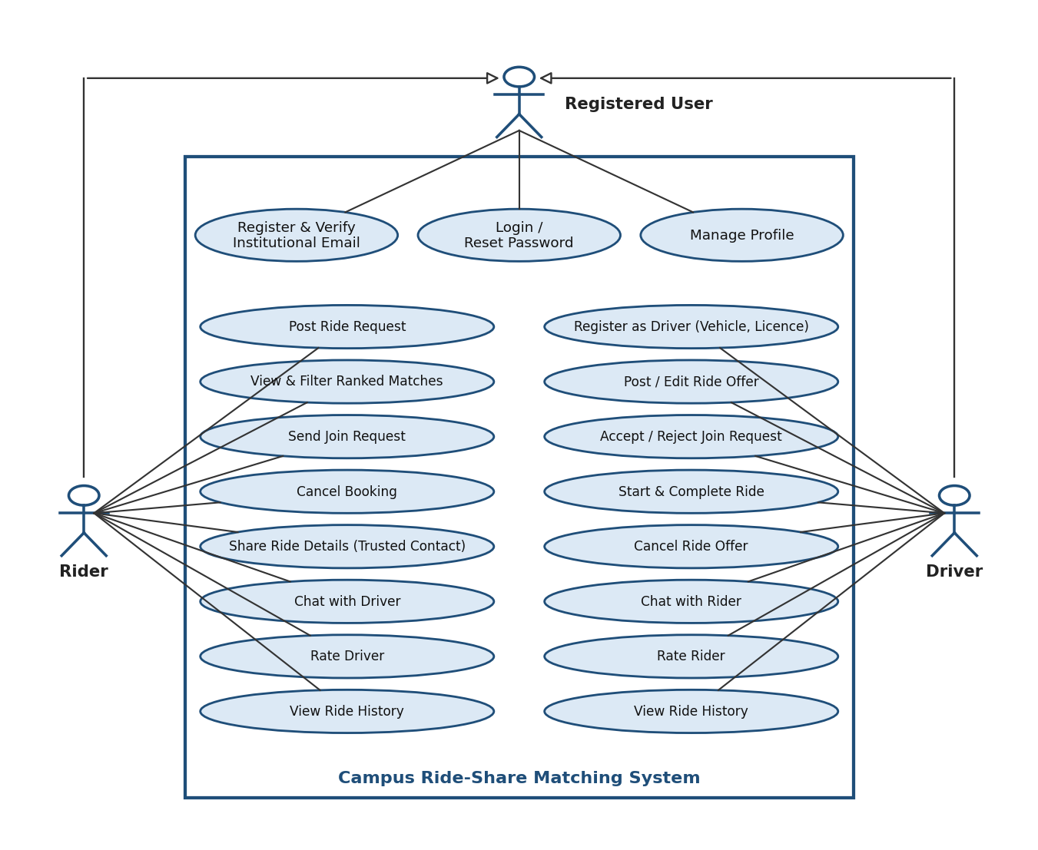
Figure 1: Use-case diagram - Rider and Driver (Registered User)
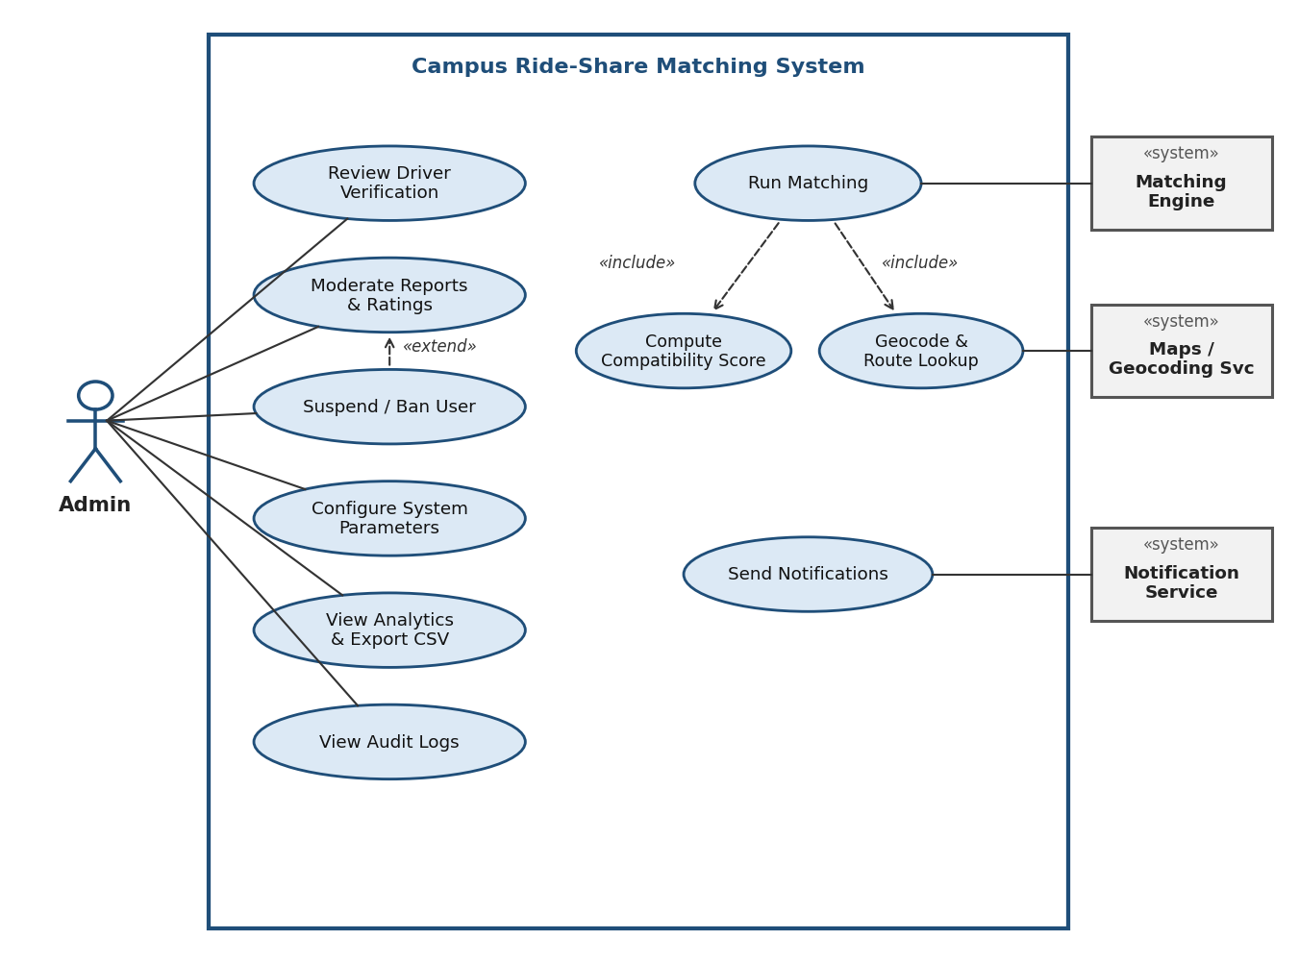
Figure 2: Use-case diagram - Administration and system services

7.2 Key use-case specifications

UC-01 Post ride request and select a match
Actor | Rider (primary); Matching Engine, Maps service (supporting)
Precondition | Rider is logged in with a verified account
Main flow | 1. Rider opens 'Find a Ride' and enters pickup, drop, time window and seats.  2. System validates locations (CRS-F-014) and stores the request (CRS-F-012).  3. Matching Engine returns compatible offers ranked by score (CRS-F-020, CRS-F-021).  4. Rider filters/sorts and selects an offer, then sends a join request (CRS-F-030).  5. System notifies the driver (CRS-F-060).
Alternate flows | A1: No match found - system keeps the request open and notifies the rider when a new compatible offer appears (CRS-F-022).  A2: Location outside service area - system shows an error and asks for another location.
Postcondition | A pending booking exists; request remains OPEN until a booking is confirmed or the request is cancelled/expired
Related requirements | CRS-F-012, 014, 020, 021, 022, 023, 030, 060

UC-02 Accept a join request
Actor | Driver (primary); Notification Service (supporting)
Precondition | Driver is approved and has an open offer with a pending join request
Main flow | 1. Driver receives a notification and opens the request with rider profile and rating.  2. Driver accepts the request (CRS-F-031).  3. System atomically reduces available seats (CRS-F-024) and confirms the booking (CRS-F-032).  4. System notifies the rider and reveals exact pickup details and chat to both parties (CRS-F-040).
Alternate flows | A1: Driver rejects - booking becomes REJECTED and the rider is notified.  A2: No seats left (concurrent acceptance) - system returns a conflict and keeps the other booking unchanged.  A3: No response in 30 min - request expires (CRS-F-035).
Postcondition | Booking is CONFIRMED and seats are reduced; or REJECTED/EXPIRED with notification
Related requirements | CRS-F-024, 031, 032, 035, 040, 060

UC-03 Complete ride and rate partner
Actor | Driver and Rider
Precondition | Booking is CONFIRMED and the departure time has been reached
Main flow | 1. Driver marks the ride as started and later completed (CRS-F-034).  2. System writes the ride to both users' history (CRS-F-050) and sends rating reminders (CRS-F-060).  3. Each participant submits 1-5 stars and an optional comment within 7 days (CRS-F-051).  4. System recalculates average ratings (CRS-F-052).
Alternate flows | A1: Rating submitted twice or after 7 days - system rejects it.  A2: Abusive comment - participant flags it for admin review (CRS-F-053).
Postcondition | Ride is COMPLETED; ratings stored and averages updated
Related requirements | CRS-F-034, 050, 051, 052, 053

8. Requirements Traceability Matrix (RTM)
Status legend: N = Not started, P = In progress / partially verified, A = Achieved (implemented and test passed). Design Spec references (DS-*) point to the SAD. Test cases are listed in the Test Plan (Appendix A).
Req ID | Requirement short | Section ref / Design Spec | Module | Test case(s) | Status (N/P/A) | Comments
CRS-F-001 | Register with institutional email + OTP | 4.1 / DS-Auth-01 | AuthService | TC-Auth-01, TC-Auth-02 | N | Requires email service (SMTP).
CRS-F-002 | Login and session handling | 4.1 / DS-Auth-01 | AuthService | TC-Auth-03, TC-Auth-04 | N | Depends on CRS-F-001.
CRS-F-003 | Account lockout after failed logins | 4.1 / DS-Auth-01 | AuthService | TC-Auth-05 | N | Audit log (CRS-F-074).
CRS-F-004 | Password reset | 4.1 / DS-Auth-01 | AuthService | TC-Auth-06 | N | Email service.
CRS-F-005 | Create and edit profile | 4.1 / DS-Prof-01 | ProfileService | TC-Prof-01 | N | Depends on CRS-F-002.
CRS-F-006 | Driver registration and verification | 4.1 / DS-Prof-01 | ProfileService | TC-Prof-02 | N | Admin review (CRS-F-070).
CRS-F-010 | Create ride offer | 4.2 / DS-Ride-01 | RideService | TC-Ride-01, TC-Ride-02 | N | Depends on CRS-F-006, CRS-F-014.
CRS-F-011 | Edit or cancel ride offer | 4.2 / DS-Ride-01 | RideService | TC-Ride-03 | N | Notification service.
CRS-F-012 | Create ride request | 4.2 / DS-Ride-01 | RideService | TC-Ride-04 | N | Depends on CRS-F-014.
CRS-F-013 | Edit or cancel ride request | 4.2 / DS-Ride-01 | RideService | TC-Ride-05 | N
CRS-F-014 | Location selection and validation | 4.2 / DS-Ride-01 | RideService | TC-Ride-06 | N | Maps/geocoding API.
CRS-F-015 | Prevent overlapping rides | 4.2 / DS-Book-01 | BookingService | TC-Ride-07 | N | Depends on CRS-F-032.
CRS-F-020 | Find compatible offers | 4.3 / DS-Match-01 | MatchingEngine | TC-Match-01, TC-Match-02 | N | Maps/routing API; PostGIS.
CRS-F-021 | Rank matches by compatibility score | 4.3 / DS-Match-01 | MatchingEngine | TC-Match-03 | N
CRS-F-022 | Re-evaluate matches on changes | 4.3 / DS-Match-01 | MatchingEngine | TC-Match-04 | N | Notification service.
CRS-F-023 | Filter and sort match results | 4.3 / DS-Match-01 | Web UI / MatchingEngine | TC-Match-05 | N
CRS-F-024 | Atomic seat allocation | 4.3 / DS-Book-01 | BookingService | TC-Match-06 | N | DB transaction isolation.
CRS-F-025 | Reverse matching for drivers | 4.3 / DS-Match-01 | MatchingEngine | TC-Match-07 | N | Uses CRS-F-020 rules.
CRS-F-030 | Send join request | 4.4 / DS-Book-01 | BookingService | TC-Book-01 | N
CRS-F-031 | Accept or reject join request | 4.4 / DS-Book-01 | BookingService | TC-Book-02 | N
CRS-F-032 | Confirmation updates seats and notifies | 4.4 / DS-Book-01 | BookingService | TC-Book-03 | N | Depends on CRS-F-024.
CRS-F-033 | Cancel confirmed booking | 4.4 / DS-Book-01 | BookingService | TC-Book-04, TC-Book-05 | N
CRS-F-034 | Start and complete ride | 4.4 / DS-Book-01 | BookingService | TC-Book-06 | N
CRS-F-035 | Auto-expire pending requests | 4.4 / DS-Book-01 | BookingService | TC-Book-07 | N | Scheduler.
CRS-F-036 | Share ride details with a trusted contact | 4.4 / DS-Book-01 | BookingService | TC-Book-08 | N
CRS-F-040 | In-app chat between linked users | 4.5 / DS-Msg-01 | MessagingService | TC-Msg-01 | N
CRS-F-041 | Persistent, near real-time delivery | 4.5 / DS-Msg-01 | MessagingService | TC-Msg-02 | N | WebSocket; Notification service.
CRS-F-042 | Report and block users | 4.5 / DS-Msg-01 | MessagingService | TC-Msg-03 | N | Admin moderation (CRS-F-071).
CRS-F-043 | Chat becomes read-only after the ride | 4.5 / DS-Msg-01 | MessagingService | TC-Msg-04 | N
CRS-F-044 | Message validation | 4.5 / DS-Msg-01 | MessagingService | TC-Msg-05 | N
CRS-F-050 | Ride history | 4.6 / DS-Rate-01 | RatingHistoryService | TC-Hist-01 | N
CRS-F-051 | Mutual ratings after completion | 4.6 / DS-Rate-01 | RatingHistoryService | TC-Rate-01, TC-Rate-02 | N | Depends on CRS-F-034.
CRS-F-052 | Average rating display | 4.6 / DS-Rate-01 | RatingHistoryService | TC-Rate-03 | N
CRS-F-053 | Immutable ratings and abuse flagging | 4.6 / DS-Rate-01 | RatingHistoryService | TC-Rate-04 | N
CRS-F-060 | Event notifications | 4.7 / DS-Notif-01 | NotificationService | TC-Notif-01 | N | Email / push providers.
CRS-F-061 | Departure reminders | 4.7 / DS-Notif-01 | NotificationService | TC-Notif-02 | N | Scheduler.
CRS-F-062 | Notification preferences | 4.7 / DS-Notif-01 | NotificationService | TC-Notif-03 | N
CRS-F-070 | Driver verification queue | 4.8 / DS-Admin-01 | AdminService | TC-Admin-01 | N
CRS-F-071 | Moderation and user sanctions | 4.8 / DS-Admin-01 | AdminService | TC-Admin-02, TC-Admin-03 | N
CRS-F-072 | System configuration | 4.8 / DS-Admin-01 | AdminService | TC-Admin-04 | N
CRS-F-073 | Usage analytics and export | 4.8 / DS-Admin-01 | AdminService | TC-Admin-05 | N
CRS-F-074 | Audit logging | 4.8 / DS-Admin-01 | AdminService | TC-Admin-06 | N
CRS-NF-001 | Match search response time | 5 / DS-Perf-01 | MatchingEngine / DB | TC-Perf-01 | N
CRS-NF-002 | General API and page speed | 5 / DS-Perf-01 | API / Web UI | TC-Perf-02 | N
CRS-NF-003 | Scalability | 5 / DS-Perf-01 | Application tier | TC-Perf-03 | N
CRS-NF-004 | Availability | 5 / DS-Rel-01 | Deployment | TC-Rel-02 | N
CRS-NF-005 | Backup and recovery | 5 / DS-Rel-01 | Database / Ops | TC-Rel-01 | N
CRS-NF-006 | Privacy and data protection | 5 / DS-Sec-01 | All modules | TC-Sec-01 | N
CRS-NF-007 | Usability | 5 / DS-UX-01 | Web UI | TC-UX-01 | N
CRS-NF-008 | Accessibility | 5 / DS-UX-01 | Web UI | TC-UX-02 | N
CRS-NF-009 | Compatibility | 5 / DS-UX-01 | Web UI | TC-Compat-01 | N
CRS-NF-010 | Maintainability | 5 / DS-Arch-01 | All modules | TC-Maint-01 | N
CRS-NF-011 | Audit and data retention | 5 / DS-Ops-01 | AdminService / DB | TC-Ops-01 | N
CRS-SR-001 | TLS 1.2+ everywhere | 5.1.2 / DS-Sec-01 | Security Layer | TC-Sec-02 | N | Objective SO-1
CRS-SR-002 | Password hashing & policy | 5.1.2 / DS-Sec-01 | Security Layer | TC-Sec-03 | N | Objective SO-1
CRS-SR-003 | RBAC & access control | 5.1.2 / DS-Sec-01 | Security Layer | TC-Sec-04 | N | Objective SO-3
CRS-SR-004 | Location & contact privacy | 5.1.2 / DS-Sec-01 | Security Layer | TC-Sec-05 | N | Objective SO-1
CRS-SR-005 | Input validation (SQLi/XSS/CSRF) | 5.1.2 / DS-Sec-01 | Security Layer | TC-Sec-06 | N | Objective SO-3
CRS-SR-006 | Rate limiting | 5.1.2 / DS-Sec-01 | Security Layer | TC-Sec-07 | N | Objective SO-4
CRS-SR-007 | Session / JWT security | 5.1.2 / DS-Sec-01 | Security Layer | TC-Sec-08 | N | Objective SO-2
CRS-SR-008 | Encryption at rest | 5.1.2 / DS-Sec-01 | Security Layer | TC-Sec-09 | N | Objective SO-1
CRS-SR-009 | Append-only audit log | 5.1.2 / DS-Sec-01 | Security Layer | TC-Sec-10 | N | Objective SO-3
CRS-SR-010 | Secure file upload | 5.1.2 / DS-Sec-01 | Security Layer | TC-Sec-11 | N | Objective SO-3

