# NetScope — Nmap Scan Report

## 1. Overview

**Target Network:** 192.168.56.0/24 **Scan Profile:** full (-sV -T4 -p-) **Date:** 2025-08-16 12:57:05 **Alive hosts discovered:** 1

## 2. Host Summaries

|  |  |  |  |
| --- | --- | --- | --- |
| IP Address | Hostname | Open Ports | Services & Versions |
| 192.168.56.1 | - | 135, 137, 139, 445, 3296, 3306, 5040, 7680, 8000, 8089, 8191, 49664, 49665, 49668, 49669, 49670, 49680 | msrpc Microsoft Windows RPC; netbios-ns; netbios-ssn Microsoft Windows netbios-ssn; microsoft-ds; http Node.js Express framework; mysql MariaDB 11.6.2; ; pando-pub; http Splunkd httpd; http Splunkd httpd; limnerpressure; msrpc Microsoft Windows RPC; msrpc Microsoft Windows RPC; msrpc Microsoft Windows RPC; msrpc Microsoft Windows RPC; msrpc Microsoft Windows RPC; msrpc Microsoft Windows RPC |

## 3. Visuals

Open ports per host:

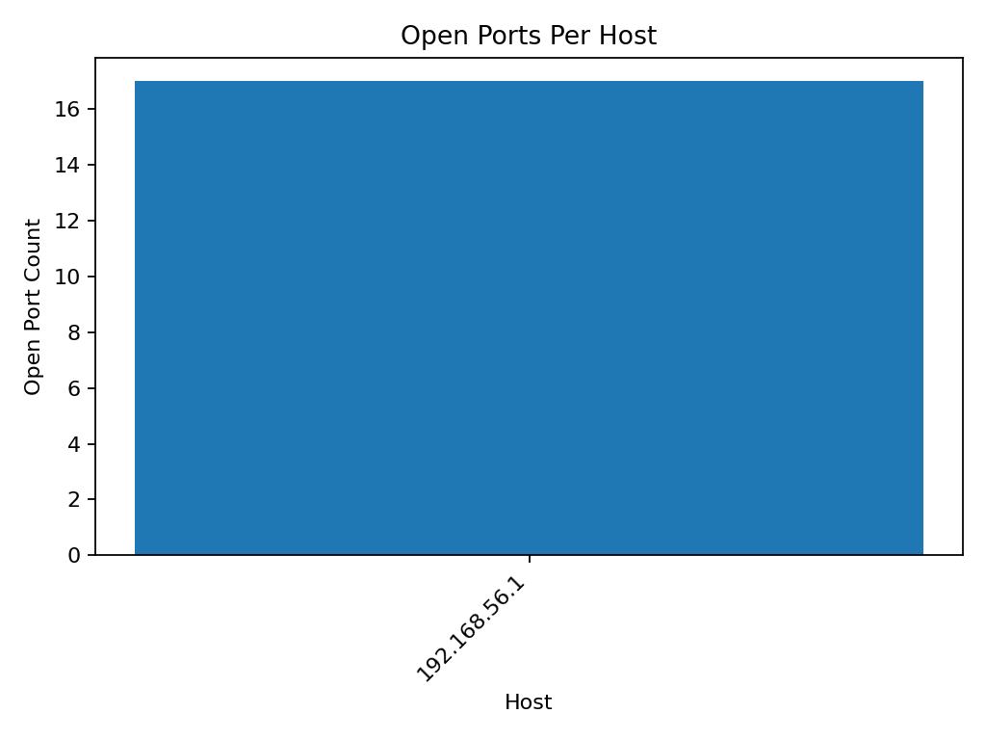

## 4. Notes & Ethical Use

These scans were performed only on authorized networks for learning purposes. Always obtain explicit permission before scanning any network you do not own.