**Dataset3:**

Random Forest

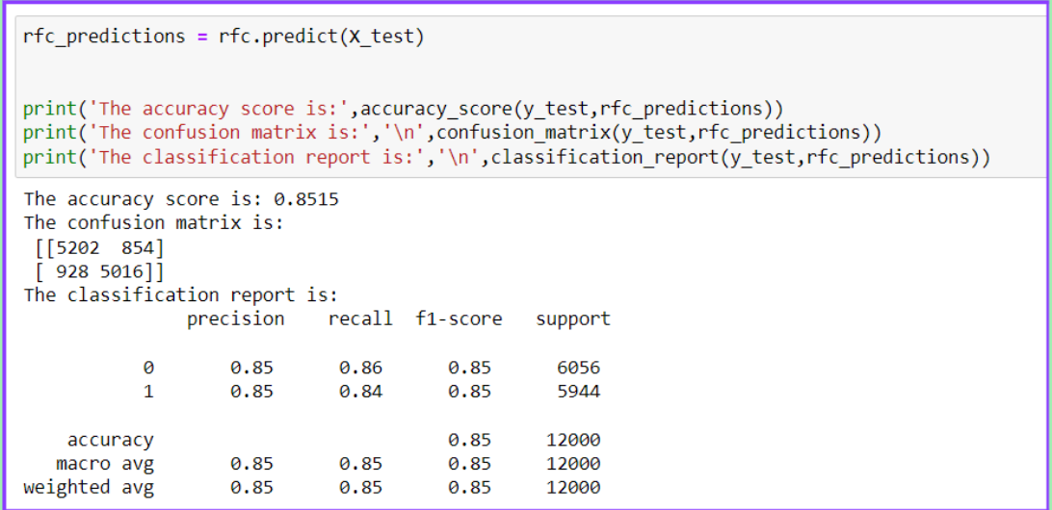

Logistic Regression

Decision Trees

KNN

**LR > RF > KNN > DT**

**Dataset2:**

Random Forest

Logistic Regression

Decision Trees

KNN

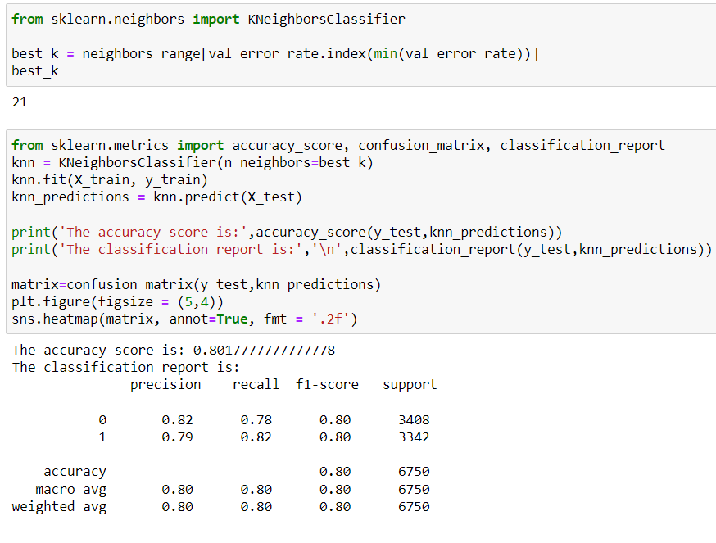

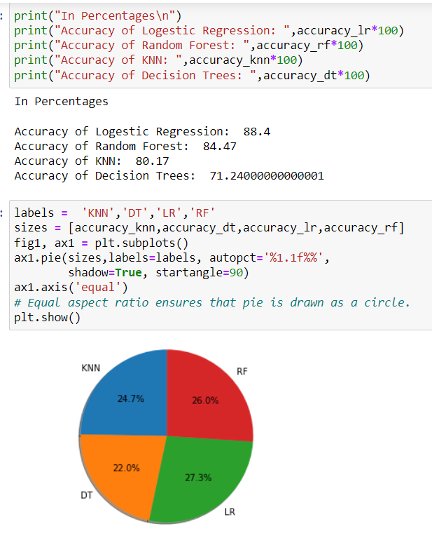

**LR > RF > KNN > DT**

**Dataset 1:**

Random Forest

Logistic Regression

Decision Trees

KNN

**LR > RF > KNN > DT**