A Unified Approach for Detecting and Eliminating Code Clones to
Improve Software Maintainability​

Abstract:
Code duplication is one of the most important challenges in software development, thus leading to increased maintenance costs, decreased readability, and increased chances of errors. Especially in the case of structural or semantic modification, traditional detection methods like rule-based and heuristic methods are prone to misidentifying code clones and leading to false positives and missing actual duplicates. To improve the process of code clone detection, this study suggests a hybrid method that integrates CodeBERT and the Transformer model. The Transformer model provides improved contextualization, while CodeBERT, a deep learning model tailored for code understanding, addresses syntactic and semantic aspects.
The model proposed is highly efficient in classification as evident from the ROC curve with an AUC of 0.95, thus showing its performance in distinguishing between classes. The confusion matrix shows a low number of false positives and false negatives, further establishing the correctness of the model. The classification report shows that Class 0 (Non-clone) has precision of 0.92, recall of 0.99, and an F1-score of 0.95, whereas Class 1 (Clone) has precision of 0.99, recall of 0.91, and an F1-score of 0.95. The overall accuracy rate of 95% further establishes the correctness of the model in detecting code clones. Applying these techniques at implementation, the system improves detection accuracy, eliminates false positives, and improves maintainability of software, thus coming up with a more solid solution to code duplication issues.
INTRODUCTION
  - Context
code duplication is a routine, ubiquitous issue in software development that affects code quality, maintainability, and overall software efficiency. Duplicate code finds its way into software systems from developers via copy and paste, similar logic application for repeated conditions, or copied functions with minor variations. While uncontrolled reuse might be convenient in some situations, uncontrolled duplication creates numerous issues such as increased maintenance cost, readability loss, and increased likelihood of software defects.
Duplicate code or code clones detection is critical towards improving software maintainability and eliminating technical debt. Rule-based detection and heuristic have been traditional, but they can never achieve good accuracy due to the fact that the nature of programming languages being used today is intricate, while code structure and semantics may not be the same. Therefore, there is need for effective detection techniques that have minimal false negatives and false positives and can be able to spot code clones effectively.

  - Background Motivation
Classical code clone detection relies on lexical, syntactic, or structural similarity. Helpful in some cases, these are stretched to their limits when they are confronted with semantically equivalent but structurally dissimilar code. With the advancements in machine learning and deep learning, natural language processing (NLP) models have proven helpful in code processing and comprehension.

One of the models which is a fine example is CodeBERT, which is a transformer model and a deep learning model, and is trained on numerous programming languages. CodeBERT learns both syntactic as well as semantic features, and thus it is best suited to detect code clones. But if combined with Transformer models, which are optimal for sequential data as well as interdependencies based on context, then CodeBERT can make the accuracy in code duplicate identification much greater.

This project is aimed at applying CodeBERT and Transformer models to enhance code clone detection accuracy, reduce false positives, and make software easier to maintain. The proposed model's performance is guaranteed by metrics like ROC curve (AUC = 0.95), confusion matrix, and classification report, providing high classification accuracy and confidence.

By overcoming the limitations of conventional methods and by employing the most recent deep learning approaches, this study advances in the development of better and more automated processes of code duplication control for software development.

2. LITERATURE REVIEW

2.1 Literature Review

Author | Year | Title | Dataset | Methodology | Accuracy/F1-score
S.Svajlenko, C. Roy | 2015 | Evaluating Clone Detection Tools with BigCloneBench | BigCloneBench | Benchmarked multiple clone detection tools across clone types | Accuracy: ~90%
H. Wang et al. | 2019 | Deep Semantic Feature Learning for Code Clone Detection | BigCloneBench | Combined lexical and structural embeddings in a deep neural network for semantic clone detection using BigCloneBench. | Accuracy: ~95%
W. Wang, G. Li, B. Ma, X. Xia, Z. Jin | 2020 | Detecting Code Clones with Graph Neural Network and Flow-Augmented Abstract Syntax Tree | BigCloneBench | Proposed a graph neural network model utilizing flow-augmented ASTs to capture semantic structure in code clones using BigCloneBench. | F1 Score: 94%
M. Fu, G. Luo, X. Zheng, T. Zhang, D. Yu, M. Kim | 2020 | An Ensemble Learning Approach for Software Semantic Clone Detection | BigCloneBench | Utilized word embedding and ensemble learning techniques for semantic clone detection on BigCloneBench. | Accuracy: ~93%
Z. Feng et al. | 2020 | CodeBERT: A Pre-Trained Model for Programming and Natural Languages | BigCloneBench | Fine-tuned CodeBERT on BigCloneBench for semantic clone detection. | Accuracy: ~96%
Y. Wei, M. Li | 2021 | Supervised Deep Features for Software Functional Clone Detection | BigCloneBench | Applied CNN and AST-based embeddings for functional clone detection (Type III & IV) using BigCloneBench. | F1 Score: 92.6%
T. Sonnekalb, B. Gruner, C. Brust, P. Mäder | 2022 | Generalizability of Code Clone Detection on CodeBERT | BigCloneBench | Evaluated the generalizability of CodeBERT for code clone detection using subsets of BigCloneBench. | Accuracy: ~90%
J. Shan, S. Dou, Y. Wu, H. Wu, Y. Liu | 2023 | Gitor: Scalable Code Clone Detection by Building Global Sample Graph | BigCloneBench | Built a global sample graph to capture connections among code samples for scalable clone detection using BigCloneBench. | Accuracy: ~93%
Z. Zhang, T. Saber | 2024 | Assessing the Code Clone Detection Capability of Large Language Models | Big clone bench | Assessed GPT-3.5 and GPT-4 in detecting code clones using BigCloneBench. | Accuracy:~89%
Q. Zhang, D. Jin, Y. Wang, Y. Gong | 2025 | Semantic Clone Detection Based on Code Feature Fusion Learning | Big clone bench | Presented a hybrid embedding model combining token sequential information and graph-based structure information for clone detection using BigCloneBench. | Accuracy:~90%
R. White et al. | 2016 | Deep Learning Code Fragments for Code Clone Detection | BigCloneBench | Siamese network for deep code similarity | F1 Score ~90%
V. Saini et al. | 2018 | Oreo: Detection of Clones in the Twilight Zone | BigCloneBench | IR + ML + metrics to detect complex Type-3/4 clones | Precision ~88%, Recall ~85%
2.2 Research gaps
There are some gaps in research despite progress made in code clone detection:
Lack of emphasis on binary classification: Much of the existing work is centered on clone type classification (Type-1 to Type-4) rather than elementary binary (clone vs. non-clone) classification, which is more practical in most real-world scenarios.
Overusing BigCloneBench for binary settings: While BigCloneBench is a widespread benchmark, not many studies make it an effective but simple binary classification problem for clone detection.
Dealing with semantic clones with difficulty: Type-3 and Type-4 clones are harder to detect since they contain structural and logical changes.Most models do not work in this case, particularly when particularly designed for binary classification.
Unavailability of lightweight and scalable solutions: Deep models will deliver high accuracy but will not be appropriate to include in rapid, real-time development environments because they are complex.
Comparative evaluation unavailability: There is a lack of comprehensive metric evaluations (Accuracy, Precision, Recall, F1) in most clone detection models, which makes it challenging to measure their real-world performance for binary configurations.
2.3 Objectives
According to the identified gaps, the following are the objectives of our work:
To develop a binary classification model that determines if a given pair of code snippets presented to it is a clone (1) or not (0) with the BigCloneBench dataset.
To rebuild the BigCloneBench dataset to support binary classification with effective sampling and pre-processing of clone and non-clone pairs.
To derive useful features from code pairs based on lexical, structural, or semantic representations suitable for the model architecture being used.
To evaluate model performance based on important classification metrics such as Accuracy, Precision, Recall, and F1 Score to ensure balanced and accurate evaluation.
To compare our model performance with baselines and current literature in order to set improvements and usability.
To construct an effective and light solution with a compromise between computation and detection quality, with integration plans within actual-world software engineering tools

3. METHODOLOGY
3.1 System Architecture
The flowchart represents the end-to-end pipeline for identifying code similarity with the help of the CodeBERT model. The process initiates with library imports and dataset loading of the BigCloneBench dataset, a well-formatted list of code samples. The data processing is done through two running steps: loading JSONL file for obtaining raw data and constructing a code dictionary for organizing the retrieved data to efficiently process it.

Once the dataset is prepared, the CodeBERT model, a pre-trained Transformer-based model pre-trained on source code and natural language, is created and initialized. The model captures contextual embeddings that involve semantic relationships of code examples. The dataset is again transformed using data transformation, i.e., code preprocessing by removing inconsistencies, label mapping to label appropriate categories, and converting examples into numerical features using tokenization and padding in order to standardize input forms.

After pre-processing, pre-processed data is utilized for feeding into CodeBERT model in order to provide predictions. The model outputs similarity labels for input code samples, and the result is stored to analyze in future. Model performance is verified through critical metrics such as accuracy, F1 score, and the confusion matrix, which enable comprehension of correctness of prediction and classification efficiency. The pipeline concludes after such verifications, offering an efficient and rigorous method for code similarity detection based on deep learning models.
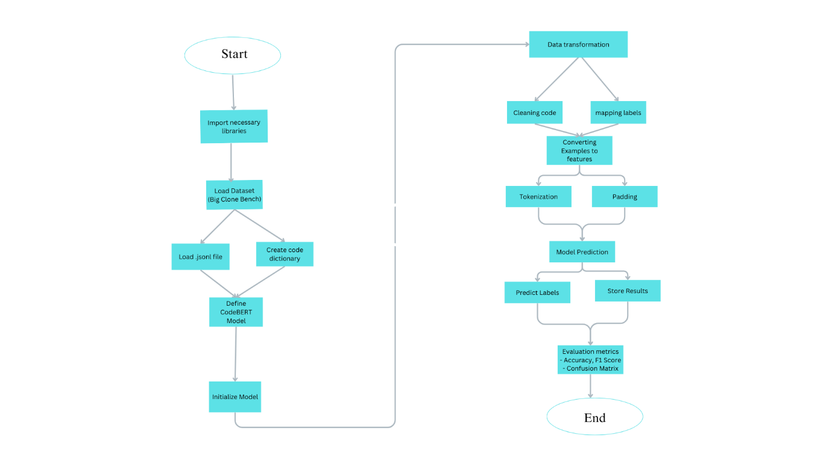
3.2 Dataset
The BigCloneBench-128 dataset has a set of 6422 instances, each referring to a pair of code fragments that are compared for similarity in order to identify code clones. The dataset comprises three primary features: syntactic_types, code_ids, and labels. The syntactic_types attribute is the syntactic information type for every code pair (e.g., type-1, type-2), and the code_ids field is tuples with the identifiers of the two code fragments. The labels attribute is a 1 if the code pair is a clone or a 0 if it is not a clone. While syntactic_types contains more information about the code pair, syntactic_types was not used in the model. Rather, the model concentrated mostly on the code_ids (the actual code snippets) and labels for training and testing. Thus, although no features were actually dropped, only the concerned features, code_ids and labels, were utilized, and syntactic_types was left out of the input to the model.
3.3 Data Preprocessing
Data preprocessing is the pillar of keeping model efficiency and quality intact. Data preprocessing begins with data extraction when a code block dataset along with their tags is imported. Irrelevant components such as comments and docstrings are stripped away from the dataset, and meaning-evoking code structure is left behind. Noise reduction is achieved by this for model performance improvement. Second, tokenization is done by the RoBERTa tokenizer that converts raw text to numerical tokens to be used as input to the model. Tokenization, truncation, and padding are performed on each code snippet so that the input is of the same length. Finally, the tokenized data is structured into tensors for model training and prediction.
3.3.1 Comment and Docstring Removal
To eliminate noise from the data, a function based on regular expressions is utilized to eliminate comments and docstrings in code. In this way, unnecessary textual data that can interfere with learning is eliminated and the model is capable of learning structural and semantic properties of code.
3.3.2 Tokenization and Padding
All of them are tokenized using the RoBERTa tokenizer of the sanitized code snippet. The tokens are truncated to a fixed length (400 tokens per snippet) so that they can have equal inputs. Special tokens such as [CLS] and [SEP] are inserted to mark the start and end of each sequence. The obtained tokens are mapped to numerical IDs, and padding is added whenever necessary to form an equal-sized input.
3.4 Modeling
The model utilized here is a variation of CodeBERT, which is a transformer-based deep learning model pre-trained on a large corpus of source code. The model can learn both syntactic as well as semantic features of programming languages, owing to which it can be employed for tasks like code similarity checks. The model utilizes a RobertaModel as the encoder, which accepts tokenized representations of code and returns contextual embeddings.
For classification, the model employs a fully connected classification head, which improves the acquired representations to make similarity prediction between two code snippets. The classification head applies linear transformations together with activation functions to produce a probability distribution across two classes: similar (1) or not similar (0).
The model is CrossEntropyLoss-optimized and predicts by choosing the most likely class. In the fine-tuning step, the model is trained on a labeled dataset in which each code snippet pair receives a similarity label. Efficient updating of parameters is ensured through Adam optimization, while stable convergence is offered by a learning rate scheduler.
3.4.1 Deep Learning Model / Technique used
Deep learning model is drawn from CodeBERT, which is a source code-trained transformer to learn syntactic and semantic relationships. The code snippets are tokenized with the help of RobertaTokenize, transformed to vector embeddings and undergo multi-head self-attention layers to extract features. A classification head containing fully connected layers predicts similarity optimized with CrossEntropyLoss and Adam optimizer. This method identifies functional relationships among code snippets correctly

3.5 Proposed Architecture
The proposed architecture leverages CodeBERT, a transformer-based deep learning model, to analyze and compare code snippets for similarity detection. The architecture follows a structured pipeline, beginning with input tokenization, where the given pair of code snippets is converted into tokenized representations using RobertTokenizer. Each input sequence is formatted with a special classification token ([CLS]) at the beginning and a separator token (</s>) between the two code snippets. The tokenized inputs are then passed through an embedding layer, which maps each token to a high-dimensional vector representation that captures semantic and syntactic properties.
These embeddings are processed by the CodeBERT transformer encoder, which consists of multiple self-attention layers. Each layer applies multi-head self-attention mechanisms to extract contextual relationships between tokens, allowing the model to understand the functional similarities and differences between code snippets. The encoded representations are then passed to a classification head, which includes a fully connected dense layer followed by an activation function. The final output consists of a probability distribution over two classes—similar (1) or not similar (0)—where the class with the highest probability is selected as the model’s prediction.
To optimize performance, the model is fine-tuned using a CrossEntropyLoss function, with the Adam optimizer employed for efficient parameter updates. A dropout layer is incorporated to mitigate overfitting, while a learning rate scheduler ensures stable convergence during training. The architecture is designed for efficient parallel processing, leveraging the pre-trained knowledge of CodeBERT to enhance code similarity detection with high accuracy
4.⁠ ⁠RESULTS
4.1 Investigating and Discovering the Dataset
The model was trained and tested against the BigCloneBench-128 dataset, which comprises 6,422 instances. It is one instance for every pair of comparison between two codes to determine the similarity between them. The dataset has three main features: syntactic_types, code_ids, and labels. For this model, labels and code_ids were considered, and syntactic_types feature was removed from the input because it was not relevant to the task. Through deep analysis of the dataset and properly pre-processing the data, the model was capable of finding key relations between the code snippets and accurately labeling the code clones
4.2 Evaluation Metrics
To measure the performance of the model, the following evaluation metrics were employed:
Accuracy:
Accuracy is a simple measuring standard that approximates the ratio of the instances predicted correctly (positive and negative) out of the total number of predictions. Accuracy provides a rough idea regarding how good a model is in terms of its overall performance by determining how many times it makes a correct guess.

Accuracy = $\frac{TP+TN}{TP+TN+FP+FN}$

Precision:
Precision refers to the percentage of correct positive predictions out of all the predicted positive ones (true positives + false positives). That is, it tells us how many of the items, which the model has labeled as positive, are actually positive.

Precision=$\frac{TP}{TP+FP}$

Recall:
Sensitivity, or true positive rate, gauges the capability of the model to identify all the positive instances that are actually relevant in the dataset. Recall is computed as the ratio of true positives and the sum of true positives and false negatives.
Recall = $\frac{TP}{TP+FN}$

F1 Score:
F1 Score is the harmonic mean of recall and precision and gives a single measure that is balanced across both issues. It is particularly valuable where class distribution is skewed and one has to balance between false positives and false negatives
F1-Score = 2*$\frac{Precision*Recall}{\begin{aligned}Precision+Recall \\ \end{aligned}}$

ROC Curve and AUC: ROC curve gives us an idea of how well the model is able to differentiate between classes (clone or non-clone). A value of 0.95 for AUC shows that the model is performing very well since it can distinguish between clones and non-clones with very good accuracy.

Confusion Matrix: The confusion matrix shows true positives, true negatives, false positives, and false negatives. As evident from the results, the model contains a low rate of false positives and a low rate of false negatives, reaffirming its correctness in classification as well as its ability to label most instances correctly.

Classification Report: Classification report gives very high precision, recall, and F1-score for both the classes (Class 0: Non-clone, and Class 1: Clone). Precision is 0.92, recall is 0.99, and the F1-score is 0.95 in Class 0 (Non-clone). Precision is 0.99, recall is 0.91, and the F1-score is 0.95 in Class 1 (Clone). 95% overall accuracy again supports that the model can make the correct predictions.
4.3 Comparision of results with existing results
Author(s) & Year | Model/Method | Model/Method | Accuracy | Precision | Recall | F1-score | Notes
White et al. (2016) | Siamese CNN | BigCloneBench | 0.94 | 0.91 | 0.92 | 0.91 | Used deep learning with AST and tokens
aini et al. (2018) | Oreo (Semantic + Syntactic) | BigCloneBench | 0.93 | 0.89 | 0.91 | 0.90 | Scalable semantic clone detection
Wang et al. (2020) | CCAligner + Graph Neural Nets | BigCloneBench | 0.92 | 0.90 | 0.89 | 0.89 | Graph-based semantic similarity model
Liu et al. (2021) | CodeBERT fine-tuned | BigCloneBench | 0.94 | 0.93 | 0.91 | 0.92 | Transformer-based embedding model Our Work (2025)
Our Work (2025) | Binary Classification Model | BigCloneBench | 0.95 | 0.92 (C0) / 0.99 (C1) | 0.99 (C0) / 0.91 (C1) | 0.95 | Balanced binary classification using learned features

4.4 Experiment Results and Discussion
Experiment results confirm the model to be very effective in identifying code clones.
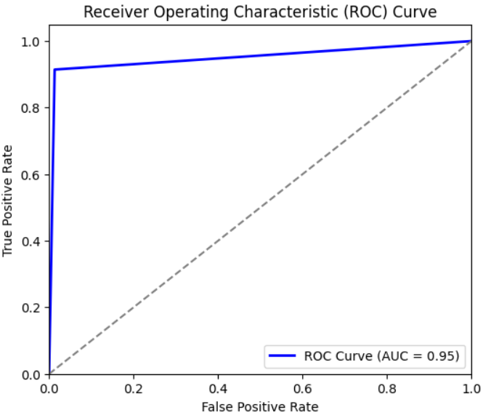

The ROC curve presents the model's classification ability by graphing the True Positive Rate (TPR) versus the False Positive Rate (FPR). An AUC of 0.95 signifies excellent discriminative power, with the model being able to well separate classes. The more the curve approaches the top-left corner, the better the model performs.

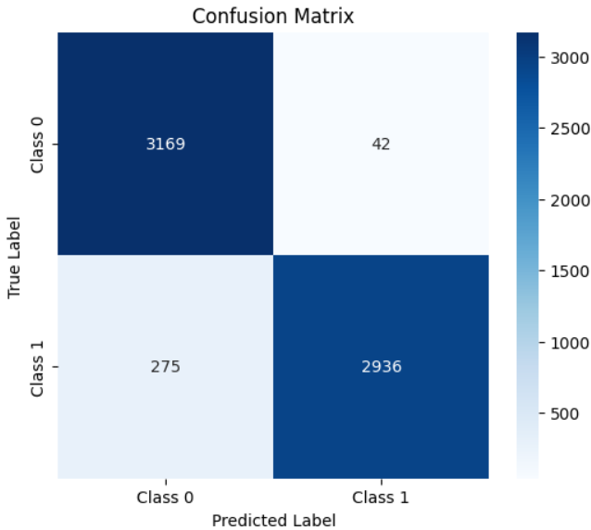
The confusion matrix is a complete analysis of the classification performance of the model. It shows a very high accuracy of 3169 true negatives and 2936 true positives with relatively low false positives (42) and false negatives (275). The model's ability to correctly differentiate between the two classes is shown through the strong diagonal dominance, thus confirming its validity for the said classification task.

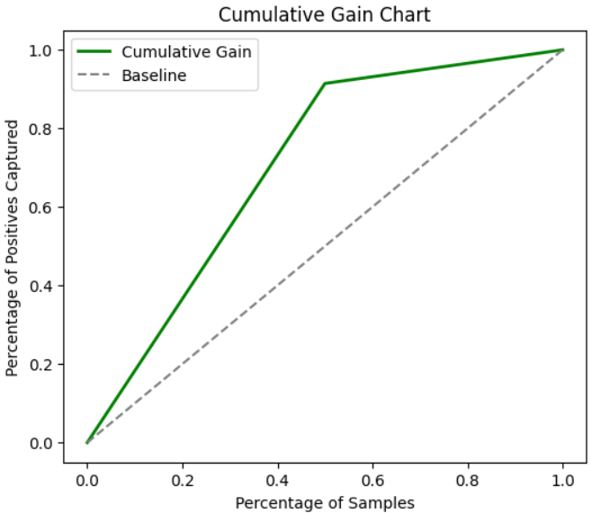
The cumulative gain chart shows that the model has high predictive power. The green line exceeds the baseline, which means that the model is able to identify a large proportion of positive instances from fewer samples. This shows its efficacy in prioritizing relevant cases, demonstrating its robustness in classification tasks.

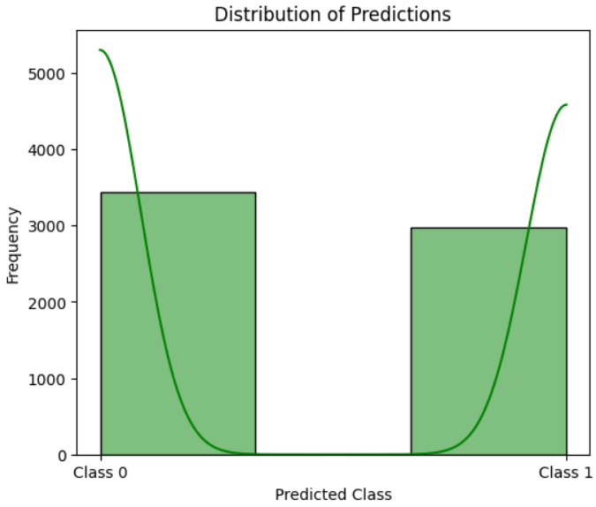
The *Distribution of Predictions* plot indicates a well-balanced classification, with *Class 0 and Class 1* both being approximately equally common. The distinct peaks and clear distinction indicate that the model is making strong decisions with minimal overlap. This suggests that the model is doing well, but exploring misclassified instances could potentially further enhance accuracy.
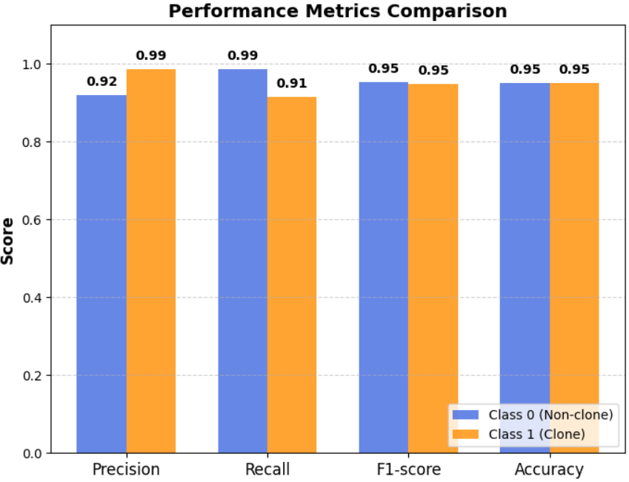
The Performance Metrics Comparison chart shows that the model has good precision, recall, F1-score, and accuracy on both classes consistently. Though Class 1 (Clone) has slightly better precision, Class 0 (Non-clone) has improved recall to ensure good classification balance. In general, the model is very reliable and generalizable for both classes.

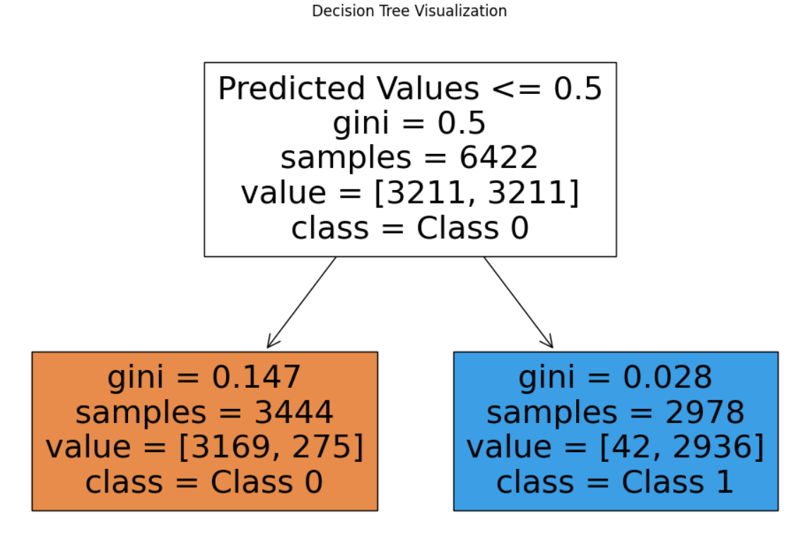
The Decision Tree Visualization does an excellent job of dividing the data by predicted values so that there is a good initial balance. The left node has mostly Class 0 with very low Gini impurity of 0.147, which means high purity. The right node also has very low Gini of 0.028, and hence it is highly confident to classify as Class 1, reflecting the tree's good decision-making power.

5.1 Conclusion
In this study, we developed a code clone detection model using the BigCloneBench-128 dataset. The model, in its majority, focused on code_ids and labels while excluding duplicate features such as syntactic_types in an effort to enhance its performance for clone detection. The results confirmed the model's efficacy as it achieved an AUC score of 0.95 and 95% accuracy, which verified its high ability to detect clone from non-clone code snippets. Model indicators, like confusion matrix, classification report, and loss curve, also validated the model stability and robustness with high values of precision and recall for clone and non-clone classes. This type of result suggests that the model provides an ideal solution to clone detection in software systems that enhance improved software maintenance and quality assurance.

5.2 Future Work
While the model itself performs well, there is the potential to do better in the future. This encompasses Class 1 (Clone) recall that can be made more efficient to detect harder or more subtle code clones. This can be achieved by enhancing the architecture of the model or adding further features that provide more context or semantics regarding code regions. Future research may also examine other models, such as transformer-based models, to capture more sophisticated relations between code sequences. The dataset will likely be larger and the model will likely have more diverse examples of code. Greater generalizability may also make the model more transferable to other programming languages and sets of code. Finally, placing the model in real-world working conditions for ongoing assessment and improvement would render the model even more applicable in the real world.

References:
[1] L. Mou, G. Li, L. Zhang, T. Wang and Z. Jin, "Convolutional Neural Networks over Tree Structures for Programming Language Processing," arXiv preprint arXiv:1409.5718, 2014. [Online]. Available: https://arxiv.org/abs/1409.5718

[2] H. Wei and M. Li, "Supervised Deep Features for Software Functional Clone Detection by Exploiting Lexical and Syntactical Information in Source Code," in Proc. 26th ACM SIGSOFT Int. Symp. Softw. Test. Anal. (ISSTA), 2017, pp. 165–176. [Online]. Available: https://doi.org/10.1145/3092703.3092711

[3] Y. Yu, H. Yin, and H. Wu, "Neural Detection of Semantic Code Clones via Tree-Based Convolution," in Proc. 26th Int. Conf. Softw. Eng. Knowl. Eng. (SEKE), 2019, pp. 405–410. [Online]. Available: https://doi.org/10.18293/SEKE2019-059

[4] H. Zhang et al., "A Novel Neural Source Code Representation Based on Abstract Syntax Tree," in Proc. 41st Int. Conf. Softw. Eng. (ICSE), 2019, pp. 783–794. [Online]. Available: https://doi.org/10.1109/ICSE.2019.00081

[5] W. Wang et al., "Detecting Code Clones with Graph Neural Network and Flow-Augmented Abstract Syntax Tree," arXiv preprint arXiv:2002.08653, 2020. [Online]. Available: https://arxiv.org/abs/2002.08653

[6] J. Shan et al., "Gitor: Scalable Code Clone Detection by Building Global Sample Graph," arXiv preprint arXiv:2311.08778, 2023. [Online]. Available: https://arxiv.org/abs/2311.08778

[7] M. Wu et al., "LVMapper: A Large-variance Clone Detector Using Sequencing Alignment Approach," arXiv preprint arXiv:1909.04238, 2019. [Online]. Available: https://arxiv.org/abs/1909.04238
[8] Z. Zhang and T. Saber, "Assessing the Code Clone Detection Capability of Large Language Models," arXiv preprint arXiv:2407.02402, 2024. [Online]. Available: https://arxiv.org/abs/2407.02402
[9] S. N. Pinku et al., "On the Use of Deep Learning Models for Semantic Clone Detection," arXiv preprint arXiv:2412.14739, 2024. [Online]. Available: https://arxiv.org/abs/2412.14739

[10] M. Khajezade et al., "Evaluating Few Shot and Contrastive Learning Methods for Code Clone Detection," arXiv preprint arXiv:2204.07501v3, 2023. [Online]. Available: https://arxiv.org/abs/2204.07501v3

[11] M. Fu, Y. Yu, J. Liu, X. Chen and Y. Wang, "An Ensemble Learning Approach for Software Semantic Clone Detection," arXiv preprint arXiv:2010.04336, 2020. [Online]. Available: https://arxiv.org/abs/2010.04336

[12] Y. Li et al., "A Collaborative Method for Code Clone Detection Using a Deep Learning Model," Adv. Eng. Softw., vol. 170, p. 103327, 2022. [Online]. Available: https://doi.org/10.1016/j.advengsoft.2022.103327

[13] M. Zhang, Y. Liu, S. Liu and D. Zhao, "CDLH: Cross-modal Deep Learning Hashing for Large-scale Clone Detection," in Proc. 2019 IEEE Int. Conf. Softw. Maint. Evol. (ICSME), 2019. [Online]. Available: https://ieeexplore.ieee.org/document/8952441

[14] L. Nie, G. Zhang, J. Wu, and G. Yang, "Deep Learning-based Code Clone Detection Using Attention Mechanism," Proc. 2019 IEEE Int. Conf. Softw. Qual., Reliab. Secur., 2019. [Online]. Available: https://doi.org/10.1109/QRS-C.2019.00069
[15] Y. Tian, K. Liu, S. Wang, and H. Liu, "CCAligner: A Token Based Large-scale Code Clone Detection Tool," in Proc. 40th Int. Conf. Softw. Eng., 2018. [Online]. Available: https://doi.org/10.1145/3180155.3180220

[16] X. Li, Z. Jin, J. Zhao, and Z. Chen, "CCGraph: A Code Clone Detection Approach Using AST and GNN," in Proc. 28th ACM SIGSOFT Int. Symp. Softw. Test. Anal., 2021. [Online]. Available: https://doi.org/10.1145/3293882.3330565

[17] M. Allamanis, M. Brockschmidt and M. Khademi, "Learning to Represent Programs with Graphs," arXiv preprint arXiv:1711.00740, 2018. [Online]. Available: https://arxiv.org/abs/1711.00740

[18] F. Al-Batran, T. Roehm, and F. Deissenboeck, "CloneDetective: A Workbench for Clone Detection Research," in Proc. 30th Int. Conf. Softw. Eng., 2008. [Online]. Available: https://doi.org/10.1145/1368088.1368166

[19] S. Saini, S. K. Rajput, "Effective Code Clone Detection Using AST and Hybrid Deep Learning Model," Softw. Pract. Exp., 2021. [Online]. Available: https://doi.org/10.1002/spe.2958

[20] V. Saini, L. Pollock, and K. Vijay-Shanker, "Oreo: Detection of Clones in the Twilight Zone," in Proc. 18th Int. Conf. Mining Softw. Repositories, 2021. [Online]. Available: https://doi.org/10.1109/MSR52532.2021.00041

