Question 1: Design the student bio-data form using button, label, textbox, radio button, table and
checkbox using CSS.

<!DOCTYPE html>
<html lang="en">
<head>
<meta charset="UTF-8">
<meta name="viewport" content="width=device-width, initial-scale=1.0">
<title>Student Bio-Data Form</title>

<style>
/* General Body Styles */
body {
font-family: 'Arial', sans-serif;
background-color: #f7f7f7;
margin: 0;
padding: 0;
}

h1 {
text-align: center;
margin-top: 30px;
color: #4CAF50;
}

/* Form Container */
.form-container {
background-color: white;
width: 70%;
margin: 50px auto;
padding: 30px;
border-radius: 10px;
box-shadow: 0 4px 8px rgba(0, 0, 0, 0.1);
}

/* Form Heading */
.form-container h2 {
text-align: center;
color: #333;
}

/* Input and Select Fields */
input[type="text"], input[type="email"], input[type="date"], select, textarea {
width: 100%;
padding: 10px;
margin: 8px 0;
border: 1px solid #ccc;
border-radius: 5px;
box-sizing: border-box;
}

input[type="text"]:focus, input[type="email"]:focus, input[type="date"]:focus, select:focus, textarea:focus {
border-color: #4CAF50;
outline: none;
}

/* Labels */
label {
font-size: 16px;
font-weight: bold;
color: #333;
margin-bottom: 8px;
display: block;
}

/* Checkbox and Radio Button Styles */
.container, .radcontainer {
display: block;
position: relative;
padding-left: 35px;
cursor: pointer;
font-size: 18px;
user-select: none;
}

.container input, .radcontainer input {
position: absolute;
opacity: 0;
cursor: pointer;
height: 0;
width: 0;
}

.checkmark, .radcheckmark {
position: absolute;
top: 0;
left: 0;
height: 25px;
width: 25px;
background-color: #eee;
border-radius: 50%;
}

.container:hover input ~ .checkmark, .radcontainer:hover input ~ .radcheckmark {
background-color: #ccc;
}

.container input:checked ~ .checkmark, .radcontainer input:checked ~ .radcheckmark {
background-color: #2196F3;
}

.checkmark:after, .radcheckmark:after {
content: "";
position: absolute;
display: none;
}

.container input:checked ~ .checkmark:after, .radcontainer input:checked ~ .radcheckmark:after {
display: block;
}

.container .checkmark:after, .radcontainer .radcheckmark:after {
left: 9px;
top: 5px;
width: 5px;
height: 10px;
border: solid white;
border-width: 0 3px 3px 0;
transform: rotate(45deg);
}

/* Custom Submit Button */
.btn-submit {
background-color: #4CAF50;
color: white;
padding: 10px 20px;
border: none;
border-radius: 5px;
cursor: pointer;
width: 100%;
font-size: 18px;
}

.btn-submit:hover {
background-color: #45a049;
}

/* Table Styling */
table {
width: 100%;
margin-top: 20px;
border-collapse: collapse;
}

th, td {
padding: 10px;
text-align: left;
border-bottom: 1px solid #ddd;
}

th {
background-color: #f4f4f4;
}

/* Styling for textareas */
textarea {
height: 100px;
}

</style>
</head>

<body>

<h1>Sarvagyas Autism Bio-Data Form</h1>

<!-- Form Container -->
<div class="form-container">
<h2>Student Bio-Data</h2>

<form>
<!-- Personal Information -->
<div class="form-group">
<label for="name">Full Name:</label>
<input type="text" id="name" name="name" placeholder="Enter your full name" required>
</div>

<div class="form-group">
<label for="dob">Date of Birth:</label>
<input type="date" id="dob" name="dob" required>
</div>

<div class="form-group">
<label for="email">Email Address:</label>
<input type="email" id="email" name="email" placeholder="Enter your email" required>
</div>

<!-- Favourite Mental Health Disorder (Checkboxes) -->
<div class="form-group">
<label>What is your favourite mental health disorder in your partner?</label>
<label class="container">Schizophrenia
<input type="checkbox" checked="checked">
<span class="checkmark"></span>
</label>
<label class="container">Autism
<input type="checkbox">
<span class="checkmark"></span>
</label>
<label class="container">Crippling Anxiety
<input type="checkbox">
<span class="checkmark"></span>
</label>
<label class="container">ADHD
<input type="checkbox">
<span class="checkmark"></span>
</label>
<label class="container">Substance Abuse Disorder
<input type="checkbox">
<span class="checkmark"></span>
</label>
</div>

<!-- What do you like about yourself? (Checkboxes) -->
<div class="form-group">
<label>What do you like about yourself?</label>
<label class="radcontainer">ADHD
<input type="checkbox" checked="checked">
<span class="radcheckmark"></span>
</label>
<label class="radcontainer">Bajaj Chetak
<input type="checkbox" checked="checked">
<span class="radcheckmark"></span>
</label>
<label class="radcontainer">Dont need external validation
<input type="checkbox" checked="checked">
<span class="radcheckmark"></span>
</label>
<label class="radcontainer">Active
<input type="checkbox" checked="checked">
<span class="radcheckmark"></span>
</label>
<label class="radcontainer">Self Dependent
<input type="checkbox" checked="checked">
<span class="radcheckmark"></span>
</label>
</div>

<!-- Favourite Hotwheels Car (Select Dropdown) -->
<div class="form-group">
<label for="cars">Choose your favourite Hotwheels:</label>
<select id="cars" name="cars">
<option value="volvo">Maruti 800</option>
<option value="saab">Lord Alto</option>
<option value="mercedes">Bajaj Chetak</option>
<option value="audi">Passion Pro</option>
</select>
</div>

<!-- Text Area for Additional Information -->
<div class="form-group">
<label for="info">Additional Information:</label>
<textarea id="info" name="info" placeholder="Any additional comments..." required></textarea>
</div>

<!-- Submit Button -->
<button type="submit" class="btn-submit">Submit</button>
</form>
</div>

</body>
</html>
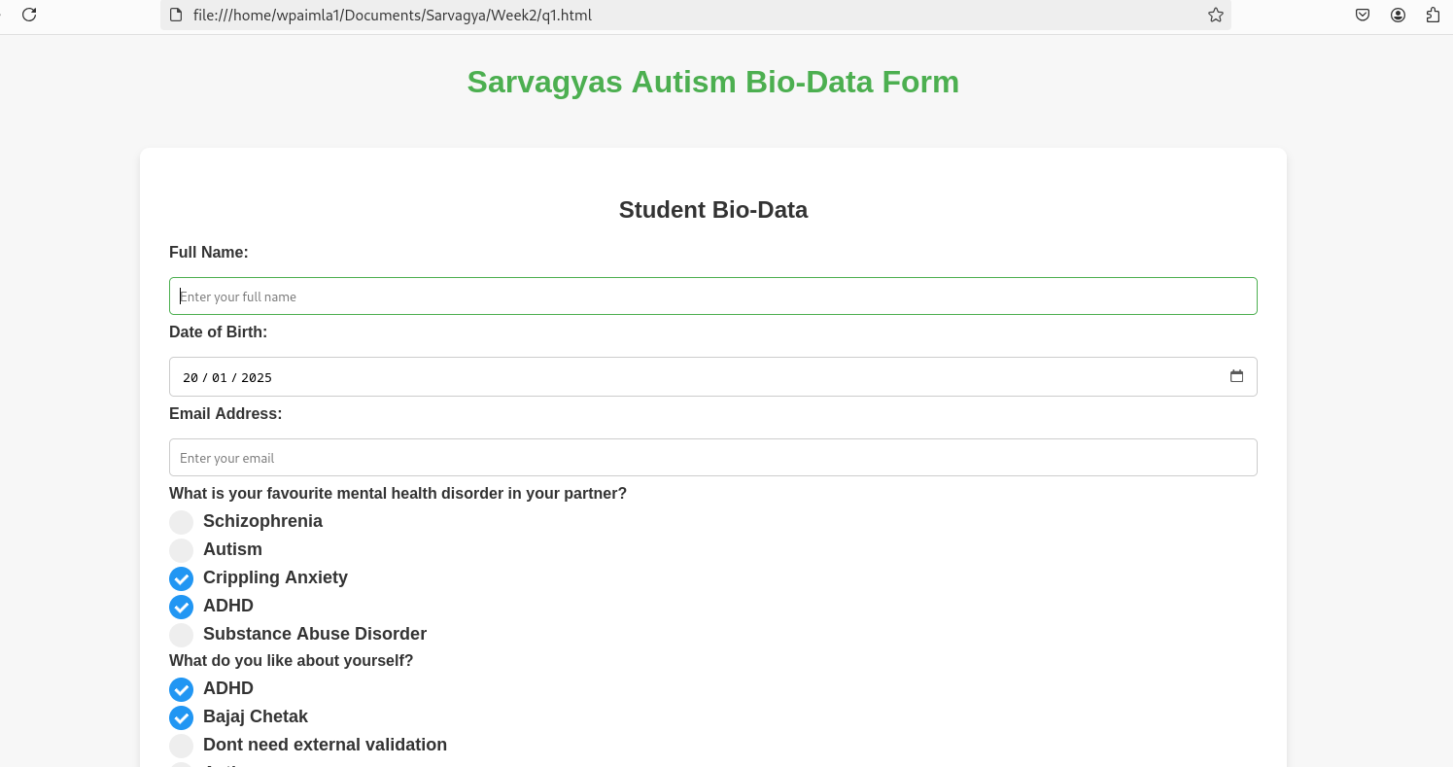

Question 3: Create a web page using bootstrap as mentioned. Divide the page in to 2 parts top and
bottom, then divide the bottom into 3 parts and design each top and bottom part using
different input groups, input, badges, buttons and button groups. Make the design more
attractive using bootstrap.

<!DOCTYPE html>
<html lang="en">
<head>
<meta charset="UTF-8">
<meta name="viewport" content="width=device-width, initial-scale=1.0">
<title>Bootstrap Layout Example</title>
<!-- Bootstrap CSS Link -->
<link href="https://cdn.jsdelivr.net/npm/bootstrap@5.3.0-alpha1/dist/css/bootstrap.min.css" rel="stylesheet">

</head>
<body>

<!-- Top Section -->
<div class="container-fluid bg-light py-4">
<div class="row">
<div class="col text-center">
<h1>Welcome to Sarvagya's Web Page</h1>
<p class="lead">Just trying out different Bootstrap components</p>
</div>
</div>
</div>

<!-- Bottom Section -->
<div class="container-fluid py-5">
<div class="row">
<!-- Left Section -->
<div class="col-md-4">
<h3>Input Group with Badges</h3>
<div class="input-group mb-3">
<span class="input-group-text">#</span>
<input type="text" class="form-control" placeholder="Enter a hashtag">
<span class="input-group-text"><span class="badge bg-primary">New</span></span>
</div>
<button class="btn btn-success btn-lg">Submit</button>
</div>

<!-- Center Section -->
<div class="col-md-4 text-center">
<h3>Button Groups</h3>
<div class="btn-group" role="group" aria-label="Basic example">
<button type="button" class="btn btn-primary">Left</button>
<button type="button" class="btn btn-secondary">Middle</button>
<button type="button" class="btn btn-danger">Right</button>
</div>
<br><br>
<div class="btn-group-vertical" role="group" aria-label="Vertical buttons">
<button type="button" class="btn btn-warning">Top</button>
<button type="button" class="btn btn-info">Middle</button>
<button type="button" class="btn btn-dark">Bottom</button>
</div>
</div>

<!-- Right Section -->
<div class="col-md-4">
<h3>Search Input with Button</h3>
<div class="input-group mb-3">
<input type="text" class="form-control" placeholder="Search..." aria-label="Search">
<button class="btn btn-outline-primary" type="button">Search</button>
</div>
<button class="btn btn-danger btn-lg">Cancel</button>
</div>
</div>
</div>

<!-- Bootstrap JS Link -->
<script src="https://cdn.jsdelivr.net/npm/bootstrap@5.3.0-alpha1/dist/js/bootstrap.bundle.min.js"></script>
</body>
</html>

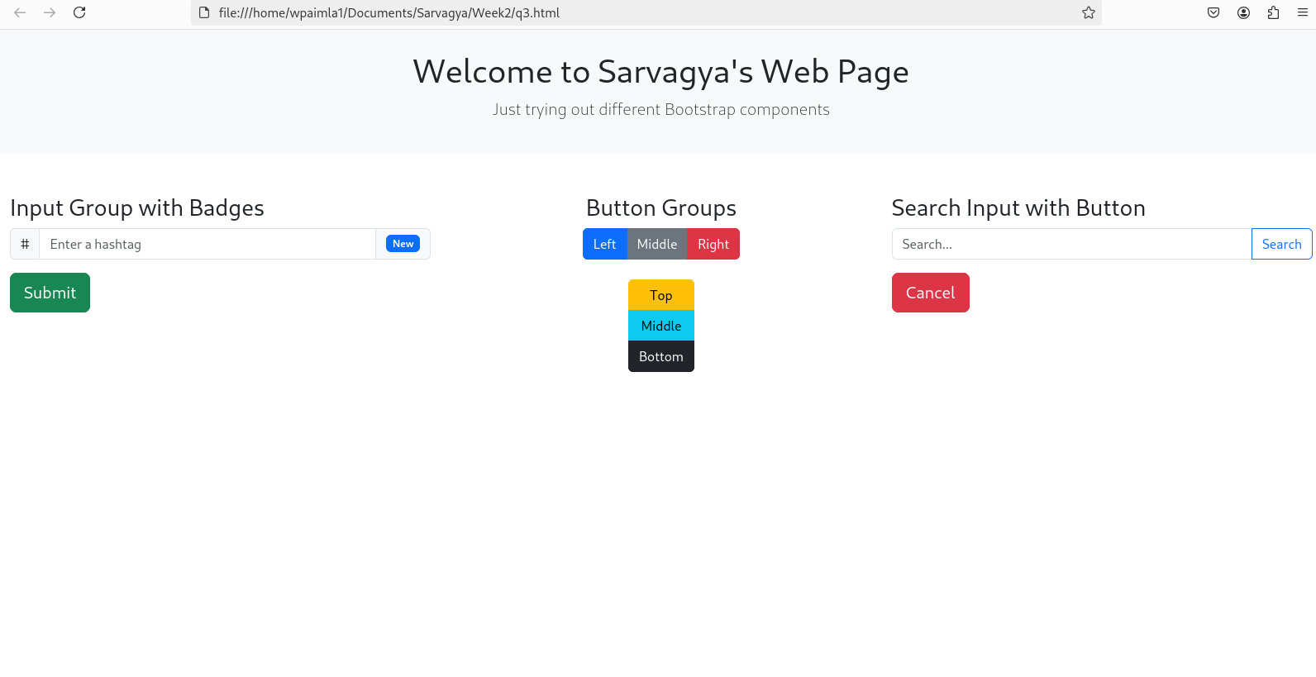

Question 4: Design your class timetable using bootstrap table and carousel.

<!DOCTYPE html>
<html lang="en">
<head>
<meta charset="UTF-8">
<meta name="viewport" content="width=device-width, initial-scale=1.0">
<title>Class Timetable</title>
<!-- Bootstrap CSS Link -->
<link href="https://cdn.jsdelivr.net/npm/bootstrap@5.3.0-alpha1/dist/css/bootstrap.min.css" rel="stylesheet">
</head>
<body>

<!-- Carousel for Week Navigation -->
<div id="weekCarousel" class="carousel slide" data-bs-ride="carousel">
<div class="carousel-inner">
<div class="carousel-item active">
<div class="container py-5">
<h2 class="text-center">A Section Timetable</h2>
<div class="table-responsive">
<!-- Table for Timetable (Week 1) -->
<table class="table table-bordered table-striped">
<thead class="table-dark">
<tr>
<th>Time</th>
<th>Monday</th>
<th>Tuesday</th>
<th>Wednesday</th>
<th>Thursday</th>
<th>Friday</th>
</tr>
</thead>
<tbody>
<tr>
<td>8:00 AM - 9:00 AM</td>
<td>Math</td>
<td>Physics</td>
<td>Chemistry</td>
<td>Biology</td>
<td>English</td>
</tr>
<tr>
<td>9:15 AM - 10:15 AM</td>
<td>History</td>
<td>Math</td>
<td>Physics</td>
<td>Computer Science</td>
<td>Art</td>
</tr>
<tr>
<td>10:30 AM - 11:30 AM</td>
<td>English</td>
<td>Chemistry</td>
<td>Math</td>
<td>History</td>
<td>PE</td>
</tr>
<tr>
<td>11:45 AM - 12:45 PM</td>
<td>Biology</td>
<td>History</td>
<td>PE</td>
<td>Math</td>
<td>Physics</td>
</tr>
</tbody>
</table>
</div>
</div>
</div>
<!-- Week 2 Timetable -->
<div class="carousel-item">
<div class="container py-5">
<h2 class="text-center">B Section Timetable</h2>
<div class="table-responsive">
<!-- Table for Timetable (Week 2) -->
<table class="table table-bordered table-striped">
<thead class="table-dark">
<tr>
<th>Time</th>
<th>Monday</th>
<th>Tuesday</th>
<th>Wednesday</th>
<th>Thursday</th>
<th>Friday</th>
</tr>
</thead>
<tbody>
<tr>
<td>8:00 AM - 9:00 AM</td>
<td>Math</td>
<td>Physics</td>
<td>Chemistry</td>
<td>Biology</td>
<td>English</td>
</tr>
<tr>
<td>9:15 AM - 10:15 AM</td>
<td>History</td>
<td>Math</td>
<td>Physics</td>
<td>Computer Science</td>
<td>Art</td>
</tr>
<tr>
<td>10:30 AM - 11:30 AM</td>
<td>English</td>
<td>Chemistry</td>
<td>Math</td>
<td>History</td>
<td>PE</td>
</tr>
<tr>
<td>11:45 AM - 12:45 PM</td>
<td>Biology</td>
<td>History</td>
<td>PE</td>
<td>Math</td>
<td>Physics</td>
</tr>
</tbody>
</table>
</div>
</div>
</div>
<!-- Week 3 Timetable -->
<div class="carousel-item">
<div class="container py-5">
<h2 class="text-center">C Section Timetable</h2>
<div class="table-responsive">
<!-- Table for Timetable (Week 3) -->
<table class="table table-bordered table-striped">
<thead class="table-dark">
<tr>
<th>Time</th>
<th>Monday</th>
<th>Tuesday</th>
<th>Wednesday</th>
<th>Thursday</th>
<th>Friday</th>
</tr>
</thead>
<tbody>
<tr>
<td>8:00 AM - 9:00 AM</td>
<td>Math</td>
<td>Physics</td>
<td>Chemistry</td>
<td>Biology</td>
<td>English</td>
</tr>
<tr>
<td>9:15 AM - 10:15 AM</td>
<td>History</td>
<td>Math</td>
<td>Physics</td>
<td>Computer Science</td>
<td>Art</td>
</tr>
<tr>
<td>10:30 AM - 11:30 AM</td>
<td>English</td>
<td>Chemistry</td>
<td>Math</td>
<td>History</td>
<td>PE</td>
</tr>
<tr>
<td>11:45 AM - 12:45 PM</td>
<td>Biology</td>
<td>History</td>
<td>PE</td>
<td>Math</td>
<td>Physics</td>
</tr>
</tbody>
</table>
</div>
</div>
</div>
</div>
<!-- Carousel Controls -->
<button class="carousel-control-prev" type="button" data-bs-target="#weekCarousel" data-bs-slide="prev">
<span class="carousel-control-prev-icon" aria-hidden="true"></span>
<span class="visually-hidden">Previous</span>
</button>
<button class="carousel-control-next" type="button" data-bs-target="#weekCarousel" data-bs-slide="next">
<span class="carousel-control-next-icon" aria-hidden="true"></span>
<span class="visually-hidden">Next</span>
</button>
</div>

<!-- Bootstrap JS and Popper.js Link -->
<script src="https://cdn.jsdelivr.net/npm/bootstrap@5.3.0-alpha1/dist/js/bootstrap.bundle.min.js"></script>
</body>
</html>

