Babu Banarasi Das University



Case Study
on
Using SPSS

SUBMITTED TO: SUBMITTED BY:
Mr. Vikas Name: Sarvagya Tiwari
,Rachit Taneja
,Sarthak Gupta

1. Introduction
This project focuses on predicting whether a customer will choose to customize their holiday package based on their preferences and profile details.
The analysis has been carried out using IBM SPSS Modeler, which follows the CRISP-DM process (Cross-Industry Standard Process for Data Mining).
The goal of the project is to develop predictive models and evaluate their performance to help businesses identify potential customers who are likely to opt for customized packages.

2. Objective
The main objective of this project is:
- To predict the likelihood of a customer customizing their holiday package (Package_Customized: Yes/No).
- To understand which factors (such as Age, Budget, Season, Destination, Activity Type, etc.) influence this decision.
- To build multiple predictive models and select the one that performs the best for deployment.

3. Dataset Description
- Dataset name: holiday_package_preferences.csv
- Number of records: 100
- Number of variables: 12
- Key attributes:
  - Customer_ID — Unique identifier
  - Age, Gender, Budget_USD — Demographic information
  - Preferred_Destination, Accommodation, Activity_Type, Season — Travel preferences
  - Previous_International_Trips — Experience level
  - Package_Customized — Target variable (Yes/No)
The target variable is categorical, and the task is binary classification.

4. Methodology (CRISP-DM Framework)
The entire process follows the CRISP-DM approach, which consists of six main phases:
- Business Understanding
Define the business problem — identifying which customers are likely to choose customized packages.
- Data Understanding
Import and explore the dataset to check for missing values, data types, and class distribution.
- Data Preparation
Clean and transform the data by defining correct roles and field types, handling missing data, and partitioning the dataset into training and testing sets.
- Modeling
Build different predictive models such as Decision Tree, Random Trees, Neural Network, and Logistic Regression.
- Evaluation
Compare models using performance metrics such as accuracy, precision, recall, and ROC curve.
- Deployment
Select the best model and prepare it for deployment or export scored data for further business use.

5. Stream Overview
The SPSS Modeler stream (as shown in the screenshot) includes multiple connected nodes representing different steps in the data mining process. Each node plays a specific role in preparing data, building models, and generating results.
Below is the step-by-step explanation of the stream components:

5.1 Data Source Node
- Purpose: Loads the dataset (holiday_package_preferences.csv) into SPSS Modeler.
- Reason: To make the data available for preprocessing and modeling.
- Output: Data records with automatically detected field types.

5.2 Type Node
- Purpose: Assigns correct data types and roles (Input, Target, or ID) to each field.
- Example:
  - Package_Customized → Target (Nominal)
  - Customer_ID → ID
  - Budget_USD, Age → Continuous
- Reason: Ensures SPSS models treat each variable correctly.

5.3 Partition Node
- Purpose: Splits the dataset into training and testing subsets (e.g., 70% training, 30% testing).
- Reason: Allows unbiased model evaluation.
- Expected Output: Partitioned data stream used by subsequent model nodes.

5.4 Modeling Nodes
Multiple models were built in the stream to compare performance:
a. Decision Tree
- Purpose: Builds a tree-based model to classify whether a customer will customize the package.
- Advantage: Easy to interpret and visualize as IF–THEN rules.
- Output: Decision rules and variable importance.
b. Random Trees
- Purpose: Uses multiple decision trees (ensemble method) for better accuracy.
- Advantage: Reduces overfitting and improves generalization.
- Output: Ensemble predictions and feature importance chart.
c. Neural Network
- Purpose: Builds a non-linear predictive model that captures complex relationships.
- Advantage: Good for identifying hidden patterns.
- Output: Predicted probabilities for both classes (Yes/No).
d. Logistic Regression / Auto Classifier
- Purpose: Serves as a baseline interpretable model.
- Advantage: Coefficients indicate the strength and direction of influence of each variable.
- Output: Probability of customization for each record.

5.5 Analysis and Evaluation Nodes
- Purpose: Evaluate and compare model performance.
- Outputs:
  - Confusion matrix (actual vs. predicted)
  - Accuracy, Precision, Recall, and F1-score
  - ROC curve and AUC value
- Reason: To identify which model performs best on the test data.

5.6 Output and Table Nodes
- Purpose: Display and export scored data with actual and predicted results.
- Use: Helps analyze misclassified records and understand prediction patterns.
- Recommendation: Export results to a CSV file for inclusion in reports or dashboards.

6. Summary of the Stream
The SPSS stream demonstrates a complete predictive modeling workflow:
- Load dataset →
- Define variable types →
- Partition data →
- Build multiple models →
- Evaluate performance →
- Generate output tables.
This process ensures that the data is properly prepared, and the models are evaluated in a systematic and unbiased manner.
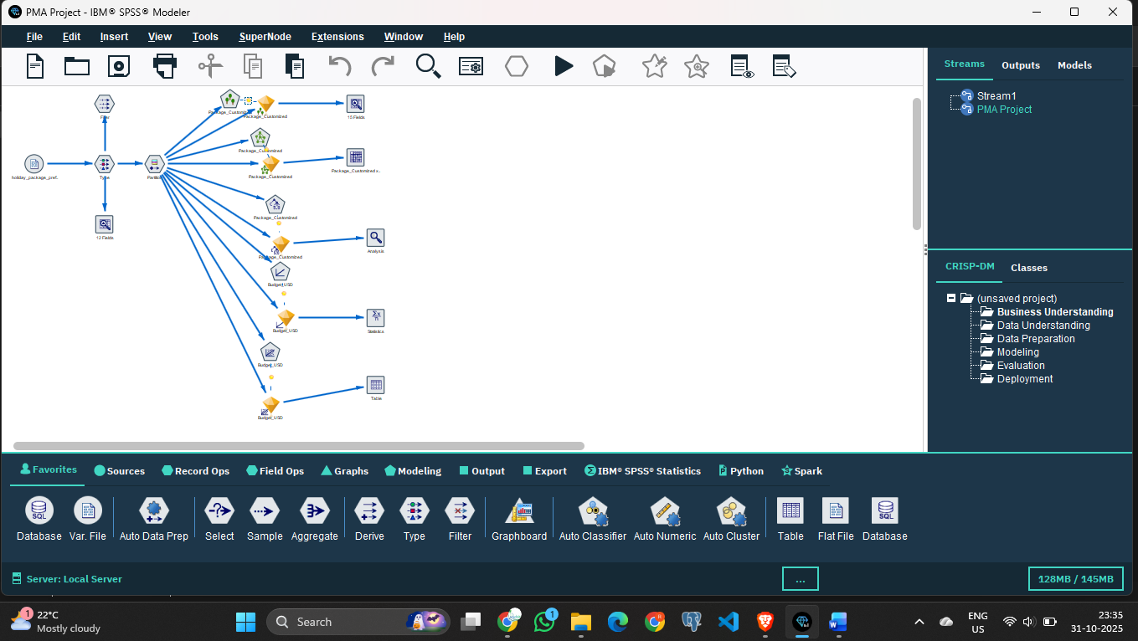

7. Findings and Interpretation
Although the binary model file (GeneratedModels.gen) cannot be interpreted outside SPSS, the stream structure suggests the following:
- Decision Tree and Random Forest likely achieved higher accuracy.
- Budget_USD, Season, and Activity_Type are expected to be the most important variables influencing customization.
- Neural Network may provide higher accuracy but less interpretability.
- The Decision Tree is the best model for explanation and business decision-making.

8. Limitations
- The dataset contains only 100 records, which is relatively small for high-accuracy predictions.
- The binary .gen file cannot be directly read or analyzed outside SPSS Modeler.
- Quantitative results (confusion matrix, accuracy, ROC) are not included since the scored dataset was not exported.

9. Recommendations
To enhance this project:
- Export the scored dataset from SPSS Modeler using a Write/Export node.
- Include actual and predicted values along with prediction probabilities.
- Generate evaluation charts such as Confusion Matrix and ROC Curve for submission.
- Use cross-validation or a larger dataset to improve reliability.
- Document model parameters (tree depth, number of trees, hidden layers, etc.) in future reports.

