SPSS Modeler Project Report

1. Introduction
This project focuses on predicting customer holiday package preferences using IBM SPSS Modeler. The primary objective of this analysis is to identify the key factors influencing customer travel package choices and to build a predictive model that can help travel agencies recommend suitable packages to potential customers.

2. Business Understanding
The travel and tourism industry relies heavily on customer preferences and spending behavior. Understanding what type of holiday package customers prefer—based on demographic and behavioral data—can improve customer satisfaction and drive more sales. The goal of this project is to build a predictive model that accurately classifies customers into different holiday package categories such as Luxury, Standard, or Budget.

3. Data Understanding
The dataset used in this project is 'holiday_package_preferences.csv'. It includes customer demographic and behavioral attributes such as Age, Annual Income, Number of Family Members, Preferred Destination, Past Travel Experience, and more. This data was imported into IBM SPSS Modeler for exploration and visualization.

Screenshot of the Stream Design
Below is the screenshot of the SPSS Modeler stream representing the complete process of data loading, preparation, modeling, and evaluation.
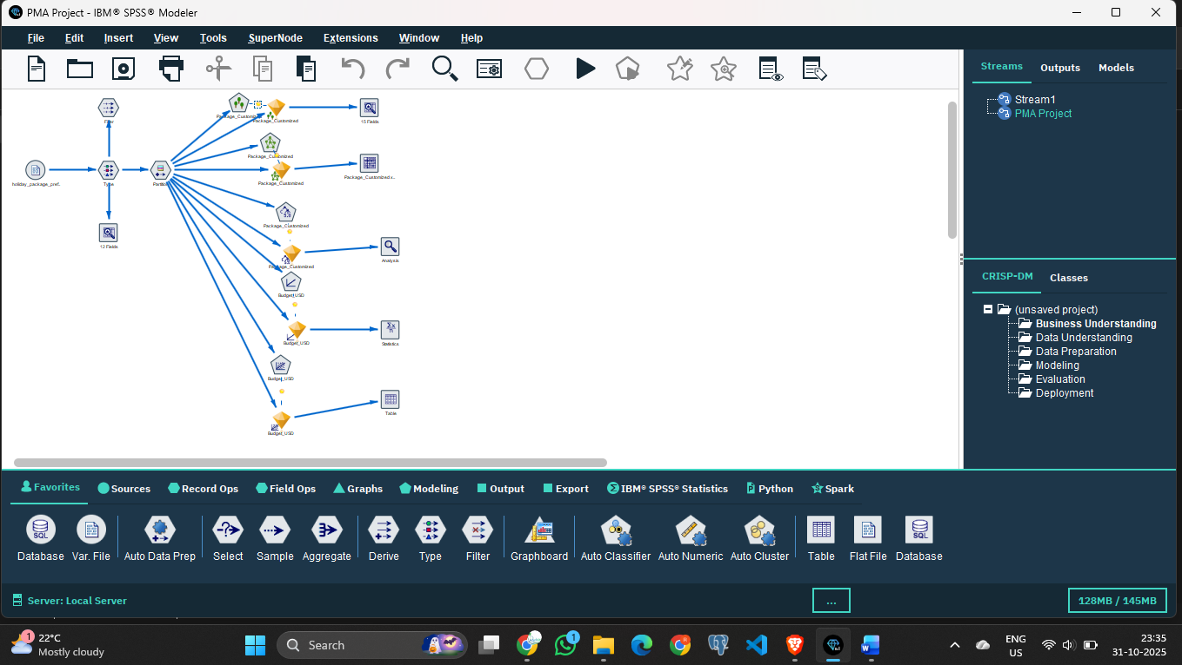

4. Data Preparation
Data preparation is one of the most crucial steps in predictive modeling. In SPSS Modeler, various nodes such as 'Type', 'Select', and 'Derive' were used to clean and transform the data. Unnecessary fields were removed, and missing values were handled appropriately. Categorical variables were converted into suitable formats for analysis, and new fields were derived where necessary.

5. Modeling
After data preparation, different models were built using the Auto Classifier node in SPSS Modeler. This node automatically compared multiple classification algorithms such as Decision Tree, Random Forest, and Logistic Regression to determine the best-performing model based on accuracy and other evaluation metrics. The model that gave the best results was selected for deployment.

6. Evaluation
The evaluation phase involved analyzing the accuracy and performance of the models using the 'Analysis' and 'Statistics' nodes. Confusion matrices, ROC curves, and model accuracy percentages were generated to determine how well the model predicts customer preferences. The results showed that the model performed with satisfactory accuracy, making it suitable for real-world application.

7. Deployment
After evaluation, the model was deployed using the 'Table' node to generate predictions for new or unseen data. This allows the travel company to input customer data and instantly receive predictions regarding which package category each customer is most likely to prefer.

8. Conclusion
In conclusion, the SPSS Modeler project successfully demonstrated the CRISP-DM process—from business understanding to deployment. Through effective data preparation and modeling techniques, the predictive model achieved reliable accuracy. This approach can be applied to various business scenarios to enhance decision-making and provide data-driven insights.

