**Project Title: COVID-19 HelpCare Website**

**Purpose of creating this project:** This website has been created after observing the situation of people grasping help from their relative and friends to save their or their relative’s life. The second wave of COVID hit India like a Tsunami taking away lives of many people. Feeling helpless about people who were not able to get the oxygen cylinders, plasma donors, and medicines, I decided to build a website for the people so that they can use it as a common platform for services where patient can retrieve information very easily and at the same time post his/her request directly on the website to seek help from people. There is no common platform build by the Government where everyone can contact in this era of technology. I was receiving lot of messages on social media seeking help from me. This prompted me to help not only my relatives but everyone suffering from this infectious disease through a one platform.

**Salient features of my website:**

1. Provide tabular representation of data with essential columns (like contact no. , alternate number, state, city, etc.) which makes it easier for to find their requirement.
2. Search Records by state provides content to be sorted by the State making it easier for people to locate their service provider as per their state.
3. People can post their request directly on the website seeking help from the people.
4. People can delete their posted request by logging in again once their requirement is fulfilled.
5. There is no two way authentication making the process faster for people to post their request.
6. However, to maintain the authenticity of data entered, website is continuously monitored.
7. Purpose of login proves to be useful when person post his/her request and want to delete it once the requirement is fulfilled or data entered is incorrect.
8. Provides analytics for each list available on the website like list of oxygen suppliers, list of plasma donors or patient’s requirement. People can see if their state has any record mentioned in the database. It might help health officials to ensure that suppliers are adequate In their state to meet the requirements.
9. Home page provide list of essential resources like contact number, government’s official website.

Hardware Requirements:

Since we are building a web application, our hardware requirements will include:

1. Device: Laptop or computer
2. Memory: Minimum 2GB RAM is required but preferred is 4GB RAM or more. My laptop has 4GB RAM.
3. Processor: 3.3 gigahertz (GHz) or faster 64-bit dual core processor with SSE2 instruction set.
4. Display: Super VGA with a resolution of 1024 x 768

**Software Requirements:**

The website has been developed on Django web framework. You need django installed in your computer along with Python, and code editor like VS Code. You need knowledge of Python, Django, Javascript, HTML, CSS which has been used in this website. To run your app locally, you need to have a non-internet browser like Internet Explorer, Google Chrome, or Edge. This app has used Django inbuilt database SQlite. On deploying this app on internet, you need internet connection, a cloud platform like Heroku or AWS. I have deployed this app on Heroku Hobby teir which provides free database access like PostgresSQl

Flow Diagram

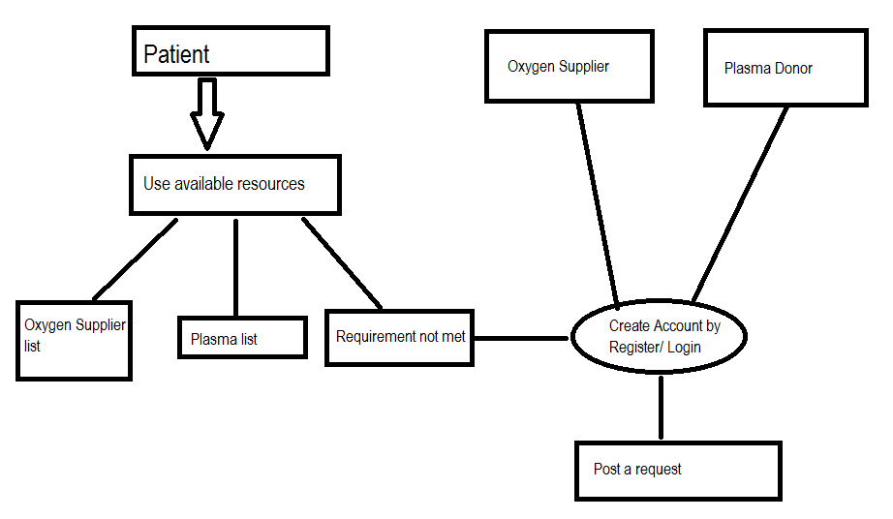

How Website Works?

1. All information is available on the home page.
2. If you are patient: look for your requirement: plasma/ oxygen cylinder/ ICU beds availability. Even if your requirement is not met, post your requirement. To post follow step 6.
3. You want to help patients, look for patient requirements and contact them.
4. If you have a oxygen supplier contact, post the details of supplier.
5. If you want to donate plasma, post your request on the website, somebody who needs will contact you directly.
6. To post: If you are a new user, register yourself and fill the form as per your requirement. If you are already register, kindly login and post your request by filling the form.
7. If you want to delete your request, login into account, click “Delete your entry”, click delete corresponding to your entry, then entry will be deleted.