CS 699 - Project

Bird Image Classification and Visualization

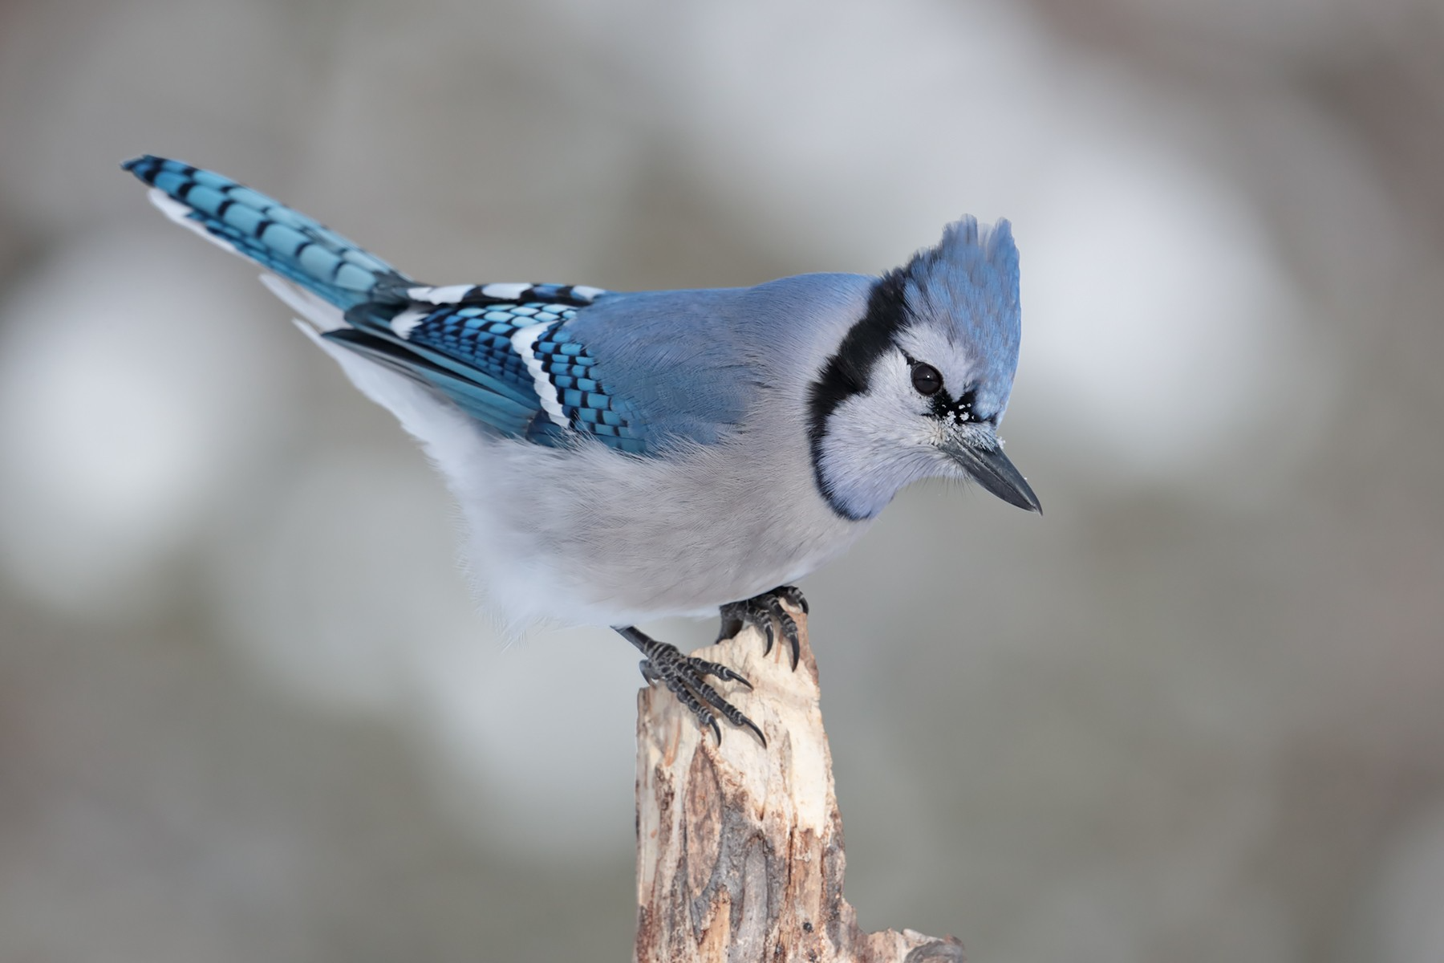 Uploaded image:

Predicted Species: <Species name>

Classifier: <Classifier name>

Top 5 predictions:

|  |  |
| --- | --- |
| Species Name | Prediction Probability |
|  |  |
|  |  |
|  |  |
|  |  |
|  |  |

**Classifier**: <classifier name>

**Dataset**:

Images scrapped from <https://ebird.org/explore>for species classificaition across 5 species.

Total images: 5000

Train-Test Split: 80:20

Species:

1. Blue Jay

2. Grey Heron

3. Indian Peafowl

4. Little Egret

5. Red-Vented Bulbul

**Metrics:**

**Accuracy:** <score>

**Classification Report:**

|  |  |  |  |
| --- | --- | --- | --- |
| Species Name | Precision | Recall | F1-score |
|  |  |  |  |
|  |  |  |  |
|  |  |  |  |
|  |  |  |  |
|  |  |  |  |

|  |  |  |  |
| --- | --- | --- | --- |
|  |  |  |  |

|  |  |  |  |
| --- | --- | --- | --- |
|  |  |  |  |

|  |  |  |  |
| --- | --- | --- | --- |
|  |  |  |  |

**Confusion Matrix:**

<image>