Project Report

# Holiday Planner Website

1. **Introduction**

The Holiday Planner Website is a responsive web-based application designed to help users plan and organize their vacations. It allows users to browse popular destinations, view travel packages, check itineraries, and create personalized travel plans. The platform provides convenience by offering essential details such as hotels, attractions, and travel costs in one place.

The project is built using HTML, CSS, JavaScript, Bootstrap, and jQuery, ensuring an interactive and visually appealing design.

# Objectives

* + To provide a simple and effective platform for planning holidays.
  + To allow users to explore destinations and create personalized itineraries.
  + To implement a responsive design for mobile, tablet, and desktop devices.
  + To enhance user experience through interactive features using jQuery and JavaScript.
  + To demonstrate the practical usage of modern web development technologies.

# Technologies Used

1. HTML5 – For structuring web pages.
2. CSS3 – For styling, colors, fonts, and layouts.
3. JavaScript – For client-side interactivity and validations.
4. Bootstrap – For responsiveness and pre-designed UI components.
5. jQuery – For simplifying DOM manipulation and adding animations.

# System Design

1. **Architecture**
   * Front-End: Developed using HTML, CSS, Bootstrap, JavaScript, and jQuery.
   * Data Handling: Travel packages and itineraries simulated using JavaScript arrays.
   * Back-End: Not included in this version, but can be extended with server-side scripting.
2. **Modules**
   1. Home Page – Displays introduction and featured destinations.
   2. Destinations Page – Lists available travel destinations with details and images.
   3. Itinerary Planner – Allows users to add activities and customize their holiday schedule.
   4. Booking Page – Collects user details for trip booking and confirmations.
   5. Contact Page – Provides help and customer support information.

# Implementation

* + Home Page: Contains a navigation bar, image carousel, and highlights of destinations.
  + Destinations Page: Displays travel packages with price, duration, and descriptions.
  + Itinerary Planner: Users can select activities and add them to a daily schedule using

jQuery.

* + Booking Page: A form to capture user details with JavaScript validations.
  + Contact Page: Displays contact form and support details.

# Features

* + Attractive and responsive user interface.
  + Destination showcase with images and package details.
  + Itinerary customization using JavaScript and jQuery.
  + Booking form with validation.
  + Smooth navigation and compatibility across all devices.

# Sample Code Snippets

<!doctype html>

<html lang="en">

<head>

<meta charset="utf-8">

<title>Holiday Planner</title>

<link href="[https://cdn.jsdelivr.net/npm/bootstrap@5.3.3/dist/css/bootstrap.min.css](https://cdn.jsdelivr.net/npm/bootstrap%405.3.3/dist/css/bootstrap.min.css)" rel="stylesheet">

<script src="<https://code.jquery.com/jquery-3.6.0.min.js>"></script>

<link rel="stylesheet" href="style.css">

</head>

<body>

<!-- Navbar -->

<nav class="navbar navbar-expand-lg navbar-dark bg-info">

<div class="container">

<a class="navbar-brand fw-bold" href="index.html">Holiday Planner</a>

<div class="collapse navbar-collapse">

<ul class="navbar-nav ms-auto">

<li class="nav-item"><a class="nav-link" href="goa.html">Goa</a></li>

<li class="nav-item"><a class="nav-link" href="manali.html">Manali</a></li>

</ul>

</div>

</div>

</nav>

<!-- Search Section -->

<div class="container mt-4">

<h1 class="text-center">Find Your Destination</h1>

<input id="searchBox" class="form-control mb-4" type="text" placeholder="Search (e.g., beach, mountains)">

<div class="col-md-6 mb-3 destination-card" data-keywords="beach party water sports">

<div class="card p-3">

<img src="images/goa.avif" alt="Goa Beach" class="mb-2" style="width:100%;height:auto;object-fit:cover;">

<h3> 🌴 Goa</h3>

<p>Relax on sandy beaches, enjoy nightlife, and water sports.</p>

<a href="goa.html" class="btn btn-info">Explore Goa</a>

</div>

</div>

<div class="col-md-6 mb-3 destination-card" data-keywords="beach party water sports">

<div class="card p-3">

<img src="images/manali.jpg" alt="Manali" class="mb-2" style="width:100%;height:auto;object-fit:cover;">

<h3> 🌴 Manali</h3>

<p>Snowy mountains, adventure sports, and scenic views.</p>

<a href="manali.html" class="btn btn-info">Manali</a>

</div>

</div>

<script>

// Search filter

$("#searchBox").on("keyup", function() { var value = $(this).val().toLowerCase();

$(".destination-card").filter(function() {

$(this).toggle($(this).attr("data-keywords").toLowerCase().indexOf(value)

> -1);

});

});

</script>

</body>

</html><!doctype html>

<html lang="en">

<head>

<meta charset="utf-8">

<title>Goa - Holiday Planner</title>

<link href="[https://cdn.jsdelivr.net/npm/bootstrap@5.3.3/dist/css/bootstrap.min.css](https://cdn.jsdelivr.net/npm/bootstrap%405.3.3/dist/css/bootstrap.min.css)" rel="stylesheet">

<script src="<https://code.jquery.com/jquery-3.6.0.min.js>"></script>

<link rel="stylesheet" href="style.css">

</head>

<body>

<!-- Navbar -->

<nav class="navbar navbar-expand-lg navbar-dark bg-info">

<div class="container">

<a class="navbar-brand fw-bold" href="index.html">Holiday Planner</a>

<div class="collapse navbar-collapse">

<ul class="navbar-nav ms-auto">

<li class="nav-item"><a class="nav-link active" href="goa.html">Goa</a></li>

<li class="nav-item"><a class="nav-link" href="manali.html">Manali</a></li>

</ul>

</div>

</div>

</nav>

<div class="container mt-4">

<h1> 🌴 Goa</h1>

<p>Experience the vibrant beaches, nightlife, and water sports.</p>

<!-- Activities -->

<div class="card p-3 mb-3">

<h3>Activities</h3>

<form id="activities">

<label><input type="checkbox" class="cost" value="1000"> Beach

Party (₹1000)</label><br>

<label><input type="checkbox" class="cost" value="2000"> Water

Sports (₹2000)</label><br>

<label><input type="checkbox" class="cost" value="1500">

Heritage Walk (₹1500)</label><br>

<label><input type="checkbox" class="cost" value="800"> Sunset

Cruise (₹800)</label><br>

</form>

</div>

<!-- Accommodation & Transport -->

<div class="row">

<div class="col-md-6">

<div class="card p-3 mb-3">

<h3>Accommodation</h3>

<select id="hotel" class="form-select cost">

<option value="0">Choose Hotel</option>

<option value="4000">Budget Hotel (₹4000)</option>

<option value="8000">Resort (₹8000)</option>

</select>

</div>

</div>

<div class="col-md-6">

<div class="card p-3 mb-3">

<h3>Transport</h3>

<select id="transport" class="form-select cost">

<option value="0">Choose Transport</option>

<option value="3000">Flight (₹3000)</option>

<option value="1500">Train (₹1500)</option>

<option value="1000">Bus (₹1000)</option>

</select>

</div>

</div>

</div>

<!-- Itinerary -->

<div class="row">

<div class="col-md-6 mb-3">

<a href="5daygoa.html" class="text-decoration-none">

🗺<div class="card p-3" style="cursor:pointer;">

<h3> 5-Day Itinerary</h3>

<p>See the plan for an exciting 5-day trip.</p>

</div>

</a>

</div>

<div class="col-md-6 mb-3">

<a href="10daygoa.html" class="text-decoration-none">

🗺<div class="card p-3" style="cursor:pointer;">

<h3> 10-Day Itinerary</h3>

<p>Check out the itinerary for an extended 10-day stay.</p>

</div>

</a>

</div>

</div>

<!-- Budget Tracker -->

💰<div class="card p-3 mb-3">

<h3> Budget Tracker</h3>

<p>Total Estimated Cost: <b>₹<span id="total">0</span></b></p>

</div>

</div>

<script>

const itineraries = { "5days": { cost: 15000 }, "10days": { cost: 30000 }

};

function updateTotal() { let total = 0;

// Activities

$(".cost:checked").each(function() { total += parseInt($(this).val());

});

// Hotel + Transport

total += parseInt($("#hotel").val()); total += parseInt($("#transport").val());

$("#total").text(total);

// Save to localStorage let activities = [];

$(".cost:checked").each(function() { activities.push($(this).val()); }); localStorage.setItem("activities", JSON.stringify(activities)); localStorage.setItem("hotel", $("#hotel").val()); localStorage.setItem("transport", $("#transport").val()); localStorage.setItem("totalBudget", total);

}

$(".cost, #hotel, #transport").on("change", updateTotal);

$(document).ready(updateTotal);

</script>

</body>

</html><!doctype html>

<html lang="en">

<head>

<meta charset="utf-8">

<title>Manali - Holiday Planner</title>

<link href="[https://cdn.jsdelivr.net/npm/bootstrap@5.3.3/dist/css/bootstrap.min.css](https://cdn.jsdelivr.net/npm/bootstrap%405.3.3/dist/css/bootstrap.min.css)" rel="stylesheet">

<script src="<https://code.jquery.com/jquery-3.6.0.min.js>"></script>

<link rel="stylesheet" href="style.css">

</head>

<body>

<!-- Navbar -->

<nav class="navbar navbar-expand-lg navbar-dark bg-info">

<div class="container">

<a class="navbar-brand fw-bold" href="index.html">Holiday Planner</a>

<div class="collapse navbar-collapse">

<ul class="navbar-nav ms-auto">

<li class="nav-item"><a class="nav-link" href="goa.html">Goa</a></li>

<li class="nav-item"><a class="nav-link active"

href="manali.html">Manali</a></li>

</ul>

</div>

</div>

</nav>

🏔️<div class="container mt-4">

<h1> Manali</h1>

<p>Enjoy the scenic mountains, adventure sports, and relaxing nature.</p>

<!-- Activities -->

<div class="card p-3 mb-3">

<h3>Activities</h3>

<form id="activities">

<label><input type="checkbox" class="cost" value="1200">

Solang Valley Adventure (₹1200)</label><br>

<label><input type="checkbox" class="cost" value="1800">

Rohtang Pass Visit (₹1800)</label><br>

<label><input type="checkbox" class="cost" value="1000"> River

Rafting (₹1000)</label><br>

<label><input type="checkbox" class="cost" value="1500">

Paragliding (₹1500)</label><br>

</form>

</div>

<!-- Accommodation & Transport -->

<div class="row">

<div class="col-md-6">

<div class="card p-3 mb-3">

<h3>Accommodation</h3>

<select id="hotel" class="form-select cost">

<option value="0">Choose Hotel</option>

<option value="3500">Budget Hotel (₹3500)</option>

<option value="7500">Luxury Resort (₹7500)</option>

</select>

</div>

</div>

<div class="col-md-6">

<div class="card p-3 mb-3">

<h3>Transport</h3>

<select id="transport" class="form-select cost">

<option value="0">Choose Transport</option>

<option value="4000">Flight (₹4000)</option>

<option value="2000">Train (₹2000)</option>

<option value="1200">Bus (₹1200)</option>

</select>

</div>

</div>

</div>

<!-- Itinerary -->

<div class="row">

<div class="col-md-6 mb-3">

<a href="5daymanali.html" class="text-decoration-none">

🗺<div class="card p-3" style="cursor:pointer;">

<h3> 5-Day Itinerary</h3>

<p>Plan your exciting 5-day Manali trip.</p>

</div>

</a>

</div>

<div class="col-md-6 mb-3">

<a href="10daymanali.html" class="text-decoration-none">

🗺<div class="card p-3" style="cursor:pointer;">

<h3> 10-Day Itinerary</h3>

<p>Explore an extended 10-day Manali adventure.</p>

</div>

</a>

</div>

</div>

<!-- Budget Tracker -->

<div class="card p-3 mb-3">

💰<h3> Budget Tracker</h3>

<p>Total Estimated Cost: <b>₹<span id="total">0</span></b></p>

</div>

</div>

<script>

function updateTotal() { let total = 0;

$(".cost:checked").each(function() { total += parseInt($(this).val());

});

total += parseInt($("#hotel").val()) || 0; total += parseInt($("#transport").val()) || 0;

$("#total").text(total);

// Save to localStorage let activities = [];

$(".cost:checked").each(function() { activities.push($(this).val()); }); localStorage.setItem("activities", JSON.stringify(activities)); localStorage.setItem("hotel", $("#hotel").val()); localStorage.setItem("transport", $("#transport").val()); localStorage.setItem("totalBudget", total);

}

$(".cost, #hotel, #transport").on("change", updateTotal);

$(document).ready(function() {

// Load saved selections if present let savedActivities =

JSON.parse(localStorage.getItem("activities") || "[]");

$(".cost").each(function() { if(savedActivities.includes($(this).val()))

$(this).prop("checked", true);

});

$("#hotel").val(localStorage.getItem("hotel") || "0");

$("#transport").val(localStorage.getItem("transport") || "0");

updateTotal();

});

</script>

</body>

</html><!DOCTYPE html>

<html lang="en">

<head>

<meta charset="UTF-8" />

<title>Manali 5-Day Itinerary</title>

<link href="[https://cdn.jsdelivr.net/npm/bootstrap@5.3.3/dist/css/bootstrap.min.css](https://cdn.jsdelivr.net/npm/bootstrap%405.3.3/dist/css/bootstrap.min.css)" rel="stylesheet" />

<script src="<https://code.jquery.com/jquery-3.6.0.min.js>"></script>

<link rel="stylesheet" href="style.css" />

</head>

<body>

🏔️<div class="container mt-4">

<h1 class="mb-4 text-center"> Manali 5-Day Itinerary</h1>

<hr class="mb-5" />

<div id="itineraryContent"></div>

<div class="text-center mt-4">

<h4>Total Estimated Cost: <span class="text-info fw-bold">₹12,000 (Approx.)</span></h4>

</div>

</div>

<script>

const itineraryData = { "5days": [

{

"day": "Day 1: Arrival and Local Sightseeing", "activities": [

"Arrive in Manali and check-in to hotel", "Visit Hadimba Temple",

"Explore Manu Temple", "Stroll along Mall Road"

],

"description": "Settle into Manali’s serene environment and

explore the key local attractions at a relaxed pace."

},

{

"day": "Day 2: Solang Valley Adventure",

"activities": [

"Visit Solang Valley for adventure sports", "Try paragliding or zorbing",

"Enjoy a cable car ride", "Return to Manali for dinner"

],

"description": "Experience thrilling activities in the picturesque Solang Valley surrounded by snow-capped mountains."

},

{

"day": "Day 3: Rohtang Pass Excursion", "activities": [

"Full-day trip to Rohtang Pass", "Snow activities and sightseeing", "Picnic lunch in the mountains"

],

"description": "Take a memorable excursion to Rohtang Pass, famous for its stunning snowy landscapes."

},

{

"day": "Day 4: Naggar Castle and Art Tour", "activities": [

"Visit historic Naggar Castle",

"Explore Nicholas Roerich Art Gallery", "Relax by the River Beas"

],

"description": "Discover the rich culture and history of the region through art and architecture."

},

{

"day": "Day 5: Leisure Day & Departure", "activities": [

"Shopping and strolling on Mall Road", "Visit Vashisht Baths for hot springs", "Departure"

],

"description": "Unwind, shop for souvenirs, enjoy the natural hot springs before heading back home."

}

]

};

$(document).ready(function () {

const days = itineraryData["5days"]; let html = "";

days.forEach((item) => { html += `

<div class="card mb-4 shadow-sm rounded-3">

<div class="card-body">

<h3 class="card-title display-6 text-info">${item.day}</h3>

<ul class="list-group list-group-flush my-3">

${item.activities.map((act) => `<li class="list-group-item">${act}</li>`).join('')}

</ul>

<p class="card-text text-muted">${item.description}</p>

</div>

</div>

`;

});

$("#itineraryContent").html(html);

});

</script>

</body>

</html><!DOCTYPE html>

<html lang="en">

<head>

<meta charset="UTF-8" />

<title>Shimla & Manali 10-Day Itinerary</title>

<link href="[https://cdn.jsdelivr.net/npm/bootstrap@5.3.3/dist/css/bootstrap.min.css](https://cdn.jsdelivr.net/npm/bootstrap%405.3.3/dist/css/bootstrap.min.css)" rel="stylesheet" />

<script src="<https://code.jquery.com/jquery-3.6.0.min.js>"></script>

<link rel="stylesheet" href="style.css" />

</head>

<body>

🏔️<div class="container mt-4">

<h1 class="mb-4 text-center"> Shimla & Manali 10-Day Itinerary</h1>

<hr class="mb-5" />

<div id="itineraryContent"></div>

<div class="text-center mt-4">

<h4>Total Estimated Cost: <span class="text-info fw-bold">₹50,000 (Approx.)</span></h4>

</div>

</div>

<script>

const itineraryData = { "10days": [

{

"day": "Day 1: Arrival Delhi - Shimla", "activities": [

"Arrival at Delhi airport", "Travel to Shimla by road", "Check-in at hotel and relax"

],

"description": "Start your journey from Delhi and unwind with a scenic drive to Shimla."

},

{

"day": "Day 2: Shimla Local Sightseeing", "activities": [

"Visit Jakhoo Temple", "Explore Ridge, Mall Road", "Visit Christ Church", "Evening at Lakkar Bazaar"

],

"description": "Enjoy Shimla’s colonial charm and vibrant

market streets."

},

{

"day": "Day 3: Shimla - Kufri - Mashobra", "activities": [

"Day trip to Kufri for adventure activities", "Visit Mashobra village",

"Return to Shimla for dinner"

],

"description": "Experience adventure sports and peaceful village surroundings near Shimla."

},

{

"day": "Day 4: Shimla - Manali Transfer", "activities": [

"Travel to Manali by road",

"Check-in and relax at the hotel"

],

"description": "Scenic road journey to the beautiful hill station Manali."

},

{

"day": "Day 5: Manali Local Tour", "activities": [

"Visit Hadimba Temple", "Explore Manu Temple", "Visit Vashisht Baths"

],

"description": "Discover Manali’s spiritual and natural highlights."

},

{

"day": "Day 6: Solang Valley and Rohtang Pass", "activities": [

"Adventure activities at Solang Valley", "Excursion to Rohtang Pass (weather permitting)"

],

"description": "Enjoy thrilling activities and stunning snow landscapes."

},

{

"day": "Day 7: Naggar Castle & Art Tour", "activities": [

"Visit Naggar Castle",

"Explore Nicholas Roerich Art Gallery", "Relax by River Beas"

],

"description": "Step into history and art in the scenic Kullu valley."

},

{

"day": "Day 8: Manikaran & Kasol Day Trip", "activities": [

"Visit hot springs at Manikaran", "Explore the hippie village Kasol", "Return to Manali"

],

"description": "Explore the cultural and natural beauties of Parvati Valley."

},

{

"day": "Day 9: Leisure & Shopping Day", "activities": [

"Leisure day for shopping at Mall Road", "Try local Himachali cuisine",

"Relax at hotel"

],

"description": "Relax and enjoy the local flavors and shopping experiences."

},

{

"day": "Day 10: Departure", "activities": [

"Pack and check out",

"Travel back to Delhi or next destination"

],

"description": "End your memorable trip and head home."

}

]

};

$(document).ready(function () {

const days = itineraryData["10days"]; let html = "";

days.forEach((item) => { html += `

<div class="card mb-4 shadow-sm rounded-3">

<div class="card-body">

<h3 class="card-title display-6 text-info">${item.day}</h3>

<ul class="list-group list-group-flush my-3">

${item.activities.map((act) => `<li class="list-group-item">${act}</li>`).join('')}

</ul>

<p class="card-text text-muted">${item.description}</p>

</div>

</div>

`;

});

$("#itineraryContent").html(html);

});

</script>

</body>

</html><!DOCTYPE html>

<html lang="en">

<head>

<meta charset="UTF-8">

<title>Goa 5-Day Itinerary</title>

<link href="[https://cdn.jsdelivr.net/npm/bootstrap@5.3.3/dist/css/bootstrap.min.css](https://cdn.jsdelivr.net/npm/bootstrap%405.3.3/dist/css/bootstrap.min.css)" rel="stylesheet">

<script src="<https://code.jquery.com/jquery-3.6.0.min.js>"></script>

<link rel="stylesheet" href="style.css">

</head>

<body>

🗺<div class="container mt-4">

<h1 class="mb-4 text-center"> Goa 5-Day Itinerary</h1>

<hr class="mb-5">

<div id="itineraryContent"></div>

<div class="text-center mt-4">

<h4>Total Estimated Cost: <span class="text-info fw-bold">₹15,000</span></h4>

</div>

</div>

<script>

const itineraryData = { "5days": [

{

"day": "Day 1: Explore Old Goa", "activities": [

"Basilica Of Bom Jesus", "Church of St. Francis of Assisi", "Se Cathedral",

"Museum of Christian Art", "Meal At River Aisle"

],

"description": "If you want to experience the real authentic Goa and delve deep into its history, well then Old Goa is where you need to start your journey..."

},

{

"day": "Day 2: Explore North Goa, Its Beaches & Night Life", "activities": [

"Explore Little Vagator Beach", "Indulge in water sports", "Visit Chapora Fort",

"Have A Meal At Thalassa", "Go Partying At Cohiba",

"Go To Anjuna Night Market"

],

"description": "North Goa is that part of Goa that’s most

spoken about. From forts to shimmering shorelines, cutesy eateries to beach shacks – North Goa has everything..."

},

{

"day": "Day 3: Explore Panjim & Dona Paula", "activities": [

"Get Mesmerised By The Beauty Of Dona Paula", "Chill at Miramar Beach",

"Eat At Ritz Classic", "Shop At Panjim Market",

"Visit the Floating Casinos"

],

"description": "Panjim is the very heart of Goa. It’s the

perfect mix of beaches, shopping, food, architecture, narrow winding lanes and more..."

},

{

"day": "Day 4: Head To South Goa", "activities": [

"Visit Salaulim Dam", "Cabo De Rama", "Eat At Martin’s",

"Explore Palolem & Agonda", "Enjoy A Silent Party"

],

"description": "South Goa is that part of Goa that went abroad and got firang wala education. Start your day by visiting the beautiful Salaulim Dam..."

},

{

"day": "Day 5: Chill In Goa Like The Locals", "activities": ["Do Nothing"],

"description": "You know what makes Goa so unique? It’s the

susegaad life. Susegaad literally translates to lazing around and doing nothing..."

}

]

};

$(document).ready(function(){

const days = itineraryData["5days"]; let html = "";

days.forEach(item => { html += `

<div class="card mb-4 shadow-sm rounded-3">

<div class="card-body">

<h3 class="card-title display-6 text-info">${item.day}</h3>

<ul class="list-group list-group-flush my-3">

${item.activities.map(act => `<li class="list-group-item">${act}</li>`).join('')}

</ul>

<p class="card-text text-muted">${item.description}</p>

</div>

</div>

`;

});

$("#itineraryContent").html(html);

});

</script>

</body>

</html><!DOCTYPE html>

<html lang="en">

<head>

<meta charset="UTF-8">

<title>Goa 10-Day Itinerary</title>

<link href="[https://cdn.jsdelivr.net/npm/bootstrap@5.3.3/dist/css/bootstrap.min.css](https://cdn.jsdelivr.net/npm/bootstrap%405.3.3/dist/css/bootstrap.min.css)" rel="stylesheet">

<script src="<https://code.jquery.com/jquery-3.6.0.min.js>"></script>

<link rel="stylesheet" href="style.css">

</head>

<body>

<div class="container mt-4">

🗺<h1 class="mb-4 text-center"> Goa 10-Day Itinerary</h1>

<hr class="mb-5">

<div id="itineraryContent"></div>

<div class="text-center mt-4">

<h4>Total Estimated Cost: <span class="text-info fw-bold">₹30,000 (Approx.)</span></h4>

</div>

</div>

<script>

const itineraryData = { "10days": [

{

"day": "Day 1: Arrival & Relax", "activities": [

"Arrive at Goa airport", "Transfer to hotel/resort",

"Relax and enjoy resort amenities", "Evening beach walk at Calangute"

],

"description": "Ease into your Goa vacation by settling into your accommodation and taking in the serene beach views."

},

{

"day": "Day 2: North Goa Beaches and Forts", "activities": [

"Visit Baga Beach and enjoy water sports", "Explore Fort Aguada and Lighthouse", "Lunch at a beach shack",

"Sunset at Chapora Fort"

],

"description": "Experience the lively beaches and historical forts of North Goa."

},

{

"day": "Day 3: Old Goa Heritage Tour", "activities": [

"Visit Basilica of Bom Jesus",

"Se Cathedral",

"Museum of Christian Art",

"Walk through Fontainhas Latin Quarter"

],

"description": "Delve into Goa’s rich Portuguese heritage with

visits to its iconic churches and heritage sites."

},

{

"day": "Day 4: South Goa Exploration", "activities": [

"Relax at Palolem Beach", "Visit Cabo De Rama Fort", "Evening at Agonda Beach"

],

"description": "Discover the tranquil and lush southern beaches far from the bustling north."

},

{

"day": "Day 5: Spice Plantation & Dudhsagar Waterfalls", "activities": [

"Tour a spice plantation",

"Trek or jeep safari to Dudhsagar Waterfalls", "Picnic lunch near waterfall"

],

"description": "Explore Goa’s natural beauty and spice farms

accompanied by a majestic waterfall visit."

},

{

"day": "Day 6: Leisure and Shopping Day", "activities": [

"Shopping at Anjuna Flea Market", "Relax at hotel/resort",

"Try local Goan cuisine"

],

"description": "Unwind with shopping and savor authentic Goan flavors at leisure."

},

{

"day": "Day 7: Water Sports & Nightlife", "activities": [

"Parasailing, jet skiing at Candolim Beach",

"Evening party at Tito’s or Mambo’s"

],

"description": "Feel the adrenaline with exciting water

sports, then dive into Goa’s vibrant nightlife."

},

{

"day": "Day 8: Cruise on Mandovi River", "activities": [

"Sunset river cruise with live music", "Dinner on board",

"Spot dolphins if lucky"

],

"description": "Relax and enjoy a beautiful river cruise

highlighting Goa’s scenic waterways."

},

{

"day": "Day 9: Explore Panjim & Casinos", "activities": [

"Visit Panjim city market",

"Explore Boutique shops and cafes", "Try luck at a floating casino"

],

"description": "Experience Goa’s capital city culture,

markets, and casino entertainment."

},

{

"day": "Day 10: Departure", "activities": [

"Pack and check out",

"Last-minute shopping or beach stroll", "Transfer to airport"

],

"description": "Make the most of your last day with a relaxed morning before your journey home."

}

]

};

$(document).ready(function(){

const days = itineraryData["10days"]; let html = "";

days.forEach(item => { html += `

<div class="card mb-4 shadow-sm rounded-3">

<div class="card-body">

<h3 class="card-title display-6 text-info">${item.day}</h3>

<ul class="list-group list-group-flush my-3">

${item.activities.map(act => `<li class="list-group-item">${act}</li>`).join('')}

</ul>

<p class="card-text text-muted">${item.description}</p>

</div>

</div>

`;

});

$("#itineraryContent").html(html);

});

</script>

</body>

</html>

Output (screenshots)

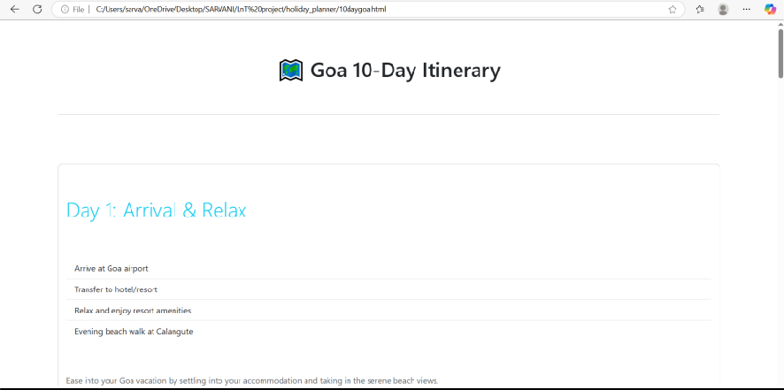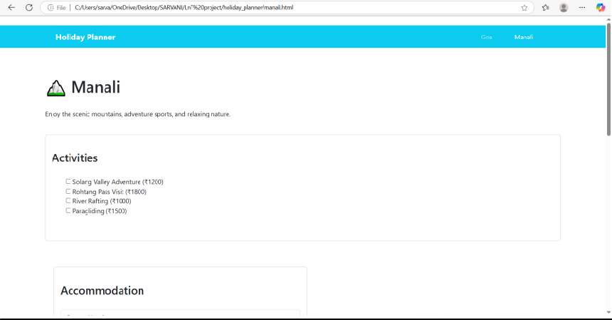

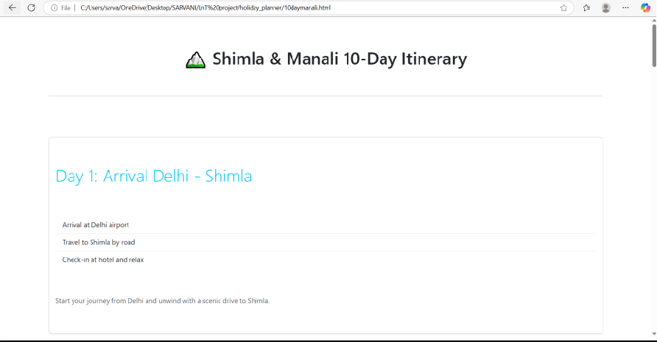

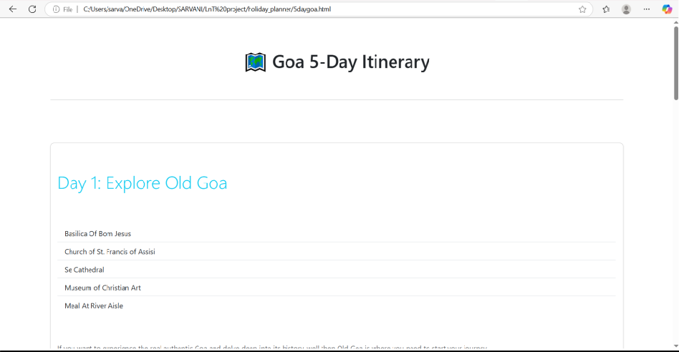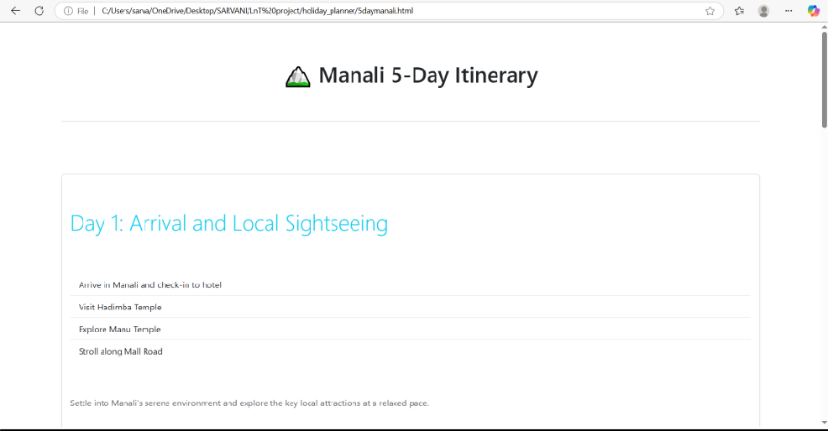

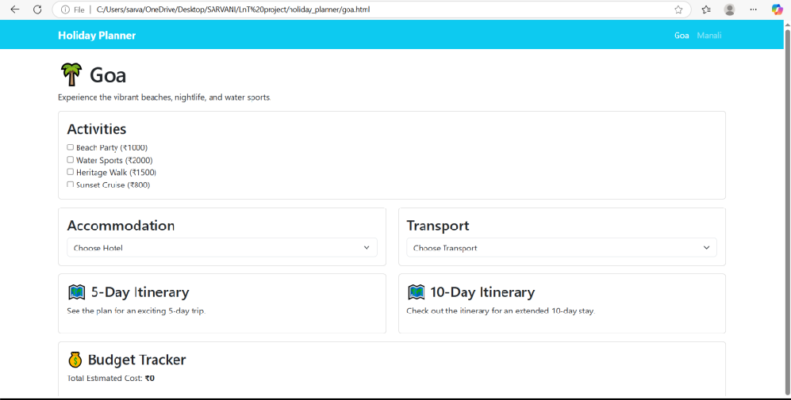

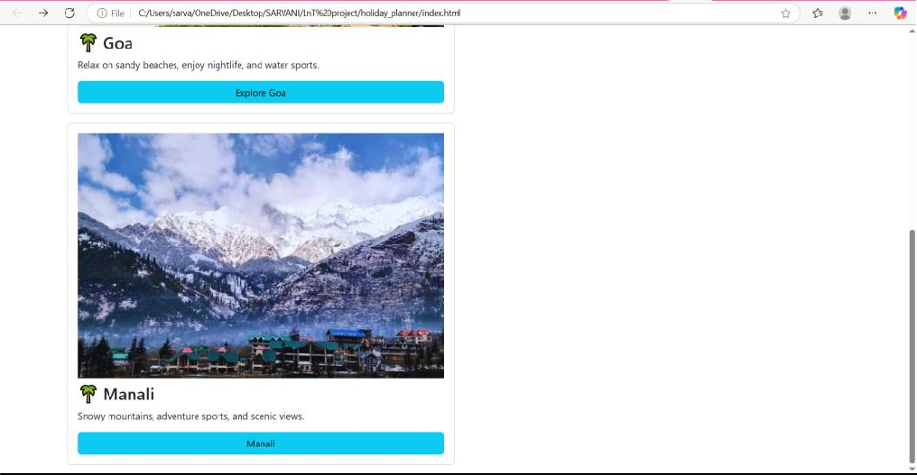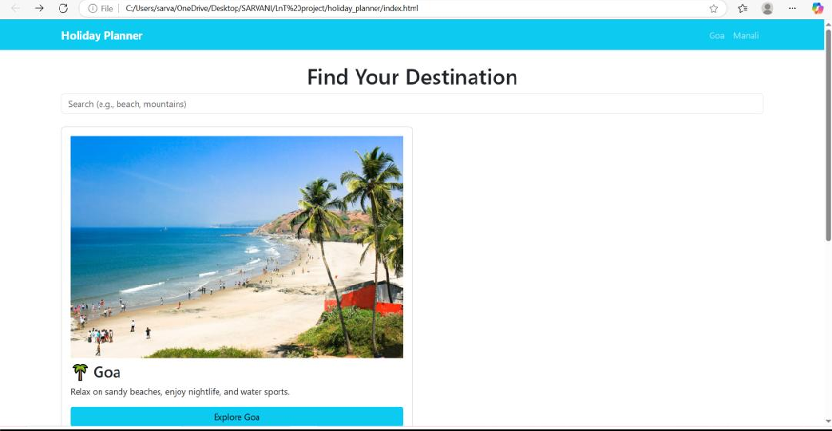

# Results

The project successfully provides a Holiday Planner Website where users can browse destinations, plan their itineraries, and book trips. The design is responsive and interactive, ensuring usability across devices.

# Conclusion

The Holiday Planner Website demonstrates how HTML, CSS, JavaScript, Bootstrap, and jQuery can be combined to create an interactive and responsive travel planning platform. It highlights the potential of web technologies in providing a smooth and engaging user experience.

# Future Scope

* + Integration with online payment gateways for secure booking.
  + Addition of user accounts and login system.
  + Admin panel for travel agencies to manage packages and bookings.
  + Real-time weather updates for destinations.
  + Integration with Google Maps API for location tracking and navigation.