**HelpMate AI Project Report**

1. **Problem Statement:**

We are building a project in the insurance domain. The goal of the project will be to build a robust generative search system capable of effectively and accurately answering questions from various insurance policy documents.

1. **Implementation**

* Data Loading:

Used the Simple Directory Reader and read the data from the PDFs given as source data and load the data into a variable.

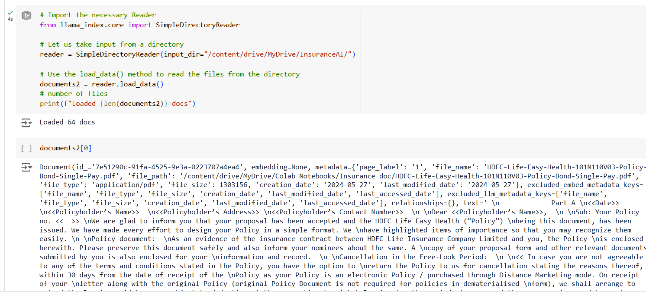

* Building query engine:

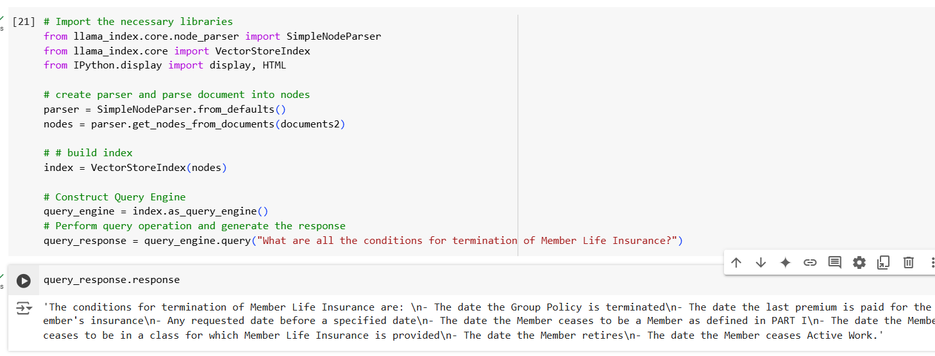

* Creating a response pipeline:

This involves a query response function and initialize_conv function.

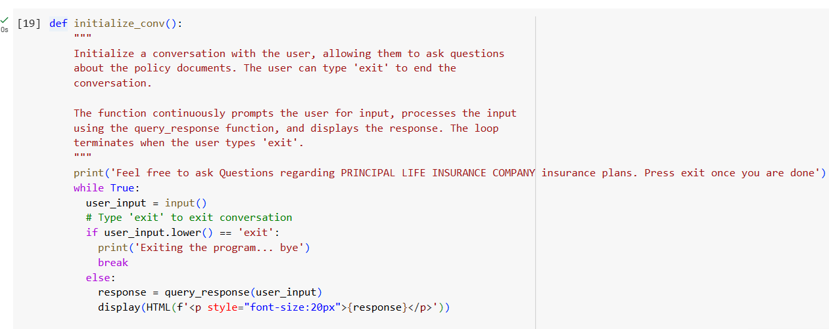

* Build a Testing Pipeline:

Created 3 questions and store them in the questions list to be queried by the RAG system using the testing_pipeline function.

* Optimization and fine tuning:

Based on the testing pipeline’s feedback, we can improve the performance by building a custom prompt template, Using customised notes and templates, Sub question query engine, Build RAG using Agentic Systems