**Objective:**

Implement a text-based Blackjack program in one of the following programming languages: Java, Clojure, Scala, C, C++, Python, or Ruby. There should be one player and one dealer. The dealer should hit until his hand value is 17 or greater. You should implement the basic actions of hitting and standing. Implementing the more advanced actions such as splitting is optional. The player should start with 100 chips and must bet at least 1 chip each hand.

**Solution:**

I have decided to develop the Blackjack program using Python on Windows 7 Professional Laptop. Below are the details about the development environment.

**System Configuration:**

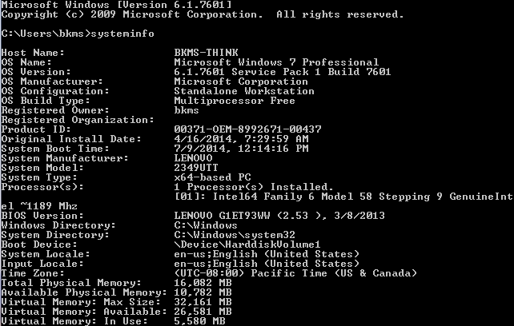

**IDE Details (Eclipse & Python):**

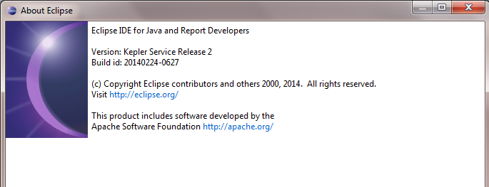

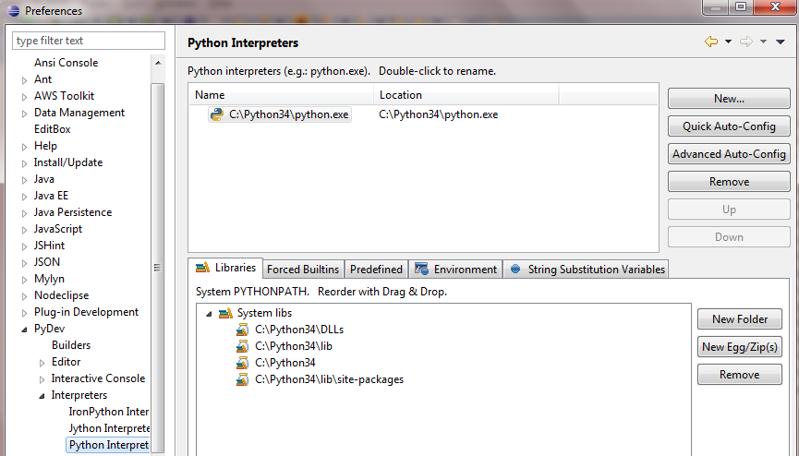

**Source Code:**

The source code is zipped into the file: bvBlackJack.py.zip

**Install Instructions:**

Down load the bvBlackJack.py.zip

1. Unzip the bvBlackJack.py
2. Run module bvBlackJack.py for playing the game

For help & support on running this version of bvBlackJack game, please reach out to bvuppala@gmail.com