**Survey Web App**

**ABSTRACT**

In the realm of ocean exploration and bathymetric data acquisition, the development of a robust web application emerges as a pivotal tool for efficient planning, real-time tracking, and detailed analysis. This report introduces a comprehensive web application designed to enhance Remote Operated Vehicle (ROV) operations, facilitating live tracking and data visualization for bathymetric surveys. The application boasts an array of features catering to the diverse needs of ROV missions. Users can effortlessly plot and clear placemarks, as well as draw and remove polylines, providing a dynamic representation of the ROV's path. These functionalities play a crucial role in tracking the ROV's movement, allowing users to gauge the covered distance, plan future routes, and optimize exploration strategies. Furthermore, the application supports the creation and management of distinct layers, enabling users to organize and save critical data points efficiently. The capability to download these layers as images or Keyhole Markup Language (KML) files enhances data accessibility and sharing. This feature is particularly advantageous for offline use, ensuring seamless functionality even in remote or challenging underwater environments. The application extends its utility by facilitating the upload and processing of KML files, enabling users to visualize and analyze pre-existing data sets. Additionally, the ability to upload Comma-Separated Values (CSV) files and plot their contents further broadens the application's scope, providing a versatile platform for comprehensive data integration. Its user-friendly interface, coupled with the flexibility to handle various data formats, positions it as an invaluable asset for optimizing ROV missions. Whether planning future routes or analyzing past expeditions, this application serves as a centralized hub for efficient, data-driven decision-making in underwater exploration scenarios.

1. **INTRODUCTION**

In the vast expanse of the water bodies, exploration has always been a challenging endeavor, pushing the boundaries of human knowledge and technological capabilities. Among the myriad tools at our disposal, Remote Operated Vehicles (ROVs) have emerged as indispensable assets for probing the depths and unraveling the secrets concealed beneath the waves. As we navigate the complexities of underwater exploration, the demand for sophisticated solutions that streamline planning, enable real-time tracking, and facilitate in-depth data analysis becomes increasingly pronounced.

This report unveils a comprehensive web application meticulously designed to elevate ROV operation. Rooted in the necessity for efficient planning, dynamic tracking, and detailed data analysis, this web application is poised to revolutionize bathymetric surveys.

At its core, the application addresses the intricate challenges associated with ROV operations, presenting an array of features tailored to the diverse needs of underwater missions. The ability to effortlessly plot and clear placemarks, coupled with the capacity to draw and remove polylines, provides users with a real-time, dynamic representation of the ROV's trajectory. These functionalities are not merely technical conveniences; they are the keystones of effective ROV tracking. By meticulously recording the ROV's movement, users can gauge covered distances, plan future routes with precision, and strategically optimize exploration strategies, thereby enhancing the overall efficiency and success of underwater missions.

One of the distinctive strengths of this web application lies in its support for the creation and management of distinct layers. These layers serve as organized repositories for critical data points, allowing users to categorize and store information efficiently. Beyond mere data organization, the application empowers users to save layers and download them as images or Keyhole Markup Language (KML) files. This versatility in data output enhances accessibility and facilitates seamless sharing, crucial elements for collaborative exploration efforts. What sets this feature apart is its adaptability to offline environments, ensuring that the application remains fully functional even in the remote and challenging underwater terrains where traditional connectivity might be compromised.

Delving deeper into its capabilities, the application opens new avenues for data integration and analysis. With the ability to upload and process KML files, users can visualize and analyze pre-existing data sets. Moreover, the application extends its reach by enabling the upload of Comma-Separated Values (CSV) files and seamlessly plotting their contents. This not only broadens the application's scope but also transforms it into a versatile platform for comprehensive data integration, catering to the diverse requirements of the exploration teams.

The user-friendly interface of the application, paired with its flexibility to handle various data formats, positions it as an invaluable asset for optimizing ROV missions. Beyond its technical prowess, the application serves as a centralized hub for efficient, data-driven decision-making in underwater exploration scenarios. Whether it's the meticulous planning of future routes or the in-depth analysis of past expeditions, this web application emerges as a transformative tool, propelling the frontiers of ocean exploration into a new era of efficiency and insight.

As we embark on this journey through the depths of the oceanic frontier, this report unfolds the intricacies and potential of the web application, setting the stage for a comprehensive exploration of its features, functionalities, and the paradigm shift it brings to ROV operations and bathymetric data acquisition.

1. **METHODOLOGY**

**2.1. DEVELOPMENT FRAMEWORK**

The web application was developed using standard web technologies, with the primary programming languages being HTML, CSS, and JavaScript (JS). This choice facilitated a versatile and widely supported foundation for implementing various functionalities related to ROV operations and bathymetric data acquisition.

The development process took place on Visual Studio Code (VsCode), a lightweight and feature-rich code editor. VsCode's extensibility and compatibility with web development frameworks ensured a smooth coding experience, facilitating efficient development and debugging.

**2.2 SYSTEM ARCHITECTURE**

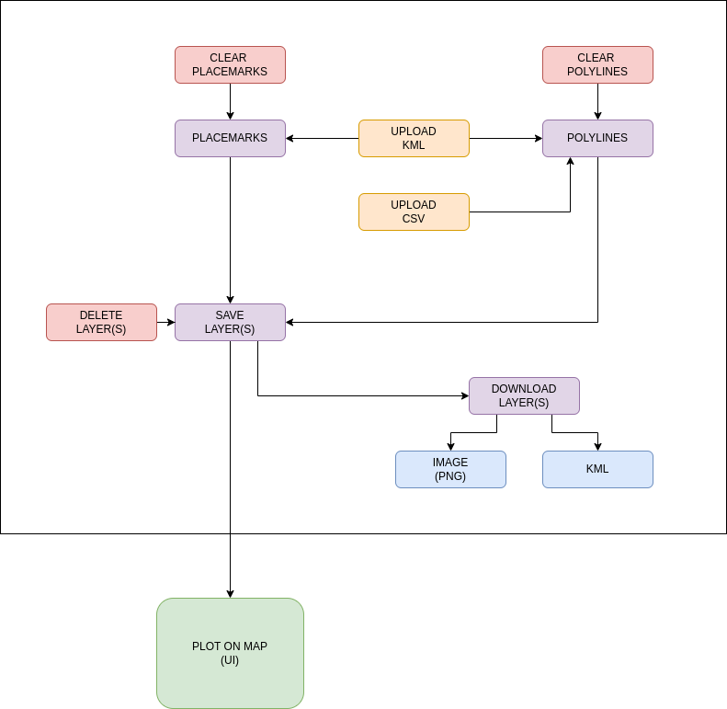

Figure 1 Interaction between the components of the Survey Web App

1. User Interface (UI):

- The user interface serves as the primary interaction point for users, providing an intuitive and user-friendly experience. It displays a dynamic map, allowing users to interact with the application through mouse clicks to plot and clear placemarks, draw and clear polylines, save and delete layers, download layers as image or as KMl, Upload CSv, Upload KMl

2. Plotting Functionality:

- The plotting functionality captures user input, such as mouse clicks, to dynamically plot placemarks on the map. As coordinates are recorded, they are stored in an array, forming the basis for the placemark features. Similarly, the application enables the drawing of polylines, with coordinates sequentially added to an array to represent the path of exploration.

3. Clear Functionality:

- The clear functionality allows users to reset the plotting arrays, removing all placemarks and polylines from the map. This feature ensures a clean slate for users to start afresh, vital for planning and tracking during ROV missions.

4. Save Layer Functionality:

- The save layer functionality organizes placemarks and polylines into distinct layers, providing users with the ability to compartmentalize and manage data efficiently. These layers are integral for organizing bathymetric data and planning expeditions.

5. Download Functionality:

- The download functionality empowers users to export saved layers in different formats. Layers can be downloaded as Keyhole Markup Language (KML) files, allowing for easy sharing and collaboration. Additionally, the option to download layers as images enhances data accessibility and provides a snapshot of the exploration progress.

6. Upload Functionality (CSV and KML):

- Users can upload Comma-Separated Values (CSV) files containing coordinates, which are then processed, saved as layers, and plotted on the map as polylines. This functionality adds versatility to the application, accommodating various data formats seamlessly.

- Uploading Keyhole Markup Language (KML) files is supported, allowing users to save the uploaded content as layers. The application intelligently interprets the KML content, offering the flexibility to plot it as either placemarks or polylines, depending on the nature of the data.

7. Map Integration:

- The heart of the system lies in its integration with mapping functionalities. The UI dynamically reflects the plotted placemarks and polylines, providing a visual representation of the ROV's exploration path and the geographical distribution of bathymetric data.

This cohesive system architecture ensures a smooth flow of data, from user interaction to visualization on the map. The modular design allows for the addition of new functionalities and easy maintenance, making the web application a powerful and adaptable tool for ROV-based bathymetric data acquisition and analysis.

**2.3 SPECIFICATIONS**

**1. SOFTWARE REQUIREMENTS**

| **Operating System** | Linux |
| --- | --- |
| **Web Browser** | Google Chrome, Mozilla Firefox |
| **Programming Languages** | JavaScript (ES6+), HTML5, CSS3, Bootstrap (v4.4.1) |
| **Frontend Framework** | HTML5, CSS3 |
| **Backend Framework** | JavaScript (ES6+) |
| **Data Formats** | CSV, KML |
| **Version Control System** | Git |
| **Libraries** | PapaParse (5.3.0), html2canvas (1.4.1) |
| **API Key** | Mapbox |

**2. HARDWARE REQUIREMENTS**

| PROCESSOR | Dual-core processor or higher |
| --- | --- |
| RAM | 4 GB or Higher |
| STORAGE | 20 GB available disk space |
| GRAPHICS | Graphics card for enhanced mapping visualization (optional) |

1. **RESULT AND DISCUSSION**

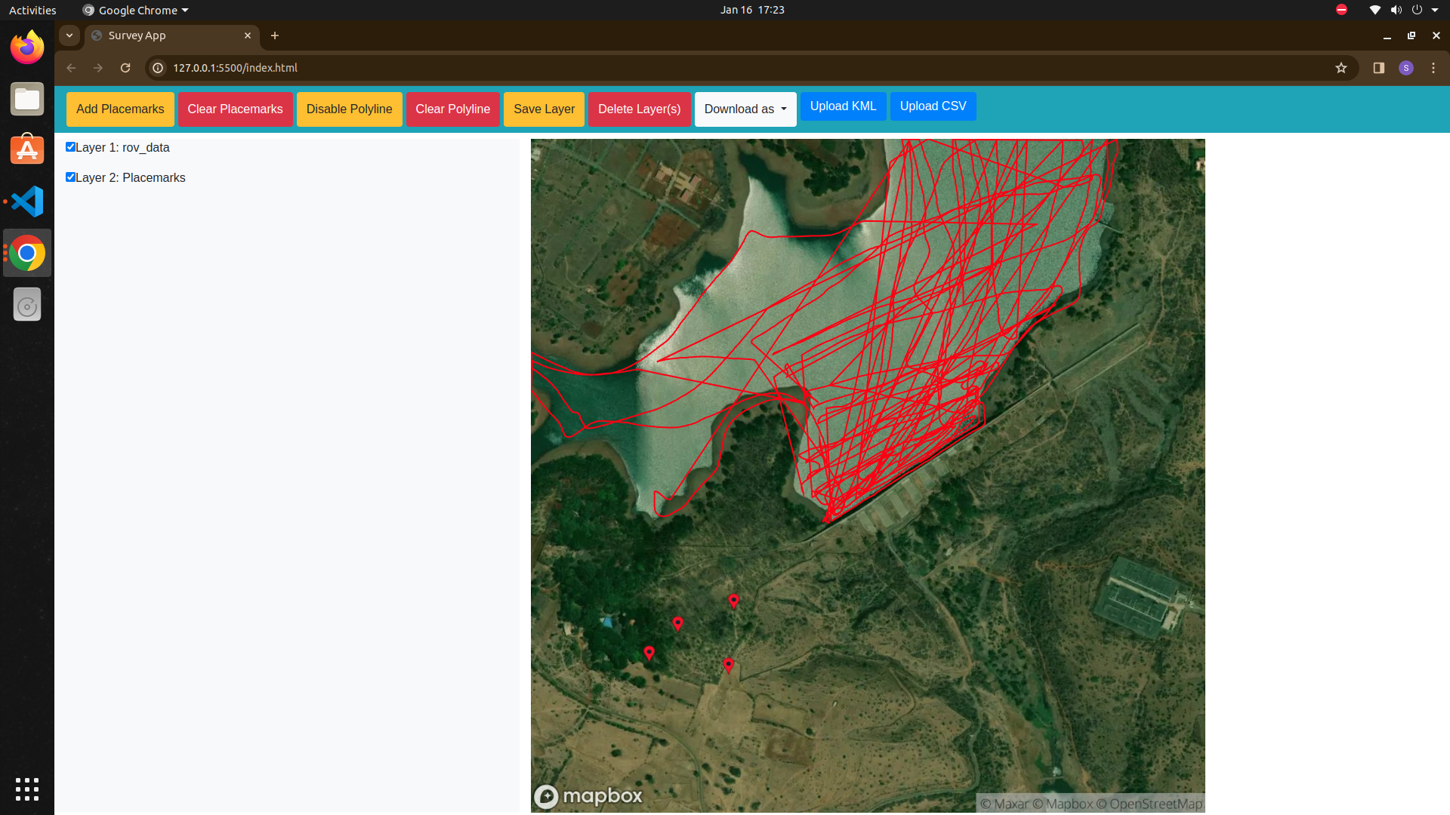

Figure 2 The user interface of Survey Web App

The implementation of the web application yielded compelling results, establishing its efficacy in enhancing ROV operations and bathymetric data acquisition. The dynamic plotting of placemarks and polylines based on user input showcased the application's real-time tracking capabilities. As users interacted with the map, coordinates were accurately recorded and stored in arrays, providing a visual representation of the ROV's exploration path. The clear functionality proved essential for maintaining a clean and organized map, facilitating efficient planning and exploration. The save layer functionality emerged as a pivotal feature, enabling users to categorize and manage data seamlessly. Layers, containing both placemarks and polylines, offered a structured approach to organizing bathymetric information, contributing to streamlined data analysis. The download functionality enhanced data accessibility, allowing users to share their findings easily in KML or image formats. The application's versatility was evident in its ability to process external data sources. Uploading CSV files resulted in the automatic creation of layers and the plotting of extracted coordinates as polylines. Similarly, the upload and interpretation of KML files offered flexibility, allowing users to choose between plotting uploaded content as placemarks or polylines. Overall, the results highlight the web application's effectiveness in providing a comprehensive solution for ROV-based bathymetric data acquisition. The discussion delves into the implications of these results, emphasizing the application's potential for optimizing exploration strategies, supporting offline functionality, and fostering collaborative research efforts in underwater environments.

1. **SUMMARY, RECOMMENDATIONS AND FUTURE WORK**

The developed web application stands as a transformative tool in the domain of ROV-based bathymetric data acquisition. Its dynamic plotting, layer management, and data integration capabilities contribute to a holistic solution for efficient planning, real-time tracking, and detailed analysis of underwater exploration. The user-friendly interface ensures accessibility, while the flexibility to handle various data formats enhances its applicability in diverse marine research scenarios.

Based on the findings and user experiences, several recommendations can be made to further enhance the application's utility. First and foremost, continuous user feedback should be sought to identify areas for improvement in user interface design and functionality. Additionally, the integration of more advanced mapping features and the exploration of 3D visualization capabilities could elevate the application's analytical capabilities. Future iterations could explore the incorporation of machine learning algorithms to automate the recognition and classification of bathymetric features, providing more sophisticated analysis capabilities. Augmenting the application with real-time communication features could facilitate collaborative decision-making during ROV missions. Furthermore, extending support for additional data formats beyond KML and CSV could broaden the application's compatibility with various sources of bathymetric data.

In conclusion, the developed web application lays a solid foundation for future advancements in ROV-based bathymetric data acquisition. By embracing user feedback, forging collaborations, and embracing emerging technologies, the application can evolve into an even more powerful and indispensable tool for marine researchers and exploration teams.