BuyMart

Welcome to BuyMart, a flutter application built with Node.js!

This project is a comprehensive e-commerce application that simulates the core features of popular ecommerce website (eg: amazon, flipkart), providing a seamless shopping experience.

Features

BuyMart incorporates many of the key features that can make it the leading online shopping platform. Here are some of the main features:

User Authentication

\* Sign Up & Login: Users can create an account and log in securely.

\* Profile Management: Users can manage their personal information, addresses, and payment methods.

Browsing & Searching

\* Home Page: Displays featured products, deals, and recommendations.

\* Product Categories: Users can browse products by categories.

\* Search Functionality: Users can search for products using keywords.

Product Details

\* Product Information: Detailed information about products, including images, descriptions, and specifications.

\* Reviews & Ratings: Users can read and write reviews, and see product ratings.

Shopping Cart & Checkout

Shopping Cart: Users can add products to their cart, update quantities, and remove items.

Wishlist: Users can add products to their wishlist for future reference.

Checkout Process: A smooth and secure checkout process with multiple payment options.

Order Management

Order History: Users can view their past orders and order details.

Order Tracking: Users can track the status of their current orders.

Notifications

Push Notifications: Users receive notifications for order updates, promotions, and more.

Technologies Used

Flutter: Used for building the front-end of the application.

Node.js: Used for building the back-end and API services.

Screenshots

1). Splash screen

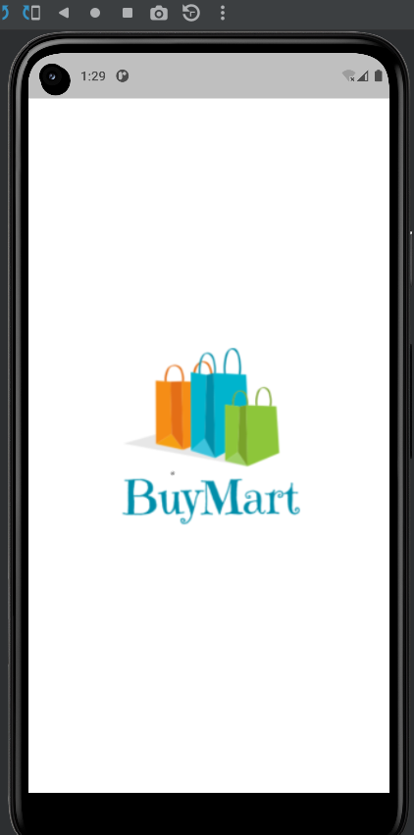

2). User Authentication screen

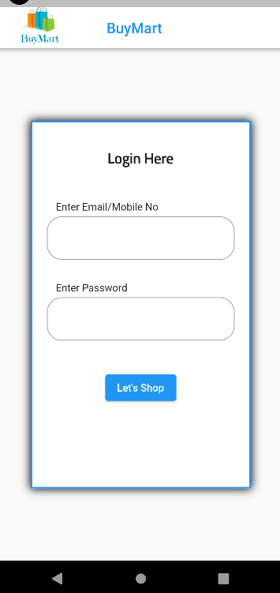

3). Home Screen

