Technical Documentation
Date: 24 Jul 2026 Version: 1.0
Revision History
Version | Date | Author | Description
1.0 | 24-Jul-2026 | Sarvesh N | Initial draft, derived from the AI Service Desk API Project report

Table of Contents
Technical Documentation 1
1. Introduction 3
1.1 Purpose 4
1.2 Scope 4
1.3 Intended Audience 4
1.4 References 4
1.5 Acronyms and Definitions 4
2. System Overview 4
2.1 High-Level Architecture 4
2.2 System flow - Key Components 4
2.3 User Roles and Access Levels 4
3. Functional Requirements 4
3.1 Module/Feature Name 4
3.2 Inputs/Outputs 4
3.3 Business Rules 4
3.4 Error Handling 5
4. Non-Functional Requirements 5
4.1 Performance 5
4.2 Security 5
4.3 Availability 5
4.4 Maintainability 5
5. Data Model / Database Design 5
5.1 Entity-Relationship Diagram 5
5.2 Tables and Fields 5
5.3 Indexes and Keys 5
5.4 Sample Data 5
6. Integration Points 5
6.1 External Systems 5
6.2 APIs Used 5
6.3 Data Flow Diagram 5
6.4 Authentication/Authorization 6
7. Test Strategy 6
7.1 Test Scenarios 6
7.2 Expected Results 6
7.3 Traceability to Requirements 6
8. Deployment & Configuration 6
8.1 Environments 6
8.2 Setup Steps 6
8.3 Configuration Files and Parameters 6
9. Appendix 6
Glossary 6
Screenshots 6
Code Snippets 6
References 6

1. Introduction

1.1 Purpose
This document describes the technical design and internal workflows of the AI Service Desk application, a FastAPI-based ticket management service. It is intended to give readers an accurate reference for how the system starts up, how ticket data is created and managed, and how the AI-assisted summarization feature integrates with Amazon Bedrock, based on a review of the application's source files and test suite.

1.2 Scope
This document covers the application startup sequence, the ticket CRUD workflow (including modern and legacy routes), the underlying data model, the AI summarization workflow built on Amazon Bedrock, and the test workflow used to validate the system. It does not cover deployment infrastructure, environment-specific configuration values, UI/frontend design, or non-functional benchmarks, as this information was not provided in the Application Report.

1.3 Intended Audience
This document is likely to be used by backend developers and QA engineers who build, maintain, or test the ticket management and AI summarization features.

1.4 References
This document is based on the AI Service Desk Workflow Report and the following application files referenced in that report: app/main.py, app/api/ticket_routes.py, app/api/ai.py, app/services/ticket_service.py, app/services/bedrock_services.py, app/services/prompt_templates.py, app/models/ticket.py, app/schemas/ticket_schema.py, app/core/database.py, app/core/config.py, tests/conftest.py, tests/unit/, tests/integration_test/, and tests/end_to_end_test/.

1.5 Acronyms and Definitions
API - Application Programming Interface.
CRUD - Create, Read, Update, Delete.
CORS - Cross-Origin Resource Sharing.
ORM - Object-Relational Mapping (implemented via SQLAlchemy).
UUID - Universally Unique Identifier, used as the ticket primary key.
JSON - JavaScript Object Notation, used for AI summarization responses. AI - Artificial Intelligence, referring to the Amazon Bedrock-based summarization feature.

2. System Overview

2.1 High-Level Architecture
The application is built on FastAPI and follows two primary flows:
A ticket CRUD and query flow backed by SQLAlchemy models on SQLite/PostgreSQL-compatible storage, and an AI summarization flow that sends ticket text to Amazon Bedrock. At startup, app/main.py builds the FastAPI app, loads settings from app/core/config.py, configures CORS, and a lifespan hook calls Base.metadata.create_all(bind=engine) so database tables are created automatically. Routers are then mounted for the /tickets endpoints and the /ai/summarize endpoint. The application also exposes a root (/) status endpoint and a /health database health check endpoint.

2.2 System flow - Key Components
Ticket requests flow from the route handlers in app/api/ticket_routes.py into TicketService (app/services/ticket_service.py), which uses a SQLAlchemy Session to read from and write to the Ticket model and underlying database. AI summarization requests flow from app/api/ai.py into BedrockService (app/services/bedrock_services.py), which renders a prompt using the TICKET_SUMMARY_V1 template, calls the Amazon Bedrock Converse API through boto3, and returns a structured JSON summary. The engine and session factory used by both flows are defined in app/core/database.py.

2.3 User Roles and Access Levels
The system primarily interacts with a generic "Client/End User" making HTTP requests, without detailing strict role-based access controls for its endpoints. However, the FastAPI backend does include a designated layer for "Authentication & Authorization (If Configured)" to handle access levels if implemented. Furthermore, the underlying database schema includes a User entity featuring an optional "Agent" field, which provides the structural foundation to differentiate between standard users creating tickets and support agents resolving them.

3. Functional Requirements

3.1 Module/Feature Name
The system has two functional modules.
- Ticket Management: exposed through app/api/ticket_routes.py and TicketService, this module supports creating, listing, retrieving, updating, and deleting support tickets, including both modern REST-style routes and legacy compatibility routes.
- AI Summarization: exposed through app/api/ai.py and BedrockService, this module accepts ticket text, sends it to Amazon Bedrock using the TICKET_SUMMARY_V1 prompt template, and returns a structured summary together with a suggested response.

3.2 Inputs/Outputs
Ticket Management accepts a TicketCreate payload on POST /tickets (title, description, priority, and status/isOpen fields) and a TicketUpdate payload on PUT /tickets/{ticket_id} for partial updates; it returns TicketResponse objects, a DeleteTicketResponse on deletion, and a 404 error when a ticket is not found. AI Summarization accepts a SummarizeRequest containing ticket description text on POST /ai/summarize and returns a SummarizeResponse containing a summary and a suggested_response field, as defined in app/schemas/ticket_schema.py.

3.3 Business Rules
Ticket creation and updates translate the legacy isOpen boolean into a TicketStatus enum value. Updates apply only the fields explicitly provided in the request and refresh the updated_at timestamp on commit. List queries support filtering by TicketStatus, TicketPriority, or the legacy isOpen parameter, and results are sorted by created_at in descending order. Both modern and legacy routes are supported for list, get, update, and delete operations to maintain compatibility with older clients. For AI summarization, the BedrockService strips code fences from the model response before parsing it as JSON.

3.4 Error Handling
When a ticket is not found by ID, the API raises a 404 error. For the AI summarization flow, if Amazon Bedrock fails or returns content that cannot be parsed as valid JSON, the service raises a BedrockServiceError. The codebase also defines a FakeBedrockService that returns a deterministic offline response, though the live /ai/summarize route currently calls the real BedrockService directly rather than this fallback. The report notes that the /health endpoint depends on a SQL text helper that is not shown as imported in the reviewed code, so this endpoint may fail at runtime unless that import exists elsewhere or is added.

4. Non-Functional Requirements

4.1 Performance

The system is built upon FastAPI, a Python framework specifically chosen for its high-performance and fast execution capabilities.To proactively manage and optimize response times, the architecture incorporates Locust as part of its technology stack for continuous load, performance, and API stress testing .Data retrieval is also managed efficiently through SQLAlchemy, such as sorting ticket lists by creation date to ensure fast query responses.

4.2 Security

Security is addressed at the perimeter, with the FastAPI backend featuring a dedicated component for "Authentication & Authorization" to control API access. Data integrity and protection against malformed payloads are strictly enforced using Pydantic models for request and response validation. Additionally, all communication with external services, such as the Amazon Bedrock Converse API, is conducted over secure HTTPS protocols

4.3 Availability
The architecture promotes high availability through a decoupled, layered design that separates the FastAPI backend, external AI services, and the PostgreSQL database. It operates using robust, production-ready frameworks like Uvicorn for application serving. Furthermore, the system exposes a dedicated /health endpoint designed to monitor database health and application status, which aids in proactive downtime prevention and system monitoring.

4.4 Maintainability

The application ensures long-term maintainability through a strict separation of concerns, dividing the application into dedicated Controller, Service, and Repository layers. Database schema evolution is safely managed and version-controlled using Alembic migrations. Additionally, the codebase is highly testable, supported by comprehensive unit, integration, and end-to-end tests that utilize isolated temporary SQLite databases for reliable development.

5. Data Model / Database Design

5.1 Entity-Relationship Diagram

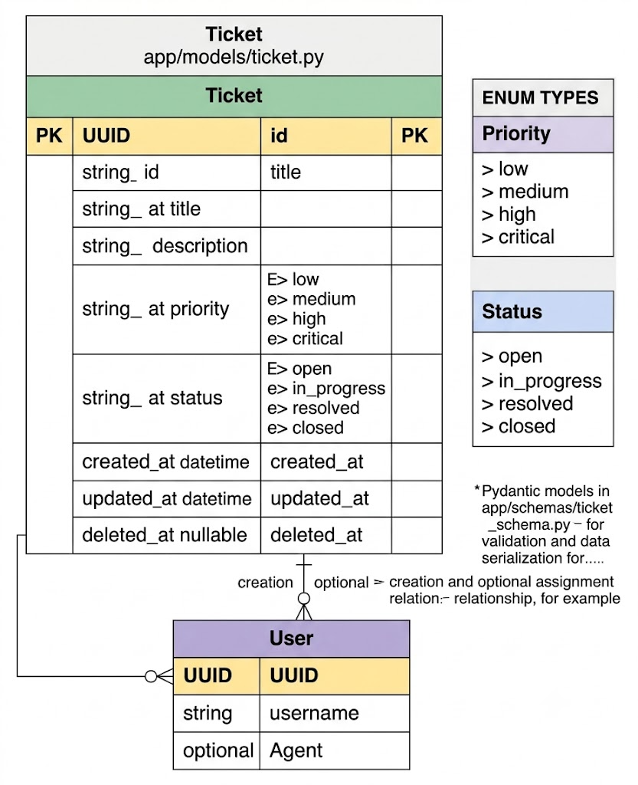

5.2 Tables and Fields
Column Name | Data Type | Nullable | Keys/Constraints | Description
id | UUID | No | Primary Key, default UUIDv4 | Unique ticket identifier.
title | String | No | - | Brief title of the issue.
priority | Enum (priority_enum) | No | LOW, MEDIUM, HIGH, CRITICAL | Severity level of the ticket.
status | Enum (status_enum) | No | OPEN, IN_PROGRESS, RESOLVED, CLOSED | Lifecycle status of the ticket.

5.3 Indexes and Keys
The Ticket table uses a UUID primary key. The report does not describe any secondary indexes or foreign key relationships beyond this primary key.

5.4 Sample Data
id | title | priority | status |  | created_at | assigned_email | summary
550e8400-e29b-41d4-a716-446655440001 | Login issue after password reset | HIGH |  | OPEN | 2026-07-24 09:15:32 | support1@company.com | User is unable to log in after resetting the password.
550e8400-e29b-41d4-a716-446655440002 | Email notification not received | MEDIUM |  | IN_PROGRESS | 2026-07-24 10:20:15 | support2@company.com | User reports that email notifications are not being delivered.
550e8400-e29b-41d4-a716-446655440003 | Application crashes on startup | CRITICAL |  | OPEN | 2026-07-24 11:05:48 | support3@company.com | Application crashes immediately after launch on Windows 11.
550e8400-e29b-41d4-a716-446655440004 | Unable to upload PDF document | LOW |  | RESOLVED | 2026-07-23 16:40:10 | support4@company.com | File upload issue resolved.

6. Integration Points

6.1 External Systems
Amazon Bedrock is the only external system described in the report. It is used by the AI Summarization module to generate a structured ticket summary and a suggested response from ticket description text.

6.2 APIs Used
The application exposes
- POST /tickets, GET /tickets (and the legacy GET /tickets/get_tickets),
- GET /tickets/{ticket_id}, PUT /tickets/{ticket_id} (and legacy PUT /tickets/update),
- DELETE /tickets/{ticket_id} (and legacy DELETE /tickets/delete),
- POST /ai/summarize, along with / and /health status endpoints. It consumes the Amazon Bedrock Converse API through boto3 for AI-generated ticket summaries.

6.3 Data Flow Diagram

Ticket CRUD Flow

Client / End User

|

FastAPI Application

|

Controller Layer

|

Service Layer

|

Repository Layer

|

PostgreSQL Database

AI Summarization Flow

Client / End User

|

FastAPI Application

|

Controller / AI Route

|

Bedrock Service

|

Amazon Bedrock API

6.4 Authentication/Authorization

Authentication and authorization are integrated directly into the FastAPI backend as a configurable module. When configured, this security layer intercepts incoming HTTP/REST requests from the client to verify user identity and enforce appropriate access controls before routing the request to the API endpoints. This design ensures that sensitive system operations, whether they involve modifying database records or triggering the external Amazon Bedrock AI service, can be securely restricted to permitted users or support agents.

7. Test Strategy

7.1 Test Scenarios
- Unit tests : cover create, list, get, update, and delete ticket behavior.
- Integration tests: verify route-to-database behavior for ticket creation and retrieval/update flows.
- End-to-end tests : exercise the full ticket lifecycle: create, get, update, and delete.

7.2 Expected Results
- Each ticket operation is expected to correctly persist or retrieve data through the database and return the appropriate response payload or status, including a 404 response when a ticket cannot be found.
- tests/conftest.py prepares the environment before the application is imported, since settings are loaded during app startup, and overrides get_db with a temporary SQLite database rather than mocking the service layer, so tests exercise real database behavior.

7.3 Traceability to Requirements
Information not provided in the report beyond the general test categories described. Based on the described structure, unit tests correspond to the Ticket Management functional requirements (Section 3), integration tests correspond to the route-to-database behavior underlying those same requirements, and end-to-end tests correspond to the Complete End-to-End Workflow described in the report.
8. Deployment & Configuration
8.1 Environments
The AI Service Desk application supports multiple environments to facilitate development, testing, and deployment. The Development environment is used for feature implementation and debugging, while the Testing environment validates application functionality using unit, integration, and performance tests. The Production environment hosts the live application, integrated with PostgreSQL and Amazon Bedrock services to provide reliable AI-powered ticket management.

8.2 Setup Steps

· Clone the project repository to the local system.

· Install the required Python dependencies using requirements.txt.

· Configure the environment variables in the .env file.

· Apply database migrations using Alembic.

· Start the PostgreSQL database service.

· Run the FastAPI application using Uvicorn or deploy it using Docker.

· Verify the application using the Health and Readiness API endpoints.

8.3 Configuration Files and Parameters

The application uses configuration files to manage environment-specific settings. The .env file stores database connection details, AWS credentials, and Amazon Bedrock configuration. The requirements.txt file manages Python dependencies, while alembic.ini and the Alembic migration scripts handle database schema management. The Dockerfile defines the container configuration for deployment, ensuring consistent execution across different environments.

9. Appendix

Glossary
- Key terms used in this document:
- API – Application Programming Interface.
- CRUD – Create, Read, Update, Delete.
- AI – Artificial Intelligence.
- LLM – Large Language Model.
- AWS – Amazon Web Services.
- ORM – Object-Relational Mapping.
- UUID – Universally Unique Identifier.
- E2E – End-to-End.
- DFD – Data Flow Diagram.
- Alembic – Python database migration tool used together with SQLAlchemy.
- Pydantic – Python data-validation library used to define API request/response schemas.

Screenshots

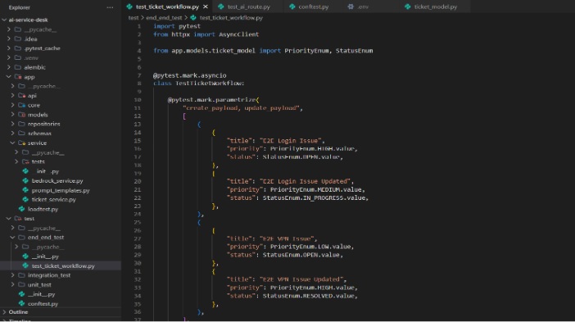

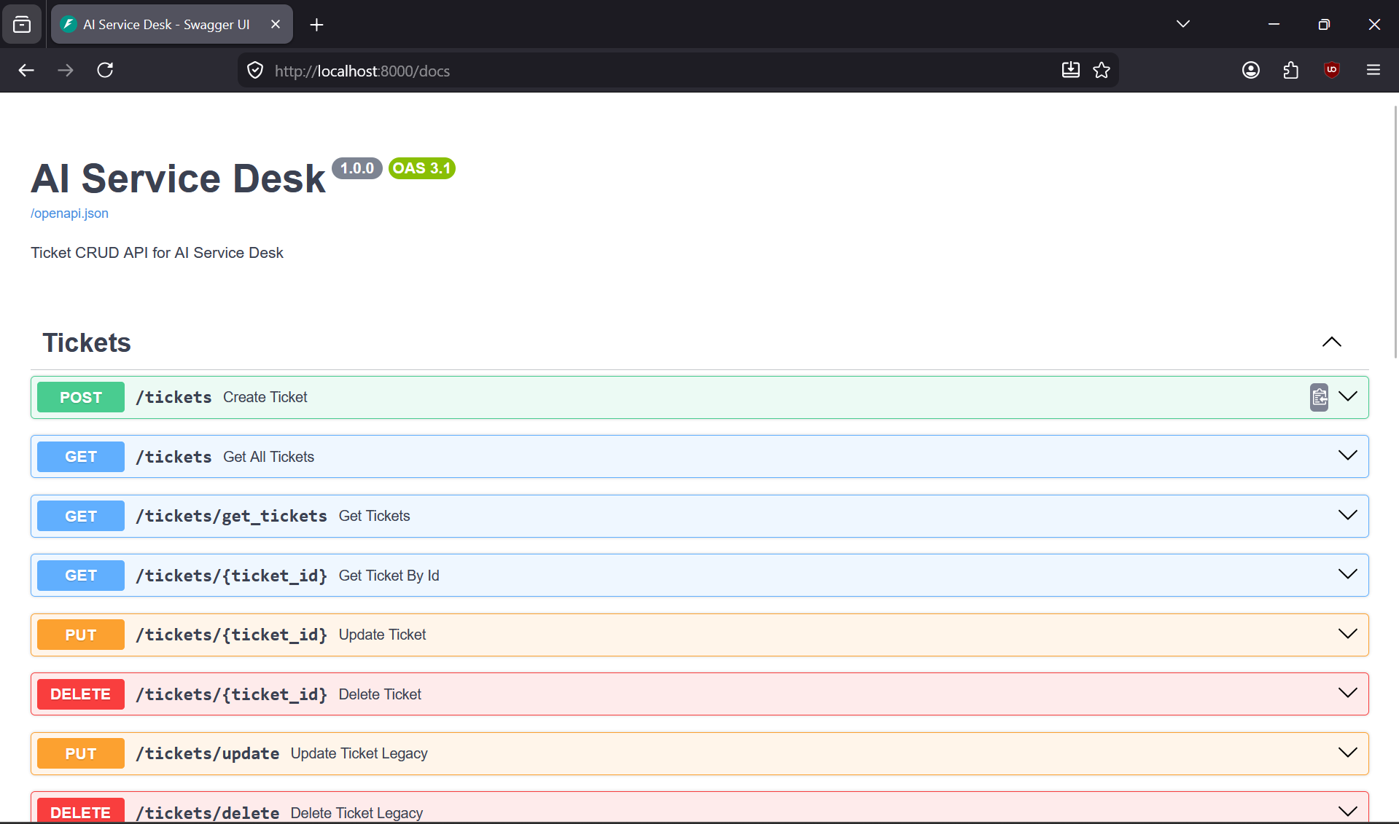

Code Snippets
1.Ticket Route:
@router.post("/ticket", response_model=ticket_schema.TicketOutSchema,status_code=201) [Text Wrapping Break]async def post_ticket(ticket_in: ticket_schema.TicketInSchema,db:AsyncSession=Depends(get_db)): [Text Wrapping Break] [Text Wrapping Break] service=TicketService(TicketRepository(db)) [Text Wrapping Break] ticket=await service.create_ticket(ticket_in) [Text Wrapping Break] return { [Text Wrapping Break] "message":"User Created successfully", [Text Wrapping Break] "ticket": ticket [Text Wrapping Break] }

2.Ticket model:
class Ticket(Base): [Text Wrapping Break] __tablename__ = "ticket" [Text Wrapping Break] id = Column(UUID(as_uuid=True), primary_key=True, default=uuid.uuid4) [Text Wrapping Break] title = Column(String, nullable=False) [Text Wrapping Break] priority = Column(Enum(PriorityEnum,name="priority_enum"), nullable=False) [Text Wrapping Break] status = Column(Enum(StatusEnum,name="status_enum"), nullable=False) [Text Wrapping Break] created_at = Column(DateTime, server_default=func.now())

3.Ticket schema:
class TicketSchema(BaseModel): [Text Wrapping Break] id: UUID [Text Wrapping Break] title: str [Text Wrapping Break] priority: str [Text Wrapping Break] status: str [Text Wrapping Break] created_at: datetime

4.Ticket repo:
[Text Wrapping Break]async def create_ticket(self,payload: TicketInSchema): [Text Wrapping Break] ticket = Ticket(**payload.model_dump()) [Text Wrapping Break] self.db.add(ticket) [Text Wrapping Break] await self.db.flush() [Text Wrapping Break] await self.db.refresh(ticket) [Text Wrapping Break] return ticket

5.Ticket Service:
class TicketService: [Text Wrapping Break] def __init__(self, repo: TicketRepository): [Text Wrapping Break] self.repo = repo [Text Wrapping Break] [Text Wrapping Break] async def create_ticket(self,ticket_input:TicketInSchema): [Text Wrapping Break] return await self.repo.create_ticket(ticket_input)

6.AI Route:
@router.post("/summarize", response_model=SummarizeResponse) [Text Wrapping Break]def summarize_ticket( [Text Wrapping Break] payload: SummarizeRequest, [Text Wrapping Break] service: BedrockService = Depends(get_bedrock_service), [Text Wrapping Break]) -> dict[str, str]: [Text Wrapping Break] try: [Text Wrapping Break] return service.summarize_ticket(payload.ticket_description) [Text Wrapping Break] except BedrockServiceError as exc: [Text Wrapping Break] raise HTTPException( [Text Wrapping Break] status_code=status.HTTP_502_BAD_GATEWAY, [Text Wrapping Break] detail="The AI service is temporarily unavailable", [Text Wrapping Break] ) from exc

References
AI Service Desk API Project Report (source document); Amazon Bedrock Converse API documentation (AWS); PostgreSQL documentation; SQLAlchemy documentation; Alembic documentation; Pydantic V2 documentation; Locust documentation. Source file references: app/models/ticket_model.py, app/core/database.py, app/schemas/ticket_schema.py, app/repositories/ticket_repo.py, app/service/ticket_service.py, app/service/bedrock_service.py, app/api/ticket_routes.py, app/api/AI.py, and alembic/versions/.

