Childcare Supply, Competition and Accessibility (Member 2 section - DRAFT)

1. Approach and data
This section compares existing childcare supply, competitor strength and access in Ku-ring-gai, Bayside and North Sydney. Supply and competition data come from the ACECQA National Register of approved education and care services for NSW (ACECQA 2026), accessed [DATE]. We counted services approved for long day care (LDC), the closest substitute for a new Childtime centre. Stand-alone preschools were counted separately as weaker substitutes, and outside school hours care was excluded because it serves school-age children. Demand denominators and accessibility indicators come from the 2021 Census General Community Profile for each LGA (ABS 2022): children aged 0-4 (table G01), motor vehicles per dwelling (G34) and method of travel to work (G62).
The register has no LGA field, so each service was assigned to an LGA from its suburb. Suburbs split between LGAs (for example St Leonards, Crows Nest, Wahroonga, Kingsgrove) are an approximation and are flagged in the workbook; the counts below are therefore provisional until boundaries are verified [UPDATE AFTER BOUNDARY CHECK].

2. Findings
Table 1. Childcare supply, competition and accessibility indicators
Indicator | Ku-ring-gai | Bayside | North Sydney
Children aged 0-4 (2021) | 5,602 | 9,986 | 3,435
LDC centres | 60 | 84 | 31
Approved LDC places | 3,785 | 4,298 | 2,024
Places per 100 children 0-4 | 67.6 | 43.0 | 58.9
Centres per 1,000 children 0-4 | 10.7 | 8.4 | 9.0
Average places per centre | 63 | 51 | 65
Stand-alone preschools | 16 | 9 | 5
LDC opened since 2021 (share) | 12 (20%) | 14 (17%) | 3 (10%)
Rated Exceeding / Meeting NQS | 28% / 67% | 17% / 75% | 19% / 77%
Largest provider share of places | 7.9% | 4.0% | 15.3%
HHI (provider concentration) | 279 | 170 | 703
Dwellings with no car | 4.3% | 14.7% | 18.9%
Train share of commuting workers | 2.3% | 5.6% | 2.2%
Sources: ACECQA (2026); ABS (2022). Provisional pending LGA boundary verification. HHI = sum of squared provider shares of LDC places x 10,000.
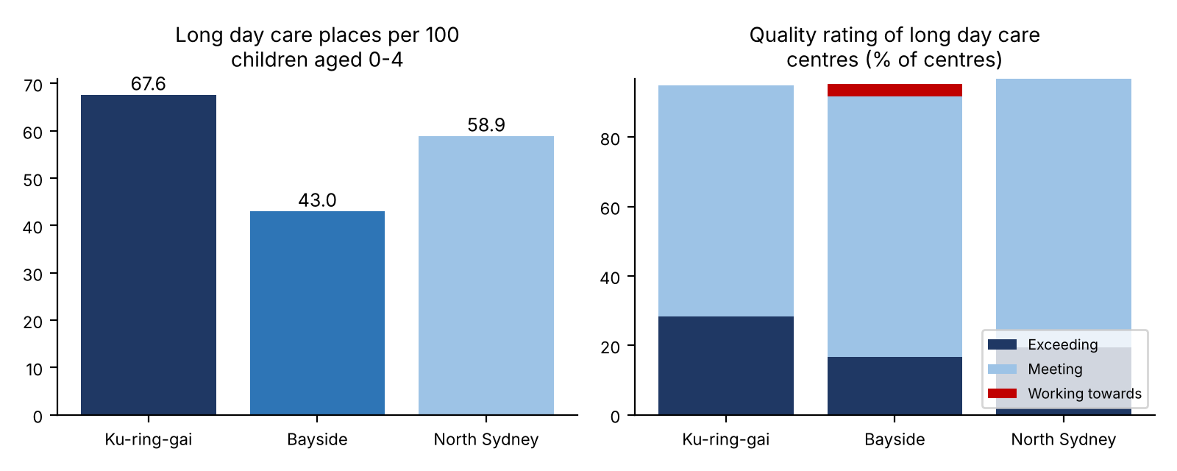
Figure 1. Places per 100 children (left) and quality ratings (right). Sources: ACECQA (2026); ABS (2022).
Supply relative to children. The normalised indicator is LDC places per 100 children aged 0-4. We chose places over centre counts because places measure capacity, and children aged 0-4 are the target market. Bayside has the lowest ratio (43.0), Ku-ring-gai the highest (67.6) and North Sydney sits between (58.9). On this indicator alone Bayside has the most unserved potential and Ku-ring-gai looks closest to saturation. This is an inference: the register gives no occupancy or waiting-list data, and children may attend centres outside their LGA or near a parent's workplace, which matters most for North Sydney.
Competition strength. All three markets are unconcentrated by HHI (below 1,500), but North Sydney is the most concentrated (703), with its largest provider holding 15.3% of places, against 7.9% in Ku-ring-gai and 4.0% in Bayside. Quality is high everywhere: 92-97% of LDC centres are rated Meeting or Exceeding. Ku-ring-gai has the highest share rated Exceeding (28%), so a new centre there would face higher quality benchmarks. Bayside is the only LGA with centres rated Working Towards (3), which may leave room for a high-quality entrant. Recent openings (since 2021) were 12 in Ku-ring-gai and 14 in Bayside against 3 in North Sydney, which suggests supply is still being added in the first two.
Accessibility. 4.3% of Ku-ring-gai dwellings have no car, against 14.7% in Bayside and 18.9% in North Sydney, so a car-dependent centre with a large car park suits Ku-ring-gai best, while North Sydney and Bayside families rely more on walking and transit. Train use for commuting is highest in Bayside (5.6%). Census travel data were collected during the 2021 lockdown, when a high share worked at home (55% in Ku-ring-gai, 34% in Bayside, 61% in North Sydney), so commuting patterns are probably understated. [ADD: train stations per LGA (TfNSW) and peak-hour drive times (Google Maps, weekday 8:00 am).]

3. Implications and limitations
Taken alone, the supply and competition evidence points to Bayside as the least saturated market, with Ku-ring-gai the most crowded and highest-quality, and North Sydney the most concentrated with the least recent growth. These results must be weighed against Rohan's demand and income evidence and Jiayi's cost findings, since lower supply per child can reflect lower demand or lower fee capacity. Limitations: the suburb-to-LGA mapping is approximate; centre counts and places are proxies for supply and do not show occupancy, fees or unmet demand [ADD fee and vacancy sample if completed]; the register is a 2026 snapshot while Census demographics are from 2021, so child numbers may have changed; and Census travel data reflect lockdown conditions.

References (Harvard - confirm access dates)
ACECQA (2026) National Register of approved providers and services, Australian Children's Education and Care Quality Authority, [URL], accessed [DATE].
ABS (2022) 2021 Census General Community Profile: Ku-ring-gai, Bayside and North Sydney (LGA14500, LGA10500, LGA15950), Australian Bureau of Statistics, [URL], accessed [DATE].

