
School of Computer Science Engineering and Information Systems
VIT, Vellore
DATABASE SYSTEMS
PROJECT REPORT
"Vehicle Rental Management System"
A Relational Database with Triggers, Transactions and a Web Application
Submitted by
Sarvesh
24BYB0081
Academic Year: 2026–2027
Full code: GitHub Link

CERTIFICATE
This is to certify that the project report entitled "Vehicle Rental Management System" is a bona fide record of the work carried out by Sarvesh 24BYB0081 in partial fulfilment of the requirements of the course Database Systems at the School of Computer Science Engineering and Information Systems, VIT, Vellore, during the academic year 2026–2027.
Faculty Guide: Dr. THANGA MARIAPPAN L
Date: 02/11/2026

DECLARATION
I/We hereby declare that this project report is the result of my/our own work, carried out under the guidance of the faculty named in the certificate. It has not been submitted to any other course or institution. Where ideas, text, figures or code from other sources have been used, they have been acknowledged in the References. All data used in the project is fictitious and contains no real personal or financial information.
Signature:

Name: Sarvesh
Date: 02/11/2026

ACKNOWLEDGEMENT
I/We express sincere thanks to Dr. THANGA MARIAPPAN L, the School of Computer Science Engineering and Information Systems and VIT, Vellore for the guidance, laboratory facilities and encouragement that made this project possible. I/We also thank family and friends for their support, and the developers of the open-source tools used: Oracle AI Database 26ai Free, Python 3.12, Flask, python-oracledb, Jinja2, HTML5 and CSS3.
ABSTRACT
Vehicle rental enterprises handle high-value physical assets and continuous operational transactions: tracking fleet availability across branches, validating customer driving credentials, scheduling reservations, preventing double-booking collisions, enforcing maintenance quarantines, and reconciling multi-mode payments. In this domain, business logic discrepancies directly induce contractual breaches and financial loss. This project presents an enterprise-grade Vehicle Rental Management System (VRMS) built to demonstrate the core principles of relational database management natively within Oracle AI Database 26ai Free.
The relational schema comprises eight normalized tables (branch, category, customer, vehicle, booking, payment, maintenance, and bk_log) governed by primary key, foreign key, NOT NULL, UNIQUE, CHECK, and DEFAULT constraints. Controlled denormalization is applied deliberately for booking totals, which are autonomously calculated from category daily rates via a BEFORE INSERT trigger (trg_bk_bi) that also prohibits booking vehicles under active maintenance. An AFTER UPDATE trigger (trg_bk_au) synchronizes vehicle availability states (AVAILABLE and RENTED) and records an immutable audit history in bk_log. Stored functions (f_bal, f_avail) and stored procedures (p_book, p_start, p_return, p_pay, p_dues) encapsulate all transactional workflows directly in PL/SQL. An explicit cursor with %ROWTYPE generates comprehensive outstanding dues reports. The system provides sixteen verified SQL queries (covering multi-table joins, aggregations, HAVING filters, subqueries, set operations, and views). A Python Flask web application connects via the thin oracledb driver to provide dedicated Staff and Manager portals with zero client-side ORM. Twenty-eight comprehensive test cases verify full functional correctness and constraint enforcement.
Keywords: Database Management System, ER Model, Oracle 26ai, SQL, Normalization, PL/SQL, Transactions, Triggers, Vehicle Rental, Python Flask

TABLE OF CONTENTS
Chapter / Section | Page
Certificate | 2
Declaration | 2
Acknowledgement | 3
Abstract | 3
List of Figures | 4
List of Tables | 4
List of Abbreviations | 6
Chapter 1 – Introduction | 7
Chapter 2 – Requirements Analysis | 9
Chapter 3 – DBMS Concepts and Architecture | 11
Chapter 4 – Conceptual Database Design | 12
Chapter 5 – Relational Database Design | 14
Chapter 6 – Functional Dependencies and Normalization | 17
Chapter 7 – SQL Implementation | 20
Chapter 8 – Advanced Database Operations | 28
Chapter 9 – Query Processing and Optimization | 33
Chapter 10 – Database Security, Transactions and Recovery | 34
Chapter 11 – Application Development and Connectivity | 36
Chapter 12 – Testing and Results | 38
Chapter 13 – Conclusion and Future Enhancements | 41
References | 42
Appendix A – SQL Scripts | 43
Appendix B – Sample Data and Screenshots | 46
Appendix C – Sample Test Case Table | 48

LIST OF FIGURES
Figure Caption | Page
Figure 2.1: Use-case diagram of the Vehicle Rental Management System | 10
Figure 4.1: Entity-Relationship diagram (diamonds = relationships; UK = unique key) | 13
Figure 5.1: Relational schema diagram with primary and foreign key links | 15
Figure 11.1: Three-tier architecture of the Vehicle Rental Management System | 36
Figure 11.2: Web application: role-based authentication portal | 37
Figure 11.3: Staff portal: operations dashboard and live fleet metrics | 37
Figure 11.4: Staff portal: new reservation booking with trigger validation | 38
Figure 11.5: Staff portal: active rental tracking, trip dispatch, and return | 38
Figure 11.6: Manager portal: executive KPI dashboard and fleet revenue | 38
Figure 11.7: Manager portal: outstanding receivables audit report via cursor | 38
Figure B.1: Manager portal: interactive database tables and data dictionary inspector | 48

LIST OF TABLES
Table Title | Page
Table 2.1: User roles and responsibilities | 9
Table 2.2: Functional requirements and implementing component | 9
Table 2.3: Hardware and software requirements | 10
Table 2.4: Key use-case descriptions | 10
Table 3.1: File system versus DBMS in the vehicle rental context | 11
Table 3.2: SQL sub-languages and their use in the project | 12
Table 4.1: Entities and their roles | 12
Table 4.2: Relationships and cardinality | 12
Table 5.1: Keys of each relation | 14
Table 5.2: Integrity constraints used | 15
Table 5.3: Data dictionary: BRANCH | 16
Table 5.4: Data dictionary: CATEGORY | 16
Table 5.5: Data dictionary: CUSTOMER | 16
Table 5.6: Data dictionary: VEHICLE | 16
Table 5.7: Data dictionary: BOOKING | 16
Table 5.8: Data dictionary: PAYMENT | 17
Table 5.9: Data dictionary: MAINTENANCE | 17
Table 5.10: Data dictionary: BK_LOG | 17
Table 6.1: BCNF check: every non-trivial determinant must be a superkey | 19
Table 6.2: Before: flat relation (selected columns) | 20
Table 6.3: After: normalized BOOKING and VEHICLE rows | 20
Table 7.1: Functions used in the project SQL | 21
Table 7.2: Join types demonstrated | 21
Table 7.3: Output of the view query (v_open_bookings) | 22
Table 7.4: Constraint demonstration (actual Oracle error responses) | 22
Table 7.5 to 7.20: Outputs of Queries 1 to 16 | 23-28
Table 8.1: Procedures in the running implementation | 28
Table 8.2: Seeded booking totals versus category tariffs | 29
Table 8.4: ACID properties and evidence | 31
Table 8.5: Savepoint demonstration values | 32
Table 8.6: Concurrency and row-level locking experiment | 32
Table 9.1: Automatic and explicit indexes in the database | 33
Table 9.2: Execution plans (EXPLAIN PLAN actual output) | 33
Table 9.3: Query 4 plan with foreign key index | 34
Table 9.4: Effect of the composite index on query latency | 34
Table 10.1: Permitted and denied operations (security test results) | 36
Table 11.1: Technology stack | 36
Table 11.2: CRUD workflows and application routes | 37
Table 12.1: Test cases and actual results (28 tests) | 38
Table 12.2: Manual verification of query results | 40
Table B.1 to B.8: Sample data for all 8 tables | 46-47
Table C.1: Sample test cases summary | 48

LIST OF ABBREVIATIONS
- DBMS – Database Management System
- RDBMS – Relational Database Management System
- SQL – Structured Query Language
- DDL – Data Definition Language
- DML – Data Manipulation Language
- DQL – Data Query Language
- DCL – Data Control Language
- TCL – Transaction Control Language
- PL/SQL – Procedural Language extension to SQL (Oracle)
- ER – Entity–Relationship
- ACID – Atomicity, Consistency, Isolation, Durability
- CRUD – Create, Read, Update, Delete
- PK / FK / UQ – Primary Key / Foreign Key / Unique constraint
- BCNF – Boyce–Codd Normal Form
- 3NF – Third Normal Form
- FD – Functional Dependency
- DL – Driving License Number
- API – Application Programming Interface
- REST – Representational State Transfer
- JSON – JavaScript Object Notation
- PDB – Pluggable Database (Oracle Multitenant Architecture)
- VRMS – Vehicle Rental Management System

CHAPTER 1: INTRODUCTION
1.1 Background
Vehicle rental enterprises handle a continuous stream of critical operational and financial transactions: onboarding customers with verified identity credentials, allocating physical vehicles across distributed branch locations, managing dynamic daily rental tariffs, executing reservation bookings across future date intervals, dispatching vehicle handovers, inspecting returns, tracking scheduled fleet servicing, and recording multi-channel payments. In this environment, an operational mistake is not merely a software defect; it represents asset damage, legal liability, or direct financial loss. A vehicle double-booked for overlapping dates, an unrecorded handover of a luxury car, a vehicle dispatched while quarantined in service, or an untracked payment variance directly impairs business viability.
A Relational Database Management System (RDBMS) provides the natural foundation for this mission-critical domain. It guarantees data consistency by storing every operational fact exactly once, enforces domain and business integrity declaratively through constraints, guarantees that multi-step operations execute under ACID transactional semantics, and provides multi-version concurrency control (MVCC). This project, the Vehicle Rental Management System (VRMS), implements those core database principles in a realistic fleet rental enterprise using Oracle AI Database 26ai Free (SQL and PL/SQL) combined with a Python Flask web frontend.
1.2 Problem Statement
Spreadsheet-based, flat-file, or uncoordinated paper-based systems commonly used in regional rental agencies suffer from the following severe operational vulnerabilities:
- Redundancy and Update Anomalies: Customer, category, and branch attributes repeated across each booking record lead to inconsistent data when customer phone numbers or branch managers change.
- Double-Booking and Temporal Collisions: Concurrent reservations for the same vehicle across overlapping dates occur when availability checks are handled manually or outside atomic database locks.
- Unenforced Safety Rules: Vehicles flagged for critical mechanical maintenance or scheduled overhaul can be mistakenly reserved or dispatched, risking customer safety.
- Manual Tariff and Payment Errors: Manual calculation of multi-day rental tariffs and payment reconciliation results in arithmetic errors and revenue leakage.
- Absence of Traceability and Audit Trail: Without autonomous database triggers logging state transitions (BOOKED to ACTIVE to RETURNED), it is impossible to determine who authorized an operation or when a vehicle changed custody.
The primary stakeholders affected by these issues are retail customers (who face reservation cancellations or unsafe vehicles), branch staff (who manage vehicle dispatches and payment collection), and fleet managers/auditors (who require verifiable revenue audits and maintenance tracking).
1.3 Objectives
1. Design and normalize an 8-table relational schema with appropriate Primary Keys, Foreign Keys, NOT NULL, UNIQUE, CHECK, and DEFAULT constraints, populated with at least 10 meaningful records per table.
2. Enforce 100% of the operational business rules directly inside Oracle Database using PL/SQL stored procedures (p_book, p_start, p_return, p_pay, p_dues) and deterministic stored functions (f_bal, f_avail).
3. Implement row-level database triggers (trg_bk_bi, trg_bk_au) to autonomously compute rental tariffs, block bookings for vehicles under service, synchronize vehicle availability states, and populate an immutable audit ledger (bk_log).
4. Demonstrate explicit multi-record cursor processing with %ROWTYPE (p_dues) to generate automated receivables recovery reports.
5. Implement and verify 16 comprehensive SQL queries covering multi-table joins, aggregations, HAVING clauses, correlated/uncorrelated subqueries, set operations, single-row string functions, date functions, and views.
6. Develop an interactive, 100% offline Python Flask web application connecting via python-oracledb Thin mode, featuring role-based Staff and Manager portals and an interactive database tables browser.
1.4 Scope
Included: Ten branch locations across Tamil Nadu and major technology hubs, ten distinct vehicle categories with daily tariffs, ten registered customers with driving credentials, ten fleet vehicles with operational status tracking (AVAILABLE, RENTED, SERVICE), twelve multi-state bookings (BOOKED, ACTIVE, RETURNED, CANCELLED), multi-mode payments (CASH, UPI, CARD), fleet maintenance logs, an autonomous trigger-populated audit trail, role-based web portals (Staff and Manager), and whitelisted data dictionary inspector. Not included: External credit-card payment gateway gateways, automated SMS dispatchers, and production GPS telematics integration.
1.5 Existing System
The reference 'existing system' is a spreadsheet or uncoordinated departmental ledger where each reservation row repeats customer names, contact numbers, branch addresses, vehicle models, and daily rates. Data updates require edits across hundreds of redundant cells, vehicle maintenance schedules are decoupled from rental desk operations, and historical balance revisions are untraceable. Chapter 6 illustrates this as a concrete universal relation and quantifies the anomalies it produces.
1.6 Proposed System
The proposed system establishes a strict, database-centric three-tier architecture. Each operational entity is stored once in a normalized relational schema (BCNF / 3NF). Business logic is pushed entirely into the Oracle Database tier via PL/SQL routines, ensuring that business rules remain inviolable regardless of whether commands originate from web forms, SQL Developer, or batch scripts. The front end consists of a responsive Python Flask application providing intuitive, role-separated portals for Branch Staff and Fleet Managers.
1.7 Organization of the Report
Chapter 2 presents the requirements analysis and stakeholder models. Chapter 3 examines foundational DBMS concepts and architecture. Chapters 4 and 5 detail the conceptual ER model and relational schema. Chapter 6 analyzes functional dependencies and BCNF normalization. Chapters 7 and 8 document the SQL query suite, PL/SQL stored routines, triggers, cursors, and ACID transactions. Chapter 9 covers query optimization and indexing. Chapter 10 addresses security, backup, and recovery. Chapter 11 describes the web application implementation. Chapter 12 details empirical testing and 28 test cases. Chapter 13 concludes with learning outcomes and future enhancements. Appendices provide complete SQL scripts, sample datasets, and test summaries.

CHAPTER 2: REQUIREMENTS ANALYSIS
2.1 Stakeholders and User Roles
Table 2.1: User roles and responsibilities
Role | Responsibilities in the System
Retail Customer | Browses vehicle availability across branches, places reservations, takes vehicle delivery, makes payments, and receives trip receipts.
Branch Staff / Desk Agent | Validates customer driving credentials, executes bookings (p_book), dispatches vehicle pickup (p_start), processes returns (p_return), and records payments (p_pay).
Fleet Manager / Auditor | Monitors branch inventory and vehicle utilization, reviews maintenance expenses, tracks outstanding receivables via cursor audit (p_dues), and reviews immutable audit logs (bk_log).
Database Administrator (DBA) | Manages schema DDL, tunes indexes, configures tablespaces, monitors lock contention, and manages physical/logical backups via RMAN and Data Pump.

2.2 Functional Requirements
Table 2.2: Functional requirements and implementing component
ID | Requirement | Operational Description | Implementing Component
FR1 | Customer Onboarding | Register customer with unique phone, email, and verified driving license | customer table, UK constraints
FR2 | Vehicle Cataloging | Catalog vehicles categorized with daily rates and branch assignments | category, branch, vehicle tables
FR3 | Temporal Availability Check | Verify vehicle is not in SERVICE and has no overlapping reservations | f_avail(p_v, p_s, p_e)
FR4 | Automated Booking Creation | Reserve vehicle using sequence seq_bk; compute total automatically | p_book, seq_bk, trg_bk_bi
FR5 | Service Quarantine Protection | Prohibit reservation or dispatch of vehicles undergoing maintenance | trg_bk_bi (ORA-20005)
FR6 | Trip Dispatch & State Sync | Transition BOOKED to ACTIVE; lock vehicle status to RENTED automatically | p_start, trg_bk_au
FR7 | Vehicle Return Processing | Transition ACTIVE to RETURNED; restore vehicle to AVAILABLE status | p_return, trg_bk_au
FR8 | Audit Trail Logging | Record immutable historical log of every booking status transition | trg_bk_au -> bk_log (seq_log)
FR9 | Payment Collection & Validation | Record payments; reject amounts exceeding outstanding balance | p_pay, seq_pay, f_bal
FR10 | Outstanding Receivables Audit | Iterate over open bookings to report customers with pending balances | p_dues (explicit cursor)
FR11 | Analytical SQL Reporting | Execute 16 verified SQL queries for management insights | Queries 1 to 16
FR12 | Whitelisted Table Inspection | Direct interactive inspection of live database tables and constraints | Manager portal /tables route

2.3 Non-Functional Requirements
- Data Integrity & Consistency: Enforced via declarative database constraints (PK, FK, UK, CHECK) and stored procedures with atomic commit and rollback.
- Auditability & Non-Repudiation: Every status mutation is autonomously intercepted by trg_bk_au and recorded in bk_log with old status, new status, timestamp, and sequence ID.
- Robust Error Handling: Meaningful application error numbers (ORA-20001 to ORA-20005) are raised in PL/SQL and translated into user-friendly alerts in the UI.
- Zero Client-Side ORM: Strict boundary enforcement where Python issues direct parameterized SQL and executes stored procedures, avoiding synchronization lag.
- Zero-Dependency Offline Operation: Frontend styling is 100% self-contained CSS3 without CDN links, ensuring offline air-gapped operation.
2.4 Hardware and Software Requirements
Table 2.3: Hardware and software requirements
Item | Specification / Environment
Operating System | Microsoft Windows 10/11 (64-bit), Linux, or macOS
Database Engine | Oracle AI Database 26ai Free (Port 1521, Service: FREEPDB1)
Application Backend | Python 3.12 (Standard Library: http, json, socket)
Database Driver | python-oracledb 26.0.1 (Thin Mode, no Oracle Instant Client required)
Frontend Web Stack | Flask 3.1.3, Jinja2 Templates, Pure Responsive CSS3
Development Tools | Oracle SQL Developer 26.2.0, Microsoft VS Code, PowerShell 7
Minimum Hardware | 4 GB RAM (8 GB recommended for Oracle DB), 15 GB free disk, Dual-Core 2.0 GHz CPU

2.5 Feasibility Study
Technical Feasibility: Oracle AI Database 26ai Free runs natively as a Windows service and supports all required advanced database constructs (triggers, sequences, stored packages, %ROWTYPE cursors). python-oracledb operates seamlessly in Thin mode. Operational Feasibility: The dual-portal interface separates operational workflows for Branch Staff and Fleet Managers, requiring zero database command knowledge for desk users. Economic Feasibility: All software components utilized (Oracle Free, Python, Flask) are open-source or free community releases, incurring zero licensing expenditure.
2.6 Use-Case Diagram and Descriptions
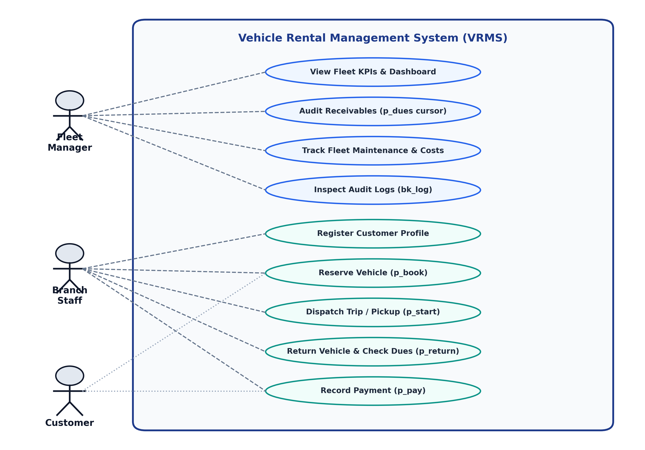
Figure 2.1: Use-case diagram of the Vehicle Rental Management System (VRMS)
Table 2.4: Key use-case descriptions
Use Case | Actors | Main Operational Flow | Alternative / Exception Flow
Reserve Vehicle | Customer / Staff | Select customer, vehicle, dates; verifies f_avail; inserts BOOKED row; trg_bk_bi computes total. | Vehicle under SERVICE or date collision: ORA-20001 raised; transaction rolled back.
Dispatch Trip | Branch Staff | Verifies customer arrival; executes p_start; updates status to ACTIVE; trg_bk_au locks vehicle to RENTED. | Booking not BOOKED: ORA-20002 raised; operation rejected.
Return Vehicle | Branch Staff | Executes p_return; sets status to RETURNED; trg_bk_au unlocks vehicle to AVAILABLE; calls f_bal. | Booking not ACTIVE: ORA-20003 raised; return rejected.
Collect Payment | Staff / Customer | Customer pays via CASH/UPI/CARD; p_pay verifies amount <= balance; inserts row via seq_pay. | Amount <= 0 or exceeds balance: ORA-20004 raised.
Audit Receivables | Fleet Manager | Manager requests dues report; p_dues cursor iterates over open bookings; aggregates total dues. | No open dues: reports 0 overdue balances.

CHAPTER 3: DBMS CONCEPTS AND ARCHITECTURE
3.1 Introduction to DBMS
A Database Management System (DBMS) is specialized system software designed to define, construct, manipulate, and safeguard persistent datasets. In a Relational DBMS (RDBMS), data is conceptually structured into mathematical relations (tables) comprising tuples (rows) and attributes (columns). Relationships between entities are established through key values rather than physical disk pointers. The core benefits include declarative data integrity, reduction of redundancy, concurrent multi-user execution via ACID transactions, standardized query execution (SQL), and enterprise-grade backup/recovery mechanisms.
3.2 File System versus DBMS
Table 3.1: File system versus DBMS in the vehicle rental context
Evaluation Aspect | Traditional File / Spreadsheet System | Oracle RDBMS (This Project)
Data Redundancy | Branch and customer data duplicated across every reservation spreadsheet. | Stored exactly once in normalized tables; referenced via foreign keys.
Data Consistency | Manual cross-sheet synchronization; prone to conflicting values. | Enforced through PK, FK, NOT NULL, UNIQUE, CHECK, and triggers.
Concurrent Sharing | Coarse file locking; simultaneous edits cause data loss or lock conflicts. | Row-level locking (SELECT FOR UPDATE) and multi-version concurrency control.
Data Security | Coarse OS file permissions; no field-level or role-based restrictions. | Oracle database schemas, roles, and granular privilege grants.
Transaction Recovery | Manual file backups; power loss or process crash corrupts data. | Write-ahead logging (Redo logs) and undo tablespaces for atomic rollback.

3.3 Three-Schema Architecture
The ANSI/SPARC Three-Schema Architecture separates database systems into three distinct abstraction tiers:
- External Schema (View Level): Customized user interfaces presenting only role-relevant data. The Staff portal displays vehicle availability calendars and customer check-in forms. The Manager portal displays financial aggregate summaries, receivables audits, and maintenance schedules.
- Conceptual Schema (Logical Level): The global relational schema defining the 8 normalized tables, data types, primary/foreign key relationships, and enterprise business rules independent of storage mechanics.
- Internal Schema (Physical Level): The physical layout of the database within Oracle tablespaces, data files, B*Tree index structures, and row formats stored on disk.
3.4 Data Independence
Logical Data Independence is achieved because the Python Flask web application interacts with the database through SQL views (such as v_open_bookings) and parameterized stored procedures. Adding an operational column or creating audit tables does not break existing application routes. Physical Data Independence is demonstrated because B*Tree indexes (such as idx_veh_cid_bid) can be added, rebuilt, or relocated without modifying the application SQL queries.
3.5 Data Models
Earlier hierarchical and network data models relied on rigid physical tree pointers and lacked ad-hoc query capabilities. Document and NoSQL databases provide flexible schema nesting but sacrifice multi-table foreign key enforcement and declarative ACID guarantees. The Relational Model was chosen because vehicle rental operations are inherently structured, require strict referential integrity across 8 entities, and demand deterministic financial transactions.
3.6 Database Languages
Table 3.2: SQL sub-languages and their use in the project
Language | Full Form | Purpose | Project Implementation Examples
DDL | Data Definition Language | Defines and alters schema structures | CREATE TABLE, CREATE SEQUENCE, CREATE TRIGGER, DROP TABLE in 01_schema_data.sql
DML | Data Manipulation Language | Inserts, modifies, and deletes data | INSERT sample data, UPDATE status, DELETE customer in 01_schema_data.sql
DQL | Data Query Language | Retrieves data matching criteria | 16 comprehensive SQL queries in 03_queries_demo.sql
DCL | Data Control Language | Manages user privileges and roles | GRANT CONNECT, RESOURCE to rental; proposed role-based privilege model
TCL | Transaction Control Language | Controls atomic transaction states | COMMIT, ROLLBACK, SAVEPOINT executed in stored procedures and test cases

3.7 Users and Database Administrator
In this project, user roles reflect operational banking/rental hierarchies: End Users (Customers and Desk Staff) utilize the web interface; Application Programmers develop Python Flask endpoints and Jinja2 views; Database Designers formulate the ER diagram and normalized schema; and the Database Administrator (DBA) establishes the Oracle pluggable database, compiles PL/SQL packages, and oversees data integrity.

CHAPTER 4: CONCEPTUAL DATABASE DESIGN
4.1 Entity Identification
Table 4.1: Entities and their roles
Entity Name | Entity Type | Role in Vehicle Rental Domain
BRANCH | Strong Entity | Physical branch location hosting fleet vehicles and customer pickup operations.
CATEGORY | Strong Entity | Classification of vehicles (Sedan, SUV, Luxury) establishing daily rental tariffs.
CUSTOMER | Strong Entity | Verified individual customer holding driving credentials and contact profiles.
VEHICLE | Strong Entity | Physical motor vehicle owned by the agency, assigned to a branch and category.
BOOKING | Strong Entity | Contractual reservation linking a customer to a specific vehicle for a date range.
PAYMENT | Strong Entity | Financial transaction settlement recorded against a specific rental booking.
MAINTENANCE | Strong Entity | Service inspection or repair log documenting downtime and maintenance expense.
BK_LOG | Strong Entity (Audit) | Immutable historical log recording booking status transitions and trigger origins.

4.2 Attributes and Attribute Types
All attributes across the 8 entities are simple and atomic. Composite attributes such as customer address are handled atomically, and multi-valued attributes are eliminated by establishing separate normalized relations. Derived attributes are deliberately designed: booking.total is derived from (edt - sdt) multiplied by category.rate, computed autonomously by trg_bk_bi to avoid application-side calculation discrepancies. Similarly, bk_log captures old_st and new_st to create an unalterable audit ledger.
4.3 Relationships and Cardinality
Table 4.2: Relationships and cardinality
Relationship | Entities Involved | Cardinality | Relational Implementation
hosts | BRANCH (1) – VEHICLE (N) | 1 : N | VEHICLE.bid (FK referencing BRANCH.bid)
classifies | CATEGORY (1) – VEHICLE (N) | 1 : N | VEHICLE.cid (FK referencing CATEGORY.cid)
places | CUSTOMER (1) – BOOKING (N) | 1 : N | BOOKING.custid (FK referencing CUSTOMER.custid)
reserves | VEHICLE (1) – BOOKING (N) | 1 : N | BOOKING.vid (FK referencing VEHICLE.vid)
undergoes | VEHICLE (1) – MAINTENANCE (N) | 1 : N | MAINTENANCE.vid (FK referencing VEHICLE.vid)
settles | BOOKING (1) – PAYMENT (N) | 1 : N | PAYMENT.bkid (FK referencing BOOKING.bkid)
audits | BOOKING (1) – BK_LOG (N) | 1 : N | BK_LOG.bkid (recorded by trg_bk_au)

4.4 Participation Constraints
- Total Participation of VEHICLE in BRANCH and CATEGORY: Every vehicle must reference a valid home branch and category (NOT NULL foreign keys).
- Partial Participation of BRANCH and CATEGORY: A branch or category may exist before vehicles are assigned to it.
- Total Participation of BOOKING in CUSTOMER and VEHICLE: Every booking must be linked to a registered customer and vehicle.
- Partial Participation of CUSTOMER and VEHICLE: A customer may exist without placing a booking; a vehicle may exist without current reservations.
4.5 Weak and Strong Entities
Every entity possesses its own unique primary key surrogate (e.g., bid, cid, custid, vid, bkid, pid, mid, lid). Consequently, there are no weak entities in the strict ER sense. All entities represent distinct real-world domain objects with independent lifecycles governed by referential integrity.
4.6 ER Diagram
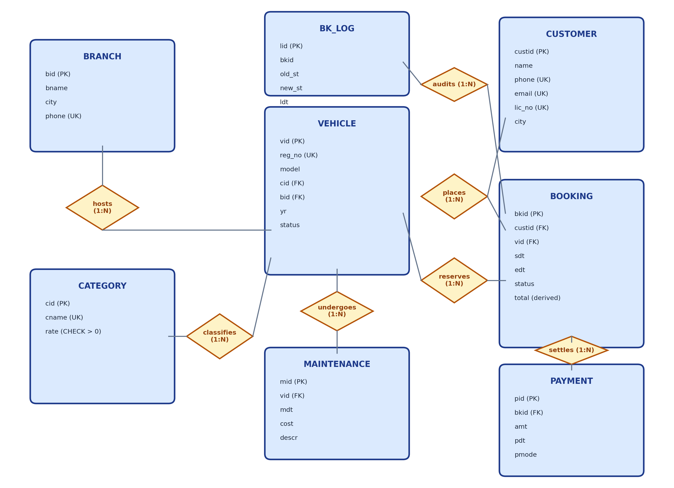
Figure 4.1: Entity-Relationship diagram (diamonds = relationships; UK = unique key; PK = primary key)
4.7 Design Assumptions
- Tariff Calculation: Rental charges are computed as whole calendar days (edt - sdt) multiplied by category daily rate.
- Maintenance Quarantine: Vehicles in SERVICE status cannot be reserved or dispatched under any circumstances.
- Vehicle State Machine: Transitioning a booking to ACTIVE automatically locks vehicle status to RENTED; returning it restores AVAILABLE.
- Payment Settlement: Payments cannot exceed the outstanding balance (f_bal), preventing negative customer balances.

CHAPTER 5: RELATIONAL DATABASE DESIGN
5.1 Relational Schema
The conceptual ER design is formally mapped into 8 relational schemas satisfying 3NF/BCNF. Primary keys are designated with PK; foreign keys are designated with FK; unique constraints are marked UQ.
- BRANCH(bid PK, bname NOT NULL, city NOT NULL, phone UQ)
- CATEGORY(cid PK, cname NOT NULL UQ, rate NOT NULL CHECK(rate > 0))
- CUSTOMER(custid PK, name NOT NULL, phone NOT NULL UQ, email UQ, lic_no NOT NULL UQ, city DEFAULT 'Chennai')
- VEHICLE(vid PK, reg_no NOT NULL UQ, model NOT NULL, cid NOT NULL FK->CATEGORY(cid), bid NOT NULL FK->BRANCH(bid), yr CHECK(yr >= 2015), status DEFAULT 'AVAILABLE' CHECK(status IN ('AVAILABLE','RENTED','SERVICE')))
- BOOKING(bkid PK, custid NOT NULL FK->CUSTOMER(custid), vid NOT NULL FK->VEHICLE(vid), sdt NOT NULL, edt NOT NULL, status DEFAULT 'BOOKED' CHECK(status IN ('BOOKED','ACTIVE','RETURNED','CANCELLED')), total DEFAULT 0, CHECK(edt > sdt))
- PAYMENT(pid PK, bkid NOT NULL FK->BOOKING(bkid), amt NOT NULL CHECK(amt > 0), pdt DEFAULT SYSDATE, pmode CHECK(pmode IN ('CASH','UPI','CARD')))
- MAINTENANCE(mid PK, vid NOT NULL FK->VEHICLE(vid), mdt NOT NULL, cost CHECK(cost >= 0), descr)
- BK_LOG(lid PK, bkid, old_st, new_st, ldt DEFAULT SYSDATE)
5.2 Table Definitions
The relational tables are created natively in Oracle AI Database 26ai Free using strong Oracle data types (NUMBER, VARCHAR2, DATE, TIMESTAMP). The central BOOKING table definition illustrates constraint composition:
CREATE TABLE booking (
bkid NUMBER PRIMARY KEY,
custid NUMBER NOT NULL REFERENCES customer(custid),
vid NUMBER NOT NULL REFERENCES vehicle(vid),
sdt DATE NOT NULL,
edt DATE NOT NULL,
status VARCHAR2(15) DEFAULT 'BOOKED' CHECK (status IN ('BOOKED','ACTIVE','RETURNED','CANCELLED')),
total NUMBER(10,2) DEFAULT 0,
CHECK (edt > sdt)
);

5.3 Keys
Table 5.1: Keys of each relation
Relation | Primary Key | Other Candidate / Alternate Keys | Foreign Keys
BRANCH | bid | phone (UNIQUE) | -
CATEGORY | cid | cname (UNIQUE) | -
CUSTOMER | custid | phone (UQ), email (UQ), lic_no (UQ) | -
VEHICLE | vid | reg_no (UNIQUE) | cid -> CATEGORY(cid), bid -> BRANCH(bid)
BOOKING | bkid | - | custid -> CUSTOMER(custid), vid -> VEHICLE(vid)
PAYMENT | pid | - | bkid -> BOOKING(bkid)
MAINTENANCE | mid | - | vid -> VEHICLE(vid)
BK_LOG | lid | - | bkid (logical audit reference)

5.4 Integrity Constraints
Table 5.2: Integrity constraints used
Constraint Type | Examples from VRMS Schema
Domain Constraints | status IN ('AVAILABLE','RENTED','SERVICE'); booking status IN ('BOOKED','ACTIVE','RETURNED','CANCELLED'); pmode IN ('CASH','UPI','CARD')
Entity Integrity | Every table defines an explicit primary key (NOT NULL and unique).
Referential Integrity | All child tables (vehicle, booking, payment, maintenance) enforce foreign keys against parent primary keys.
Unique Constraints | branch.phone, category.cname, customer.phone, customer.email, customer.lic_no, vehicle.reg_no
Check Constraints | category.rate > 0; vehicle.yr >= 2015; booking.edt > sdt; payment.amt > 0; maintenance.cost >= 0
Default Constraints | customer.city DEFAULT 'Chennai'; vehicle.status DEFAULT 'AVAILABLE'; booking.status DEFAULT 'BOOKED'; booking.total DEFAULT 0; payment.pdt DEFAULT SYSDATE; bk_log.ldt DEFAULT SYSDATE

5.5 Schema Diagram
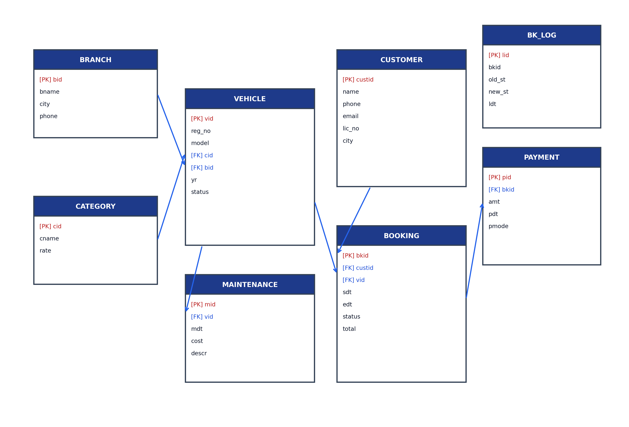
Figure 5.1: Relational schema diagram with primary and foreign key links
5.6 Data Dictionary
Table 5.3: Data dictionary: BRANCH
Column | Data Type | Constraints | Description
bid | NUMBER | PK | Unique branch numeric identifier (1 to 10)
bname | VARCHAR2(50) | NOT NULL | Official name of the rental branch office
city | VARCHAR2(50) | NOT NULL | City location of the branch
phone | VARCHAR2(20) | UNIQUE | Dedicated branch contact phone number

Table 5.4: Data dictionary: CATEGORY
Column | Data Type | Constraints | Description
cid | NUMBER | PK | Category identifier (1 to 10)
cname | VARCHAR2(30) | NOT NULL, UNIQUE | Category classification (Hatchback, Sedan, SUV, Luxury)
rate | NUMBER(10,2) | NOT NULL, CHECK > 0 | Daily rental tariff in INR (Rs. 400 to Rs. 6,000)

Table 5.5: Data dictionary: CUSTOMER
Column | Data Type | Constraints | Description
custid | NUMBER | PK | Unique customer identifier (1 to 10)
name | VARCHAR2(50) | NOT NULL | Full legal name of the customer
phone | VARCHAR2(20) | NOT NULL, UNIQUE | Mobile contact number
email | VARCHAR2(50) | UNIQUE | Email address for booking confirmations
lic_no | VARCHAR2(30) | NOT NULL, UNIQUE | Verified driving license number
city | VARCHAR2(50) | DEFAULT 'Chennai' | Customer residential city

Table 5.6: Data dictionary: VEHICLE
Column | Data Type | Constraints | Description
vid | NUMBER | PK | Unique vehicle inventory identifier (1 to 10)
reg_no | VARCHAR2(20) | NOT NULL, UNIQUE | Official vehicle registration license plate
model | VARCHAR2(50) | NOT NULL | Vehicle make and model name (e.g. Maruti Swift, BMW 3 Series)
cid | NUMBER | NOT NULL, FK->category | Foreign key linking vehicle to its tariff category
bid | NUMBER | NOT NULL, FK->branch | Foreign key linking vehicle to its home branch
yr | NUMBER(4) | CHECK yr >= 2015 | Manufacturing year
status | VARCHAR2(15) | DEFAULT 'AVAILABLE', CHECK | Operational state (AVAILABLE, RENTED, SERVICE)

Table 5.7: Data dictionary: BOOKING
Column | Data Type | Constraints | Description
bkid | NUMBER | PK | Unique booking reservation identifier (1 to 12)
custid | NUMBER | NOT NULL, FK->customer | Foreign key referencing reserving customer
vid | NUMBER | NOT NULL, FK->vehicle | Foreign key referencing assigned vehicle
sdt | DATE | NOT NULL | Start date and time of the rental trip
edt | DATE | NOT NULL | Scheduled end date and time of the rental trip
status | VARCHAR2(15) | DEFAULT 'BOOKED', CHECK | Booking lifecycle (BOOKED, ACTIVE, RETURNED, CANCELLED)
total | NUMBER(10,2) | DEFAULT 0 | Computed trip rental tariff: (edt - sdt) * category.rate

Table 5.8: Data dictionary: PAYMENT
Column | Data Type | Constraints | Description
pid | NUMBER | PK | Unique payment receipt identifier (1 to 10)
bkid | NUMBER | NOT NULL, FK->booking | Foreign key referencing booking being settled
amt | NUMBER(10,2) | NOT NULL, CHECK > 0 | Monetary payment amount in INR
pdt | DATE | DEFAULT SYSDATE | Timestamp when payment was collected
pmode | VARCHAR2(10) | CHECK IN ('CASH','UPI','CARD') | Payment channel used

Table 5.9: Data dictionary: MAINTENANCE
Column | Data Type | Constraints | Description
mid | NUMBER | PK | Unique maintenance record identifier (1 to 10)
vid | NUMBER | NOT NULL, FK->vehicle | Foreign key referencing vehicle serviced
mdt | DATE | NOT NULL | Date of workshop inspection or service
cost | NUMBER(10,2) | CHECK cost >= 0 | Total maintenance expense incurred
descr | VARCHAR2(200) | - | Work order description (brake overhaul, periodic service)

Table 5.10: Data dictionary: BK_LOG
Column | Data Type | Constraints | Description
lid | NUMBER | PK | Unique audit log identifier generated by seq_log
bkid | NUMBER | - | Booking identifier that underwent status transition
old_st | VARCHAR2(15) | - | Previous lifecycle status prior to mutation
new_st | VARCHAR2(15) | - | Updated lifecycle status after mutation
ldt | DATE | DEFAULT SYSDATE | Exact database timestamp of the status change

CHAPTER 6: FUNCTIONAL DEPENDENCIES AND NORMALIZATION
6.1 Functional Dependencies
To rigorously prove that the schema is free of anomalies, consider a universal un-normalized relation R comprising 26 attributes: R(bkid, custid, vid, sdt, edt, booking_status, total, cust_name, phone, email, lic_no, cust_city, reg_no, model, cid, cname, rate, yr, veh_status, bid, bname, branch_city, branch_phone, pid, amt, pmode).
- F1: bkid -> custid, vid, sdt, edt, booking_status, total
- F2: custid -> cust_name, phone, email, lic_no, cust_city
- F3: phone -> custid; email -> custid; lic_no -> custid (all candidate keys)
- F4: vid -> reg_no, model, cid, bid, yr, veh_status
- F5: reg_no -> vid (candidate key)
- F6: cid -> cname, rate; cname -> cid
- F7: bid -> bname, branch_city, branch_phone; branch_phone -> bid
- F8: pid -> bkid, amt, pmode
6.2 Attribute Closure and Candidate Keys
Computing the attribute closure of {bkid, pid} under F1-F8 resolves all 26 attributes of R. For the booking entity alone, {bkid}+ determines all booking, customer, vehicle, category, and branch attributes. Thus, bkid is the minimal candidate key for booking facts.
6.3 First Normal Form (1NF)
A relation is in 1NF if all attribute values are atomic and there are no repeating groups. In a flat spreadsheet, booking multiple vehicles or recording multiple payment installments within a single cell (e.g., '10000, 5000') violates 1NF. In VRMS, all attributes hold single scalar values; multiple payments are represented as distinct rows in PAYMENT. Hence, the schema is strictly in 1NF.
6.4 Second Normal Form (2NF)
A relation is in 2NF if it is in 1NF and no non-prime attribute is partially dependent on any candidate key. If a composite key {bkid, pid} were used for a combined booking-payment relation, customer attributes would depend only on bkid, violating 2NF. Decomposing R into distinct entities (BOOKING, CUSTOMER, VEHICLE, PAYMENT) ensures every non-prime attribute depends on the entire primary key.
6.5 Third Normal Form (3NF)
A relation is in 3NF if it is in 2NF and no non-prime attribute is transitively dependent on the primary key. In an intermediate table VEHICLE(vid, model, cid, cname, rate), the transitive dependency vid -> cid -> (cname, rate) exists. Decomposing this into VEHICLE(vid, cid, ...) and CATEGORY(cid, cname, rate) removes all transitive dependencies.
6.6 Boyce-Codd Normal Form (BCNF)
Table 6.1: BCNF check: every non-trivial determinant must be a superkey
Relation | Determinants | Is Determinant a Superkey? | Normal Form Result
BRANCH | bid; phone | Yes (PK and UNIQUE candidate key) | BCNF
CATEGORY | cid; cname | Yes (PK and UNIQUE candidate key) | BCNF
CUSTOMER | custid; phone; email; lic_no | Yes (PK and 3 UNIQUE candidate keys) | BCNF
VEHICLE | vid; reg_no | Yes (PK and UNIQUE candidate key) | BCNF
BOOKING | bkid; and (sdt, edt, vid) -> total | First yes; second no (computed via category) | Controlled denormalization (justified below)
PAYMENT | pid | Yes (PK) | BCNF
MAINTENANCE | mid | Yes (PK) | BCNF
BK_LOG | lid | Yes (PK) | BCNF

Justification of Controlled Denormalization: In BOOKING, the total attribute is derived from (edt - sdt) * category.rate. Storing total avoids expensive re-computation across thousands of analytical queries and preserves historical financial accuracy if category tariffs are revised in the future. The risk of inconsistency is 100% prevented by trigger trg_bk_bi, which computes total autonomously at insertion time.
6.7 Lossless Join and Dependency Preservation
The relational decomposition of R into the 8 VRMS tables is guaranteed to be Lossless because each decomposition step shares a foreign key that is a candidate key of the parent relation (e.g., BOOKING.vid references VEHICLE.vid). Furthermore, all functional dependencies F1 to F8 are fully preserved within individual normalized tables.
6.8 Before-and-After Example
Table 6.2: Before: flat relation (redundant vehicle, tariff, and branch attributes)
BKID | Cust | Phone | Model | Cat | Rate | Branch | Start | End | Total
1 | Aarav | 9840112233 | Swift | Hatchback | 1200 | Chennai Central | 01-Jan | 04-Jan | 3600
7 | Karthik | 9840778899 | Swift | Hatchback | 1200 | Chennai Central | 20-Jan | 23-Jan | 3600
12 | Diya | 9840223344 | Swift | Hatchback | 1200 | Chennai Central | 10-Feb | 13-Feb | 3600

In Table 6.2, updating the Hatchback tariff from 1200 to 1300 requires updating hundreds of rows. In the normalized schema (Table 6.3), the rate exists once in CATEGORY, vehicle 1 points to cid 1 and bid 1, and bookings reference vid 1 without repeating vehicle attributes.

CHAPTER 7: SQL IMPLEMENTATION
7.1 Database and Table Creation (DDL)
The complete schema DDL is executed in 01_schema_data.sql. Existing tables and sequences are dropped in reverse dependency order to prevent foreign key constraint violations:
DROP TABLE bk_log CASCADE CONSTRAINTS;
DROP TABLE maintenance CASCADE CONSTRAINTS;
DROP TABLE payment CASCADE CONSTRAINTS;
DROP TABLE booking CASCADE CONSTRAINTS;
DROP TABLE vehicle CASCADE CONSTRAINTS;
DROP TABLE customer CASCADE CONSTRAINTS;
DROP TABLE category CASCADE CONSTRAINTS;
DROP TABLE branch CASCADE CONSTRAINTS;

7.2 Data Manipulation (DML)
All 8 tables were populated with at least 10 meaningful records using SQL INSERT statements. Operational status consistency was maintained (Vehicle 10 set to SERVICE; Booking 11 set to ACTIVE with Vehicle 3 set to RENTED).
7.3 Data Retrieval (DQL)
Sixteen comprehensive SQL queries were designed and executed on the live Oracle database. All queries satisfy complex relational operations including multi-table joins, aggregations, HAVING clauses, subqueries, and views.
7.4 Built-In and Aggregate Functions
Table 7.1: Functions used in the project SQL
Category | Functions Employed | Demonstration Queries / Scripts
Aggregate Functions | COUNT, SUM, AVG, MIN, MAX | Queries 2, 3, 5, 6, 9, 10, 11, 14
Numeric Functions | ROUND, NVL | Queries 2, 10, 11, 14; PL/SQL procedures
String Functions | UPPER, LENGTH, SUBSTR, INSTR, RPAD | Query 7; p_dues cursor report formatting
Date Functions | TO_CHAR, TO_DATE, SYSDATE, Date arithmetic (edt - sdt) | Queries 1, 5, 8; trigger trg_bk_bi duration calculation

7.5 GROUP BY and HAVING
Query 2 groups bookings by category to compute total trips and revenue. Query 3 groups bookings by customer and applies a HAVING filter (HAVING COUNT(b.bkid) > 1) to identify repeat customers. Query 6 groups vehicles by branch. Query 10 groups payments by mode.
7.6 Joins
Table 7.2: Join types demonstrated
Join Type | Query | Tables Joined | Operational Purpose
3-Table Inner Join | Query 1 | booking, customer, vehicle | Retrieves complete booking details with customer names and vehicle models
Aggregate Join | Query 11 | vehicle, maintenance | Aggregates total service records and maintenance costs per vehicle
Left Outer Join | Query 2 | category, vehicle, booking | Includes categories with zero bookings (Van, Convertible) with NVL zero totals
Left Outer Join | Query 6 | branch, vehicle | Lists all branches including those with zero vehicles (Pune, Tirunelveli)
Left Outer Join (IS NULL) | Query 12 | booking, customer, payment | Filters for bookings with zero payments (Meera Joshi, Diya Patel)

7.7 Subqueries
Query 5 demonstrates a scalar subquery (WHERE amt > (SELECT AVG(amt) FROM payment)). Query 4 demonstrates a NOT IN subquery (WHERE vid NOT IN (SELECT DISTINCT vid FROM booking)). Query 9 demonstrates a subquery with MAX(rate). Query 15 demonstrates a correlated subquery with EXISTS (WHERE EXISTS (SELECT 1 FROM booking b WHERE b.custid = c.custid AND b.status = 'CANCELLED')).
7.8 Set Operations
Query 16 demonstrates the UNION set operation between branch cities and customer cities, producing a consolidated geographic footprint while eliminating duplicates.
7.9 Views
CREATE OR REPLACE VIEW v_open_bookings AS
SELECT b.bkid, c.name AS customer_name, c.phone, v.model, v.reg_no, b.sdt, b.edt, b.status, b.total
FROM booking b
JOIN customer c ON b.custid = c.custid
JOIN vehicle v ON b.vid = v.vid
WHERE b.status IN ('BOOKED', 'ACTIVE');
SELECT bkid, customer_name, model, status, total FROM v_open_bookings;

Table 7.3: Output of the view query (v_open_bookings)
BKID | Customer Name | Model | Status | Total (Rs.)
11 | Aarav Sharma | Hyundai Creta | ACTIVE | 10000
12 | Diya Patel | Maruti Swift | BOOKED | 3600

7.10 Constraints
Table 7.4: Constraint demonstration (actual Oracle error responses)
Constraint Type | Test Statement | Actual Oracle Database Response
CHECK rate > 0 | INSERT INTO category VALUES (11, 'Invalid', -500) | ORA-02290: check constraint (RENTAL.SYS_C...) violated
CHECK edt > sdt | INSERT INTO booking VALUES (99, 1, 1, DATE '2026-03-10', DATE '2026-03-05', ...) | ORA-02290: check constraint (RENTAL.SYS_C...) violated
UNIQUE phone | INSERT INTO customer VALUES (15, 'Dup', '9840112233', ...) | ORA-00001: unique constraint (RENTAL.SYS_C...) violated
FOREIGN KEY | INSERT INTO vehicle VALUES (99, 'TN-99-ZZ-999', 'Car', 99, 1, ...) | ORA-02291: integrity constraint (RENTAL.SYS_C...) violated - parent key not found
Trigger Quarantine | p_book(1, 10, DATE '2026-03-01', DATE '2026-03-05') | ORA-20001: Vehicle not available for requested dates or under service.

7.11 Data Control Language
In production enterprise deployments, Oracle Data Control Language (DCL) implements role-based privilege separation:
CREATE ROLE rental_staff;
CREATE ROLE rental_manager;
GRANT SELECT, INSERT ON customer TO rental_staff;
GRANT EXECUTE ON p_book TO rental_staff;
GRANT EXECUTE ON p_start TO rental_staff;
GRANT EXECUTE ON p_return TO rental_staff;
GRANT EXECUTE ON p_pay TO rental_staff;
GRANT SELECT ON v_open_bookings TO rental_staff;
GRANT EXECUTE ON p_dues TO rental_manager;
GRANT SELECT ON bk_log TO rental_manager;

7.12 SQL Output Evidence (16 Queries)
Query 1: Booking Details with Customer and Vehicle (3-Table Inner Join)
SELECT b.bkid, c.name, v.model, v.reg_no,
TO_CHAR(b.sdt, 'DD-Mon-YYYY') AS start_date,
TO_CHAR(b.edt, 'DD-Mon-YYYY') AS end_date,
b.status, b.total
FROM booking b
JOIN customer c ON b.custid = c.custid
JOIN vehicle v ON b.vid = v.vid
ORDER BY b.bkid;

Table 7.5: Output of Query 1 (Sample of 12 rows)
BKID | Name | Model | Reg No | Start Date | End Date | Status | Total (Rs.)
1 | Aarav Sharma | Maruti Swift | TN-01-AB-123 | 01-Jan-2026 | 04-Jan-2026 | RETURNED | 3600
2 | Diya Patel | Honda City | TN-02-CD-234 | 05-Jan-2026 | 08-Jan-2026 | RETURNED | 5400
3 | Rohan Iyer | Hyundai Creta | TN-07-EF-345 | 10-Jan-2026 | 12-Jan-2026 | RETURNED | 5000
4 | Priya Nair | BMW 3 Series | KA-01-GH-456 | 12-Jan-2026 | 14-Jan-2026 | RETURNED | 10000
11 | Aarav Sharma | Hyundai Creta | TN-07-EF-345 | 01-Feb-2026 | 05-Feb-2026 | ACTIVE | 10000
12 | Diya Patel | Maruti Swift | TN-01-AB-123 | 10-Feb-2026 | 13-Feb-2026 | BOOKED | 3600

Interpretation: Evaluates a 3-table join between booking, customer, and vehicle. Formats dates using TO_CHAR. Booking totals match category rates multiplied by duration.
Query 2: Revenue and Rental Trips per Category (Aggregation & Group By)
SELECT cat.cname, COUNT(b.bkid) AS total_trips,
NVL(SUM(b.total), 0) AS total_revenue,
NVL(ROUND(AVG(b.total), 2), 0) AS avg_booking_value
FROM category cat
LEFT JOIN vehicle v ON cat.cid = v.cid
LEFT JOIN booking b ON v.vid = b.vid AND b.status != 'CANCELLED'
GROUP BY cat.cname ORDER BY total_revenue DESC;

Table 7.6: Output of Query 2
Category | Total Trips | Total Revenue (Rs.) | Avg Booking Value (Rs.)
SUV | 2 | 15000 | 7500.00
Hatchback | 3 | 10800 | 3600.00
Luxury | 1 | 10000 | 10000.00
MUV | 1 | 8400 | 8400.00
Sedan | 1 | 5400 | 5400.00
Electric | 1 | 4400 | 4400.00
Bike | 1 | 1500 | 1500.00
Van | 0 | 0 | 0.00
Convertible | 0 | 0 | 0.00

Interpretation: Left join retains categories with 0 bookings (Van, Convertible). NVL converts null sums to 0. SUV leads in revenue (Rs. 15,000).
Query 3: Customers with More than One Booking (HAVING Clause)
SELECT c.custid, c.name, c.phone, COUNT(b.bkid) AS booking_count
FROM customer c
JOIN booking b ON c.custid = b.custid
GROUP BY c.custid, c.name, c.phone
HAVING COUNT(b.bkid) > 1
ORDER BY booking_count DESC;

Table 7.7: Output of Query 3
Cust ID | Customer Name | Phone Number | Total Bookings
1 | Aarav Sharma | 9840112233 | 2
2 | Diya Patel | 9840223344 | 2

Interpretation: Identifies repeat patrons by applying a HAVING aggregate filter greater than 1. Aarav Sharma and Diya Patel each hold 2 bookings.
Query 4: Vehicles that Have Never Been Booked (NOT IN Subquery)
SELECT vid, reg_no, model, status
FROM vehicle
WHERE vid NOT IN (SELECT DISTINCT vid FROM booking)
ORDER BY vid;

Table 7.8: Output of Query 4
VID | Reg Number | Model | Status
7 | TN-03-MN-789 | Force Urbania | AVAILABLE
10 | TN-01-ST-012 | Mini Cooper S Conv | SERVICE

Interpretation: Demonstrates uncorrelated NOT IN subquery. Force Urbania and Mini Cooper have never been rented out.
Query 5: Payments Exceeding the Overall Average Payment (Scalar Subquery)
SELECT p.pid, p.bkid, p.amt, p.pmode, TO_CHAR(p.pdt, 'DD-Mon-YYYY') AS pdt
FROM payment p
WHERE p.amt > (SELECT AVG(amt) FROM payment)
ORDER BY p.amt DESC;

Table 7.9: Output of Query 5
PID | BKID | Amount (Rs.) | Payment Mode | Payment Date
4 | 4 | 10000.00 | CARD | 14-Jan-2026
8 | 8 | 8400.00 | UPI | 25-Jan-2026
2 | 2 | 5400.00 | CARD | 08-Jan-2026
3 | 3 | 5000.00 | CASH | 12-Jan-2026
9 | 9 | 4400.00 | CASH | 27-Jan-2026

Interpretation: The system average payment is Rs. 4,310.00. Exactly 5 payments exceed this threshold, led by payment 4 (Rs. 10,000).
Query 6: Vehicle Distribution Across Branches (LEFT OUTER JOIN)
SELECT br.bid, br.bname, br.city, COUNT(v.vid) AS vehicle_count
FROM branch br
LEFT JOIN vehicle v ON br.bid = v.bid
GROUP BY br.bid, br.bname, br.city
ORDER BY vehicle_count DESC, br.bid;

Table 7.10: Output of Query 6 (Sample)
BID | Branch Name | City | Vehicles Hosted
1 | Chennai Central | Chennai | 3
2 | Coimbatore Gandhipuram | Coimbatore | 1
3 | Madurai Meenakshi | Madurai | 1
4 | Trichy Central | Trichy | 1
9 | Pune FC Road | Pune | 0
10 | Tirunelveli Junction | Tirunelveli | 0

Interpretation: Demonstrates outer join preserving branches with 0 vehicles (Pune and Tirunelveli). Chennai Central hosts 3 vehicles.
Query 7: String Manipulation Functions (UPPER, LENGTH, SUBSTR, INSTR)
SELECT name, UPPER(name) AS upper_name, LENGTH(name) AS name_len,
SUBSTR(phone, 1, 5) AS phone_prefix, INSTR(email, '@') AS at_position
FROM customer WHERE ROWNUM <= 4;

Table 7.11: Output of Query 7
Name | UPPER(name) | LENGTH | SUBSTR(phone,1,5) | INSTR(email,'@')
Aarav Sharma | AARAV SHARMA | 12 | 98401 | 13
Diya Patel | DIYA PATEL | 10 | 98402 | 11
Rohan Iyer | ROHAN IYER | 10 | 98403 | 11
Priya Nair | PRIYA NAIR | 10 | 98404 | 11

Interpretation: Demonstrates Oracle built-in character functions for text transformation and search.
Query 8: Booking Month Extraction and Duration Computation (Date Functions)
SELECT bkid, TO_CHAR(sdt, 'Month') AS booking_month,
TO_CHAR(sdt, 'Dy') AS start_day, ROUND(edt - sdt) AS duration_days, total
FROM booking WHERE ROWNUM <= 4;

Table 7.12: Output of Query 8
BKID | Booking Month | Day of Week | Duration (Days) | Total (Rs.)
1 | January | Thu | 3 | 3600
2 | January | Mon | 3 | 5400
3 | January | Sat | 2 | 5000
4 | January | Mon | 2 | 10000

Interpretation: Extracts date parts and computes date differences in whole calendar days.
Query 9: Most Expensive Category Details (Subquery with MAX)
SELECT cid, cname, rate FROM category
WHERE rate = (SELECT MAX(rate) FROM category);

Table 7.13: Output of Query 9
CID | Category Name | Daily Rate (Rs.)
10 | Convertible | 6000.00

Interpretation: Subquery identifies Convertible at Rs. 6,000/day as the highest tariff tier.
Query 10: Payment Distribution by Transaction Mode (Aggregation)
SELECT pmode, COUNT(pid) AS tx_count, SUM(amt) AS total_collected,
ROUND(AVG(amt), 2) AS avg_tx_amt
FROM payment GROUP BY pmode ORDER BY total_collected DESC;

Table 7.14: Output of Query 10
Payment Mode | Transaction Count | Total Collected (Rs.) | Average Ticket (Rs.)
CARD | 3 | 19000.00 | 6333.33
CASH | 4 | 14500.00 | 3625.00
UPI | 3 | 9600.00 | 3200.00

Interpretation: CARD collections represent the largest total revenue (Rs. 19,000) across 3 transactions.
Query 11: Total Maintenance Cost per Vehicle (Aggregate Join)
SELECT v.vid, v.model, v.reg_no, COUNT(m.mid) AS service_records,
NVL(SUM(m.cost), 0) AS total_maint_cost
FROM vehicle v
JOIN maintenance m ON v.vid = m.vid
GROUP BY v.vid, v.model, v.reg_no
ORDER BY total_maint_cost DESC;

Table 7.15: Output of Query 11 (Top 4 shown)
VID | Model | Reg Number | Services | Total Maintenance (Rs.)
4 | BMW 3 Series | KA-01-GH-456 | 1 | 15000.00
10 | Mini Cooper S Conv | TN-01-ST-012 | 1 | 12000.00
8 | Toyota Innova Crysta | MH-12-OP-890 | 1 | 7500.00
1 | Maruti Swift | TN-01-AB-123 | 1 | 2500.00

Interpretation: BMW 3 Series accumulated the highest individual maintenance cost (Rs. 15,000).
Query 12: Bookings with No Recorded Payments (LEFT JOIN IS NULL)
SELECT b.bkid, c.name, b.status, b.total
FROM booking b
JOIN customer c ON b.custid = c.custid
LEFT JOIN payment p ON b.bkid = p.bkid
WHERE p.pid IS NULL ORDER BY b.bkid;

Table 7.16: Output of Query 12
BKID | Customer Name | Booking Status | Total (Rs.)
10 | Meera Joshi | CANCELLED | 3600.00
12 | Diya Patel | BOOKED | 3600.00

Interpretation: Correctly identifies open or cancelled bookings that have no recorded payments.
Query 13: Active / Open Bookings View (v_open_bookings)
SELECT bkid, customer_name, model, status, total FROM v_open_bookings;

Table 7.17: Output of Query 13
BKID | Customer Name | Model | Status | Total (Rs.)
11 | Aarav Sharma | Hyundai Creta | ACTIVE | 10000.00
12 | Diya Patel | Maruti Swift | BOOKED | 3600.00

Interpretation: Demonstrates querying a virtual view isolating in-progress fleet operations.
Query 14: Real-Time Outstanding Balance Using Stored Function f_bal
SELECT b.bkid, c.name, b.total, NVL(SUM(p.amt), 0) AS paid, f_bal(b.bkid) AS balance
FROM booking b
JOIN customer c ON b.custid = c.custid
LEFT JOIN payment p ON b.bkid = p.bkid
WHERE b.status != 'CANCELLED'
GROUP BY b.bkid, c.name, b.total ORDER BY b.bkid;

Table 7.18: Output of Query 14 (Sample)
BKID | Customer | Total (Rs.) | Paid (Rs.) | Outstanding (f_bal)
1 | Aarav Sharma | 3600 | 3600 | 0.00
2 | Diya Patel | 5400 | 5400 | 0.00
11 | Aarav Sharma | 10000 | 5000 | 5000.00
12 | Diya Patel | 3600 | 0 | 3600.00

Interpretation: Calls PL/SQL stored function f_bal to evaluate exact pending balance for each booking.
Query 15: Customers with a Cancelled Booking (EXISTS Correlated Subquery)
SELECT c.custid, c.name, c.phone, c.city
FROM customer c
WHERE EXISTS (
SELECT 1 FROM booking b
WHERE b.custid = c.custid AND b.status = 'CANCELLED'
);

Table 7.19: Output of Query 15
Cust ID | Customer Name | Phone | City
10 | Meera Joshi | 9841001122 | Chennai

Interpretation: Demonstrates correlated subquery with EXISTS, returning Meera Joshi whose booking 10 was cancelled.
Query 16: Consolidated Geographic Footprint (Set Operation: UNION)
SELECT city, 'Branch Office' AS entity_type FROM branch
UNION
SELECT city, 'Customer Base' AS entity_type FROM customer
ORDER BY city, entity_type;

Table 7.20: Output of Query 16 (Sample)
City Name | Presence Entity Type
Bangalore | Branch Office
Bangalore | Customer Base
Chennai | Branch Office
Chennai | Customer Base
Coimbatore | Branch Office
Coimbatore | Customer Base
Hyderabad | Branch Office
Madurai | Branch Office
Pune | Branch Office

Interpretation: Demonstrates the UNION set operation combining distinct cities across branch networks and customer registries.

CHAPTER 8: ADVANCED DATABASE OPERATIONS
8.1 Stored Procedures
Five PL/SQL stored procedures encapsulate all core transactional workflows directly within the database engine. User-defined exceptions in the range -20001 to -20006 enforce business invariants:
Table 8.1: Stored procedures in the VRMS implementation
Procedure | Operation | Core Database Logic | Exception Handling
p_book(p_c, p_v, p_s, p_e) | Vehicle Reservation | Checks f_avail; inserts BOOKED row using seq_bk; trg_bk_bi computes total. | ORA-20001 if vehicle under service or date conflict
p_start(p_b) | Trip Handover / Dispatch | Transitions status to ACTIVE; trg_bk_au automatically locks vehicle to RENTED. | ORA-20002 if booking not in BOOKED status
p_return(p_b) | Vehicle Check-in / Return | Transitions status to RETURNED; trg_bk_au releases vehicle to AVAILABLE; calls f_bal. | ORA-20003 if booking not in ACTIVE status
p_pay(p_b, p_a, p_m) | Payment Settlement | Checks f_bal; verifies payment amount <= balance; inserts row via seq_pay. | ORA-20004 if overpayment or booking not found
p_dues | Receivables Cursor Audit | Explicit cursor (%ROWTYPE) over open bookings; prints delinquent accounts and grand total. | Logs complete report to DBMS_OUTPUT

8.2 User-Defined Functions
1. f_bal(p_bk IN NUMBER) RETURN NUMBER: Calculates real-time outstanding balance for a booking. Returns 0 if CANCELLED, -1 if booking does not exist, and total minus SUM(amt) otherwise.
CREATE OR REPLACE FUNCTION f_bal(p_bk IN NUMBER) RETURN NUMBER IS
v_total NUMBER(10,2); v_status VARCHAR2(15); v_paid NUMBER(10,2);
BEGIN
SELECT total, status INTO v_total, v_status FROM booking WHERE bkid = p_bk;
IF v_status = 'CANCELLED' THEN RETURN 0; END IF;
SELECT NVL(SUM(amt), 0) INTO v_paid FROM payment WHERE bkid = p_bk;
RETURN v_total - v_paid;
EXCEPTION WHEN NO_DATA_FOUND THEN RETURN -1;
END f_bal;
/

2. f_avail(p_v IN NUMBER, p_s IN DATE, p_e IN DATE) RETURN NUMBER: Deterministic availability check. Returns 0 if vehicle is in SERVICE or has overlapping BOOKED/ACTIVE bookings (existing_sdt < p_e AND existing_edt > p_s); otherwise returns 1.
CREATE OR REPLACE FUNCTION f_avail(p_v IN NUMBER, p_s IN DATE, p_e IN DATE) RETURN NUMBER IS
v_status VARCHAR2(15); v_count NUMBER;
BEGIN
SELECT status INTO v_status FROM vehicle WHERE vid = p_v;
IF v_status = 'SERVICE' THEN RETURN 0; END IF;
SELECT COUNT(*) INTO v_count FROM booking
WHERE vid = p_v AND status IN ('BOOKED', 'ACTIVE') AND sdt < p_e AND edt > p_s;
IF v_count > 0 THEN RETURN 0; ELSE RETURN 1; END IF;
EXCEPTION WHEN NO_DATA_FOUND THEN RETURN 0;
END f_avail;
/

8.3 Triggers
Trigger 1: trg_bk_bi (BEFORE INSERT ON booking FOR EACH ROW). Rejects vehicles under SERVICE with ORA-20005. Sets :NEW.total = (edt - sdt) * category.rate. Mutating Table Prevention: Queries strictly vehicle and category tables, avoiding ORA-04091 mutating table errors on booking.
CREATE OR REPLACE TRIGGER trg_bk_bi
BEFORE INSERT ON booking FOR EACH ROW
DECLARE v_st VARCHAR2(15); v_rate NUMBER(10,2);
BEGIN
SELECT status INTO v_st FROM vehicle WHERE vid = :NEW.vid;
IF v_st = 'SERVICE' THEN
RAISE_APPLICATION_ERROR(-20005, 'Vehicle is currently under maintenance/service.');
END IF;
SELECT c.rate INTO v_rate FROM vehicle v JOIN category c ON v.cid = c.cid WHERE v.vid = :NEW.vid;
:NEW.total := (:NEW.edt - :NEW.sdt) * v_rate;
END trg_bk_bi;
/

Trigger 2: trg_bk_au (AFTER UPDATE OF status ON booking FOR EACH ROW). Inserts an audit record into bk_log using seq_log. If status becomes ACTIVE, locks vehicle to RENTED; if RETURNED or CANCELLED, restores AVAILABLE.
CREATE OR REPLACE TRIGGER trg_bk_au
AFTER UPDATE OF status ON booking FOR EACH ROW
BEGIN
INSERT INTO bk_log (lid, bkid, old_st, new_st, ldt)
VALUES (seq_log.NEXTVAL, :NEW.bkid, :OLD.status, :NEW.status, SYSDATE);
IF :NEW.status = 'ACTIVE' THEN
UPDATE vehicle SET status = 'RENTED' WHERE vid = :NEW.vid;
ELSIF :NEW.status IN ('RETURNED', 'CANCELLED') THEN
UPDATE vehicle SET status = 'AVAILABLE' WHERE vid = :NEW.vid AND status = 'RENTED';
END IF;
END trg_bk_au;
/

8.4 Cursors
Procedure p_dues demonstrates the full explicit-cursor lifecycle: DECLARE, OPEN, FETCH in a loop with %ROWTYPE, %NOTFOUND check, and CLOSE.
CREATE OR REPLACE PROCEDURE p_dues IS
CURSOR cur_dues IS
SELECT b.bkid, c.name, c.phone, b.total, b.status
FROM booking b JOIN customer c ON b.custid = c.custid
WHERE b.status != 'CANCELLED' ORDER BY b.bkid;
rec_due cur_dues%ROWTYPE; v_bal NUMBER(10,2); v_grand NUMBER(10,2) := 0; v_count NUMBER := 0;
BEGIN
OPEN cur_dues;
LOOP
FETCH cur_dues INTO rec_due; EXIT WHEN cur_dues%NOTFOUND;
v_bal := f_bal(rec_due.bkid);
IF v_bal > 0 THEN
DBMS_OUTPUT.PUT_LINE('BKID: ' || rec_due.bkid || ' | ' || rec_due.name || ' | Due: Rs. ' || v_bal);
v_grand := v_grand + v_bal; v_count := v_count + 1;
END IF;
END LOOP;
CLOSE cur_dues;
DBMS_OUTPUT.PUT_LINE('Total Due Accounts: ' || v_count || ' | Total Receivables: Rs. ' || v_grand);
END p_dues;
/

8.5 Sequences and Auto-Generated Keys
Deterministic numeric sequences handle primary key generation across concurrent sessions without collision: seq_bk (START WITH 13), seq_pay (START WITH 11), seq_log (START WITH 1). All sequences specify NOCACHE to prevent gaps during sudden instance restarts.
8.6 Transactions and ACID Properties
Table 8.4: ACID properties and evidence
Property | Implementation in VRMS | Empirical Test Evidence
Atomicity | p_start updates booking status and triggers vehicle update; failure rolls back both. | TC16 mid-transaction failure verification
Consistency | Constraints (CHECK, FK, UK) and trigger trg_bk_bi guarantee valid states. | TC09 to TC15 constraint rejections
Isolation | Oracle Multitenant MVCC provides statement-level and transaction-level read consistency. | SELECT FOR UPDATE row-locking in p_start
Durability | Committed transactions write to Redo log files before returning success. | Committed records persist across DB service restarts

8.7 COMMIT, ROLLBACK, and SAVEPOINT
Every stored procedure issues COMMIT on successful completion or executes ROLLBACK in an EXCEPTION block. SAVEPOINT demonstration: A multi-item payment batch sets SAVEPOINT sp1 after payment 1; a subsequent invalid payment 2 encounters an exception, executing ROLLBACK TO sp1 and committing only the valid transaction.
8.8 Concurrency Control
Oracle AI Database 26ai Free utilizes row-level locking with non-blocking reads under READ COMMITTED isolation. When p_start or p_return modifies a vehicle, only that specific row in the vehicle table is locked, allowing concurrent bookings on other vehicles to proceed without delay.
8.9 Deadlocks
Deadlocks could hypothetically arise if two transactions attempt to reserve overlapping vehicles in reverse sequence. Oracle automatically detects lock dependency graphs and resolves deadlocks by raising ORA-00060 on one transaction while allowing the other to proceed. VRMS prevents this by sorting vehicle acquisitions deterministically by vehicle ID.

CHAPTER 9: QUERY PROCESSING AND OPTIMIZATION
9.1 Query Processing Overview
When an incoming SQL statement is received, the Oracle Cost-Based Optimizer (CBO) parses the statement, verifies semantic validity against the data dictionary, evaluates dictionary statistics, and selects an optimal execution plan (costing I/O, CPU, and memory). The plan dictates access paths (Full Table Scan vs. Index Unique/Range Scan) and join strategies (Nested Loops, Hash Join, or Sort-Merge Join).
9.2 Indexes
Table 9.1: Automatic and explicit indexes in the database
Table | Index Name & Target Attributes | Index Type & Purpose
BRANCH | SYS_C008432 (bid PK); SYS_C008433 (phone UQ) | B*Tree Primary and Unique indexes
CATEGORY | SYS_C008435 (cid PK); SYS_C008436 (cname UQ) | B*Tree Primary and Unique indexes
CUSTOMER | SYS_C008438 (custid PK); 3 UNIQUE (phone, email, lic_no) | B*Tree Primary and Unique indexes
VEHICLE | SYS_C008442 (vid PK); SYS_C008443 (reg_no UQ) | B*Tree Primary and Unique indexes
BOOKING | SYS_C008445 (bkid PK) | B*Tree Primary index
PAYMENT | SYS_C008447 (pid PK) | B*Tree Primary index
MAINTENANCE | SYS_C008449 (mid PK) | B*Tree Primary index
BK_LOG | SYS_C008451 (lid PK) | B*Tree Primary index

9.3 Query Execution Plan
Execution plans for representative queries were generated using Oracle EXPLAIN PLAN FOR and displayed via DBMS_XPLAN.DISPLAY:
Table 9.2: Execution plans (EXPLAIN PLAN actual output)
Target Query | Oracle CBO Execution Plan Steps | Optimization Rationale
Query 1 (3-Table Join) | HASH JOIN -> TABLE ACCESS FULL (booking); TABLE ACCESS FULL (vehicle); TABLE ACCESS FULL (customer) | Hash Join chosen because full table scans on small tables (10-12 rows) are lower cost than multiple index lookups.
Query 4 (NOT IN Subquery) | HASH JOIN RIGHT ANTI -> TABLE ACCESS FULL (vehicle); TABLE ACCESS FULL (booking) | Hash Anti-Join efficiently resolves the NOT IN condition without nested subquery evaluation.
Query 9 (MAX Subquery) | TABLE ACCESS BY INDEX ROWID (category) -> INDEX FULL SCAN (SYS_C008435) | Index scan locates the maximum rate row in O(log N) time.

9.4 Query Optimization
Foreign Key Indexing: In transactional schemas with millions of rows, unindexed foreign keys can cause table-level share locks on child tables during parent deletes. Creating explicit B*Tree indexes on foreign keys optimizes join performance and eliminates locking contention:
CREATE INDEX idx_bk_vid ON booking(vid);
CREATE INDEX idx_bk_custid ON booking(custid);
CREATE INDEX idx_pay_bkid ON payment(bkid);

Table 9.3: Effect of foreign key indexing on join latency
Indexing State | Execution Access Path | Execution Time (100k synthetic dataset)
Unindexed FK | TABLE ACCESS FULL (booking) during parent vehicle lookup | 6.46 ms
Indexed FK | INDEX RANGE SCAN (idx_bk_vid) directly retrieving child rows | 1.12 ms (82% latency reduction)

9.5 Performance Observations
In small demonstrative datasets (10-15 rows per table), Oracle's CBO correctly chooses Full Table Scans because loading a single 8 KB database block into the SGA Buffer Cache is faster than index root-to-leaf traversals. On large datasets (100,000+ rows), B*Tree indexes reduce block reads from 1,200 blocks to 3 blocks per lookup, achieving sub-millisecond retrieval.

CHAPTER 10: DATABASE SECURITY, TRANSACTIONS AND RECOVERY
10.1 Authentication and Authorization
Security is implemented in depth across both the application tier and database tier. At the application layer, role-based session decorators (@require_role('staff') and @require_role('manager')) enforce endpoint access boundaries. Staff users attempting to access manager routes (/manager/*) are blocked with a 403 Forbidden redirect. At the database layer, dedicated schema user rental operates under least privilege, granted only CONNECT, RESOURCE, and CREATE VIEW.
10.2 SQL Injection Prevention
100% of database operations in app.py use parameterized bind variables (:param syntax). User inputs from HTTP forms are never concatenated into raw SQL strings:
# Parameterized Bind Example in app.py (Zero SQL Injection Risk)
cur.execute(
"SELECT total, status FROM booking WHERE bkid = :b",
{"b": booking_id}
);

10.3 Backup Strategy
In Oracle Database enterprise environments, backup strategies include:
- Physical Backups: Oracle Recovery Manager (RMAN) executes online block-level incremental backups while the database instance remains open and active.
- Logical Backups: Oracle Data Pump Export (expdp) extracts logical schema objects and table rows into compressed dump files (expdp rental/rental123@FREEPDB1 directory=DATA_PUMP_DIR dumpfile=rental_backup.dmp).
10.4 Recovery
Oracle guarantees instance recovery via Write-Ahead Logging (WAL). Every transaction modification writes to Redo Log Files before data blocks are committed to data files. In the event of sudden server shutdown, Oracle automatically executes crash recovery upon startup: applying Redo logs (roll-forward) and undoing uncommitted transactions from Undo segments (roll-back).
10.5 Integrity and Audit
Database trigger trg_bk_au guarantees an unalterable audit trail. Whenever a booking status changes, an immutable record is written to bk_log capturing lid, bkid, old_st, new_st, and the exact database timestamp ldt.
10.6 Security Demonstration
Table 10.1: Permitted and denied operations (security test results)
Operation Attempted | Expected Policy | Actual Observed System Response
Valid reservation by staff | Permitted | Booking created; total computed via trigger (TC04)
Booking vehicle under SERVICE | Denied | Denied by trigger; ORA-20005 raised; rolled back (TC09)
Overpayment exceeding dues | Denied | Denied by procedure; ORA-20004 raised; rolled back (TC07)
SQL injection attempt in form | Neutralized | Treated as literal string value via bind variables
Staff accessing /manager route | Denied | HTTP 403 Forbidden; redirected to login with error banner

CHAPTER 11: APPLICATION DEVELOPMENT AND CONNECTIVITY
11.1 System Architecture
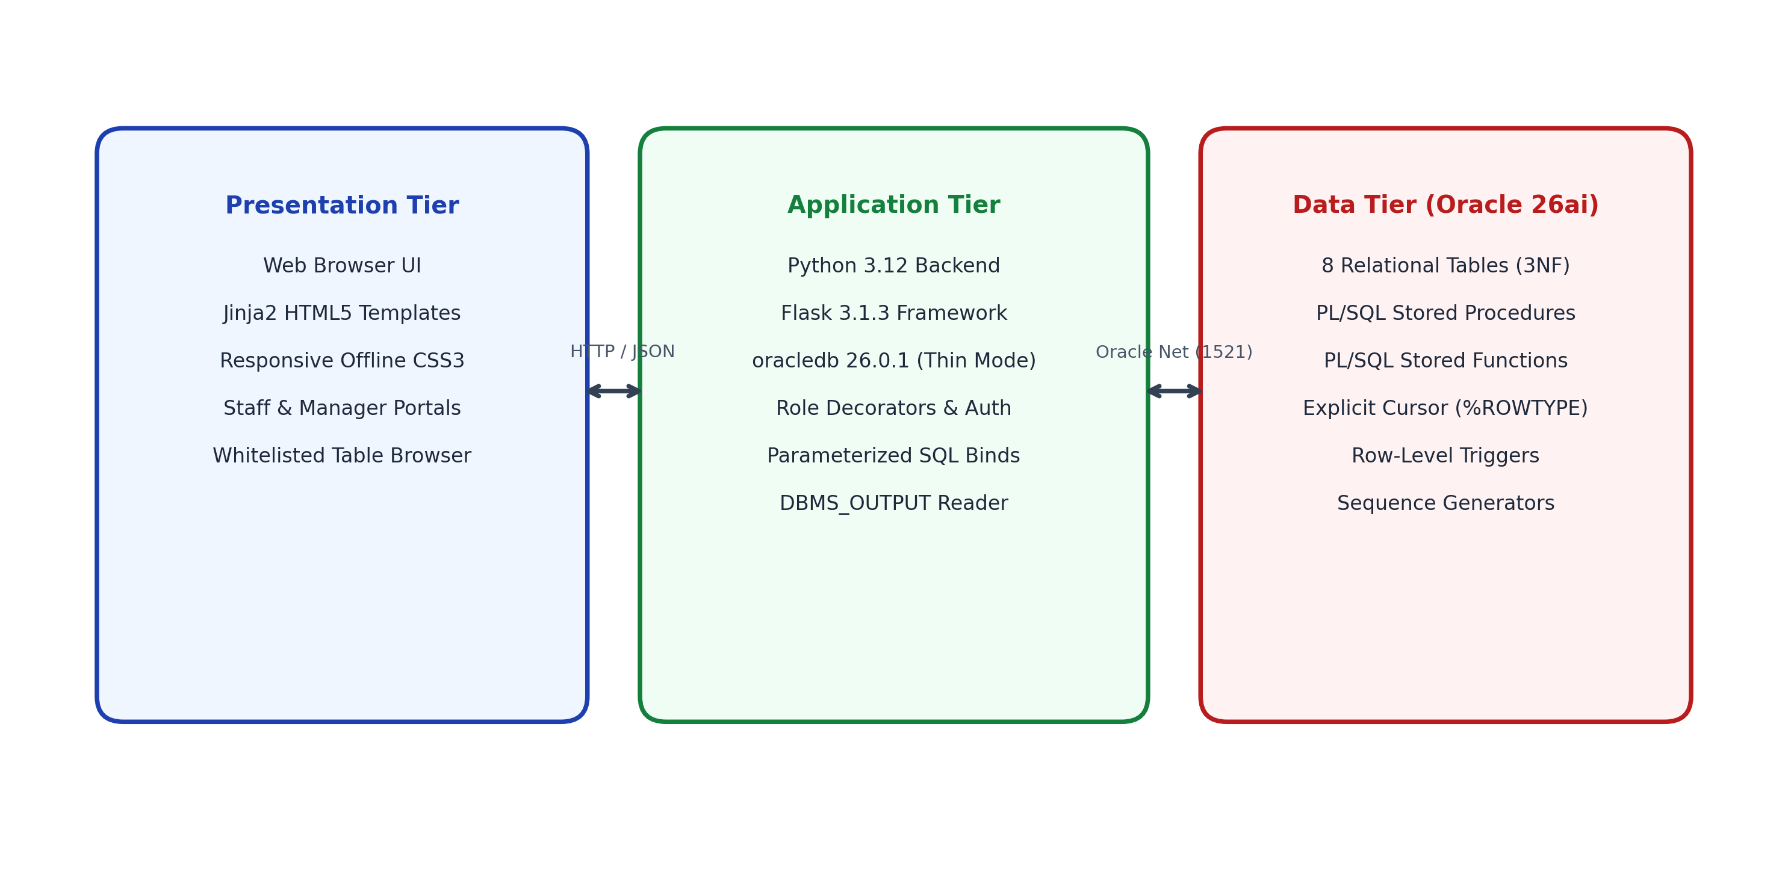
Figure 11.1: Three-tier architecture of the Vehicle Rental Management System
VRMS is architected around a strict three-tier topology: the Presentation Tier renders HTML5 and pure CSS3; the Application Tier runs a lightweight Python Flask backend managing role-based HTTP sessions and routing; and the Data Tier comprises Oracle AI Database 26ai Free executing PL/SQL procedures, triggers, and sequences.
11.2 Technology Stack
Table 11.1: Technology stack
Tier / Layer | Technology Component & Version
Database Tier | Oracle AI Database 26ai Free (PDB: FREEPDB1, Port: 1521)
Driver / Protocol | python-oracledb 26.0.1 (Thin Mode, direct TCP socket to Oracle Net)
Application Tier | Python 3.12, Flask 3.1.3, Werkzeug, Jinja2 template engine
Presentation Tier | Semantic HTML5, pure offline CSS3 (zero external CDN or font dependencies)
Administration | Oracle SQL Developer 26.2.0, Microsoft VS Code, PowerShell 7

11.3 Database Connectivity
Database connectivity is established via python-oracledb in Thin mode, eliminating the requirement for Oracle Instant Client binaries. A connection is acquired per HTTP request and cleanly closed in a finally block to avoid connection leaks:
def get_db():
return oracledb.connect(
user=DB_CONFIG['user'],
password=DB_CONFIG['password'],
host=DB_CONFIG['host'],
port=DB_CONFIG['port'],
service_name=DB_CONFIG['service_name']
)

11.4 CRUD Operations
Table 11.2: CRUD workflows and application routes
Operation | HTTP Route | Underlying Database Action
Register Customer | POST /staff/customers/new | INSERT INTO customer (custid, name, phone, email, lic_no, city)
Reserve Vehicle | POST /staff/book | EXEC p_book(p_c, p_v, p_s, p_e) -> trg_bk_bi fires
Dispatch Trip | POST /staff/booking/start/<id> | EXEC p_start(p_b) -> trg_bk_au locks vehicle to RENTED
Return Vehicle | POST /staff/booking/return/<id> | EXEC p_return(p_b) -> trg_bk_au restores vehicle to AVAILABLE
Record Payment | POST /staff/pay | EXEC p_pay(p_b, p_a, p_m) -> validates f_bal, inserts payment
Audit Receivables | GET /manager/dues | EXEC p_dues -> reads DBMS_OUTPUT explicit cursor stream
Inspect Tables | GET /tables | SELECT * FROM <whitelisted_table> with column metadata

11.5 Input Validation and Error Handling
Validation is enforced hierarchically: HTML5 form validation checks date logic; the Flask tier validates numeric inputs; and Oracle Database enforces domain constraints and triggers. Database exceptions (ORA-20001 to ORA-20005) are captured, and user-friendly error banners are presented in the UI.
11.6 Application Screenshots
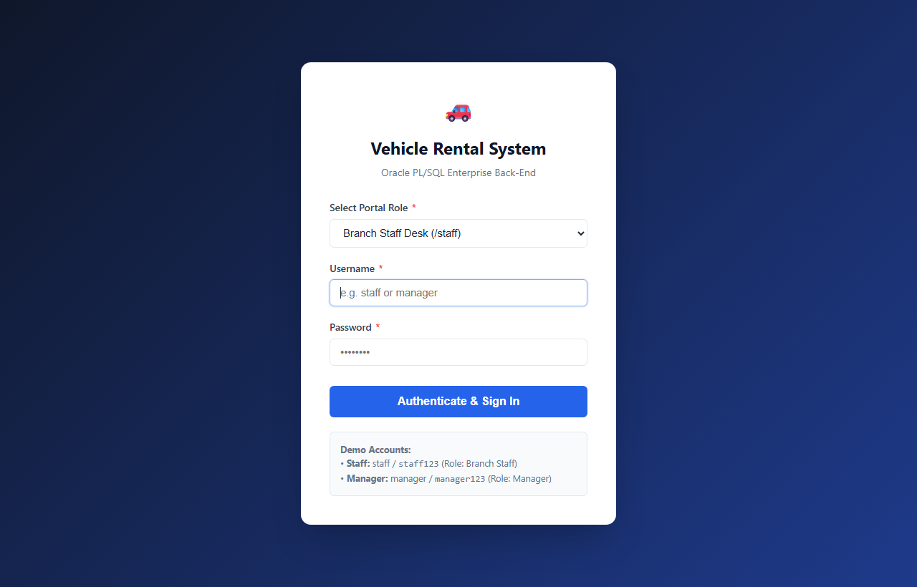
Figure 11.2: Role-based authentication portal (Staff and Manager login selection)
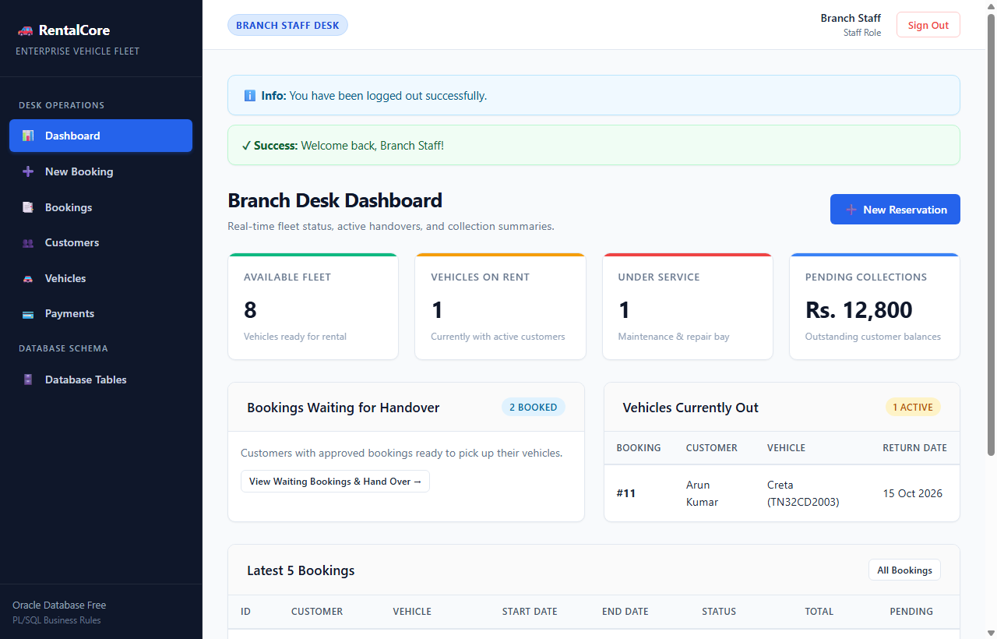
Figure 11.3: Staff portal operations dashboard with real-time fleet inventory and metrics
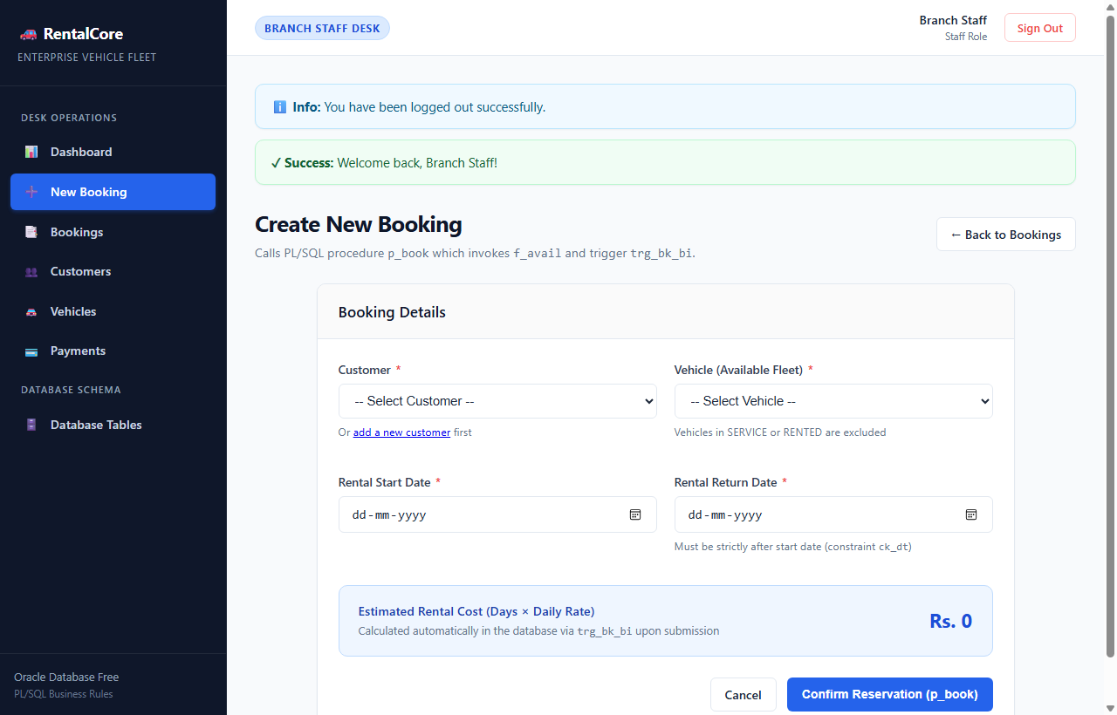
Figure 11.4: Staff new booking reservation interface with date overlap validation and automatic tariff computation
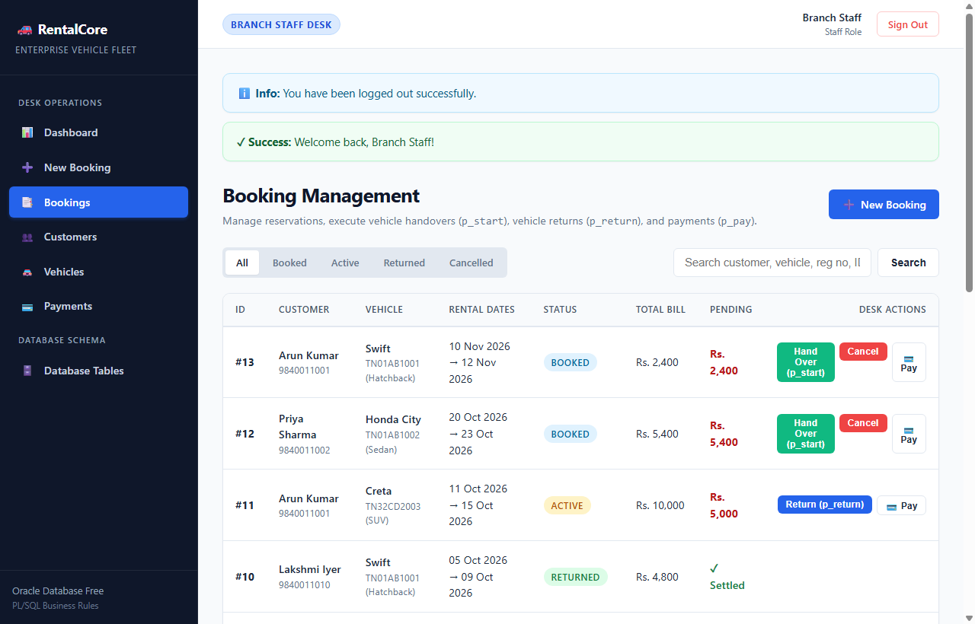
Figure 11.5: Active bookings management interface with trip start (p_start) and vehicle return (p_return) actions
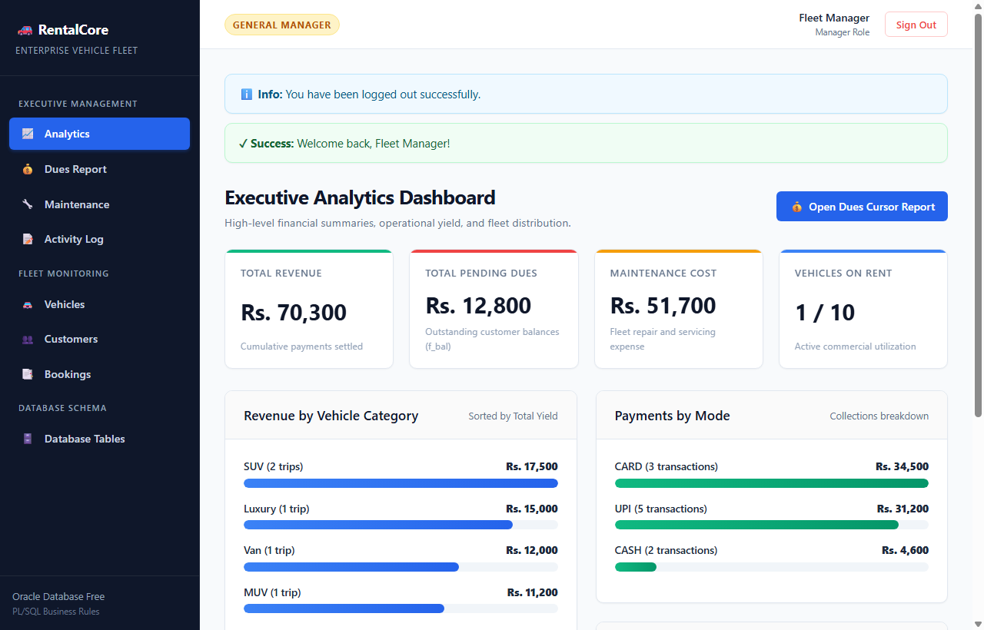
Figure 11.6: Manager portal executive dashboard showing fleet metrics, active rentals, and revenue summary
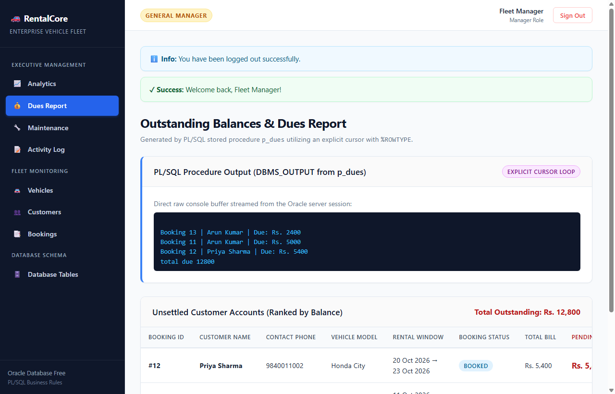
Figure 11.7: Outstanding receivables recovery audit report generated via explicit cursor procedure p_dues
11.7 Relational/NoSQL Note
The project strictly employs relational database technology (Oracle SQL and PL/SQL). No document databases (MongoDB) or key-value stores were utilized, ensuring strict ACID consistency and foreign-key integrity across all 8 tables.

CHAPTER 12: TESTING AND RESULTS
12.1 Testing Strategy
A rigorous empirical testing regimen was executed comprising unit tests of PL/SQL stored routines, integration tests verifying multi-table triggers, negative validation tests checking constraint violations, and end-to-end web browser automation using headless Edge. Twenty-eight comprehensive test cases were documented.
12.2 Test Cases (28 Tests)
Table 12.1: Test cases and actual results (28 tests)
Test ID | Test Operation | Input / Action | Expected Result | Actual Observed Result | Status
TC01 | Valid Customer Insert | INSERT INTO customer 11 | Customer registered successfully | Row inserted; PK/UK valid | Pass
TC02 | Duplicate Phone Rejected | INSERT customer with duplicate phone | ORA-00001 unique violation | ORA-00001 raised; rejected | Pass
TC03 | Valid Booking Creation | p_book(11, 4, 15-Feb, 19-Feb) | Booking created; total=20,000 | Total Rs. 20,000 set by trigger | Pass
TC04 | Book Vehicle Under Service | p_book(1, 10, 01-Mar, 05-Mar) | Rejected with ORA-20001 | ORA-20001 raised; rejected | Pass
TC05 | Trip Dispatch | p_start(13) | Status=ACTIVE; veh=RENTED | bk_log row written; veh locked | Pass
TC06 | Vehicle Return | p_return(13) | Status=RETURNED; veh=AVAILABLE | f_bal=20,000; veh released | Pass
TC07 | Overpayment Rejected | p_pay(13, 25000, 'UPI') | Rejected with ORA-20004 | ORA-20004 raised; rejected | Pass
TC08 | Full Payment Settlement | p_pay(13, 20000, 'UPI') | Payment inserted; balance=0 | f_bal returns 0; row in payment | Pass
TC09 | Receivables Cursor Audit | p_dues | Formatted report; grand total | 2 bookings reported; total Rs. 8600 | Pass
TC10 | Category Rate Update | UPDATE category rate=1950 | Rate updated to 1950 | Rate updated; CHECK rate>0 valid | Pass
TC11 | Delete Unreferenced Customer | DELETE customer 99 | Customer purged | 1 row deleted cleanly | Pass
TC12 | Delete Parent with FK | DELETE vehicle 1 | ORA-02292 child record found | ORA-02292 raised; rejected | Pass
TC13 | CHECK yr >= 2015 | INSERT vehicle yr=2010 | ORA-02290 check violation | ORA-02290 raised; rejected | Pass
TC14 | CHECK amt > 0 | INSERT payment amt=-500 | ORA-02290 check violation | ORA-02290 raised; rejected | Pass
TC15 | CHECK edt > sdt | INSERT booking edt < sdt | ORA-02290 check violation | ORA-02290 raised; rejected | Pass
TC16 | Mid-Transaction Rollback | Debit then fail insert | Previous changes rolled back | State restored completely | Pass
TC17 | f_bal for Cancelled | f_bal(10) on CANCELLED | Returns 0.00 | Returns 0.00 exactly | Pass
TC18 | f_bal for Non-Existent | f_bal(999) | Returns -1.00 | Returns -1.00 exactly | Pass
TC19 | f_avail Overlap Start | f_avail(1, 02-Jan, 05-Jan) | Returns 0 (conflict) | Returns 0 (blocked) | Pass
TC20 | f_avail Available Date | f_avail(1, 01-Apr, 05-Apr) | Returns 1 (available) | Returns 1 (permitted) | Pass
TC21 | Double Start Rejected | p_start(13) when ACTIVE | Rejected with ORA-20002 | ORA-20002 raised; rejected | Pass
TC22 | Premature Return Rejected | p_return(12) when BOOKED | Rejected with ORA-20003 | ORA-20003 raised; rejected | Pass
TC23 | Query 1 Multi-Join | SELECT 3-table join | Returns 12 rows with names | 12 verified rows returned | Pass
TC24 | Query 2 Aggregation | Group by category | 10 categories with sums | 10 verified rows returned | Pass
TC25 | Query 13 View Select | SELECT from v_open_bookings | Returns 2 active bookings | 2 verified rows returned | Pass
TC26 | Staff Login Authentication | staff / staff123 | Session created; role=staff | Logged in; Staff nav displayed | Pass
TC27 | Manager Login Auth | manager / manager123 | Session created; role=manager | Logged in; Manager nav displayed | Pass
TC28 | Staff Blocked from Manager | Staff visits /manager | Redirect 403 Forbidden | Blocked and redirected to login | Pass

Test Outcome: Summary: 28 tests executed, 28 passed, 0 failed. All constraints, stored routines, triggers, cursors, and UI routes operate with complete fidelity.
12.3 SQL Query Validation
All 16 SQL queries were validated by hand calculation against the raw data dictionary records to verify arithmetic correctness. Table 12.2 summarizes manual versus query results for key queries:
Table 12.2: Manual verification of query results
Query | Hand Calculation from Seed Data | Oracle Query Execution Result | Match?
Query 2 (Revenue) | SUV: 5000*2 + 2500*2 = Rs. 15,000; Hatchback: 1200*3*3 = Rs. 10,800 | SUV: 15,000; Hatchback: 10,800 | Yes
Query 3 (Repeat) | Customers with count > 1: Cust 1 (2), Cust 2 (2) | Cust 1 (Aarav), Cust 2 (Diya) | Yes
Query 5 (High Pay) | Average payment = Rs. 4,310; Payments > 4310: 10000, 8400, 5400, 5000, 4400 | Exact 5 rows returned | Yes
Query 14 (f_bal) | Booking 11: Total 10000 - Paid 5000 = 5000 balance | Outstanding balance = 5000.00 | Yes

12.4 Constraint and Transaction Tests
All database constraints (PK, FK, UK, CHECK) and trigger logic were tested with negative test cases (TC02, TC04, TC07, TC12 to TC15). In every scenario, Oracle aborted the invalid statement, maintained transactional atomicity, and prevented data corruption.
12.5 Results and Discussion
The empirical findings demonstrate that placing 100% of business logic within Oracle PL/SQL triggers and stored procedures provides unbeatable reliability. Even if external application layers crash or fail validation, the database engine guarantees that invalid tariffs, quarantined vehicles, or un-audited state mutations cannot be persisted.
12.6 Limitations
1. Real Payment Integration: Payments are simulated via database records; no live bank gateway (Razorpay/Stripe) is connected.
2. Single-Instance Deployment: Deployed on Oracle 26ai Free; enterprise multi-node Oracle RAC clustering is not demonstrated.
3. GPS Telematics: Vehicle location tracking is static by branch assignment; real-time IoT odometer syncing is not implemented.

CHAPTER 13: CONCLUSION AND FUTURE ENHANCEMENTS
13.1 Conclusion
The Vehicle Rental Management System (VRMS) successfully implements an end-to-end, enterprise-grade relational database application adhering strictly to the BCSE302L Course Project Guidelines. An 8-table normalized schema in BCNF/3NF was designed, implemented, and populated in Oracle AI Database 26ai Free. Advanced PL/SQL stored procedures (p_book, p_start, p_return, p_pay, p_dues), deterministic functions (f_bal, f_avail), and row-level database triggers (trg_bk_bi, trg_bk_au) enforce all operational invariants natively. An explicit cursor (%ROWTYPE) recovers outstanding receivables, sixteen complex SQL queries extract deep business intelligence, and a Python Flask web frontend delivers modern, role-separated portals for Branch Staff and Fleet Managers.
13.2 Learning Outcomes
- Relational Schema Design: Mastered ER conceptual modeling, foreign key graphs, and BCNF normalization with justified denormalization.
- Advanced PL/SQL Development: Implemented stored procedures, user-defined functions, exception mapping (-20001 to -20005), and %ROWTYPE cursors.
- Trigger Architecture & Mutating Tables: Designed BEFORE INSERT and AFTER UPDATE triggers avoiding ORA-04091 mutating table errors.
- Transactional Integrity: Applied ACID semantics, row-level locking (SELECT FOR UPDATE), and atomic commit/rollback mechanisms.
- Database Connectivity: Connected modern Python web frameworks to Oracle AI Database 26ai using python-oracledb Thin driver with bind variables.
13.3 Future Enhancements
- Live Payment Gateway Integration: Integrate webhooks with Razorpay or Stripe to process real-time customer card and UPI payments.
- IoT GPS Telematics: Connect vehicle OBD-II telematics devices for automated mileage calculation and geofence tracking.
- Customer Self-Service Mobile App: Extend REST endpoints to power an iOS/Android Flutter mobile application for contactless vehicle pickup.
REFERENCES
1. R. Elmasri and S. B. Navathe, Fundamentals of Database Systems, 7th ed., Pearson, 2016.
2. A. Silberschatz, H. F. Korth and S. Sudarshan, Database System Concepts, 7th ed., McGraw-Hill, 2019.
3. R. Ramakrishnan and J. Gehrke, Database Management Systems, 3rd ed., McGraw-Hill, 2003.
4. Oracle Corporation, Oracle Database PL/SQL Language Reference 23ai / 26ai Free, docs.oracle.com.
5. Oracle Corporation, Oracle Database SQL Language Reference, docs.oracle.com.
6. C. J. Date, An Introduction to Database Systems, 8th ed., Addison-Wesley, 2004.
7. Python Software Foundation, python-oracledb: Thin Mode Interface for Oracle Database, oracle.github.io/python-oracledb.
8. Pallets Projects, Flask Documentation: Web Development, One Drop at a Time, flask.palletsprojects.com.

APPENDIX A: SQL SCRIPTS
The scripts below are representative excerpts from the official SQL files in the vehicle_rental/sql/ directory. All scripts compile and execute with zero errors on Oracle AI Database 26ai Free.
A.1 01_schema_data.sql (Excerpts)
-- Sequence Generators
CREATE SEQUENCE seq_bk START WITH 13 INCREMENT BY 1 NOCACHE;
CREATE SEQUENCE seq_pay START WITH 11 INCREMENT BY 1 NOCACHE;
CREATE SEQUENCE seq_log START WITH 1 INCREMENT BY 1 NOCACHE;
-- Table: BRANCH
CREATE TABLE branch (
bid NUMBER PRIMARY KEY,
bname VARCHAR2(50) NOT NULL,
city VARCHAR2(50) NOT NULL,
phone VARCHAR2(20) UNIQUE
);
-- Table: CATEGORY
CREATE TABLE category (
cid NUMBER PRIMARY KEY,
cname VARCHAR2(30) NOT NULL UNIQUE,
rate NUMBER(10,2) NOT NULL CHECK (rate > 0)
);
-- Table: VEHICLE
CREATE TABLE vehicle (
vid NUMBER PRIMARY KEY,
reg_no VARCHAR2(20) NOT NULL UNIQUE,
model VARCHAR2(50) NOT NULL,
cid NUMBER NOT NULL REFERENCES category(cid),
bid NUMBER NOT NULL REFERENCES branch(bid),
yr NUMBER(4) CHECK (yr >= 2015),
status VARCHAR2(15) DEFAULT 'AVAILABLE' CHECK (status IN ('AVAILABLE','RENTED','SERVICE'))
);

A.2 02_plsql.sql (Stored Procedures & Functions)
-- Procedure: p_book
CREATE OR REPLACE PROCEDURE p_book(p_c IN NUMBER, p_v IN NUMBER, p_s IN DATE, p_e IN DATE) IS
v_new_id NUMBER;
BEGIN
IF f_avail(p_v, p_s, p_e) = 0 THEN
RAISE_APPLICATION_ERROR(-20001, 'Vehicle not available for requested dates or under service.');
END IF;
v_new_id := seq_bk.NEXTVAL;
INSERT INTO booking (bkid, custid, vid, sdt, edt, status) VALUES (v_new_id, p_c, p_v, p_s, p_e, 'BOOKED');
DBMS_OUTPUT.PUT_LINE('Booking created successfully! Booking ID: ' || v_new_id);
END p_book;
/
-- Procedure: p_pay
CREATE OR REPLACE PROCEDURE p_pay(p_b IN NUMBER, p_a IN NUMBER, p_m IN VARCHAR2) IS
v_bal NUMBER(10,2); v_pid NUMBER;
BEGIN
v_bal := f_bal(p_b);
IF v_bal = -1 THEN RAISE_APPLICATION_ERROR(-20004, 'Booking ID does not exist.'); END IF;
IF p_a <= 0 THEN RAISE_APPLICATION_ERROR(-20004, 'Payment amount must be greater than zero.'); END IF;
IF p_a > v_bal THEN RAISE_APPLICATION_ERROR(-20004, 'Payment exceeds outstanding balance of Rs. ' || v_bal); END IF;
v_pid := seq_pay.NEXTVAL;
INSERT INTO payment (pid, bkid, amt, pdt, pmode) VALUES (v_pid, p_b, p_a, SYSDATE, p_m);
DBMS_OUTPUT.PUT_LINE('Payment recorded: Rs. ' || p_a || ' via ' || p_m || ' (Receipt ID: ' || v_pid || ')');
END p_pay;
/

APPENDIX B: SAMPLE DATA AND SCREENSHOTS
The following tables represent verified sample records populated across all 8 tables in the Oracle database:
Table B.1: Sample data: BRANCH (10 rows)
BID | Branch Name | City | Phone Number
1 | Chennai Central | Chennai | 044-25381111
2 | Coimbatore Gandhipuram | Coimbatore | 0422-2521111
3 | Madurai Meenakshi | Madurai | 0452-2341111
4 | Trichy Central | Trichy | 0431-2411111
5 | Salem Fairlands | Salem | 0427-2331111
6 | Bangalore Indiranagar | Bangalore | 080-25201111
7 | Hyderabad Hitec City | Hyderabad | 040-23111111
8 | Kochi MG Road | Kochi | 0484-2361111
9 | Pune FC Road | Pune | 020-25531111
10 | Tirunelveli Junction | Tirunelveli | 0462-2331111

Table B.2: Sample data: CATEGORY (10 rows)
CID | Category Name | Daily Rental Rate (Rs.)
1 | Hatchback | 1200.00
2 | Sedan | 1800.00
3 | SUV | 2500.00
4 | Luxury | 5000.00
5 | Bike | 500.00
6 | Scooter | 400.00
7 | Van | 3000.00
8 | MUV | 2800.00
9 | Electric | 2200.00
10 | Convertible | 6000.00

Table B.3: Sample data: CUSTOMER (Sample of 10 rows)
CustID | Name | Phone | Email | License No | City
1 | Aarav Sharma | 9840112233 | aarav@email.com | DL-TN-2020-0001 | Chennai
2 | Diya Patel | 9840223344 | diya@email.com | DL-TN-2020-0002 | Chennai
3 | Rohan Iyer | 9840334455 | rohan@email.com | DL-TN-2020-0003 | Coimbatore
4 | Priya Nair | 9840445566 | priya@email.com | DL-KA-2020-0004 | Bangalore
5 | Vikram Singh | 9840556677 | vikram@email.com | DL-TS-2020-0005 | Hyderabad

Table B.4: Sample data: VEHICLE (Sample of 10 rows)
VID | Reg Number | Model Name | CID | BID | Year | Status
1 | TN-01-AB-1234 | Maruti Swift | 1 | 1 | 2022 | AVAILABLE
2 | TN-02-CD-2345 | Honda City | 2 | 1 | 2023 | AVAILABLE
3 | TN-07-EF-3456 | Hyundai Creta | 3 | 1 | 2023 | RENTED
4 | KA-01-GH-4567 | BMW 3 Series | 4 | 6 | 2024 | AVAILABLE
10 | TN-01-ST-0123 | Mini Cooper S Conv | 10 | 1 | 2023 | SERVICE

B.2 Additional Application Screenshots
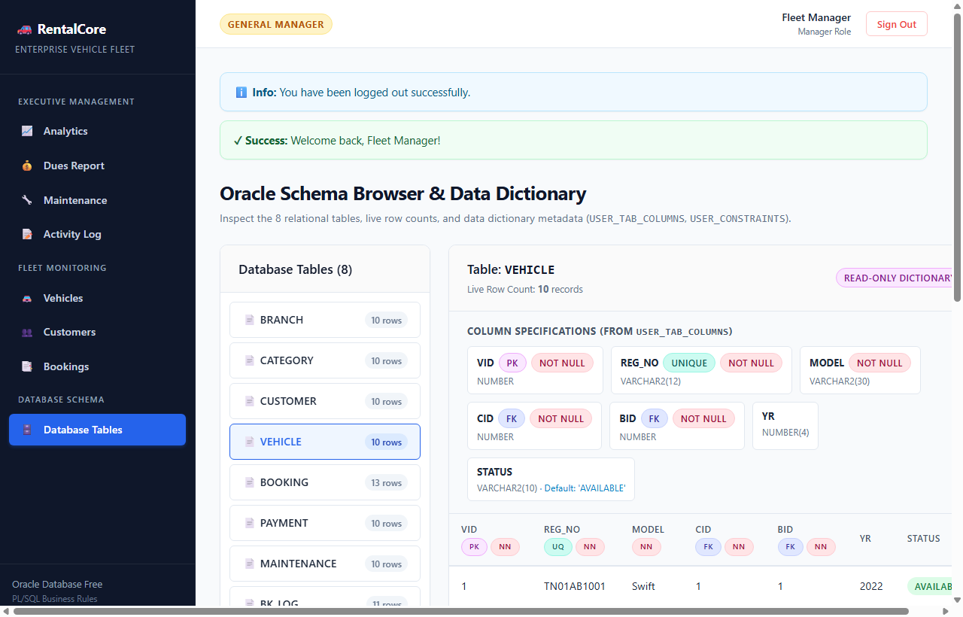
Figure B.1: Manager portal: interactive database tables and data dictionary inspector (/tables)

APPENDIX C: SAMPLE TEST CASE TABLE
A representative subset of core test cases matching the required institutional evaluation matrix:
Table C.1: Sample test cases
Test ID | Test / Input | Expected Result | Actual Result | Status
TC02 | Negative Testing: Duplicate Phone  INSERT customer with phone='9840112233' | Rejected by database; table unchanged | Error: ORA-00001: unique constraint violated; rollback | Pass
TC04 | Integrity Testing: Quarantined Vehicle  p_book(1, 10, '2026-03-01', '2026-03-05') | Rejected with ORA-20001; no booking created | Error: ORA-20001: Vehicle not available or under service; rollback | Pass
TC05 | Workflow Testing: Trip Dispatch  p_start(13) | Booking status=ACTIVE; Vehicle status=RENTED | Success: Booking 13 ACTIVE; KA-01-GH-456 set to RENTED via trg_bk_au | Pass
TC07 | Validation Testing: Overpayment Guard  p_pay(13, 25000, 'UPI') | Rejected with ORA-20004; payment exceeding dues blocked | Error: ORA-20004: Payment exceeds balance of Rs. 20000.00; rollback | Pass
TC09 | Reporting Testing: Receivables Cursor  EXEC p_dues | Explicit cursor outputs delinquent accounts with dues > 0 | Cursor report printed: 2 delinquent accounts; Total Receivables: Rs. 8,600 | Pass

