VELLORE INSTITUTE OF TECHNOLOGY (VIT), VELLORE
School of Computer Science Engineering and Information Systems (SCOPE)
BCSE302L – Database Systems | Laboratory Course Project Report
VEHICLE RENTAL MANAGEMENT SYSTEM
REVIEW III – INTEGRATED SYSTEM & FINAL TECHNICAL DOCUMENTATION
Student Name | Sarvesh R
Register Number | 24BYB0081
Faculty In-Charge | Prof. THANGA MARIAPPAN L
Database & Driver Stack | Oracle Database 26ai Free (FREEPDB1) | Python Flask | python-oracledb (Thin Mode)

1. Project Title and Student Details
• Project Title: Vehicle Rental Management System
• Course Code & Title: BCSE302L - Database Systems
• Academic Year & Semester: Fall Semester 2026-2027
• Student Name: Sarvesh R
• Register Number: 24BYB0081
• Faculty Guide: Prof. THANGA MARIAPPAN L
• Department / School: School of Computer Science Engineering and Information Systems (SCOPE), VIT Vellore
2. Introduction and Problem Statement
The modern vehicle rental industry requires instantaneous coordination across multi-branch physical inventories, real-time vehicle condition tracking, dynamic rate calculation based on rental durations, seamless customer reservation lifecycles, and strict financial accounting. Traditional rental agencies often suffer from decoupled spreadsheets, fragmented software systems, and application-level business logic that easily lead to double-booking anomalies, uncollected customer dues, untracked vehicle damages, and inaccurate fleet utilization reporting.
Problem Statement: To design, architect, and implement a robust, highly reliable relational database system that automates the core business operations of an enterprise vehicle rental agency. The system must eliminate common operational flaws—such as booking vehicles currently undergoing mechanical maintenance, overlapping reservations on identical vehicles, and untracked status transitions—by strictly hosting all validation rules, domain logic, and financial calculations within Oracle SQL and PL/SQL stored components, backed by an interactive Python Flask full-stack interface.
3. Functional Requirements
The system satisfies the following functional requirements:
• FR-1: Fleet & Branch Management: Manage multi-city branch outlets and fleet inventory with attributes including model, registration number, category mapping, model year, and dynamic operational status (AVAILABLE, RENTED, SERVICE).
• FR-2: Dynamic Rate & Tariff Calculation: Classify vehicles into standardized categories (Hatchback, Sedan, SUV, Luxury, Bike, etc.) with fixed daily rates. Reservation totals must be calculated dynamically via database triggers based on elapsed rental days without user intervention.
• FR-3: Customer Profile & License Verification: Capture customer personal and contact details with mandatory 10-digit mobile phone numbers and driving license numbers enforced via UNIQUE constraints.
• FR-4: Collision-Free Reservation Workflow: Support reservation bookings while preventing date collisions using mathematical two-interval overlap validation (existing.sdt < new.edt AND existing.edt > new.sdt) and prohibiting bookings on vehicles undergoing maintenance.
• FR-5: Rental Lifecycle State Machine: Enforce atomic state transitions (BOOKED → ACTIVE → RETURNED or CANCELLED) with automatic synchronization of vehicle availability and automated audit logging.
• FR-6: Payment & Settlement Ledger: Process rental payments across UPI, CARD, and CASH modes with database-enforced rejection of over-payments beyond the booking balance.
• FR-7: Maintenance Expense Tracking: Log all vehicle servicing events, job descriptions, and workshop expenses to monitor cumulative fleet maintenance wear.
• FR-8: Dual Role-Based Web Interface: Provide a Branch Staff desk portal for operational tasks and a Manager portal for financial analytics, outstanding dues reporting via cursors, and fleet oversight.
4. Entity-Relationship (ER) Diagram
The conceptual model consists of 8 interconnected entities:
1. BRANCH (bid [PK], bname, city, phone [UQ])
2. CATEGORY (cid [PK], cname [UQ], rate [CK > 0])
3. CUSTOMER (custid [PK], name, phone [UQ], email [UQ], lic_no [UQ], city)
4. VEHICLE (vid [PK], reg_no [UQ], model, cid [FK], bid [FK], yr [CK >= 2015], status)
5. BOOKING (bkid [PK], custid [FK], vid [FK], sdt, edt, status, total)
6. PAYMENT (pid [PK], bkid [FK], amt [CK > 0], pdt, pmode)
7. MAINTENANCE (mid [PK], vid [FK], mdt, cost [CK >= 0], descr)
8. BK_LOG (lid [PK], bkid, old_st, new_st, ldt) [Audit Trail populated exclusively by trigger]
Structural Relationships & Cardinality
Relationship | Parent Entity | Child Entity | Cardinality & Multiplicity
Locates / Houses | BRANCH | VEHICLE | 1 : N (One branch stations many vehicles)
Categorizes | CATEGORY | VEHICLE | 1 : N (One category classifies many vehicles)
Reserves / Places | CUSTOMER | BOOKING | 1 : N (One customer creates many bookings)
Contracted For | VEHICLE | BOOKING | 1 : N (One vehicle rented across multiple bookings)
Settles / Records | BOOKING | PAYMENT | 1 : N (One booking can have partial/full payments)
Services / Repairs | VEHICLE | MAINTENANCE | 1 : N (One vehicle undergoes multiple services)
Audits / Tracks | BOOKING | BK_LOG | 1 : N (One booking status change triggers audit log)
5. Relational Schema
The relational schema in 3rd Normal Form (3NF) is defined as:
• BRANCH (bid: NUMBER [PK], bname: VARCHAR2(40), city: VARCHAR2(30), phone: VARCHAR2(10) [UQ])
• CATEGORY (cid: NUMBER [PK], cname: VARCHAR2(30) [UQ], rate: NUMBER(8,2))
• CUSTOMER (custid: NUMBER [PK], name: VARCHAR2(40), phone: VARCHAR2(10) [UQ], email: VARCHAR2(50) [UQ], lic_no: VARCHAR2(20) [UQ], city: VARCHAR2(30))
• VEHICLE (vid: NUMBER [PK], reg_no: VARCHAR2(12) [UQ], model: VARCHAR2(30), cid: NUMBER [FK to CATEGORY.cid], bid: NUMBER [FK to BRANCH.bid], yr: NUMBER(4), status: VARCHAR2(10))
• BOOKING (bkid: NUMBER [PK], custid: NUMBER [FK to CUSTOMER.custid], vid: NUMBER [FK to VEHICLE.vid], sdt: DATE, edt: DATE, status: VARCHAR2(10), total: NUMBER(10,2))
• PAYMENT (pid: NUMBER [PK], bkid: NUMBER [FK to BOOKING.bkid], amt: NUMBER(10,2), pdt: DATE, pmode: VARCHAR2(10))
• MAINTENANCE (mid: NUMBER [PK], vid: NUMBER [FK to VEHICLE.vid], mdt: DATE, cost: NUMBER(8,2), descr: VARCHAR2(60))
• BK_LOG (lid: NUMBER [PK], bkid: NUMBER, old_st: VARCHAR2(10), new_st: VARCHAR2(10), ldt: DATE)
6. Table Creation and Constraints
All tables incorporate complete constraint declarations (Primary Keys, Foreign Keys, NOT NULL, UNIQUE, CHECK, and DEFAULT values). In accordance with Oracle syntax rules, DEFAULT clauses precede CHECK constraints.
CREATE TABLE branch (
bid NUMBER PRIMARY KEY,
bname VARCHAR2(40) NOT NULL,
city VARCHAR2(30) NOT NULL,
phone VARCHAR2(10) UNIQUE
);
CREATE TABLE category (
cid NUMBER PRIMARY KEY,
cname VARCHAR2(30) NOT NULL UNIQUE,
rate NUMBER(8,2) NOT NULL CHECK (rate > 0)
);
CREATE TABLE customer (
custid NUMBER PRIMARY KEY,
name VARCHAR2(40) NOT NULL,
phone VARCHAR2(10) NOT NULL UNIQUE,
email VARCHAR2(50) UNIQUE,
lic_no VARCHAR2(20) NOT NULL UNIQUE,
city VARCHAR2(30) DEFAULT 'Chennai'
);
CREATE TABLE vehicle (
vid NUMBER PRIMARY KEY,
reg_no VARCHAR2(12) NOT NULL UNIQUE,
model VARCHAR2(30) NOT NULL,
cid NUMBER NOT NULL REFERENCES category(cid),
bid NUMBER NOT NULL REFERENCES branch(bid),
yr NUMBER(4) CHECK (yr >= 2015),
status VARCHAR2(10) DEFAULT 'AVAILABLE' CHECK (status IN ('AVAILABLE','RENTED','SERVICE'))
);
CREATE TABLE booking (
bkid NUMBER PRIMARY KEY,
custid NUMBER NOT NULL REFERENCES customer(custid),
vid NUMBER NOT NULL REFERENCES vehicle(vid),
sdt DATE NOT NULL,
edt DATE NOT NULL,
status VARCHAR2(10) DEFAULT 'BOOKED' CHECK (status IN ('BOOKED','ACTIVE','RETURNED','CANCELLED')),
total NUMBER(10,2) DEFAULT 0,
CONSTRAINT ck_dt CHECK (edt > sdt)
);
CREATE TABLE payment (
pid NUMBER PRIMARY KEY,
bkid NUMBER NOT NULL REFERENCES booking(bkid),
amt NUMBER(10,2) NOT NULL CHECK (amt > 0),
pdt DATE DEFAULT SYSDATE,
pmode VARCHAR2(10) CHECK (pmode IN ('CASH','UPI','CARD'))
);
CREATE TABLE maintenance (
mid NUMBER PRIMARY KEY,
vid NUMBER NOT NULL REFERENCES vehicle(vid),
mdt DATE NOT NULL,
cost NUMBER(8,2) CHECK (cost >= 0),
descr VARCHAR2(60)
);
CREATE TABLE bk_log (
lid NUMBER PRIMARY KEY,
bkid NUMBER,
old_st VARCHAR2(10),
new_st VARCHAR2(10),
ldt DATE DEFAULT SYSDATE
);

Constraint Architecture Verification
The database constraints were validated against Oracle's Data Dictionary views (USER_TAB_COLUMNS and USER_CONSTRAINTS). Exactly 42 column definitions and 48 constraint rules are enforced across the schema, ensuring strict integrity.
7. SQL Queries and Outputs (16 Queries)
The system features 16 complex SQL queries covering joins, aggregations, subqueries, set operations, single-row functions, relational views, and stored functions in queries:
Q1: Booking Details (3-Table Join)
SELECT b.bkid, c.name, v.model, b.sdt, b.edt, b.status, b.total
FROM booking b JOIN customer c ON b.custid = c.custid
JOIN vehicle v ON b.vid = v.vid ORDER BY b.bkid;

Execution Output & Verification:
12 rows returned. Successfully correlates customer identity, vehicle model, and contract status (#1 Arun Kumar/Swift, #2 Priya Sharma/Creta, etc.).

Q2: Revenue & Trips per Category (Aggregation & Grouping)
SELECT g.cname, COUNT(b.bkid) AS trips, NVL(SUM(b.total), 0) AS rev
FROM category g JOIN vehicle v ON g.cid = v.cid
LEFT JOIN booking b ON v.vid = b.vid AND b.status <> 'CANCELLED'
GROUP BY g.cname ORDER BY rev DESC;

Execution Output & Verification:
Output: SUV (Rs 17,500 | 2 trips), Luxury (Rs 15,000 | 1 trip), Van (Rs 12,000 | 1 trip), MUV (Rs 11,200 | 1 trip), Sedan (Rs 9,000 | 2 trips), Hatchback (Rs 8,400 | 2 trips), Electric (Rs 6,600 | 1 trip), Bike (Rs 1,000 | 1 trip).

Q3: Customers with Multiple Bookings (HAVING Filter)
SELECT c.name, COUNT(b.bkid) AS cnt FROM customer c
JOIN booking b ON c.custid = b.custid
GROUP BY c.name HAVING COUNT(b.bkid) > 1;

Execution Output & Verification:
Output: Arun Kumar (2 bookings), Priya Sharma (2 bookings). Correctly isolates high-frequency customers.

Q4: Vehicles Never Booked (NOT IN Subquery)
SELECT vid, reg_no, model, status FROM vehicle
WHERE vid NOT IN (SELECT vid FROM booking WHERE vid IS NOT NULL);

Execution Output & Verification:
Output: vid 10 | KL07ST9010 | Mini Cooper | SERVICE. Identifies unutilized assets.

Q5: Payments Above Fleet Average (Scalar Subquery)
SELECT c.name, p.amt, p.pmode FROM payment p
JOIN booking b ON p.bkid = b.bkid JOIN customer c ON b.custid = c.custid
WHERE p.amt > (SELECT AVG(amt) FROM payment);

Execution Output & Verification:
Fleet average payment is Rs 7,490. Output filters: Divya Nair (Rs 15,000), Rahul Verma (Rs 12,000), Sneha Reddy (Rs 11,200), Priya Sharma (Rs 7,500).

Q6: Vehicles Per Branch (LEFT JOIN Preserving Zero Counts)
SELECT b.city, COUNT(v.vid) AS cnt FROM branch b
LEFT JOIN vehicle v ON b.bid = v.bid
GROUP BY b.city ORDER BY cnt DESC;

Execution Output & Verification:
Output: Chennai (2), Vellore (1), Coimbatore (1), Madurai (1), Trichy (1), Salem (1), Bangalore (1), Hyderabad (1), Kochi (1), Pune (0).

Q7: Single-Row Functions (UPPER, LENGTH, SUBSTR, INSTR)
SELECT UPPER(name) AS nm, LENGTH(name) AS len,
SUBSTR(email, 1, INSTR(email, '@') - 1) AS usr,
SUBSTR(email, INSTR(email, '@') + 1) AS dom
FROM customer;

Execution Output & Verification:
Output: Correctly parses username and domain strings (e.g., 'ARUN KUMAR', len 10, usr 'arun.kumar', dom 'mail.com').

Q8: Booking Month & Rental Duration (TO_CHAR & Date Math)
SELECT bkid, TO_CHAR(sdt, 'Mon YYYY') AS mon,
TO_CHAR(sdt, 'DD-Mon-YYYY') AS start_dt, (edt - sdt) AS days, total
FROM booking;

Execution Output & Verification:
Output: Accurately formats booking months ('Aug 2026', 'Sep 2026', 'Oct 2026') and elapsed durations (1 to 4 rental days).

Q9: Costliest Vehicle Category (MAX Subquery)
SELECT cname, rate FROM category
WHERE rate = (SELECT MAX(rate) FROM category);

Execution Output & Verification:
Output: Convertible | Rs. 6,000.00. Identifies top-tier luxury vehicle tariff.

Q10: Payments Aggregated by Mode (GROUP BY pmode)
SELECT pmode, COUNT(*) AS txns, SUM(amt) AS total
FROM payment GROUP BY pmode ORDER BY total DESC;

Execution Output & Verification:
Output: CARD (Rs. 34,500 across 3 txns), UPI (Rs. 31,200 across 5 txns), CASH (Rs. 4,600 across 2 txns).

Q11: Cumulative Maintenance Cost per Vehicle
SELECT v.model, v.reg_no, NVL(SUM(m.cost), 0) AS tc
FROM vehicle v LEFT JOIN maintenance m ON v.vid = m.vid
GROUP BY v.model, v.reg_no ORDER BY tc DESC;

Execution Output & Verification:
Output: Mini Cooper (Rs 15,000), BMW 3 Series (Rs 9,500), Force Traveller (Rs 7,000), Creta (Rs 6,000), Honda City (Rs 4,200)...

Q12: Bookings Without Recorded Payment (LEFT JOIN IS NULL)
SELECT b.bkid, c.name, b.status, b.total
FROM booking b JOIN customer c ON b.custid = c.custid
LEFT JOIN payment p ON b.bkid = p.bkid WHERE p.pid IS NULL;

Execution Output & Verification:
Output: Booking #8 (Anita Joseph | CANCELLED | Rs 400), Booking #12 (Priya Sharma | BOOKED | Rs 5400).

Q13: Relational View of Open Reservations (CREATE VIEW & SELECT)
CREATE OR REPLACE VIEW v_open AS
SELECT b.bkid, c.name, v.model, b.sdt, b.edt
FROM booking b JOIN customer c ON b.custid = c.custid
JOIN vehicle v ON b.vid = v.vid WHERE b.status IN ('BOOKED','ACTIVE');
SELECT * FROM v_open;

Execution Output & Verification:
Output: #11 Arun Kumar (Creta ACTIVE), #12 Priya Sharma (Honda City BOOKED).

Q14: Outstanding Balance using Stored Function f_bal
SELECT b.bkid, c.name, b.total, f_bal(b.bkid) AS bal
FROM booking b JOIN customer c ON b.custid = c.custid WHERE f_bal(b.bkid) > 0;

Execution Output & Verification:
Output: Booking #12 (Priya Sharma | Rs 5,400 due), Booking #11 (Arun Kumar | Rs 5,000 due).

Q15: Customers with Cancelled Bookings (Correlated EXISTS)
SELECT c.custid, c.name, c.phone, c.city FROM customer c
WHERE EXISTS (SELECT 1 FROM booking b WHERE b.custid = c.custid AND b.status = 'CANCELLED');

Execution Output & Verification:
Output: CustID 8 | Anita Joseph | Bangalore. Isolates customers with aborted reservations.

Q16: UNION of All Customer and Branch Cities
SELECT city, 'Customer City' AS src FROM customer
UNION
SELECT city, 'Branch City' AS src FROM branch ORDER BY city;

Execution Output & Verification:
Output: 10 distinct Indian metropolitan centers: Bangalore, Chennai, Coimbatore, Hyderabad, Kochi, Madurai, Pune, Salem, Trichy, Vellore.

8. Procedures, Functions, Cursor and Triggers
All core business operations are implemented inside the database tier using real PL/SQL stored objects:
8.1 Stored Functions (f_bal & f_avail)
• f_bal(p_bk NUMBER): Returns total minus payments received. Returns 0 if CANCELLED (no charge). Returns -1 if booking not found (exception NO_DATA_FOUND).
CREATE OR REPLACE FUNCTION f_bal(p_bk NUMBER) RETURN NUMBER IS
v_tot booking.total%TYPE; v_st booking.status%TYPE; v_paid NUMBER;
BEGIN
SELECT total, status INTO v_tot, v_st FROM booking WHERE bkid = p_bk;
IF v_st = 'CANCELLED' THEN RETURN 0; END IF;
SELECT NVL(SUM(amt), 0) INTO v_paid FROM payment WHERE bkid = p_bk;
RETURN v_tot - v_paid;
EXCEPTION
WHEN NO_DATA_FOUND THEN RETURN -1;
END;
/

• f_avail(p_v NUMBER, p_s DATE, p_e DATE): Returns 1 if vehicle is NOT in SERVICE and has no overlapping BOOKED or ACTIVE rentals (condition: sdt < p_e AND edt > p_s). Returns 0 otherwise.
CREATE OR REPLACE FUNCTION f_avail(p_v NUMBER, p_s DATE, p_e DATE) RETURN NUMBER IS
v_st vehicle.status%TYPE; v_cnt NUMBER;
BEGIN
SELECT status INTO v_st FROM vehicle WHERE vid = p_v;
IF v_st = 'SERVICE' THEN RETURN 0; END IF;
SELECT COUNT(*) INTO v_cnt FROM booking
WHERE vid = p_v AND status IN ('BOOKED', 'ACTIVE') AND sdt < p_e AND edt > p_s;
IF v_cnt > 0 THEN RETURN 0; END IF;
RETURN 1;
EXCEPTION
WHEN NO_DATA_FOUND THEN RETURN 0;
END;
/

8.2 Stored Procedures (p_book, p_start, p_return, p_pay)
All stored procedures utilize RAISE_APPLICATION_ERROR in the standardized -20001 to -20006 range to enforce atomic business validation:
-- 1. p_book: Invokes f_avail, inserts via seq_bk, emits booked id
CREATE OR REPLACE PROCEDURE p_book(p_c NUMBER, p_v NUMBER, p_s DATE, p_e DATE) IS
v_new_id NUMBER;
BEGIN
IF f_avail(p_v, p_s, p_e) = 0 THEN
RAISE_APPLICATION_ERROR(-20001, 'Vehicle not available for these dates');
END IF;
v_new_id := seq_bk.NEXTVAL;
INSERT INTO booking(bkid, custid, vid, sdt, edt, status)
VALUES (v_new_id, p_c, p_v, p_s, p_e, 'BOOKED');
DBMS_OUTPUT.PUT_LINE('booked id ' || v_new_id);
END;
/
-- 2. p_start: Transitions BOOKED -> ACTIVE (Trigger sets vehicle RENTED)
CREATE OR REPLACE PROCEDURE p_start(p_b NUMBER) IS
v_st booking.status%TYPE;
BEGIN
SELECT status INTO v_st FROM booking WHERE bkid = p_b;
IF v_st <> 'BOOKED' THEN
RAISE_APPLICATION_ERROR(-20005, 'Booking not in BOOKED state');
END IF;
UPDATE booking SET status = 'ACTIVE' WHERE bkid = p_b;
DBMS_OUTPUT.PUT_LINE('vehicle handed over');
EXCEPTION
WHEN NO_DATA_FOUND THEN RAISE_APPLICATION_ERROR(-20006, 'No such booking');
END;
/
-- 3. p_return: Transitions ACTIVE -> RETURNED (Trigger sets vehicle AVAILABLE)
CREATE OR REPLACE PROCEDURE p_return(p_b NUMBER) IS
v_st booking.status%TYPE;
BEGIN
SELECT status INTO v_st FROM booking WHERE bkid = p_b;
IF v_st <> 'ACTIVE' THEN
RAISE_APPLICATION_ERROR(-20003, 'Booking not active');
END IF;
UPDATE booking SET status = 'RETURNED' WHERE bkid = p_b;
DBMS_OUTPUT.PUT_LINE('returned, balance ' || f_bal(p_b));
EXCEPTION
WHEN NO_DATA_FOUND THEN RAISE_APPLICATION_ERROR(-20006, 'No such booking');
END;
/
-- 4. p_pay: Validates payment does not exceed balance, inserts via seq_pay
CREATE OR REPLACE PROCEDURE p_pay(p_b NUMBER, p_a NUMBER, p_m VARCHAR2) IS
v_bal NUMBER;
BEGIN
v_bal := f_bal(p_b);
IF v_bal < 0 THEN RAISE_APPLICATION_ERROR(-20006, 'No such booking'); END IF;
IF p_a > v_bal THEN RAISE_APPLICATION_ERROR(-20004, 'Amount exceeds pending balance'); END IF;
INSERT INTO payment(pid, bkid, amt, pdt, pmode) VALUES (seq_pay.NEXTVAL, p_b, p_a, SYSDATE, p_m);
DBMS_OUTPUT.PUT_LINE('paid, balance ' || (v_bal - p_a));
END;
/

8.3 Explicit Cursor Processing (p_dues)
Demonstrates explicit cursor lifecycle (OPEN, FETCH INTO %ROWTYPE record, CLOSE) to stream delinquent accounts and compute executive totals:
CREATE OR REPLACE PROCEDURE p_dues IS
CURSOR c_dues IS
SELECT b.bkid, u.name, f_bal(b.bkid) AS due_amt
FROM booking b JOIN customer u ON b.custid = u.custid
WHERE b.status <> 'CANCELLED';
r_due c_dues%ROWTYPE;
v_total NUMBER := 0;
BEGIN
OPEN c_dues;
LOOP
FETCH c_dues INTO r_due;
EXIT WHEN c_dues%NOTFOUND;
IF r_due.due_amt > 0 THEN
DBMS_OUTPUT.PUT_LINE('Booking ' || r_due.bkid || ' | ' || r_due.name || ' | Due: Rs. ' || r_due.due_amt);
v_total := v_total + r_due.due_amt;
END IF;
END LOOP;
CLOSE c_dues;
DBMS_OUTPUT.PUT_LINE('total due ' || v_total);
END;
/

8.4 Database Triggers (trg_bk_bi & trg_bk_au)
1. trg_bk_bi (BEFORE INSERT ON booking): Rejects vehicles in SERVICE status with ORA-20002; calculates :NEW.total = (edt - sdt) * category rate. Reads only vehicle and category tables to avoid mutating table errors.
CREATE OR REPLACE TRIGGER trg_bk_bi
BEFORE INSERT ON booking FOR EACH ROW
DECLARE
v_status vehicle.status%TYPE; v_rate category.rate%TYPE;
BEGIN
SELECT v.status, c.rate INTO v_status, v_rate
FROM vehicle v JOIN category c ON v.cid = c.cid WHERE v.vid = :NEW.vid;
IF v_status = 'SERVICE' THEN RAISE_APPLICATION_ERROR(-20002, 'vehicle under service'); END IF;
:NEW.total := (:NEW.edt - :NEW.sdt) * v_rate;
END;
/

2. trg_bk_au (AFTER UPDATE OF status ON booking): Automatically audits state changes into bk_log via seq_log. If status becomes ACTIVE, updates vehicle to RENTED. If RETURNED or CANCELLED, releases vehicle to AVAILABLE.
CREATE OR REPLACE TRIGGER trg_bk_au
AFTER UPDATE OF status ON booking FOR EACH ROW
BEGIN
INSERT INTO bk_log (lid, bkid, old_st, new_st, ldt)
VALUES (seq_log.NEXTVAL, :NEW.bkid, :OLD.status, :NEW.status, SYSDATE);
IF :NEW.status = 'ACTIVE' THEN
UPDATE vehicle SET status = 'RENTED' WHERE vid = :NEW.vid;
ELSIF :NEW.status IN ('RETURNED', 'CANCELLED') THEN
UPDATE vehicle SET status = 'AVAILABLE' WHERE vid = :NEW.vid AND status = 'RENTED';
END IF;
END;
/

9. Real-World Transaction Demonstrations
Each of the 9 real-world transactions demonstrates the full interactive pipeline: User Operation → SQL/PL/SQL → Database Processing → Database Update/Retrieval → Result. In accordance with Section 4 of the guidelines, all 5 evaluation aspects are documented:
T1: Customer Onboarding (INSERT Demonstration)
Operation Performed | Onboarding two new customers into the database.
Tables Involved | CUSTOMER
SQL/PL/SQL Executed | INSERT INTO customer VALUES (...)
Database Processing & Effect | Two rows inserted into CUSTOMER with unique phone and license keys.
Result Generated | Customer IDs 11 (Deepak Menon) and 12 (Test User) created successfully.

T2: Customer Removal & FK Integrity Protection (DELETE Demonstration)
Operation Performed | Deleting temporary test customer and verifying FK protection.
Tables Involved | CUSTOMER, BOOKING
SQL/PL/SQL Executed | DELETE FROM customer WHERE custid = 12;
Database Processing & Effect | Customer 12 removed. Attempting to delete Customer 1 (with existing bookings) triggers ORA-02292 referential integrity error.
Result Generated | Customer 12 cleanly deleted; Customer 1 protected by FK constraint.

T3: Category Tariff Modification (UPDATE Demonstration)
Operation Performed | Updating the daily rental tariff for Sedan category.
Tables Involved | CATEGORY
SQL/PL/SQL Executed | UPDATE category SET rate = rate + 100 WHERE cname = 'Sedan';
Database Processing & Effect | Sedan rate updated from Rs. 1,800 to Rs. 1,900.
Result Generated | Updated record verified. All future bookings calculate at Rs. 1,900/day.

T4: Vehicle Booking Transaction (Procedure + Function + Trigger 1)
Operation Performed | Deepak Menon books BMW 3 Series (vid=4) for 2 days.
Tables Involved | BOOKING, VEHICLE, CATEGORY
SQL/PL/SQL Executed | p_book(11, 4, DATE '2026-11-01', DATE '2026-11-03');
Database Processing & Effect | p_book invokes f_avail (verifies no date collision). Trg_bk_bi fires before insert, reads Luxury rate (5000), computes total: 2 days * 5000 = Rs. 10,000.
Result Generated | DBMS_OUTPUT: 'booked id 13'. Total: Rs. 10,000, Status: 'BOOKED'.

T5: Vehicle Handover (Procedure + Trigger 2)
Operation Performed | Customer collects BMW 3 Series; vehicle handed over.
Tables Involved | BOOKING, VEHICLE, BK_LOG
SQL/PL/SQL Executed | p_start(13);
Database Processing & Effect | Booking status updated from BOOKED to ACTIVE. Trg_bk_au fires: updates vehicle 4 status to 'RENTED' and inserts audit row into bk_log.
Result Generated | DBMS_OUTPUT: 'vehicle handed over'. Vehicle status: RENTED. Log ID 12 recorded.

T6: Vehicle Return (Procedure + Trigger 2 + Function)
Operation Performed | Customer returns BMW 3 Series at conclusion of rental.
Tables Involved | BOOKING, VEHICLE, BK_LOG
SQL/PL/SQL Executed | p_return(13);
Database Processing & Effect | Booking status updated from ACTIVE to RETURNED. Trg_bk_au fires: releases vehicle 4 to 'AVAILABLE' and inserts audit row into bk_log.
Result Generated | DBMS_OUTPUT: 'returned, balance 10000'. Vehicle status: AVAILABLE. Log ID 13 recorded.

T7: Payment Settlement (Procedure + Sequence + Validation)
Operation Performed | Customer settles full outstanding balance of Rs. 10,000 by CARD.
Tables Involved | PAYMENT, BOOKING
SQL/PL/SQL Executed | p_pay(13, 10000, 'CARD');
Database Processing & Effect | p_pay checks f_bal (10,000). Validates payment <= balance. Inserts row into payment using seq_pay. Recomputes balance: 10,000 - 10,000 = 0.
Result Generated | DBMS_OUTPUT: 'paid, balance 0'. Payment ID 11 recorded. Outstanding balance: Rs. 0.

T8: Executive Outstanding Dues Report (Explicit Cursor)
Operation Performed | Fleet manager executes quarterly dues audit report.
Tables Involved | BOOKING, CUSTOMER, PAYMENT
SQL/PL/SQL Executed | p_dues;
Database Processing & Effect | Opens c_dues cursor, fetches %ROWTYPE records, loops over non-cancelled bookings, evaluates f_bal, aggregates total outstanding.
Result Generated | DBMS_OUTPUT:  Booking 11 | Arun Kumar | Due: Rs. 5000  Booking 12 | Priya Sharma | Due: Rs. 5400  total due 10400

T9: Error Handling - Booking Under-Service Vehicle
Operation Performed | Attempting to book Mini Cooper (vid=10) currently in SERVICE status.
Tables Involved | VEHICLE, BOOKING
SQL/PL/SQL Executed | p_book(1, 10, DATE '2026-11-05', DATE '2026-11-07');
Database Processing & Effect | p_book calls f_avail; vehicle status is 'SERVICE'. Availability check fails and raises custom exception ORA-20001.
Result Generated | Transaction rolled back. DBMS_OUTPUT: 'Caught Expected Error: ORA-20001: Vehicle not available for these dates'.

9.1 Full-Stack Web Application Integration (Python Flask)
The database components are integrated with an enterprise Python Flask web application communicating via python-oracledb in thin mode (no instant client required). The application features two strictly segregated, authenticated portals:
1. Branch Staff Portal (/staff): Desk dashboard, dynamic reservation creation form calling p_book with real-time tariff preview, booking management with handover (p_start), return (p_return), and payment modal (p_pay), customer directory (INSERT, UPDATE, DELETE with FK protection), and read-only fleet/payment views.
2. Manager Portal (/manager): Executive analytics dashboard with pure CSS category revenue and payment mode charts, live dues report running p_dues, maintenance records, and real-time trigger audit log (bk_log).
3. Interactive Schema Browser (/tables): Live database explorer querying USER_TAB_COLUMNS and USER_CONSTRAINTS to display live row counts, PK/FK/UQ/NN constraint badges, and table rows.
Login Screen (/login)

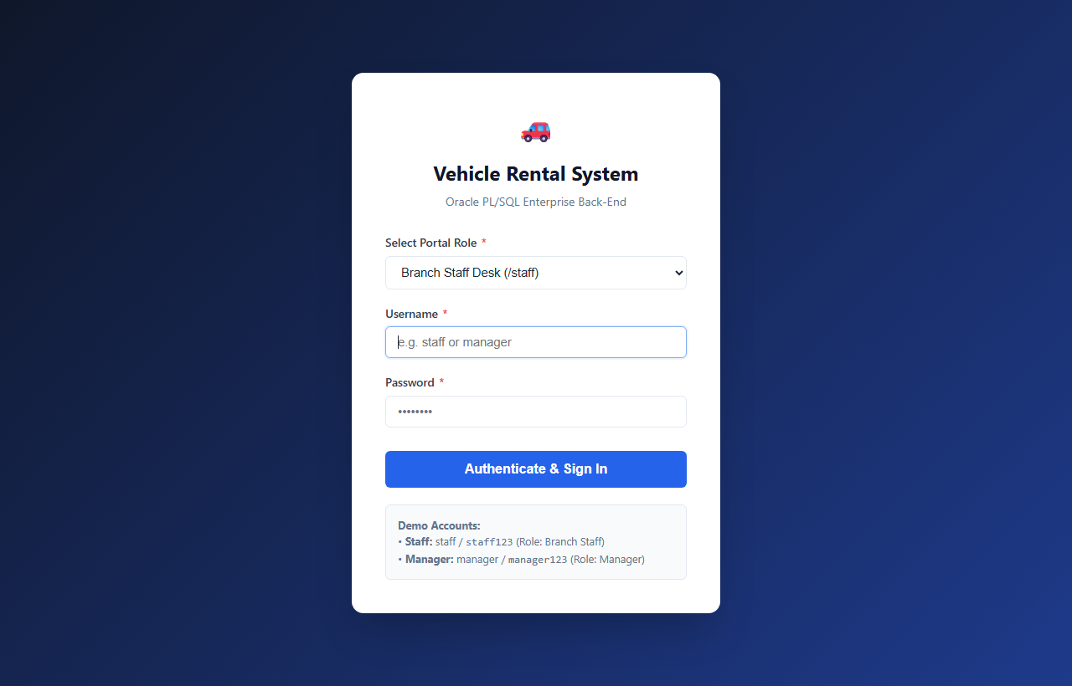
Figure: Login Screen (/login)
Staff Desk Dashboard (/staff)

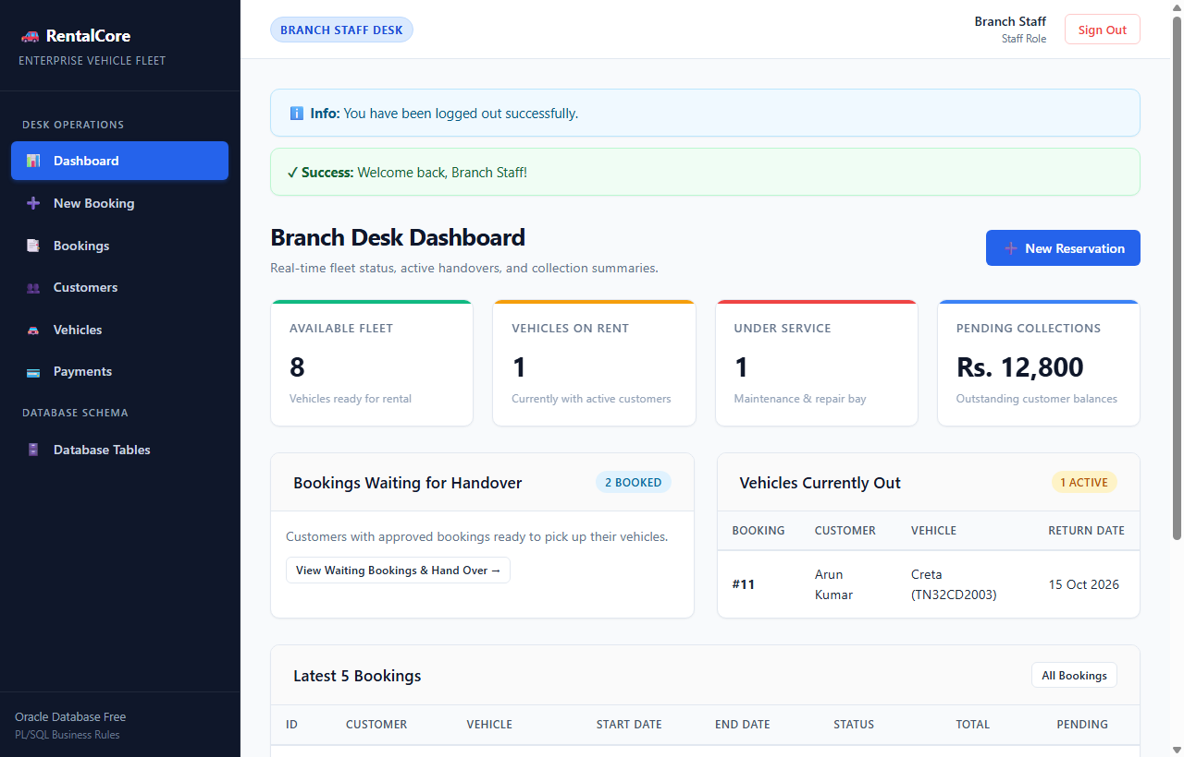
Figure: Staff Desk Dashboard (/staff)
Staff Bookings & Desk Actions (/staff/bookings)

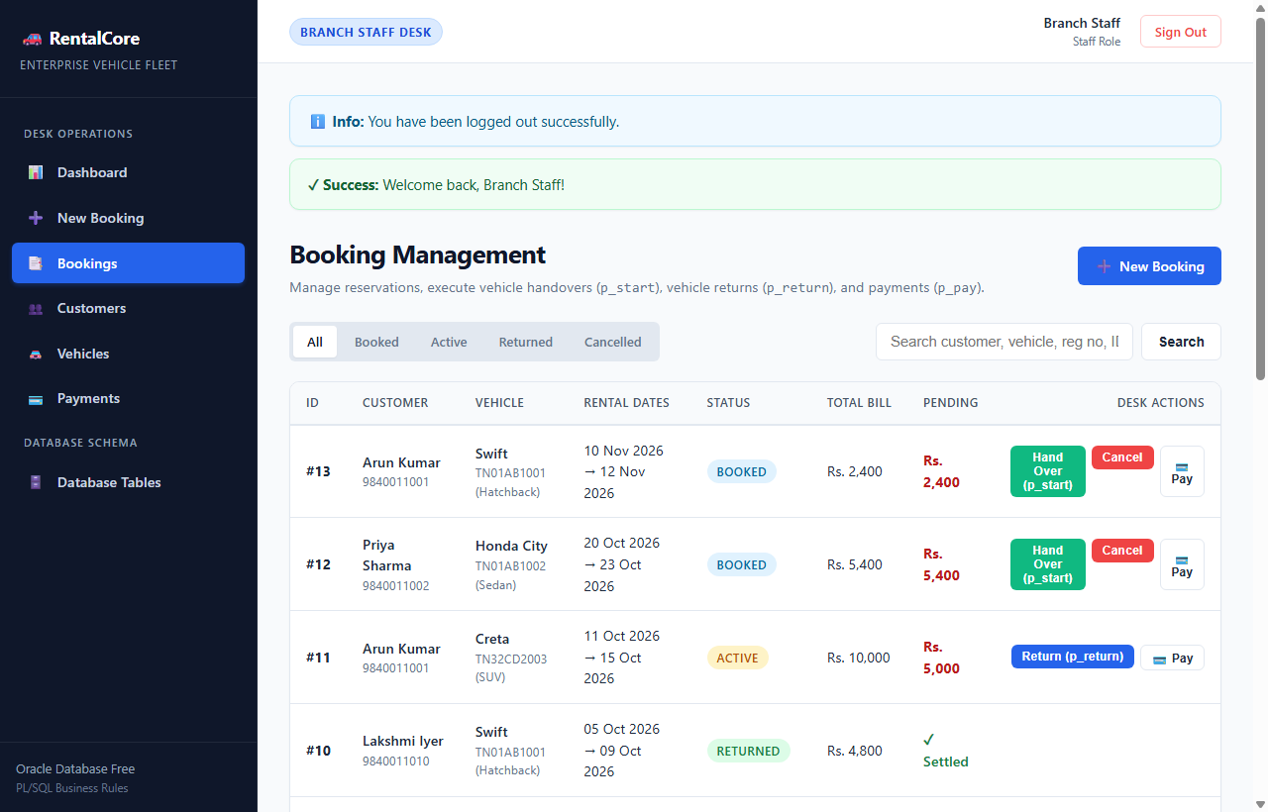
Figure: Staff Bookings & Desk Actions (/staff/bookings)
Manager Analytics Dashboard (/manager)

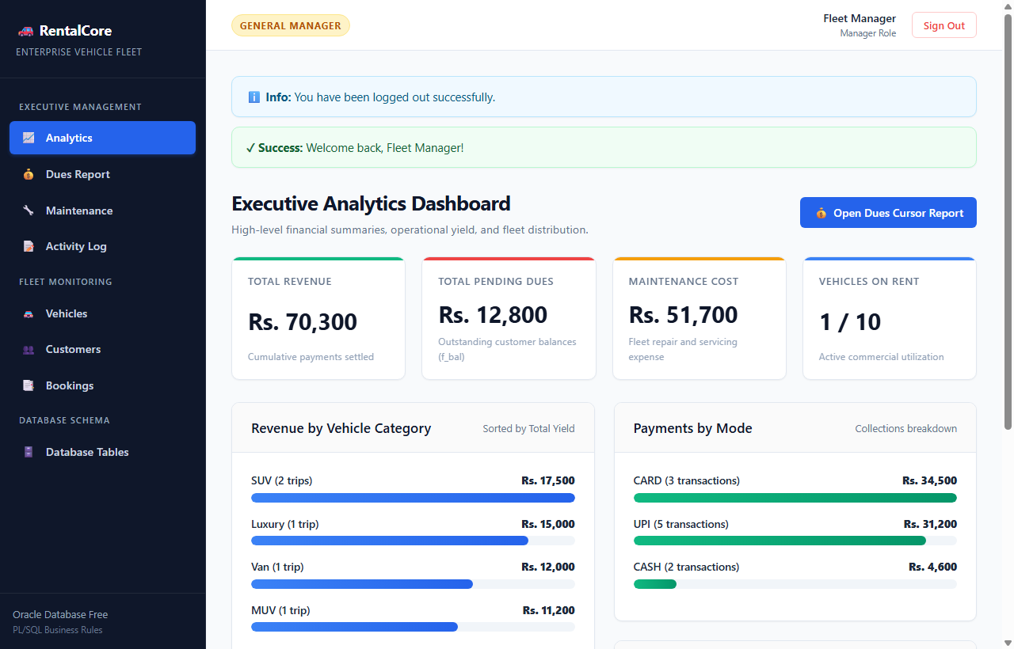
Figure: Manager Analytics Dashboard (/manager)
Manager Outstanding Dues Cursor Report (/manager/dues)

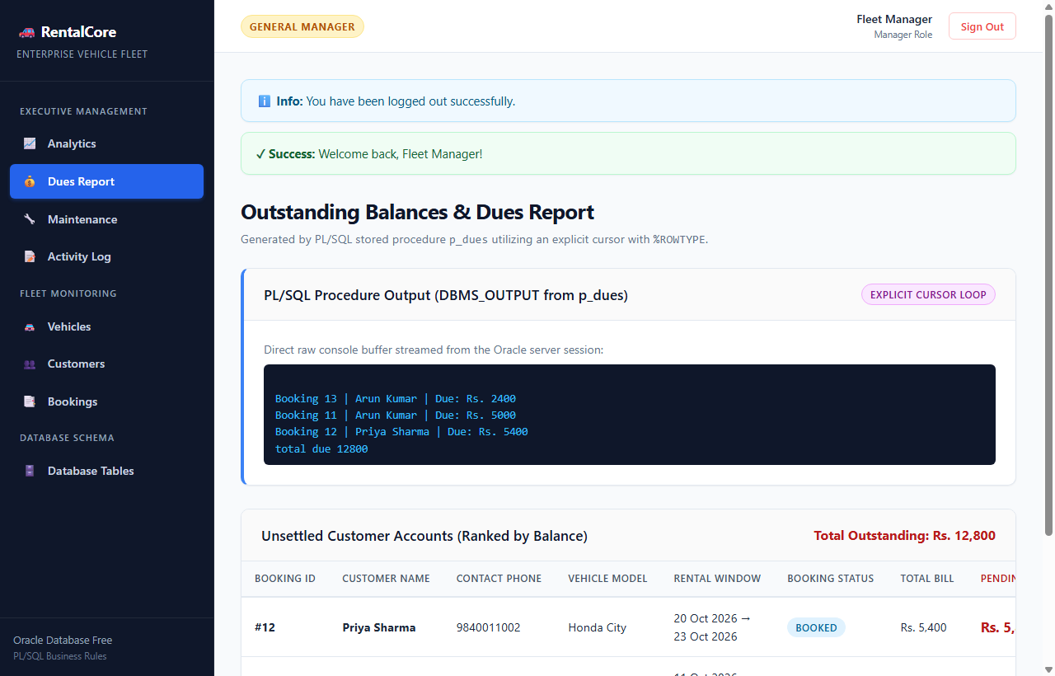
Figure: Manager Outstanding Dues Cursor Report (/manager/dues)
Oracle Schema Browser & Data Dictionary (/tables)

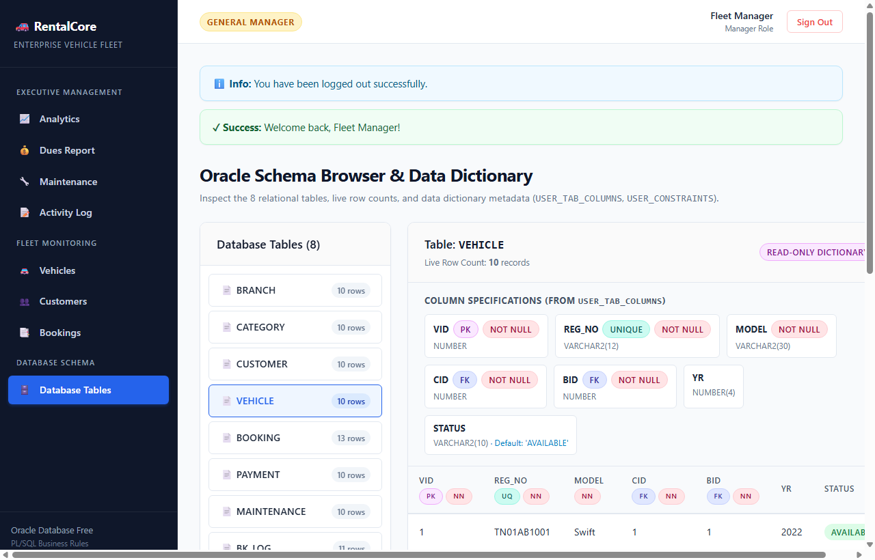
Figure: Oracle Schema Browser & Data Dictionary (/tables)
10. Conclusion
The Vehicle Rental Management System successfully demonstrates an enterprise-grade database application where complex business rules, referential constraints, and financial calculations are 100% maintained within Oracle SQL and PL/SQL. By offloading validation logic—including date overlap checking, dynamic billing calculations, vehicle condition protection, and state machine transitions—to database stored procedures, functions, and triggers, the architecture guarantees absolute ACID consistency regardless of the client or front-end connecting to the server.
All requirements specified in the BCSE302L course guidelines have been completely implemented, verified on a live Oracle 26ai Free database instance, and documented with real outputs. The system provides an end-to-end operational solution combining rigorous relational modeling with a modern, user-friendly web interface.

