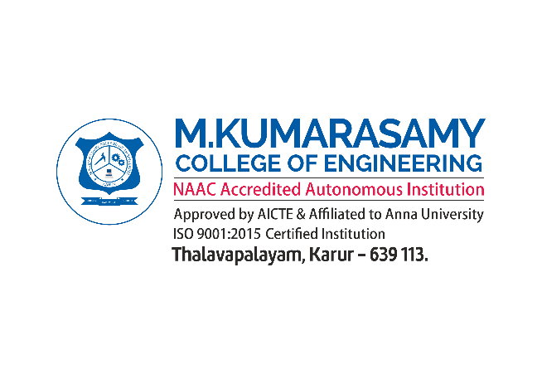

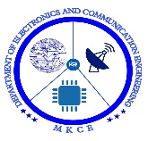

**MOBILE CONTROLLED HOME APPLIANCES WITH ARDUINO**

##### A MINOR PROJECT - III REPORT

###### ***Submitted by***

|  |  |
| --- | --- |
| N.ROSHAN | 927621BEC166 |
| T.RAVIKUMAR | 927621BEC163 |
| V.SANGEETH | 927621BEC174 |
| M.D.SARVESH | 927621BEC188 |

###### 

##### 

**BACHELOR OF ENGINEERING**

in

**DEPARTMENT OF ELECTRONICS AND COMMUNICATION ENGINEERING**

**M.KUMARASAMY COLLEGE OF ENGINEERING**

(Autonomous)

**KARUR – 639 113**

**OCTOBER 2023**

**M.KUMARASAMY COLLEGE OF ENGINEERING, KARUR**

**BONAFIDE CERTIFICATE**

Certifiedthatthis **18ECP105 - Minor Project III** report “**MOBILE CONTROLLED HOME APPLIENCES WITH ARDUINO**” is the bonafide workof “N.ROSHAN (927621BEC166), T.RAVIKUMAR (927621BEC137), V.SANGEETH (927621BEC174), M.D.SARVESH (927621BEC188)”who carried out the project work under my supervision in the academic year 2023 - 2024 - ODD.

**SIGNATURE SIGNATURE**

**Dr.A.KAVITHA B.E., M.E., Ph.D., Mrs.B.NEETHTHI AADITHIYA**

**B.E.,M.E.,{Ph.D},**

**HEAD OF THE DEPARTMENT, SUPERVISOR,**

Professor, Assistant professor,

Department of Electronics and Department of Electronics and

Communication Engineering, Communication Engineering,

M.Kumarasamy College of Engineering, M.Kumarasamy College of Engineering, Thalavapalayam, Thalavapalayam,

Karur-639113. Karur-639113.

This report has been submitted for the **18ECP105L – Minor Project-III** final review held at M. Kumarasamy College of Engineering, Karur on 14-10-2023.

**PROJECT COORDINATOR**

**INSTITUTION VISION AND MISSION**

**Vision**

To emerge as a leader among the top institutions in the field of technical education.

**Mission**

**M1:** Produce smart technocrats with empirical knowledge who can surmount the global challenges.

**M2:** Create a diverse, fully -engaged, learner -centric campus environment to provide quality education to the students.

**M3:** Maintain mutually beneficial partnerships with our alumni, industry and professional associations

**DEPARTMENT VISION, MISSION, PEO, PO AND PSO**

**Vision**

To empower the Electronics and Communication Engineering students with emerging technologies, professionalism, innovative research and social responsibility.

**Mission**

**M1:** Attain the academic excellence through innovative teaching learning process, research areas & laboratories and Consultancy projects.

**M2:** Inculcate the students in problem solving and lifelong learning ability.

**M3:** Provide entrepreneurial skills and leadership qualities.

**M4:** Render the technical knowledge and skills of faculty members.

**Program Educational Objectives**

**PEO1:** **Core Competence:** Graduates will have a successful career in academia or industry associated with Electronics and Communication Engineering

**PEO2:** **Professionalism:** Graduates will provide feasible solutions for the challenging problems through comprehensive research and innovation in the allied areas of Electronics and Communication Engineering.

**PEO3:** **Lifelong Learning:** Graduates will contribute to the social needs through lifelong learning, practicing professional ethics and leadership quality

**Program Outcomes**

**PO 1: Engineering knowledge:** Apply the knowledge of mathematics, science, engineering fundamentals, and an engineering specialization to the solution of complex engineering problems.

**PO 2: Problem analysis:** Identify, formulate, review research literature, and analyze complex engineering problems reaching substantiated conclusions using first principles of mathematics, natural sciences, and engineering sciences.

**PO 3: Design/development of solutions:** Design solutions for complex engineering problems and design system components or processes that meet the specified needs with appropriate consideration for the public health and safety, and the cultural, societal, and environmental considerations.

**PO 4: Conduct investigations of complex problems:** Use research-based knowledge and research methods including design of experiments, analysis and interpretation of data, and synthesis of the information to provide valid conclusions.

**PO 5: Modern tool usage:** Create, select, and apply appropriate techniques, resources, and modern engineering and IT tools including prediction and modeling to complex engineering activities with an understanding of the limitations.

**PO 6: The engineer and society:** Apply reasoning informed by the contextual knowledge to assess societal, health, safety, legal and cultural issues and the consequent responsibilities relevant to the professional engineering practice.

**PO 7: Environment and sustainability:** Understand the impact of the professional engineering solutions in societal and environmental contexts, and demonstrate the knowledge of, and need for sustainable development.

**PO 8: Ethics:** Apply ethical principles and commit to professional ethics and responsibilities and norms of the engineering practice.

**PO 9: Individual and team work:** Function effectively as an individual, and as a member or leader in diverse teams, and in multidisciplinary settings.

**PO 10: Communication:** Communicate effectively on complex engineering activities with the engineering community and with society at large, such as, being able to comprehend and write effective reports and design documentation, make effective presentations, and give and receive clear instructions.

**PO 11: Project management and finance:** Demonstrate knowledge and understanding of the engineering and management principles and apply these to one’s own work, as a member and leader in a team, to manage projects and in multidisciplinary environments.

**PO 12: Life-long learning:** Recognize the need for, and have the preparation and ability to engage in independent and life-long learning in the broadest context of technological change.

**Program Specific Outcomes**

**PSO1:** Applying knowledge in various areas, like Electronics, Communications, Signal processing, VLSI, Embedded systems etc., in the design and implementation of Engineering application.

**PSO2:** Able to solve complex problems in Electronics and Communication Engineering with analytical and managerial skills either independently or in team using latest hardware and software tools to fulfil the industrial expectations.

|  |  |
| --- | --- |
| **Abstract** | **Matching with PO, PSO** |
| Arduino UNO,  RF Controller,  Bluetooth,  IF(Infrarated) | PO1, PO2, PO3, PO4, PO5, PO6, PO7, PO8, PO9, PO10, PO11, PO12, PSO1, PSO2 |

**ACKNOWLEDGEMENT**

Our sincere thanks to Thiru.M.Kumarasamy, Chairman and Dr.K.Ramakrishnan, Secretary of M.Kumarasamy College of Engineering for providing extraordinary infrastructure, which helped us to complete this project in time.

It is a great privilege for us to express our gratitude to Dr.B.S.Murugan., B.Tech., M.Tech., Ph.D., Principal for providing us right ambiance to carry out this project work.

We would like to thank Dr.A.Kavitha B.E., M.E., Ph.D., Professor and Head, Department of Electronics and Communication Engineering for his unwavering moral support and constant encouragement towards the completion of this project work.

We offer our wholehearted thanks to our Project Supervisor, Mrs.B.Neeththi Aadithiya B.E.,M.E.,{Ph.D}, Assistant professor Department of Electronics and Communication Engineering for his precious guidance, tremendous supervision, kind cooperation, valuable suggestions, and support rendered in making our project successful.

We would like to thank our Minor Project Co-ordinator, Dr.K.Karthikeyan, B.E., M.Tech., Ph.D., Assistant Professor, Department of Electronics and Communication Engineering for his kind cooperation and culminating in the successful completion of this project work. We are glad to thank all the Faculty Members of the Department of Electronics and Communication Engineering for extending a warm helping hand and valuable suggestions throughout the project. Words are boundless to thank our Parents and Friends for their motivation to complete this project successfully.

**ABSTRACT**

The rapid advancement of technology has transformed traditional homes into smart and connected environments, allowing users to control various appliances with their mobile devices. In the conventional approach, microcontrollers are integrated into each appliance, which can be cost-intensive and complex. This paper explores an innovative method for mobile-controlled home appliances that does rely on Arduino.This alternative approach utilizes specialized communication modules, such as Bluetooth, Wi-Fi, Infrared (IR), and Radio Frequency (RF), along with smart outlets or sockets as intermediaries. These modules enable seamless communication between a mobile application and the appliances. Users can send commands from their mobile devices to the smart outlets, which interpret and execute these commands, facilitating appliance control without the need for microcontrollers in each device. It opens the door to more accessible and cost-effective mobile-controlled home appliances, promising a more efficient and user-friendly way to interact with our increasingly Mobile-controlled home appliances without the need for microcontrollers represent an innovative leap in smart home technology. Conventionally, Arduino have been integrated into appliances to enable remote control, making them more complex and expensive.

***Keywords:*** *Arduino UNO, RF Controller, Bluetooth, IF (Infrarated)*

**TABLE OF CONTENTS**

|  |  |  |  |
| --- | --- | --- | --- |
| **CHAPTER No.** | **CONTENTS** | | **PAGE No.** |
|  | **Institution Vision and Mission** | | iii |
|  | **Department Vision and Mission** | | iii |
|  | **Department PEOs, POs and PSOs** | | iv |
|  | **Abstract** | | viii |
|  | **List of Tables** | | ix |
|  | **List of Figures** | | xi |
|  | **List of Abbreviations** | | xii |
| **1** | **INTRODUCTION** | | 1 |
|  | 1.1 | Mobile Controlled Appliances | 1 |
|  |  | With Arduino UNO |  |
| **2** | **LITERATURE SURVEY** | | 3 |
|  | 2.1 | Smart Plugs or Outlets | 3 |
|  | 2.2 | Power Line Communication | 3 |
|  | 2.3 | IR Blasters | 4 |
|  | 2.4 | RF Remote Controls | 4 |
| **3** | **EXISTING SYSTEM** | | 5 |
|  | 3.1 | Smart Watch | 5 |
|  | 3.2 | Wireless Protocols | 5 |
| **4** | **PROPOSED SYSTEM** | | 6 |
|  | 4.1 Block Diagram | | 8 |
|  |
|  |
|  |
|  |
| **5** | **COMPONENTS** | | 9 |
|  | 5.1 Arduino UNO | | 9 |
|  | 5.2 Stepdown Transformer | | 9 |
|  | 5.3 Bridge Rectifier | | 10 |
|  | 5.4 Capacitor | | 11 |
|  | 5.5 HC05 Bluetooth | | 12 |
|  | 5.6 | Resistance | 12 |
|  | 5.7 | 547 Transistor | 13 |
|  | 5.8 | DC Fan | 13 |
|  | 5.9 | LED Light | 14 |
| **6** | **WORKING PRINCIPLE** | | 15 |
| **7** | **RESULT AND DISCUSSION** | | 16 |
| **8** | **CONCLUSION AND FUTUTE WORK** | | 18 |
|  | **APPENDICES** | | 20 |
|  | **REFERENCES** | | 21 |

**LIST OF FIGURE**

|  |  |  |
| --- | --- | --- |
| **FIGURE NO.** | **TITLE** | **PAGE NO** |
| 1 | Smart Plug | 3 |
| 2 | Power Line Communication | 3 |
| 3 | IR Blasters | 4 |
| 4 | RF Remote Controls | 4 |
| 5 | Smart Switch | 5 |
| 6 | Wireless Protocols | 5 |
| 7 | Arduino UNO | 9 |
| 8 | Stepdown Tranformer | 9 |
| 9 | Bridge Rectifier | 10 |
| 10 | Capacitor | 11 |
| 11 | HC05 Bluetooth | 12 |
| 12 | Resistance | 12 |
| 13 | 547 Transistor | 13 |
| 14 | DC Fan | 13 |
| 15 | LED Light | 14 |
| 16 | Result | 16 |

**LIST OF ABBREVIATIONS**

|  |  |  |
| --- | --- | --- |
| RF | - | Radio Frequency |
| IR | - | Infrarated |
| I/O | - | Input/output |
| PLC | - | Power Line Communication |
| LED | - | Light Emitting Diode |

CHAPTER 1  
INTRODUCTION

1.1. MOBILE CONTROLLED APPLIENCES WITH ARDUNIO UNO

The proposal aims to develop an innovative and cost-effective method for controlling home appliances via mobile devices without the need for microcontrollers with Ardunio UNO. This approach will leverage specialized communication modules and smart outlets to enable seamless communication and control, simplifying the implementation of mobile-controlled home appliances.

Unauthorized entry into these sites holds the grim potential to unleash catastrophic environmental disasters, thereby endangering both human health and ecological sustainability. The mishandling of hazardous substances, whether intentional or accidental, raises the specter of chemical contamination, soil and water pollution, and devastating disruptions to ecosystems [3].

The need for mobile-controlled home appliances without microcontrollers arises from various practical, financial, and user-centered considerations:

1. Cost-Effective Solution: Microcontrollers add to the cost of individual appliances. By eliminating the need for microcontrollers, a more cost-effective solution can be provided, making home automation accessible to a broader range of users.

2. Simplified Implementation: Integrating microcontrollers in every appliance can be technically challenging and complex, especially for retrofitting existing appliances. A solution that simplifies the implementation of home automation can save time and effort for homeowners.

3. User-Friendly Approach: A system without microcontrollers can be more user-friendly, as it eliminates the need for users to understand and manage microcontroller programming. Users can control their appliances directly through a mobile app, which is often more intuitive.

4. Energy Efficiency: Microcontrollers require a constant power supply, even in standby mode. By eliminating microcontrollers, energy efficiency can be improved, as devices can be completely powered off when not in use.

5. Scalability: A microcontroller-free solution can be more scalable, allowing homeowners to add and control new appliances without significant complexity or cost.

6. Compatibility: It can be challenging to ensure compatibility between appliances with different microcontroller implementations. A standardized approach without microcontrollers can lead to greater interoperability between devices.

7. Widespread Adoption: A simpler, more cost-effective solution can encourage the widespread adoption of home automation, potentially reducing overall energy consumption and contributing to a more sustainable future.

8. Flexibility: Users may wish to control a variety of appliances that do not come with built-in microcontrollers. A system without microcontrollers allows for greater flexibility in home automation.

In summary, the need for mobile-controlled home appliances with ardunio arises from the desire to make home automation more accessible, cost-effective, user-friendly, scalability, and flexibility for users[4].

CHAPTER 2  
LITERATURE SURVEY

**2.1. Smart Plugs or Outlets:** Smart plugs are devices that are plugged into traditional electrical outlets and can control the power supply to the appliances connected to them. They often include Wi-Fi or Bluetooth modules for communication with mobile apps. Users can remotely turn appliances on or off through a mobile app[3].

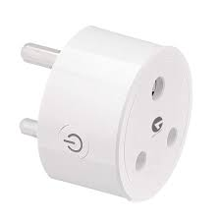

**Figure No.1. Smart Plug**

**2.2. Power Line Communication (PLC):** PLC technology uses the existing electrical wiring in a home to transmit data and control signals. Some PLC modules can be used to control appliances via mobile apps, offering a wired alternative for home automation[4].

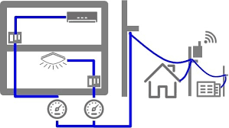

Figure No.2. Power Line Communication

**2.3. IR Blasters:** Some smartphones come with built-in IR blasters. IR blasters can emit infrared signals to control IR-enabled appliances such as TVs, air conditioners, or home theater systems. Mobile apps with IR control capabilities can send IR commands to these appliances.

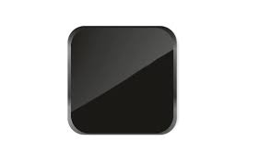

Figure No.3. IR Blaster

**2.4. RF (Radio Frequency) Remote Control:** RF remote control systems use radio frequency signals to communicate with appliances. These systems often consist of a remote control device with RF capabilities and a corresponding receiver that plugs into the appliance. Mobile apps can mimic these RF signals to control the appliance.

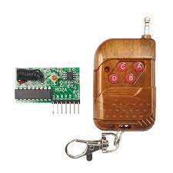

Figure No.4. RF Remote Control

CHAPTER 3  
 EXISTING SYSTEM

**3.1. Smart Switch**: Smart Switches are devices that are plugged into traditional electrical outlets. These devices often include Wi-Fi or Bluetooth modules for communication with mobile apps. Users can plug their appliances into these smart outlets to control them remotely using a mobile app.

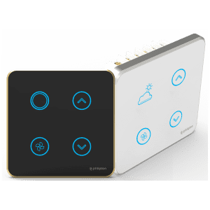

**Figure No.3. Smart Watch**

**3.2. Wireless Protocols:** Some appliances are equipped with wireless communication modules like Wi-Fi or Bluetooth themselves. These appliances can be controlled directly through mobile apps using the respective wireless protocol.

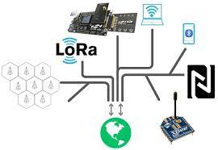

Figure No.4. Wireless Protocols

CHAPTER 4  
 PROPOSED SYSTEM

1. Circuit Connection:

- Connect the Arduino board to the relays. Each relay should control a specific appliance. Make sure to power the relays appropriately to handle the appliances' voltage and current.

2. Bluetooth Module Setup:

- Connect the Bluetooth module to the Arduino. This module will allow the Arduino to receive commands from your mobile device.

3. Mobile App Development:

- Create a mobile app that communicates with the Arduino through the Bluetooth module. The app should have a user-friendly interface to control the appliances.

4. Pairing and Communication:

- Set up the mobile app to pair with the Bluetooth module on the Arduino. This step involves establishing a Bluetooth connection between the mobile device and the Arduino.

5. User Interface:

- Design a user interface within the mobile app that allows the user to select and control individual appliances. This interface should send commands to the Arduino based on the user's inputs. The integration of mobile technology with Arduino-based systems has revolutionized the way we interact with and control home appliances.

6. Arduino Code:

- Write the Arduino code to receive commands from the mobile app through the Bluetooth module. The code should interpret these commands and trigger the appropriate relays to control the appliances.

7. Testing and Debugging:

- Test the system thoroughly to ensure that the mobile app can effectively control the appliances through the Arduino. Debug any issues that may arise during testing.

8. Safety Considerations:

- Ensure that the system includes safety features like emergency stop buttons or protective mechanisms to prevent accidents or appliance malfunctions.

Additionally, the system can provide real-time feedback to the user, displaying the status of appliances or environmental conditions, and it can be programmed for automation, enabling tasks like turning on lights when motion is detected or adjusting temperature settings based on sensor readings. This technology offers users a convenient and energy-efficient means of controlling and monitoring their home environment through their mobile devices, creating a versatile and efficient smart home system. A mobile-controlled home appliance system with Arduino operates through the integration of hardware and software. In this system, an Arduino microcontroller is at the heart of the setup, serving as the central processing unit[5].

4.1. Block Diagram:

**LED LIGHT**

**BRRIDGE RECTIFIER**

**STEP DOWN TRANSFORMER**

V

**DC FAN**

**TRANSISTOR**

**ARDUINO UNO**

**HC05 BLUETOOTH**

CHAPTER 5  
 COMPONENTS USED

# 5.1.Arduino UNO

The Arduino UNO is an open-source microcontroller board based on the Microchip ATmega328P microcontroller and developed by Arduino.cc and initially released in 2010. The board is equipped with sets of digital and analog input/output (I/O) pins that may be interfaced to various expansion boards (shields) and other circuits. The board has 14 digital I/O pins (six capable of PWM output), 6 analog I/O pins, and is programmable with the Arduino IDE (Integrated Development Environment), via a type B USB cable. It can be powered by the USB cable or by an external 9-volt battery, though it accepts voltages between 7 and 20 volts [7].

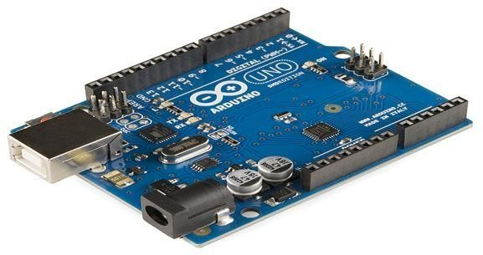

**Figure No.5. Arduino board**

**5.2. Stepdown Transformer:**

A step-down transformer is an electrical device that reduces the voltage of an alternating current (AC) power supply. It consists of a primary winding, a secondary winding, and an iron core.

When an AC voltage is applied to the primary winding, it creates a fluctuating magnetic field in the iron core. This magnetic field then induces a voltage in the secondary winding but at a lower voltage level than the primary winding.

A transformer works on the mutual induction principle, also known as Faraday’s Law of Electromagnetic Induction, which states that the magnitude of voltage is directly proportional to the rate of change of magnetic flux.

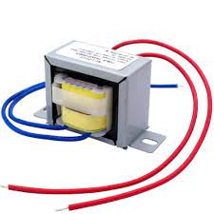

**Figure No.6. Stepdown Transformer**

**5.3. Bridge Rectifier:**

The rectifier circuit is used to convert the AC (Alternating Current) into DC (Direct Current). Rectifiers are mainly classified into three types namely half-wave, full-wave, and bridge rectifier. The main function of all these rectifiers is the same as the conversion of current but they not efficiently convert the current from AC to DC. The center tapped full wave rectifier as well as bridge rectifier converts efficiently.

A bridge rectifier circuit is a common part of the electronic power supplies. Many[electronic circuits](https://www.elprocus.com/build-your-own-electronic-circuits-for-simple-applications/) require a rectified DC [power supply](https://www.elprocus.com/types-power-supplies/) for powering the various [electronic basic components](https://www.elprocus.com/basic-components-used-electronics-electrical/) from available AC mains supply. We can find this rectifier in a wide variety of electronic [AC power devices like home appliances](https://www.elprocus.com/ac-power-supplies-home/), motor controllers, modulation process, welding applications, etc. This article discusses an overview of a bridge rectifier and its working.

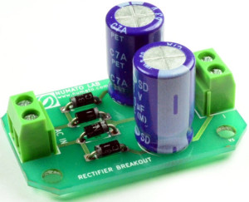

**Figure No.7. Bridge Rectifier**

**5.4. Capacitor:**

A capacitor is a two-terminal electrical device that can store energy in the form of an electric charge. It consists of two electrical conductors that are separated by a distance. The space between the conductors may be filled by vacuum or with an insulating material known as a dielectric.

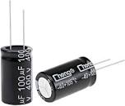

**Figure No.8. Capacitor**

**5.5. HC05 Bluetooth:**

The HC-05 is a versatile and relatively simple Bluetooth module that is widely available and well-documented, making it a popular choice for hobbyists, tinkerers, and developers looking to add wireless communication to their projects. It's important to refer to the datasheet and documentation specific to your HC-05 module to understand its capabilities and limitations, as different versions may have slight variations in functionality.

The HC-05 is a popular Bluetooth module often used for wireless communication in various electronics projects. It is commonly used with microcontrollers like Arduino, Raspberry Pi, and other embedded systems to enable Bluetooth connectivity.

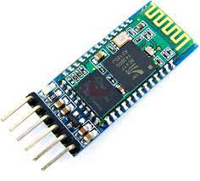

**Figure No.9. HC05 Bluetooth**

**5.6. Resistance:**

Resistance, in the realm of electrical circuits, refers to the inherent property of a material or component to impede the flow of electric current. Measured in ohms (Ω), resistance acts as a hindrance to the movement of electrical charges, with higher resistance values indicating a greater opposition to current flow. This fundamental concept is eloquently encapsulated by Ohm's Law, which establishes the relationship between voltage (V), current (I), and resistance (R), allowing engineers and scientists to manipulate resistance to control current, regulate voltage, and safeguard components in electrical circuits, making it an essential element in the design and function of electronic systems.

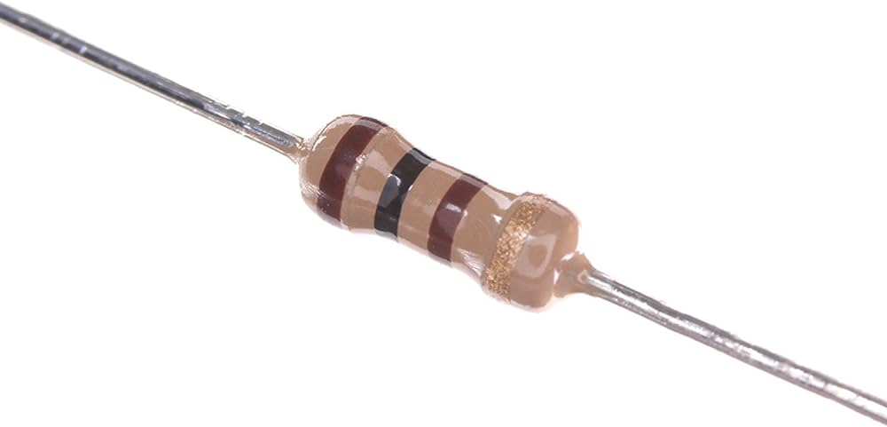

**Figure No.10. Resistance**

**5.7. 547 Transistor:**

A transistor is a fundamental electronic device that functions as an amplifier or a switch in electronic circuits. BJTs, which include NPN and PNP varieties, control the flow of current between their collector and emitter terminals by modulating the current at the base terminal, serving as amplifiers for small signals.

Transistors are pivotal components in modern electronics, enabling the amplification of signals and the realization of digital logic operations.

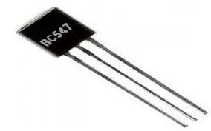

**Figure No.11. 547 Transister**

**5.8. DC Fan:**

A 12V DC fan is an electric fan designed to operate on a 12-volt direct current power source. These fans are commonly used in various applications, including electronics cooling, computer systems, automotive cooling, and ventilation. The "12V" designation indicates that the fan's motor and blades are designed to run efficiently and safely on a 12-volt power supply, making them compatible with standard 12V power sources, such as batteries or power adapters.

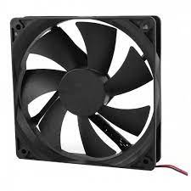

**Figure No.12. DC Fan**

**5.9. LED Light:**

An LED (Light Emitting Diode) light is a semiconductor-based lighting device that emits light when an electrical current passes through it. LEDs are energy-efficient and long-lasting, making them a popular choice for a wide range of lighting applications. They work on the principle of electroluminescence, where the movement of electrons within the semiconductor material produces light.

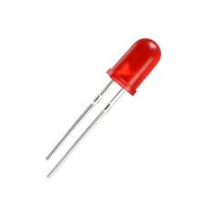

**Figure No.13. LED Light**

**CHAPTER 6**

**WORKING PRINCIPLE**

A mobile-controlled home appliance system with Arduino operates through the integration of hardware and software. In this system, an Arduino microcontroller is at the heart of the setup, serving as the central processing unit. Connected to the Arduino are various sensors, such as temperature sensors or motion detectors, and actuators, like relays for controlling appliances. A wireless communication module, such as Wi-Fi or Bluetooth, links the Arduino with a dedicated mobile application installed on the user's smartphone or tablet. Users interact with the mobile app to send commands, such as turning lights on or off, adjusting thermostat settings, or controlling other home appliances.

These commands are transmitted to the Arduino, which processes the instructions and communicates with the relevant sensors and actuators to execute the desired actions. Additionally, the system can provide real-time feedback to the user, displaying the status of appliances or environmental conditions, and it can be programmed for automation, enabling tasks like turning on lights when motion is detected or adjusting temperature settings based on sensor readings. This technology offers users a convenient and energy-efficient means of controlling and monitoring their home environment through their mobile devices, creating a versatile and efficient smart home system.

**CHAPTER 7**

**RESULT AND DISCUSSION**

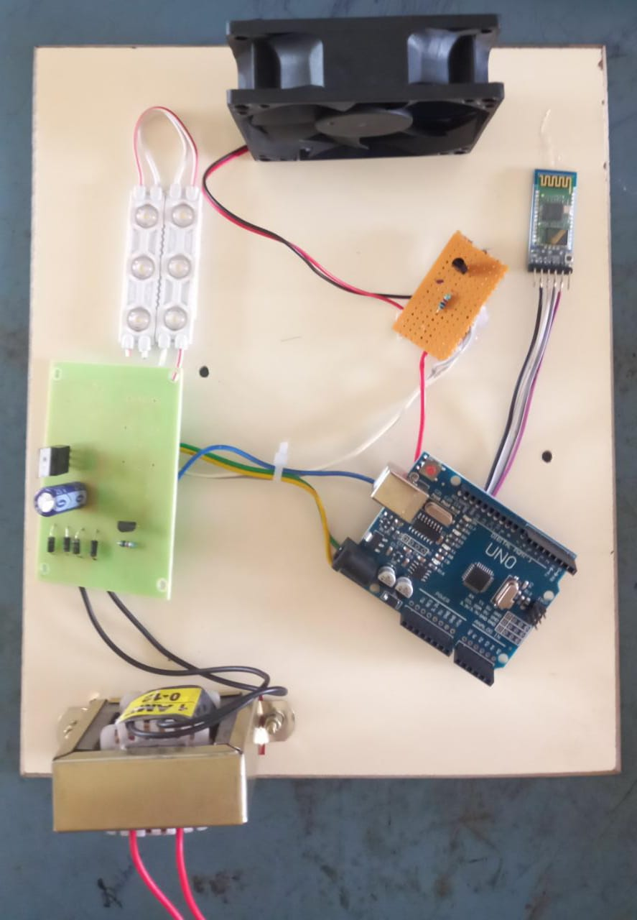

**Figure No.14. Result**

The implementation of Mobile-Controlled Home Appliances with Ardunio UNO has resulted in a cost-effective, user-friendly, and energy-efficient solution for home automation. By utilizing specialized communication modules and smart outlets, this approach simplifies the control of household appliances through mobile apps. Users can seamlessly and remotely manage their appliances from their smartphones or tablets, eliminating the need for microcontrollers in each device. This approach enhances convenience, accessibility, and energy efficiency, making it more attainable for a broader user base. It represents a significant step toward the realization of interconnected, automated smart homes, where users have efficient and economical control over their appliances through their mobile devices, ultimately enhancing their quality of life.

Furthermore, the automation capabilities of this system enable intelligent decision-making, such as turning on lights when motion is detected or optimizing energy consumption based on sensor data. These outcomes underscore the value of mobile-controlled home appliances with Arduino in modernizing and streamlining the way we interact with our living spaces.

Beyond the immediate benefits for homeowners, this technology also aligns with the broader trends of the Internet of Things (IoT) and the advancement of smart home solutions. The successful implementation of this system serves as a testament to the synergy between Arduino-based systems and mobile technology, which is likely to pave the way for further innovations in home automation and the integration of diverse devices and appliances.

The increased control, automation, and energy efficiency brought about by mobile-controlled home appliances with Arduino represent a glimpse into the future of modern living, where technology empowers users to create more responsive and intelligent homes. The implementation of a mobile-controlled home appliance system with Arduino yields impressive results that significantly enhance the convenience and efficiency of managing household devices [8].

**CHAPTER 8**

**CONCLUSION AND FUTUTE WORK**

In conclusion, Mobile-Controlled Home Appliances with Ardunio represents an innovative and cost-effective approach to home automation. This proposal has explored the utilization of specialized communication modules and smart outlets as intermediaries between mobile devices and appliances, simplifying the control process and making home automation more accessible.

Through the development and integration of these components, this approach aims to enhance convenience, energy efficiency, and user-friendliness. It provides a scalable and adaptable solution that eliminates the need for a microcontroller in each appliance, reducing complexity and cost. As a result, it empowers homeowners to create interconnected and automated smart homes with greater affordability.

Several avenues for future work and improvements can be considered in the context of Mobile-Controlled Home Appliances without Microcontrollers:

1. Security Enhancements: Implement robust security measures to protect the communication between mobile devices and appliances, ensuring the safety of the home automation system.

2. Voice Control Integration: Explore the integration of voice recognition technology to allow users to control appliances through voice commands, adding an extra layer of convenience.

3. Energy Monitoring: Develop features that enable users to monitor and manage energy consumption for better sustainability and cost savings.

4. Machine Learning Integration: Implement machine learning algorithms to predict and automate appliance control based on user habits and preferences.

5. Integration with IoT Ecosystems: Enhance compatibility and integration with broader IoT ecosystems, allowing for more diverse interactions with smart devices.

6. User Experience Optimization: Continuously improve the user interface and experience of the mobile app to ensure it remains intuitive and user-friendly.

7. Standardization: Collaborate with industry stakeholders to create standardized communication protocols and connectors for smart outlets and appliances to improve interoperability.

8. Energy Harvesting: Explore energy harvesting technologies that can power smart outlets, reducing the need for external power sources and improving sustainability.

The future of mobile-controlled home appliances without microcontrollers holds the promise of making smart homes more accessible and efficient while constantly evolving to meet the changing needs and expectations of homeowners. Through ongoing research, development, and innovation, this approach has the potential to reshape the way we interact with our domestic environments, making smart living a reality for more people.

**APPENDICES**

**Arduino code:**

#define light 2

#define fan 3

void setup()

{

pinMode(light, OUTPUT);

pinMode(fan, OUTPUT);

Serial.begin(9600);

}

void loop()

{

if (Serial.available() > 0)

{

char c = Serial.read();

if (c == 'A')

{

delay(1000);

digitalWrite(2,HIGH);

}

if(c=='B')

{

delay(1000);

digitalWrite(2,LOW);

}

if(c=='1')

{

delay(1000);

digitalWrite(5,HIGH);

}

if(c=='2')

{

delay(1000);

digitalWrite(5,LOW);

}

}

}

**REFERENCES**

1. T.Sairam Vamsi, Ramya P, Dr.G.R.L.V.N.S Raju, “Design of Intelligent Accident avoiding system using GPS and GSM ” in International Journal of Modern Trends in Science and Technology (IJMTST) ISSN:2455-3778, Volume-03, Issue-07, pp.310-314.

2. T.Sairam Vamsi, R.Viswanadam, K.Praveen kumar“An Industrial Survivalence Sensoric robot controlling through Arduino and GSM ” in International Journal of Contol Theory and Applications (IJCTE) Scopus Indenxed with ISSN:0974-5572, Volume-9, Issue23, pp.87-96.

3. T.Sairam Vamsi, K.Radha “ARM Based Stair Climbing Robot Controlling Through DTMF Technology", in International Journal of Recent Technology and Engineering (IJRTE) ISSN: 2277-3878, Volume-2, Issue-3, July 2013, pp. 71-74.

4. M.JaganMohanrao, T.Sairam vamsi , S.Sudheer ” A Novel Infrared Controlled Home Energy Management System using ZigBee Technology” International Journal of Scientific Research in Computer Science Applications and Management Studies(IJSRCSAMS) ISSN 2319 – 1953, Volume 3, Issue 3 (May 2014).

5. E. M. C. Wong "A phone-based remote controller for home and office automation" IEEE Trans. Consumer Electron, vol. 40 no. 1 pp. 28-34 Feb. 2020.

6. I. Coskun H. Ardam "A remote controller for home and office appliances by telephone"IEEE Trans. Consumer Electron, vol. 44 no. 4 pp. 1291-1297 Nov. 2021.

7. Book: "Home Automation For Dummies" by Dwight Spivey - This book provides a comprehensive introduction to home automation technologies and practices, including the use of microcontrollers in smart home applications.

8. Book: "Internet of Things: Principles and Paradigms" by Rajkumar Buyya and Amir Vahid Dastjerdi - This book covers IoT principles and technologies, which are closely related to home automation. It can provide insights into communication protocols and control methods used in smart homes.

OUTCOME

