# HIGH LEVEL DATA

# 

# SWIGGY DELIVERY OUTLET

# DATA ANALYSIS

# 

# Revision Number: 1.0

Last date of revision: 05/01/2022

SARVESH S

DOCUMENT VERSION CONTROL

|  |  |  |  |  |
| --- | --- | --- | --- | --- |
| **Date Issued** |  | **Version** | **Description** | **Author** |
| **05/11/2021** |  | 1.0 | First Version of Complete HLD | Sarvesh S |
|  |  |  |  |  |
|  |  |  |  |  |
|  |  |  |  |  |
|  |  |  |  |  |

# Contents

Document Version Control 1

Abstract 3

1. Introduction 4
   1. Why this High-Level Design Document? 4
   2. Scope 4
2. General Description 4
   1. Product Perspective & Problem Statement 4
   2. Tools used 5
3. Design Details 6
   1. Functional Architecture 6
   2. Optimization 7
4. KPIs 8
   1. KPIs (Key Performance Indicators) 8
5. Deployment
   1. Advantages 9
   2. Disadvantages 10

# Abstract

Food delivery industry is a continuously booming industry for the last couple of

years. Even during the time of pandemic, it was considered as one of the essential

services in towns and cities .Swiggy is one of the leading players in this industry and

is continuously consolidating its position. Moreover, with rapid hike in internet usage,

the customer base in this industry has also seen enormous growth. Data analytics

would help the company in tracking the business through data based insights and

improving the business methodologies.

# Introduction

## Why this High-Level Design Document?

The purpose of this High-Level Design (HLD) Document is to add the necessary detail to the current project description to represent a suitable model for coding. This document is also intended to help detect contradictions prior to coding, and can be used as a reference manual for how the modules interact at a high level.

The HLD will:

* + - Present all of the design aspects and define them in detail
    - Describe the user interface being implemented
    - Describe the hardware and software interfaces
    - Describe the performance requirements
    - Include design features and the architecture of the project
    - List and describe the non-functional attributes like:
      * Security
      * Reliability
      * Maintainability
      * Portability
      * Reusability
      * Application compatibility o Resource utilization
      * Serviceability

## Scope

The HLD documentation presents the structure of the system, such as the database architecture, application architecture (layers), application flow (Navigation), and technology architecture. The HLD uses non-technical to mildly-technical terms which should be understandable to the administrators of the system.

# .General Description

## Product Perspective & Problem Statement

Development of the reports and the Dashboards from which one can simply understand about the availability of restaurants around various regions in Bangalore and also provides insights into the influence of region, cost of food and cuisine on the customers’ rating.

Food industry is one of the continuously booming ones for the last couple of years. Swiggy is one of the leading app-based food delivery company. Customers can use its interactive customer-friendly dashboard to make perfect food choices. Its database on food outlets is very useful in improving customer interface and in deriving business decisions.

## Tools used

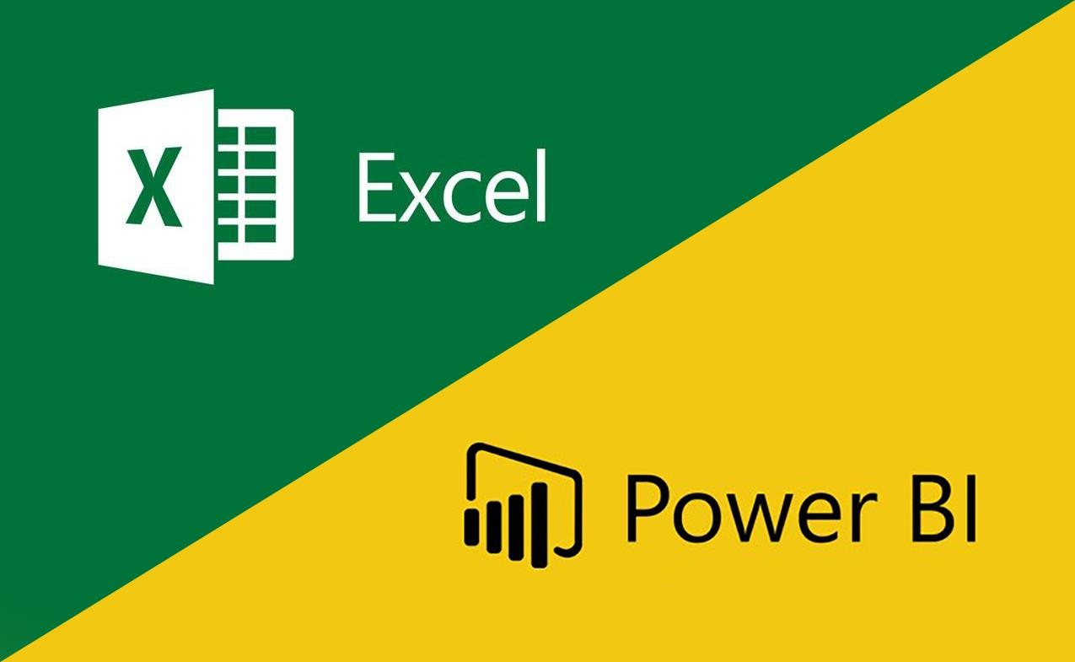Business Intelligence tool Microsoft Power Bi and Excel are used to build this Project.

# Design Details

## Functional Architecture

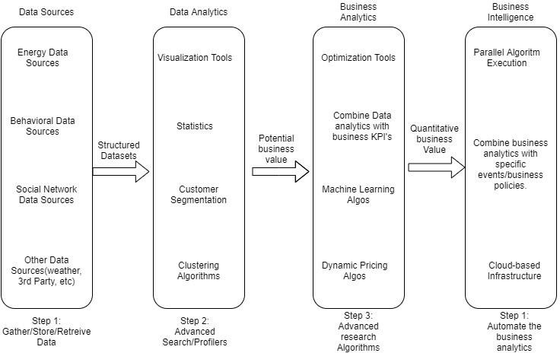

Figure 1: Functional Architecture of Business Intelligence

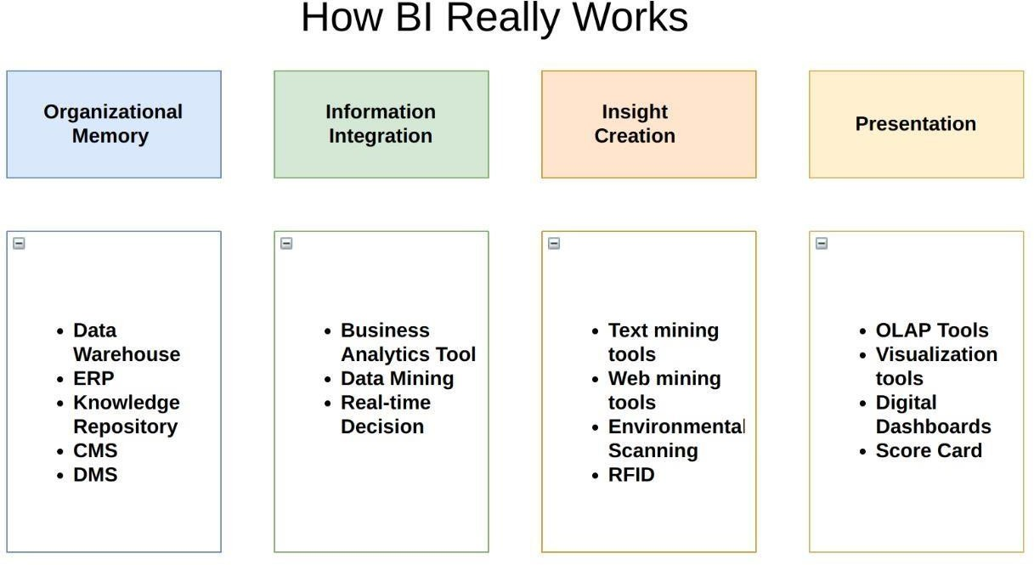

## Optimization

### Your data strategy drives performance

* + - Minimize the number of fields
    - Minimize the number of records
    - Optimize extracts to speed up future queries by materializing calculations, removing columns and the use of accelerated views

### Reduce the marks (data points) in your view

* + - Practice guided analytics. There’s no need to fit everything you plan to show in a single view. Compile related views and connect them with action filters to travel from overview to highly-granular views at the speed of thought.
    - Remove unneeded dimensions from the detail shelf.
    - Explore. Try displaying your data in different types of views. **Limit your filters by number and type**
    - Reduce the number of filters in use. Excessive filters on a view will create a more complex query, which takes longer to return results. Double-check your filters and remove any that aren’t necessary.
    - Use an include filter. Exclude filters load the entire domain of a dimension, while include filters do not. An include filter runs much faster than an exclude filter, especially for dimensions with many members.
    - [Use a continuous date filter.](http://onlinehelp.tableau.com/current/pro/online/mac/en-us/help.htm#filtering_add_dragfields_dates.html) Continuous date filters (relative and range-of-date filters) can take advantage of the indexing properties in your database and are faster than discrete date filters.
    - [Use Boolean or numeric filters.](http://www.tableau.com/learn/tutorials/on-demand/logical-calculations) Computers process integers and Booleans (t/f) much faster than strings.
    - Use [parameters](http://onlinehelp.tableau.com/current/pro/online/en-us/help.htm#parameters.html) and [action filters.](http://onlinehelp.tableau.com/current/pro/online/en-us/help.htm#actions.html) These reduce the query load (and work across data sources).

### Optimize and materialize your calculations

* + - Perform calculations in the database • Reduce the number of nested calculations.
    - Reduce the granularity of LOD or table calculations in the view. The more granular the calculation, the longer it takes.
      * LODs - Look at the number of unique dimension members in the calculation.
      * Table Calculations - the more marks in the view, the longer it will take to calculate.
    - [Where possible, use MIN or MAX instead of AVG.](http://onlinehelp.tableau.com/current/pro/online/windows/en-us/help.htm#calculations_aggregation.html) AVG requires more processing than MIN or MAX. Often rows will be duplicated and display the same result with MIN, MAX, or AVG.
    - [Make groups with calculations.](http://kb.tableau.com/articles/knowledgebase/creating-groups-using-calculated-fields) Like include filters, calculated groups load only named members of the domain, whereas Tableau’s group function loads the entire domain.
    - [Use Booleans or numeric calculations instead of string calculations.](http://onlinehelp.tableau.com/current/pro/online/mac/en-us/help.htm#functions_functions_string.html) Computers can process integers and Booleans (t/f) much faster than strings. Boolean>Int>Float>Date>DateTime>String

# KPIs

Dashboards will be implemented to display and indicate certain KPIs and relevant indicators for the disease.



As and when, the system starts to capture the historical/periodic data for a user, the dashboards will be included to display charts over time with progress on various indicators or factors

## KPIs (Key Performance Indicators)

Key indicators used to identify the relation between customer rating and various other factors are as follows:

1. Relationship between cost of food and rating.
2. The regional distribution of restaurants and the average rating of restaurants across

regions.

1. Cuisines Vs rating to identify the most sort after cuisine.
2. Distribution of hotels across cost and rating to choose the one which has the best rating at an affordable price.
3. **Deployment**

The deployment process lets you clone content from one stage in the pipeline to another, typically from development to test, and from test to production.

During deployment, Power BI copies the content from the current stage, into the target one. The connections between the copied items are kept during the copy process. Power BI also applies the configured deployment rules to the updated content in the target stage. Deploying content may take a while, depending on the number of items being deployed. During this time, you can navigate to other pages in the Power BI portal, but you cannot use the content in the target stage.

There are some advantages and disadvantages of Power Bi.

 9 High Level Design (HLD)

## Advantages

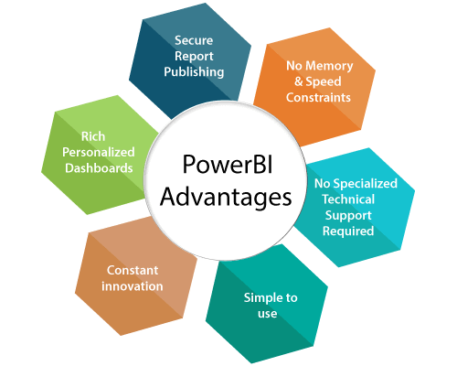

1. **Secure Report Publishing:** You can automate setup data refresh and publish reports that allowing all the users to avail the latest information.
2. **No Memory and Speed Constraints:** To Shift an existing BI system into a powerful cloud environment with Power BI embedded eliminates memory. Speed constraints ensure that data is quickly retrievable and analyzed.
3. **No Specialized Technical Support required:** The Power BI provides quick inquiry and analysis without the need for specialized technical support. It also supports a powerful natural language interface and the use of intuitive graphical designer tools.
4. **Simple to Use:** Power BI is simple to use. Users can easily find it only on behalf of a short learning curve.

10



High Level Design (HLD)

**5. Constant innovation:** The Power BI product is updated in every month with new functions

and features.

**6. Rich, personalized dashboard:** The crowning feature of Power BI is the information dashboards that can be customized to meet the exact need of any enterprise. You can easily embed the dashboards, and BI reports in the applications to provide a unified user experience.

## Disadvantages

1. Dashboards and reports are only shared with the users who are having the same email domains.
2. Power BI will not merge imported data that is accessed from real-time connections.
3. Power BI only accepts the file size maximum 250 Mb and the zip file which is compressed by the data of the x-velocity in-memory database.
4. Dashboard never accepts or pass user, account, or any other entity parameters.
5. Very few data sources permit real-time connections to Power BI reports and dashboards.