Low Level Design

# Swiggy Delivery Outlet Data Analysis

|  |  |
| --- | --- |
| **Written By** | Sarvesh S |
| **Document Version** | 0.1 |
| **Last Revised Date** |  |

# DOCUMENT CONTROL

## Change Record:

|  |  |  |  |
| --- | --- | --- | --- |
| **VERSION** | **DATE** | **AUTHOR** | **COMMENTS** |
| 0.1 | 05/01/2022 | Sarvesh S | Introduction, Architecture and unit test cases defined. |
|  |  |  |  |
|  |  |  |  |
|  |  |  |  |

**Reviews:**

|  |  |  |  |
| --- | --- | --- | --- |
| **VERSION** | **DATE** | **REVIEWER** | **COMMENTS** |
|  |  |  |  |

## Approval Status:

|  |  |  |  |  |  |
| --- | --- | --- | --- | --- | --- |
| **VERSION** | **REVIEW DATE** | **REVIEWED BY** |  | **APPROVED BY** | **COMMENTS** |
|  |  |  |  |  |  |

**Contents**

DOCUMENT CONTROL **2**

Contents Error! Bookmark not defined.

1. Introduction **4**

1.2 Scope **4**

1. Architecture **5**

Power Bi Server Architecture **5**

* 1. Data Sources **6**
  2. Power BI Desktop **7**
  3. Power BI Service **7**
  4. Power BI Report Server **7**
  5. Power BI Gateway **8**
  6. Power BI Mobile **8**
  7. Power BI Embedded **8**

1. Architecture Description **8**
   1. Data Description **8**
   2. Data Insertion in Microsoft Power Bi **9**

3.4. Data Transformation in Power Query Editor **9**

1. Unit Test Cases **10**

# Introduction

## What is Low-Level design document?

The goal of the LDD or Low-level design document (LLDD) is to give the internal logic design of the actual program code for the swiggy data analysis dashboard. LDD describes the class diagrams with the methods and relations between classes and programs specs. It describes the modules so that the programmer can directly code the program from the document.

## Scope

Low-level design (LLD) is a component-level design process that follows a step-by- step refinement process. The process can be used for designing data structures, required software architecture, source code and ultimately, performance algorithms. Overall, the data organization may be defined during requirement analysis and then refined during data design work.

 **5 LOW LEVEL DESIGN**

# Architecture

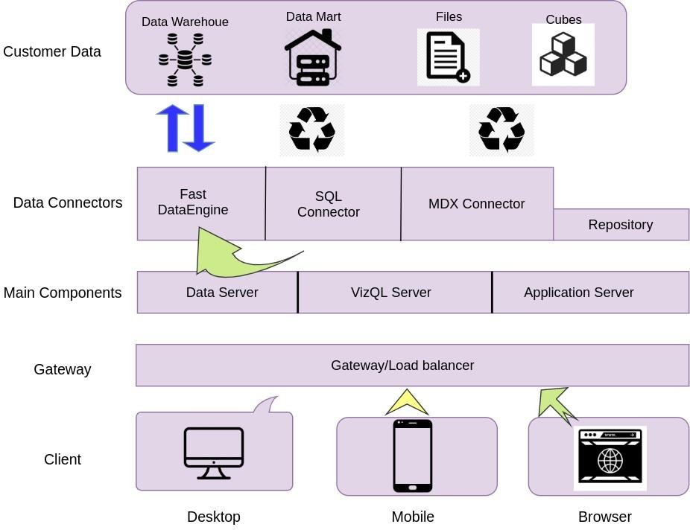

# Power Bi Server Architecture

*Power BI is a business suite that includes several technologies that work together.* To deliver outstanding business intelligence solutions, Microsoft Power BI technology consists of a group of components such as:

* Power Query (for data mash-up and transformation)
* Power BI Desktop (a companion development tool)
* Power BI Mobile (for Android, iOS, Windows phones)
* Power Pivot (for in-memory tabular data modeling)
* Power View (for viewing data visualizations)
* Power Map (for visualizing 3D geo-spatial data)
* Power Q&A (for natural language Q&A)

In simple terms, a Power BI user takes data from various data sources such as **files, Azure source, online services, Direct Query or gateway sources.**

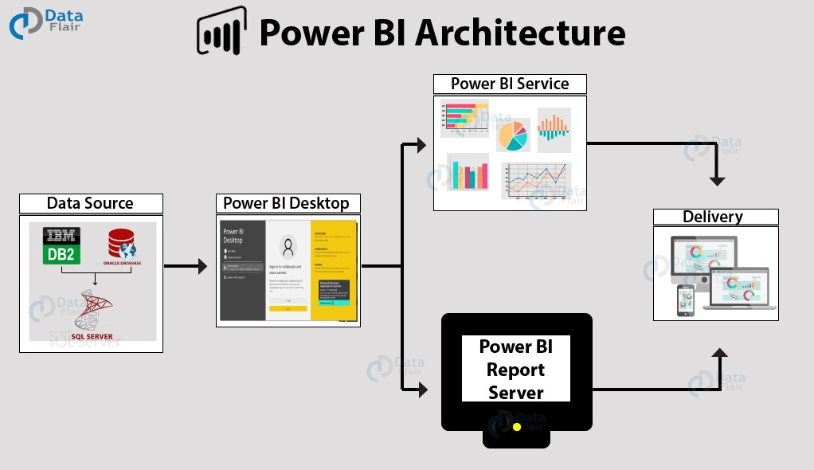

## Data Sources

An important component of Power BI is its vast range of data sources. You can import data from files in your system, cloud-based online data sources or connect directly to live connections. If you import from data on-premise or online services there is a limit of 1 GB. Some commonly used data sources in Power BI are:

* + Excel
  + Text/CSV
  + XML
  + JSON
  + Oracle Database
  + IBM DB2 Database
  + MySQL Database
  + PostgreSQL Database
  + Sybase Database
  + Teradata Database
  + SAP HANA Database
  + SAP Business Warehouse server
  + Amazon Redshift
  + Impala
  + Google Big Query (Beta)
  + Azure SQL Database
  + Salesforce Reports
  + Google Analytics
  + Facebook
  + GitHub

1. **Power BI Desktop**

Power BI Desktop is a client-side tool known as a companion development and authoring tool.

This desktop-based software is loaded with tools and functionalities to *connect to data sources, transform data, data modeling and creating reports.*

You can download and install Power BI Desktop in your system for free. Using Power BI Desktop features, one can do *data cleansing, create business metrics and data models, define the relationship between data, define hierarchies, create visuals and publish reports.*

## Power BI Service

Power BI Service is a web-based platform from where you can *share reports made on Power BI Desktop, collaborate with other users, and create dashboards.*

It is available in three versions:

* + Free version
  + Pro version
  + Premium version

Power BI Service is also known as, **“Power BI.com”**, **“Power BI**

**Workspace”, “Power BI Site”** and **“Power BI Web Portal”**. This component also offers advanced features like *natural language Q&A* and *alerts*.

## Power BI Report Server

The Power BI Report Server is similar to the Power BI Service. The only difference between these two is that Power BI Report Server is an on-premise platform. It is

used by organizations who do not want to publish their reports on the cloud and are concerned about the security of their data.

Power BI Report Server enables you to create dashboards and share your reports with other users following proper security protocols. To use this service, you need to have a Power BI Premium license.

## Power BI Gateway

This component is used to connect and access on-premise data in secured networks. Power BI Gateways are generally used in organizations where data is kept in security and watch. Gateways help to extract out such data through secure channels to Power BI platforms for analysis and reporting.

## Power BI Mobile

Power BI Mobile is a native Power BI application that runs on iOS, Android, and Windows mobile devices. For viewing reports and dashboards, these applications are used.

## Power BI Embedded

Power BI Embedded offers APIs which are used to embed visuals into custom applications.

# Architecture Description

## Data Description

Swiggy delivery outlet data contains retings of restaurants which fall under the category such as name of the restaurant, cuisine ,location, cost for two, customer rating.

* + 1. Shop_name: Name of the restaurants
    2. Cuisine: Different varieties of cuisines available in the restaurants.
    3. Location: Address where the shop is located.
    4. Sub-district: The shop is located in this region of Bangalore.
    5. Cost_for_two: The average cost of food for two people at the restaurant.
    6. Rating: The average rating given by the customers based on their experience.

## Data Insertion in Microsoft Power Bi

I have imported the files containing swiggy data into Microsoft Power Bi.

## 3.4. Data Transformation in Power Query Editor

The data has been transformed according to the requirement. One of the missing value of ratings was obtained under suitable statistical methodologies. An extra colum was added which accommodated the split location column. This was required for conducting sub-district based analysis.

## 3.5 Deployment.

Once you’ve completed your dashboard, click on Publish.

**10**

**LOW LEVEL DESIGN**



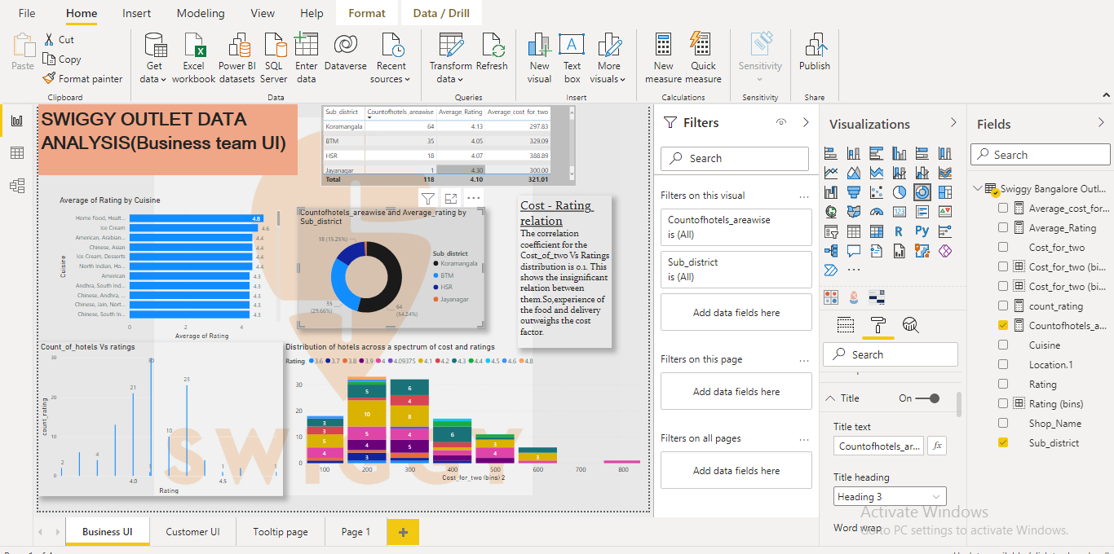

You may be prompted to log into your Microsoft Power Bi profile first if this is your first time publishing.

After the login your data and report will be publish on Microsoft Power Bi Server.

# 

# Unit Test Cases

|  |  |
| --- | --- |
| **TEST CASE DESCRIPTION** | **EXPECTED RESULTS** |
| Region wise analysis of  restaurants | Average rating and average cost of food for the four different regions or sub-districts. When the cursor is  Brought near the values, a table pops up showing  The details of shops in the particular region. |
| Average rating Vs  Cuisine | Cuisine is plotted against the average rating. It shows the most preferred cuisine of people |
| Cost Vs Rating | The correlation of cost of food and rating was done to understand the relation. |
| Count of hotels Vs  Average Rating | It gives an idea about the number of shops with a particular rating. |
| Shop name slicer | The hotel can be searched to get details about the shop. |
| Cuisine slicer | It shows the details of all the shops hosting a particular cuisine. |
| Cost of food Vs count  across various ratings | It shows the distribution of number of shops across various average cost and rating. It helps the customer in choosing the best restaurant. |