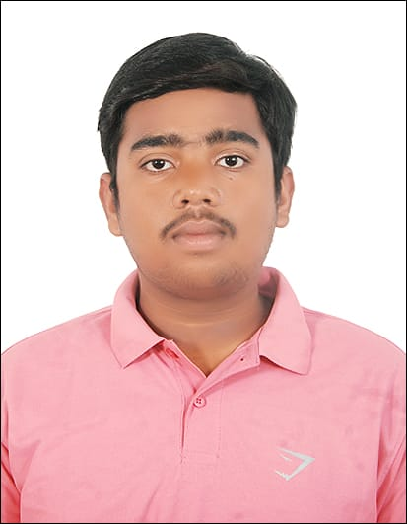

SARVESH SINGH

9137986824
sarvesh9137@gmail.com
www.linkedin.com/in/sarvesh-singh-935b8a250/
https://github.com/sarvesh9137
EDUCATION
Thakur College of Engineering and Technology Mumbai, 2021-25
- B.E. in Computer Engineering
CGPA :7.9

SKILLS
Engineering
- Languages - Java, Python, C, C++, Javascript ,react.js,node.js,next.js,Tailwind,Angular.js Mongodb , Sql ,etc.
- Tech Stacks – Full Stack Web Development,CCNA

PROJECT

- Phonebook website: (Full-Stack)
This is my very first project through which I learned a lot of applications of HTML CSS,Javascript & Bootstrap. This phonebook website helps user to save,add,edit,delete contacts.
While working on this I applied basic HTML,CSS,javascript with prior knowledge of frontend development.
I used java and SQl in backhend to save,add,delete,edit contacts.
- Voice Asssisstant for desktop:
This was my very second project in which I learned a lots of applications of python language.It helps user to control their desktop.For ex- A user with his/her voice can shut down the desktop and many more, etc..
- Stickman Story Animation:
In this project I created a stickman story animation using HTML, CSS, and JavaScript involves combining these technologies to produce a visually appealing and interactive narrative.
- CWS(Code With Sarvesh) Landing Page:
In this Project I created Animated Landing Page for IT Services Business using HTML,CSS,J avascript.
CWS IT Services is a leading provider of comprehensive IT solutions tailored to meet the unique needs of businesses across various industries. This website serves as a gateway to our wide range of services designed to enhance efficiency, productivity, and security within your organization.

EXPERIENCE
- Mathematics Tutor -IX,X,XI, XII, and Engg.Maths
Delivered dedicated 70+hours to teaching tuition as well as private (calculus mostly) this task helped me how to deal with various queries arising in student’s minds and boosted my patience as I had to stay calm even after repeating the same topic multiple times.

Student mentor at JKB Education Group
Being a mentor at JKB Education I helped students for choosing the right career option and also helped students with engineering admission process.

Business management in computer networks in association with Microscan Infocommtech Limited Pvt Ltd.

Working in Computer networks since 2 years I learned configurion of switches,routers,microtik,OLTs,etc..

and

Competitive coding
80+ problems solved on various platfrom Codechef.

Worked as a Network Analyst at Area Link Networks(ALN) Pvt Ltd. ,Mumbai.

Being a network analyst I consulted with users evaluating their needs to recommend designs desirable for

Them with cost analysis,project plans and plan tasks for installation.I also analyzed technical probems and solved them.I also planned and tested network for recommendation and implementation purpose in the server,mainframe,and workstation software and hardware requirements. I provided Network Documentaton,guidance as well as training to the clients.Installing,maintain and configuring the components of the network

